Response to Referee #1

Major comment :

Abstract and elsewhere: The authors claim that the Northwest Corner is a source of vorticity through the non-linear terms for driving the subpolar gyre in the North Atlantic. But I do not see how this is possible dynamically. The problem is that information propagates westwards along potential vorticity
contours – either lines of latitude, as in the formulation of the barotropic vorticity balance given by equation (1), or along f/H contours as in the formulation used by Wang et al. (2017) (see comment 10. below). In either case, it is not possible for a vorticity forcing applied at the northwest corner to
influence the gyre interior. It seems to me, therefore, that it is the eastern boundary regions that are important for driving the gyre and not the Northwest corner. Unfortunately, one cannot appeal to non-linear advection to get around this problem. To be influential, the non-linear term must be important in
the eastern part of the gyre or in the gyre interior itself.

In our definition of the gyre interior with the 3000-m isobath and the -3-Sv (along the South Eastern edge) contour we include the Northwestern Corner (NWC) which is part of the subtropical gyre.
It is true there is no vorticity flux from the NWC to the subpolar gyre interior ( except maybe by a small eddy component) then it does not contribute directly to the gyre circulation.
But in a case without NWC, water masses will drift which will influence the gyre dynamics. Then the NWC is contributing indirectly to the circulation of the subpolar gyre and taking into account the NL term from it seems a good way to imply this.
The facts that there is no net transport from the NWC to the gyre interior and how the NWC can influence the gyre dynamics were added. (l.394-396)

Minor comments :

1. Line 31: Why mention Munk (1950) but not Stommel (1948)? I would refer to both.

Reference to Stommel (1948) was added (l.10)

2. Line 35: An important role for the bottom pressure torque is also anticipated in the early, diagnostic model of Greatbatch et al. (1991) – their Figure 6.

Reference to Greatbatch (1991) was added (l.37)

3. Lines 51-52: Wang et al. also showed the importance of the nonlinear terms in the subpolar gyre for driving the so-called Lavender recirculation – see their Figure 2c.

The case of the Lavender recirculation was added to the list of location where NL term is important (l.55)

4. Line 80: From Chelton et al., I would say that the radius of deformation for the 1 st baroclinic mode has trouble exceeding 10 kms and certainly does not reach 20 kms – see their Figure 6.

On the Southern edge of the domain the first radius of deformation is close to 20-km. To nuance our words we are now saying « first Rossby deformation radius has trouble exceeding 10-km over most of the region » (l.82)

5. Line 97: From Figure 2, the vertical grid does not look to be particularly bottom intensified?

We changed the section in the the Irminger bassin by one in the Labrador Sea where we think it is clearer. We also added the evolution of the grid spacing with depth along the vertical black line in (b)
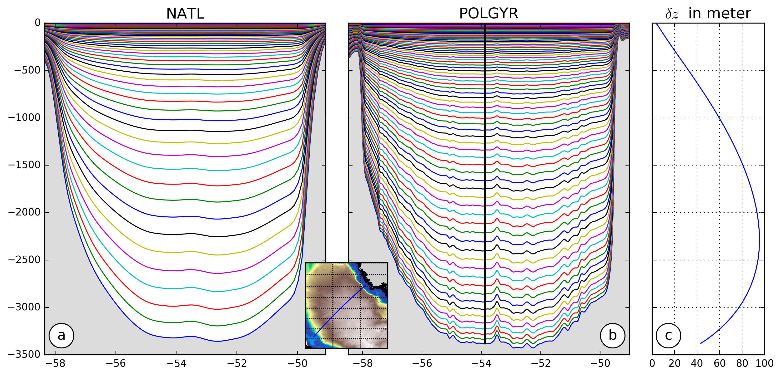

6. Figure 3: It is not easy to see all the details in this figure – although I do not have specific suggestions for improvement.

We tried improving the figure by changing the colormap to better see arrows (p.6)

7. Line 156-157: As noted above, Wang et al. find an important role for what they call “mean flow advection” for driving the Lavender recirculation along the slope around the Labrador Sea.

Thank you for noticing this forgetting. The following was added » More recently Wang (2017) showed the importance of the mean flow advection in these circulations. ». (l.163)

8. Paragraph beginning on line 165: Could refer to Brandt et al. (2004, JGR).

Thank you for suggesting Brandt et al. (2004), the reference was added. (l.171)

9. Line 175: How is EAPE defined? This should be given somewhere.

The definition of EAPE is now added in the new equation (1) :
EAPE =
Where z' is the vertical isopycnal displacement,ρ’ the density anomaly associated with this displacement and is the time average.
Also precisions on the EAPE version of Roullet et al. (2014) where added. (l.182-188)

10. Line 186 and equation (1): Should mention that this is the vorticity equation for the vertically integrated flow. There is also an equivalent vorticity equation for the vertically averaged flow.

The way to obtain the two equations is now mentioned along with the difference between them. (l.197-201)

11. Lines 205-206: Do the acronyms for these different models get defined somewhere?

Acronyms are now defined along with references to previous studies using theses models. (l.219-224)

12. Line 218: ...also the subpolar North Atlantic, as noted above (point 3).

Same as in pont 3 (l.235)

13. Line 221: I would not say the “advection of vorticity” when you are referring to the nonlinear term. It is easy to confuse with the “advection of planetary vorticity”.

In order to avoid confusion « advection of vorticity » was changed by « nonlinear term » (l.238)

14. Line 280: Should “over” be replaced by “within”? Actually, the integral of this term should be very close to zero by construction.

« Over » was replaced by « within ». Because of model discretisation the integral in not exactly zero but very close. (l.297)

15. Line 294: My only objection here is that the Csanady paper uses dynamics linearized about a state of rest which means that the NL term plays no role, as could, perhaps, be made clearer. However, the comparison with the arrested topographic wave is certainly illuminating.

Reference to Csanady (1997) talking about JEBAR effect on the shelf was added. The NL term is only important along Greenland shelf and is related to eddy-barotropic component suggesting eddy interaction between the shelf and the open ocean. On the Canadian shelf the NL term is small and is barely contributing to the dynamics, thus the uses of linearized dynamics seems valid there. The part with coordinate changes has been removed. (l.310-316)

16. Figure 12: The dashed lines show isopycnal surfaces but which density is this? From the labelling, it must be a potential density of some kind. Please make clear.

Indeed, we are talking about potential density. Precision was added in the caption. (p.19)

Typos and language issues :

All the typos and language issues were corrected.

