3GPP TS 34.121-2 V12.4.0 (2016-09)

Technical Specification

3rd Generation Partnership Project;

Technical Specification Group Radio Access Network;

User Equipment (UE) conformance specification;

Radio transmission and reception (FDD);

Part 2: Implementation Conformance Statement (ICS)

(Release 12)

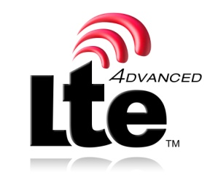 

The present document has been developed within the 3rd Generation Partnership Project (3GPP TM) and may be further elaborated for the purposes of 3GPP.   
The present document has not been subject to any approval process by the 3GPPOrganizational Partners and shall not be implemented.   
This Specification is provided for future development work within 3GPPonly. The Organizational Partners accept no liability for any use of this Specification.  
Specifications and reports for implementation of the 3GPP TM system should be obtained via the 3GPP Organizational Partners' Publications Offices.

Keywords

ICS, Mobile, UE, Terminal, Testing, UMTS

***3GPP***

Postal address

3GPP support office address

650 Route des Lucioles - Sophia Antipolis

Valbonne - FRANCE

Tel.: +33 4 92 94 42 00 Fax: +33 4 93 65 47 16

Internet

http://www.3gpp.org

***Copyright Notification***

No part may be reproduced except as authorized by written permission.  
The copyright and the foregoing restriction extend to reproduction in all media.

© 2016, 3GPP Organizational Partners (ARIB, ATIS, CCSA, ETSI, TSDSI, TTA, TTC).

All rights reserved.

Change the copyright date above as necessary.

UMTS™ is a Trade Mark of ETSI registered for the benefit of its members

3GPP™ is a Trade Mark of ETSI registered for the benefit of its Members and of the 3GPP Organizational Partners  
LTE™ is a Trade Mark of ETSI currently being registered for the benefit of its Members and of the 3GPP Organizational Partners

GSM® and the GSM logo are registered and owned by the GSM Association