3GPP TS 34.121-2 V12.4.1 (2016-10)

Technical Specification

3rd Generation Partnership Project;

TEST

User Equipment (UE) conformance specification;

Radio transmission and reception (FDD);

Part 2: Implementation Conformance Statement (ICS)

(Release 12)

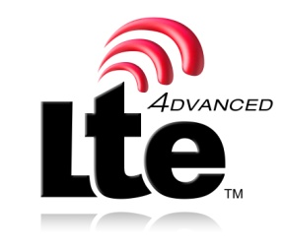 

The present document has been developed within the 3rd Generation Partnership Project (3GPP TM) and may be further elaborated for the purposes of 3GPP.   
The present document has not been subject to any approval process by the 3GPPOrganizational Partners and shall not be implemented.   
This Specification is provided for future development work within 3GPPonly. The Organizational Partners accept no liability for any use of this Specification.  
Specifications and reports for implementation of the 3GPP TM system should be obtained via the 3GPP Organizational Partners' Publications Offices.