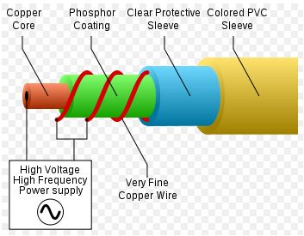

An electric potential of approximately 90 - 120 volts at about 1000 Hz is applied between the copper core wire and the fine wire that surrounds the phosphor coated copper core.

The wire can be modelled as a coaxial capacitor with about 1 nF of capacitance per foot,

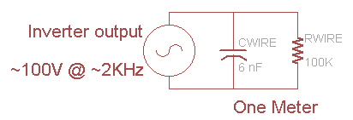

<https://www.instructables.com/id/The-Full-How-Too-Manual-For-EL-Electroluminesce/>

Each meter of high brightness EL draws about 10-15mA at the high voltage, which means about 1.5 Watt/meter (at 100VAC).

We can use this information to determine the power draw.

Assuming you have LyTec EL wire, 2.3mm diameter 'standard'…if have one meter, that is 6nF and 100KΩ in parallel. The capacitance has an impedance of 1/(2πfC) so at 2000 Hz, the impedence per meter is 12 KΩ, in parallel with 100 KΩ it is 11 KΩ total. For a 100V AC power source, the current draw is 100V/11KΩ = 9mA per meter. 100V * 9mA/meter = 0.9 Watts/meter!

Thus an inverter with a 100mA output capability can drive 10 meters

The output of the inverter must be a sine-wave with no DC component.

50-120V AC RMS (150V-360V peak-to-peak). The AC frequency can run from 60Hz to 2000Hz,

Most inverters run at around 100VAC and 2KHz.

**never run an EL inverter without EL wire attached**

<https://learn.adafruit.com/el-wire/using-el-wire>

https://ocw.mit.edu/courses/music-and-theater-arts/21m-735-technical-design-scenery-mechanisms-and-special-effects-spring-2004/assignments/drkp_tn6_1.pdf