Jmeter rapport

First I had to choose an application who fitted the needs of our company : a load testing application open source for measuring the performance of its website.

After doing some research, only two applications held my attention :
Jmeter and Gatling.

Explique un peu mieux pourquoi jmetter ? Psk la la seule raison c'est les graphics results
Je n'ai pas de meilleurs arguments..
I have chosen Jmeter even though it was difficult to choose : I have read both good and bad commentary on the net. Jmeter is older than Gatling, hence we can find more tutorial on the net. Moreover, I have read that it is easier to make graphics results on Jmeter, and I was asked to do some graphics analysis.

Presentation
Apache JMeter is a pure Java application that can be used as a load testing tool for analyzing and measuring the performance of a variety of services. It was originally designed for testing Web Applications but has since expanded to other test functions.
I was asked to test the compagny's website with this tool because some errors appear sometime and it is needed to use load testing in order to reproduce those bugs.

Instal
http://jmeter.apache.org/download_jmeter.cgi
It is not very complex to install, just downloading the release and be sure to have the requirements as java 6 or some optional jars (for jdbc, jms..)
Then it is possible to run the application.

Steps for running the application
First we need to prepar our scenario, the one we will test.
Then we need to record it. Jmeter can generate recording script by following our action on the internet.
After the script is automatically genereted, we have to add some few (on veut affiner le script… en ajoutant des variable pour des inputs etc.. )
Finally we can start the load test.
There are differents ways to extract the result, especially with graphs.

Scenario
Définition scénario
A scenario is a proceedings detailed of some action. (Déroulement préétabli d'une action)
Before running Jmeter, we need to know exactly what scenario we are going to test.
Exemple de scénario
As an example, a scenario of connection on the website :
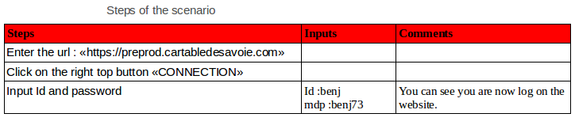

Hence I made a document with fews scenarios to execute :
- Connection to the website
- Create files on the website
- Add external files from the user's machine
- Download files already existant on the website
- Create a recurrent event into the diary
- Create a new lecture classe
- …

Recording script test
Est ce que tu pourrais mieux expliquer les grandes étapes et pourquoi ?
Sans rentrer trop dans les détails genre les étapes sur jmetter.
On Jmeter, we need a Test Script Recorder, in order to record every step of our scenario we do on the website. C'est quoi un TestScript Recorder ? Ça sert à quoi plus précisément?

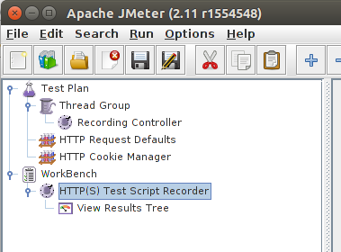

We need also to add a Thred Group inside the Test Plan, where the scenario will be recorded thanks to the Recording Controller. C'est quoi un Thred Group ?? ça sert à quoi ?? Pareil pour Recording Controller...
And also an HTTP Request Defaults that we configured : set the web server and the port. Pareil pour HTTP Request Defaults
Finally, we can start recording.

Configure the browser to use the Jmeter Proxy Server
Dans quel but ?? C'est quoi le jmetter proxy ??
When we start recording, it start the JMeter proxy server which is used to intercept the browser requests.
A file called ApacheJMeterTemporaryRootCA.crt will be generated in jmeter/bin folder in order to know what we did on the website. The recorder script will be based on this file.
En fait j'ai pas trop envie de mettre les étapes c'est trop formel donc faudrait plutôt expliquer pourquoi t'as du configurer le navigateur
(- Start Firefox → Settings (open a page : about:home, then you can see settings on the bottom)
then select Advanced → Network → Settings.
Then select Manual proxy configuration → HTTP Proxy : ''local host'', Port : ''8081''
Check ''Use this proxy server for all protocols''. -) tu peux donc delete tout ca !

LOAD TESTING
Once the scenario is recorded, we start to test with the Thread Group.
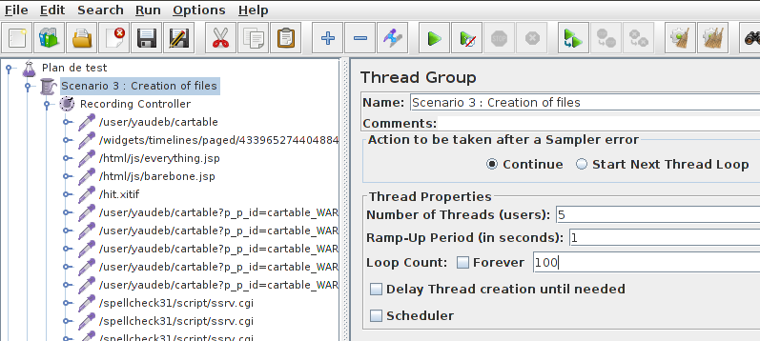
We set the number of Threads (ex:5) and Loop count (ex : 100).
As we can see inside the Recording Controller, there a lot of different steps have been recorded. The thred will execute all of them as many times as it is asked to.

We create a summary report to see the results of the execution. Detailles un peu plus.. Qu'est ce qu'on peut voir sur le summary report...

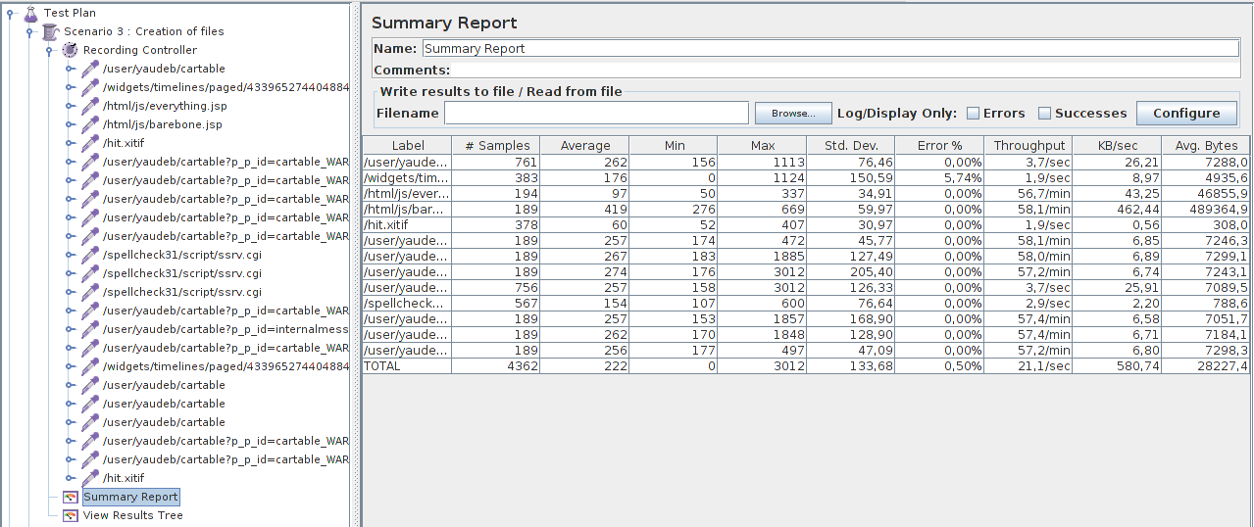
As we can see, it displays every error in each step, the throughput and so on. Donne un exemple ?

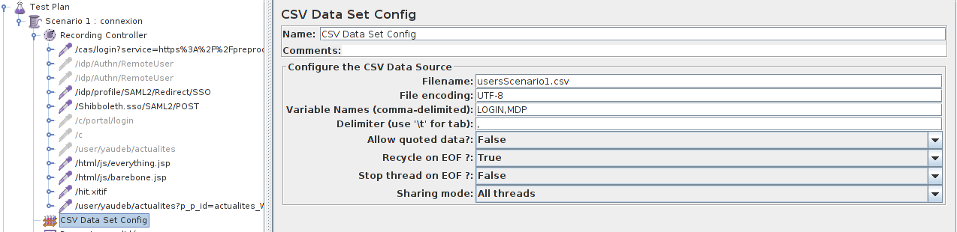
Tu pourrais expliquer un peu mieux ce paragraphe ? C'est pas mal d'en parler mais là c'est pas super clair
We can also execute some tests with differents users. We write in a file.csv the login and password of some users and add in the application a CSV Data Set Config where we can enter the variables names : LOGIN and MDP (password) for example.

Then we add the variables inside step of the test. We can see in the tab, near username and password we enter the variables.

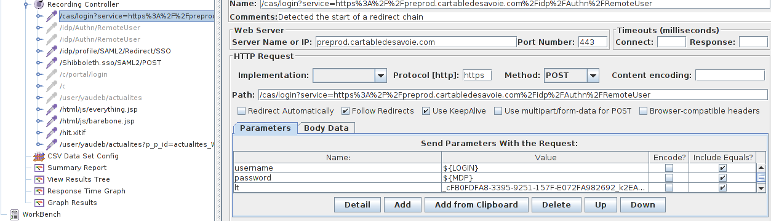

Graphical Result
It is possible to view some graphics result on Jmeter :

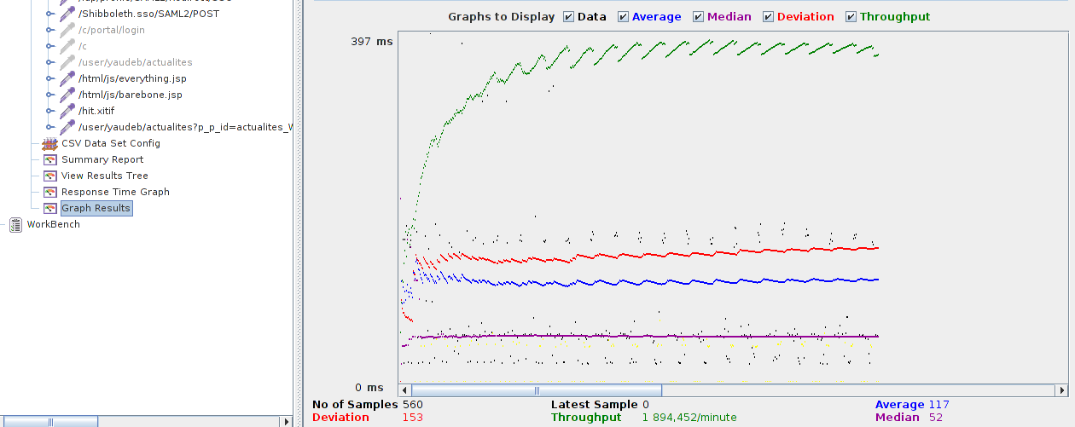

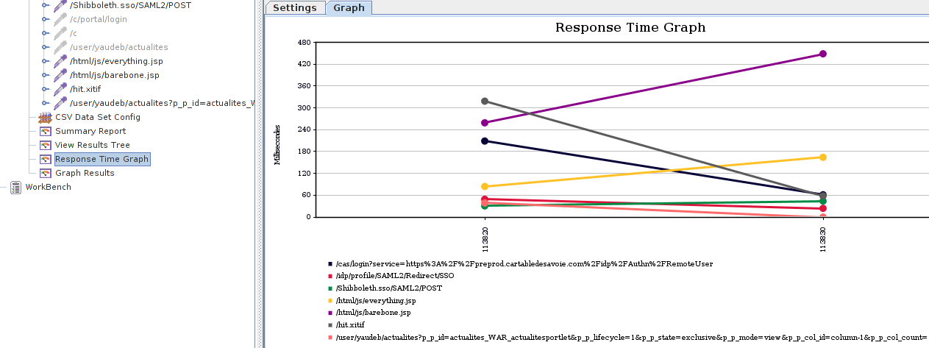

We can exploit those graphs, also it is possible to generate some graphs on excel to analysis the performance . I used this strategy because they are clearer, and it is easier to exploit them.

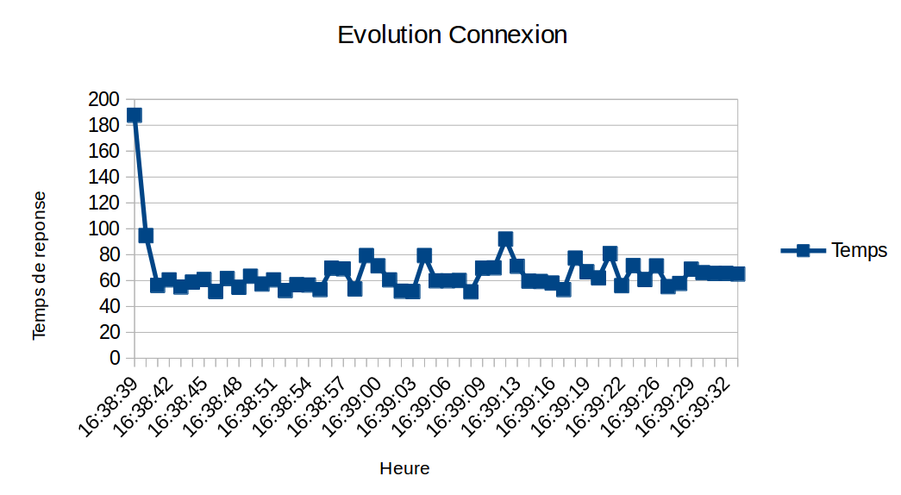
We extract the jmeter's run test results into a file.csv. And then import it into excel in order to generate this graph above.
This point was quite difficult because we have to change some part of jmeter's configuration in order to extract the result and it cause some errors..

