What is an operating system?
An operating is an interface between user and the hardware, for a user to interact with the hardware; he needs to know machine language. A primarily window is a interface between the user and hardware.

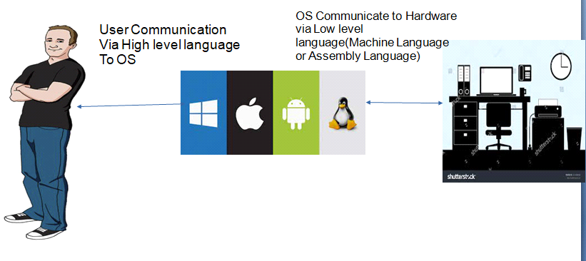

What are the Operating systems that you are of?
- Microsoft Windows
Android (Mobile operating system)
- IOS
What is UNIX? Why UNIX? Which UNIX?-

- Unix is also a operating system like windows, Unix is an open source system (Open is freely available software ) . Windows is licensed software, an subscription to a windows 11 costs around 12000 INR.
- UNIX has a community of developers who contribute for the development of the operating system.
- UNIX is faster and safer than windows, Windows has a GUI (graphical user interface) is meant recreational purposes. UNIX is CLI (Command line interface)
- There are many flavors of UNIX ix in the market, but all the commands that we will study will work on all flavors of UNIX (Redhat, sun solaris),ubuntu, there are 100 most of flavors.
- All organizations use UNIX to host their applications
Characteristics of UNIX
UNIX is CLI (Command line interface), everything will be done with the help of command, UNIX you will have black screen and you will work on the black screen with the help of commands.
UNIX is very sensitive (Case sensitive and Space sensitive), so all the command that you type should adhere to the space and case.
shaja@shaja-VirtualBox:~$ date
Tuesday 19 April 2022 02:00:59 PM IST
shaja@shaja-VirtualBox:~$ Date

Command 'Date' not found, did you mean:
If the wrong case is provided, it will result in an error.
UNIX is a terminal based operating system, each one of you would be connected via a terminal to a server, these terminals are called clients and you will be connected to a server. There are 5 terminal connected to one server
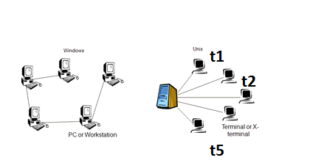
How will connect to UNIX:
- At you work you will use software called PUTTY to connect to the UNIX server.
- At The center you will use VMWARE and open a terminal to work with the UNIX server.
What is SHELL?
- Shell will take user inputs, it will check if the given input is right or wrong, if the wrong input is provided it will throw and error, if the right input is provided, it will take with the kernel.
kernel is the heart of OS, it will interact with the hardware and does the required operations

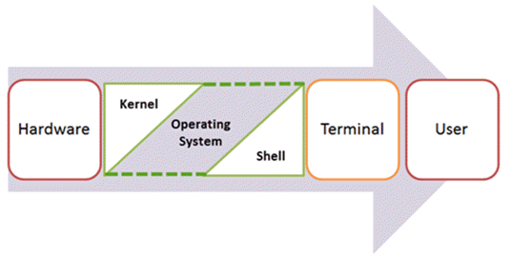

File system of UNIX
The File system of Unix will not have C:/ D:/ and E:/, like we have in windows, the FS will start with a root, the root is denoted by /
the word root is used in two context, root user (root) and root directory (/)
root - it means root user, root user is like admin user . root user is never denied of access to any resources. A root can create/delete files and folder where he wants and can install any packages or software.
Unix File System Windows File System
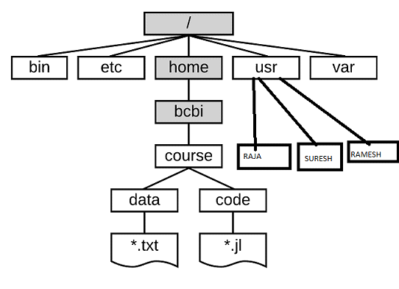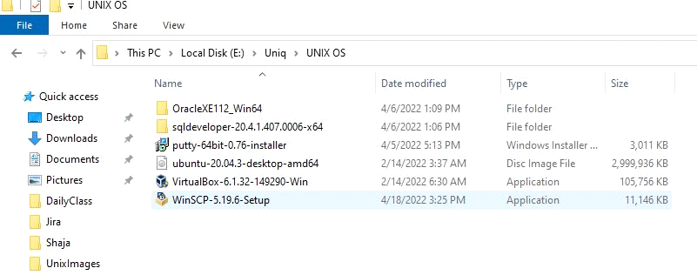
Command structure in UNIX

Any UNIX command s compromises of 3 parts

- Command is mandatory and it usually command name (ls)
- Option(s) - is optional , it will modify the behavior of the command or program( -lrt)
- Argument(s) is optional , arguments are usually, the file or directory name(test.txt)
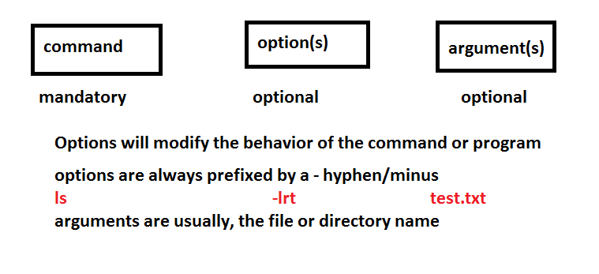
<<<<<<<<<<<<<<< just command >>>>>>>>>>>>>>>>>>>
shaja@shaja-VirtualBox:~/unix$ ls
bigfile.TXT datafile_cma.txt imageMagicPath.txt
Capture.jpg datafile_pipe.txt testfile.txt
Chennai datafile_sp.txt unix_architecture.jpg
<<<<<<<<<<<<<<< command with option >>>>>>>>>>>>>>>>>>>
shaja@shaja-VirtualBox:~/unix$ ls -l
-rw-rw-r-- 1 shaja shaja 15831 Apr 18 20:35 bigfile.TXT
-rw-rw-r-- 1 shaja shaja 135298 Apr 18 17:03 Capture.jpg
drwxrwxr-x 2 shaja shaja 4096 Apr 19 12:03 Chennai
-rw-rw-r-- 1 shaja shaja 456 Apr 18 20:24 datafile_cma.txt
<<<<<<<<<<<<<<< command with option and arguments >>>>>>>>>>>>>>>>>>>
shaja@shaja-VirtualBox:~/unix$ ls -l datafile_cma.txt
-rw-rw-r-- 1 shaja shaja 456 Apr 18 20:24 datafile_cma.txt
ls command:
ls is used to list the files and directories in Unix
FILE COMMAND
COMMAND | DESCRIPTION | USED FOR
ls | List | it gives the list of directory contents
ls -l | detail list | It is used to list the files ,directories with detailed information like permissions , size owner modification time etc.
ls -lt | time based list | it is used to list the file based on the time when they are created (decending)
ls -ltr | reverse list | it is used to list the file in the reverse order based on the time of creation (asending)

<<<<<<<<<<<<<<< demo of ls >>>>>>>>>>>>>>>>>>>
shaja@shaja-VirtualBox:~/unix$ ls
bigfile.TXT datafile_cma.txt imageMagicPath.txt
Capture.jpg datafile_pipe.txt testfile.txt
<<<<<<<<<<<<<<< demo of ls -l>>>>>>>>>>>>>>>>>>>
shaja@shaja-VirtualBox:~/safeunix$ ls -l
-rw-rw-r-- 1 shaja shaja 15831 Apr 18 20:35 bigfile.TXT
-rw-rw-r-- 1 shaja shaja 456 Apr 18 20:24 datafile_cma.txt
-rw-rw-r-- 1 shaja shaja 456 Apr 18 20:25 datafile_pipe.txt
-rw-rw-r-- 1 shaja shaja 488 Apr 18 20:22 datafile_sp.txt
<<<<<<<<<<<<<<< demo of ls -lt>>>>>>>>>>>>>>>>>>>
shaja@shaja-VirtualBox:~/safeunix$ ls -lt
-rw-rw-r-- 1 shaja shaja 1074 Apr 18 20:37 testfile.txt
-rw-rw-r-- 1 shaja shaja 15831 Apr 18 20:35 bigfile.TXT
-rw-rw-r-- 1 shaja shaja 456 Apr 18 20:25 datafile_pipe.txt
<<<<<<<<<<<<<<< demo of ls -ltr>>>>>>>>>>>>>>>>>>>
shaja@shaja-VirtualBox:~/safeunix$ ls -ltr
-rw-rw-r-- 1 shaja shaja 488 Apr 18 20:22 datafile_sp.txt
-rw-rw-r-- 1 shaja shaja 456 Apr 18 20:24 datafile_cma.txt
-rw-rw-r-- 1 shaja shaja 456 Apr 18 20:25 datafile_pipe.txt
To find help in UNIX:
- Whatis
- man
whatis will give a line description of the command
<<<<<<<<<<<<<<<demo of what is >>>>>>>>>>>
shaja@shaja-VirtualBox:~/safeunix$ whatis ls
ls (1) - list directory contents
man stands for manual pages, it will give a detailed description of the command with all the options and arguments.
<<<<<<<<<<<<<<<demo of man >>>>>>>>>>>
LS(1) User Commands LS(1)
NAME
ls - list directory contents
SYNOPSIS
ls [OPTION]... [FILE]...
Basic commands in UNIX

basic command
uname | uname will give the unix name
-a | will give the detailed description of the command (all)
-p | will give the processor details

<<<<<<<<<<<<<<<demo of uname >>>>>>>>>>>
shaja@shaja-VirtualBox:~/safeunix$ uname
Linux
<<<<<<<<<<<<<<<demo of uname –a and -p >>>>>>>>>>>
shaja@shaja-VirtualBox:~/safeunix$ uname -a
Linux shaja-VirtualBox 5.13.0-39-generic #44~20.04.1-Ubuntu SMP Thu Mar 24 16:43:35 UTC 2022 x86_64 x86_64 x86_64 GNU/Linux
shaja@shaja-VirtualBox:~/safeunix$ uname -p
x86_64
basic command
whoami | will show which user you have logged in as
who | will show the list of all users logged in

<<<<<<<<<<<<<<<demo of whoami >>>>>>>>>>>
shaja@shaja-VirtualBox:~/safeunix$ whoami
shaja
<<<<<<<<<<<<<<<demo of who>>>>>>>>>>>
shaja@shaja-VirtualBox:~/safeunix$ who
shaja :0 2022-04-19 11:17 (:0)
shaja pts/1 2022-04-19 13:17 (192.168.1.19)

basic command
date | will print the system date and time
cal | will print the current month calendar
cal 2020 | will print the calendar for the year 2020 (cal 2020)
cal 03 2020 | will print the calendar for the year 2020 and month of march(cal 02 2020)

<<<<<<<<<<<<<<<demo of date >>>>>>>>>>>

shaja@shaja-VirtualBox:~/safeunix$ date
Tuesday 19 April 2022 01:28:05 PM IS
<<<<<<<<<<<<<<<demo of cal >>>>>>>>>>>
shaja@shaja-VirtualBox:~/safeunix$ cal
April 2022
Su Mo Tu We Th Fr Sa
1 2
3 4 5 6 7 8 9
10 11 12 13 14 15 16
17 18 19 20 21 22 23
24 25 26 27 28 29 30
Summary of some basic command
COMMAND
uname | unix name | it will diplay the unix name
whoami | userid | it is used to print logged in user id
whatis | definition | it is used to know one line definition for all commands
cal | calander | it is used to show the calander for the current month
id |  | it is used to print user or grp id
man | Manual | it is used to show the manual of any command that we run on the shell
clear |  | it is used to clear the terminal screen
history |  | it is used to view the command history

Present working directory
To know where we are in the file system we can use the command called pwd. pwd stands for present working directory.
COMMAN COMMAND
pwd | Present working directory | it is used to find pathname of the current working directory

<<<<<<<<<<<<<<<demo of pwd >>>>>>>>>>>
shaja@shaja-VirtualBox:~$ pwd
/home/shaja

Displaying date in different formats:

DATE COMMAND
date +%d | small d denotes date | it is used to display the current date
date +%m | small m denotes month in numeric | it is used to display the current month in numeric or in words
date +%Y | Y denotes year in four digit(2022) | it is used to diplay the current year
date +%H | H denotes hour | it is used to display the current hour
date +%M | capital M denotes minutes | it is used to display the current minutes
date +%S | S denotes second | it is used to display the current second

The date can be broken into
DD
MM
YY
HH
MI
SS
<<<<<<<<<<<<<<<demo of Displaying date >>>>>>>>>>>
shaja@shaja-VirtualBox:~/uniq_april$ date
Mon Apr 11 12:20:53 IST 2022
shaja@shaja-VirtualBox:~/uniq_april$ date +%d
11
shaja@shaja-VirtualBox:~/uniq_april$ date +%m
04
shaja@shaja-VirtualBox:~/uniq_april$ date +%Y
2022
shaja@shaja-VirtualBox:~/uniq_april$ date +%H
12
shaja@shaja-VirtualBox:~/uniq_april$ date +%M
20
shaja@shaja-VirtualBox:~/uniq_april$ date +%S
53
Displaying in DDMMYYHHMISS format

shaja@shaja-VirtualBox:~/uniq_april$ date +%d%m%Y%H%M%S
11042022122249

shaja@shaja-VirtualBox:~/uniq_april$ date +%d-%m-%Y:%H-%M-%S
11-04-2022:12-23-53
Change directory
To navigate from folder to another we can use a command called (cd), cd stands for change directory.
cd dir_name | Change directory | it is used to navigate to specified directory
cd.. | previous directory | it is used to move to the previous directory
cd ../.. | previous directory | will take you to two levels back
cd~ or cd | home directory | it is used to move directly to the home directory
cd - | Toggle directory | will allow you to toggle between two directories

.. (Previous directory)
.( currently directory)
<<<<<<<<<<<<<<<demo of cd >>>>>>>>>>>
To navigate to specified directory
shaja@shaja-VirtualBox:~$ cd safeunix
shaja@shaja-VirtualBox:~$ pwd
/home/shaja/safeunix
To move to the previous directory
shaja@shaja-VirtualBox:~/safeunix$ cd ..
shaja@shaja-VirtualBox:~$ pwd
/home/shaja
To move directly to the home directory
shaja@shaja-VirtualBox:~$ cd T3/11/22/44/55
shaja@shaja-VirtualBox:~/T3/11/22/44/55$ cd
shaja@shaja-VirtualBox:~$ pwd
/home/shaja

Determining if the it’s a file or directory in UNIX
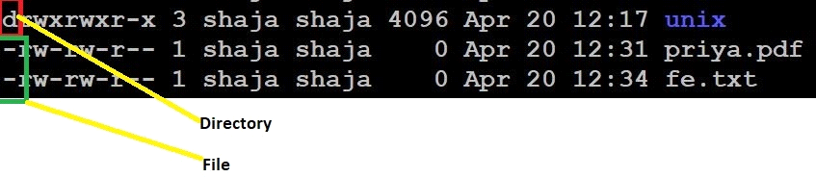
In UNIX to know if the file is a file or directory, we use the initial indictors,
d is for directory
- is for file
UNIX does not have a concept of extension and association.
Creating a file in UNIX:
The simplest program to create a file in UNIX is called touch.
touch command
touch | create file | it is used to create zero byte file
touch deepak.txt | create single file | will create a zero byte file name deepak.txt
touch f1.txt f2.txt | create multiple files | will create multiple zero byte file name f1.txt and f2.txt

shaja@shaja-VirtualBox:~$ touch deepak.txt
shaja@shaja-VirtualBox:~$ ls -l deepak.txt
-rw-rw-r-- 1 shaja shaja 0 Apr 20 13:11 deepak.txt
How to Create 100 files in a directory at a single command
touch file{1..100}
touch file{1..50}.txt

touch /home/sb/unix/testtest/file{200..250}

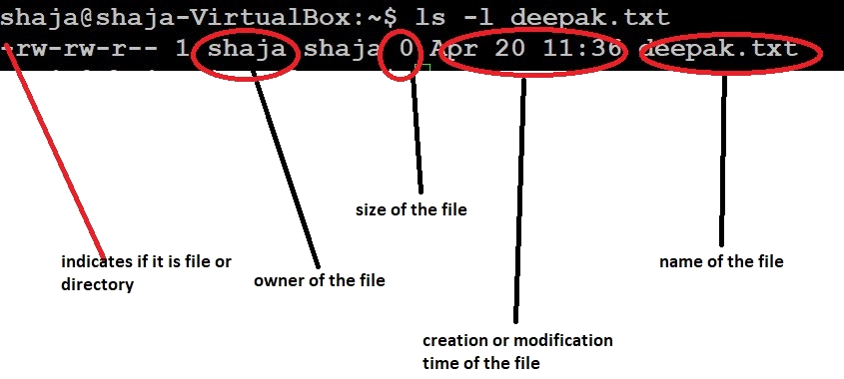

Size chart
1024 bytes=1KB
1024 Kilo bytes=1MB
1024 mega bytes=1GB
1024 GIGA bytes=1TB

Hidden files:
Unix also has a concept of hidden files, like how we have in windows. The hidden file in Unix, always begin with a dot (.)
While listing the files, the hidden will not be shown, to show all the hidden files, we can use the option (-a), a stands for all files (including hidden files)
Hidden files are creating by prefixing a dot in the beginning
touch .priya.txt
Usually the profile files are kept as hidden files, profiles files are rarely modified.
Create a hidden file in UNIX

shaja@shaja-VirtualBox:~$ touch .priya.txt
listing a hidden file in UNIX

shaja@shaja-VirtualBox:~$ ls -la .pr*
-rw-rw-r-- 1 shaja shaja 0 Apr 20 13:14 .priya.txt
Creating a directory in UNIX:
By default the file created using touch are zero bytes and the directories created using mkdir are 4KB.
TO CREATE FILE AND directory
mkdir abinash | create directory | it is used to create a directory (by default its size is 4kb)
mkdir d1 d2 d3 | create multiple directory | it is used to create multiple directory the directory names are seperated by spaces
mkdir -p d1 /d2 /d3 | create nested directory | it is used to create nested directory like (d1/d2/d3)

<<<<<<<<<<<<<<<demo of mkdir >>>>>>>>>>>
Create a directory
mkdir aninash
it will create a directory called abinash
shaja@shaja-VirtualBox:~$ ls -l
drwxrwxr-x 2 shaja shaja 4096 Apr 20 11:55 abinash
create multiple directory
shaja@shaja-VirtualBox:~ $ mkdir d1 d2 d3
shaja@shaja-VirtualBox:~$ ls -l
drwxrwxr-x 2 shaja shaja 4096 Apr 20 11:56 d1
drwxrwxr-x 2 shaja shaja 4096 Apr 20 11:56 d2
drwxrwxr-x 2 shaja shaja 4096 Apr 20 11:56 d3
create nested directory
mkdir -p F1/F2/F3
shaja@shaja-VirtualBox:~$ ls -l
shaja@shaja-VirtualBox:~$ cd F1
shaja@shaja-VirtualBox:~/F1$ ls -l
drwxrwxr-x 3 shaja shaja 4096 Apr 20 11:58 F2
shaja@shaja-VirtualBox:~/F1$ cd F2
shaja@shaja-VirtualBox:~/F1/F2$ ls -l
drwxrwxr-x 2 shaja shaja 4096 Apr 20 11:58 F3
mkdir -p htg/{articles,images,note,done}
mkdir -p htg/{articles/{new,rewrites},images,notes,done}
mkdir -p ~/Documents/htg/{articles/{new,rewrites},images,notes,done}
Creating 500 directory’s or creating multiple directories at same time
mkdir dir{A..Z}
mkdir dir{1..500}
mkdir -p {a,b,c}/tmp{1,2,3}
Removing all directories
ls | xargs rm -rf
Viewing a file in UNIX :
To view a file in UNIX, we have a command cat.
cat file_name | read file | it is used to read the content in the file
cat >file_name | overwrite the file | it is used to create non zero byte file and to overwrite the file
cat >>file_name | append the file | it is used to create non zero byte file and to append the file
cat -n file_name | n - gives number to the lines | it is used to read the content in the file along with the row number
read the content in the file
shaja@shaja-VirtualBox:~/unix$ cat test.txt
kodampakkam
Tnagar
egmore
numngampakkam
Read the content in the file along with the row number
shaja@shaja-VirtualBox:~/unix$ cat -n test.txt
1 kodampakkam
2 Tnagar
3 egmore
4 numngampakkam
create non zero byte file and to overwrite the file
shaja@shaja-VirtualBox:~/unix$ cat > test.txt
chennai
Trichy
create non zero byte file and to append the file
shaja@shaja-VirtualBox:~/unix$ cat >> test.txt
CBE
Blore
shaja@shaja-VirtualBox:~/unix$ cat test.txt
chennai
Trichy
CBE
Blore
Wildcard characters in UNIX:
wildcards are used for pattern matching in UNIX, commands can use wildcards to perform action on multiple files or find part of phrase in text file.
“*” - matches all characters
? - Matches one characters
<<<<<<<<<<<<<<<demo of wildcard in unix >>>>>>>>>>>
Using ‘*’ as wildcard
in the below example all files ending with .txt will be listed
shaja@shaja-VirtualBox:~$ ls -l *.txt
-rw-rw-r-- 1 shaja shaja 0 Apr 19 13:47 test1.txt
-rw-rw-r-- 1 shaja shaja 0 Apr 19 13:47 test2.txt
-rw-rw-r-- 1 shaja shaja 0 Apr 19 13:47 test3.txt
Using ‘*’ as wildcard
in the below example all files that contains a .(dot) in-between are listed
shaja@shaja-VirtualBox:~$ ls -l *.txt
-rw-rw-r-- 1 shaja shaja 0 Apr 19 13:47 test1.txt
-rw-rw-r-- 1 shaja shaja 0 Apr 19 13:47 test2.txt
-rw-rw-r-- 1 shaja shaja 0 Apr 19 13:47 test3.txt
-rw-rw-r-- 1 shaja shaja 35 Apr 18 11:08 Mymeet.TXT
Using ‘?’ ls -as wildcard
in the below example all files ending with .txt will be listed, but the file name is only two characters
shaja@shaja-VirtualBox:~$ ls -l ??.txt
-rw-rw-r-- 1 shaja shaja 0 Apr 20 12:35 ab.txt
-rw-rw-r-- 1 shaja shaja 0 Apr 20 12:34 fe.txt
Special characters seen so far
special characters
.. | previous directory
. | current directory
~ | home directory
> | overwrite a file
>> | appending into a file
* | matches all characters
?? | matches only one characters
Absolute path vs. relative path

ABSOLUTE AND RELATIVE PATH
ABSOLUTE PATH | For ex;  I have to go to deepak.txt  the path will be like cat/home/shaja/deepak.txt | The absolute path is the full path of the file starting from root .  In this we are giving the full path starting from root to the last file so this is known as absolute path
RELATIVE PATH | for ex ; if we are in  home/shaja  I have to go to deepak.txt  the path will be like  cat/ deepak.txt | The relative path will be constructed based on our current location .  In this example I am somewere in the middle of the path so we use the relative path for reaching the file destination

Absolute path is the entire path of the file from the root , a absolute path always begins with /
relative path is always based on your current path.
My home directory is - /home/shaja
shaja@shaja-VirtualBox:~$ cd unix
shaja@shaja-VirtualBox:~/unix$ cd /home/shaja/F1/F2/F3 - used absolute path
shaja@shaja-VirtualBox:~/F1/F2/F3$ pwd
/home/shaja/F1/F2/F3
shaja@shaja-VirtualBox:~/F1/F2/F3$ cd
shaja@shaja-VirtualBox:~$ cd F1/F2/F3 - used relative path
shaja@shaja-VirtualBox:~/F1/F2/F3$ pwd
/home/shaja/F1/F2/F3
shaja@shaja-VirtualBox:~/F1/F2/F3$
Other commands to view a file:
Cat does not allow pagination, to pagination and view a file, we have two command more and less
more:
more file_name.txt
more allows allow pagination of file and help us to read In a systematic way, it does not allow backward pagination
To go to the next line press enter
To go to the next page press space
to quit q
less:
less file_name.txt
less allows allow pagination of file and help us to read In a systematic way, allows backward pagination
To go to the next line press enter
To go to the next page press space
To go to the previous line press y
To go to the previous page press b
to quit q
more | it is used to view the file with pagination  we use enter for viewing next line and space for next page  but the major drawback in more is we can’t do backward pagination
less | it is used to view the file with pagination  we use enter for viewing next line and space for next page , y for previous line and b for previous page

tac and rev

tac file_name | reverse the file | it is used to print the content in the file in reverse order
rev file_name | mirror the file | it is used to print the content in the file in a mirror format
tac ( reverse of cat)
tac file_name.txt
it will display the file in the reverse order
rev :
will print the lines in reverse, mirror image.
<<<<<<<<<<<<<<<demo of tac in unix >>>>>>>>>>>

shaja@shaja-VirtualBox:~/unix$ cat test.txt
chennai
Trichy
CBE
Blore
shaja@shaja-VirtualBox:~/unix$ tac test.txt
Blore
CBE
Trichy
chennai

<<<<<<<<<<<<<<<demo of rev in unix >>>>>>>>>>>
shaja@shaja-VirtualBox:~/unix$ rev test.txt
iannehc
yhcirT
EBC
erolB
head:
OTHER WAYS TO VIEW FILE
head |  | It is used to print the first 10 lines of the file
tail |  | it is used to print the last 10 lines of the file
head -2 file name |  | it is used to print the first 2 lines of the file
head -50 file name |  | it is used to print the first 50 lines of the file
head -3 f1 f2 |  | it is used to print the first 3 lines of both the files
head -8 f1|tail -1 | to get specific line from file | it is used to get the 8th line line from the file
tail -2 file name |  | it is used to print the last 2 lines of the file
head will print the first 10 lines of a file.
head file_name.txt
head (-n) file_name.txt
n can be any number
head (-2) file_name.txt it will show only the first two lines of file
head (-4) file_name.txt- it will show only the first four lines of file
<<<<<<<<<<<<<<<demo of head in unix >>>>>>>>>>>
Head without any options
shaja@shaja-VirtualBox:~$ head names.txt
Sathya
Buvana
SaravananVLM
saravanan
Lalith
deepak
srikanth
venkatesh
abinash
balaji
Head to print only the first two lines
shaja@shaja-VirtualBox:~$ head -2 names.txt
Sathya
Buvana
Head to print only the first four lines
shaja@shaja-VirtualBox:~$ head -4 names.txt
Sathya
Buvana
SaravananVLM
saravanan
tail:
tail will print the last 10 lines of a file.
tail file_name.txt
tail (-n) file_name.txt
n can be any number
tail (-2) file_name.txtit will show only the last two lines of file
head (-4) file_name.txtit will show only the last four lines of file
<<<<<<<<<<<<<<<demo of tail in unix >>>>>>>>>>>

Tail without any options
shaja@shaja-VirtualBox:~$ tail names.txt
Lalith
deepak
srikanth
venkatesh
abinash
balaji
palani
john
priya
shravya
Tail to print only the last four lines
shaja@shaja-VirtualBox:~$ tail -4 names.txt
palani
john
priya
shravya
Tail to print only the last two lines
shaja@shaja-VirtualBox:~$ tail -2 names.txt
priya
shravya

wc ( word count)
wc file_name | wc- word count | it is used to show number of words, lines , character in the file
wc - l (or) wc -w (or) wc -c | l-line , w-word , c-count | it is used to get only total number of lines , words , character

you can print the
- no of lines in a file
- no of words in a file
- no of characters in a file
wc file_name.txt
shaja@shaja-VirtualBox:~$ cat -n names.txt
1 Sathya
2 Buvana
3 SaravananVLM
4 saravanan
5 Lalith
6 deepak
7 srikanth
8 venkatesh
9 abinash
10 balaji
11 palani
12 john
13 priya
14 shravya
15 Shahid
<<<<<<<<<<<<<<<demo of wc in unix >>>>>>>>>>>
- shaja@shaja-VirtualBox:~$ wc names.txt
- 15 15 118 names.txt
- 15 is no of lines
15 is no of words
118 is no of characters
Print only the no of lines(wc –l)
shaja@shaja-VirtualBox:~$ wc -l names.txt
15 names.txt
Print only the no of words(wc –w)

shaja@shaja-VirtualBox:~$ wc -w names.txt
15 names.tx
I Print only the no of the no of characters(wc –c)

shaja@shaja-VirtualBox:~$ wc -c names.txt
118 names.txt
sort:
sort file_name |  | it will sort data in the file in an ascending order
sort -r file_name | r means reverse | it will sort data in the file in a decending order
sort -n file_name | n is used for sorting numbers | it will sort data in the file in an ascending order by default unix dose a string sort to do numberic sort we use -n
sort -nr file_name |  | it is used to sort the numbers in the decending order
sort -k file_name | k is used for column sorthing | if a file contains columnar data we can use this command for column based sorting
sort -k2 file_name | 2 denotes the secound column | it sorts the data in the second column of file
sort -k3r file_name |  | it sorts the data in the third column in that file in reverse order
sort is used to sort or arrange the data in a file
<<<<<<<<<<<<<<<demo of sort >>>>>>>>>>>

sort file_name.txt
sort the data in the file in ascending order

shaja@shaja-VirtualBox:~$ cat city.txt
chennai
trichy
salem
madurai
shaja@shaja-VirtualBox:~$ sort city.txt
chennai
madurai
salem
trichy
sort the data in the file in descending order
Sort –r file_name.txt
shaja@shaja-VirtualBox:~$ sort -r city.txt
trichy
salem
madurai
chennai
By default, sort does a string sort, to do a numeric sort, we have to use the option (-n)
sort –n ( does a numeric sort in ascending order)
Numeric sort the data in the file in ascending order
shaja@shaja-VirtualBox:~/unix$ sort -n test1.txt
1
23
345
346
4567
5000
10000
200000
Numeric sort the data in the file in descending order
sort –nr ( does a numeric sort in descending order)
shaja@shaja-VirtualBox:~/unix$ sort -nr test1.txt
200000
10000
5000
4567
346
345
23
1
Column sort:
if the file has multiple columns, we can explicitly say on which column the sort can be applied, using the columnar sort .
sort –k 2 sort2.txt-- will sort on the 2nd column
sort –k 2n sort2.txt-- will sort on the 2nd column but will do a numeric sort (ascending)
sort –k 2nr sort2.txt-- will sort on the 2nd column but will do a numeric sort in reverse(descending)
Numeric sorts the data in the second column of file(ascending)
shaja@shaja-VirtualBox:~/unix$ sort -k2 datafile_sp.txt
103 Arun 9895123456 30000 PS Trichy
106 Bala 9894173356 40000 Dev CBE
101 Deepa 9894123356 20000 Dev CBE
102 Diwagar 9894223456 15000 Testing Chennai
EMP_ID EMP_NAME EMP_NUMBER SALARY DEPT_NAME EMP_CITY
104 Gopal 9894143456 25000 Testing Salem
107 kaali 9893223456 15000 Testing Chennai
108 kabali 9895127456 50000 PS Trichy
105 Moni 9894723456 10000 Dev Chennai
100 Prakash 9894123456 10000 Dev Chennai
109 Sudagar 9894193456 25000 Testing Salem
Numeric sorts the data in the second column of file(descending)
sb@sb-Inspiron-N5010:~/uniq_april$ sort -k2n sort2.txt
shaja@shaja-VirtualBox:~/unix$ sort -k4n datafile_sp.txt
EMP_ID EMP_NAME EMP_NUMBER SALARY DEPT_NAME EMP_CITY
100 Prakash 9894123456 10000 Dev Chennai
105 Moni 9894723456 10000 Dev Chennai
102 Diwagar 9894223456 15000 Testing Chennai
107 kaali 9893223456 15000 Testing Chennai
101 Deepa 9894123356 20000 Dev CBE
104 Gopal 9894143456 25000 Testing Salem
<<<<<<<<<<<<<<<demo of rm and rmdir >>>>>>>>>>>

rmdir Dir_name |  | it is used to delete the directory (it will delete only if the directory is empty )
rm -r dir_name | r (recursively ) | it is used to delete the directory even if it has some files in it
rm -rf dir_name | rf (recursively and force) | it is used to delete the directory forcefully with out any intraction (intractive mode )
rm file_name |  | it is used to delete the file
 |  | we can also use ? And * to delete multiple files

To remove a directory in unix, we have a command called rmdir – remove directory
rmdir <dir_name>
* the directory should be empty
<<<<<<<<<<<<<<<demo of rm and rmdir >>>>>>>>>>>
delete the directory (If the directory is not empty, the rmdir command will not work )
shaja@shaja-VirtualBox:~/unix$ rmdir dir1
shaja@shaja-VirtualBox:~$ ls -l dir1
ls: cannot access 'dir1': No such file or directory
shaja@shaja-VirtualBox:~/unix$ rmdir Chennai
rmdir: failed to remove 'Chennai': Directory not empty
shaja@shaja-VirtualBox:~/unix$ rm -r Chennai
To delete non empty dir using rm -r
To remove non empty directories, we can use the command rm
rm –rf non_empty_dir
r (recursive)
f (force)
shaja@shaja-VirtualBox:~/unix$ rm -r Chennai
shaja@shaja-VirtualBox:~$ ls -l Chennai
ls: cannot access 'Chennai': No such file or directory
rm -rf non_empty_dir
f will not give any interaction or warning, while removing the directory.
To remove a files in unix, we can use rm –r
rm –rf file_name.txt
r (recursive)
f (force)
To delete files using rm -r
shaja@shaja-VirtualBox:~/unix/chennai$ ls
a.pdf a.txt b.txt c.txt sss
shaja@shaja-VirtualBox:~/unix/chennai$ rm -rf *.pdf
shaja@shaja-VirtualBox:~/unix/chennai$ ls
a.txt b.txt c.txt sss
using wildcards while while removing the files

removing all two character letter files ending with .txt
sb@sb-Inspiron-N5010:~/uniq_april$ rm -rf ??.txt
sb@sb-Inspiron-N5010:~/uniq_april$ ls -l ??.txt
ls: cannot access ??.txt: No such file or directory
Removing all the files ending with .txt
shaja@shaja-VirtualBox:~/unix/chennai$ rm -rf *.txt

COPY COMMAND
cp f1 destination new_f1_name |  | it is used to copy the f1 file to the required destination with new name or same name
cp file_1 file_01 |  | it used to copy the file 1 in the Same directory with different name
cp -p file_1 file_01 |  | it used to copy the file 1 in the Same directory with different name and preserve (mode , ownership and timestamp

To copy files in unix we have a command called, cp. cp is just like control +c in windows.
<<<<<<<<<<<<<<<demo of cp >>>>>>>>>>>
Syntax: cp source destination
Copy files:
cp abdul.txt abdul_bkp.txt
Copy directories:
cp -r abc ./xyz copy the directory abc to in the xyz directory.
cp -r abc xyz copy the directory abc(with content) and creating new directory xyz(Inside the xyz directory abc content will be copied.)

create a copy of a file in the same directory with a different name
shaja@shaja-VirtualBox:~/uniq_april$ cp abdul.txt abdul_bkp.txt
shaja@shaja-VirtualBox:~/uniq_april$ ls -l abd*
-rw-rw-r-- 1 shaja shaja 12 Apr 9 12:20 abdul_bkp.txt
-rw-rw-r-- 1 shaja shaja 12 Apr 6 12:16 abdul.txt

Create a copy of a file with a different name in the home directory
shaja@shaja-VirtualBox:~/uniq_april$ cp abdul.txt /home/shaja/abdul_bkp.txt
shaja@shaja-VirtualBox:~/uniq_april$ ls -l /home/shaja/abdul_bkp.txt
If the destination is a directory all the files, will be copied into that directory
cp abdul.txt /home/shaja (copies the file in the home directory)
cp abdul.txt ~ (copies the file in the home directory)
cp abdul.txt .. (copies the file in the previous directory directory)

copies the file in the home directory
shaja@shaja-VirtualBox:~/uniq_april$ cp abdul.txt /home/shaja/
shaja@shaja-VirtualBox:~/uniq_april$ ls -l /home/shaja/abdul.txt
-rw-rw-r-- 1 shaja shaja 12 Apr 9 12:28 /home/shaja/abdul.txt

copies the file in the previous directory
shaja@shaja-VirtualBox:~/uniq_april$ cp abdul.txt ..
-rw-rw-r-- 1 shaja shaja 12 Apr 9 12:29 /home/shaja/abdul_bkp.txt

Using wildcards while copying ( copies all the .txt file in tmp directory)
shaja@shaja-VirtualBox:~/uniq_april$ cp *.txt /tmp
shaja@shaja-VirtualBox:~/uniq_april$ cd /tmp
cp ???.txt /tmp ( copies all the 3char.txt files in tmp directory)
copying using preserve mode ( ownership and timestamp cp - p )
shaja@shaja-VirtualBox:~/uniq_april$ cp -p abdul.txt abdul_preserve_mode.txt
shaja@shaja-VirtualBox:~/uniq_april$ ls -l abd*
-rw-rw-r-- 1 shaja shaja 12 Apr 6 12:16 abdul_preserve_mode.txt
-rw-rw-r-- 1 shaja shaja 12 Apr 6 12:16 abdul.txt

Copying directories using cp (-r recursive)
shaja@shaja-VirtualBox:~$ cp -r uniq_april /tmp
shaja@shaja-VirtualBox:~$ cd /tmp
shaja@shaja-VirtualBox:/tmp$ ls -ld uniq_april
drwxrwxr-x 8 shaja shaja 4096 Apr 9 12:35 uniq_april

copy files from previous directory to current directory
cp ../ETL* .

shaja@shaja-VirtualBox:~/uniq_april$ cp ../ETL* .
shaja@shaja-VirtualBox:~/uniq_april$ ls -l ETL*

How to copy 50 files out of 100 in a directory
The file name like file1.txt, file2.txt, file3.txt. etc…

copy
cp file{1..50}.txt ./test1

find . -type f | head -15 | xargs cp -t /home/sb/unix/testtest

here –t is --target-directory
xargs - build and execute command lines from standard input

move
mv file{1..50}.txt ./test1

Moving files in UNIX

MOVE COMMAND
mv f1 destination f1 |  | it is used to move the file from one directory to other also we can rename the file in this move command
mv d1 destination d1 |  | it is used to move one directory to other directory

To move files in Unix we have a command called, mv. mv is just like control +x in windows(cut and paste)
mv source destination
if the destination is a directory all the files, will be moved into that directory
move the file into the directory
mv abdul.txt /tmp( moves all the abdul.txt file in tmp directory)
shaja@shaja-VirtualBox:~/uniq_april$ mv abdul.txt /tmp/demo
shaja@shaja-VirtualBox:~/uniq_april$ ls -l abdul.txt
ls: cannot access abdul.txt: No such file or directory
shaja@shaja-VirtualBox:~/uniq_april$ ls -l /tmp/demo/abdul.txt
-rw-rw-r-- 1 shaja shaja 12 Apr 6 12:16 /tmp/demo/abdul.txt

Using wildcards while moving ( copies all the .txt file in tmp directory)
mv *.txt /tmp( moves all the *.txt file in tmp directory)
shaja@shaja-VirtualBox:~/uniq_april$ mv ETL* /tmp/demo/
shaja@shaja-VirtualBox:~/uniq_april$ ls -l ETL*
ls: cannot access ETL*: No such file or directory
shaja@shaja-VirtualBox:~/uniq_april$ ls -l /tmp/demo/ETL*

mv can be used to rename a file in unix
mv abdul.txt abdul_renamed.txt
Move to rename a file

shaja@shaja-VirtualBox:~/uniq_april$ mv abdul_bkp.txt abdul_renamed.txt
shaja@shaja-VirtualBox:~/uniq_april$ ls -l abdul_bkp.txt
ls: cannot access abdul_bkp.txt: No such file or directory
shaja@shaja-VirtualBox:~/uniq_april$ ls -l abdul_renamed.txt
-rw-rw-r-- 1 shaja shaja 12 Apr 9 12:20 abdul_renamed.txt

grep (Global regular expression print)
100% interview question

The grep command can search for a string in groups of files and single file.
grep is used to search for a word or pattern in a file
grep 'string' file_name |  | it prints the line with matches the specific word or a pattern
grep -i 'string' file_name | case insensitive | it will find and display the word even it is in upper or lowercase
grep -w 'string' file_name | w denotes whole word search | it will show only the whole word which is mentioned in the string
grep -n 'string' file_name | n denotes line number | it will show the matched Pattern along with the line number
grep -c 'string' file_name | count no of lines | it will show the count of the matched lines
grep -l 'string' *.txt | l denotes file name | it will show the file names in which the Pattern are matched
grep -v 'string' file_name | Omits matched line(except) | it will omit the matched lines and gives the remaining lines
grep -o 'string' file_name | matched words | it will show only the matched words
grep -E 'string1|string2' file_name | Searching more than one words
grep is used to search for a word or pattern in a file, it is similar to control + f in windows.
but its very powerful compared to windows search
<<<<<<<<<<<<<<<demo of grep >>>>>>>>>>>
grep 'unix' grep.txt
grep will show all lines matching the word unix
shaja@shaja-VirtualBox:~/unix$ grep 'UNIX' testingfile.txt
What is UNIX?
:UNIX® License PlateUNIX is an operating system which was first developed
UNIX systems also have a graphical user interface (GUI)
Types of UNIX
Case insensitive search (grep -i 'unix')
shaja@shaja-VirtualBox:~/unix$ grep -i 'UNIX' testingfile.txt
What is UNIX?
:UNIX® License PlateUNIX is an operating system which was first developed
UNIX systems also have a graphical user interface (GUI)
Types of UNIX and unix
Whole word search using grep (grep -iw 'unix')
shaja@shaja-VirtualBox:~/unix$ grep -w 'UNIX' testingfile.txt
What is UNIX?
:UNIX® License PlateUNIX is an operating system which was first developed
UNIX systems also have a graphical user interface (GUI)
show the count of the matched lines using grep (grep –ic)
shaja@shaja-VirtualBox:~/unix$ grep -c 'UNIX' testingfile.txt
7

Grep omit the matched lines and gives the remaining lines (except) grep -iv 'unix' grep.txt

shaja@shaja-VirtualBox:~/unix$ grep -vi 'UNIX' testingfile.txt
the suite of programs which make the computer work
for operations which aren't covered by a graphical program,
grep can be done on multiple files as well grep -i 'unix' grep1.txt grep.
shaja@shaja-VirtualBox:~/unix$ grep -i 'UNIX' testingfile.txt testfile.txt
What is UNIX?
:UNIX® License PlateUNIX is an operating system which was first developed

Grep to show the file names in which the Pattern are matched grep -il 'unix' *.txt
shaja@shaja-VirtualBox:~/unix$ grep -li 'UNIX' *.txt
testfile.txt
testingfile.txt
shaja@sb:~/jan23$ grep chennai *
grep: abc: Is a directory
city.txt:chennai
city.txt:chennai trichy
city.txt:trichychennai
hai.txt:Welcome to chennai
hai.txt:to chennai
name_new.txt:chennai
shaja@sb:~/jan23$ grep -l chennai *
grep: abc: Is a directory
city.txt
hai.txt
name_new.txt
shaja@sb:~$ grep -r chennai * ( To access inside of directory)
11.txt:rithik 22 chennai
11.txt:suresh 21 chennai
big.txt:rithik 22 chennai
big.txt:suresh 21 chennai
big.txt:rithik 22 chennai
big.txt:suresh 21 chennai
big.txt:rithik 22 chennai
big.txt:suresh 21 chennai
big.txt:4 chennai 8456256647 25000 chennai
big.txt:im 22 yrs oldchennai
data:chennai
jan23/hai.txt:Welcome to chennai
Multi pattern search:
Method 1:
shaja@sb:~/jan23$ grep -E 'chennai|vellore' city.txt
chennai
chennai trichy
vellore tvm
trichychennai
trichi vellore
velloretrichy
Method 2:
shaja@sb:~/jan23$ grep -e 'chennai' -e 'vellore' city.txt
chennai
chennai trichy
vellore tvm
trichychennai
trichi vellore
velloretrichy
Method 3:
shaja@sb:~/jan23$ grep 'chennai\|vellore' city.txt
chennai
chennai trichy
vellore tvm
trichychennai
trichi vellore
velloretrichy
TO GET A LINE STARTING OR ENDING WITH SPECIFIC WORD OR PATTEN
grep '^string' file_name |  | it will show all the lines which are starting with the specific string mentioned
grep 'string$' file_name |  | it will show all the lines which are ending with the specific string mentioned

There are two special characters called ^ and $.
it is said that every line begins with a ^ and every line end with a $
^hi I am abdul from Chennai$
^ I like watching ipl during my free time$
this can be used to find line starting with a particular pattern or ending with a particular pattern
show all the lines which are starting with the specific string mentioned (grep -iw '^unix' greptestfile.txt)

shaja@shaja-VirtualBox:~/uniq_april$ grep -iw '^unix' greptestfile.txt
unix is great os, opensource and free os.
unix is easy to learn, unix is a multiuser os and unix is a powerful.

show all the lines which are ending with the specific string mentioned(grep -i 'unix$' greptestfile.txt)
shaja@shaja-VirtualBox:~/uniq_april$ grep -i 'unix$' greptestfile.txt
It is stable, multi-user, multi-tasking system for servers, desktops and laptops in unix
There are many different versions of UNIX

Want the lines numbers of a blank line

shaja@shaja-VirtualBox:~/uniq_april$ grep -n '^$' greptestfile.txt
5:
6:

Disadvantage of grep:
- grep does not support regular expressions
egrep (extended Global regular expression print)
EGREP
In grip we cannot search multiple pattern so for searching multiple pattern and regular expression egrep is used
egrep 'str1|str2' file_name | To search 2 or more string | it show both the matched pattern which is given in the option
REGULAR EXPRESSION
egrep '[6-9][0-9]{9}' |  | it will show the number starting with 6 ,7,8,9 and remaining 9 numbers may be from 0 to 9
egrep '[l][o][n[r][s][0-9]{5}'  grep1.txt |  | it will show the result that word (lonrs) and followed by 5 numbers which may be from (0-9)

- egrep can support multiple patterns.
- egrep does support regular expressions
egrep can support multiple pattern (egrep -i 'unix|Linux' grep.txt)
shaja@shaja-VirtualBox:~/uniq_april$ egrep -i 'unix|Linux' grep.txt
unix is great os, opensource and free os.
And Fedora Linux on the servers and desktop PCs
The kernel of UnIx is the hub of the operating system

regular expressions:
TN05 DM 4354
A-Z - All alphabets A TO Z (CAPS)
a-z - All alphabets a TO z(small)
0-9- numbers from 0 to 9
Scenario:
I have a file which contains many telephone numbers, I can use a regular expression to identify these telephone number.
Solution:
- Telephone number has 10 digits.
- the telephone numbers in India will start with 6 or 7 or 8 or 9
show the number starting with 6 ,7,8,9 and remaining 9 numbers may be from 0 to 9
shaja@shaja-VirtualBox:~/uniq_april$ egrep '[6-9][0-9][0-9][0-9][0-9][0-9][0-9][0-9][0-9][0-9]' grep1.txt
9632458747
8745632199
7896542398
6321547896

show the number starting with 6 ,7,8,9 and remaining 9 numbers may be from 0 to 9

shaja@shaja-VirtualBox:~/uniq_april$ egrep '[6-9][0-9]{9}' grep1.txt
9632458747
8745632199
7896542398
6321547896

Scenario:
I have a file which contains server name, these server name start with lonrs
solution:
show that word (lonrs) and followed by 5 numbers which may be from (0-9)
egrep '[l][o][n][r][s][0-9][0-9][0-9][0-9][0-9]' grep1.txt
reporting server name is lonrs11802
production server name is lonrs09106
UAT server name is lonrs69874

Show the valid mail id from the file.
egrep '[a-zA-Z0-9._]+@[a-zA-Z]+.[a-zA-Z]+' mailid.txt

or

egrep '[a-zA-Z0-9._]{1,64}@[a-zA-Z]{1,20}.[a-zA-Z.]{1,20}' mailid.txt

or

egrep -wo '[a-zA-Z0-9._]{1,64}@[a-zA-Z]{1,20}.[com|gov]{1,20}' mailid.txt

or

egrep -wo '[a-zA-Z0-9._]+@[a-zA-Z]+.[com]+' mailid.txt

or

grep -woE '[\ba-zA-Z0-9._]+@[a-zA-Z]+.[com]+\b' mailid.txt

shaja@sb:~/jan23$ egrep [[:upper:]] city.txt
CBE
CHENNAI
Chennai
Tambaram
Mumbai
Delhi
Pune
shaja@sb:~/jan23$

zgrep

zgrep is used to search in a compressed file
shaja@shaja-VirtualBox:~/uniq_april$ zgrep 'abdul' more_than_22kb.txt.gz
hi am balaji
Copying files in UNIX

fgrep
fgrep similar to egrep but the file pattern is locacted in file
fgrep -f pattern.txt grep.txt--> the pattern is on the file
cat pattern.txt
Fedora
Solaris
The words in pattern.txt will be searched in the file grep.txt

Data Streams (stdin(0), stdout(1) & stderr(2))

Standard output and standard error

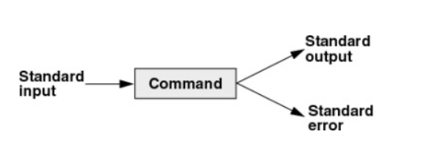

Standard output

By default the standard output is send to screen, but the standard output can be send to
- File
- Another program
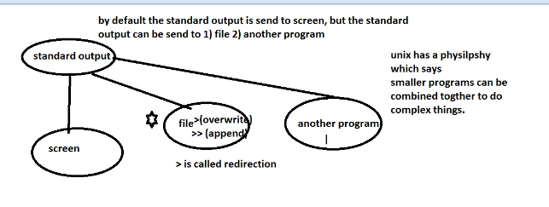Output redirection
shaja@shaja-VirtualBox:~/uniq_april$ ls -l cmp1.txt > out.txt
shaja@shaja-VirtualBox:~/uniq_april$ cat out.txt
-rw-rw-r-- 1 sb sb 51 Aug 31 2021 cmp1.txt
shaja@shaja-VirtualBox:~/uniq_april$ ls -l emp.txt >> out.txt
shaja@shaja-VirtualBox:~/uniq_april$ cat out.txt
-rw-rw-r-- 1 sb sb 51 Aug 31 2021 cmp1.txt
-rw-rw-r-- 1 sb sb 221 Aug 31 2021 emp.txt

Piping(|):
Combining programs together using pipe

-piping is used to combine two or more commands together.
-The output of the first command work as input of the second command, and so on.
-Pipe charecter(|) is represented as piping.
Finding the count of all files under current directory

shaja@shaja-VirtualBox:~/uniq_april$ ls -l | wc -l
25
shaja@shaja-VirtualBox:~/uniq_april$ ls -lrt
total 104

Finding the last two modified files under current directory

shaja@shaja-VirtualBox:~/uniq_april$ ls -lrt | tail -2
-rw-rw-r-- 1 sb sb 96 Apr 9 13:15 out.txt
-rw-rw-r-- 1 sb sb 10479 Apr 9 13:19 grep_practice.txt
listing only the directories current directory

shaja@shaja-VirtualBox:~/uniq_april$ ls -l | grep '^d'
drwxrwxr-x 2 sb sb 4096 Apr 6 12:00 d1
drwxrwxr-x 2 sb sb 4096 Apr 6 12:00 d2
drwxrwxr-x 2 sb sb 4096 Apr 6 12:00 d3
drwxrwxr-x 3 sb sb 4096 Apr 6 12:00 d4
drwxrwxr-x 2 sb sb 4096 Apr 6 11:53 mani_data
drwxrwxr-x 3 sb sb 4096 Apr 6 12:35 rafeeq

Standard error

By default the standard error is send to screen, but the standard error can be send to a file. The standard error is redirected to a file using 2>

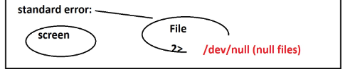
Redirecting the output to out.txt and error to 2>out.err
shaja@shaja-VirtualBox:~/uniq_april$ ls -l emp.txt deepika.txt >out.txt 2>out.err
shaja@shaja-VirtualBox:~/uniq_april$ cat out.txt
-rw-rw-r-- 1 sb sb 221 Aug 31 2021 emp.txt
shaja@shaja-VirtualBox:~/uniq_april$ cat out.err
ls: cannot access deepika.txt: No such file or directory

/dev/null --> is a special file when anything gets redirected here, it disappears

shaja@shaja-VirtualBox:~/uniq_april$ ls -l /dev/null
crw-rw-rw- 1 root root 1, 3 Apr 8 19:57 /dev/null

Suppressing errors using /dev/null
Example 1:

shaja@shaja-VirtualBox:~/uniq_april$ ls -l emp.txt 11.txt 22.txt 2>/dev/null
-rw-rw-r-- 1 sb sb 221 Aug 31 2021 emp.txt

Example 2:

When finding files, there will be many errors, those can be suppressed using /dev/null

shaja@shaja-VirtualBox:~/uniq_april$ find / -name 'abdul_renamed.txt' 2>/dev/null
/home/sb/uniq_april/abdul_renamed.txt
Removing duplicates in a file in unix (uniq):

UNIQ
uniq file_name |  | it is used to show the uniq values in the file
uniq -i file_name | case insensitive | it is used to show the uniq values with case insensitive
uniq -c file_name | group and count | it is used to count the occurrence of each line
uniq -d file_name | duplicate alone | it is used to show only the duplicate records in the file
uniq -u file_name | uniq alone | it is used to show only the uniq records in the file

Uniq command in unix is used to de-duplicate the record, it will show only the unique records
It is similar to the remove duplicate that we see on excel.
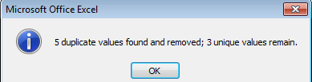
Uniq expects the data to be sorted before the uniq operation is done.
Uniq has following options
-i - case insensitive
-c count the occurrence
-u uniq records
-d - show only duplicates
<<<<<<<<<<<<<<<demo of uniq >>>>>>>>>>>
Uniq requires data to be sorted, else it won’t work
shaja@shaja-VirtualBox:~/uniq_april$ uniq sort.txt
DevOps
Unix
Shell
Aimore
Java
Oracle
Java
shell

Sorting the data and the applying uniq
shaja@shaja-VirtualBox:~/uniq_april$ sort sort.txt | uniq
Aimore
DevOps
Java
Oracle
shell
Shell
Unix

Removing duplicates with uniq (case insensitive)
shaja@shaja-VirtualBox:~/uniq_april$ sort sort.txt | uniq -i
Aimore
DevOps
Java
Oracle
shell
Unix
Uniq to counts the occurrence ( using -c )
shaja@shaja-VirtualBox:~/uniq_april$ sort sort.txt | uniq -ic
1 Aimore
1 DevOps
2 Java
2 Oracle
2 shell
1 Unix

Show only uniq records

shaja@shaja-VirtualBox:~/uniq_april$ sort sort.txt | uniq -iu
Aimore
DevOps
Unix
show only duplicates
shaja@shaja-VirtualBox:~/uniq_april$ sort sort.txt | uniq -id
Java
Oracle
Shell

Comparing files in Unix :
DIFFERNCE AND COMPARE
diff f1 f2 | difference | it will show the difference in the two files
cmp f1 f2 | compare | it will show only the first difference and the line number which have difference
diff
cmp
diff:
- It is used to compare two files in unix, diff file_name1.txt file_name2.txt
- When there are no differences it will not display anything
- when there are differences it will show the:
- no of lines added
- no of lines modified
- no of lines removed

<<<<<<<<<<<<<<<demo of diff >>>>>>>>>>>
When two files are identical

shaja@shaja-VirtualBox:~/uniq_april$ diff cmp1.txt cmp3.txt

When two files have different

shaja@shaja-VirtualBox:~/uniq_april$ diff cmp1.txt cmp2.txt
3c3
< Kolkata
---
> Andhra Pradesh
5c5
< Jammu and Kashmir

Special symbols are:
a : add
c : change
d : delete

Add and Change Example:

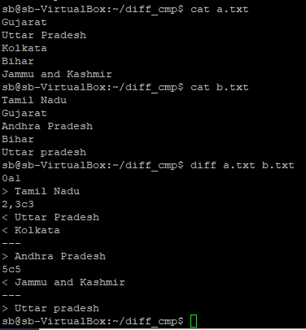

Delete Example:
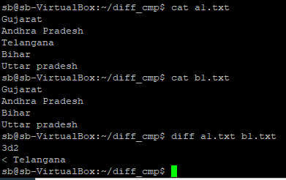
Linux system offers two different ways to view the diff command output i.e. context mode (-c) and unified mode(-u).
cmp:
- It is used to compare two files in unix, cmp file_name1.txt file_name2.txt
- When there are no differences it will not display anything
- when there are differences it will show the only the first difference
- it is basically used for byte by byte comparison of two files to determine the first mismatch byte.
windows alternatives winmerge and windiff
<<<<<<<<<<<<<<<demo of cmp>>>>>>>>>>>
When two files are identical

shaja@shaja-VirtualBox:~/uniq_april$ cmp cmp1.txt cmp3.txt

When two files have different

shaja@shaja-VirtualBox:~/uniq_april$ cmp cmp1.txt cmp2.txt
cmp1.txt cmp2.txt differ: byte 20, line 3

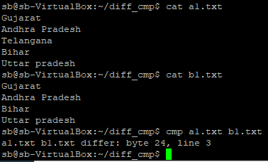

Switching from one user to another user in UNIX:

SWITCH USER
su user_name |  | it will switch to the user but when we do pwd it will show that we re in our home directory
su - user_name |  | it will switch to the user and when we do pwd it will show that we are in the logined user home directory
sudo -i |  | it is used to switch to the root
UNIX is a multiuser operating system, there will be many users connect to server.
To switch from user to another, we have a command called su ( switch user)
<<<<<<<<<<<<<<<demo of su>>>>>>>>>>>
su user_name
sb@sb-VirtualBox:~$ su navin
Password:
navin@sb-Inspiron-N5010:/home/sb$ whoami
navin
navin@sb-Inspiron-N5010:/home/sb$ pwd
/home/sb
navin@sb-Inspiron-N5010:/home/sb$ exit;
exit
su - <user name >
password:
it will login into the user, but will take you to the user’s home directory
su user_name (using hyphen)
sb@sb-VirtualBox:~$ su - navin
Password:
$whoami
navin

login into root user:
sb@sb-VirtualBox:~$ sudo -i
[sudo] password for sb:
root@sb-VirtualBox:~# whoami
root

Sudo ( super user do)
To do any operation as root without explicitly login in as root
sb@sb-VirtualBox:/$ pwd
/
sb@sb-VirtualBox:/$ touch kalsa.txt
touch: cannot touch ‘kalsa.txt’: Permission denied
sb@sb-VirtualBox:/$ sudo touch kalsa.txt
sb@sb-VirtualBox:/$ ls -l kalsa.txt
-rw-r--r-- 1 root root 0 Apr 28 13:07 kalsa.txt
sb@sb-VirtualBox:/$ whoami
sb

Permissions in unix:

PERMISSIONS
To change the permission of the file or directory we use the command called chmod. They are two types of mode they are symbolic and numeric mode
PREMISSIONS | FILE (-) | DIRECTORY (d) | FOR NUMERIC MODE
READ ( r ) | able to read the file | able to list the files | read (r) = (4)
WRITE (w) | able to modify the content | able to create file or directory | write (w) = (2)
EXECUTE (x) |  | able to get into the directory | execute (x) = (1)
SYMBOLIC MODE
chmod (u/g/o)+(r/w/x) file_name | adding permission | This is used to add (read/write/execute) permission for the (user/group/other) to the file
chmod (u/g/o)-(r/w/x) file_name | removing permission | This is used to remove (read/write/execute) permission for the (user/group/other) to the file
NUMERIC MODE
chmod 777 file_name | rwxrwxrwx | By using 777 we can give read, write and execute permission for user, group and others
chmod 000 file_name |  | By using 000 we can remove all permission for user , group and others
chmod 467 file_name | r--rw-rwx | this command gives read permission for user , read and write permission for group , read , write and execute permission for others

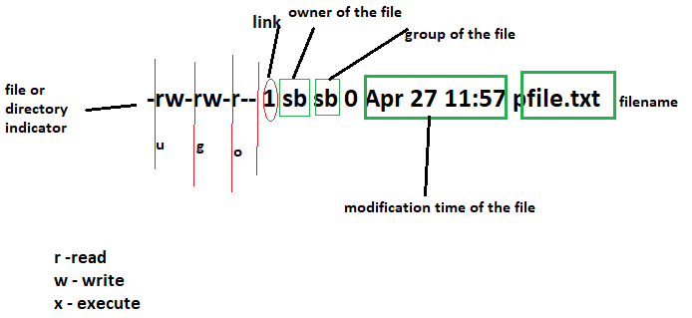

The above file is owned by Abdul (Abdul is owner of the file), Abdul belongs to a group called april_1st_batch
- 1st set of permission is for the user/owner of the file (Abdul).
- 2nd set of permission is for group members (batch members).
- 3rd set of permission is for others (everybody else in the building)
If there are 100 users in the system, 1st set of permission is for Abdul, 2nd set is for 10 members in his batch, 3rd set is for rest of the 90 members.
What does permission mean with the context of file and directory
permission | file | directory
read ( r ) | able to read the file | list the contents of the directory
write ( w ) | able to write into the file | create or delete a file in a directory
execute (x) | able to make it a executable script | able to get into a directory (cd)

When a new file is created, it is created with the below permissions
sb@sb-VirtualBox:~/uniq_april$ touch faisal.txt
sb@sb-VirtualBox:~/uniq_april$ ls -l faisal.txt
-rw-rw-r-- 1 sb sb 0 Apr 12 12:25 faisal.txt
To modify the file permissions we have command called chmod (change mode)
Chmod works in two modes:

Symbolic mode

Numeric mode (used in the industry)

Symbolic mode:
person | action | permission
u | "+ / -" | r /w/x
g | "+ / -" | r /w/x | + is to give permission
o | "+ / -" | r /w/x | - is to remove permission

Few examples of Symbolic mode
chmod o+wx abdul.txt | giving others write and execute permissions
chmod o-wx abdul.txt | removing write and execute permissions from others
chmod g+w abdul.txt | giving group write permissions

Numeric mode (used in the industry)
4 | read
2 | write
1 | execute

Few examples of Symbolic mode
chmod 777 sample.txt | rwxrwxrwx
chmod 000 sample.txt | ---------
chmod 644 sample.txt | rw-r--r--
chmod 400 sample.txt | r--------
chmod 764 sample.txt | rwx-rw-r
chmod 600 sample.txt | rw-------
chmod 555 sample.txt | r-xr-xr-x

------------- demo of symbolic mode-----------------
Granting others r/w
sb@sb-VirtualBox:~/uniq_april$ ls -l emp.txt
-rw-rw-r-- 1 sb sb 221 Apr 28 2022 emp.txt
sb@sb-VirtualBox:~/uniq_april$ chmod o+wx emp.txt

sb@sb-VirtualBox:~/uniq_april$ ls -l emp.txt
-rw-rw-rwx 1 sb sb 221 Apr 28 2022 emp.txt

Revoking others r/w
sb@sb-VirtualBox:~/uniq_april$ chmod o-wx emp.txt
sb@sb-VirtualBox:~/uniq_april$ ls -l emp.txt
-rw-rw-r-- 1 sb sb 221 Apr 28 2022 emp.txt

------------- demo of numeric mode for file-----------------

Revoking all permissions
sb@sb-VirtualBox:~/uniq_april$ chmod 000 emp.txt
sb@sb-VirtualBox:~/uniq_april$ ls -l emp.txt
---------- 1 sb sb 221 Apr 28 2022 emp.txt

Unable to read file
sb@sb-VirtualBox:~/uniq_april$ cat emp.txt
cat: emp.txt: Permission denied

Providing read access to owner
sb@sb-VirtualBox:~/uniq_april$ chmod 400 emp.txt
sb@sb-VirtualBox:~/uniq_april$ head -1 emp.txt
eno,ename,esal,edep,egen

Unable to write to file
sb@sb-VirtualBox:~/uniq_april$ cat >> emp.txt
bash: emp.txt: Permission denied

Providing write access to owner
sb@sb-VirtualBox:~/uniq_april$ chmod 600 emp.txt
sb@sb-VirtualBox:~/uniq_april$ cat >> emp.txt
hii
sb@sb-VirtualBox:~/uniq_april$ tail -1 emp.txt
hii

------------- Demo of numeric mode for file-----------------

Revoking all permissions
sb@sb-VirtualBox:~/uniq_april$ ls -ld test_dir
d--------- 2 sb sb 4096 Apr 12 12:58 test_dir

Unable to list a directory
sb@sb-VirtualBox:~/uniq_april$ ls -l test_dir/
ls: cannot open directory test_dir/: Permission denied

Unable to cd into a directory
sb@sb-VirtualBox:~/uniq_april$ cd test_dir/
bash: cd: test_dir/: Permission denied

Providing execute access to owner for directory
sb@sb-VirtualBox:~/uniq_april$ chmod 500 test_dir
sb@sb-VirtualBox:~/uniq_april$ cd test_dir
sb@sb-VirtualBox:~/uniq_april/test_dir$ ls -l
total 0
-rw-rw-r-- 1 sb sb 0 Apr 12 12:58 file1.txt
-rw-rw-r-- 1 sb sb 0 Apr 12 12:58 file2.txt

Unable to create or remove files in a directory
sb@sb-VirtualBox:~/uniq_april/test_dir$ touch file3.txt
touch: cannot touch ‘file3.txt’: Permission denied
sb@sb-VirtualBox:~/uniq_april/test_dir$ rm -rf file1.txt
rm: cannot remove ‘file1.txt’: Permission denied

Providing write access to owner for directory
sb@sb-VirtualBox:~/uniq_april$ chmod 700 test_dir/
sb@sb-VirtualBox:~/uniq_april$ cd test_dir/
sb@sb-VirtualBox:~/uniq_april/test_dir$ ls -l
total 0
-rw-rw-r-- 1 sb sb 0 Apr 12 12:58 file1.txt
-rw-rw-r-- 1 sb sb 0 Apr 12 12:58 file2.txt
sb@sb-VirtualBox:~/uniq_april/test_dir$ rm -rf file1.txt
sb@sb-VirtualBox:~/uniq_april/test_dir$ touch file3.txt
These two commands are restricted at our workplace, due to security
Loopholes

- chgrp (change group)
- chown (change owner)

Links in UNIX:

Soft links are similar to MS windows shortcuts.
--one file can have many shortcuts pointing to it.
Hard links are just different names for the same file.
--One file can have many different names or hard links.

TO CREATE LINK
They are two types of link they are hard link and soft link. By default all the file has the link value of 1 and the directory has the link count of 2
HARD LINK |  | SOFT LINK
The hard link is used to create a clone of the file.  If we change the content to any one of the file all the remaining files will be changed. The link count will be increased , depending on the num of file created |  | The soft link is used to create a shortcut for the file  If we delete the original file the soft link has no value , because it points to the non-exiting file
HARD LINK
ln file_1 new_name(f1) |  | It will create a clone of the file_1 as new_name(f1) .  The link count will be increased and if we make any changes in the file all the file will be changed . If we delete any one of the file only the link count will be reduced
SOFT LINK
ln -s file_1 new_name(f1)

The 1 highlighted and represented in the link count.

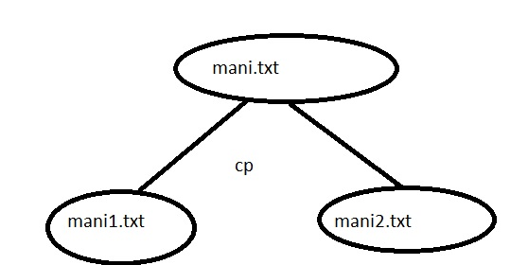
I am creating a copy of 2 file using cp mani1.txt and mani2.txt; if i modify mani1 will it impact the other copies?
Answer: No because it’s a copy of a file.

Links are of two types
1) Hard link
2) soft/symbolic link
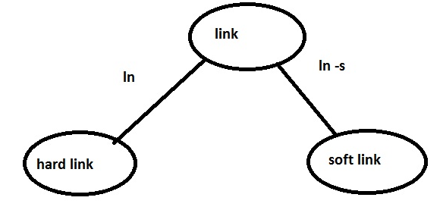

Hard link:
Hard link are created using ln, I am creating a link of a file mani1.txt and mani2.txt, if I modify mani1.txt, it will it impact all the other copies
- Links are like clones and removing the link will not remove all the files.
- Removing the link will just reduce the link count.
- A file is considered to be deleted when all the links are removed.
>>>>>>>>>>>>>>Demo of hard links<<<<<<<<<<<<<<<<
Creating a hard link using ln command
sb@sb-VirtualBox:~/uniq_april$ln cmp1.txt cmp4_ln.txt
sb@sb-VirtualBox:~/uniq_april$ ls -l cmp1.txt cmp4_ln.txt cmp4_ln3.txt
-rw-rw-r-- 3 sb sb 71 Apr 14 12:30 cmp1.txt
-rw-rw-r-- 3 sb sb 71 Apr 14 12:30 cmp4_ln3.txt
-rw-rw-r-- 3 sb sb 71 Apr 14 12:30 cmp4_ln.txt

Modifying one link will change all the links

sb@sb-VirtualBox:~/uniq_april$ cat >> cmp4_ln3.txt
modifying for links
sb@sb-VirtualBox:~/uniq_april$ tail -1 cmp4_ln3.txt
modifying for links
sb@sb-VirtualBox:~/uniq_april$ tail -1 cmp4_ln3.txt
modifying for links

Removing files would reduce the link count

sb@sb-VirtualBox:~/uniq_april$ rm -rf cmp1.txt
sb@sb-VirtualBox:~/uniq_april$ ls -l cmp4_ln.txt cmp4_ln3.txt
-rw-rw-r-- 2 sb sb 71 Apr 14 12:30 cmp4_ln3.txt
-rw-rw-r-- 2 sb sb 71 Apr 14 12:30 cmp4_ln.txt
sb@sb-VirtualBox:~/uniq_april$ rm -rf cmp4_ln.txt
sb@sb-VirtualBox:~/uniq_april$ ls -l cmp4_ln3.txt
-rw-rw-r-- 1 sb sb 71 Apr 14 12:30 cmp4_ln3.txt
sb@sb-VirtualBox:~/uniq_april$ rm -rf cmp4_ln3.tx

Symbolic link: (soft link)
- Symbolic link are created using ln –s, symbolic link are similar to windows short cut.
- When the original is removed, the short cut becomes invalid.
- l indicates it’s a link
- -> indicates it’s a short cut to a original file

>>>>>>>>>>>>>>Demo of symbolic links<<<<<<<<<<<<<<<<
Creating a symbolic link using ln -s command
sb@sb-VirtualBox:~/uniq_april$ ln -s cmp2.txt cmp2.txt_shortcut
sb@sb-VirtualBox:~/uniq_april$ ls -l cmp2.txt_shortcut

lrwxrwxrwx 1 sb sb 8 Apr 14 12:47 cmp2.txt_shortcut -> cmp2.txt
sb@sb-VirtualBox:~/uniq_april$ tail -1 cmp2.txt_shortcut
Uttar Pradesh

Removing original files would make the symbolic link invalid

sb@sb-VirtualBox:~/uniq_april$ rm -rf cmp2.txt
sb@sb-VirtualBox:~/uniq_april$ tail -1 cmp2.txt_shortcut
tail: cannot open ‘cmp2.txt_shortcut’ for reading: No such file or directory

Cut
It just cut the specified character/byte/field in each and every line in the file.
The cut command in linux is a command for cutting out the sections from each line of files, and also we can writing the result to standard output.
It can be used to cut parts of a line by byte position, character and field.
We can cut
- A specific character
- multiple characters
- range of characters
- based on delimiter
>>>>>>>>>>>>>>Demo of cut <<<<<<<<<<<<<<<<
cut -b
list with out ranges
cut -b 1,2,3 names.txt

list with ranges
cut -b 1-3 names.txt
cut -b 1-3,5-7 names.txt

In this, 1- indicate from 1st byte to end byte of a line.
cut -b 1- names.txt

In this, 3- indicate from 3rd byte to end byte of a line.
cut -b 3- names.txt

In this, -3 indicate from 1st to 3rd byte of a line.
cut -b -3 names.txt
.
cut –c
To cut by character use the -c option. This selects the character given to the -c option.
This can be a list of numbers separated comma or a range of numbers separated by hyphen (-).

Cut and show only the first character (A specific character)
sb@sb-VirtualBox:~/unix$ echo Nadeem | cut -c1
N

Cut and show only the fourth character from a file(A specific character from a file)
sb@sb-VirtualBox:~/unix$ cut -c4 emp.txt
S
D
n
l

Cut and show only the 2nd and 5th character from a file (multiple characters)
sb@sb-VirtualBox:~/unix$ cut -c2,5 emp.txt
ne
0R
0R
0S
0L
Cut and show only the 2nd to 5th character from a file (range of characters)
sb@sb-VirtualBox:~/unix$ cut -c2-5 emp.txt
no,e
00,R
00,R
00,S

-it will print 2nd and 5th charecter from each line of the file.
cut -c 2,5 names.txt

-it will print second to fifth of each line from the file.
cut -c 2-5 names.txt

cut –f
To extract the useful information you need to cut by fields rather than columns.

Cut based on delimiter, f1 is field 1(based on delimiter)

sb@sb-VirtualBox:~/unix$ cut -d',' -f1 emp.txt
eno
100
200
300
400

To view list of users

cat /etc/passwd | tail -5
cut -d':' -f1 /etc/passwd | tail -5

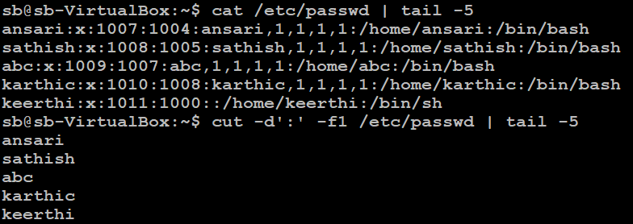

Paste
It is used to join files horizontally (parallel merging) by outputting lines consisting of lines from each file specified, separated by tab as delimiter, to the standard output.

Here state is separate file and city is separate file.
sb@sb-VirtualBox:~/unix/bkp$ paste state city
TamilNadu Chennai
Kerala Kochin
Karnataka Bangalore
Andra Hydrabad

sb@sb-VirtualBox:~/unix/bkp$ paste -d "|" state city
TamilNadu|Chennai
Kerala|Kochin
Karnataka|Bangalore
Andra|Hydrabad
sb@sb-VirtualBox:~/unix/bkp$

Combining N consecutive lines:
--The paste command can also be used to merge N consecutive lines from a file into a single line.

Balajisb@sb-VirtualBox:~/unix/bkp$ cat names.txt | paste - -
Sathya Bhuvana
Priya Sharvya
SaravananVLM Saravanan
Deepak Lalith
Palani Venkatesh
Srikanth Abinash
Shahid John
Balaji
sb@sb-VirtualBox:~/unix/bkp$

sb@sb-VirtualBox:~/unix/bkp$ cat names.txt | paste - - -
Sathya Bhuvana Priya
Sharvya SaravananVLM Saravanan
Deepak Lalith Palani
Venkatesh Srikanth Abinash
Shahid John Balaji
sb@sb-VirtualBox:~/unix/bkp$

paste (merge lines of files)

-s---sequence
-d---delimiter
paste file1.txt file2.txt--merging lines in parallel manner.
paste -s file1.txt file2.txt--merge in sequence way
paste -s -d ',' cmp1.txt cmp2.txt (using delimeter)
paste -d ',' cmp1.txt cmp2.txt (using delimeter)

what is delimeter:

delimter is something that seprates columns
for a csv files (comma seperated values) , is a delimter

commonly delimter:
,(comma)
|(pipe)
space
tab

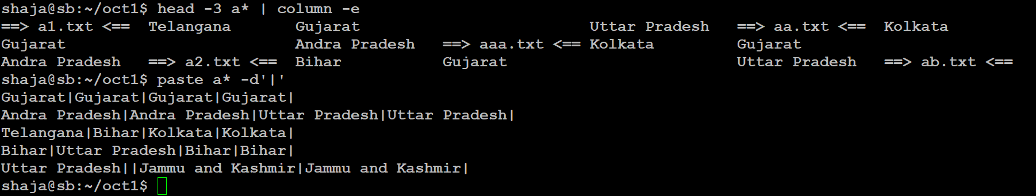

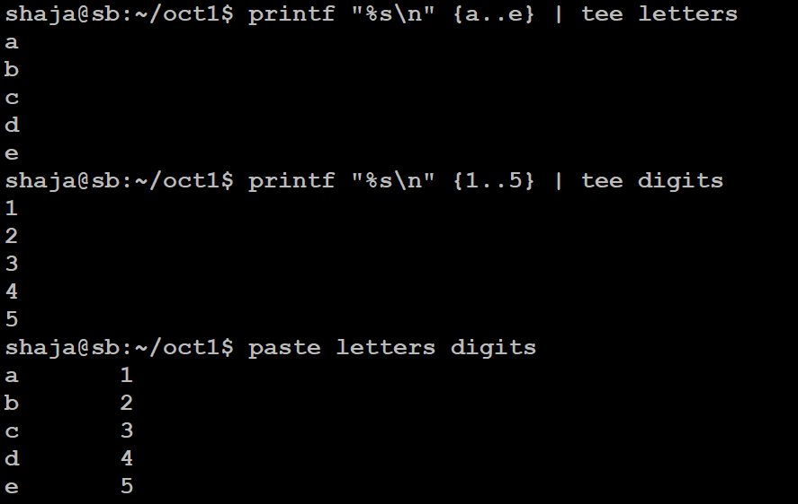

Tee:

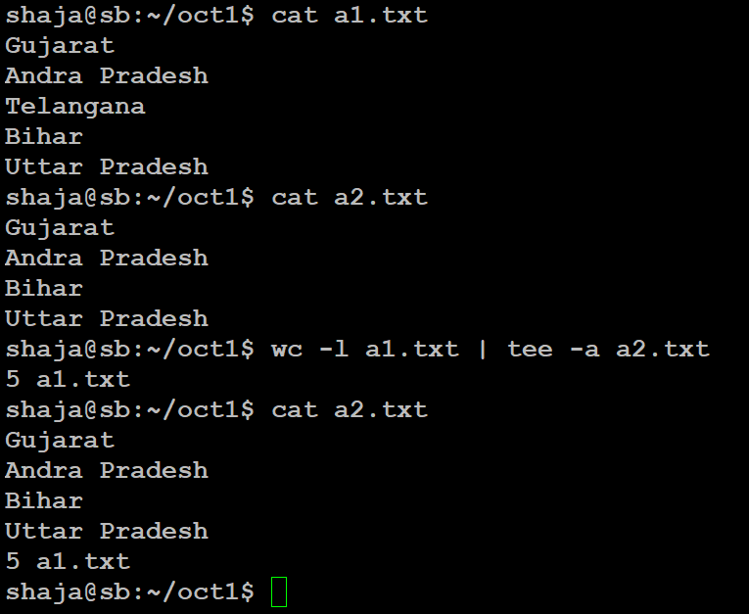

tr command

The tr command in linux is a command line utility for translating or deleting characters.
It supports a range of transformation including uppercase to lowercase, squeezing repeating characters, deleting specific characters and basic find and replace.

-d -- delete characters in the first set from the output

-s -- replaces repeated characters listed in the set with single occurrence.

sb@sb-VirtualBox:~$ cat sample
i am learning unix

sb@sb-VirtualBox:~$ tr "aeiou" "AEIOU" < sample
I Am lEArnIng UnI0078

sb@sb-VirtualBox:~$ tr "aeiou" "AEIOU" < sample
I Am lEArnIng UnIx

sb@sb-VirtualBox:~$ tr "n" "N" < sample
i am learNiNg uNix
sb@sb-VirtualBox:~$ tr "aeiou" "AEIOU" < sample > sample1
sb@sb-VirtualBox:~$ cat sample1
I Am lEArnIng UnIx

sb@sb-VirtualBox:~$ tr "[a-z]" "[A-Z]" < sample
I AM LEARNING UNIX

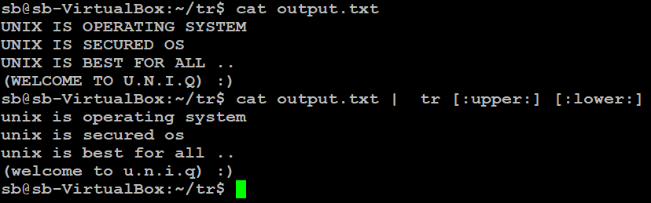

sb@sb-VirtualBox:~$ cat emp
101,Bhakiyaraj,Tiruvannamalai,50000
102,Imthiyas,Chennai,40000
103,Jaasir,Chennai,900000

sb@sb-VirtualBox:~$ tr "," "\t" < emp
101 Bhakiyaraj Tiruvannamalai 50000
102 Imthiyas Chennai 40000
103 Jaasir Chennai 900000

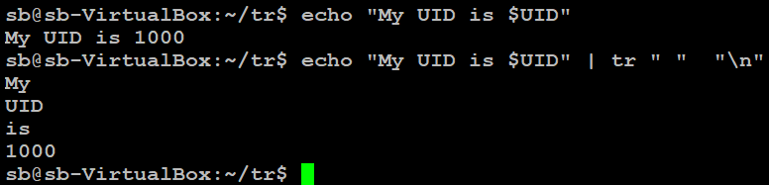

sb@sb-VirtualBox:~$ tr "0" "9" < emp
191,Bhakiyaraj,Tiruvannamalai,59999
192,Imthiyas,Chennai,49999
193,Jaasir,Chennai,999999

sb@sb-VirtualBox:~$ tr -s 'n' < emp
101,Bhakiyaraj,Tiruvanamalai,50000
102,Imthiyas,Chenai,40000
103,Jaasir,Chenai,900000

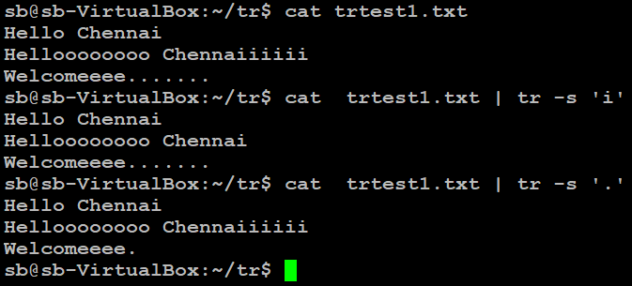

-d example:
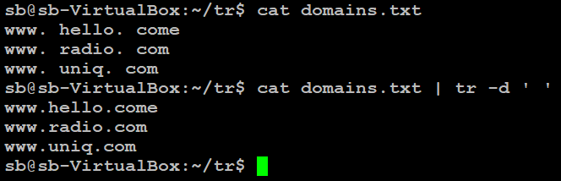

file:
File command will guess the type of the file.
Syntax: file file_name.txt
>>>>>>>>>>>>>>Demo of file <<<<<<<<<<<<<<<<
Using file command on a soft link
sb@sb-VirtualBox:~/uniq_april$ file cmp2.txt_shortcut
cmp2.txt_shortcut: symbolic link to `cmp2.txt'

Using file command on a directory
sb@sb-VirtualBox:~/uniq_april$ mkdir bruce.txt
sb@sb-VirtualBox:~/uniq_april$ file bruce.txt
bruce.txt: directory

Using file command on regular file
sb@sb-VirtualBox:~/uniq_april$ file grep1.txt
grep1.txt: ASCII text

Using file command on image file

sb@sb-VirtualBox:~/uniq_april$ file csv-sample-file.gif
csv-sample-file.gif: GIF image data, version 89a, 390 x 177

Find command
TO FIND A FILE & EXECUTE COMMAND
The find is used to find all the file / directories/links in unfix . When using the find command we can use 2> dev/null to avoid the error message
syntax for find is -----> find (search from) type(file/directory/link) (options)
find / -type f -name 'file_name' 2> /dev/null | search from root to last directory and from all user | this command search the given file from the root directory and gives the output
find / -type d -iname 'dir_name' 2> /dev/null | search from root to last directory and from all user | this command search the given file with (case in sensitive ) from the root directory and gives the output
find . -type f -empty 2> /dev/null | search from current to last directory and from all user | this command search the empty file from the current directory and gives the output
find . -type f -perm 666 2> /dev/null | search from current to last directory and from all user | this command search the file based on the permission from the current directory and gives the output
find . -type f -name '*.pdf' -exec rm -rf {} \ |  | this command search the file ending with pdf from the current directory and execute the remove command
TO LOCATE A FILE
locate file_name |  | it will locate the given file name from the data base
locate -i file_name |  | it will locate the given file (case insensitive) name from the data base

Find Command in UNIX:
Find command is used to search for a file or a directory in the Unix file system.
find <search from> <file/directory/link> < option name etc>

<search from>
- find / -type f -name 'mani.txt' ( to search from root directory)
- find ~ -type f -name 'mani.txt'( to search from home directory)
- find . -type f -name 'mani.txt' ( to search from current directory)
- find .. -type f -name 'mani.txt'( to search from previous directory)

Type
<file/directory/link>
- f (file)
- d (directory)
- l (link)
< option name etc>

- name: search files with this name
- iname: search files with this name (case insensitive)
- empty :search for zero byte files
- size :search for files based on size
- perm :search for files based on permissions
- mtime :search for files based on modification time
- exec: search for files and execute any command

>>>>>>>>>>>>>>Demo of find <<<<<<<<<<<<<<<<
Searching for a file from root dir using name option
sb@sb-VirtualBox:~/uniq_april$ find / -type f -name 'abdul.txt' 2>/dev/null
/home/sb/abdul.txt
/home/sb/uniq_april/abdul.txt

Searching for a file from root dir using iname option
sb@sb-VirtualBox:~/uniq_april$ find / -type f -iname 'abdul.txt' 2>/dev/null
/home/sb/abdul.txt
/home/sb/uniq_april/ABDUL.TXT

Searching for empty files from current directory

sb@sb-VirtualBox:~/uniq_april$ find . -type f -empty
./faisal.txt
./nadeem.mp4
./.yamuna.txt
./cmp2.txt
Searching for empty files from current directory (size zero)

sb@sb-VirtualBox:~/uniq_april$ find . -type f -size 0
./faisal.txt
./nadeem.mp4
./.yamuna.txt

Searching for files from current directory (exactly 22kb)

sb@sb-VirtualBox:~/uniq_april$ find . -type f -size 22k
./grep_practice.txt

Searching for files from current directory (greater than 22kb)

sb@sb-VirtualBox:~/uniq_april$ find . -type f -size +22k

Searching for files from current directory (less than 22kb)

sb@sb-VirtualBox:~/uniq_april$ find . -type f -size -22k
./faisal.txt
./sort1.txt
./csv-sample-file.gif

Searching for files from current directory(using permission 777 and 666)

sb@sb-VirtualBox:~/uniq_april$ find . -type f -perm 777
./mani.txt
sb@sb-VirtualBox:~/uniq_april$ find . -type f -perm 666
./emp.txt

Searching for all pdf files and removing them

Searching for all pdf files

sb@sb-VirtualBox:~/uniq_april$ find . -type f -name '*.pdf'
./1.pdf
./2.pdf
./3.pdf
Searching for all pdf files and removing them

sb@sb-VirtualBox:~/uniq_april$ find . -type f -name '*.pdf' -exec rm -rf {} \;
sb@sb-VirtualBox:~/uniq_april$ find . -type f -name '*.pdf'
sb@sb-VirtualBox:~/uniq_april$

we can use below command also
find . -type f | xargs rm –rf
find 90 days older files and zip that recursively and move that target location.
find /var/FILES/ -type f -mtime +90 -exec zip -r zipped.zip {} \; -exec mv {} /var/ARCHIVES \;
find /var/FILES/ -type f -mtime +90 -exec zip -r /var/ARCHIVES/zipped.zip {} \;

find . -type f -name '*.txt' -exec mv {} /home/shaja/www\; --fins all text files and move to another location.
find . -type f -name '*.txt' -exec mv {} /home/shaja/www \;

find . -type f -mtime -2 -exec rm -rf {} \; --find files which created within last 2 days and remove it
find . -type f -size 0 -exec rm -rf {} \; -- fine zero bytes files and remove it.

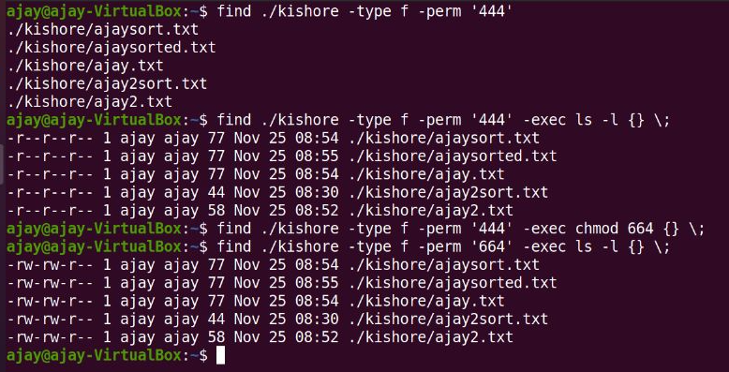

Find files within a size range:

find . -type f -size +100k -size -500k – will display list of files with in a size range.
find . -type f -size +100k -size -500k -exec du -sh {} \; -- will display with size of the file.

Locate:
Locate command is used to search for a file or a directory in the Unix file system.
- Locate is faster than find but less efficient.
- Locate relies on an internal database called /var/lib/mlocate/mlocate.db.
- Only when this internal -db is up to date, locate will be able to find files from
- To update internal -db we have a command called, sudo updated

>>>>>>>>>>>>>>Demo of locate <<<<<<<<<<<<<<<<

Searching files using locate
locate abdul.txt
/home/sb/abdul.txt
Searching files using locate case insensitive option

sb@sb-VirtualBox:~/uniq_april$ locate -i abdul.txt
/home/sb/abdul.txt

Seeing the internal database of locate

sb@sb-VirtualBox:~/uniq_april$ locate -S
Database /var/lib/mlocate/mlocate.db:
31,900 directories
3,40,589 files
2,33,16,669 bytes in file names
90,25,845 bytes used to store database

sb@sb-VirtualBox:~/uniq_april$ ls -l /var/lib/mlocate/mlocate.db
-rw-r----- 1 root mlocate 9025845 Apr 14 12:15 /var/lib/mlocate/mlocate.db

Updating the internal database of locate

sb@sb-VirtualBox:~/uniq_april$ sudo updatedb
sb@sb-VirtualBox:~/uniq_april$ ls -l /var/lib/mlocate/mlocate.db
-rw-r----- 1 root mlocate 9026246 Apr 14 13:40 /var/lib/mlocate/mlocate.db

sb@sb-VirtualBox:~/uniq_april$ locate -i abdul.txt
/home/sb/abdul.txt
/home/sb/uniq_april/ABDUL.TXT

Difference between grep,find and locate

grep | find | locate
grep is used to find a word or a pattern in a file. | find is used to find the file itself | locate is used to find the file itself
example searching for hobbies in mani_resume.txt | example searching the file mani_resume.txt itself | faster than find but less efficient
equivalent to control + f in windows | equivalent to search in windows | equivalent to search in windows
 | searches the file in the entire file system | uses a internal database to perform the search

Tar ( Tape Archive)
The tar is the most widely used command to create compressed archive files that can be moved easily from one disk to another disk or machine to machine.
TAR/COMPRESSION AND UNCOMPRESSION
The tar command lets you create compressed archives which contain a particular file or set of files. We can compress the file using gzip and bzip2
tar -cvf my_tar * |  | it is used to create a tar file
tar -tvf my_tar |  | it is used to view the tar file
tar -xvf my_tar |  | it is used to extract the tar file

- Tar is used to bundle files together.
- tar is similar winrar in windows
- tar stands for tape archive

options | description | example
c | create a archive file or tar | tar -cvf my_files.tar emp.txt sort1.txt sort2.txt
x | extract from archive file or tar file | tar -xvf my_files.tar
t | list the contents of an archive | tar -tvf my_files.tar
f | file name
v | verbose

While creating a tar, we can create a tar as well as compress it by using two options z or j
- z it will do gzip compression (tar -czvf my_files_comp.tar emp.txt)
- j it will do bzip2 compression (tar -cjvf my_files_comp.tar emp.txt) --highly compressed tar file we use the option j.

>>>>>>>>>>>>>>Demo of tar <<<<<<<<<<<<<<<<
Creating a tar file with verbose
sb@sb-VirtualBox:~/uniq_april$ tar -cvf my_files.tar emp.txt sort1.txt sort2.txt
emp.txt
sort1.txt
sort2.txt
sb@sb-VirtualBox:~/uniq_april$ ls -l my_files.tar
-rw-rw-r-- 1 sb sb 10240 Apr 15 20:02 my_files.tar
sb@sb-VirtualBox:~/uniq_april$ file my_files.tar
my_files.tar: POSIX tar archive (GNU)

Creating a tar file without verbose
sb@sb-VirtualBox:~/uniq_april$ tar -cf my_files1.tar emp.txt sort1.txt sort2.txt
sb@sb-VirtualBox:~/uniq_april$ ls -l my_files1.tar
-rw-rw-r-- 1 sb sb 10240 Apr 15 20:05 my_files1.tar

Creating a tar file with wilcards
sb@sb-VirtualBox:~/uniq_april$ tar -cvf my_files_wild.tar grep*
grep1.txt
grep_practice.txt
grep.txt

Displaying the table of contents of tar
sb@sb-VirtualBox:~/uniq_april$ tar -tvf my_files.tar
-rw-rw-rw- sb/sb 237 2022-04-12 12:57 emp.txt
-rw-rw-r-- sb/sb 22 2022-08-31 17:22 sort1.txt
-rw-rw-r-- sb/sb 99 2022-08-31 17:22 sort2.txt
Extracting contents of tar

sb@sb-VirtualBox:/tmp$ tar -xvf my_files.tar
emp.txt
sort1.txt
sort2.txt
sb@sb-VirtualBox:/tmp$ ls -l emp.txt sort1.txt sort2.txt
-rw-rw-r-- 1 sb sb 237 Apr 12 12:57 emp.txt
-rw-rw-r-- 1 sb sb 22 Apr 28 2022 sort1.txt
-rw-rw-r-- 1 sb sb 99 Apr 28 2022 sort2.txt

TO CREATE TAR AND COMPRESS/UNCOMPRESS IN A SINGLE COMMAND
tar -cvzf my_tar |  | it is used to create tar and compress the file
tar _xvzf my_tar |  | it is used to uncompress and extract the file

Creating a compressed tar
sb@sb-VirtualBox:~/uniq_april$ tar -czvf my_files_comp.tar emp.txt sort1.txt sort2.txt
emp.txt
sort1.txt
sort2.txt
sb@sb-VirtualBox:~/uniq_april$ ls -l *.tar
-rw-rw-r-- 1 sb sb 397 Apr 15 12:32 my_files_comp.tar

Extracting tar file to another directory:
tar -xvf tar1.tar -C /abc

-r adding one more file to existing tar file:
tar -rvf tar1.tar sample adding file to a .tar file.
tar –delete -f tar1.tar sample - remove a file from a .tar file.
tar -cvf jan23.tar /home/shaja/jan23 tar all files from directory

Compression techniques:

TO COMPRESS AND UNCOMPRESS FILE USING GZIP
gzip my_file.txt |  | it is used to compress the file
gunzip my_file.txt.gz  (or)  gzip -d my_tar |  | it is used to uncompress the file
TO COMPRESS AND UNCOMPRESS FILE USING BZIP2
bzip2 my_file.txt |  | it is used to compress the file using bz2
bunzip2 my_file.txt.bz2 |  | it is used to uncompress the file

Why we need compression
I have a 1GB file when I compress the file, it becomes 450 MB
- Reduce the file size
- portability increase and reduce the transfer file
There are two main commands to compress and uncompress files in UNIX
- gzip and gunzip
- bzip2 and bunzip2
gzip file_name.txt
it will create a compressed file called file_name.txt.gz
gunzip file_name.txt.gz
it will uncompress the compressed file file_name.txt.gz
The .gz file cannot be read by normal command; we need z command to read the .gzfile, some of the common the z commands called
- zcat
- zgrep
- zmore
- zless
Another compression technique used bzip2
bzip2 file_name.txt
it will create a compressed file called file_name.txt.bz2
bunzip2 file_name.txt. bz2
it will uncompress the compressed file file_name.txt. bz2, It is said that bzip has better compression technique and reduces more size.

>>>>>>>>>>>>>>Demo of gz <<<<<<<<<<<<<<<<
Size of original file
sb@sb-VirtualBox:~/uniq_april$ ls -lh more_than_22kb.txt
-rw-rw-r-- 1 sb sb 27K Apr 15 11:44 more_than_22kb.txt
Creating a .gz file with gzip
sb@sb-VirtualBox:~/uniq_april$ gzip more_than_22kb.txt
sb@sb-VirtualBox:~/uniq_april$ ls -l more_than_22kb*
-rw-rw-r-- 1 sb sb 4.9K Apr 15 11:44 more_than_22kb.txt.gz

The .gz files cannot be viewed by cat commands
sb@sb-VirtualBox:~/uniq_april$ cat more_than_22kb.txt.gz
Yb#more_than_22kb.txt�#�r�����#��z���#I���n�I6��=2���t��#\

To view .gz files we need z commands (zcat zcmp zdiff zegrep zfgrep zgrep zless zmore )
sb@sb-VirtualBox:~/uniq_april$ zcat more_than_22kb.txt.gz | head -1
hi am abdul
Uncompressing the .gz file
sb@sb-VirtualBox:~/uniq_april$ gunzip more_than_22kb.txt.gz
sb@sb-VirtualBox:~/uniq_april$ ls -lh more_than_22kb.txt

Creating a compressed file with bzip2
sb@sb-VirtualBox:~/uniq_april$ bzip2 more_than_22kb.txt
sb@sb-VirtualBox:~/uniq_april$ ls -lh more_than_22kb*
-rw-rw-r-- 1 sb sb 4.8K Apr 15 11:44 more_than_22kb.txt.bz2

Uncompressing the .bz2 file

sb@sb-VirtualBox:~/uniq_april$ bunzip2 more_than_22kb.txt.bz
sb@sb-VirtualBox:~/uniq_april$ ls -l more_than_22kb.*
-rw-rw-r-- 1 sb sb 26900 Apr 15 11:44 more_than_22kb.txt

Admin commands in Unix

ps
ps stands for process (like task manager in windows)
- ps will show the processes in the current terminal (without any options)
- ps -ef will list everything.
- every process will have a process id

>>>>>>>>>>>>>>Demo of ps <<<<<<<<<<<<<<<<
ps without options
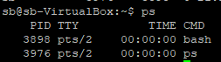
ps withoptions (ps -ef)
sb@sb-VirtualBox:~$ ps -ef
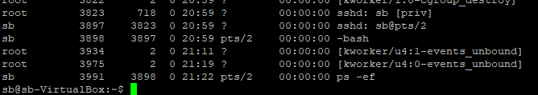

To search for a particular process (searching for vlc)
Method 1: Using Grep
Method 2: Using Pgrep( If process have only one PID we can use pgrep to find pid)
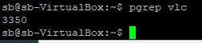

Kill command

Kill the process by specifying its PID
To terminate any process, we have a command called kill (like end task in windows)
- kill -2 process id ( normal termination)
- kill -9 process id ( forceful termination)

Example on how to find a PID of a process using pidof command.
Let’s assume that we need to kill the firefox process running on a Linux system.
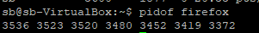
>>>>>>>>>>>>>>Demo of kill <<<<<<<<<<<<<<<<

kill -2 process id ( normal termination)
sb@sb-VirtualBox:~/uniq_april$ kill -2 21939

kill -9 process id ( forceful termination)
sb@sb-VirtualBox:~/uniq_april$ kill -2 21951

For Example : There is running two processes 1. VLC, 2.Firefox
with use of ps –ef command
1.VLC – getting only one process id like below
2.Firefox getting more than one process id like below
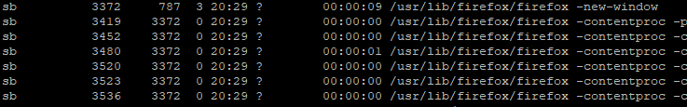
--Using kill command we can kill multi process id like below
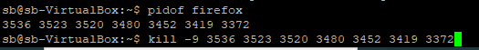

killall Command – kill the processes by name. By default, it will send a TERM(-15) signal. The killall command can kill multiple processes with a single command. If more than one process runs with that name, all of them will be killed.
Example: Kill all the firefox processes
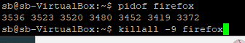

--How to kill all user processes with killall

Pkill Command – Send signal to the process based on its name. You can send signal to any process by specifying the full name or partial name. So there is no need for you to find out the PID of the process to send the signal.
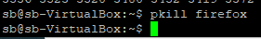

Helping command : man 7 signal

Du:
- du command, short for disk usage, is used to estimate file space usage.
- The du command can be used to track the files or directories which are consuming excessive amount of space on hard disk drive.
- du will show the disk usage ( -s will show summary and -h will show human readable format)

>>>>>>>>>>>>>>Demo of du <<<<<<<<<<<<<<<<
du without arguments
sb@sb-VirtualBox:~/uniq_april$ du
4 ./d2
4 ./d1
4 ./d4/d5/d6
8 ./d4/d5
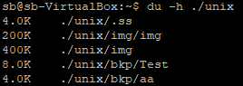
Summary of disk usage from home directory in human readable format

sb@sb-VirtualBox:~$ pwd
/home/sb
sb@sb-VirtualBox:~$ du -sh
94G

For particular directory

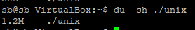

With time stamp
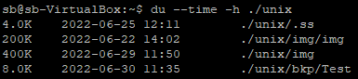

df

The df command to find total disk space and available space on Unix file system

>>>>>>>>>>>>>>Demo of df <<<<<<<<<<<<<<<<
df without arguments

sb@sb-VirtualBox:~$ df
Filesystem 1K-blocks Used Available Use% Mounted on
udev 3970748 4 3970744 1% /dev
tmpfs 796932 1464 795468 1% /run
/dev/sda7 132183448 109113812 16332024 87% /
none 4 0 4 0% /sys/fs/cgroup

df in human readable format
sb@sb-VirtualBox:~$ df -h
Filesystem Size Used Avail Use% Mounted on
udev 3.8G 4.0K 3.8G 1% /dev
tmpfs 779M 1.5M 777M 1% /run
/dev/sda7 127G 105G 16G 87% /
none 4.0K 0 4.0K 0% /sys/fs/cgroup

top (table of processes)
The top utility is a commonly used tool for displaying system-performance information.
this command shows a real-time view of running processes in Linux and displays kernel-managed tasks.
The command also provides a system information summary that shows resource utilization, including CPU and memory usage.
top updates the information every three seconds by default

>>>>>>>>>>>>>>Demo of top <<<<<<<<<<<<<<<<

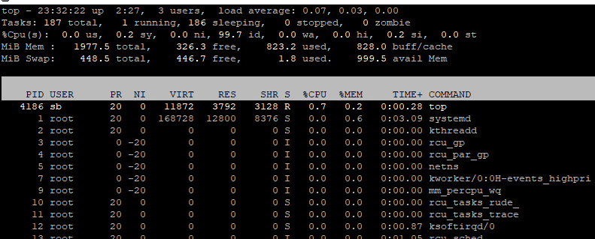

For particular user:
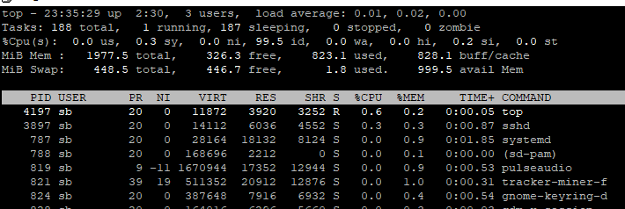

Exit Top Command After Specific repetition:

Sort Processes
By default, top sorts the process list using the %CPU column. To sort processes using a different column, press one of the following keys:
- M. Sort by the %MEM column.
- N. Sort by PID column.
- T. Sort by the TIME+ column.
- P. Sort by the %CPU column.

Top's first line, top, shows the same information as the uptime command.
The first value is the system time. The second value represents how long the system has been up and running, while the third value indicates the current number of users on the system. The final values are the load average for the system.
The load average is broken down into three time increments. The first shows the load for the last one minute, the second for the last five minutes, and the final value for the last 15 minutes.

top - 18:57:35 up 8:36, 2 users, load average: 0.07, 0.08, 0.02

Sed (stream editor)

- Sed is a all-round program, it can do many things in Unix.
- Sed will read one line at a time, perform the operation and move to the next line, this is called sed cycle
SED workflow:
SED follows a simple workflow: Read,Execute,Display
Read – Read a line from input stream.
Execute – Execute sed command(s) on a line.
Display – Display result on output stream.

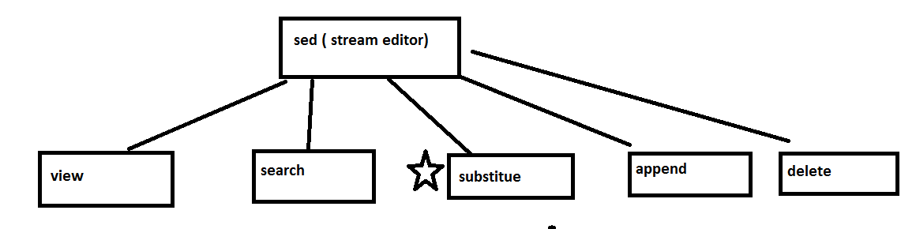
With sed we will be able:

- view files ( like how we do with cat/head)
- search in a file (like how we do with grep)
- substitute
- append
- Delete
Interview they will ask about how to substitute in sed ( control + h find and replace)

View files ( like how we do with cat/head)

sed behaving as cat | functionality
sed -n 'p' grep.txt | print all lines of a file
sed -n '1p' grep.txt | print only the first line of a file
sed -n '1!p' grep.txt | print all lines except the first line
sed -n '1,5p' grep.txt | print 1st to 5th line
sed -n '1p;5p' grep.txt | print 1st and 5th line
sed -n '$p' grep.txt | print last line

>>>>>>>>>>>>>>>>>sed is behaving as cat<<<<<<<<<<<<<<<<<<<<<<<<
print all lines of a file
sb@sb-VirtualBox:~/unix$ sed -n 'p' grep.txt
unix is great os, opensource and free os.
learn operating system.
unixlinux which one you choose.
unix is easy to learn, unix is a multiuser os and unix is a powerful.

sb@sb-VirtualBox:~/unix$ sed -n '1p' grep.txt
unix is great os, opensource and free os.

Print only the first line of a file

sb@sb-VirtualBox:~/unix$ sed -n '1p' grep.txt
unix is great os, opensource and free os.

print all lines except the first line

sb@sb-VirtualBox:~/unix$ sed -n '1!p' grep.txt
learn operating system.
unixlinux which one you choose.
unix is easy to learn, unix is a multiuser os and unix is a powerful

print 1st to 5th line
sb@sb-VirtualBox:~/unix$ sed -n '1,5p' grep.txt
unix is great os, opensource and free os.
learn operating system.
unixlinux which one you choose.
unix is easy to learn, unix is a multiuser os and unix is a powerful.

print 1st and 5th line
sb@sb-VirtualBox:~/unix$ sed -n '1p;5p' grep.txt
windows is great os, opensource and free os.

print last line
sb@sb-VirtualBox:~/unix$ sed -n '$p' grep.txt
The shell acts as an interface between the user and the kernel.

search in a file (like how we do with grep)

sed is behaving as grep | functionality
sed -n /'unix'/p grep.txt | print all lines matching the word unix
sed -n /'unix'/Ip grep.txt | print all lines matching the word unix(case insenstive)
sed -n /'\bunix\b'/p grep.txt | whole word match
sed -n /'^unix'/p grep.txt | lines starting with unix
sed -n /'unix$'/p grep.txt | lines ending with unix
sed -n /'^$'/p grep.txt | empty lines

Print all lines matching the word Unix

sb@sb-VirtualBox:~/unix$ sed -n /'unix'/p grep.txt
unix is great os, opensource and free os.
unixlinux which one you choose.
unix is easy to learn, unix is a multiuser os and unix is a powerful.

Print all lines matching the word Unix(case insensitive)

sb@sb-VirtualBox:~/unix$ sed -n /'unix'/Ip grep.txt
unix is great os, opensource and free os.
unixlinux which one you choose.
unix is easy to learn, unix is a multiuser os and unix is a powerful.
It is stable, multi-user, multi-tasking system for servers, desktops and laptops in unix
There are many different versions of UNIX

whole word match

sb@sb-VirtualBox:~/unix$ sed -n /'\bunix\b'/p grep.txt
unix is great os, opensource and free os.
unix is easy to learn, unix is a multiuser os and unix is a powerful.
It is stable, multi-user, multi-tasking system for servers, desktops and laptops in unix

lines starting with Unix

sb@sb-VirtualBox:~/unix$ sed -n /'^unix'/p grep.txt
unix is great os, opensource and free os.
unixlinux which one you choose.
unix is easy to learn, unix is a multiuser os and unix is a powerful.

lines ending with Unix

sb@sb-VirtualBox:~/unix$ sed -n /'unix$'/p grep.txt
It is stable, multi-user, multi-tasking system for servers, desktops and laptops in unix

empty lines
sb@sb-VirtualBox:~/unix$ sed -n /'^$'/p grep.txt

Substitute

sed will read one line a time, will substitue once and move to next line
sed to substitute | functionality
sed s/unix/windows/ grep.txt | find unix and replace with windows
sed s/unix/windows/Ig grep.txt | find unix and replace with windows(globally)
sed s/unix/windows/I2 grep.txt | find unix and replace with windows(2nd occurrence)
sed 1s/unix/windows/g grep.txt | find unix and replace with windows first line alone
sed 1,5s/unix/windows/g grep.txt | find unix and replace with windows first line to fifth line alone

Find unix and replace with windows

sb@sb-VirtualBox:~/unix$ sed s/unix/windows/ grep.txt
windows is great os, opensource and free os.
learn operating system.
windowslinux which one you choose.
windows is easy to learn, unix is a multiuser os and unix is a powerful.

find unix and replace with windows(globally)

sb@sb-VirtualBox:~/unix$ sed s/unix/windows/Ig grep.txt
windows is great os, opensource and free os.
learn operating system.
windowslinux which one you choose.
windows is easy to learn, windows is a multiuser os and windows is a powerful.

Find Unix and replace with windows (2nd occurrence)

sb@sb-VirtualBox:~/unix$ sed s/unix/windows/I2 grep.txt
unix is great os, opensource and free os.
learn operating system.
unixlinux which one you choose.
unix is easy to learn, windows is a multiuser os and unix is a powerful.

find unix and replace with windows first line alone

sb@sb-VirtualBox:~/unix$ sed 1s/unix/windows/g grep.txt
windows is great os, opensource and free os.
learn operating system.
unixlinux which one you choose.
unix is easy to learn, unix is a multiuser os and unix is a powerful.

find unix and replace with windows first line to fifth line alone

sb@sb-VirtualBox:~/unix$ sed 1,5s/unix/windows/g grep.txt
windows is great os, opensource and free os.
learn operating system.
windowslinux which one you choose.
windows is easy to learn, windows is a multiuser os and windows is a powerful.

It is stable, multi-user, multi-tasking system for servers, desktops and laptops in unix

Delete

sed to delete | functionality
sed 'd' grep.txt | delete all lines of a file
sed '1d' grep.txt | delete only the first line of a file
sed '1!d' grep.txt | delete all lines except the first line
sed '1,5d' grep.txt | delete 1st to 5th line
sed '1d;5d' grep.txt | delete 1st and 5th line
sed '$d' grep.txt | delete last line

Delete all lines of a file

sb@sb-VirtualBox:~/unix$ sed 'd' grep.txt

Delete only the first line of a file

sb@sb-VirtualBox:~/unix$ sed '1d' grep.txt
learn operating system.
unixlinux which one you choose.
unix is easy to learn, unix is a multiuser os and unix is a powerful.

Delete all lines except the first line

sb@sb-VirtualBox:~/unix$ sed '1!d' grep.txt
unix is great os, opensource and free os.

Delete 1st to 5th line
sb@sb-VirtualBox:~/unix$ sed '1,5d' grep.txt

It is stable, multi-user, multi-tasking system for servers, desktops and laptops in unix
There are many different versions of UNIX
The most popular varieties of UNIX are Sun Solaris, GNU/Linux, and MacOS X.
Here in the School, we use Solaris on our servers and workstations,
And Fedora Linux on the servers and desktop PCs

Delete 1st and 5th line
sb@sb-VirtualBox:~/unix$ sed '1d;5d' grep.txt
learn operating system.
unixlinux which one you choose.
unix is easy to learn, unix is a multiuser os and unix is a powerful.

It is stable, multi-user, multi-tasking system for servers, desktops and laptops in unix
There are many different versions of UNIX

Delete last line
sb@sb-VirtualBox:~/unix$ sed '$d' grep.txt
unix is great os, opensource and free os.
learn operating system.
unixlinux which one you choose.
unix is easy to learn, unix is a multiuser os and unix is a powerful.

Append

sed to append | functionality
sed 'a hi' grep.txt | appends hi to end of each line
sed '1a hi' grep.txt | appends hi to end of first line alone

Appends hi to end of each line
sb@sb-VirtualBox:~/unix$ sed 'a hi' grep.txt
unix is great os, opensource and free os.
hi
learn operating system.
hi
unixlinux which one you choose.
hi
unix is easy to learn, unix is a multiuser os and unix is a powerful.
hi

Appends hi to end of first line alone
sb@sb-VirtualBox:~/unix$ sed '1a hi' grep.txt
unix is great os, opensource and free os.
hi
learn operating system.
unixlinux which one you choose.

If you want to modify or make changes to files, you can used the “-i” option.
Modifying the original files, using “-i” option
sed -i s/unix/windows/Ig grep.txt
sb@sb-VirtualBox:~/unix$ ls -l grep.txt
-rw-rw-r-- 1 sb sb 700 Aug 31 2021 grep.txt
sb@sb-VirtualBox:~/unix$ sed -i s/unix/windows/Ig grep.txt
sb@sb-VirtualBox:~/unix$ ls -l grep.txt
-rw-rw-r-- 1 sb sb 727 Apr 16 13:18 grep.txt
sb@sb-VirtualBox:~/unix$ date
Sat Apr 16 13:18:32 IST 2022

If you want to backup the original files, we can use “-i.copy” or “-i.bckup”
Backup the original files
sb@sb-VirtualBox:~/unix$ ls -l grep.txt
-rw-rw-r-- 1 sb sb 700 Aug 31 2021 grep.txt
sb@sb-VirtualBox:~/unix$ sed -i.copy s/unix/windows/Ig grep.txt
sb@sb-VirtualBox:~/unix$ ls -l grep.*
-rw-rw-r-- 1 sb sb 727 Apr 16 13:21 grep.txt
-rw-rw-r-- 1 sb sb 700 Aug 31 2021 grep.txt.copy

Awk:

Is a full fledged programming, we can everything with awk.
Awk works with data files, data file is a file that contains data.
Awk is used for horizontal and vertical dissection of data (before the invent of rdbms awk was used extensively, but with the advent of rdbms the usage of awk has gone down significantly)

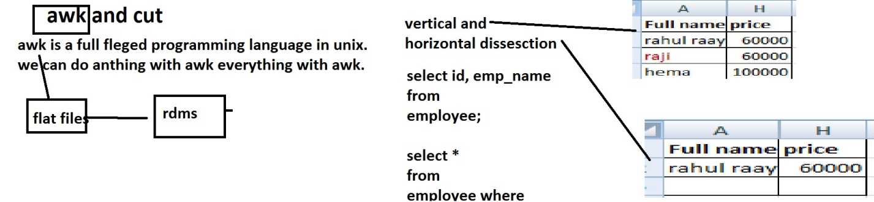

Characteristics of a data file:

eno,ename,esal,edep,egen
100,Raja,1000,Admin,Male
200,Ravi,2000,IT,Male
count:3 date:Mon Apr 18 12:52:18 IST 2022

A data file contains
- header (usually indicates the columns)
- data (actual data )
- trailer record ( optional)

The elements that separates the two fields are called delimiter
delimiter is usually comma(,),space,pipe(|),tab spaces and tilda (~)

100 kalsa---> space separated
100 kalsa---> tab separated
When the delimeter is comma, it’s called comma separator values.

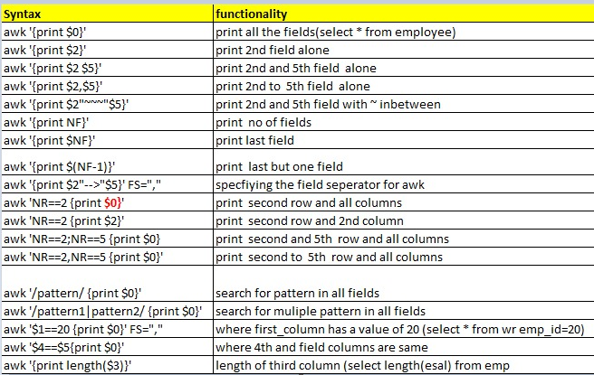

awk '1 { print }' file print all lines.
awk 1 file print all lines.
awk 'NR>1' file (or) awk 'NR>1 { print }' file remove a file header.
awk 'NR>1 && NR < 4' file print lines in range.
awk 'NF' file removing white space lines .
awk '{ print $1, $3}' FS=, OFS=, file extracting fields.
Or
awk 'NF { print $1, $3 }' FS=, OFS=, file

awk - column range wise print

cat datafile_sp.txt | awk '
BEGIN { first = 3; last = 5 }
{ for (i = first; i < last; i++) { printf("%s ", $i) }
print $last }
'

>>>>>>>>>>>>>>Demo of awk <<<<<<<<<<<<<<<<
Print all the fields
sb@sb-VirtualBox:~/unix$ awk '{print $0}' emp.txt_space
eno ename esal edep egen
100 Raja 1000 Admin Male
200 Ravi 2000 IT Male

Print 2nd field alone

sb@sb-VirtualBox:~/unix$ awk '{print $2}' emp.txt_space
ename
Raja
Ravi

Print 2nd and 5th field alone
sb@sb-VirtualBox:~/unix$ awk '{print $2"|"$5}' emp.txt_space
ename|egen
Raja|Male
Ravi|Male

Internal variables used by awk

- NF--> field number
- NR--> row Number
- FS--> field separator

Print no of fields
sb@sb-VirtualBox:~/unix$ awk '{print NF}' emp.txt_space
5
5
5
5

Print last field alone
sb@sb-VirtualBox:~/unix$ awk '{print $NF}' emp.txt_space
egen
Male
Male

Print last but one field alone
sb@sb-VirtualBox:~/unix$ awk '{print $(NF-1)}' emp.txt_space
edep
Admin
IT
Admin

Awk expects the files to be space delimited, if the field has any other delimiter, we will use the variable FS to tell awk that a different delimiter is being used
Mentioning Awk that a different delimiter is being used
sb@sb-VirtualBox:~/unix$ awk '{print $2"-->"$5}' FS="," emp.txt
ename-->egen
Raja-->Male
Ravi-->Male
Steven-->Male

Printing seconds rows all columns
sb@sb-VirtualBox:~/unix$ awk 'NR==2 {print $0}' emp.txt
100,Raja,1000,Admin,Male

Printing seconds rows and 2nd column

sb@sb-VirtualBox:~/unix$ awk 'NR==2 {print $2}' emp.txt_space
Raja

Printing seconds rows and fifth row

sb@sb-VirtualBox:~/unix$ awk 'NR==2;NR==5 {print $0}' emp.txt_space
100 Raja 1000 Admin Male
400 Lex 4000 Admin Female

Printing seconds rows to fifth row

sb@sb-VirtualBox:~/unix$ awk 'NR==2,NR==5 {print $0}' emp.txt_space
100 Raja 1000 Admin Male
200 Ravi 2000 IT Male
300 Steven 3000 Admin Male
400 Lex 4000 Admin Female

Search for a pattern in all fields
sb@sb-VirtualBox:~/unix$ awk '/100/ {print $0}' emp.txt_space
100 Raja 1000 Admin Male

Search for a multiple pattern in all fields
sb@sb-VirtualBox:~/unix$ awk '/100|200/ {print $0}' emp.txt_space
100 Raja 1000 Admin Male
200 Ravi 2000 IT Male

Find records where 1st column has a value of 20

sb@sb-VirtualBox:~/unix$ awk '$1==20 {print $0}' FS="," emp.txt
20,Shan,7000,IT,Male

Length of the 3rd column
sb@sb-VirtualBox:~/unix$ awk '{print length($3)}' emp.txt_space
4
4
4

SCP(Secure copy)
Copies files within in the same machine
Copies files from local machine to remote machine.
Copies files from remote machine to local machine.
Copies files between two different remote servers.

scp file1.txt /home/shaja/jan23---copying the file from local host to local host
scp file1.txt user/pass@hostname:/home/manisha/new---copying the file local host to remote host
scp user/pass@hostname:/home/manisha/file1.txt .---copying the file remote host to local host
scp user/pass@hostname:/home/manisha/file.txt user/pass@hostname:/home/rakesh---copying the file one remote host to other remote host

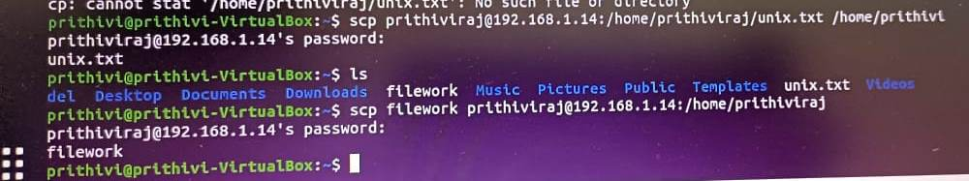
remote server : sb@192.168.58.1
clint server : /home/prithiv

copy a file from local server to remote server
scp emp.txt sb@192.168.58.1:/home/prithiv

scp -r test123 sb@192.168.58.1:/home/prithiv

copy a file from remote server to local server.
scp sb@192.168.58.1:/home/sb/filename.txt /home/prithiv/Desktop

Putty

How will you to the Unix server at work, There is software called putty. At work you will be given a list of IP addresses or hostname or Unix BOX.
Server | Ip address
Prod Server 1 | 1.1.2.9
Prod Server 2 | 1.1.2.10
…. | ….
Prod Server 20 | 1.1.2.12
putty is a open source available for free, but at work you should not download any Software and try to install it.
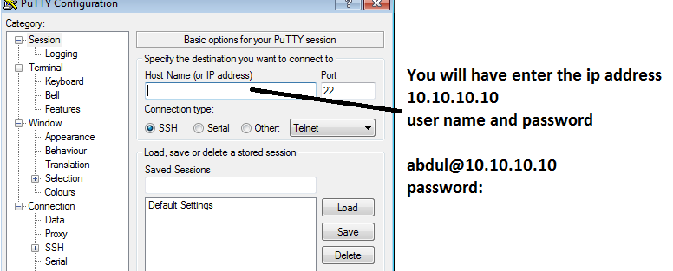
Same as putty, we have several apps to connect another server.
1. Putty
2. ZOC
3. SecureCRT
4. Tera Term
5. Windows Terminal
6. xterm
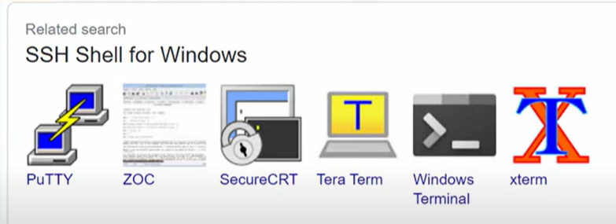

Connect UNIX server using windows command prompt(Windows Terminal):
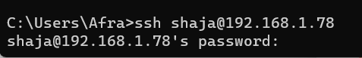

WinSCP
Windows secure copy,
It’s used to transfer files between unix and windows and vice-versa.

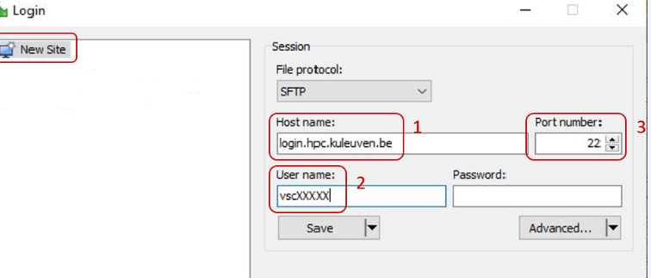
We can simply do a drag and drop to move files between windows and unix

Move files between windows and Unix
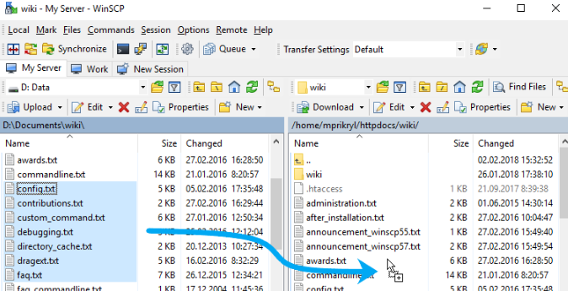

Move files between Unix and windows
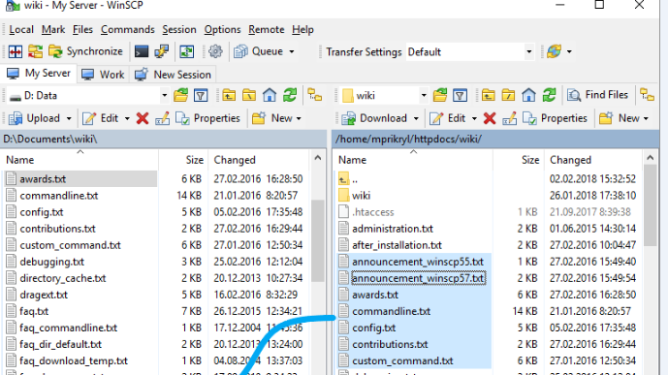

FTP and SFTP
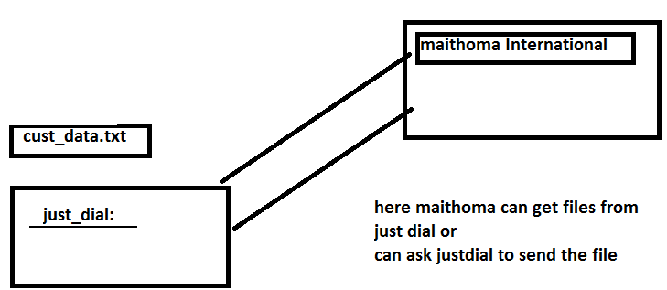
File transfer protocol, when two servers want to exchange files between them, they used a protocol called file transfer protocol.
In our example, meithoma can get the file from just dial or just dial can send the file to meithoma.
How to transfer files from one server to another server.
For example if meithoma(1.1.1.1) wants to get the file from just dial (2.2.2.2)
ftp user_name@2.2.2.2
password:test123
ftp> get cust_data.txt
ftp> mget *.txt
ftp>bye
- get is to download files from one server
- mget is used to get multiple files from one server
for example if just dial (2.2.2.2) wants to send the file to meithoma(1.1.1.1)
ftp user_name@1.1.1.12
password:test123
ftp> put cust_data.txt
ftp> mput *.txt
ftp>bye
- put is to upload files from one server
- mput is used to put multiple files from one server
FTP ( it using port number: 20 & 21)
--used to transfer file to one server to another server
--it will not encrypt files or password

ftp user_name/pass@remote_server_name---to connect remote server
ftp> get file_name---Copy file from remote machine to local machine.
ftp> mget *.sh---copy multiple file from remote machine to local machine
ftp> put file1.sh---copy file from local machine to remote machine
ftp> mput *.txt---copy multiple file from local machine to remote machine
ftp> dir---to list the file from another remote machine
ftp> delete file1.txt---delete file1.txt file from remote host
ftp> mdelete *.dat---delete multiple files from romote host
ftp> quit or bye--- to close or disconnect the ftp connection.
Advantage:
ease of use
Disadvantage:
less secure, because the password should be shared.
Data being transferred is not encrypted.
Data is sent in clear text(plain format).
So, FTP is not secure.
Example: Ftp client is there to use FTP server.(Filezilla)
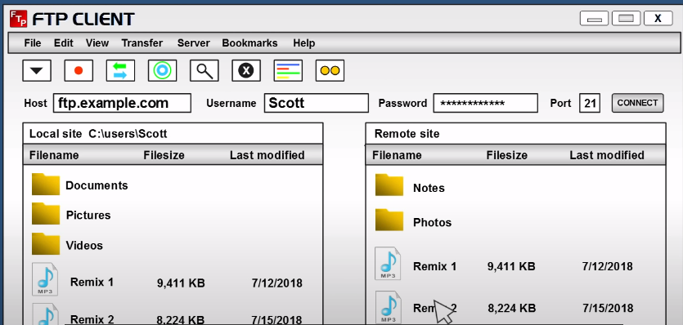

SFTP( it using port number – 22)

SFTP: Secure File transfer protocol, when two servers want to exchange files between them, they used a protocol called secure file transfer protocol in a secure way.
SFTP is same as FTP.
In SFTP adds the layer of security.
Data is encrypted using secure shell during data transfer.
It Authenticate user and server.
SFTP passwordless
sftp user_name@1.1.1.12
SFTP setup has to be done, keys will be exchanged. UNIX administrator will do. Public keys exchange.
I have logged in meithoma server (1.1.1.1) hussain
Note: FTP and SFTP both are connection oriented protocols.
The both use TCP for file transfer.
TCP/IP – Transmission control protocol/Internet protocol
Ftp | Sftp
File transfer protocol | secure File transfer protocol
required a password for transfer for files | does not a password for transfer for files
no such setup is required | exchange of public keys should be done before the setup

TFTP – Trivial File Transfer Protocol.
It is very simple transfer protocol.
Not used to transfer files over the internet.
It is a connection less protocol.
Used here UDP instead of TCP.
UDP – User Datagram protocol.
TFTP does not provide any security during the file transfer.
This is only use in local area network(LAN). It will not use in internet like FTP & SFTP.

Vi editor:( also called VIM editor)

Is an editor provided by UNIX, it’s just like a notepad of UNIX.
It works in different modes:
- Insert mode (I can do edits only in insert mode,)
- command mode
- escape mode (Cursor navigations, delete the lines, characters..etc)

When I do vi abdul.txt,
- First it will check if the file(abdul.txt )exist,
- if it does it will open the existing file(abdul.txt)
- If not it will create a new file called abdul.txt

As soon as it opens the file, it goes into command mode, editing is not possible in command mode, to edit the file, we have to get into insert mode.
After the editing is done, we can press esc to get back to command mode again.
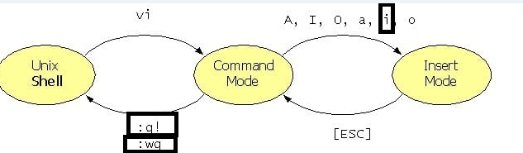

:wq (write and quit)
:q!(quit without saving)s
Demo of vi editor:
Create a new file called samplefile
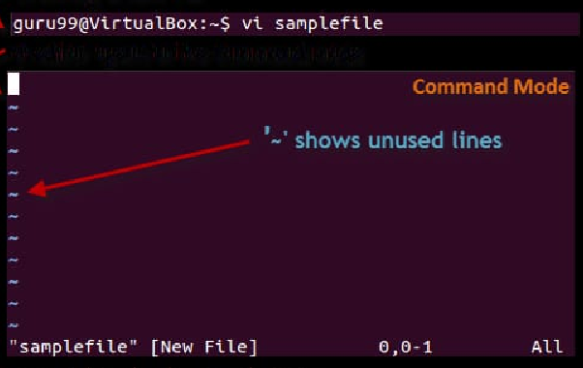
When you press (i), it goes into insert mode
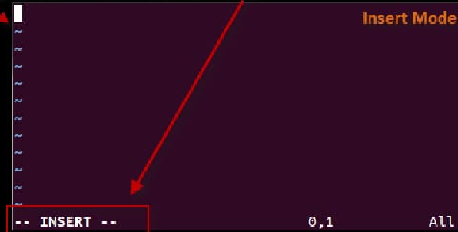
Add the desired text:
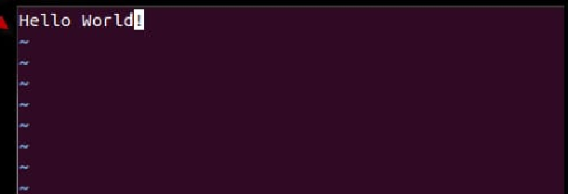

Press escape to get into command mode, and :wq (write and quit)

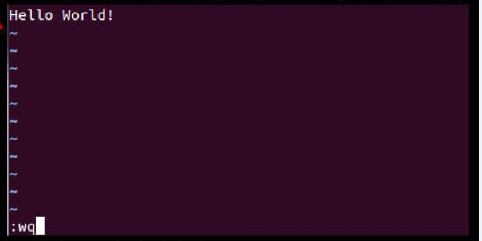
Cat and see the contents of the file
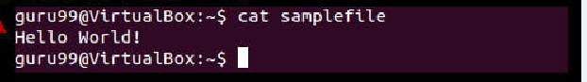

Navigation on vi
l | right
h | left
j | down
k | up
G | last line of the file
gg | first line of the file

line delete | dd
char delete | x
copy line | yy
past line | p
undo | u

Crontab:

CRONTAB
The crontab is used for scheduling the commands or script to run based on the time. For example if a user want to run a series of command daily means he can create a script and schedule it on crontab based on the time so it will run the command automatically at that time daily
crontab -l | listing | this command is used to list all the jobs in the crontab
crontab -e | editing | this command is used to edit (add any new command ) jobs in the crontab
crontab -r | remove | this command is used to remove the all jobs from the crontab

- Cron is a greek word which means time,
- Crontab is used for scheduling tasks,
You can say google assistant:
wake me up at 4
play music at 4:30
open maps to uniq at 5 am

Typically to schedule crontab, you need to understand the 5 *
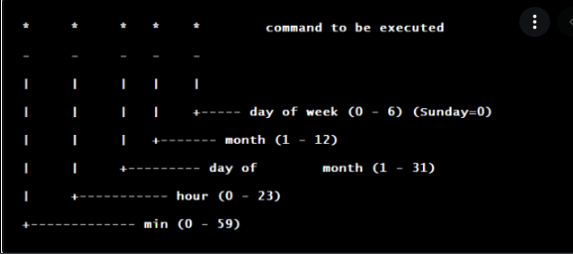
Some example of crontab expressions:
1.Every minutes * * * * *
2.Every hours: 0 * * * *
3.daily at 1 AM: 0 1 * * *
4.Every sunday at 1 AM: 0 1 * * 0
5.Every Month 1st: 0 0 1 * *
You can schedule command or you can schedule scripts.
Demo of crontab
Edit the crontab
sb@sb-VirtualBox:~/uniq_april$ crontab –e
Select an editor. To change later, run 'select-editor'.
1. /bin/ed
2. /bin/nano <---- easiest
3. /usr/bin/vim.tiny
Choose 1-3 [2]: 3
Add the desired entry
0 5 * * 1 tar -zcf /var/backups/home.tgz /home/
crontab: installing new crontab
Do a crontab listing (crontab “-l”) to see if the entry has been added
Disadvantage:
its only time dependant, we cannot set dependencies based on processes and files.
Tip:
If you want to understand any crontab expression use the two resources
https://crontab.guru/
To understand any existing expression

to create any new expression
https://crontab-generator.org/
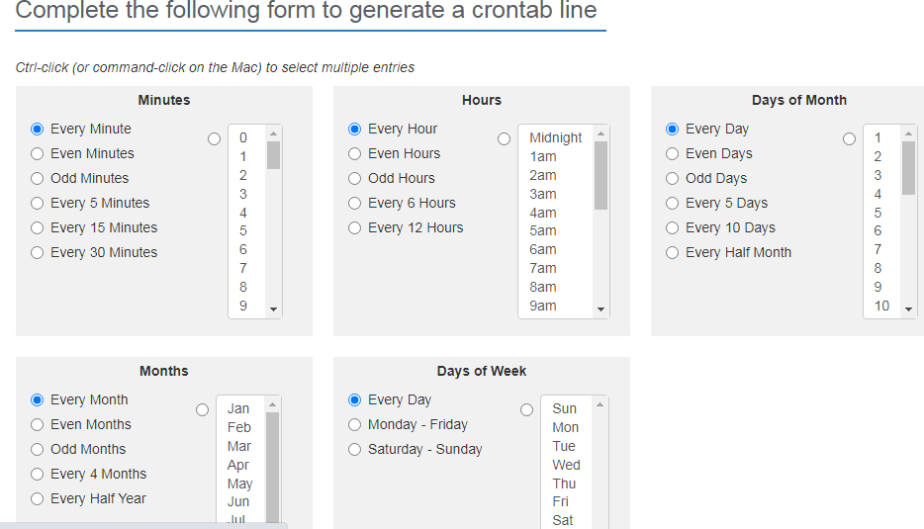

@yearly | (non-standard)
@annually | (non-standard)
@monthly | (non-standard)
@weekly | (non-standard)
@daily | (non-standard)
@hourly | (non-standard)
@reboot | (non-standard)

@daily mv

Basics Shell script

- Shell script is also a programming language.
- Shell script is a series of command to execute certain task.
- It is used to automate certain task.
- In shell scripts we can use conditional operators and looping ( for while etc)
- Usually shell scripts will have a extension of .sh
For example:
- We can write a shell script which can Get the cust_data.txt file from just dial and email to hussain@uniq.com.
- This can be scheduled on crontab at 10 AM.
Sample script 1:
# A basic command to print (# indicates comment)
echo "hello world"

How to execute a shell script (interview question)
./script_name.sh -- it will ask execute permission for script.
Sh script_name.sh
While executing the script, it should have execute privilege
sb@sb-VirtualBox:~/uniq_april/script$ ./test1.sh
bash: ./test1.sh: Permission denied

sb@sb-VirtualBox:~/uniq_april/script$ ls -l test1.sh
-rw-rw-r-- 1 sb sb 20 Apr 21 15:05 test1.sh

The execute privilege seems to be missing in the script which needs to be added
sb@sb-VirtualBox:~/uniq_april/script$ chmod 764 test1.sh

sb@sb-VirtualBox:~/uniq_april/script$ ls -l test1.sh
-rwxrw-r-- 1 sb sb 20 Apr 21 15:05 test1.sh

After that the shell script can be executed

sb@sb-VirtualBox:~/uniq_april/script$ ./test1.sh
hello world

Other method to execute a script
sh test1.s
Sample script 2:
# A basic command to print with variables
a=20
b=30
echo "value of a is: $a"
echo "value of b is: $b"

Executing the shell script
sb@sb-VirtualBox:~/uniq_april/script$ ./test1.sh
value of a is: 20
value of b is: 30

Back tick in UNIX:

- Back tick is used to store, the result of a command.
- a=`ls`, here the ls command will be executed the result of ls command will be stored in a variable.
Example of back tick
Without back tick
sb@sb-VirtualBox:~/uniq_april/script$ a=ls
sb@sb-VirtualBox:~/uniq_april/script$ echo $a
ls

With back tick

sb@sb-VirtualBox:~/uniq_april/script$ a=`ls`
sb@sb-VirtualBox:~/uniq_april/script$ echo $a
1.sh 1.sh~ test1.sh test1.sh~ Untitled Document Untitled Document~

Sample script 3:
#A basic command to add two number
a=20
b=30
c=`expr $a + $b`
echo "sum is $c"

Executing the shell script
sb@sb-VirtualBox:~/uniq_april/script$ ./test1.sh
sum is 50

Command line Arguments

Allows users to pass run time arguments to these commands, these arguments, also known as command line parameters
./test1.sh 10 20 30 40

- First Argument to the script is 10 which will be stored in $1
- Second Argument to the script is 20 which will be stored in $2
- Third Argument to the script is 20 which will be stored in $3
- fourth Argument to the script is 20 which will be stored in $4

These range from $1 to $9, $@ refers to all of a shell script's command-line arguments

Sample script 4:

#using agruments to shell scripts
a=$1
b=$2
c=`expr $a + $b`
echo "sum is $c"

Executing the shell script

sb@sb-VirtualBox:~/uniq_april/script$ ./test1.sh 1 11
sum is 12

If-else statement
This block will process if specified condition is true, if specified condition is not then else part will be execute.
Syntax
if [expression ]
then
statement1
else
statement2
fi
Sample script 5:
# show the number bigger

a=100
b=20

if [ $a -gt $b ]
then
echo "a is greater"
else
echo "b is greater"
fi

Executing the shell script
sb@sb-VirtualBox:~/uniq_april/script$ ./test1.sh 1 11
a is greater

We can also use the below comparison operators
- -gt greater than
- -ge greater than or equal to
- -eq equal to
- -lt lesser than
- -le less than or equal to

How to execute a shell script (interview question)
./script_name.sh
sh script_name.sh
How will pass arguments to shell script
./script_name.sh 100 200
$1 will store the 1st argument
$2 will store the 2nd argument
$3 will store the 3rd argument
$@ print all argument

Exit status: ( echo $?)

- It will show the execution status of the previous command
- Each Unix command returns a status when it terminates normally(0)
or abnormally( non-zero)
- We can use value of exit status in the shell script to display an error message or take some sort of action.
Demo of Exit status
sb@sb-VirtualBox:~/uniq_april/script$ date
Fri Apr 22 11:59:27 IST 2022
sb@sb-VirtualBox:~/uniq_april/script$ echo $?
0
sb@sb-VirtualBox:~/uniq_april/script$ date1
date1: command not found
sb@sb-VirtualBox:~/uniq_april/script$ echo $?
127

========================= End of UNIX=======================================

