PROJECT DOCUMENTATION
STUDENT ENROLLMENT MANAGEMENT SYSTEM

A Project Report
Submitted in partial fulfillment of the requirements
for the award of the degree

Prepared by
______N.Mathi________________________
Register No.: ___24132011802522055_______________

Department of ____B.Sc, complete science ________________
College / Institution: ___________Arignar Anna Government Arts College Villupuram _______________
Academic Year: 2026–2027

DECLARATION
I hereby declare that the project entitled “Student Enrollment Management System” is an original project work carried out as part of the academic requirements. The project has been developed to simplify and computerize the process of student enrollment, course selection, and maintenance of enrollment records.
Place: ___Villupuram _________________
Date: ______24/09/2026______________
Signature of the Student
______N.mathi__________________

ACKNOWLEDGEMENT
I express my sincere gratitude to the management, principal, head of the department, project guide, faculty members, and everyone who supported me during the development of the Student Enrollment Management System. Their guidance and encouragement helped me understand the requirements, design the system, implement the modules, and prepare this project documentation.

ABSTRACT
The Student Enrollment Management System is a software application designed to manage student enrollment activities in an organized and efficient manner. The system maintains student details, course information, enrollment records, and related academic data in a centralized system. It reduces manual paperwork, minimizes data-entry errors, improves record retrieval, and provides a simple interface for managing enrollment operations. The system can be used by administrators or authorized staff to add, update, search, and manage student and course records. Students can be associated with the courses they select, while administrators can monitor enrollment information. The project demonstrates the use of database management, user-interface design, validation, and software testing concepts in a practical application.

TABLE OF CONTENTS
1. Introduction
2. Existing System
3. Proposed System
4. Objectives
5. Scope of the Project
6. Feasibility Study
7. System Requirements
8. System Analysis
9. System Design
10. Database Design
11. Module Description
12. Implementation
13. Testing
14. Results and Discussion
15. Advantages and Limitations
16. Future Enhancements
17. Conclusion
18. References

1. INTRODUCTION
Student enrollment is an important administrative activity in educational institutions. Traditional enrollment processes often depend on paper forms, spreadsheets, and manual verification. Such methods can make it difficult to maintain accurate records and quickly retrieve information.
The Student Enrollment Management System provides a computerized approach for storing and managing enrollment information. It allows authorized users to maintain student records, course records, and enrollment details in a structured manner. The application aims to make the enrollment process faster, more accurate, and easier to manage.

2. EXISTING SYSTEM
In a manual or semi-manual system, student information and enrollment details may be recorded using paper forms or separate files. Searching for records, updating information, checking course selections, and preparing reports can require significant time.
Common issues include:
- Duplicate or inconsistent records
- Time-consuming data retrieval
- Higher possibility of manual data-entry errors
- Difficulty in maintaining updated enrollment information
- Increased paperwork and administrative effort

3. PROPOSED SYSTEM
The proposed Student Enrollment Management System stores student, course, and enrollment information electronically. The system provides a structured way to add, view, update, search, and manage records. Validation rules can be applied to ensure that required information is entered correctly.
The proposed system improves accessibility of records, reduces repetitive work, and provides a foundation for future features such as online registration, notifications, reports, and role-based access.

4. OBJECTIVES
- To maintain student information in a centralized system.
- To manage course information efficiently.
- To record and maintain student enrollment details.
- To reduce manual paperwork and data duplication.
- To provide quick search and retrieval of records.
- To improve accuracy through validation.
- To make enrollment management simple and user-friendly.

5. SCOPE OF THE PROJECT
The system covers the basic management of students, courses, and enrollment transactions. It can be used as an academic project and can also serve as a foundation for a larger institutional enrollment application.
- Student registration and profile management
- Course creation and course information management
- Enrollment/registration of students for courses
- Viewing and searching enrollment records
- Updating and maintaining records
- Basic validation and data management

6. FEASIBILITY STUDY

6.1 Technical Feasibility
The system can be implemented using commonly available programming languages, development tools, and relational database technologies. It does not require highly specialized hardware for normal academic use.

6.2 Economic Feasibility
The project can be developed using commonly available or open-source development tools. The reduction in paperwork and manual processing can provide operational benefits.

6.3 Operational Feasibility
The system is designed with straightforward screens and operations so that authorized users can learn the workflow with minimal training.

7. SYSTEM REQUIREMENTS

7.1 Hardware Requirements
- Processor: Dual-core processor or above
- RAM: 4 GB or above
- Storage: At least 10 GB free space
- Display: Standard monitor
- Input: Keyboard and mouse

7.2 Software Requirements
- Operating System: Windows / Linux / macOS
- Development environment: Suitable IDE or code editor
- Database: MySQL / PostgreSQL / SQLite or equivalent
- Web/application runtime: According to the selected technology stack
- Browser: Chrome / Edge / Firefox for web-based implementation
Note: The exact technologies should be replaced with the technologies used in the submitted implementation.

8. SYSTEM ANALYSIS

8.1 Functional Requirements
- The system shall allow authorized users to create student records.
- The system shall allow course records to be created and maintained.
- The system shall allow students to be enrolled in available courses.
- The system shall display enrollment information.
- The system shall support searching for student or enrollment records.
- The system shall allow authorized updates to stored information.
- The system shall validate mandatory input fields.

8.2 Non-Functional Requirements
- Usability: Interfaces should be simple and understandable.
- Performance: Common operations should respond quickly.
- Reliability: Data should be stored consistently.
- Security: Only authorized users should access administrative functions.
- Maintainability: The system should be organized into manageable modules.
- Scalability: The design should support future growth in students and courses.

9. SYSTEM DESIGN

9.1 High-Level Architecture
User → User Interface → Application Logic → Database
The user interacts with the application through the user interface. The application layer validates input and performs enrollment operations. The database stores student, course, and enrollment information.

9.2 Data Flow
Administrator/User enters information → System validates information → Application processes the request → Database stores or retrieves records → Result is displayed to the user.

9.3 Use Case Summary
- Admin/User Login – access the system securely.
- Manage Students – add, view, edit, and search student information.
- Manage Courses – add, view, edit, and search course information.
- Manage Enrollment – enroll students and view enrollment records.
- Logout – terminate the active session.

10. DATABASE DESIGN
A relational database can be used to maintain the core records. A suggested logical structure is given below.
Table | Key Field | Important Fields | Purpose
Student | Student_ID | Name, DOB, Gender, Email, Phone, Address | Stores student details
Course | Course_ID | Course_Name, Department, Duration, Capacity | Stores course details
Enrollment | Enrollment_ID | Student_ID, Course_ID, Enrollment_Date, Status | Stores enrollment transactions
User | User_ID | Username, Password/Hash, Role | Stores authorized user information

11. MODULE DESCRIPTION

11.1 Login Module
Authenticates authorized users and provides access to the system based on the available role.

11.2 Student Management Module
Maintains student profiles and supports adding, viewing, editing, and searching student information.

11.3 Course Management Module
Maintains course information such as course name, department, duration, and capacity.

11.4 Enrollment Module
Records student enrollment in selected courses and maintains enrollment status.

11.5 Search and Report Module
Provides access to stored records and can be extended to generate enrollment summaries or reports.

12. IMPLEMENTATION
Implementation consists of developing the user interface, application logic, database operations, validation, and integration of the modules. Each module is tested individually and then integrated with the complete application.

12.1 Input Validation
Mandatory fields should be checked before submission. Email and phone formats should be validated where applicable. Duplicate identifiers should be prevented. Enrollment should reference valid student and course records.

12.2 Security
Authentication should be used for administrative functions. Passwords should be stored securely using appropriate hashing rather than plain text. Database access should be restricted to authorized application operations.

13. TESTING
Testing verifies that the system performs the required operations correctly.
Test ID | Test Case | Input | Expected Result | Status
TC01 | Login with valid credentials | Valid username/password | User is authenticated | Pass
TC02 | Login with invalid credentials | Invalid username/password | Error message is displayed | Pass
TC03 | Add student | Valid student details | Student record is saved | Pass
TC04 | Add course | Valid course details | Course record is saved | Pass
TC05 | Enroll student | Valid student and course | Enrollment is recorded | Pass
TC06 | Search record | Existing ID/name | Matching record is displayed | Pass
TC07 | Submit missing required field | Incomplete input | Validation message is displayed | Pass
TC08 | Update record | Modified valid details | Updated information is saved | Pass

14. RESULTS AND DISCUSSION
The Student Enrollment Management System provides a structured method for managing student and enrollment information. The major operations—student management, course management, enrollment, searching, and record maintenance—can be performed through the application. The system demonstrates how database-driven software can reduce manual effort and improve the organization of enrollment records.

15. ADVANTAGES AND LIMITATIONS

15.1 Advantages
- Reduces paperwork
- Provides faster record retrieval
- Improves organization of student data
- Reduces repetitive manual work
- Supports consistent enrollment records
- Can be extended with additional features

15.2 Limitations
- Requires access to the application and database
- Security depends on correct configuration and user management
- Advanced institutional integrations may require additional development
- The exact capabilities depend on the implemented technology stack

16. FUTURE ENHANCEMENTS
- Online student self-registration
- Email/SMS notifications
- Role-based access control
- Online fee/payment integration
- Course capacity and waitlist management
- Automated reports and dashboards
- Attendance and academic record integration
- Cloud deployment and backup
- Mobile-friendly interface

17. CONCLUSION
The Student Enrollment Management System is designed to simplify and organize the student enrollment process. By maintaining student, course, and enrollment information in a structured digital system, it reduces manual effort and makes information easier to manage and retrieve. The project demonstrates the practical application of software analysis, design, database management, implementation, and testing concepts. The system can be further enhanced to support the broader administrative requirements of an educational institution.

18. REFERENCES
- Pressman, R. S., Software Engineering: A Practitioner’s Approach.
- Elmasri, R. and Navathe, S. B., Fundamentals of Database Systems.
- Official documentation of the programming language/framework used in the implementation.
- Official documentation of the database management system used in the implementation.

APPENDIX A – SCREENSHOTS
Insert screenshots from the submitted application/video here. Suggested screenshots: Login Page, Dashboard/Home Page, Student Registration, Course Management, Enrollment Form, Enrollment List, Search/Report Page.
Screenshot 1: M.Mohan rahul______________________________
Screenshot 2: M.mohamed Zubair _________K.Mukesh_____________________
Screenshot 3: K.Manikandan_____________________________

APPENDIX A – SCREENSHOTS
Screenshot 1 – Salesforce Developer Edition registration page
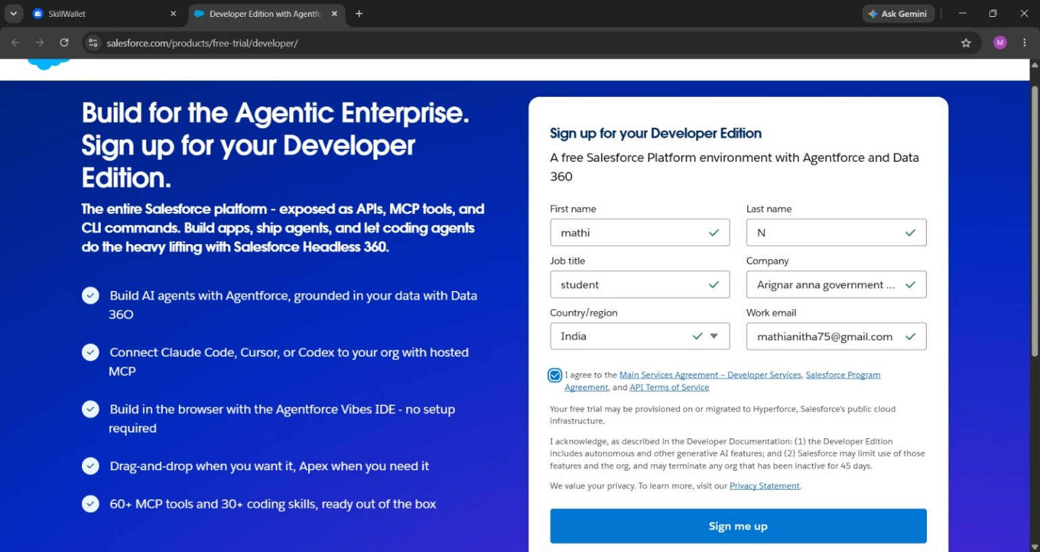

Screenshot 2 – Student Enrollment & Course Management System workspace
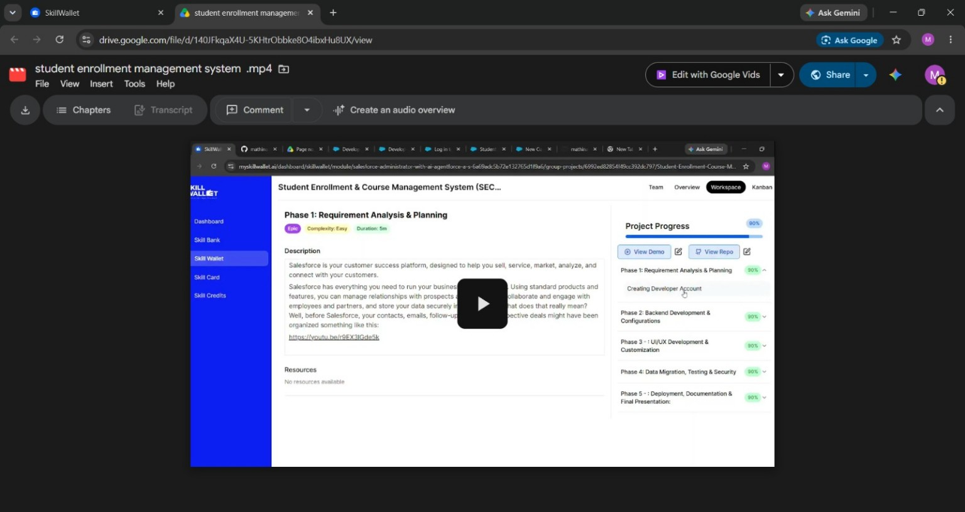

Screenshot 3 – Salesforce Developer Edition confirmation page
