**Configurer OSPF**

1-







**2-**

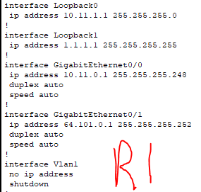

**3-**



**4-**





**5-**

**6-**

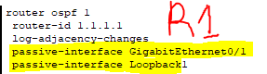

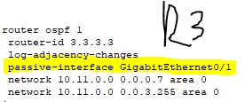

**7-**

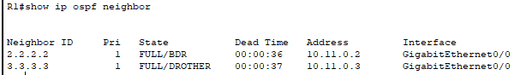

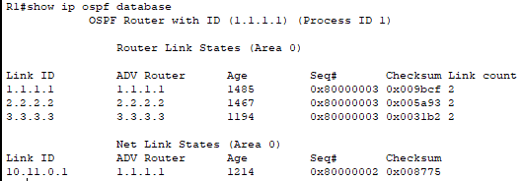

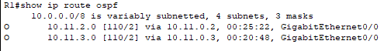

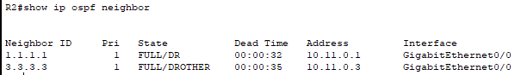

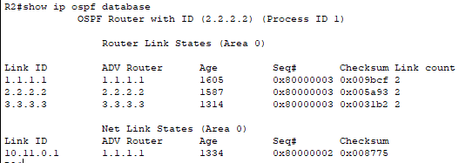

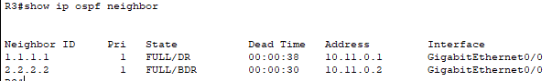

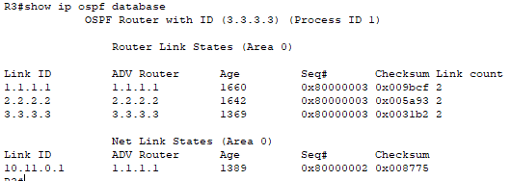

**8-**







**9-**

**10-**



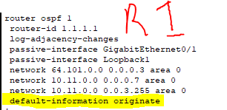

**11-**

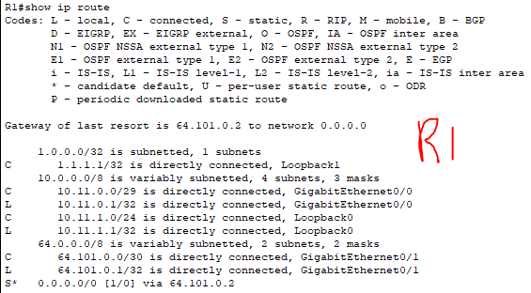

**12-**

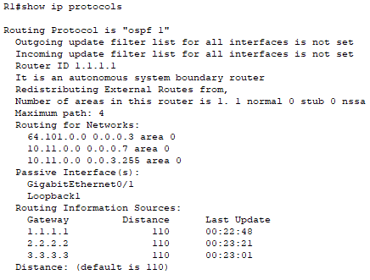

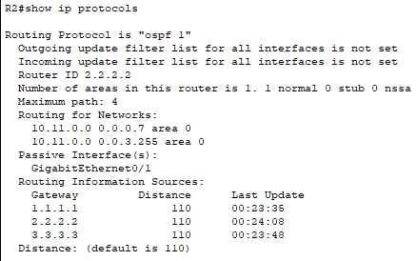

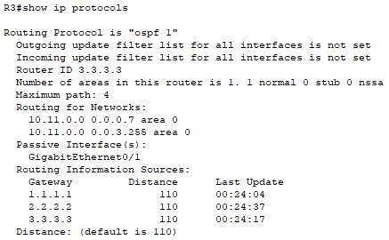

**13-** Ils sont encryptés, c’était juste pour montrer les mots de passe.

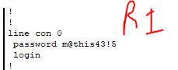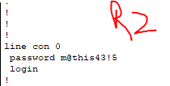

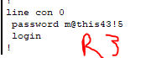

**14- ssh mdp: adadadad**

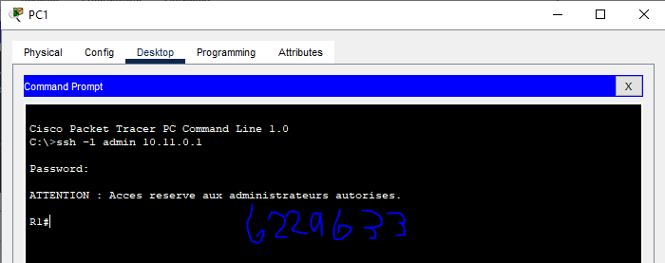

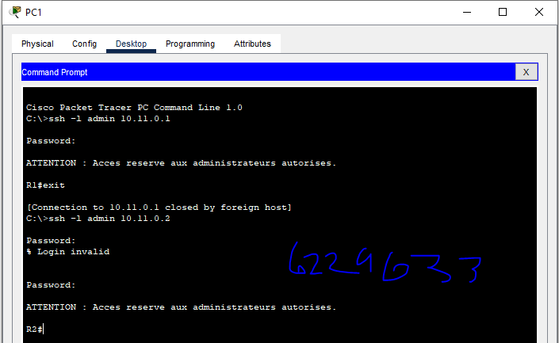

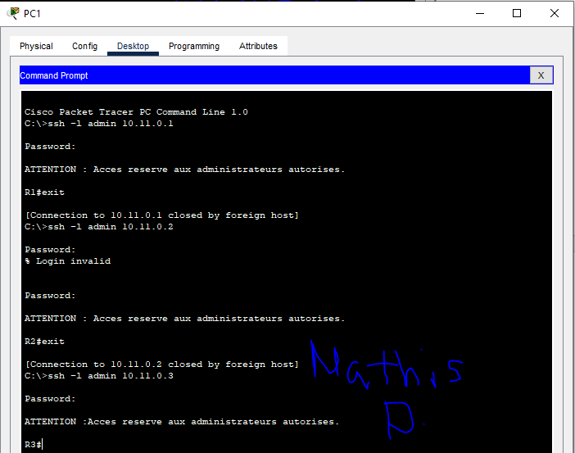

**QUESTION 15 EN DESSOUS! ⬇**

**15-**

