The original products table

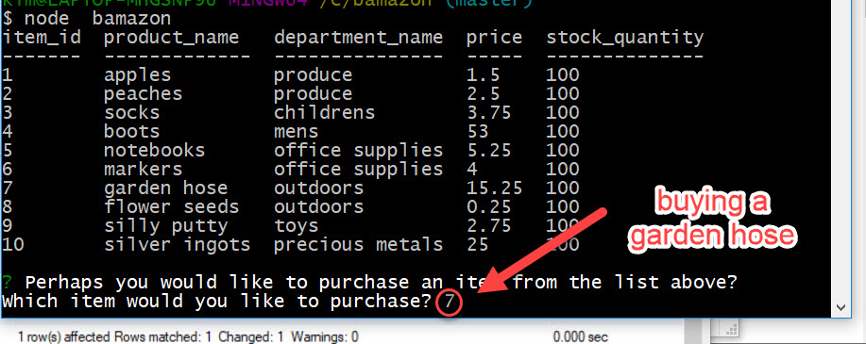

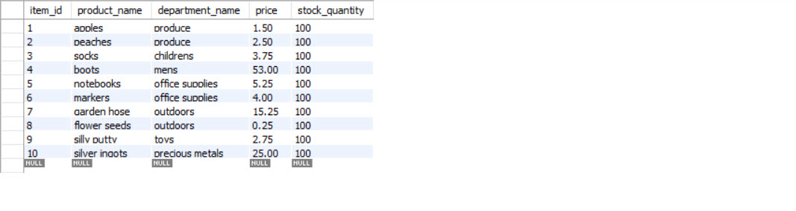

Type node bamazonCustomer on the command line. The products table will be displayed.

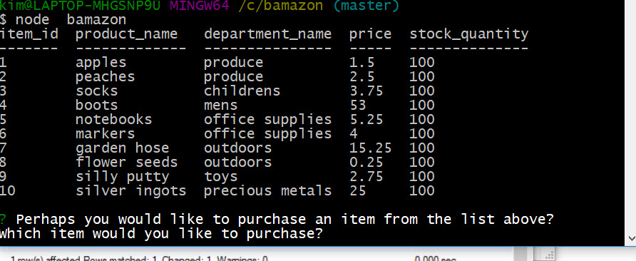

Type the item_id you wish to “purchase”.



Type the quantity you would like to “purchase”.

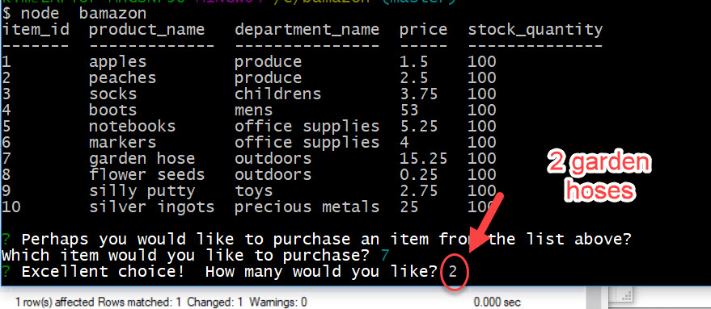

Confirmation of the purchase if the quantity desired is less than or equal to the stock_quantity

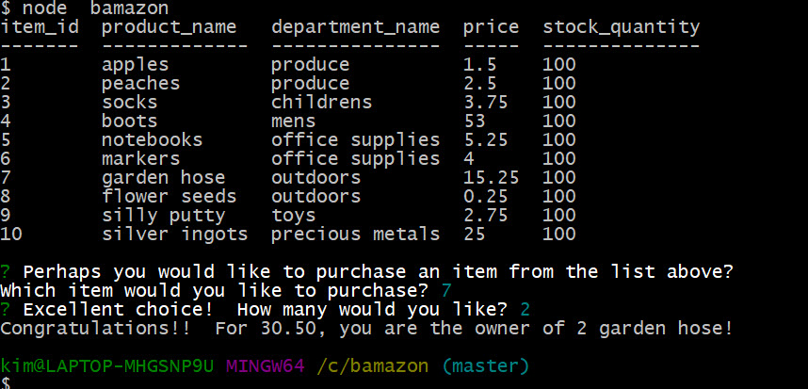

The quantity has been adjusted on the Products table.

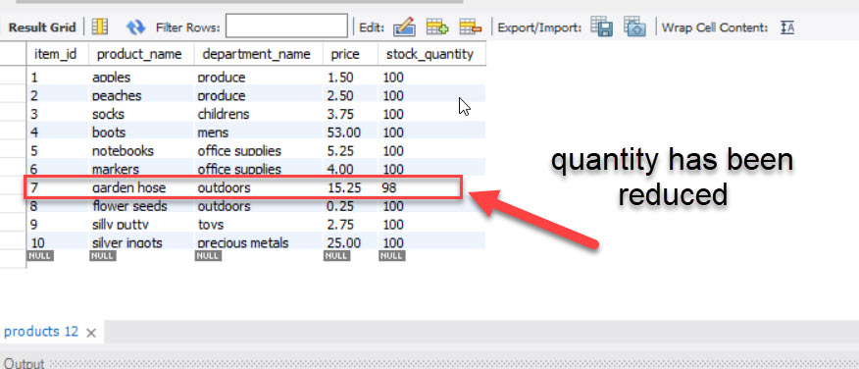

Message when the quantity requested exceeds the quantity on hand

