Quarto Basics
Norah Jones
2021-05-22
Table of contents

1 Colors
- Red
- Green
- Blue

2 Shapes
- Square
- Circle
- Triangle

3 Textures
- Smooth
- Bumpy
- Fuzzy

4 Overview
See Figure 1 in Section 5 for a demonstration of a simple plot.
See Equation 1 to better understand standard deviation.

5 Plot
import matplotlib.pyplot as plt
plt.plot([1,23,2,4])
plt.show()
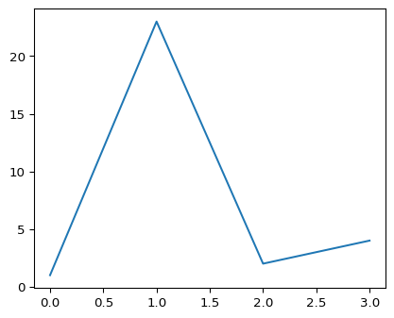
Figure 1: Simple Plot

6 Equation
$$s=\sqrt{\frac{1}{N−1}\sum_{i=1}^{N}{{\left(x_{i}−\overline{x}\right)}^{2}}} \left(1\right)$$

7 Citation
Knuth says always be literate (Knuth 1984).

8 References
Knuth, Donald Ervin. 1984. “Literate Programming.” The Computer Journal 27 (2): 97–111.

