Domain-decomposed antiderivative transformation iterative method: A deep learning approach for weakly and Cauchy types singular integral equations
Dong Liu^{a,b,*} , Zhenyu Liu^{a,b}, Ziliang Feng^{b} ,Kangjun Heª, Yang Liu^{b}, Zhen Liaoª, Le Xuª, Jiali Yu^{c}
ªNuclear Power Institute of China, State Key Laboratory of Advanced Nuclear Energy Technology, Chengdu 610213, China
^{b}College of Computer Science (School of Software and School of Artificial Intelligence), Sichuan University, Chengdu 610065, China
^{c}School of Mathematical Sciences, University of Electronic Science and Technology of China, Chengdu 611731, China
Abstract
Solving singular integral equations is crucial in various practical industrial systems and has long been a challenging and active research area in numerical computation. In recent years, significant progress has been made in numerical techniques for solving differential and integral equations by leveraging deep learning methods, demonstrating notable advantages in continuity and accuracy. However, the singularity of the kernel function in singular integral equations poses unique challenges for traditional deep learning methods. To address this, we propose a Domain-decomposed Antiderivative transformation Iterative Method (D-AIM) for weakly and Cauchy types singular integral equations. For linear singular equations, we divide the solution domain into multiple subdomains and transform the integral terms of the regional equations into antiderivatives of the integrand functions, thereby converting singular integral equations into exact differential equation systems. Multiple neural network functions are mapped to the unknown functions and antiderivatives of the equations, and corresponding loss functions are constructed for deep learning to ultimately obtain numerical solutions of the unknown functions. Numerical experiments on various typical examples demonstrate that the proposed method has high accuracy and applicability, with computational results exhibiting continuity advantages, thus establishing new technical approaches for numerical solutions of singular integral equations.
Keywords Cauchy singular integral equations; Weakly singular integral equations; Deep learning; Domain decomposition; Antiderivative transformation
- Introduction
Singular integral equations are found in a wide range of scientific and technological fields[1-4]. Solving these equations is essential for the quantitative analysis of problems in elasticity and fracture mechanics[5,6], electromagnetic wave scattering[7,8], and the multi-physics coupling analysis of piezoelectric semiconductors[9,10]. Unlike conventional integral equations, singular integral equations feature kernel functions with singularities within the integration domain. This characteristic introduces unique challenges for both theoretical analysis and numerical solution. Research on numerical methods for singular integral equations has always been a key focus and a major challenge in computational mathematics. Classical solution strategies include collocation methods[1,11,12], techniques for handling singular integrals in the boundary element method[7,13,14], and spectral methods suited for mixed-type singular kernels[15-17]. These methods handle singularities through different mathematical mechanisms and strive to improve computational efficiency and stability. Developing efficient, high-precision numerical algorithms to address singular integral equations in different engineering contexts remains an active research direction in this field[1,2,18].
In recent years, deep learning has been used not only for differential equations [19-23] but also increasingly for integral equations. PINN-based methods have been developed for multidimensional Fredholm integral equations [24,25], volume integral equations [26], boundary integral equations [27] and other multidimensional integral equations with continuous kernels [28]. For integral equations with discontinuous coefficients, domain-decomposed XPINNs are often used to accommodate non-smooth solutions across interfaces [29]. DeepONet and neural-operator methods are suitable for solving a class of parameterized problems [21,30-32], thereby enhancing the generalization capability of deep learning based numerical computation. Most of these studies concern non-singular integral equations and evaluate the integral terms by numerical integration, which introduces additional discretization error. The boundary integral neural network (BINN) is an important exception: it converts a PDE into a boundary integral equation using a Green’s function and evaluates weakly singular and Cauchy-type singular integrals by regularization techniques. Its applicability, however, depends on the existence of the BIE formulation and the fundamental solution. In many non-linear problems, the unknowns in the interior region cannot be completely eliminated. Moreover, the fundamental solution may be hard to obtain or even not exist [27]. Therefore, it is necessary to explore new deep learning methods for solving singular integral equations.
To tackle the challenges posed by singular integral equations in deep learning, this paper proposes a Domain-decomposed antiderivative transformation iterative method (D-AIM) for weakly and Cauchy types singular integral equations. For linear singular equations, we divide the solution domain into multiple subdomains. The integral terms in the equations on these subdomains are then transformed into antiderivatives of the integrands, thereby converting the singular integral equations into exact differential equation systems. Multiple neural network functions are mapped to the unknown functions and antiderivatives of the equations, and corresponding loss functions are constructed for deep learning to ultimately obtain numerical solutions of the unknown functions, thus providing new technical approaches for numerical solution methods of singular integral equations. Unlike traditional methods, the deep-learning approach proposed in this work builds the solution scheme directly from the original equation, without any model simplification. The solution process is well-organized and relatively simple to implement. Moreover, deep-learning approaches are widely regarded as a promising method for solving high-dimensional integro-differential equations. The proposed method may therefore provide a useful and potentially high-performance route for solving singular integral equations arising in fracture mechanics and other complex engineering problems.
Since second-kind linear singular integral equations have canonical forms and the existence of their solutions is well established, this paper focuses primarily on this type. Nevertheless, the basic ideas presented can also provide insights for solving other forms of singular integral equations. Although multi-dimensional integral equations are often encountered in practical problems, methods for solving single-variable integral equations can, in principle, be extended to multi-dimensional ones [1]. For simplicity, we focus on single-variable linear singular integral equations, and the basic principles are applicable to high-dimensional and nonlinear singular equations.
- Various forms of linear singular integral equations
The general form of linear singular integral equations is [1,2]:
where is the unknown function, is a fixed parameter, , , and the singular integral kernel are known functions. When the integration limits in the equation are constants, the linear equation is a Fredholm equation. When the limits contain variables, the integral equation becomes a Volterra integral equation. Additionally, when , it is a first-kind integral equation; when , it is a second-kind integral equation; when is a continuous function of , it is a third-kind integral equation. The following discussion focuses on second-kind linear singular integral equations. According to different forms of the singular integral kernel , this type of equation has three forms [1].
1) Weakly singular integral equations:
Let , where is a continuous and bounded function, is a constant with . The specific form of weakly singular integral equations is:
2) Cauchy integral equations:
Let , where is continuous and has partial derivatives with respect to and , and satisfies the Hölder condition [1] on . The equation form is:
Cauchy singular integral equations are generally divergent in the usual sense but converge under the principal value integral definition, i.e., the limit exists.
3) Hypersingular equations:
Let , where is a constant with is at least times differentiable, and its -th derivative satisfies the Hölder continuity condition [1]. The equation form is:
This equation has higher singularity than Cauchy principal value integrals and requires mathematical meaning through integration by parts. This type of equation can be transformed into Cauchy integral equations for solution under certain conditions [1].
The forms of and in equations - significantly affect the existence and uniqueness of equation solutions, and extensive theoretical research has been proposed [1,2]. This paper develops deep learning numerical solution methods under the assumption that the integral kernels and related forms of these equations satisfy the conditions for solution existence and uniqueness.
- Antiderivative transformation theory

3.1. Basic theoretical principles
The basic principle of the D-AIM method is to divide the solution domain into different regions based on the positions of singular points, according to the specific form of singular integral equations. In each region, integral terms are represented using antiderivatives of the integrand functions, and methods for constructing specific solutions of the antiderivatives are established. Simultaneously, mathematical relationships between the unknown functions and the regional antiderivatives are established, thereby transforming the singular integral equations into exact systems of differential equations. Subsequently, the unknown functions to be solved and the regional antiderivatives are mapped to different neural networks, and loss functions corresponding to the governing equations, antiderivative equations, and definite solution constraints are established for deep learning. Through iterative training of these neural networks, the loss functions are gradually reduced. When the loss functions approach their minimum values, the outputs of the neural networks approximate the antiderivatives, and the numerical solutions for the unknown functions are consequently obtained.
By the Newton–Leibniz formula, if the kernel in an integral term is continuous over the solution domain, then, provided that a definite solution exists, the integral term and its antiderivative are in one-to-one correspondence. This establishes the equivalence between the original singular integral equation and the transformed differential system [1,28]. Because the antiderivative transformation of an integral term with a continuous kernel is mathematically rigorous, the transformation is stable.
Since Fredholm and Volterra equations have different forms of integration domains, the following discusses second-kind Volterra-type weakly singular equations and Fredholm-type Cauchy singular equations separately. The approaches for other types of equations can be derived by analogy.

3.2. Volterra-type weakly singular equations
Introducing a small quantity and changing the original equation integration domain to , the original equation becomes:
According to the properties of weakly singular integral equations, when , equation converges and has a continuous solution. In the integration domain with respect to , equation can be treated as a normal integral equation. and are both continuous. The integrand is singular along the diagonal , but it is continuous outside the region around with width . According to the fundamental theorem of calculus [33], there exists an integral antiderivative , and the derivative of with respect to is:
It should be noted that when taking the derivative of with respect to can be treated as a variable independent of and treated as a constant. From the Newton-Leibniz formula, it follows that:
Substituting equation into gives:
It is worth noting that according to the properties of calculus, the antiderivative of the same integrand is a family of functions differing by a real constant [33]. The antiderivatives satisfying equations and are not uniquely determined, and all these antiderivatives have equal derivatives with respect to .
Let denote a specific antiderivative, such that:
and satisfy:
By choosing , we obtain a specific antiderivative:
This expression directly implies that when , .
Thus, within the family of antiderivatives , a specific antiderivative satisfying the prescribed constraint has been obtained. Substituting equation into equation and combining with equation gives:
Thus, the Volterra-type weakly singular equation is transformed into a differential equation system without integral terms through antiderivative transformation. The ranges of and are as shown in Fig. 1.
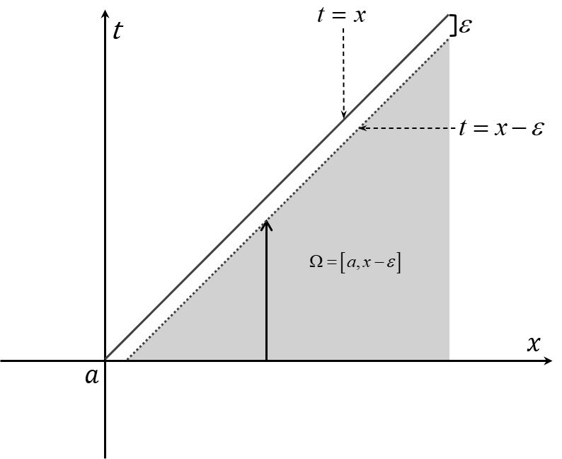
Fig. 1 The range of values for and .
It is worth noting that the first and second terms in equation can be combined into the following form:
To further reduce the complexity of the equation, we can first solve for using equation , and subsequently obtain an implicit solution for the unknown function through equation .
For normalization purposes and to focus on the main deep learning principles, the analysis in the following sections will continue to employ equation as the basis of discussion.

3.3. Fredholm-type Cauchy singular equations
Since the original equation converges under the principal value integral definition [1], introducing a small quantity and changing the original equation integration domain to transforms to:
Similar to Section 3.2, the two integral terms in equation are normal integral terms, and there also exist integral antiderivatives and with respect to :
From the Newton-Leibniz formula, it follows that:
Substituting into gives:
As shown in the above derivation of equation , there also exist specific antiderivatives such that when ,, and when , . Combining equations and gives:
Thus, the original Fredholm-type Cauchy singular equation is transformed through antiderivative transformation into a differential equation system without integral terms. The ranges of and for and are as shown in Fig. 2.
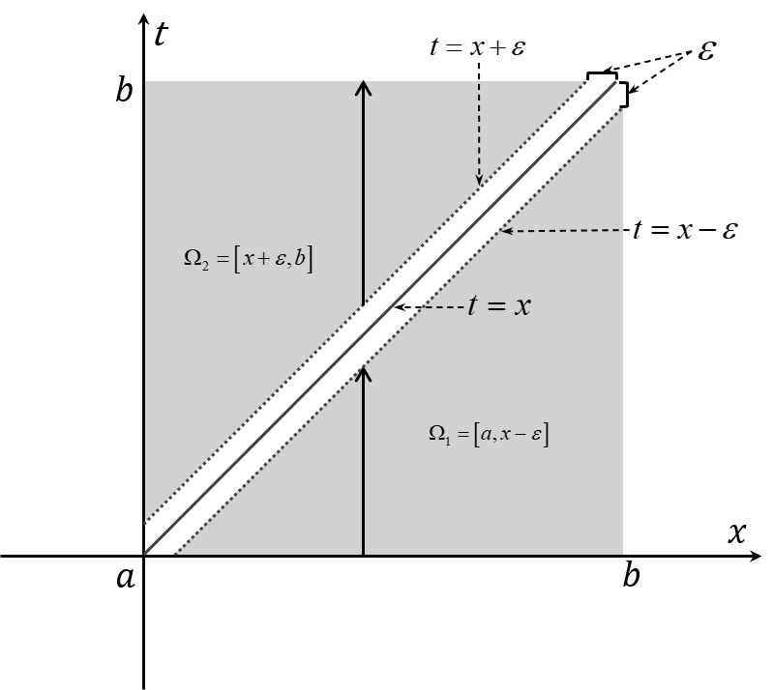
Fig. 2 The range of values for and .
Equation can also be simplified in the same manner as equation , enabling an implicit solution for . It should be noted that the above two types of singular equations are representative. Other forms of singular equations can be transformed into these two forms using mathematical methods for solution, or can be derived through analogy to these two forms according to the convergence definition of the singular equation.
- Neural network loss function construction
After transforming the singular integral equations into exact systems of differential equations, we employ artificial neural networks as trial functions to approximate the unknown function and the antiderivative , based on the fundamental theory and framework of deep learning methods for numerically solving the differential equations [19,24]. These functions are then substituted into the transformed system of differential equations to construct the neural network loss function.
The function form represented by fully connected deep neural networks is [34]:
where is the neural network input vector, is the neural network output, is the neural network connection weight, is the neural network bias term, is the network depth, is the number of hidden neural units, and is the network mapping function.
Using equation as trial functions, we substitute them into the governing equations, antiderivative equations, and definite solution constraint conditions of and to generate corresponding loss functions. The generation of these loss functions follows the deep learning methods established for continuous integral equations [24-28]. The following section uses equation as an example for illustration.

4.1. Governing equation loss function
Let , where the neural network vectors and represent the input variables and in equation . If the equation contains multi-dimensional variables, and can be adaptively adjusted according to the dimensions of and .
Substituting the above equivalent relationships into the first term of equation , the loss function represented by the original governing equation residual is:
where represents the sample points required for machine learning, which can be generated according to certain probability density distributions or using different density distribution strategies based on the equation form [19].

4.2. Antiderivative equation loss function
Substituting the neural network functions into the second and third terms of equation , the loss functions for the antiderivative equations are:
where represents the sample points required for machine learning. It should be noted that since the second and third terms in equation contain divided by (), when approaches , extremely large values occur. Therefore, both sides of the equation are multiplied by to obtain the corresponding loss functions in equation .

4.3. Antiderivative definite solution constraint loss function
For antiderivative definite solution constraints, which are defined by given function values at specific points, the corresponding loss functions can be constructed in a data-driven manner [19]. Let and . From the last term of equation , and , the definite solution constraint loss functions are:
where and are machine learning sample points on the domain of definite solution constraint terms. The domain of definite solution constraint terms in equation is a line, and the range is uniformly zero.

4.4. Unified weighted loss function
Among the three neural network functions , and corresponds to the separate loss function of the governing equation, while and correspond to antiderivative equations and definite solution constraint loss functions respectively. These two loss functions need to be weighted to obtain unified machine learning loss functions for antiderivatives:
where , and are loss function weights for antiderivative equations and antiderivative definite solution constraints. As machine learning hyperparameters, they are typically set empirically or through experimentation.
- Deep learning process for antiderivative forms differential equations
After transforming the integral equations into exact differential equations and defining the corresponding loss functions, the deep learning process can be carried out either with the standard PINN framework [19] or with one of the improved deep-learning architectures developed for differential equations [27,29,35]. The deep learning process involves setting the network structures of neural network functions , and , constructing machine learning sample sets according to their respective solution domains, and updating the weights and biases in equation according to the weighted loss functions determined by equations and , so that , and decrease alternately and gradually approach zero. In the training process described above, the number of loop iterations in the computational procedure depends on the complexity of the task. Once training is complete, approximates the numerical solution of the equation. In practice, convergence criteria are generally set for loss functions, i.e., less than the preset minimum value , or a maximum number of machine learning rounds. Machine learning stops when convergence criteria are satisfied. Taking the case where all neural network loss functions are less than as the convergence criterion, the iterative computation flowchart is shown in Fig. 3:
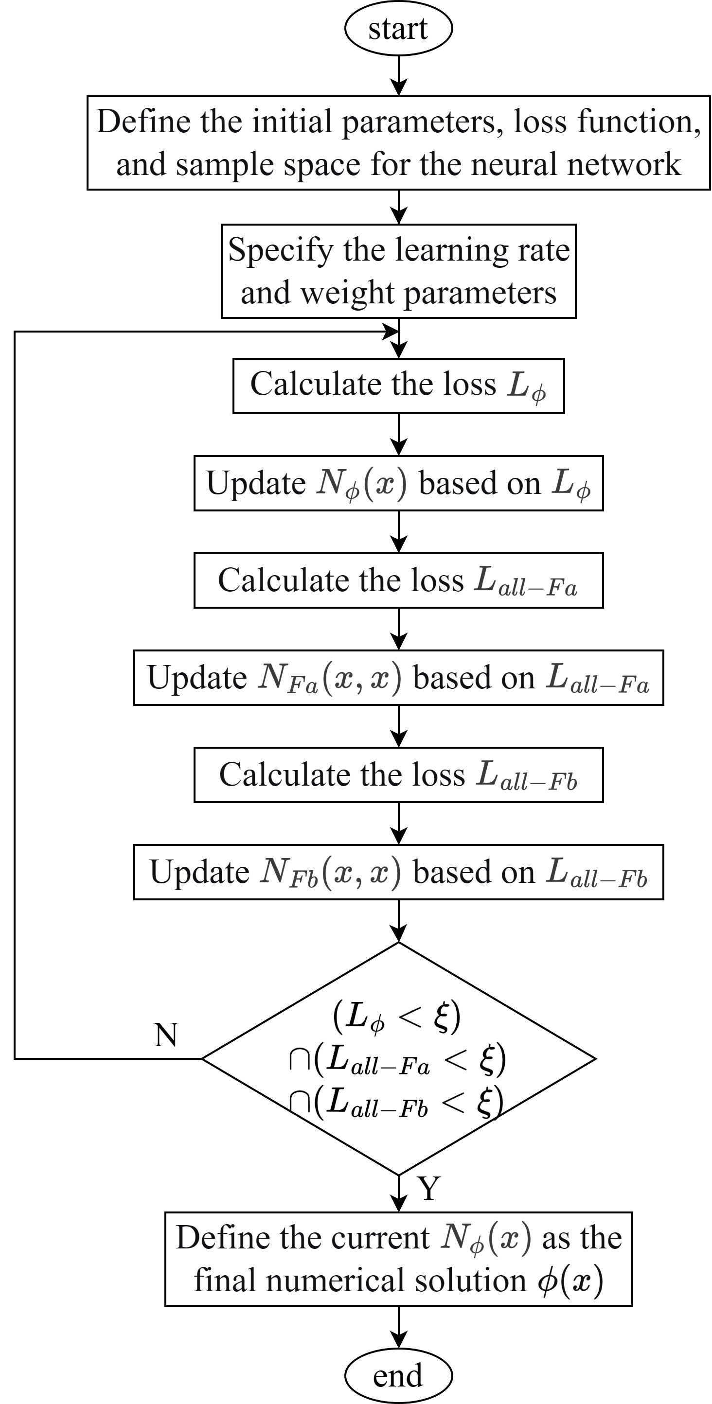
Fig. 3 Workflow of the D-AIM procedure
- Numerical verification
In this section, all numerical examples were trained on a single NVIDIA GeForce RTX 4070 Ti GPU. The networks were implemented, differentiated automatically and trained using PyTorch 2.12.0 with CUDA 12.6 acceleration, and the complete workflow was run in Python 3.13.

6.1. Verification of the second kind Volterra integral equation with weakly singular kernel
Problem description: The Volterra integral equation of the second kind with weakly singular kernel described by equation has an analytical solution given by the form of equation .
The analytical solution is:
The transformed form of Equation (12) is adopted for deep machine learning solution.
Machine learning method and parameter selection: A standard fully connected neural network is employed with 100 hidden units () and 5 network layers (), using the Adam optimization algorithm. The learning rate starts from and gradually decreases as the number of training iterations increases. Training continues until loss function value ceases to decrease. The number of samples and corresponding loss function weights are selected using empirical coefficients.
Detailed parameters and numerical results are presented in Table 1. Fig. 4 shows the scatter plots of the computed results for the antiderivative and the unknown function . The parameter in Table 1 represents the mean square error between the generalization results computed by the trained neural network at all sample points and the analytical solution. The Loss denotes the loss function value after training, and the small quantity is set to 0.001. Since is singular at , the computation of in the table below is performed for .
Table 1 Loss function, and numerical results for the second kind Volterra integral equation with weakly singular kernel.
Network | Type of Loss Function | Form of Loss Function | Number of Samples | Loss Function Weight |  | Loss
 | Governing equation | Equation | 10000 | 1 | 2.513e-3 | 3.271e-7
 | Antiderivative equation | Equation | 24990 |  |  | 7.320e-6
 | Antiderivative definite solution constraint | Equation | 150
 | 
(a) The antiderivative distribution | (b) The numerical solution distribution
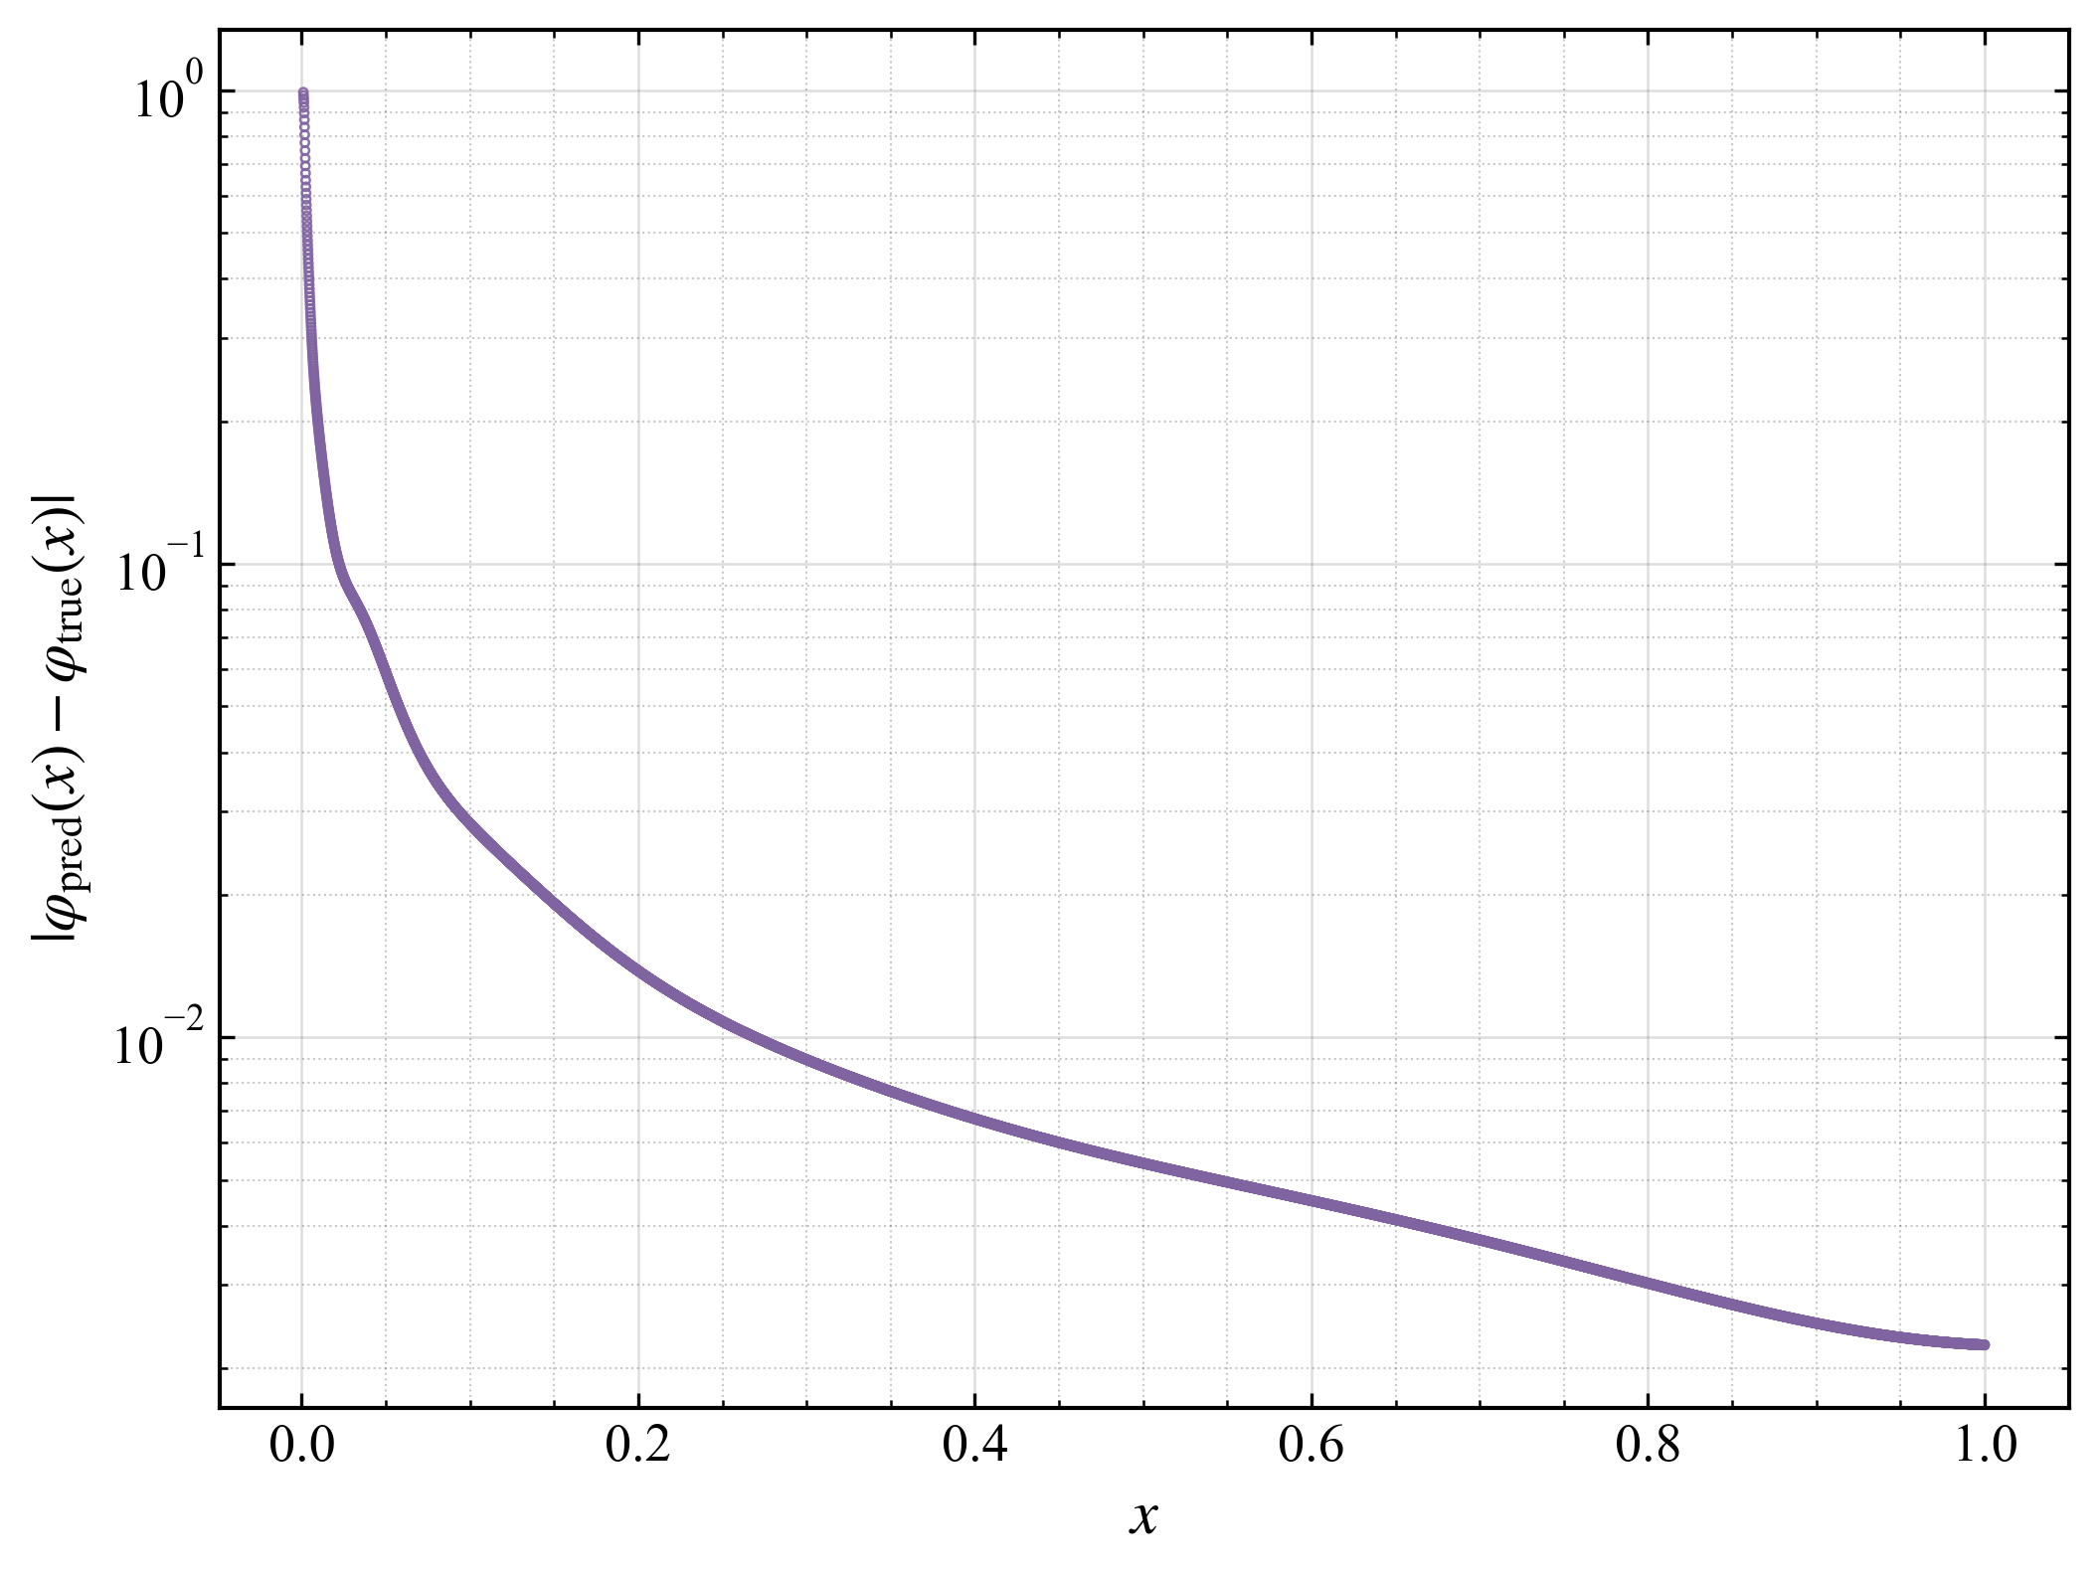
(c) The pointwise absolute error distribution
Fig. 4. Numerical results of the second kind Volterra weakly singular integral equation. (a) deep-learning result for the antiderivative over the two-dimensional (x, t) domain, where the red line segment denotes the antiderivative definite solution constraint; (b) comparison between the D-AIM numerical solution and the analytical solution of the Volterra weakly singular equation; (c) pointwise absolute error between the D-AIM numerical solution and the analytical solution of the Volterra weakly singular equation.

6.2. Verification of the second kind Fredholm weakly singular integral equation
Problem description: Equation defines a second kind Fredholm weakly singular integral equation, whose analytical solution is given by Equation :
where
The analytical solution is expressed as
For the second kind Fredholm weakly singular integral equation, the deep learning solution is obtained using the transformed formulation analogous to Equation .
The machine learning framework and parameter settings are consistent with those in Section 6.1. The loss functions and numerical computation results are summarized in Table 2, where the small quantity is set to 0.004. The resulting point cloud visualization is shown in Fig. 5.
Table 2 Loss function, and numerical results for the second kind Fredholm weakly singular integral equation.
Network | Type of Loss Function | Form of Loss Function | Number of Samples | Loss Function Weight |  | Loss
 | Governing equation | Equation | 10000 | 1 | 5.171e-8 | 1.376e-7
 | Antiderivative equation | Equation | 24990 |  |  | 5.516e-7
 | Antiderivative definite solution constraint | Equation | 150
 | Antiderivative equation | Equation | 25001 |  |  | 1.503e-6
 | Antiderivative definite solution constraint | Equation | 150
 | 
(a) The antiderivative distribution | (b) The numerical solution distribution
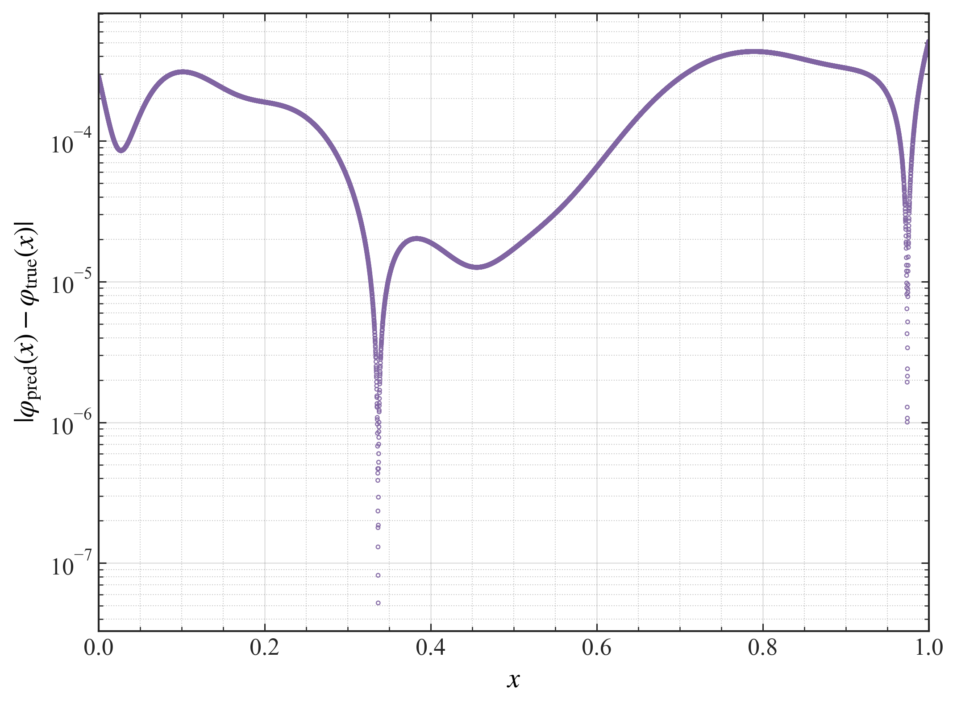
(c) The pointwise absolute error distribution
Fig. 5. Numerical results of the second kind Fredholm weakly singular integral equation. (a) deep-learning result for the antiderivative over the two-dimensional (x, t) domain, where the red line segment denotes the antiderivative definite solution constraint; (b) comparison between the D-AIM numerical solution and the analytical solution of the Fredholm weakly singular equation; (c) pointwise absolute error between the D-AIM numerical solution and the analytical solution of the Fredholm weakly singular equation.
To quantitatively analyze the sensitivity of the proposed method to the small quantity 𝜀, a systematic sensitivity analysis was carried out. Eleven values of 𝜀 were selected across different orders of magnitude,
and five independent repeated runs were carried out for each value. In the above computing environment, each training run took approximately 5400 s on average. Fig. 6 shows the evolution of the total loss with the number of training epochs. The loss decreases steadily and levels off at roughly 500,000 epochs, indicating that training has converged.
Fig. 7 shows the variation of the MSE with 𝜀, together with the error bars obtained from the repeated runs. The results show that for ε > 0.001 the prediction error decreases as ε decreases, whereas for ε < 0.001 the prediction error remains essentially unchanged. The experimental results show that the total loss of the proposed method decreases progressively with the iterations and then levels off, indicating that the computational process exhibits good convergence, as shown in Fig. 6.
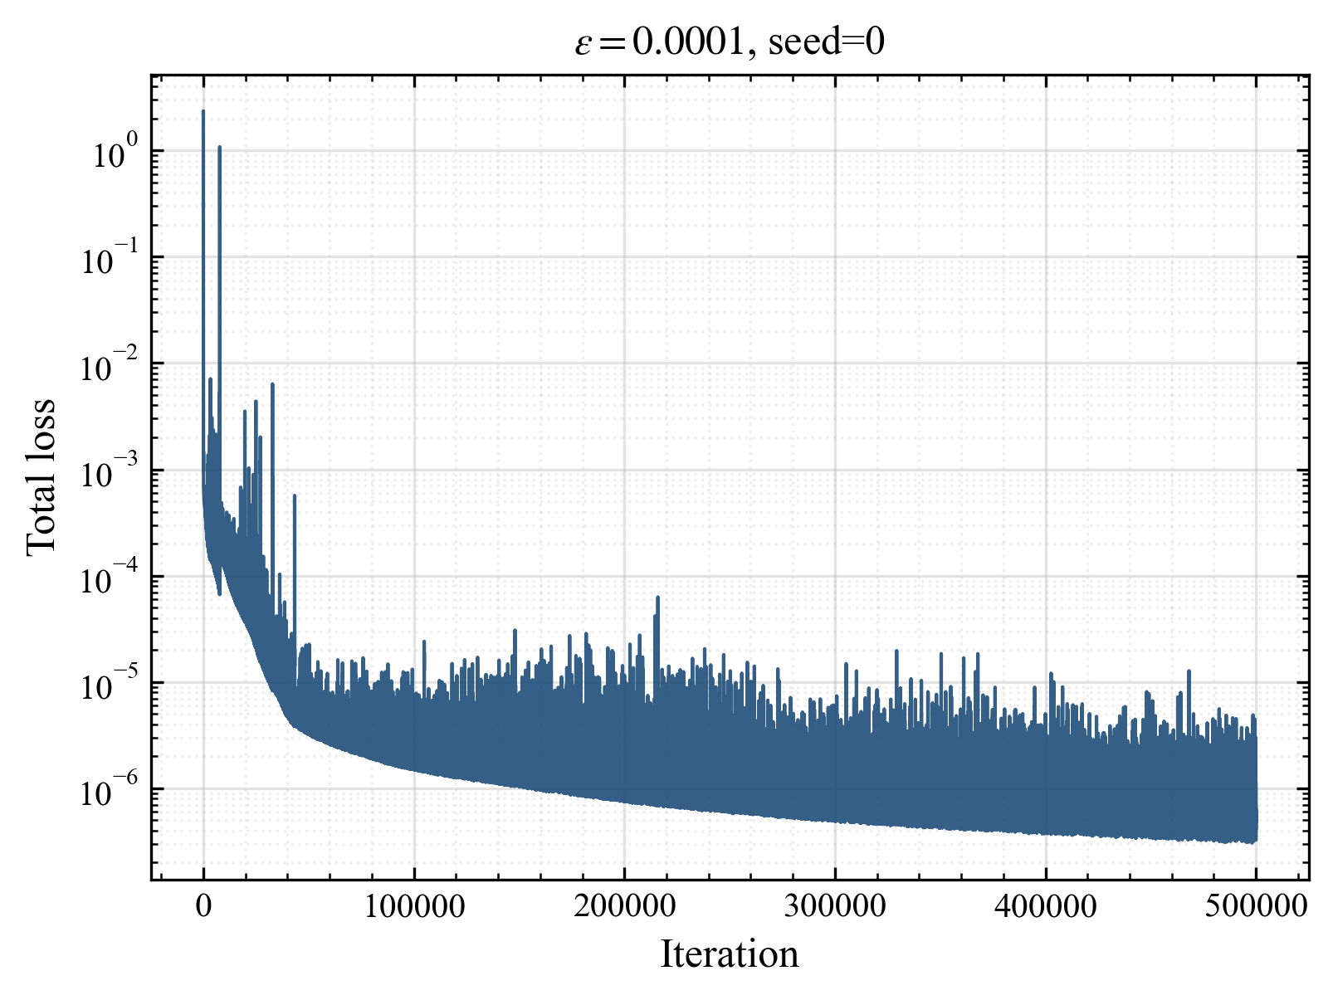 | 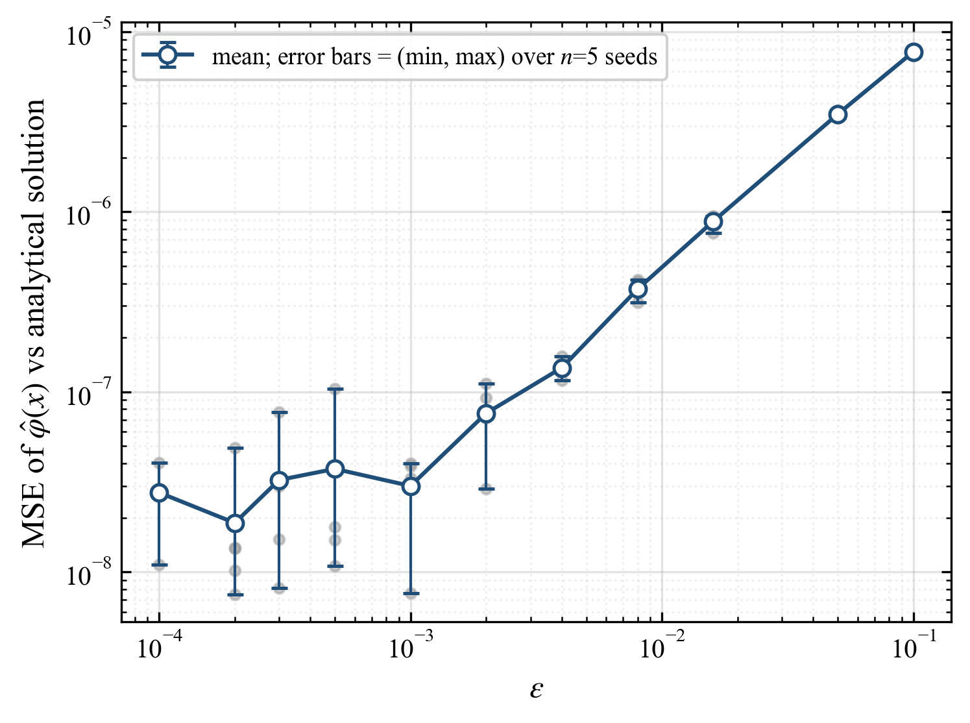
Fig. 6. The evolution of the total loss | Fig. 7. Mean squared error of the predicted solution as a function of
For comparison, the present problem is also solved using the conventional PINN deep learning framework. Fig. 8 shows the evolution of the total loss with the number of training epochs for the PINN method, and Fig. 9 compares the D-AIM solution, the PINN solution, and the analytical solution. The results show that the loss of the PINN method oscillates drastically during training and does not decrease to a converged level, resulting in a large error; the D-AIM method therefore exhibits a clear performance advantage over the conventional PINN in this example.
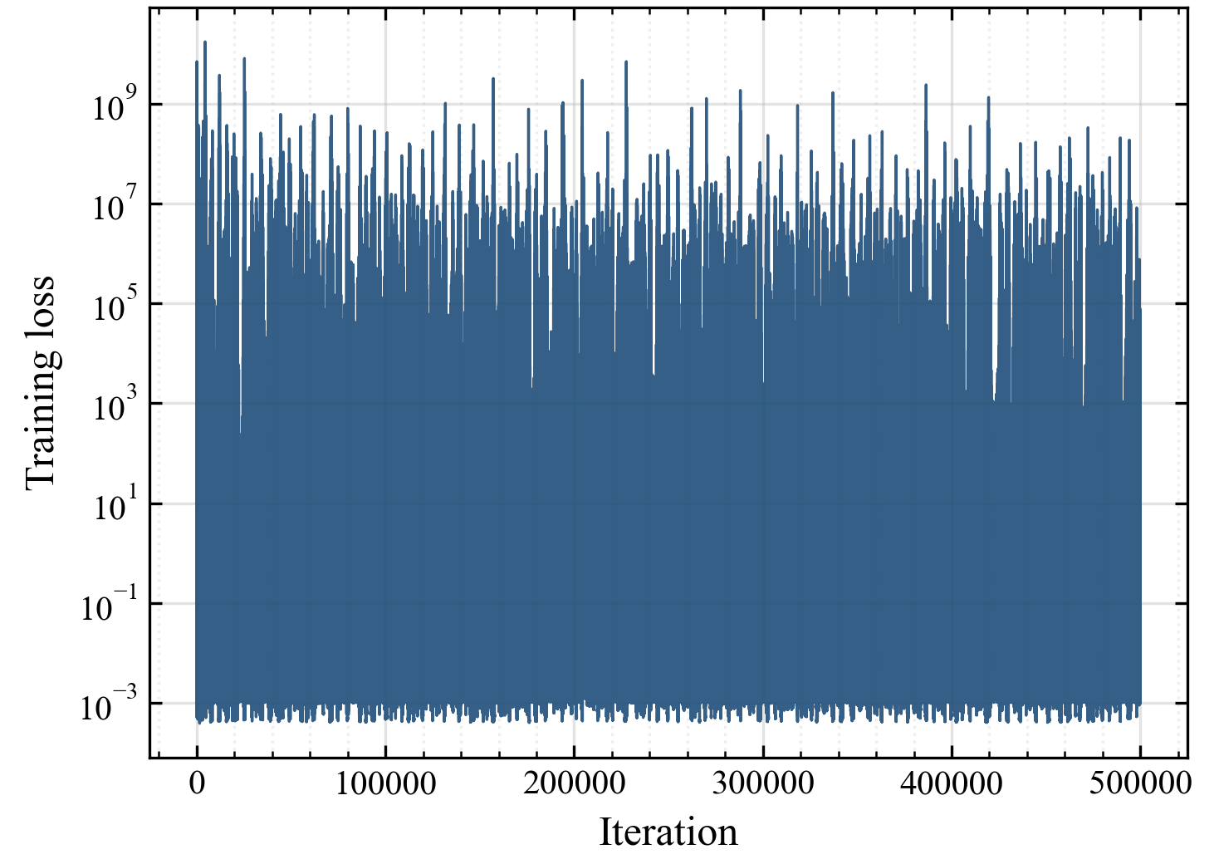 | 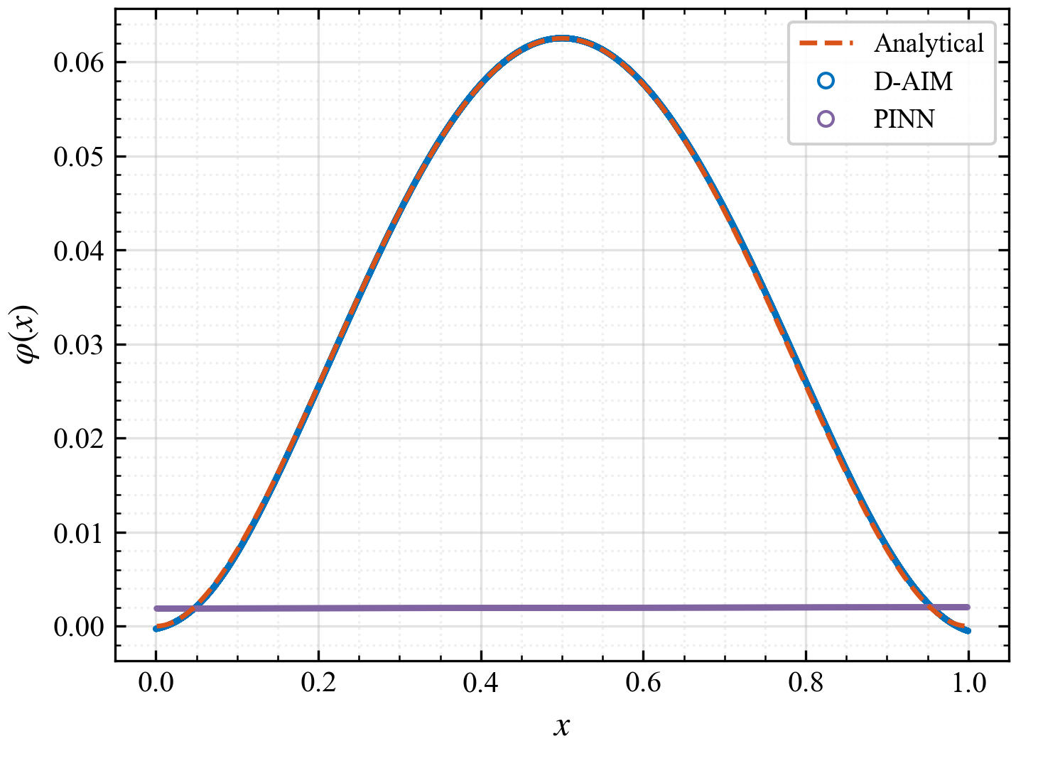
Fig. 8. The evolution of the total loss | Fig. 9. Comparison of the predicted solutions with the analytical solution

6.3. Verification of the second kind Fredholm Cauchy singular integral equation
Problem description: Equation defines a second kind Fredholm Cauchy singular integral equation, whose analytical solution is given by Equation :
The analytical solution is expressed as
For the second kind Fredholm Cauchy singular integral equation, the deep learning solution is similarly obtained using the transformed formulation given by Equation .
The machine learning framework and parameter settings are identical to those in Section 6.1, while the loss functions follow those in Section 6.2. The small quantity is set to 0.005. The resulting point cloud visualization is shown in Fig. 10, and the mean square error between the numerical and analytical solutions after training is 8.0324e-4. Since is singular at , the computation of is performed for .
 | 
(a) The antiderivative distribution | (b) The numerical solution distribution
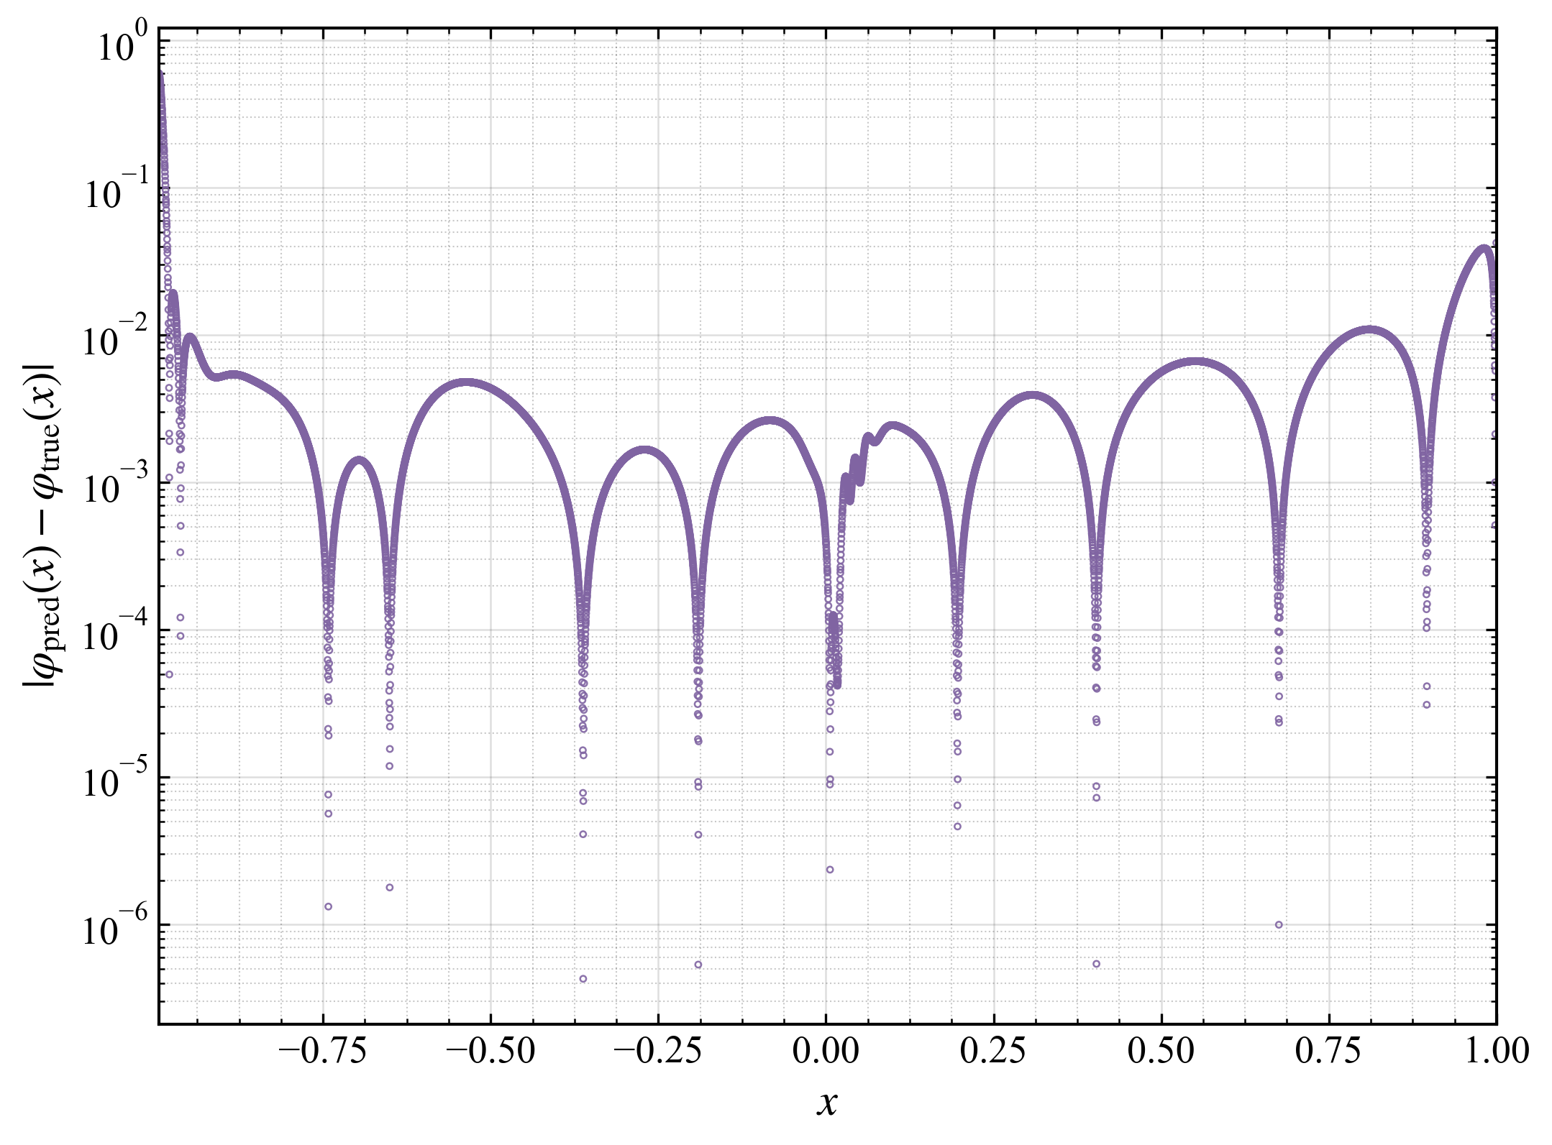
(c) The pointwise absolute error distribution
Fig. 10. Numerical results of the second kind Fredholm Cauchy singular integral equation. (a) deep-learning result for the antiderivative over the two-dimensional (x, t) domain, where the red line segment denotes the antiderivative definite solution constraint; (b) comparison between the D-AIM numerical solution and the analytical solution of the Fredholm Cauchy singular equation; (c) pointwise absolute error between the D-AIM numerical solution and the analytical solution of the Fredholm Cauchy singular equation.

6.4. Verification of the second kind Fredholm Hilbert singular integral equation
Problem description: Equation (31) defines a second-kind Fredholm Hilbert singular integral equation, in which the function is known to be periodic, satisfying, where is an integer. The analytical solution is given by Equation (32):
The analytical solution is expressed as
For this equation, the deep learning solution is obtained in the same manner as before, using the transformed formulation given in Equation .
The machine learning framework and parameter settings are identical to those in Section 6.1, while the loss functions follow those in Section 6.2. The small quantity is set to 0.004. The resulting point cloud visualization is shown in Fig. 11, and the mean square error between the numerical and analytical solutions after training is 1.4144e-4.
 | 
(a) The antiderivative distribution | (b) The numerical solution distribution
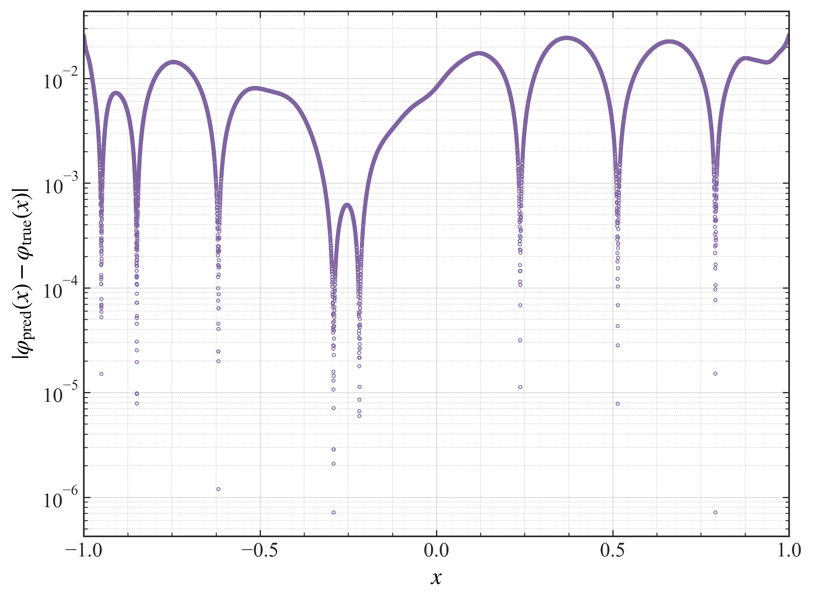
(c) The pointwise absolute error distribution
Fig. 11. Numerical results of the second kind Fredholm Hilbert singular integral equation. (a) deep-learning result for the antiderivative over the two-dimensional (x, t) domain, where the red line segment denotes the antiderivative definite solution constraint; (b) comparison between the D-AIM numerical solution and the analytical solution of the Fredholm Hilbert singular equation; (c) pointwise absolute error between the D-AIM numerical solution and the analytical solution of the Fredholm Hilbert singular equation.

6.5. Verification of the second kind Fredholm hypersingular integral equation
Problem description: Equation defines a second kind Fredholm hypersingular integral equation. Under the auxiliary condition , the analytical solution [36] is given by Equation :
The analytical solution can be expressed as
According to the properties of hypersingular integrals [37], when is first-order differentiable and satisfies , the original equation can be transformed into a Cauchy type integral equation:
For the above equation, the deep learning solution is obtained in the same manner as before, using the transformed formulation given by Equation .
The machine learning framework and parameter settings are identical to those in Section 6.1, while the loss functions follow those in Section 6.2. The small quantity is set to 0.002. The resulting point cloud visualization is shown in Fig. 12, and the mean square error between the numerical and analytical solutions after training is 5.6532e-4.
 | 
(a) The antiderivative distribution | (b) The numerical solution distribution
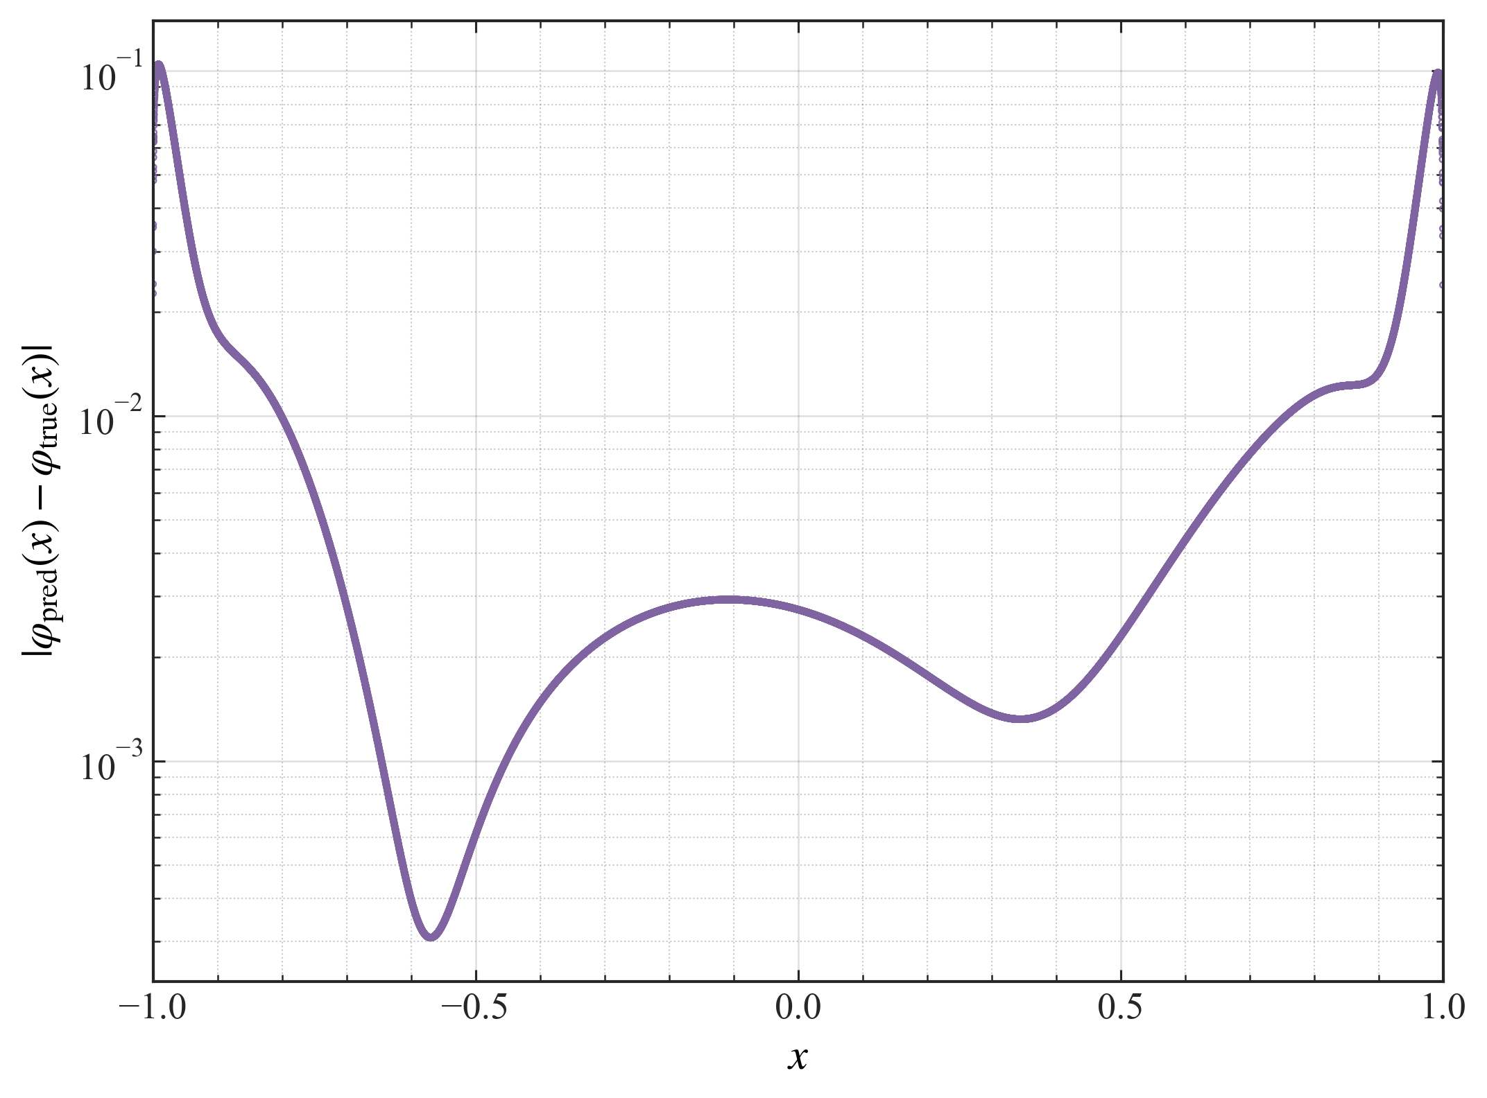
(c) The pointwise absolute error distribution
Fig. 12. Numerical results of the second kind Fredholm hypersingular integral equation. (a) deep-learning result for the antiderivative over the two-dimensional (x, t) domain, where the red line segment denotes the antiderivative definite solution constraint; (b) comparison between the D-AIM numerical solution and the analytical solution of the Fredholm hypersingular equation; (c) pointwise absolute error between the D-AIM numerical solution and the analytical solution of the Fredholm hypersingular equation.
In summary, validations across various forms of singular integral equations demonstrate that the proposed D-AIM deep learning method achieves favorable computational accuracy compared to both numerical benchmarks and analytical solutions. The numerical results exhibit a notable characteristic of continuity. It is particularly important to note that the neural network used in this study is a standard fully connected network [26], and the deep learning approach utilizes the fundamental PINN framework along with the Adam algorithm [27,38]. The computational accuracy is expected to be further improved by adopting more advanced neural network architectures and machine learning frameworks [39-42].
- Conclusion
This paper addresses the challenges posed by singular kernel functions in the numerical computation of singular integral equations and proposes a deep learning-based approach to solve them. The main contribution lies in proposing a Domain-decomposed antiderivative transformation iterative method (D-AIM) that divides the equation solution domain into multiple subdomains while using mathematical methods to transform singular integral equations into exact differential equation systems. Multiple neural networks are mapped to the unknown functions and their corresponding antiderivatives, and are trained alternately to ultimately obtain numerical solutions. Numerical experiments demonstrate that the proposed D-AIM method achieves high accuracy for linear weakly singular equations and Cauchy singular equations, while also producing continuous solutions. Moreover, it can be effectively extended to hypersingular equations and singular equations with periodic characteristics, demonstrating broad applicability. The related domain decomposition transformation theory and iterative processes also provide valuable insights for solving other forms of singular equations.
Future research will focus on theoretically analyzing the convergence and stability of the multi-network iterative deep learning method and quantitatively evaluating its time and space complexity. Further theoretical studies will also examine how key hyperparameters, including network architecture, loss weights, and sampling strategies, affect solver performance. Meanwhile, more advanced neural network architectures, such as graph neural networks, large-scale GPU-based parallel computing frameworks, and next-generation deep learning algorithms, will be explored to further improve computational accuracy and efficiency. In addition, the proposed method will be extended to high-dimensional spaces, more complex nonlinear integral kernels, more general forms of hypersingular equations, and engineering applications of greater practical relevance, such as fracture mechanics.

Appendix
The notation used in this paper is summarized in Table 3.
Table 3 Symbols and definitions
Symbol | Definition
a, b | Lower and upper limits of integration
x, t | Independent and integration variables, x, t ∈ [a, b]
ϕ(x) | Unknown solution of the singular integral equation
λ | Fixed parameter of the integral equation
a(x), f(x) | Known functions
K(x, t) | Singular integral kernel
G(x, t) | Continuous and bounded part of the kernel
α | Order of the kernel singularity
ε | Small quantity
Ω | Integration domain
F(x, t) | Antiderivative of the integral term
C | Constant
 | Neural-network input vector
 | Neural-network weights and biases
 | Network depth
 | Number of hidden neurons
 | Neural-network output for ϕ(x)
 | Neural-network output for F_{a} (x, t), F_{b} (x, t)
 | Loss function for the original governing equation
 | Loss function for the antiderivative equation
 | Loss function for the antiderivative definite solution constraint
 | Unified machine-learning loss for the antiderivative
 | Loss-function weights
 | Convergence tolerance for the training loss
 | Mean squared error

Acknowledgements
This research is supported by the National Natural Science Foundation of China (Grant No. 12575189), the Basic Research and Stable Support Research Project of Science and Technology Industry Bureau of China (Grant No. WDZC-2023050305) and the Supported by Sichuan Science and Technology Program (Grant No. 2023YFG0373).

References
- F.G. Tricomi, Integral Equations, Dover Publications, New York, 1985.
- A.G. Polimeridis, F. Vipiana, J.R. Mosig, D.R. Wilton, DIRECTFN: Fully numerical algorithms for high precision computation of singular integrals in galerkin SIE methods, IEEE Trans. Antennas Propag. 61 (2013) 3112–3122. https://doi.org/10.1109/TAP.2013.2246854.
- N.I. Muskhelishvili, Singular Integral Equations, Springer Netherlands, Dordrecht, 1977. https://doi.org/10.1007/978-94-009-9994-7.
- F. Erdogan, G.D. Gupta, T.S. Cook, Numerical solution of singular integral equations, in: G.C. Sih (Ed.), Methods of Analysis and Solutions of Crack Problems, Springer Netherlands, Dordrecht, 1973, 368–425. https://doi.org/10.1007/978-94-017-2260-5_7.
- W. Lei, H. Li, X. Qin, R. Chen, D. Ji, Dynamics-based analytical solutions to singular integrals for elastodynamics by time domain boundary element method, Appl. Math. Model. 56 (2018) 612–625. https://doi.org/10.1016/j.apm.2017.12.019.
- D.A. Hills, P.A. Kelly, D.N. Dai, A.M. Korsunsky, Solution of Crack Problems: The Distributed Dislocation Technique, Kluwer Academic Publishers, Dordrecht, 1996.
- A.B. Samokhin, A.S. Samokhina, Investigation and methods for solving problems of scattering of electromagnetic waves on three-dimensional anisotropic dielectric structures, J. Commun. Technol. Electron. 68 (2023) 619–624. https://doi.org/10.1134/S1064226923060116.
- D. Colton, R. Kress, Integral Equation Methods in Scattering Theory, Society for Industrial and Applied Mathematics, Philadelphia, PA, 2013. https://doi.org/10.1137/1.9781611973167.
- F. Shang, Z. Wang, Z. Li, Thermal stresses analysis of a three-dimensional crack in a thermopiezoelectric solid, Eng. Fract. Mech. 55 (1996) 737–750. https://doi.org/10.1016/0013-7944(96)00043-4.
- S.B. Park, C.T. Sun, Effect of electric field on fracture of piezoelectric ceramics, Int. J. Fract. 70 (1993) 203–216. https://doi.org/10.1007/BF00012935.
- K.E. Atkinson, The Numerical Solution of Integral Equations of the Second Kind, Cambridge University Press, Cambridge, 1997.
- H. Cai, A Jacobi-collocation method for solving second kind Fredholm integral equations with weakly singular kernels, Sci. China Math. 57 (2014) 2163–2178. https://doi.org/10.1007/s11425-014-4806-2.
- M. Guiggiani, G. Krishnasamy, T.J. Rudolphi, F.J. Rizzo, A general algorithm for the numerical solution of hypersingular boundary integral equations, J. Appl. Mech. 59 (1992) 604–614. https://doi.org/10.1115/1.2893766.
- J. Li, X. Zhang, D. Yu, Extrapolation methods to compute hypersingular integral in boundary element methods, Sci. China Math. 56 (2013) 1647–1660. https://doi.org/10.1007/s11425-013-4593-1.
- S. Chakraborty, S.K. Agrawal, G. Nelakanti, Spectral approximated superconvergent method for nonlinear Volterra Hammerstein integral equations with weakly singular kernels, J. Comput. Appl. Math. 467 (2025) 116601. https://doi.org/10.1016/j.cam.2025.116601.
- C. Canuto, M.Y. Hussaini, A. Quarteroni, T.A. Zang, Spectral Methods: Fundamentals in Single Domains, Springer, Berlin, Heidelberg, 2006.
- Y. Wang, S. Xiang, Levin methods for highly oscillatory integrals with singularities, Sci. China Math. 65 (2022) 603–622. https://doi.org/10.1007/s11425-018-1626-x.
- L. Chen, X. Li, Numerical calculation of regular and singular integrals in boundary integral equations using Clenshaw–Curtis quadrature rules, Eng. Anal. Bound. Elem. 155 (2023) 25–37. https://doi.org/10.1016/j.enganabound.2023.05.047.
- M. Raissi, P. Perdikaris, G.E. Karniadakis, Physics-informed neural networks: A deep learning framework for solving forward and inverse problems involving nonlinear partial differential equations, J. Comput. Phys. 378 (2019) 686–707. https://doi.org/10.1016/j.jcp.2018.10.045.
- G.E. Karniadakis, I.G. Kevrekidis, L. Lu, P. Perdikaris, S. Wang, L. Yang, Physics-informed machine learning, Nat. Rev. Phys. 3 (2021) 422–440. https://doi.org/10.1038/s42254-021-00314-5.
- E. Zappala, A.H. de O. Fonseca, J.O. Caro, A.H. Moberly, M.J. Higley, J. Cardin, D. van Dijk, Learning integral operators via neural integral equations, Nat. Mach. Intell. 6 (2024) 1046–1062. https://doi.org/10.1038/s42256-024-00886-8.
- S. Cuomo, V.S. Di Cola, F. Giampaolo, G. Rozza, M. Raissi, F. Piccialli, Scientific machine learning through physics–informed neural networks: where we are and what’s next, J. Sci. Comput. 92 (2022) 88. https://doi.org/10.1007/s10915-022-01939-z.
- S.L. Brunton, J.N. Kutz, Promising directions of machine learning for partial differential equations, Nat. Comput. Sci. 4 (2024) 483–494. https://doi.org/10.1038/s43588-024-00643-2.
- Y. Guan, T. Fang, D. Zhang, C. Jin, Solving fredholm integral equations using deep learning, Int. J. Appl. Comput. Math. 8 (2022) 87. https://doi.org/10.1007/s40819-022-01288-3.
- Y. Ma, W. Li, Efficient solution of second-kind Fredholm integral equations using L1 space discrete coordinates and physics-informed neural networks, Next Res. 2 (2025) 100534. https://doi.org/10.1016/j.nexres.2025.100534.
- R. Guo, T. Shan, X. Song, M. Li, F. Yang, S. Xu, A. Abubakar, Physics embedded deep neural network for solving volume integral equation: 2-D case, IEEE Trans. Antennas Propag. 70 (2022) 6135–6147. https://doi.org/10.1109/TAP.2021.3070152.
- J. Sun, Y. Liu, Y. Wang, Z. Yao, X. Zheng, BINN: A deep learning approach for computational mechanics problems based on boundary integral equations, Comput. Methods Appl. Mech. Eng. 410 (2023) 116012. https://doi.org/10.1016/j.cma.2023.116012.
- D. Liu, Y. Liu, H. Dang, K. Wang, B. Zhang, F. Wang, Z. Liu, Y. Jiang, The neutron transport equation in exact differential form, Sci. China Phys. Mech. Astron. 68 (2025) 270511. https://doi.org/10.1007/s11433-024-2642-3.
- A.D. Jagtap, G.E. Karniadakis, Extended physics-informed neural networks (XPINNs): A generalized space-time domain decomposition based deep learning framework for nonlinear partial differential equations, Commun. Comput. Phys. 28 (2020) 2002–2041. https://doi.org/10.4208/cicp.oa-2020-0164.
- L. Lu, P. Jin, G. Pang, Z. Zhang, G.E. Karniadakis, Learning nonlinear operators via DeepONet based on the universal approximation theorem of operators, Nat. Mach. Intell. 3 (2021) 218–229.
- Z. Li, N. Kovachki, K. Azizzadenesheli, B. Liu, K. Bhattacharya, A. Stuart, A. Anandkumar, Fourier neural operator for parametric partial differential equations, in: International Conference on Learning Representations, 2021.
- N. Kovachki, Z. Li, B. Liu, K. Azizzadenesheli, K. Bhattacharya, A. Stuart, A. Anandkumar, Neural operator: Learning maps between function spaces, arXiv:2108.08481, 2021.
- R. Courant, F. John, Introduction to calculus and analysis, Springer, Berlin, Heidelberg, 1999. https://doi.org/10.1007/978-3-642-58604-0.
- H.B. Demuth, M.H. Beale, O. De Jess, M.T. Hagan, Neural Network Design, Martin Hagan, 2014. https://dl.acm.org/doi/abs/10.5555/2721661 (accessed July 18, 2024).
- G. Pang, L. Lu, G.E. Karniadakis, fPINNs: fractional physics-informed neural networks, SIAM J. Sci. Comput. 41 (2019) A2603–A2626. https://doi.org/10.1137/18M1229845.
- B.N. Mandal, S. Bhattacharya, Numerical solution of some classes of integral equations using Bernstein polynomials, Appl. Math. Comput. 190 (2007) 1707–1716. https://doi.org/10.1016/j.amc.2007.02.058.
- E.M. Stein, Singular Integrals and Differentiability Properties of Functions, Princeton University Press, 1971. https://doi.org/10.1515/9781400883882.
- M. Reyad, A.M. Sarhan, M. Arafa, A modified Adam algorithm for deep neural network optimization, Neural Comput. Appl. 35 (2023) 17095–17112. https://doi.org/10.1007/s00521-023-08568-z.
- K. Kontolati, S. Goswami, G.E. Karniadakis, M.D. Shields, Learning nonlinear operators in latent spaces for real-time predictions of complex dynamics in physical systems, Nat. Commun. 15 (2024) 5101. https://doi.org/10.1038/s41467-024-49411-w.
- S.L. Brunton, J.L. Proctor, J.N. Kutz, Discovering governing equations from data by sparse identification of nonlinear dynamical systems, Proc. Natl. Acad. Sci. 113 (2016) 3932–3937. https://doi.org/10.1073/pnas.1517384113.
- Z. Liu, P. Ma, Y. Wang, W. Matusik, M. Tegmark, KAN 2.0: Kolmogorov-Arnold networks meet Science, (2024). https://doi.org/10.48550/arXiv.2408.10205.
- Y. Wang, C.-Y. Lai, Multi-stage neural networks: Function approximator of machine precision, J. Comput. Phys. 504 (2024) 112865. https://doi.org/10.1016/j.jcp.2024.112865.

* Corresponding author Email addresses: liudong@npic.ac.cn (Dong Liu)

