Exploring Real Data: A look at AirBnB

Amanda Francis and Eric Sullivan

According to Jonathan Rosenberg, adviser to Larry Page and former SVP of products at Google, “Data is the sword of the 21st century, those who weild it well, the samurai.” The world of data and data analysis is growing in importance, and those with the interest and appropriate skillset are uniquely positioned to solve interesting problems and answer vital questions.

In this article we highlight one freely-available, rich and complex data set which you might use to try out asking and answering data-driven questions. What follows are a collection of explorations that you can try out along with us. After each exploration we’ll give some of our own thoughts, discussion, and visualization. We encourage the reader to head over to insideairbnb.com, find some interesting data, and start exploring.

## Airbnb

We have all likely experienced the traveler’s dilemma: I want to travel cheaply so that my trip can last longer, but the cost of lodging is prohibitively high. In 2008 the San Francisco based company Airbnb changed the nature of finding lodging and provided an alternative to traditional hotels by creating “ … a trusted community marketplace for people to list, discover, and book unique accommodations around the world”. In their words: “whether an apartment for a night, a castle for a week, or a villa for a month, Airbnb connects people to unique travel experiences, at any price point, in more than 65,000 cities and 191 countries” (www.airbnb.com).

As Airbnb has grown in popularity, a wealth of data has been accumulated about many aspects of the Airbnb experience. One particular independent website, insideairbnb.com, has developed “ … a set of tools and data that allows you to explore how Airbnb is really being used in cities around the world.” Insideairbnb has gathered public data from Airbnb sites around the world and this provides us with a treasure trove of questions to explore!

### Exploration #1:Go to insideairbnb.com now and find a data set for the city of your choice. Spend a few minutes exploring the data set and propose several questions. When you press “Get the Data” on insideairbnb.com and find your city you will see a link “see data visually here”. Spend some time exploring their visual aids.

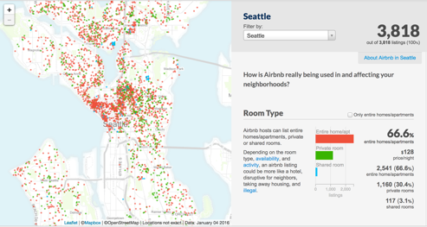We are located somewhat near Seattle, so, for our discussions, we’ll use the Seattle data. You are welcome to use whichever data set you find most interesting. The graphical visualization tool allows you to see several descriptive statistics for your chosen city, animate through the frequency and location of reviews, see top rated hosts, and much more.

## 

## Initial Exploratory Data Analysis:

Let’s explore some questions related to your particular city (These explorations are meant to increase in difficulty as you work through them).

### Exploration #2: You’re trying to budget your travel money. Give a *pracical* estimate for the daily prices of an Airbnb rentals in a particular neighborhood.

**Discussion:** There is a beautiful beach on the Puget Sound in the Alki neighborhood of Seattle. Let's filter the data to explore the prices of rentals from the Alki beach area. We'll start with some basic descriptive statistics: the average rental price there is $172 but the standard deviation is $97! The question in this exploration is best answered with a range of prices, and, based on the rather large standard deviation, the estimate will have a rather large range as well. If this data were normally distributed we would expect *most* of the rentals (~68% of them) to be withing one standard deviation of the mean: between $75 and $269. The large variance in the prices leads us to believe that there is more going on here. Let's create a data visualization to investigate further:

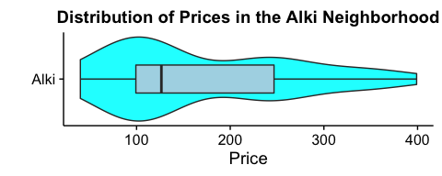

The plot above is called a violin plot. The curved shape tells us where 'clusters' of the data are located, while the boxplot tells us where the median and quartiles are. We observe that this data does *not* appear to be normally distributed. In fact, a relatively low concentration of the rentals in the Alki neighborhood are near the mean price; many are between $40 and $100 away from the 'center'. You may want to investigate the types of rentals in this data, or perhaps, their distance from the coastline to figure out what is creating this interesting shape. In addition, if we want to use prices in this neighborhood as part of some further analysis, we might consider performing a variable transformation. Since the prices here are all greater than zero, bimodal, and fairly "right skewed" a square root or log transformation might prove useful for further analysis.

### Exploration #3:Do you wonder if hosts with cleaner rentals charge more? Here is a more specific question: is there a significant difference between the daily price of the *cleanest* rentals verus the *least clean* rentals?

**Discussion:** The first order of business in this exploration is to decide what *cleanest and* least clean* mean to us. The cleanliness rating scale goes from 0 to 10, but we shouldn't assume that cleanliness ratings are evenly distributed among these numbers, or even that the numbers 0-10 represent a linear progression of cleanliness. In fact, many travelers might feel guilty giving a low cleanliness rating, so we may expect the ratings to be artificially inflated. Having learned from our last exploration, this time let's look at a visualization of the data first. How about a scatterplot of cleanliness rating versus price?

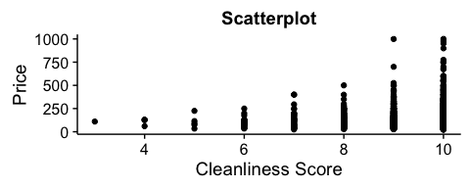One problem with this graphic is that the dots we've plotted are likely hiding the very information we want! We assume that every dot we see represents one rental, but there may be places in this scatterplot where many dots all landed on top of each other.

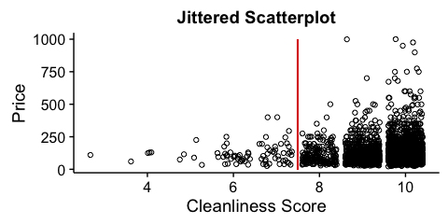One option is to add a ‘jitter’ to our graphic, so that we can see all (or, at least, more) of our points, which will help us get a sense about where our clusters are.

The jittered scatterplot suggests that 7 might be a good *cut-off* value for separating clean and unclean rentals. Notice that the sample sizes are wildly different: 80 rentals with lower cleanliness ratings and 3,165 with higher ratings. It *looks* like the rentals rated higher for cleanliness get better prices, perhaps with a few outliers. However, our scatterplot dots are still so clustered that it makes it hard for us to see what's going on. Let's try a side-by-side violin plot. In this case, we've added a log-scale to the price variable, to make the shapes easier to see.

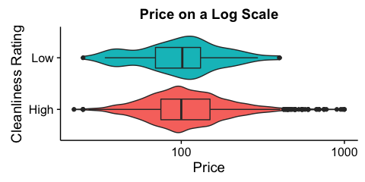We see that actually, the bulk of the rental prices for *both* High and Low ratings are centered near $100, but the high rentals have some 'outlier' observations with much higher prices. On the whole, though, the average rental price in either category doesn't appear to be drastically different. If we conduct a statistical $t$-test on two means, we come to roughly the same conclusion (with a p-value of about 0.23), so there doesn't appear to be strong evidence of a difference in price between the two groups.

### Exploration #4: I want to be safe and allow myself an out in case my travel plans fall through, but I still want to have several Airbnb rentals to choose from. Is there a difference between the proportion of rentals in one neighborhood that have a strict cancellation policy as compared to the rentals in another neighborhood?

**Discussion:** Lets say that we want to stay on the waterfront in Seattle so we’ll compare Alki beach and Belltown, both of which are on the water.

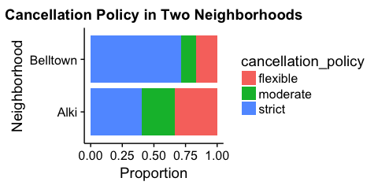The visualization above shows us the distribution of cancellation policies in the two neighborhoods, and a statistical test on the difference of the proportions of *strict* policies in each neighborhood gives us a p-value much less than .01, and we conclude that there is evidence to suggest that rentals in Belltown have a much stricter cancellation policy than those in Alki. The safe bet seems to be Alki, but if we want to spend our social time in downtown we now need to consider the transportation costs.

### Exploration #5: Now I'm considering inviting some friends on my trip, but first I want to know: For each additional bed, how much more should I expect a rental to cost?

**Discussion:** Let's start with a visualization of our data points in a (jittered) scatterplot and a contour plot showing which combinations of number of beds and rental price occur most frequently.

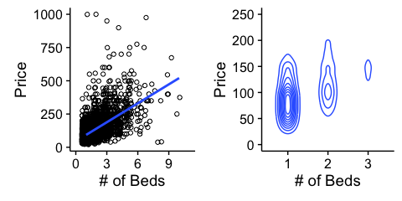

A simple linear regression tells us that the best-fit line for our data is approximately

$$Price in \$=\$46+\frac{\$47}{bed}⋅\left(\#of beds\right),$$

so, I should expect to pay about $93 for a rental with one bed and $47 more per additional bed. You might next want to try find a 95% confidence interval for the true slope (marginal price) of this regression line. What about a 95% confidence interval for the average price of rentals with 3 beds? What about a predicted interval for the *actual* price of a rental with 3 beds? (How are these questions different from each other?)

## Moving Beyond the Basics:

In this section we pose more questions and leave the investigations open to you. If you would like to see how we answered these questions wth the Seattle data, you can visit our workfile at mathquest.carroll.edu/AirbnbExplorations/. Several of these exercises suggest more advanced techniques, such as multiple regression, logistic regression, or machine learning techniques to answer. A good idea for each of the following explorations would be to split your data into a training and a test set so that you can test your predictions on data that your model has not seen.

As you work on these explorations consider the following questions:

* Which variables turn out to be the most important? The least important?
* Are there any variables that amount to just 'noise' in this analysis?
* How reliable do you think your model is?
* Do you think this same model would work in other regions of the world? Why or why not?
* Do you think it would be necessary to pre-process that data in any way?
* Do you think that the variables should be transformed in any way?
* Do you think any additional features should be included in your data (e.g. the square of a feature, the product of two features, etc)?

### 

### Exploration #6: What variables in this data set do you think would be the most useful in predicting the price of a particular rental? For example, try accommodates, beds, bathrooms, guests_included, review_scores_rating, and dummy variables for various neighborhoods, and see if you can build a model (maybe a multiple regression, regression tree, or artificial neural network) that is good at predicting prices.

### Exploration #7: Can you use the data to predict whether a rental is an "Entire home" or a "Private room"" based on the other characteristics of that rental? What variables in this data set do you think would be the most useful to you? Try using the same variables as in the last exploration (including price) to build a model?

### Exploration #8: Can you use the data to predict which neighborhood a rental is in based on other characteristics in the data? Pick three or four neighborhoods which contain "many" rentals and keep only data from these neighborhoods. Can you build a model (maybe hierarchical clustering, k-means, or something else) which can predict which neighborhood you're in, based on certain *important* variables? Which variables do you think you should use? Do you think using latitude and/or longitude is like cheating? How well does your model work?

## Conclusions:

## Recently, the field of data science has become a successful and popular way to analyze data like the one presented in this article. If you want to learn more about this field, there are starter courses on the web (e.g., Coursera and DataCamp) and many universities and colleges around the world are implementing data science programs. As you may have discovered in the last three exercises, the level of mathematical sophistication associated with data analysis can be quite high, so if you find the data-driven problems interesting, then we recommend taking more courses in statistics, computer science and computational mathematics! For, as Jennifer Pahlka, Founder and Executive Director for Code for America has said: "[o]ur ability to do great things with data will make a real difference in every aspect of our lives."

Many data sets like the one we've considered here are available for free online.  
For example, some of our favorite places to find interesting (and real) data are

* data.gov
* kaggle.com
* archive.ics.uci.edu/ml
* Quandl.com
* gapminder.org
* flowingdata.com