Math-o-mir brief guide, v2.0

Welcome to a brief guide to Math-o-mir software. This guide will introduce you to basics of math typing.

The software natively runs under Microsoft Windows. The installation program, MOMsetup.exe, will install the software on your computer. It will take about 1.5MB from your disk space (Note: the software can also run from an USB stick if needed; the installation is not really necessary.)

The main window

When started, the main window opens in less than 2 seconds (making me proud). Here you can see the Math-o-mir main window. I labeled certain regions.

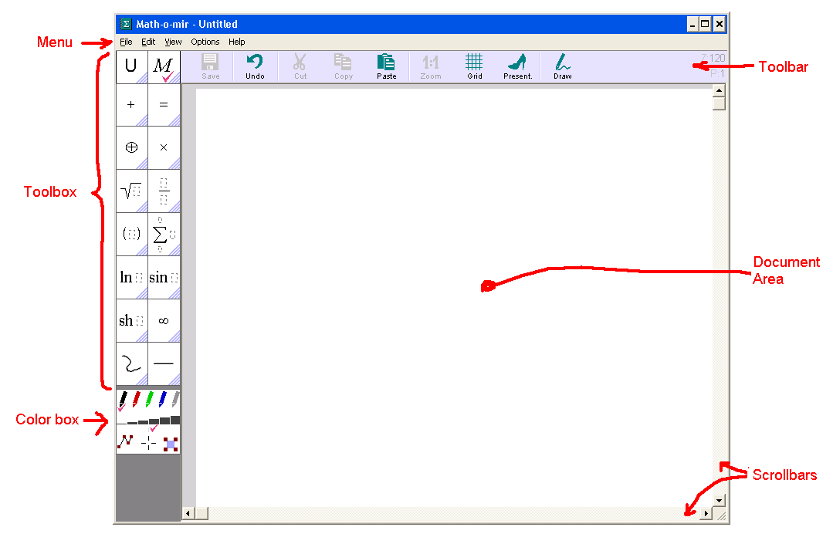

The Toolbox contains math elements. If you hold your mouser pointer above any of its options, a Subtoolbox with more options will open… On the next page you can see a picture detail with a Subtoolbox that opens when mouse pointer hovers above the summation sign.

Just below the color box, a simple help text can be shown if the mouse pointer points to a Toolbox / Subtoolbox / Color box item. This help text may contain a reminder how to produce that particular symbol or action using keyboard.

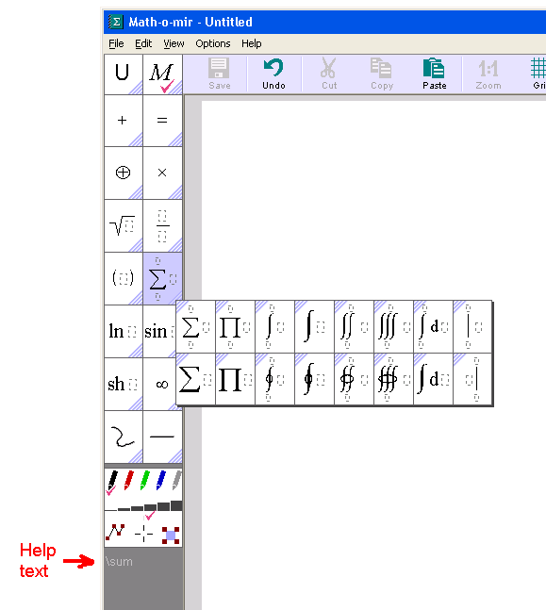

Remember: For efficient math-typing you should not visit the toolbox often. Instead you should learn to type common symbols by specific keystrokes.

Few words about your mouse pointer

The mouse usage is elaborate. For example, you can pick up math elements and expressions anywhere from your document or from the toolbox, carry them around and place them down into other expressions... The mouse pointer shape will reflect actions that you are currently doing:

White arrow | This is the starting, neutral mode to start various actions.
Black arrow (carrying) | When you carry (tow) some stuff (e.g. a math expression) with your mouse. You can place the stuff down by left-mouse-click.
Heart-shaped arrow (typing) | When the typing mode is active – the blinking keyboard cursor should be visible somewhere and you should be able to type.
  Pencil arrow (drawing) | When a hand-drawing tool is selected and you are ready to make some drawings.

Whatever you do with your mouse, you can always reach the ‘white arrow’ state by hitting the Esc key (once or few times) or by right-mouse clicking on the empty document area. In Math-o-mir the right-mouse click on empty document area will almost always have the same effect as the Esc key - aborting the current action.

Our first equation

To type something, we first must start the typing mode - to do this just mouse-click anywhere on the document area. Here is what you can expect to happen:

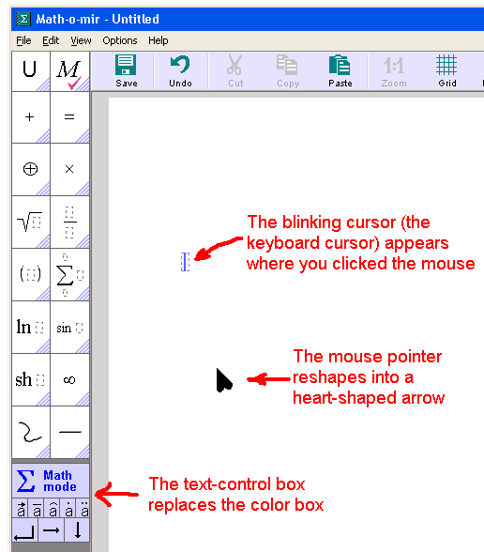

Observe that both, the blinking cursor and the text control box are of blue color. This means that math-typing mode is active (if you see them green, then the text-typing mode is active).

As we now have the blinking cursor, we can just type: F = m a

You typed your first super-simple equation. From here you can do several things:

- you can mouse-click somewhere else to start another equation on another place
- you can hit the Enter key to start another equation just below this one
- you can use arrow keys to move the blinking cursor around your document
- you can hit the Esc key or right-mouse click anywhere on the empty document area to end the typing mode (the mouse pointer will revert to the white arrow)

Typing plain text

Before we continue to more complex math, I want to first show you how to type plain text, that is, how to switch between math-typing and plain-text-typing modes.

Start the typing mode (by mouse clicking somewhere on the document area, as explained in the previous chapter) and then hit the Alt+Spacebar (or Spacebar+Enter or double-backslash) keystroke. Two things should happen:
- the blinking keyboard cursor line will become green
- the text-control box will become green
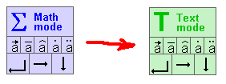

The green color represents the text typing mode (while the blue color represents math typing mode). As we now have the green blinking cursor we can type any text:

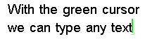

The plain-text may be written with different font than when you are typing math. Also notice that if you press the Enter key while typing plain text, the text line will be warped (while when you type math, the Enter key will create new object below the current object).

Here is the deal: you can toggle between math-typing mode and text-typing mode by using the Alt+Spacebar keystroke (or by Spacebar+Enter. whatever suits you better).

Example:
[spacebar] T h e [spacebar] f o r m u l a[Alt+spacebar] F = m a [Alt+Spacebar] i s [spacebar] c o o l .
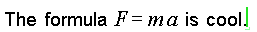

(In the above example the first spacebar can switch into the text-typing mode because the object is still entirely empty. But later we had to use Alt+Spacebar to make the switch.)

There are other ways to begin typing a plain text. I will name a few:
- If you started an entirely new object (if the object is still entirely empty), then you can just hit the Spacebar key (instead of Alt+Spacebar or Spacebar+Enter). In my opinion, this is the handiest method to start typing a plain text.
- You can use double-click (instead of just simple mouse click) at empty document area.
- If you start typing plain text vigorously into an empty math object, the software will understand and will automatically switch into text typing mode. I find this handy.

Typing Greek symbols

I don’t have to worry any more that you will accidentally switch into the text-typing mode (if you do, you will know how to use Alt+Spacebar to return back into the ‘blue’ math-typing mode).

Greek symbols are best typed by double-stroking. For example to type the Greek alpha character, you should quickly double-stroke the letter ‘a’ on your keyboard; so let try with: aa + bb = DD
You have to double-stroke relatively fast – within one second. If you are slow when typing the ‘aa’ sequence, then instead of the alpha symbol you will just get the ‘a’ two times.

An alternative way to generate a Greek symbol would be by typing a command like \alpha and then hitting spacebar or enter or some math operator. Therefore, the above example can be generated by using: \alpha + \beta = \Delta [spacebar]

Exponents and indexes

To type a simple exponent use Alt+something keystroke. For example Alt+2 should generate square. Let’s type: E = m c [Alt+2]

The ‘c’ in the above formula got squared. You can hold down the Alt key to type more complex exponents - as long as you keep the Alt key down, you will type into the exponent.

But to type complex exponents, it may be handier to use the ^ key instead. For example we could type: e ^ i pp [Enter] = - 1

By using the ^ key we created the exponent box where we can freely write any expression. We then used the Enter key to exit the exponent and continue typing on the main equation line. Note that instead of the ^ key you can also use the “ key (double quotation mark). It is because on some keyboards the ^ key might act as an annoying ‘dead key’.

Indexes (indices) are typed in a very similar way, only except Alt+something, you should use Spacebar+something. For example: R [Spacebar+1] = R [Spacebar+2] + R [Spacebar+3]

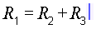

Again, you can instead use the _ key (underline) to create an index box where you can write the index without need to hold down the spacebar key.

Typing fractions

There are two ways to type a fraction. One method is to first generate a fraction line, and then type the numerator and the denominator. Hit the ‘/ ‘ key twice (double slash) to generate the fraction line. For example: F = G / / m [spacebar+1] m [spacebar+2] [Enter] r [Alt+2] [Enter]

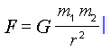

In the above example we generated the fraction using the double slash. The cursor was automatically placed into the numerator. After finishing with the numerator, we used the Enter key to quickly transfer the cursor into the denominator.

The second method to type a fraction may be handier for fractions that have simple numerators. You first type the numerator and then you use the # key to put the fraction line under the numerator. For example: I = U # R [Enter]

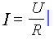

In the above example, when we typed the # (hash) key, the last typed character was sucked into the numerator. But we could type the # key more times to suck in more characters. For example: N a + b # # # 2 [Enter]
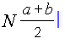

I would suggest you to get familiar with both these methods of fraction typing. Instead of # key you can also use the grave accent key (handy on US keyboards).

Casting commands and using quick sequences

As you type, you can cast a command to instruct the software to insert particular symbol or to do some other action. To cast a command, you start it with the \ (backslash) key and you execute it by hitting the Spacebar key, the Enter key or any math-operator key (like + or -). Example: A \oplus [spacebar] B = C

For example, to change the text color to red, you can cast the \red command. To convert the text to a headline you can use \h1 or \h2 or \h3 commands. Some interesting commands to insert various symbols are: \sqrt, \root, \angle, \emptyset, \sum, \int, \iint, \oint, \d, \par, \dd, \parpar, \case, \exists, \forall, \elm, \therefore, \because, \nabla, \delta, \times, \cap, \cup, \perp, \parallel, \mapsto, \mid, \propto, \approx… If you know the LaTeX, you already noticed that many commands are just the same.

Many symbols can also be generated handier way by using keystroke sequences or keystroke combinations. For example, if you type plus sign and then minus sign, the sequence will be converted into the plus-minus sign. Here is the partial list of quick sequences:

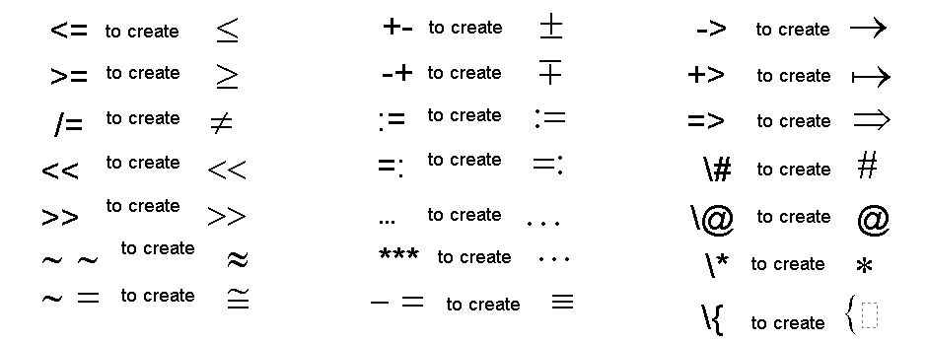
Note: the @ key is always converted into the infinity symbol; the * key into the small dot (the multiplying dot). Pressing Ctrl+X, the ‘times’ symbol can be created. Arrows can be generated by Alt+arrow keystrokes… Also try: AA (for all), EE (exists), UU (union), II (parallel), TT (perpendicular), MM (mid), BB (bullet)… NN, ZZ, RR, KK, CC…

Typing functions

You might be tempted not to use functions. You may decide that it is easier just to type things like:

In the above example the ‘f’ was not entered as a function, but just as a regular variable. To you it might look pretty much clear that the f() is a function, but to the software, due to math notation ambiguity, it is looks as if you wrote:

To make the software understand there is a function, the ‘f’ should be entered the special way. One way is by the backslash key (as when casting a command): \f ( x [Enter] = x [Alt+2]

To show the difference between a function and a variable, the software displays function names in a bit greenish color (also uses upright serif font).

Fortunately there is a more handy way to type common functions (such as: f, sin, cos, tg, tan, arcsin, sh, ch, log, exp, Re, Im…). Type the function name and then hit the dot (period) key. The dot key will generate the function, like in the following example:
s i n . 2 x [Enter] = 2 s i n . x [Enter] c o s . x [Enter]

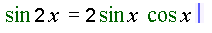

In the above example we generated a function three times. Each time we used the Enter key to exit the function argument.

Our first example can thus be typed as: f . x [Enter] = x [Alt+2]. Note that when you are creating multi-letter function names (like ‘sin’ or ‘cos’) parentheses will not be added automatically around the function argument; if needed, you can type them yourself.

Units of measurement

When you need to type a measurement unit, you hit the dot (period) key and then type the unit(s). For example: F = 1 0 . 3 . k g [Spacebar] m / s [Alt+2]

Measurement units are displayed in pale color to distinguish them from variables. The first dot in the above example is only used as the decimal point, but the second dot is used to start the entry of the measurement unit (if you type a letter after the dot, it triggers the measurement unit entry)

The letter ‘u’ can be converted to the Greek ‘mi’ symbol: l = 5 . u m

Tip: To make a degree sign, you can hit the ‘ (apostrophe) key three times after a number. To make degree Celsius, you can use ‘C (apostrophe-C) sequence after a number. To enter foots, I would suggest using the apostrophe (‘) key twice instead of the double quotation mark.

Typing multi-letter variables

By factory defaults, the software will prefer single letter variables. That is, if you just type abc, the software will generate three variables.

But if you really want to enter a multi-letter variable then you must start the entry with the apostrophe key and finish it with the Spacebar key or the Enter key or with any math operator key (like + or – or =). For example: ‘ t h i r d = ‘ f i r s t + ‘ s e c o n d [Spacebar]

If you are like me, you will forget to start a multi-letter variable with the apostrophe key. You can then help yourself by using Shift+Backspace keystroke. This keystroke will splice letters together, like in the following example: 1 + a b c [Shift+backspace] [Shift+backspace] + X

Differentials, Integrals, Summation

The dot key can be useful to quickly type several things – look at examples below:

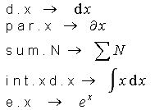

Note that if you use above methods to insert summation or integral signs, you can then immediately hit the underline key to insert/edit summation/integral limits.

Uppercase letters

To type capital (uppercase) letters and some other keyboard symbols you typically use a Shift+key combination. That is easy.

However in Math-o-mir you sometimes hold down the Alt key to type exponents or you hold down the Spacebar key to type indexes. This means that if you want to type an uppercase letter into an exponent you might end using Alt+Shift+key combination. Awkward!

In Math-o-mir, when you press a key and keep it pressed down for about half second, the symbol will turn itself into the uppercase variant. So if you type: y = x [Alt+n kept down]

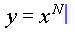

This surely slows down your typing, but can be useful to avoid using both hands.

Editing equations, making corrections

More or less, we now know how to type. But as we type we will make many mistakes and we will want to make corrections. The backspace key is our primary weapon to make immediate corrections.

But when you notice an earlier error, you might want to place the blinking cursor there and make the correction. The cursor can be moved by:
- Keyboard arrow keys – you can move the cursor within your current equation or drive it outside of the equation and then into another equation. That is, you can use keyboard arrow keys to drive the cursor all over the document. You will need experience to know the most efficient way to move the cursor across an equation.
- Mouse – point the mouse pointer between equation elements and click. The cursor will be moved there. (The ‘insertion point’ will be shown when you point the mouse pointer between elements – I will talk more about insertion points later in this document)

Working with keyboard selections

Using Shift+LeftArrow or Shift+RightArrow keystrokes, you can select (highlight) elements toward left or toward right from your current cursor location. The selected elements will be highlighted blue. For example: 2 n + 1 [Shift+Left] [Shift+Left] [Shift+Left]

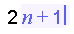

In the above example we typed the ‘2n+1’ equation and then we selected ‘n+1’ part by hitting the Shift+LeftArrow three times (of course, you may hold the Shift key down and only hit the Left Arrow key three times).

Once you have elements selected, you can use following keystrokes in order to:
- Ctrl+C – copy them (use Ctrl+V to paste them later)
- Ctrl+X – cut them (use Ctrl+V to paste them later)
- Backspace or Delete – delete them
- / (slash key) or # (hash key) or ` (grave accent key) – put the fraction line under them
- 0…9 (number keys) – put them to the power
- ( or [ or { (parentheses keys) – put parentheses around them
- R (red), G (green) – changes the color of selected objects
- B (bold), I (italic), U (underline), O (overline), S (strikeout)
- C – puts restriction line after them
- Enter – opens popup menu with additional options

Using mouse: touching

Touching (highlighting) math elements and expressions is an art on its own. When you move the mouse pointer over an equation you will see various parts of it being highlighted as you are touching them. Here are examples:

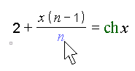 | Here the mouse is pointed at the ‘n’ variable in the fraction denominator. The variable is touched.
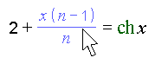 | Here the mouse is pointed at the fraction line. The whole fraction gets touched. (When you touch an element that contains other elements, they all get touched)

If you hold down the Shift key while you are touching, you will be able to touch (highlight) more objects (multitouch) than you normally can by pointing your mouse arrow at one single spot. In the following example we highlighted (touched) objects by pointing at the ‘2’, then pressing and holding down the Shift key while moving the mouse pointer toward the fraction line.
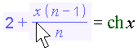
Multitouched elements have blue background hue… (Instead of holding down the Shift key while multitouching, you could mouse click at the ‘2’ and hold the mouse button down while sliding the pointer toward the fraction line.)

To recognize the best places where to point your mouse in order to touch certain equation elements you should get some experience.

Once you have elements touched you can pick them up by a mouse click (better said, you will create a copy of touched objects) that you can then carry somewhere else. You can also use ‘long mouse click’ to cut the touched objects. Finally, with a right-mouse click you can open the pop-up menu with additional options that you can apply to the touched objects.

But there is one more thing. In addition to object and expressions, you can also touch ‘insertion points’. Insertion points are spaces between math elements. When touched, an insertion point will be represented by a thin blue (or green, for plain-text) vertical line.

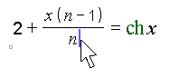
In the above example, the mouse pointer hovers above the insertion point that is placed just behind the ‘n’ element. If you mouse-click at a touched insertion point, the typing mode will start at this point (that is, the blinking cursor will appear at this insertion point and you will be able to type something there). You can also insert object that you carry (tow) with your mouse by clicking at insertion points – more about this in the next chapter.

Using mouse to edit equations

You must make difference between two cases:

- When the typing mode is active (that is, when the blinking cursor is present and the mouse pointer is heart shaped) – clicking at any math object (an element or expression within your document or an element from the toolbox) will immediately copy this object where your blinking cursor is placed (as if you typed it there).

- When the typing mode is not active (that is, when the mouse pointer looks like white arrow) – clicking at any math object (an element or expression within your document or an element from the toolbox) will ‘pick up’ a copy of this object and you will be able to carry it around and place it down, by another click, wherever you want.

Here is an example for the first case (the typing mode is active)… Let say we have some math already written and we are now typing the second line. The blinking cursor is placed just after the + sign:
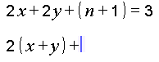

Now we point our heart-shaped mouser pointer to one of parenthesis from the first line (this will highlight the whole parentheses object) and we click. The parentheses object gets copied to the blinking cursor position immediately

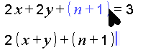

This is how you can quickly copy elements and expressions into the equation that you are typing. As said, you can click at an object or expressions within your document or within the toolbox.

Let also check a similar example for the second case (the typing mode is not active)… We have two math lines written. We then touch, using our white arrow mouse pointer, one of the parenthesis from the first line (the whole parentheses object becomes highlighted).

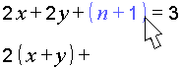

After we click, the highlighted object(s) is copied and picked up. The mouse pointer color will change to black and the object that we picked up will be seen towed around.

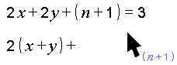

Using this black arrow you can now touch an ‘insertion point’ just behind the plus sign in the second line.
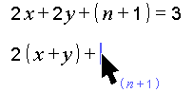

Finally, when the insertion point is touched, we can click it and the towed object(s) will be placed (inserted) right there. The mouse pointer arrow will revert to white color (as it is not towing anything anymore)

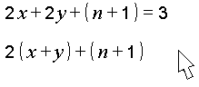
In the above example, we inserted the carried (towed) objects at the insertion point. It is also possible to place carried (towed) objects over existing objects in order to replace them. To do that use the same procedure, but instead of touching an insertion point with your black-arrow pointer, you should touch object(s) that you want to replace… and then mouse-click.

Handling fonts

Handling fonts in Math-o-mir is more elaborate than in a typical text editor. To deal with fonts, you can use two header options in the Toolbox (the ‘U’ and the ‘M’ options). There you can predefine eight uniform fonts (the ‘U’ option) and one mixed font (the ‘M’) option.

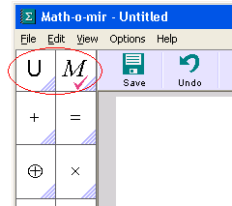

By clicking at any of these predefined font options it will become active. (note: it is also possible to define a keyboard accelerator to activate them but this is beyond the scope of this document.)

Uniform fonts are all familiar. The only new moment is that a uniform font can be declared ‘singleshoot’ – meaning that only one character will be cast in this font and as soon as you typed it, the previously active font will become active again.

The one mixed font allows you to define font casting for every character separately. You can for example adjust that whenever you type the letter F it will be cast bold-italic, while other characters will be cast upright-normal.

Even if the mixed font option is active, once you engage the text-typing mode (the green blinking cursor), the lastly used uniform font will become temporary activated for as long as the text-typing mode is active. The plain text just cannot be written with mixed font.

The moving dot

The moving dot is a small rectangle at the lower left corner of each equation in your document. It becomes visible when the mouse is pointing at the equation. It becomes black when the mouse is pointing at the moving dot itself.

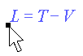
You can click-and-drag at the moving dot to move the equation around. Pointing at the moving dot is also the easiest way to touch (highlight) the whole equation.

Navigating your document

You can use your mouse wheel and scrollbars to scroll the document. You can also use PageUp and PageDown for the same. A way to precisely scroll the document is to use right-mouse-click-and-drag action.

To zoom in or zoom out you can hold down the Ctrl key (or the right-mouse-button key) while using the mouse wheel. You can also use F2 and F3 keys.

You can right-click at the vertical scrollbar to display your document in the tiles view (click at a tile to jump at the location).

Adding space for more equations

If you point your mouse pointer very near the left edge of the document area and hold it steady for 2-3 seconds, the vertical ruler will appear (a thin yellowish ribbon with a scale). You can click and drag-down at the ruler to add more space between your equations so that you can squeeze in some more math.

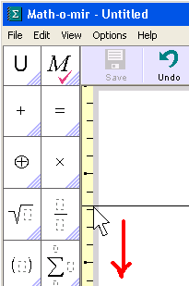

Hand drawing

Hand drawing tools can be found at the bottom of the toolbox. When you select any, the mouse pointer arrow will change into pen shape and you will be able to draw over your document.

Details are beyond the scope of this manual. Just one tip: I suggest you to learn how to edit drawing nodes because it is difficult to draw with mouse and you will need to make corrections often. To enable node editing, check the bottom-left option in the color box window.

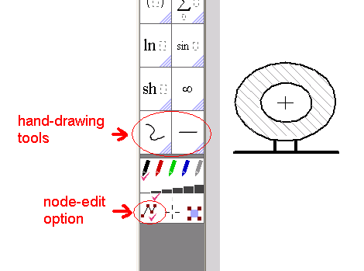

Note: to draw a horizontal/vertical section line or to draw a curly bracket (both things often drawn by mathematicians) you don’t even need to select any drawing tool. Using your normal mouse pointer just click-and-drag as if you want to paint a horizontal/vertical line or a very thin rectangle. The rectangle will contain either a pale-colored line or bracket. If you stop moving your mouse for a short while (still holding down the mouse key) the line/bracket will become darker – you can then release the mouse button and the line/bracket will appear.

What is it I did not even mention?

Toolbox customization  Keyboard accelerators  The presentation mode  Page numbering  Working with mouse selections  Grid and guidelines  Context menu types and options  The ‘Variable mode’  Decorating variables (with overhead symbols)  The Autocomplete functionality | The Quick Type feature  Labels and Hyperlinks  Editing tables and matrices  Symbolic computation issues  Description of menu options  Hand-drawing details  The Drawing Box  The Function Plotter  Document management  Making electronic exams  … more …

If you are interested to learn everything, a much more voluminous book “Math-o-mir users manual” exists. Look for it on the internet.

Contact and additional help

You can contact me by mail: danijel.gorupec@gmail.com

Do not hesitate to ask any question.

Danijel Gorupec, 2017.

