Math-o-mir user’s manual
v2.0

Kick Start in 4²/₂ examples! 3
Welcome to the Math-o-mir users manual 9
The main screen layout 9
The closer look at the Toolbox 10
The closer look at the Toolbar 12
The closer look at the document area – the document navigation 13
The Presentation mode vs the Edit mode (and the art of printing) 15
Page numbering 16
Handling your equations with mouse 17
Touching expressions and expression elements 17
Touching insertion points 19
The ‘newline’ insertion point 20
Pick-up, Carry and Place-down action 21
Pick-up 21
Carry 21
Place-down 22
The moving dot – moving objects around document 24
Working with selections 24
Adding to a selection 25
Deselecting a single object 25
Select/deselect using the Enter key 25
Drawing lines and curly brackets 26
Vertical spacement – making space for more equations 27
Grid and Guidelines 28
The Right Mouse Button 30
The Context Menu 30
Using Keyboard in Math-o-mir 33
Starting and ending the Typing mode 33
The Math/Text mode 34
The Variable Mode 34
Handling fonts 35
Nuts and bolts of math typing 38
Shortcuts and keystrokes 38
A distinctive detail on keyboard cursor position 40
Entering multi-letter variables when single-letter ones are preferred 41
Entering Greek symbols (α, β, γ, δ …) 41
Entering indexes 42
Entering exponents 43
Entering fractions 45
Entering commands 46
Entering functions 46
Entering units of measurement 48
Entering “decorated” variables 50
Typing multi-line equations 50
Writing plain text in Math-o-mir 52
Mixing math formulas and plain text 53
Editing with keyboard – cut, copy, paste 54
Keyboard Implanting 56
What is the Enter key used for? 57
What is the Dot (period) key used for? 58
The Autocomplete 58
Advanced keyboard examples 59
Finely adjusting position of the equation you type 63
Using the mouse while the Typing mode is active 63
Using the quick-type feature 64
The Main Menu 65
The File menu 65
The Edit menu 65
The View menu 66
The Options menu 66
The Help menu 67
Exporting equation images 68
Headlines, Labels and Hyperlinks 69
Matrix (table) editing 71
Matrix editing with keyboard 73
Adding borderlines to tables/matrices 74
Hand drawing 75
Adding line endings 77
Editing nodes 78
Specific modifications of basic drawing shapes 78
Stretching and rotating 79
Grouping and combining 79
Predefined drawings 80
List of keyboard functions useful when drawing 81
Drawing boxes (technical drawings) 82
Symbolic computation 85
Options in the context menu 86
Using symbolic computation with keyboard 87
What can Math-o-mir calculate? 87
Function Plotting 89
How to plot a function? 90
How to write a proper function 91
Managing documents 92
Usage in math classroom – Math teachers read here! 93
Making math exams with Math-o-mir 93
Where to search for additional help 96

Kick Start in 4²/₂ examples!

Several examples are given to explain how to type equations in an efficient manner. Here we assume that default settings are used.

EXAMPLE 1: We want to write the famous: E=mc².

STEP 1 – Mouse-click anywhere at the document area

Click anywhere at the empty area. The following should happen:
- the blinking cursor will appear (a vertical blue blinking line)
- the mouse arrow turns into a black heart-like shape
this tells you that the Typing mode is now active.

Move that black ugly mouse pointer away, not to block your view. We will use keyboard.

STEP 2…5 – On your keyboard type: E=mc

As you click a letter, it appears on the screen and the blinking cursor moves to the right.

STEP 6 – On your keyboard make the following keystroke: ALT+2

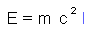

By pressing the ALT+2 keystroke, you squared the ‘c’.

In Math-o-mir, one way to type exponents is by holding down the ALT key as you type. See more here…

STEP 7 – Press the ESC key to exit the Typing mode

The blue blinking cursor will disappear, and the mouse pointer will revert to the healthy white arrow.

With the ESC key you immediately exit the Typing mode. Another way to exit the Typing mode is to right-mouse-click anywhere at the empty document area.

EXAMPLE 2: We want to write: s=1/2 x (Concentrate on steps 4...8)

STEP 1 – Mouse-click anywhere at the document area

The Typing mode starts.

STEP 2,3 – On your keyboard type: s=

STEP 4 – On your keyboard type the slash key, twice: //

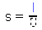

In Math-o-mir, two slashes are automatically converted into the true fraction. The blinking cursor will automatically move into the numerator. The denominator will show an empty box.

STEP 5 – On your keyboard type: 1

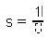

STEP 6 – On your keyboard press the ENTER key

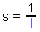

The cursor moved into the denominator. The Enter key can be used to quickly move the cursor to the next logical entry point. The next logical entry point might be an empty box within the same element (as in this example), or it might be the position just behind the current element (see Step9 below).

A more general way to move the cursor around your equation would be by using keyboard arrow keys (up, down, left, right). For example, instead of the Enter key, here we could hit the arrow-down key twice to move the cursor into the denominator.

STEP 7 – On your keyboard type: 2

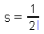

STEP 8 – On your keyboard press the ENTER key

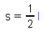

The blinking cursor is moved to the baseline again. [You could use arrow-right or arrow-up keys to achieve the same.]

STEP 9 – On your keyboard type: x

STEP 10 – Press the ESC key to exit the Typing mode

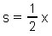

EXAMPLE 2, again: We want to write: s=1/2 x (Concentrate on steps 4 and 5)

This time we will use a faster method to enter simple fractions.

STEP 1 – Mouse-click anywhere at the document area

The Typing mode starts.

STEP 2,3 – On your keyboard type: s=

STEP 4 – On your keyboard type: 1

STEP 5 – On your keyboard type the hash key: #

The fraction was created. The number one is moved into the numerator, while the cursor is moved into the denominator.

With the # key (or, alternatively, the grave accent ` key) you can insert the fraction line ‘under’ the last typed element. You can, in fact, hit the # key more than once to ‘suck in’ more than one element into the numerator.

STEP 6 – On your keyboard type: 2

STEP 7 – On your keyboard press the ENTER key

STEP 8 – On your keyboard type: x

STEP 9 – Press the ESC key to exit the Typing mode

EXAMPLE 3: We want to write: 2 + sin π + 2 (Concentrate on steps 4...7)

STEP 1 – Mouse-click anywhere at the document area

The Typing mode starts.

STEP 2,3 – On your keyboard type: 2+

STEP 4 – On your keyboard type the following command: \sin

While in Typing mode, you can cast some commands. Every command starts with the backslash character. Examples are: \sin, \cos, \tg, \sqrt, \ln, \int, \sum, \infty, \kg... Using a command, you instruct Math-o-mir to insert specific symbol, function or a measurement unit.

A command is executed by pressing the space bar or the Enter key (see the next step).

STEP 5 – On your keyboard press the Space Bar (or the ENTER) key

By pressing the Space bar or Enter the command is executed. Math-o-mir inserted sinus function and moved the cursor into the function argument box.

STEP 6 – On your keyboard rapidly hit the ‘p’ key twice: pp

Rapid double letter sequences (within a second) are converted to Greek symbols. For example ‘aa’ sequence is converted to the Greek alpha character. ‘GG’, for example would be converted to uppercase Greek gamma (Γ).

STEP 7 – Press the ENTER key (or press the right-arrow key)

Surprise! Why did we have to hit the Enter key? Because we wanted to move out of the sinus function argument! Now our blue blinking cursor is back on the main course. If we continued typing ‘+2’ inside the function argument, we would get the following:

Notice that while the cursor was still inside the function argument, the Math-o-mir framed the function argument with dashed gray line. This can help you understand where exactly your cursor is placed.

STEP 8 – On your keyboard type: +2

STEP 9 – Press the ESC key to exit the Typing mode

EXAMPLE 3, again: We want to write: 2 + sin π + 2 (Concentrate on steps 4, 5 and 7)

This time we will use the dot (period) key to create the function. This is a faster method than the command entry method and is a preferred method to enter known (common) functions.

STEP 1 – Mouse-click anywhere at the document area

The Typing mode starts.

STEP 2,3 – On your keyboard type: 2+

STEP 4 – On your keyboard type: sin

STEP 5 – On your keyboard hit the dot (period) key: .

By pressing the dot key, Math-o-mir examines several last letters that you entered, and if it looks like a common function name, it creates that function. Otherwise, if no common function name is recognized, it only converts the single last letter into a single-letter function (for example ‘f.’ will be converted to the f( ) function).

STEP 6 – On your keyboard rapidly hit the ‘p’ key twice: pp

STEP 7 – Hit the plus key twice: ++

Using the ‘+ +’ sequence, the plus operator was inserted outside of the function argument. In the Math-o-mir you can use the ‘+ +’, ‘- -‘, or ‘= =’ sequences as a faster way to type ‘Enter +’, ‘Enter –‘ or ‘Enter =’ sequences. [ Tip: every so often you will forget to hit the Enter key to exit the function argument and thus you will mistakenly type a ‘+’ (or ‘-‘ or ‘=’) operator inside the function argument. Instead of using the backspace to delete that operator, you can just type it once more to move it outside function argument. ]

STEP 8 – On your keyboard type: 2

STEP 9 – Press the ESC key to exit the Typing mode

EXAMPLE 4: We want to write: (x+y)sqrt(2) (Concentrate on steps 2...5)

STEP 1 – Mouse-click anywhere at the document area

The Typing mode starts.

STEP 2 – On your keyboard type: (

When you type in the left bracket, the Math-o-mir inserts the parentheses object and moves the cursor inside it.

STEP 3 – On your keyboard type: x+y

STEP 4 – On your keyboard press the ENTER key

Cursor moved outside parentheses. Instead of Enter, you could also hit the right-arrow key or the ‘)’ key.

STEP 5 – On your keyboard make the following keystroke: CTRL+R

By pressing CTRL+key, an accelerator is activated. By default, the CTRL+R generates the square root sign.
[ You can freely define accelerators for any toolbox item – right-mouse-click to toolbox item, and define the desired accelerator keystroke. You can then save your settings by choosing
Options->Save settings->Save as default. ]

[ Alternatively, instead of using the CTRL+R accelerator to insert square root sign, you could cast command \sqrt for the same purpose. ]

STEP 6 – On your keyboard type: 2

STEP 7 – Press the ESC to exit the Typing mode

Bravo!

If you understood above examples, then you are ready to use Math-o-mir.
More advanced examples here…

Welcome to the Math-o-mir users manual

Here you will learn basic moves to deal with the Math-o-mir software. But first, what is Math-o-mir good for? It can be useful to engineers, students and other people that want to make quick, informal mathematical analysis of some problem. I like to say that Math-o-mir main competition is ‘pencil and back of an envelope’. Although writing math in Math-o-mir is certainly not that simple as with pencil, there are tools in Math-o-mir that can justify the initial effort.

The main screen layout

The main screen layout is quite simple - the main menu and the toolbar above, the toolbox to the left, while the rest of the screen is the document area. The overall look is intentionally made humble because Math-o-mir is only a notepad intended for quick, informal math.

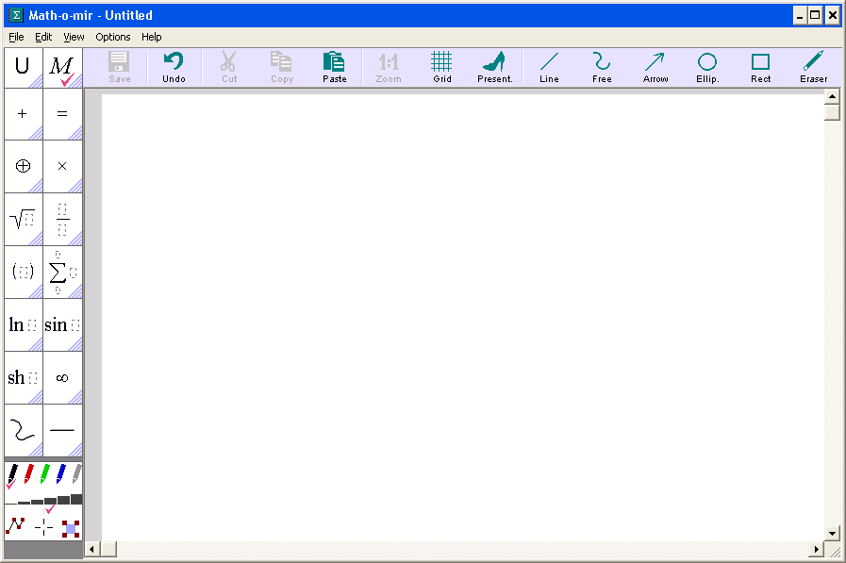

The closer look at the Toolbox

The left-side-toolbox has its ‘header’ part - those two ‘U’ and ‘M’ fields that are used to activate different fonts. The rest are math ‘building blocks’ that you can put into your document and hand-drawing tools. To pick-up any math item or to select any drawing tool, simply click at it… Just below the toolbox, there is also the color box where you can choose colors and line widths when are using drawing tools.
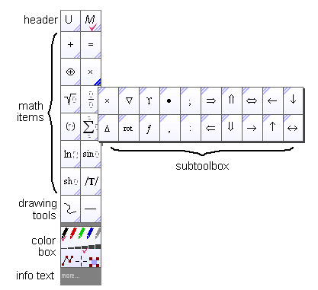
If you hover a mouse pointer above a toolbox item for some time (<1sec), the corresponding subtoolbox containing additional items will open. You can also click at the shadowed triangle area at the bottom-right corner of any toolbox item to open its subtoolbox instantly. (To close an opened subtoolbox, simply move the mouse pointer far away from it or hit the Esc key.)

Note: every item in a subtoolbox has a shadowed triangle area at the upper-left corner. A click on it will transfer the associated subtoolbox option into the main toolbox for easier subsequent access. This way you can arrange your toolbox to some extent.

Keyboard accelerators – a fast ways to access toolbox items

You can right-click at any toolbox or subtoolbox item to open the accelerator pop-up menu.

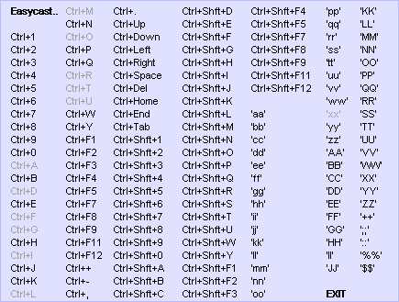

From this pop-up menu you can associate an accelerator keystroke to that particular item. There are three types of accelerators.
- CTRL+ accelerators
- Double-stroke accelerators
- Easycast accelerators

The CTRL+ accelerators always use CTRL+key or CTRL+SHIFT+key combinations. The advantage is that CTRL+ accelerators can be used even while you are typing a plain text, or even if the Typing mode is not active at all. Further advantage is that you can associate CTRL+ accelerators even to drawing tools or fonts. To associate a CTRL+ accelerator, just choose the desired combination from the popup menu.

The double-stroke accelerators work only while you type math, not while you type a plain-text. Also, double-stroke accelerators are timed – you must double-stroke the key quickly in order to trigger the accelerator (<750 millisecond). To associate a double-stroke accelerator, just click at the desired double-stroke combination from the popup menu.

Note: double-strokes are by default used to enter Greek symbols. If you, for example, define the accelerator for the ‘dd’ double-stroke, then you will not be able to easily enter Greek delta letter any more. You will have to use the \delta command instead.

Note: CTRL+ and double-stroke accelerators that are already in use are displayed using somewhat pale text, but you can still choose them if you wish to redefine the accelerator.

The easycast accelerators work similar to the double-stroke accelerators, but you can define strokes freely. Also, easycasts are not timed so you can type them slowly. To define an easycast accelerator click on the the “Easycast..” option from the popup menu. A dialog box, similar to following, will open:
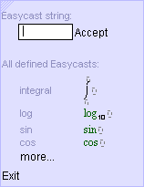

The keystroke sequence used or easycasts should be no longer than eight characters. Also, not all combinations are possible – for example if you already defined easycast sequence “sin”, then you cannot define the “sinus” or any other sequence that starts with “sin”. Neither can you define “si” sequence any more.

How to use easycasts? Suppose that you assigned “sin” easycast sequence to the sin() function in the toolbox. When you type your equations, whenever you type the “sin” on your keyboard, the sin() function will be inserted.

Customizing the toolbox

You can add new items into the left-side-toolbox. It may be that you use theexpression very often, for example. It takes time and effort to type down such an expression. Therefore, it would be handy if you could somehow keep that expression in the toolbox for easier access. This way you could even define an accelerator keystroke to it… You should do the following:

- Create the expression anywhere in the document area
- Click on it to pick it up
- Carry it to the toolbox (or subtoolbox)
- Right-mouse-click on the toolbox (or subtoolbox)

Note that new items are always appended at the end of toolbox/subtoolbox… In the picture below we appended the expression into the ‘square root’ subtoolbox. Sure, complex expressions cannot be displayed very clearly as the space is limited.

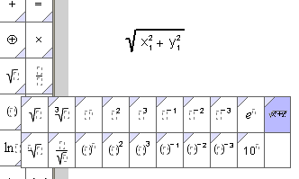

You can also insert hand-drawings into the toolbox using the same procedure. Just create a hand-drawing somewhere in the document area, pick it up and carry it to the (sub)toolbox – then right-mouse-click to drop it.

Note: The size of the toolbox can be changed by using “View->Toolbox and context menu” in four steps: small, medium, large and very large. In addition the ‘auto-resize’ option is available.

After you defined your toolbox look and feel, you can save its configuration by using the following option from the main menu: “Options->Save Settings->Save as default”. This way Math-o-mir will use the defined configuration every time you start it.

The closer look at the Toolbar

The top-toolbar can be used to quickly execute simple commands like save, cut, copy, paste… Note however that all options available from the top-toolbar are redundant and are also available by other means: from the main menu, from the side-toolbox, using keyboard shortcuts... Therefore, if you feel that the top toolbar steals too much of your screen area, you can remove it by unchecking: “View->Toolbox and context menu->Show Toolbar”

A disabled toolbar button is displayed in pale gray color and you cannot click it. For example, the ‘cut’ and ‘copy’ buttons will be disabled when there are no objects selected.

Some toolbar buttons are two-state, meaning that by mouse click you can toggle them between an active or an inactive state. In the active state such buttons will have the purple check-mark displayed. For example the ‘grid’ option can toggle between ‘grid-on’ and ‘grid-off’ states.

Due to restricted screen size, not all options are displayed all the time. The toolbar will automatically reconfigure according to the context:

- when the Typing mode is activated, the font size, text orientation, headline conversion and text-justification options might be present
- when some items are selected, alignment, group and mirror options might be present

The toolbar also reconfigures according to the main window width. If more width is available, some text options will be present even if the Typing mode is not active.

You can get the tooltip help text for any toolbox item if you hold the mouse pointer steady above it for some time (cca 1.5 sec).

The closer look at the document area – the document navigation

The document area is an endless space that has white and grayed regions. The white regions represent the paper sheets, but you can write your math even outside, on the grayed area. However, when you send your artwork to a printer, only the math within the white area will be printed.

The size and orientation of the white area (paper) can be adjusted using: View->Page menu.

Zoom-in and zoom-out

To zoom-in or zoom-out the document view you can use three methods:
- Ctrl key + mouse-wheel,
- right-mouse-button + mouse-wheel
- F2/F3 keys.

If you select ‘Options->Mouse->Mouse-wheel function: Zoom in/out’, then you will be able to use the mouse wheel for zoom (instead of scrolling) even without holding down the Ctrl key.

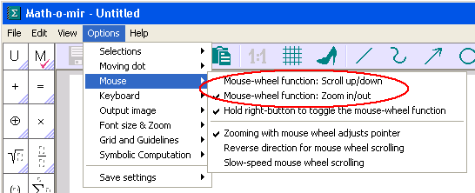

It is possible to use the F1 key to readjust zoom level back to 1:1. To make such F1 usage possible, you must check ‘Options->Keyboard->Use F1 to set zoom level to 100%’. By default, the F1 key is used to display the Handy Help.

Advanced - When you use the mouse wheel to zoom-in, you will typically first point your mouse pointer to the document area you want to zoom at and then turn the wheel. You can use the same trick even with the F2 key, but it will only work if you actually moved your mouse pointer shortly (one second) before the F2 key is pressed. Otherwise, if mouse pointer was not moved for a longer time, the F2 key will not respect your mouse pointer position while performing the zoom-in.

Scroll up and down

To scroll the view, you can use the mouse wheel (vertical scroll only), use scroll bars, or you can right-mouse click on document area and drag your mouse. You can even scroll the view by using keyboard arrow keys (only when the Typing mode is not activated) or PgUp/PgDown keys.

Note: even if you redefined the function of the mouse wheel to use it for zoom in/out, you can still use the wheel for scrolling if you hover the mouse pointer over the vertical scroll bar while rolling the wheel. Alternatively you can hold down the right-mouse-button while you are rolling the wheel (holding down the right-mouse-button temporarily toggles the mouse wheel function).

Note: you can change the mouse vertical scrolling speed and you can reverse scrolling direction by checking appropriate options from the Options->Mouse menu.

Quick document view and navigation

If you right-mouse-click at the vertical scrollbar, the Math-o-mir will show your entire document squeezed into little tiles. One tile represents a single page. This works best for documents up to 25 pages.
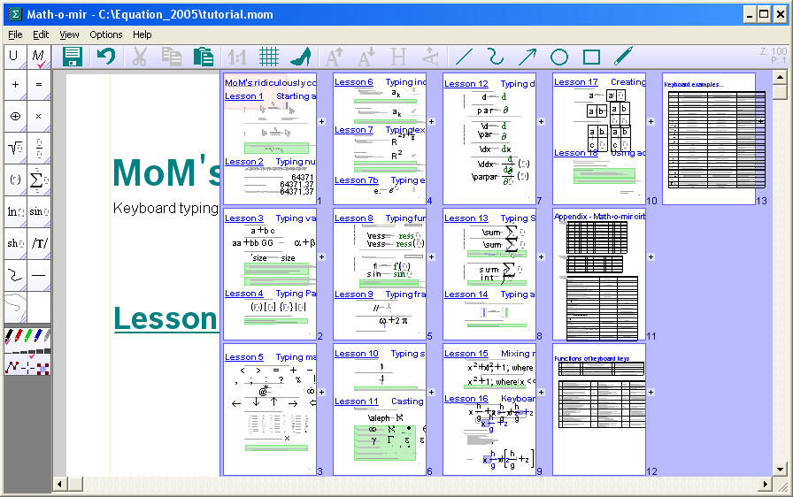

You can mouse-click at any tile to quickly move to that location. Or you can right-mouse-click (or hit the Esc key) to close the tiles view.

While tiles are shown, you can enlarge any tile by clicking at the ‘+’ sign. Note that within tiles, any headline text is displayed with unproportionally large font so that it can be read.

The Presentation mode vs the Edit mode (and the art of printing)

Your artwork can be displayed in any of two modes: the Presentation mode and the Edit mode. When you start the software, the Edit mode is active. To toggle between the Edit and Presentation mode, hit the F5 key, or use the “View->Presentation Rendering” menu option.

When the Presentation mode is active your equations will look better, but will be harder to edit. When the Presentation mode is active, you can even further improve the look of your equations by activating the Halftone rendering option: check the “View->Halftone Rendering”. Note however that the Presentation rendering, especially when the halftone smoothing is enabled, is CPU hungry and the software responsiveness might become unacceptable.

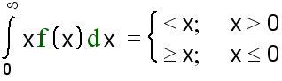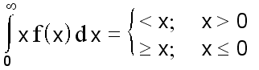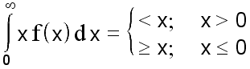

The above example shows the same equation displayed in the Edit mode (left), Presentation mode (center) and Presentation mode with halftone smoothing (right). Notice that in the Edit mode there exist more space between the integral sign and ‘x’ (also more space between the ‘dx’ and the equal sign) – because of such enlarged spacing, formulas are easier to edit in the Edit mode. Also, the Edit mode displays functions and differentials in a bit greenish color. Further, the integral sign and parentheses are simplified to gain faster screen refresh and thus better responsiveness.

If you are not specifically orientated to printing (publishing) your document, I suggest you that you do almost all of your editing in the Edit mode. It is very easy to toggle between Edit and Presentation mode by hitting the F5 key.

Still you can make basic editing of your equations in the Presentation mode and you will do this when you prepare your document for printing. In comparison to the Edit mode, the Presentation mode has one major advantage when it comes to printing – it keeps relative object sizes fixed providing better WYSIWYG experience. Take a look at following examples:

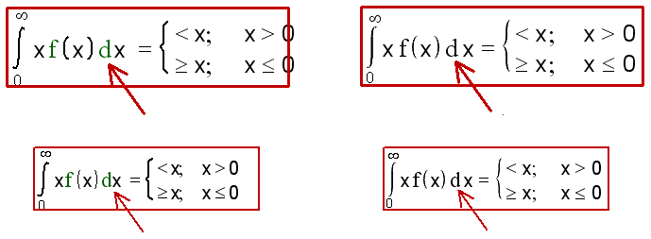

In the above 4 examples we have an equation that has some hand drawing objects drawn over it (the red rectangle and the red arrow). Two examples to the left show the Edit mode in two different zoom levels. As you can see, the relative size of the equation relative to the graphics is not kept constant – as a result, the arrow is not clearly pointing at the differential sign in the low-zoom example.

On the other hand, as it can be seen in two examples to the right, the relative size of the equation compared to the size of graphics is kept constant in the Presentation mode. It will also be the same during printing.

At a low zoom level the readability of text and equations in the Edit mode can be better than in the Presentation mode because the between-character spacing is optimized for reading (that is, inter-character spacing better matches the font size).

When you print at a high-resolution printer, you might obtain better result if you don’t use the Halftone rendering mode. The Halftone rendering is optimized for the display screen.

When you send your document to printer, it will be rendered in either Edit mode or Presentation mode, whatever is currently active. Take care to switch the mode (using F5 key) to one you prefer before you print the document!

Page numbering

Page numbering options can be found in the ‘View->Page->Page Numbering’ menu. You can choose from three different page numbering styles. You can choose the position of the page number – by default the page number is positioned at the top-center of every page. Finally, you can choose to leave the first page non-numbered.

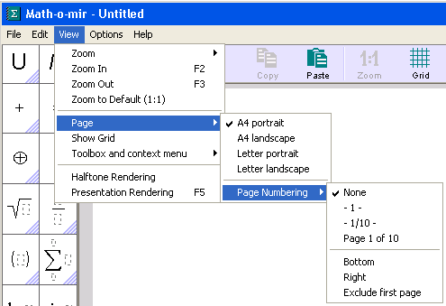

Note: Some numbering styles will show the ‘number of pages’ for the document. Because in Math-o-mir the number of pages is not strictly defined (a document has ‘infinite’ number of pages) the value displayed for the ‘number of pages’ equals to the last page that is not entirely empty.

Handling your equations with mouse

First, it is good to know about shape and color of mouse arrows (pointers).

- windows standard white – when mouse is in ‘free’ mode ready to start various actions

- windows standard black – when you carry something around with your mouse. The carried object is usually seen being towed by the mouse pointer.

- heart-like black – when the Typing mode is active. The blinking keyboard cursor, the blue vertical line, should be visible somewhere. Note that you cannot ‘carry’ anything with this pointer - as soon as you pick up anything, this will be transferred to where your blinking cursor is.

- pen-like white – when a hand-drawing tool is selected and ready for drawing

Anyway, the standard white mouse arrow is the beginning point in most examples here. If your mouse arrow looks any different, press the ESC key until it becomes white.

Touching expressions and expression elements

Suppose that you entered formula E=mc^2 using keyboard, and now you want to examine or edit it by mouse.
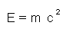

When you move (hover) your mouse pointer over the formula, you will notice that it reacts to it by changing color to blue. For example if you moved the mouse pointer above the ‘m’ letter, then the ‘m’ will turn blue – the ‘m’ is touched.

By pointing at the right spot, you can touch various parts of your expression. For example:

Touching what | Where to point mouse | Result
The ‘c’ variable | At the ‘c’
The ‘2’ exponent | At the ‘2’
The ‘c^2’ expression | Just below ‘2’, or just above ‘c’
The ‘=’ operator | Left half of the ‘=’ sign
The ‘=’ operator and everything after | Right half of the ‘=’ sign
The whole equation | Just below or just above the equation. Or at the ‘moving dot’
With experience, you will learn exactly where to point the mouse arrow to touch any desired part of an expression. Additional examples given bellow will speed up your learning process:

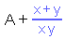 | Pointed at the fraction bar
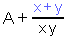 | Pointed just below the numerator expression (just above the fraction bar) or just above the numerator expression.
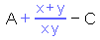 | Pointed at the right half of the ‘+’ sign. (Pointing at the left half of the plus sign would select only the plus sign itself).
 | Pointed at the bracket (either left or right)
 | Pointed just below or above the expression contained inside parentheses.
 | Pointed just below or above the expression, but in portion outside parentheses.
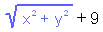 | Pointed at the square root sign
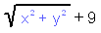 | Pointed just below or above the expression under the square root sign
 | Pointed at the sinus function
 | Pointed just below or just above the expression contained inside the sinus function argument (that is, just below or above the ‘πx’).

Multi-touching

You can also multi-touch. That is, you can touch several elements even if it is not possible to touch them by pointing mouse at one single point. You do this by holding down the SHIFT key or the left-mouse button while moving your mouse arrow over the equation. Look at the following examples:

 | Mouse is pointed at ‘b’, then the SHIFT key (or left mouse button) is pressed and held while mouse is carefully moved to the ‘d’.
 | Mouse is pointed at the ‘2’, then the SHIFT key (or left mouse button) is pressed and held while mouse is carefully moved to the ‘b’.
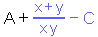 | Mouse is pointed at the fraction bar, then the SHIFT key (or left mouse button) is pressed and held while the mouse is carefully moved to the ‘C’.

Instead of holding down the SHIFT key when multi-touching, in most cases you can simply click and hold down the left mouse button key while dragging the mouse pointer over equation elements – that is, you can perform the click-and-drag over elements to touch them.

You can also use the quick multi-touch feature. To use it, you must right-click your mouse at an insertion point. To learn more about insertion points and the quick multi-touch feature, please read the next chapter.

Operations on touched element(s)

Once you touched some element(s), you can do several things:

- left mouse click – to ‘pick up’ the selection (if nothing was carried by the mouse)
- left mouse click – to replace the selection with whatever is carried by the mouse
- right mouse click – to display the context popup menu
- keyboard DEL key – to delete the selection
- keyboard CTRL+X keystroke – to delete and ‘pick up’ the selection
- keyboard CTRL+C keystroke – to ‘pick up’ the selection (the same as left mouse click)
- keyboard CTRL+V keystroke – to replace the selection with whatever is carried
- any keyboard character – to replace the selection with the typed character
- keyboard F9 key – copies the bitmap image of the selection into the windows clipboard
- keyboard F8 key – writes (saves) the bitmap image of the selection to hard disk.
- keyboard F6 key – copies the LaTeX code of the selection into windows clipboard

Touching insertion points

You probably noticed that when you point your mouse pointer in between elements, some thin vertical blue line appears. It is called the insertion point.

In the table below you see all the existing insertion points in the E=mc^2 equation:

In front of the ‘E’ variable (that is, in front of the whole equation)
Between the ‘E’ and the ‘=’
Between the ‘=’ and ‘m’
Between the variable ‘m’ and expression ‘c^2’
After the variable ‘c’ (but inside the exponent function base)
In front of the ‘2’ exponent
After the ‘2’ exponent
After the ‘c^2’ expression (that is, at the end of the whole equation)

Additional examples below:

In front of the ‘x’ variable, obviously inside the sinus function argument (Math-o-mir doesn’t display the dashed frame)
After the ‘x’ variable, but still inside the sinus function argument. The dashed frame is displayed because otherwise one could not tell if the insertion point is inside or outside function argument.
Between the ‘sin x’ expression and the ‘+’ sign. Outside the function argument.

Even more examples (advanced, brain-killer ones):

In front of the ‘x^2’ expression, inside sinus function argument
After the ‘x’ variable, inside the exponent function base
After the ‘x^2’ expression, inside sinus function argument
In front of everything
After everything.
As you can see, it can get quite complicated with function compositions. Experience is needed.

Tip: It is easier to aim at an insertion point if you hold the ALT key while aiming with the mouse. While the ALT key is held down, your mouse pointer will not touch math elements, but only insertion points. This is useful if you don’t want to miss the insertion point during low zoom level.

Once you ‘touched’ an insertion point you can do several things:

- left mouse click – starts Typing mode at this point (if nothing was carried)
- left mouse click – inserts at this position whatever is carried by the mouse
- CTRL+V – inserts at this position whatever is carried by the mouse
- any keyboard character – inserts the character at this position
- right mouse click – used for quick multi-touch. All elements (around the insertion point) on the same operator precedence level gets touched. Context menu then opens where you can chose actions like cut or copy. See the advanced section below for quick multi-touch examples.

Advanced – The quick multi-touch explanation:

The quick multi-touch is performed by right-mouse-click at an insertion point.

Insertion point | Quick multitouch result (right-click) | Explanation
 |  | As this insertion point is found at multiplication precedence level, the selection extends to ‘2cd’.
 |  | As this insertion point is found at addition precedence level, the selection extends to ‘ab+2cd’.
 |  | As this insertion point is found at ‘equal’ precedence level, the whole equation is selected.

It all depends, inside what operator level was the insertion point that was right-clicked. The selection will extend to cover all elements of that operator precedence level.

The ‘newline’ insertion point

There is another insertion point that is displayed when mouse pointer is pointed just below the last line of a plain-text object (or a multi-lined math object), at its left edge. You can click at this insertion point to start a new line for that text/math object.

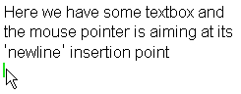
Pick-up, Carry and Place-down action

Once you know how to touch the desired part of equation/expression. You can easily pick it up, carry it away and place it down wherever you want.

Pick-up

(Notice that the ‘pick-up’ term is somewhat misleading. With a simple mouse-click at an object, you actually don’t lift it up, but you create a copy of this object that you then can carry away.)

Touch elements you want and click the left mouse button. Two things will happen.

- The cursor will change its color from ‘standard white’ to ‘standard black’
- The object that you picked up are now dragged with your mouse cursor.
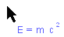
Instead of the simple mouse-click, you can also long-mouse-click at touched math elements (click and hold the button down for more than about 0.5 seconds). This will cut (delete) the original.

Alternative ways for pick-up are CTRL+X and CTRL+C keyboard keystrokes.

Carry

Simply move your pointer to the point where you want to place-down. The object that you picked up will be towed behind the pointer whenever your pointer goes.

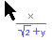

If you want to throw away whatever you are carrying, either hit the ESC key, or just right-mouse-click anywhere at empty document area. The mouse arrow will return to its white color.

Advanced: you can even start two instances of Math-o-mir and then carry objects from one instance to the other one.

Place-down

You can place down at following places:

- Over touched objects – selected objects will be replaced with whatever you carried

How to do it? Use your black mouse arrow to touch elements of an equation. Then click the left mouse button and touched elements will be replaced.
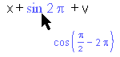 | In this example, the ‘sin 2pi’ is about to be replaced with ‘cos(pi/2-2pi)’. The result will be  ‘x+cos(pi/2-2pi)+v’

- At the insertion point – whatever you carried will be inserted at the insertion point

How to do it? Use your black mouse arrow to ‘touch’ insertion point of an equation. Then click the left mouse button and you will insert here.
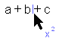 | In this example, the ‘x²’ is about to be inserted after the ‘b’ variable. The result will be ‘a+bx²+c’

- At empty document area – the new object will be created from whatever you carried.

How to do it? With your black mouse arrow simply left-click anywhere on the empty document area.
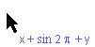 | In this example, the ‘x+sin 2pi +y’ expression will be placed at the empty document area forming the new separated equation object.

- ‘Around’ touched objects – it is called ‘implanting’ and is very useful when understood

How to do it? Use your black mouse arrow to touch elements of an equation. Then click the right mouse button. From the context menu, click at desired spot (insertion point) of the expression displayed in the ‘implanting’ section... See example below:
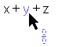 | In this example, the empty fraction carried by mouse is to be implanted ‘under’ the ‘y’ variable... Click the right mouse button after you touched the ‘y’.
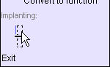 | In the context menu, in the ‘implanting’ section, touch and left-mouse-click the insertion point at the numerator.  Element(s) that you touched in previous step will be inserted exactly at this point.
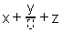 | The result is shown on the picture. The empty fraction is implanted ‘under’ the ‘y’ variable.

Alternative way of placing-down is using the CTRL+V keyboard keystroke. The difference is that whatever you carried stays in your hands, so with CTRL+V you can make multiple place-downs.

EXAMPLE – “Pick-up, Carry, Place-down” action

Suppose that there are two separate equations in your document. We want to copy part of one equation into the other one.
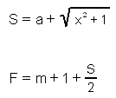

STEP 1 – Touch (select) the whole right part of the first equation. You do this by the multi-touch action – point on ‘a’, press and hold the SHIFT key while carefully moving the mouse to the root sign.

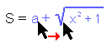

The alternative way to make the same selection is to mouse-click at the ‘a’ and then, holding down the mouse button, move the pointer to the root sign. Once you made the selection this way, you should release the button, but do not move your mouse pointer much any more because your selection might deselect.

The third alternative to make the same selection would be by the quick multi-touch: right mouse click at an insertion point between ‘a’ and ‘+’ (or between ‘+’ and square root) and then choose ‘Copy’ from the context menu. If you used this method then you should jump directly to the Step #3.

STEP 2 – Left mouse click to pick up touched object (then you may release the SHIFT key that you were holding.)

STEP 3 – Picked-up objects are now carried with the mouse. Move them toward the ‘S’ variable in the second equation.
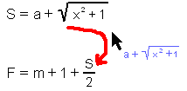

STEP 4 – Touch the ‘S’ variable in the second equation while still carrying your load.

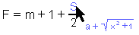

STEP 5 – Left mouse click to replace the touched ‘S’ with your carrying load.

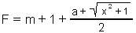

Note that the ‘Pick-up, Carry, Place-down’ is exactly what happens when you take an object from the toolbox and place it into your document.

The moving dot – moving objects around document

Did you notice a small rectangle at the bottom-left corner of any equation/expression in your document? The rectangle becomes visible when you move your mouse arrow near it. This is called the ‘moving dot’ and is used to move your equations around.

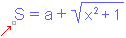
The moving dot becomes visible (white) when you point the mouse arrow at the bottom of the equation. It becomes black (selected) when you point the mouse arrow directly above it.

When it becomes black you can click and hold left mouse button and move the equation around with mouse. This is a handy way to move one single equation.

Tip: If, for whatever reason, you need to touch the whole equation, pointing your mouse at the moving dot is usually the easiest way.

Working with selections

You can select one or more equations by drawing a selection frame around them. You do this by performing click-and-drag action with your mouse. You must click at empty document area, and then stretch the selection frame around objects that you want to select.

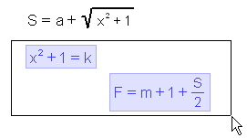
After you release the mouse button, all objects inside the selection frame will become selected.

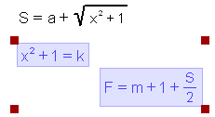

Selected objects are displayed in blue color on a light-blue background. There are also four red rectangles at selection envelope corners.

With selections you can:
- move selections around your document – click-and-drag at any selected object to move them all together.
- stretch/resize selected objects – click-and-drag at any red rectangle (Hold down the Shift key to keep the aspect ratio. Alternatively, you can hold both mouse buttons, left and right, to keep the aspect ratio.)
- rotate selected objects (drawings only) – right-click-and-drag at any red rectangle
- cut/copy/paste/delete selected objects – use menu, or keyboard (CTRL-X, CTRL-C, CTRL-V, DEL)
- display the context menu with more options – right click at any selected object. From the context menu you can resize, group/ungroup, lock, align. For hand-drawing objects you can also rotate, stretch and mirror.

You can change the color of selected object by clicking at the desired color from the color box. Line widths for selected hand-drawings can also be changed this way.

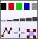

Note: Selections have precedence to touched objects. When there are objects selected, the CTRL-X, CTRL-C, CTRL-V and DEL keys will act on selections, not on touched objects.

To deselect everything, either press the ESC key, or just mouse-click anywhere at empty document area.

Adding to a selection

Add objects to existing selection by holding the SHIFT key while selecting more objects (click-and-drag to stretch selection frame around them).

Or, you can also add a single equation to the existing selection by pointing the mouse pointer at the equation’s moving dot and then by using the SHIFT+mouse-click at the moving dot.

Deselecting a single object

You can deselect single objects from existing selection by holding down the SHIFT key while left-mouse-clicking at the object you want to deselect.

Select/deselect using the Enter key

By using the Enter key you can select/deselect objects. Just point your mouse at an object and hit the Enter key. If the object was not already selected, it will be added to selection (or a new selection will be created). If the object was already selected, it will be removed from the selection. This is a handy way to select/deselect a single object.

Furthermore, you can select the object that was last created. To make this, take care that the mouse is not pointing at any object and then just hit the Enter key – the last created object will become selected. This is useful if you need to modify an object that you just created (for example, after drawing a line, you want to change its color or thickness). Multiple last-created objects can be selected if you press Enter multiple times.

Important note: The Enter key selecting only works when the Typing mode is not active. If the Typing mode is active, the Enter key is used for other purposes.

Drawing lines and curly brackets

It is possible to draw horizontal/vertical lines and curly braces without need to start the Hand-drawing mode. The procedure is simple… start as if you are going to select something – by click-and-drag – but keep your selection frame slim and make sure that it does not select any object.

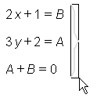
If you keep the selection frame slim and if no object is yet selected within the selection frame, the selection frame will show a pale-gray curly bracket (or a line) drawn inside it. If you then hold your mouse steady for a fraction of a second (no moving) while still keep holding the mouse button down, the pale-gray bracket (or line) will turn darker.

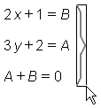
Now you can release the mouse button and the curly bracket (or line) will be created

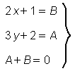

If you keep the selection frame very slim (few pixels wide only) you are going to create a horizontal/vertical line. If you make the selection frame a bit wider (but still slim), you are going to create a curly bracket. You can create horizontal or vertical curly brackets.

Vertical spacement – making space for more equations

By simple mouse action you can make more space for your equations and drawings.

Point the mouse pointer near the left edge of the document area and hold it steady there for about 1.5 seconds. The vertical ruler will appear (a yellowish ribbon with a scale). You can then click-and-drag at the ruler – the horizontal spacing-bar will appear and will move up/down together with the mouse pointer. After you release the mouse button, all objects that were initially below the spacing-bar position, will be moved down to make more space.

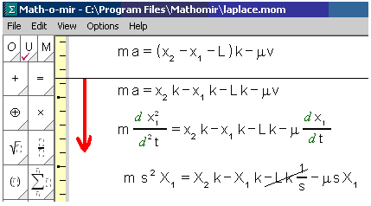

By pulling in upper direction, you can also decrease the vertical spacing between equations.

If the left gray margin of the document area is visible (a gray zone left of the white ‘paper’ area), you can make the procedure without waiting for the ruler to appear – just click at the gray margin area and pull down (or up).

Grid and Guidelines

The grid

To display and use the grid, check the ‘View->Show Grid’ menu option. The grid consists of green dots in a square raster. You can choose from three granulations: fine, medium and coarse. To change the granulation, use the ‘Options->Grid and guidelines’ menu section.

When grid is in use, you can hold down the ALT key to temporarily disable snapping to the grid.

Guidelines

The software only supports vertical guidelines. You can define vertical guidelines using the horizontal ruler. The ruler is hidden and to make it visible you need to move your mouse pointer very near the top edge of the document area and hold it steady there for 1.5 seconds. The ruler (a thin yellowish ribbon with a scale) appears.

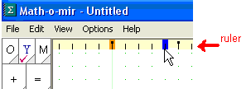

The ruler scale is aligned with the grid granulation. By changing the grid granulation, also the ruler granulation is changed.

You can left-click on the ruler to quickly define a standard guideline. You can also right-click at the ruler for additional options:
- to insert a standard guideline (a yellow-colored guideline)
- to insert a text guideline (a green-colored guideline)
- to insert a text autowrap guideline (a green-colored guideline)
To delete a guideline, you can click again at its ruler position (marked by an orange mark). Note that you can only define 12 guidelines.

Math/text objects will stick to guidelines. Also, if you click a guideline, the new object will start at exact horizontal position. The difference between a standard guideline (yellow) and a text guideline (green) is in the fact that when you click at a standard guideline you will start a math object (as usual, you can convert it to text object by the space bar key), while when you click at a text guideline, you will start a text object (and you can convert it to a math object by space bar). This way, by defining text guidelines you can simplify your text input.

You can also define a text autowrap guideline. Objects won’t stick to that guideline, but a text box, if its text line grows over a text autowrap guideline as you type it, will automatically enfold that text line.

One proposition of guideline setup in Math-o-mir is given here. Three guidelines are defined, the leftmost one is a text guideline, the middle one is a standard guideline and the rightmost one is a text autowrap guideline. You can start typing text by clicking at the text guideline. The text will automatically wrap when it reaches the text autowrap guideline. To type math, you can just click at the standard guideline.

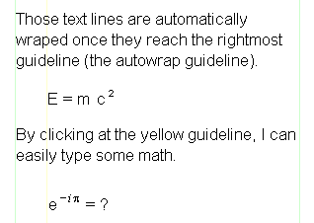

Automatic vertical guidelines

In addition to guidelines that you define for the whole document, the Math-o-mir will also display localized automatic vertical guidelines when the mouse pointer is nearly left-aligned with nearby math/text objects.
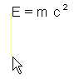

To disable/enable guidelines, use the F12 key. In order to temporarily disable/enable guidelines hold down the CTRL key.

The Right Mouse Button

The right mouse button, depending on context, can be used for following functionalities:

Click at empty document area (acts similar to the ESC keyboard key)
- if anything is carried – it will throw it away (mouse arrow changes from black to white)
- if the Typing mode – it will cancel it (mouse arrow changes from heart-black to white)
- if the Drawing mode is active – it will cancel it (mouse arrow changes from pen to white)
- if anything is selected – it will deselect it
- if context menu is opened – it will close it
- otherwise – it will redraw the document view
Click-and-drag - scrolls the main view
Click-and-drag at selection handles (read squares) - rotates selection (drawings only)
Click at an object - opens the context menu
Click at an insertion point - performs the quick multi-touch and opens the context menu

Note that the in some mouse operations (when using certain hand-drawing tools, when stretching selections, when editing drawing nodes…) you can hold down the Right mouse button instead of the Shift keyboard key for the same effect. Also, you can hold down the right mouse button instead of the Ctrl key when using the mouse wheel for zoom in/out. This way you don’t need to reach for the keyboard so often when doing mouse operations.

The Context Menu

The context menu will appear when you right-mouse-click at an object. Displayed context menu options will depend on the type of the object you right-clicked at.

You can select a context menu option either by mouse-click or by keyboard (arrow keys and the Enter key). You can close the opened context menu by right-mouse click, by pressing the ESC key, and of course, by selecting any option from it.

Right-click at a toolbox item opens accelerator context menu where you can define keyboard accelerators for given toolbox item. No two toolbox items can share the same accelerator.

Right-click at a variable or constant opens variable context menu. You can choose font face, italic/bold, and decorations dash/arrow/caret/dots/hacek/tilde. In addition, when appropriate, you can add/remove index to the given variable, convert it to measurement unit or convert it to function.

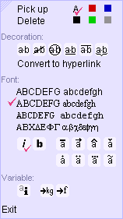

Right-click at whole expression or parentheses opens parentheses context menu. Shape and layout of parentheses can be defined. Any particular bracket can be omitted if needed.

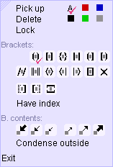

Right-click at Σ, Π or integral sign opens the symbol context menu. You can choose size of the symbol and position of limits.
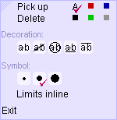

Right-click at a drawing object opens the drawing context menu. You can resize/stretch/mirror the drawing or rotate it. You can also set the drawing into ‘edit nodes’ mode or otherwise modify your drawings.
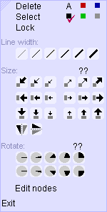

Right-click at a selected object opens the selection context menu. You can group/ungroup the selection or align its elements horizontally or vertically. You can align equations ‘on the equal sign’ or distribute object one-below-another. You can also resize the whole selection.

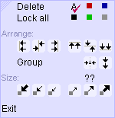

Right-click at matrix/table cell(s) or line will also bring up a context menu where cell border lines (none, single, double) and cell alignment (left, center right) can be adjusted.

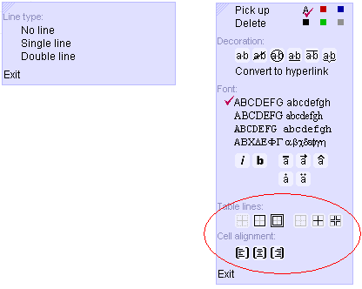

General stuff about context menus

You can move the context menu around screen by click-and-drag to upper-left corner of the context menu window. This is useful if the context menu blocks your view to the document area.

You can hold the SHIFT key while you are mouse-clicking at some options. This way the context menu will not close immediately and you will be able to choose several options in a single session!

If the symbolic computation feature is enabled, the Math-o-mir will place any calculated solution just below the ‘Exit’ option, like in the example below.

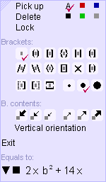

Using Keyboard in Math-o-mir

If you want to write your math rapidly and efficiently, you should learn the keyboard. At the beginning of this manual there are 4²/₂ examples if you prefer an example-based introduction.

In order to type your equations, you must first start the Typing mode. However, while the Typing mode is active, your ability to edit equations using the mouse is reduced. Therefore, while working on your document you will frequently want to move in and out of the Typing mode.

Starting and ending the Typing mode

Start the Typing mode by left-mouse-click. You can click at:

- empty document area to start typing a new equation or a new text.
- an insertion point inside any equation to start editing this particular equation

In both cases following things should happen:

- the mouse pointer will change its shape to heart-shaped black
- the blinking cursor will appear at the place you clicked the mouse (the blue or green vertical blinking line)
- the keyboard-control box will appear just below the toolbox, replacing the color-box.

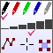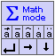

Once the Typing mode is active, any typed letter will appear at the position of the blinking cursor.

While the Typing mode is active, there are three other important modes that define how exactly your keyboard will behave. I am going to describe them in subsequent chapters:
- the Math/Text mode – whether the keyboard will act according to math-typing or to plain-text-typing rules
- the Variable mode – whether multi-letter or single-letter variables will be preferred
- the chosen Font – determines what font is going to be applied to letters you type

You can end the Typing mode by:
- hitting the ESC key
- or right-mouse-clicking at empty document area

The Math/Text mode

When typing, you can always toggle between math and text modes by using, for example, the ALT+SpaceBar keystroke. The color of the blinking cursor indicates the current mode:

- blue cursor line – math typing mode
- green cursor line – text typing mode

In addition, the math/text mode is indicated by the color of the text-control box.

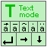
One of many alternative ways to toggle math/text mode is to mouse-click the ‘Σ’ or ‘T’ sign in the text-control box.

By switching from text to math mode and vice versa, you are able to freely mix math and text as you type. Your keyboard will act differently depending on the mode. While math typing rules are Math-o-mir specific, the text typing rules are very similar to that of any plain-text editor (MS Notepad, for example).

When you start a new entry box, usually the math typing mode will be active. You can toggle it by using ALT+SpaceBar keystroke, but even hitting the SpaceBar key alone should suffice when the box is still entirely empty.

The Variable Mode

For efficient math typing, you should choose the Variable Mode wisely. There are two variable modes that define how Math-o-mir will handle keyboard input:

- Prefer multi-letter variables - you can easily type multi-letter variables (like: ‘var’, ‘mass’, ‘anything’, ‘x’...).
If you type xyz, you will create one single variable called xyz. To begin another variable, either type a mathematical operator (‘+’, ‘-‘, ‘/’....) or press the space bar in order to separate variables.

- Prefer single-letter variables - you can easily type single-letter variables (like: ‘X’, ‘a’, ‘B’, ‘R’...).
If you type xyz, you will create three separate variables x, y, and z. You can still type multi-letter variables by starting them with the apostrophe character: ‘xyz
This mode is the default one after you install the Math-o-mir on your PC.

So, the ‘prefer single-letter variables’ mode relieves you from hitting the spacebar between two adjacent variables as the software separates them automatically. But, typing multi-letter variables then becomes more annoying.

To define the variable mode, use the Options->Keyboard menu.

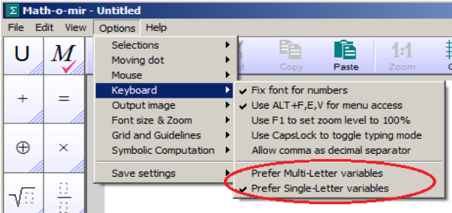

I recommend: once you decide what variable mode best suits your needs, stick with it. You can type all expressions in both modes. The only difference is how handy it is to type them.

Background: in Math-o-mir you should clearly separate math variables. This becomes of practical importance if you configured the software to prefer multi-letter variables. When multi-letter variables are preferred, you should take care to hit the SpaceBar key between two multiplied variables in case you didn’t use a specific multiplication operator between them. Take a look at the following table:
This is understood as one single variable called ‘ab’. No spacebar was hit between ‘a’ and ‘b’.
This is understood as multiplication of variables ‘a’ and ‘b’. The spacebar was hit between ‘a’ and ‘b’.
This is understood as one single variable called ‘sumZ’. No spacebar was hit.
This is understood as multiplication of variables ‘sum’ and ‘Z’. The spacebar was hit between ‘sum’ and ‘Z’.
This is understood as multiplication of variables ‘a’ and ‘b’. There was no need to press the space bar, because the specific operator (the ‘multiplying dot’) was entered in between.

Exception notice: The uppercase Greek delta ‘Δ’ symbol will not be automatically separated from the following variable even if the ‘prefer single-letter variables’ is used. This way you can type variables like Δx or Δt easily.

After you defined the variable mode, you can save it permanently by choosing:
Options->Save settings->Save as default.

Handling fonts

Due to peculiarity of math typing, fonts are implemented in a bit different way than in a typical word-processing program.

In Math-o-mir environment you can predefine up to nine fonts, and then quickly activate any of these nine fonts either by mouse click or by an accelerator keystroke. When you install the software you will already find all nine fonts predefined to some defaults, but you can redefine any of them as you wish.

Of the nine predefine-able fonts that are at your disposal, eight fonts are limited to uniform casting, while one font is capable on mixed casting. Here is the explanation:

Uniform fonts – There are 8 uniform fonts that you can predefine and quickly select between them. For each uniform font you can predefine: typeface, bold/italic flags, color, decorations… When a uniform font is active, all typed letters will be cast in that font.

The Mixed font – This font option enables you to define a different font for every letter separately. For every letter you can define typeface, bold/italic flags and decorations. You may, for example, define that ‘m’ is always cast as bold, while ‘g’ is always cast as Greek ‘gamma’ symbol… Mixed font cannot be used to type plain text (only math).

The first two toolbox options (‘U’ and ‘M’) are used to handle fonts. The active font has a purple check mark displayed. To activate a font just click it with the mouse (or use keyboard accelerators: by default two accelerators are defined: CTRL+M to activate the mixed font and CTRL+U to activate the first of the uniform fonts).

Choosing and redefining Uniform fonts

If you point you mouse arrow at the toolbox ‘U’ option and hover it there for a second, a sub-menu will open where all eight predefined Uniform fonts are displayed:

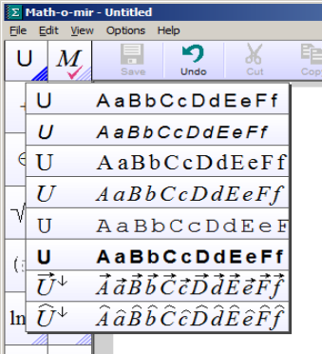

If any of them is the active one, it will have the purple check mark painted. You can click at any to activate it (the last active uniform font is also displayed directly in the main toolbox as the ‘U’ option – thus, you can quickly switch between the mixed font and the last active uniform font just by clicking on the ‘U’ and ‘M’ toolbox options without opening this sub-menu).

In the same sub-menu you can also redefine the actual font details for any of the Uniform fonts. To redefine it, move the mouse pointer at any of them and you will see the ‘font…’ option.

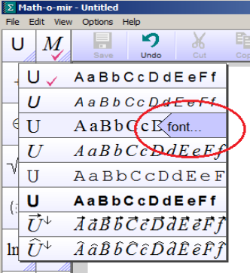

By clicking at the ‘font…’ option, the menu will open where you can define font details: typeface (sans-serif, serif, monospaced or Greek), bold/italic setting, dash/arrow/hat/dots/hacek/tilde decorations, font color…
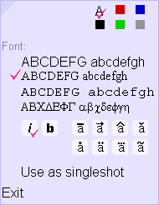

Advanced: When you will be defining a Uniform font you will notice the “use as singleshot” option. If you enable this option for a particular font, this font will behave as follows: Once selected, such singleshot font will remain selected for one character only. Thus, it will be applied only to the first next character you type. Once the character is typed, the font selection will automatically revert to font that was active just before the singleshot font was activated. This is useful if you want just one character to be cast in font different than the others (like making a letter with hat decoration), and only makes full sense if you also define a keyboard accelerator to such singleshot fonts so that you can activate them quickly as you type… Note that a singleshot font will have a downward arrow displayed in its upper-right corner (two such examples are visible in pictures above).

Redefining the Mixed font

To adjust per-character fonts used for the Mixed font, point your mouse arrow at the toolbox ‘M’ option and hover it there for a second. The following menu (table) will open:

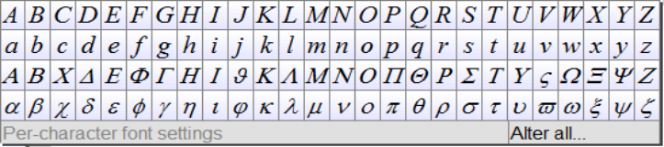

By clicking at the desired symbol (letter) from the table, you can define the font that will be used when this particular symbol is typed. However, if you want to adjust fonts for all symbols of the table at once, just click at the ‘Alter all...’ option and define the desired font.

Hang on! But I want to write math in italic style, and plain text in normal font style!

It is a common wish to, for example, type math variables in italic font, and plain text in normal (upright) font. You can use a simple trick in Math-o-mir to achieve this without need to change the font every time you change the math/text mode:

- set the ‘U’ font to the upright font
- set the ‘M’ font to the italic font
- make the ‘M’ font active and keep it that way all the time

Every time you switch to plain-text typing mode (by ALT+SpaceBar, for example) the Math-o-mir will temporary force-switch to the last used ‘U’ font. It is because the plain text simply cannot be written using the ‘M’ font... As soon as you revert back to the math-typing mode, the ‘M’ font will be reactivated.

You can permanently save your font settings by choosing: Options->Save settings->Save as default.

Nuts and bolts of math typing

Here I will only briefly mention few general techniques regarding math typing; more details will follow in subsequent chapters. Math typing is hard, much harder than plain-text typing, and Math-o-mir software uses many innovative methods of keyboard usage to make math typing more efficient:

- Handy exponent typing – hold down the Alt and type
- Handy indices (indexes) typing – hold down the Spacebar and type
- Fingerless shift – hold down a key for about 0.5 seconds to generate Shifted characters
- Double-stroke Greek symbols – quickly stroke a letter twice to generate a Greek symbol
- Handy sequences – type sequences like +-, -+, >=, <=, /=, ->… to generate math symbols
- Post-modifier keystrokes – some keystrokes modify previously entered characters
- Multi-letter variables – start a multi-letter variable with the apostrophe character
- Command casting – cast special command by starting a command with the backslash key
- Toolbox accelerators – define your own keyboard accelerators for quick toolbox access
- Toggle math/text typing mode – by using eg. Alt+Spacebar or by using the CapsLock key
- Quick typing – type in a letter or two without even starting the Typing mode

By no means is this a complete list of all Math-o-mir keyboard-handling features.

Shortcuts and keystrokes

While the Typing mode is active, you can use following:
Keyboard arrow keys | Move the cursor around (either inside expression or around the document).  If you press the shift+up_arrow combination, you can orientate the equation box vertically. This only works while the box is still completely empty.
Backspace | Deletes the character just before the cursor. If there is a more complicated expression (neither variable nor operator) before the cursor, the backspace key will not delete it immediately, but will select it first and delete only after at the subsequent backspace key hit.
DEL | Deletes the character just after the cursor. If there is a more complicated expression (neither variable nor operator) after the cursor, the DEL key will not delete it immediately, but will select it first and delete only after the subsequent DEL key hit.
ALT+SpaceBar  SpaceBar+Alt  Spacebar+Enter  \\ (two backslashes) | All these keystrokes toggle between math typing mode and text typing mode. The color of the blinking cursor changes accordingly (green for text typing mode, blue for math typing mode). In addition you can also use CapsLock (see below). Use the keystroke that is easiest to type on your keyboard.
CapsLock | Normally the key is used toggle uppercase/lowercase letters. However, it can be configured to toggle math/text typing mode instead. If you do so, you can then use Shift+CapsLock or Ctrl+CapsLock to toggle uppercase/lowercase.
SHIFT+left arrow | Selects equation elements to the left.
SHIFT+right arrow | Selects equation elements to the right.
SHIFT+backspace | If an object to the left of the cursor is a variable or a number, it will move the cursor at its end to enable appending… It can also spice separate variables into a multi-letter variable.
^ or ” | Produces exponent. You can then type the exponent. For example, if you type variable ‘c’, then press the ‘^’ and then ‘b’ it will produce ‘c^{b}’.
ALT+key | To quickly produce exponent. For example if you entered variable ‘c’ and then press ALT+t, the Math-o-mir will produce c^{t}. You can produce quite complex exponents by typing while you are holding the ALT key.
‘_’ (underline) | Creates index to variable/function/parentheses positioned just before. For example, if you just entered variable ‘R’, pressing the underline and then ‘N’ will produce ‘R_{N}’.  Note: when you really need to enter the ‘_’ character as a part of a variable, then you can do it by typing the underline key twice.  Note: also jumps into the lower limit box for integral/summation/product symbols.
SpaceBar+key | To quickly produce index. For example if you entered variable ‘c’ and then press SpaceBar+t, the Math-o-mir will produce c_{t}. You can produce quite complex indexes by typing while you are holding the SpaceBar key.
CTRL+key | Toolbox accelerators – you can define toolbox accelerators yourself. For example CTRL+R may generate the square root sign. See the toolbox chapter.
‘<<’, ‘>>’,’ <=’,  ’>=’, ’+-‘, ’-+’,  ’->’, ‘+>’, ‘:=’, ‘=:’, ‘=>’, ‘/=’, ‘~~’,‘-=’, ‘~=’ | These two-character sequences will produce adequate symbols:
‘[)’, ‘(]’, ‘<>’, ‘[>’, ‘<]’ | These two-character sequences are converted into brackets (parentheses)
@ | Is converted into the infinite sign (use \@ to produce the @ sign)
* | Is converted to the multiplication operator- the small dot (use \* to produce the * sign)
// | Two slashes – this sequence is converted to proper fraction. Cursor is automatically moved to the numerator.
# or ` | Hash key or grave accent key – this puts the fraction line under the element that was just entered. For example if you entered ‘a’ and then hit the # key, the fraction line will be inserted under the ‘a’ variable. This is most useful to enter ‘simple’ fractions that only have a single element in the numerator. But if you hit the # or ` key multiple times, you will be able to place more than one element into the numerator.
ALT+arrow key | Produces arrows. Hit twice to produce double arrow:  (Note: triple ALT+right_arrow produces the sign – same as the ‘+>’ sequence)
\{, \[, \(, \< | Will produce left-only brackets
\}, \], \), \> | Will produce right-only brackets
Tab | Inserts spacer character. The spacer character is only visible when touched/selected. Note that the spacing length can afterwards be modified with mouse.
SHIFT+Tab | Used when building matrices to insert new column (that is, inserts column separators).
SHIFT+Enter | Used when building matrices to make new row (that is, inserts row separator).
Esc | Finishes the Typing mode
Enter | Continues equation editing at next logical position. For example if you are editing parentheses content, the ENTER key will continue editing outside parentheses.  If used at the end of a math line, it will start the new object just below. If used at the end of a text line it will wrap the line.
ALT+Enter | Wraps the line (either math line or text line)
‘++’, ‘- -’, ‘= =’ | These double-stroke sequences can be used instead ‘Enter +’, ‘Enter -’, ‘Enter =’ sequences. These double-stroke sequences can also wrap the line if used at the end of a math line.
\command | By the backslash key you start a command. The command is executed after the space bar, the enter key or any operator is entered. Examples: \sqrt, \sum, \kg, \sin, \int...
SpaceBar | Used to separate two multiplied variables when there is no specific operator in between. For example ‘a’, space bar, ‘b’ for multiplication of ‘a’ and ‘b’.  The space bar key can also toggle between math/text entry modes, but only if you hit the space bar while the box is still empty. This is faster than using Alt+SpaceBar.  The space bar key can also execute a command or finish a multi-letter variable entry.
SpaceBar + arrow keys | Moves (adjusts position of) the equation you are currently editing.
?? | Typing two consecutive ‘?’ characters will invoke the context menu with given results (if any). You can select the result with keyboard arrow keys and choose it with the Enter key.... For example, you can write “2+5=??” (or “2+5??” for short). This will open context menu, where result ‘7’ will be displayed. This only works if the symbolic calculator is enabled.
%% | Two consecutive ‘%’ characters will turn into the ‘per-mille’ symbol.
‘ | Apostrophe - used to enable writing of multi-letter variables even simple variables are preferred. You must start the multi-letter variable with the single quotation mark, and end it with space bar, enter or a mathematical operator.
. | Dot (period) – used to convert variable(s) into function or to start a measurement unit. Of course, in numbers it is also used as the decimal separator.
Ins or SpaceBar + . | The Insert key or the Spacebar plus comma keystroke pastes from the auto-clipboard.

Math-o-mir will also try to help the following way:
- if the decimal dot is entered first, and then the number, the zero will be automatically placed in front of the decimal dot. Example: you type “.7”, and result will be “0.7”.
- if two numbers are separated by the space bar, the multiplying dot is automatically inserted in between.
- if a letter is entered after the number, the Math-o-mir will separate them. For example if you enter “2a”, Math-o-mir will produce “2 a” (two times ‘a’).

EXAMPLE: how do you enter 4.75 x 10⁷ ?... You must type: 4.75, then you can press the space bar (alternatively the ‘*’), then you type 10 and finally you press ALT+7.

A distinctive detail on keyboard cursor position

In many cases it is good to be familiar with differences between similar positions of the blinking cursor line. Look at examples A), B) and C):
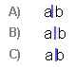

In the example A) the cursor is placed at the end of the first variable. This will be the position of the cursor immediately after you typed a variable. Some keyboard features only work when the cursor is in this position (for example, hitting the dot key to convert the variable into a function).

In the example B) the cursor is placed in a new, still entirely empty variable placed between ‘a’ and ‘b’. You will notice a pale blue hue around the cursor in this case – notifying you that the cursor started a fresh, empty variable. This would be the position of the cursor if you hit the spacebar after you typed a variable. This is also the position of the cursor after you clicked at an insertion point or after you entered a math operator. Some keyboard features only work when the cursor is in this position (for example, hitting the comma key to execute the Autocomplete). If you need to move the cursor from position B) to position A) you can use the Shift+Backspace keystroke.

In the example C) the cursor is placed at the very beginning of the second variable.

Entering multi-letter variables when single-letter ones are preferred

If you configured the Math-o-mir to prefer multi-letter variables then typing multi-letter variables is trivial. However, if the software is configured to prefer single-letter variables (default) then to enter a multi letter variable, you must start it with the apostrophe (prime) key.

Example: to enter variable named ‘weight’ you should type: ‘ w e i g h t and then hit the spacebar key or any math operator key (+,-,*,/…).

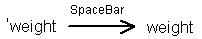

When multi-letter variables are used, it is highly recommended that you always put the multiplying dot (*) between two multiplied variables – the ‘invisible times’ should be avoided!

This recommendation will also help you with typing because you then don’t need to use the SpaceBar to separate variables.

Sometimes, however, you will forget to type the apostrophe key at the beginning of a multi-letter variable. Instead of one multi-letter variable you will create several single-letter variables - a tiny disaster. Instead of deleting all of them and starting again, you can use Shift+Backspace keystroke to splice separate single-letter variables into one multi-letter variable.

Example: You write x = a * s u m and you have

Then you can hit the Shift+Bacspace keystroke (at least) twice and you have

Entering Greek symbols (α, β, γ, δ …)

Greek symbols can be entered using double-strokes. For example, to enter a lowercase Greek letter beta (β), you need to quickly type the ‘b’ letter twice (bb). No more than 750ms must pass between two hits of the double-stroke. For uppercase Greek symbols, of course, you need to double-stroke uppercase letters (‘WW’ generates ‘Ω’, for example).

Greek symbols can be entered in both, math and text typing modes. In general, you should not worry about actual words that contain double-letters because:
- the transformation into Greek symbols only happens at the beginning of the word
- if you continue typing past the first two letters, the Greek symbol will revert back to the double letter
- if you have a rare word consisting only of a single double-letter, you should type those letters slowly (or, in math typing mode, you can also start such variable with the apostrophe sign to prevent transformation into a Greek symbol).

Some uppercase double-strokes, and the lowercase ‘oo’ double stroke, will not convert into Greek symbol because those Greek symbols are visually identical to Latin letters. Consult the following table:

Double stroke | Result
RR, NN, ZZ, CC, KK | Transform into R, N, Z, C, Q bold serif letters.
AA, EE, II, TT, OO, UU, MM, BB, HH | Transform into following math symbols:

An alternative way to generate a Greek symbol is to cast a command. For example casting the \gamma command will generate the γ symbol, while casting the \Gamma command will generate the Γ symbol. To learn more about command casting, read the Entering Commands chapter.

Note: double-strokes can be redefined as toolbox accelerators. If you keep a double-letter stroke defined as a toolbox accelerator, you will not be able to use that particular double-stroke to generate the Greek symbol. Instead, you will have to use a command to enter that Greek symbol… Still, it may make sense to define some double-stroke toolbox accelerators because you might rarely need some of Greek symbols.

Note: there is a special handling when you enter Greek symbols into indices (indexes) using the double-stroke method. When typing indices you can use the third stroke to revert back to Lattin letters. For example to type ‘V_{cc}’ you might type: V <spacebar held> c c c <spacebar released>

Entering indexes

There are two ways to enter indexes (indices):
- using the SpaceBar key
- using the underline ‘_’ key

Note: It is only possible to add indexes to variables, parentheses, functions, and differentials.

Generating indexes using the SpaceBar key

This is the handier method to type simple indexes. This can also be the handier method to type indexes that contain simple math operators (‘+’, ‘-‘, ‘,’) if you keep the ‘Options->Keyboard->Use complex indexes’ option unchecked.

Usage: imediately after you entered a variable, press and hold the SpaceBar key. Any further typing, while the SpaceBar is held, will be entered into the variable index. After you release the SpaceBar, the cursor automatically resumes at the main equation line.

Example: Typing: x <spacebar held> 1 , 2 <spacebar released> y generates:

Note: you might also have difficulties when using the SpaceBar method to type uppercase letters into index. This is because you will need to hold both, SpaceBar and Shift keys, while you are typing the index. To avoid holding the Shift key you can use the Fingerless Shift feature: hold down a key for about 0.5 seconds until the shifted version of the character is produced. For example if you want to produce ‘i_{R}’, you can type: i <spacebar held> <the‘r’ key held for about 0.5 sec> <’r’ and spacebar released>

Note: the index you are entering while holding the SpaceBar key is displayed with a pale-blue background.

Generating indexes using the underline key

This is a more general method. It too is quite handy if the underline ‘_’ key can be easily reached on your keyboard.

Usage: immediately after you entered the variable, hit the underline ‘_’ key. The variable index will be crated and the cursor will be placed inside so that you can type the index. After you finished with it, you can hit the Enter key (or any math operator) to resume typing on the main equation line.

Example: Typing: x _ 1 <Enter> y generates:

Important Note: If you use the underline key to enter indexes, any attempt to enter some math operator (like ‘+’, ‘-‘, ‘/’…) into index will exit the index entry and the operator will be force-placed into the main equation line. This is handy when you type simple indexes because in many cases you don’t need then to use the Enter key to finish the index entry. But it might trouble you if you need to enter a complex index that must contain a mathematical operator…

There are three solutions:
- Immediately after you typed the mathematical operator (it will be placed into the main line) hit the underline ‘_’ key again and the operator, together with your cursor, will be moved to the index again…
Example: typing: x _ 1 + _ 2 <Enter> y generates:

- Check the ‘Options->Keyboard->Use complex indexes’ option and then you will be allowed to freely enter math operators into indexes, but then you will always have to finish the index entry by hitting the Enter key.
- Use the handy Spacebar method, as previously explained.

Entering exponents

There are two ways to enter exponents:
- using the Alt key
- using the ^ key, or the “ key

Entering exponents using the Alt key

This is the handier method to enter simple exponents (for instance, it is ideal to enter integer exponents).

Usage: After you entered an object, press and hold the Alt key. Any further typing, while the Alt key is held, will be added to exponent. After you release the Alt key, the cursor returns back to the main equation line.

Example: Typing: x <Alt held> - 2 + a <Alt released> y generates:

Typing very complex indexes (those containing functions, other exponents, fractions or special math symbols) is usually better done, and sometimes only possible using the the ^ key (or the “ key) method.

However, you might choose to start entering an exponent using ALT key method, and then, in the middle of exponent entry, switch the method. This can be done by releasing the Alt key after you entered an operator (‘+’, ‘-‘, ‘/’,…). The Math-o-mir will conclude that the exponent entry is not yet finished and will leave the cursor inside the exponent box so that you can finish typing it.

Example: Typing x <Alt held> n + <Alt released> 2 K <Alt+2> <Enter> y generates:

Note: you might have difficulties using ALT-key method to type uppercase letters into exponent. This is because you will need to hold both, the Alt key and the Shift key, while you are typing. To avoid holding the Shift key you can use the Fingerless Shift feature: hold down a key for about 0.5 seconds until the shifted version of the character is produced. For example if you want to produce ‘x^{N}’, you can type: x <ALT held> <the‘n’ key held for about 0.5 sec> <’n’ and ALT released>

Starting an exponent with ‘f’, ‘e’ or ‘v’ letters might also be problematic because Alt+f, Alt+e and Alt+v are used to access menus. If you don’t intend to access menu using these shortcuts then, please, uncheck the following option: “Options->Keyboard->Use Alt+F,E,V for menu access”.

Note: when you type an exponent with the Alt key, you will not be able to enter the = (equal) sign into the exponent. All = signs will be replaced with the + (plus) sign. This is to make typing the ‘plus’ easier on some keyboards, as there will be no need to hold down the Shift key nor to wait for 0.5 seconds to trigger the Fingerless Shift feature.

Tip: It is sometimes easier to enter simple negative exponents the following way (the minus is typed prior the Alt key):

x - <Alt held> 3 <Alt released>

Note: the exponent you are entering is displayed with a pale-blue background while the ALT key is held down.

Entering exponents using the ^ key (or the “ key)

This is the more general method. The reason why two different keys (the ‘hat’ key and the quotation-mark key) are provided for the same purpose is because on some keyboards, the ^ key acts as a ‘dead key’ and is therefore difficult to use.

Usage: after you entered an object, hit the ^ key (or the “ key). The exponent will be created and the cursor will be placed inside so that you can type the exponent. After you finished with it, you can hit the Enter key to resume typing on the main equation line.

Example: Typing x “ 2 a <Enter> y generates:

Entering exponents of base ‘e’

There is a simple way to enter exponents of base e. Type ‘e’ and then immediately hit the dot (period) key. The exponent is created and you can type into it. The ‘e’ symbol is cast into serif, italic font.

Entering fractions

You can insert a fraction by using the double slash ‘//’. The double-slash sequence will generate the fraction line and the cursor will automatically move into the numerator.

You can hit the Enter key to move the cursor into the denominator once you are finished with the numerator.

However, for many people it is not natural to type simple fractions starting from the fraction line. Many are accustomed to write the numerator first, and then the fraction line. In Math-o-mir it is also possible to write fractions this way by using the # key (or the grave accent ` key).

Example: Typing: a + b c # d generates:
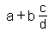

It is even possible to type the # key (or the ` key) several times in the row. For every hit, a single element left of the fraction sign will be sucked into the numerator. Thus, a + b c # # d generates:

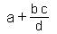

If the # key (or ` key) was hit at the beginning of an expression box, or just after a mathematical operator, the empty fraction will be generated – exactly as if you used the double-slash ‘//’.

Entering commands

When in the Typing mode, you can enter some commands. Most of these commands will instruct Math-o-mir to insert a specific mathematical symbol.

All commands start with the backslash character ‘\’.

The command is executed when the SpaceBar key, Enter key or any other keystroke (like ‘+’, ‘-‘, ‘*’, ‘/’, ‘\’...) that obviously cannot be a part of the command, is entered. For example, if you type in the “\frac” command, and then you press the space bar, the true fraction sign will be inserted and the cursor will automatically move to its numerator.

Following commands are possible:

- square root and root: \sqrt, \root
- logic operators: \and, \or, \nand, \nor, \xor, \not
- summation, product, binom: \sum, \prod, \binom
- other operators: \mod, \pm, \mp
- proper fraction: \frac (the faster way is to type double-slash ‘//’)
- integrals: \int, \iint, \iiint, \oint, \oiint, \oiiint
- case condition: \case
- vertical orientation: \vert
- Greek symbols: \alpha…\omega, \Alpha… \Omega, \ep, \varpi
- differential: \d, \dx, \dy, \dz, \par, \partial, \dd, \ddx, \ddy, \ddz, \ddt
- functions: \funcfunc_name (example: \funcint)
- unit of measurements: \unitunit_name (example: \unitpeso)
- font size: \big, \bbig, \small
- font color: \black, \red, \green, \blue, \gray
- headline: \h1, \h2, h3
- link and label: \link, \label
- other LaTeX compatible commands: \angle, \approx, \aleph, \emptyset, \infty, \ast, \neq, \nabla, \times, \cdot, \bullet, \div, \oplus, \otimes, \cup, \cap, \sim, \cong, \equiv, \doteq, \parallel, \perp, \propto, \subset, \supset, \subseteq, \supseteq, \to, \space, \varphi, \leq, \geq, \elm (equivalent to \in in LaTeX), \owns, \notin, \exists, \forall, \circ, \mapsto, \therefore, \because, \square, \triangle.

Entering functions

There are two distinct methods to enter a function:
- by conversion (using the dot/period key)
- by command casting

Conversion method

This is usually the handier method.

The idea is to type the function name as when you are typing variables and then to hit the dot (period) key to convert variable(s) into the function. For example, if you type s i n . the last three variables (‘s’, ‘i’ and ‘n’) get converted into the sin function.

Advanced: The dot-key modifier always converts the last entered variable into a function. But if the software is configured to prefer single-letter variables it will also analyze several last variables and check if combined they make a common function name. If not, only the last variable will be converted into a function… Following function names are recognized: arcsin, arccos, arctan, arccot, arctg, arcsec, arccsc, cosec, csc, sec, sin, cos, tan, log, ln, par, tg, cot, lim, arch, arsh, arth, arcoth, arsech, arcsch, sech, csch, sh, ch, th, coth, Re, Im, max, min, exp, arg, Res.

To create a non-recognized multi-letter function enter the function name starting with the apostrophe sign (like: ‘myfunc) and then hit the dot conversion key. (Or just use the command casting method instead.)

Note that single-letter functions are immediately created with parentheses: f . converts to f( ). If you want a different kind of parentheses you should then immediately hit either the ‘[‘ or the ‘{‘ key. Multi-letter functions are created without parentheses: s i n . converts to sin, but you can then immediately hit either ‘(‘ or ‘[‘ or ‘{‘ keys to add the parentheses.

There are special handlings for some conversions: e . converts to exponential function; d . converts to differential; p a r . converts to partial differential; l i m . converts to limes; s u m . converts to summation sign; i n t . converts to integral sign. (Note: the summation and the integral sign will be generated without upper and lower limits, but you can generate them if you immediately hit the underline key. Example: i n t . _ )

You can also create ‘derived’ version of function by typing, for example: f ’ . or f ’ ’ . In addition you can create Greek-symbol-named function by typing, for example: bb . or GG .

Finally, you can create indexed functions by converting an indexed variable. For example, you can type f _ 1 . to create f₁() function. Another way to create the same function would be by typing: f <space held> 1 <space released> .

But you can also add an index to an already created function: create the function and when the cursor is in the first place of the function argument either hit the underline key or type with the spacebar held down. The similar way can generate exponents to functions: create the function and when the cursor is in the first place of the function argument either hit the ^ key (or “ key) or type with the ALT key held down.

Command casting method

This is the more general method, and can be almost equally handy on keyboards where the backslash key ‘\’ is easily reachable.

To cast the function, just type the following command: \function_name (where the function_name is the name of function you want to create). Then either hit the spacebar key, enter key, bracket key or even an math operator (like ‘+’, ‘-‘, ‘*’, ‘/’) to create the function.

If you used the ‘(‘ key to create the function, it will be created with parentheses around its argument. However, even if you created your function without parentheses, you can still add the parentheses by stroking the ‘(‘ key right after the function is created – this is shown in the example below. (Note: single-letter functions are always created with parentheses.)

Example: - type: \sin
- press the space bar key (or the Enter key) to execute the command. The function sin
is created and the cursor is moved into its argument
- if we want, we can hit the ‘(‘ key to add parentheses around function argument

Not all function names can be used freely! Function with names that are already reserved for commands (\sqrt, \nand, \mod, \frac, \sum...) and those already reserved for units of measurements (\kg, \oz, \Nm, \mps...) cannot be created this way. But when you need to enter, for example, the function called sum, you can use the following command \funcsum.
In some cases, even reserved names can be used if you execute the command with the ‘(‘ key. For example, command ‘\g’ when executed with the space bar will create ‘gram’ unit, but when executed with the ‘(‘ key will create function ‘g()’.

Moreover, you can cast commands in form: \funcaplha ... \funcomega (or \funcAlpha … \funcOmega) to create Greek-symbol functions. For derivatives, you can also use for example \funsum’ or \funcGamma’’ commands.

Example: - we type the following command \funcGamma’’
- and then we hit ‘[‘ key to execute the function
- function is created, and the cursor is moved into its argument

Note: in Math-o-mir, functions are displayed in a bit greenish color and, by default, in upright serif font. This is to distinguish them from variables more easily.

Functions without arguments: Sometimes, we need to enter a function without argument box. This can be done easily by hitting the enter key while the function argument box is still entirely empty. For example, we can type: h . <enter> = f . <enter> OO g . <enter>
(The ‘OO’ sequence must be typed rapidly.) Note that if you position the cursor just after such ‘bare’ function and you hit the ‘(‘ key, you will again create the argument box to this function.

Entering units of measurement

To enter a measurement unit, you should start with the dot (period) key.

For example, if you type: . P a = . N / m <Alt held> 2 <Alt released> you should obtain:

Units of measurement are displayed in a bit pale color compared to other math elements. In addition, measurement units are typesetted in a more condensed form (less space between them).

In rare cases you might need to enter a measurement unit after you typed a variable. In this case you have to hit the SpaceBar before you type the dot key. But most often, you need to type a measurement unit behind a number in which case the SpaceBar is not needed.

For example: 2 . 7 5 . m m = X <SpaceBar> . u m

Here we see that the SpaceBar is only needed if we are entering a measurement unit behind a variable (if we don’t hit the SpaceBar after the variable, the dot key would transform the variable into a function).

In the above example, you can see that the ‘u’ letter is transformed into Greek ‘μ’ letter. This way you can type the ‘micro’ quantifier in front of many units known to Math-o-mir. Here is a list of units known to Math-o-mir.

SI units and derived SI units

- g (gram), m (meter), s (second), mol (mol),cd (candela), rad (radian), sr (steradian), A (ampere), Hz (hertz), V (volt), T (tesla), Wb (webber), F (faraday), C (coloumb), ohm (ohm), S (siemens), H (henry), lm (lumen), lx (lux), Bq (bequerel), Gy (gray), Sv (sievert), kat (katal), J (joul), N (newton), W (watt), K (kelvin), Pa (pascal), t (tonne), dB (decibel)

Other units

- eV (electron-volt), deg (degree of arc), ’ (minute of arc), ’’ (second of arc), L (liter), degC (degree Celsius), lb (pound), lbm (pound), oz (ounce), ton (ton), mi (mile), nmi (nautical mile), ft (foot), in (inch), yd (yard), h (hour), mn (minute), day (day), yr (year), pt (pint), qt (quart), gal (gallon), bbl (barrel), ppm (part-per-million)

Many of above-mentioned units can be combined with prefixes: p (pico), n (nano), u (micro), m (milli), c (centi), d (deci), h (hecto), k (kilo), M (mega), G (giga), T (tera)… The above-mentioned known units can also be inserted by casting a command. For example to insert Ω, you can cast \ohm command. This command-casting method is provided mostly for legacy reasons.

Special cases and tips:
- to type minute-of-arc or second-of-arc units behind a number you don’t need to start with the dot key. Instead of 14.’ you can just type 14’
- to type degree-of-arc unit behind a number, you don’t need to use .deg. Instead you can use triple apostrophe: 14.3’’’
- to type degree-of-Celsius behind a number, you don’t need to use .degC. Instead you can use ‘C. For example 30’C (or, if you wish, 30’’’C)
- the .ohm will be converted into the Ω sign. For example: .uohm is converted to μΩ
- the .Nm is converted to Newton-metre compound unit (that is, you don’t need to type the spacebar between N and m as it will be inserted automatically). The same with .Ns

Once you entered a unit of measurement, subsequent variables you are going to type will also be converted to units. This makes typing of compound units much easier. For example, we can type: . k g <SpaceBar> m / s <ALT+2> to produce:
As you can see, we didn’t have to use .s and .m to enter meters and seconds in the above compound unit expression. But notice that we had to hit the SpaceBar between ‘kg’ and ‘m’ to separate them.

There are two additional ways to insert a unit. The first is to cast \unitname command. For example, use command \unitpesos to enter a unit called pesos. The second is to convert any variable into a unit. For example you can write variable called ‘pesos’ and then right mouse click on this variable and choose “Convert to unit’ button.

Entering “decorated” variables

You can decorate a variable with dash, hat, arrow, dot, star… Immediately after you typed a variable, use the following decoration methods:

Key sequence | Decoration example
‘ (apostrophe)
‘‘ (two apostrophes)
^^ (two hats)
^* (hat, then star)
Alt+, (Alt+comma)
Alt+,, (Alt+comma; twice)
Alt+. (Alt+period)
Alt+.. (Alt+period, twice)
Alt+... (Alt+period, three times)

An alternative way to add a decoration to a variable is to mouse-click at the desired decoration inside the text-control box.
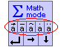

Note: you can also use singleshot fonts to generate variables with decorations, but in this case a singleshot font must be activated (by a keystroke accelerator, preferably) before you type the variable.

Typing multi-line equations

Many times we want to write a single equation with multiple lines. An alternative to this would be writing each line as a separate object (separate equation), but this might not look nice or might not come handy… In Math-o-mir you can wrap the math line by using Alt+Enter keystroke, and this is how you can create multi-line equations.

In the following example we have some equation

Then we used Alt+Enter to wrap the line

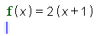

The cursor is now moved in the new line, but still inside the same equation object (this is very different than if the Enter key alone was used in which case the new object would be created). Now we can, say, hit the TAB key to insert a spacer character and then continue to type like follows:

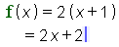

The problem is that the spacer character is too short and the two equal signs are not aligned very well. We could add another spacer character, or we can adjust the length of that spacer character – we can adjust its length using our mouse: point the mouse at the spacer character head (it will become visible when we point the mouse pointer above it in order to ‘touch’ it) and then click-and-drag to adjust its length.
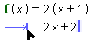

If we hit the Alt+Enter again to make another line wrap inside that equation object, and if then we use the TAB key to generate the spacer, the spacer will be automatically generated with the equal length as the spacer above it (the one whose length we just adjusted).

Sometimes, however, faster and easier methods can be used to achieve the same. Again we will begin from the same equation and then we will hit the Alt+Enter key.

If we now hit the ‘equal’ key twice (‘= =’), the result will be that the spacer character will be automatically added, and its length will be adjusted so that the equality operator will be aligned (more or less) with the equality operator of the first line.

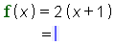

Whenever you use the double-equal keystroke at the beginning of the second (or any non-first) line, thespacer character will be added so that the equality operator will be aligned. In the following example the Alt+Enter was used at the end of every line and then the double-equal keystroke is used to align the equality operator:

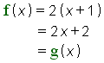

Note: If you really don’t care if every line makes a separate object, you can use the Enter key alone (instead of the Alt+Enter) at the end of each line. Even in this case the double-equal keystroke will work and will align the equality operator!

But if you want (or if you don’t care) to also have the equality operator at the end of each line (as well as at the beginning of it), you can just use the double-equal keystroke at the end of every line. This will do both, wrap the line and make the alignment.
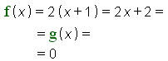

In the above example the Alt+Enter key was never used. Only the double-equal keystroke was used at the end of the first two lines.

In fact, you can use the double-plus (‘++’) or the double-minus (‘- -‘) keystrokes in a similar manner to wrap a line. In the example below, the ++ sequence is used at the end of the first line

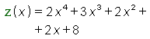

Writing plain text in Math-o-mir

Normally, when you start the Typing mode, the Math-o-mir will assume that you want to write some math and therefore the math-typing mode will be activated. However, many times you want to write just a plain text. So if you really want to start a plain-text box you can:

- mouse-click at document area to start the Typing mode and then use ALT+SpaceBar to switch into text-typing mode. Alternatives to the Alt+Spacebar are the Spacebar+Enter or the double-backslash (hit the backslash key twice) to toggle between math and text mode. These alternatives might come easier on some keyboards.
- or mouse-click at the document area to start the Typing mode and then hit the SpaceBar while the box is still entirely empty. Spacebar (even without ALT) will toggle the math/text mode if the box is entirely empty
- or mouse-click at the document area to start the Typing mode and then mouse-click at the ‘Sigma’ sign in the text control box to switch into the text-typing mode.
- or double-mouse-click at the document area. This starts the Typing mode with the text-typing already activated.
- or just mouse-click at a text guideline. This starts the Typing mode with the text-typing already activated

Instead of using the Alt+SpaceBar to toggle the typing mode, you can configure Math-o-mir to use the very handy CapsLock key for the same purpose. To make this possible, check the following menu option: Options->Keyboard->Use CapsLock to toggle typing mode. But if you use this option, you will not be able to use the CapsLock to toggle between uppercase/lowercase letters any more. Instead, you must then use either Shift+CapsLock or Ctrl+CapsLock to toggle the uppercase/lowercase letters.

When the text typing mode is active, the keyboard cursor is displayed in green color instead of the standard blue. Also the text-control box is displayed in green color.

As you type the plain text, a sign can appear below the blinking cursor. This sign tells about how the Enter key is going to be interpreted. If the sign is present, the Enter key will wrap the text line. If the sign is not present, the Enter key will start the new object.

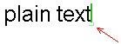
Sure, you can always wrap the line by using ALT+Enter, even if the sign is not present. On the other hand, if the sign is present but you need to start the new object, then you should hit the Enter key twice.

When the text typing mode is active, you can paste plain text from windows clipboard. Use the CTRL+V keystroke (or use menu: Edit->Paste).

You can easily mix formulas and plain text – read about it in the next chapter.

Note that: a word of plain text behaves different than a math variable. If you point the mouse pointer on it, it will not highlight – you cannot touch a word of plain text by simple mouse pointing. Instead, the mouse pointer is only able to touch insertion points between letters. You can, however, touch (highlight, select) a plain text by holding down the shift key while you are dragging your mouse pointer (i.e. by using the multi-touch action).

Mixing math formulas and plain text

When typing, you can easily switch from math-typing mode to text-typing mode and vice versa, using the ALT+SpaceBar keystroke. (Alternatively, you can hit the Spacebar+Enter or use double-backslash keystroke. You can even use the CapsLock key if you configured the Math-o-mir to use the CapsLock key as a typing mode toggle button.)

Example: - you can start typing some math (blue cursor)

- then you switch into text-typing mode by using ALT+SpaceBar (the cursor
changes to green)

- now you type your text

- switch back to math-typing by ALT+SpaceBar (the cursor changes to blue)

- and continue typing some more math

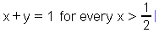

In addition, of course, you can use the mouse ‘pick up – carry – place down’ action to place math-formulas into text boxes and vice versa.

Note to Linux users: using ALT+SpaceBar may not be possible if it activates a system menu. In this case use Spacebar+ALT or SpaceBar+Enter or double-backslash to switch the typing mode.

Editing with keyboard – cut, copy, paste

While the Typing mode is active, you can select a part (or whole) of your equation, cut/copy it and then paste it to another place using keyboard only. No need to reach for the mouse. You can also modify your selections in various ways (change fonts, put parentheses around…).

To select equation elements, use right or left keyboard arrow keys while the SHIFT key is held down. Selected elements will be displayed in blue color. Once you have them selected, you can:

- delete them by DEL or Backspace key
- cut or copy them by using CTRL+X or CTRL+C keystrokes (later use CTRL+V to paste)
- use any of ‘implanting keys’ to make keyboard implanting actions (see next chapter)
- additionally modify the selection by calling up the context menu (with the Enter key)

Example:
- you typed the following expression:

- then you realized that you should multiply the ‘b+c’ by 2. To make necessary
corrections, you press the SHIFT key, and then hit the left arrow key three times
before you release the SHIFT. This way, you selected the ‘b+c’ part of the
equation (Note that the cursor actually did not change its position).

- using the CTRL+X you cut the selection

- now you type the ‘2’ and then the ‘(‘ key

- and finally, you use the CTRL+V to paste the ‘b+c’ inside parentheses

Note that you can also use SHIFT+Home and SHIFT+End keystrokes to select everything from the cursor position to the beginning or the end of the expression or line.

Using the Auto-clipboard

The Auto-clipboard is a simple clipboard that is separate from the standard clipboard (the standard clipboard is the one that is used with Ctrl+X,C,V keystrokes). You cannot specifically tell the Math-o-mir to store something into the Auto-clipboard. Instead, the Math-o-mir stores objects into this clipboard automatically whenever you place-down something into your equations.

To paste from the Auto-clipboard you can hit the Insert key or you can hit the SpaceBar+dot keystroke (the Spacebar+dot being handier on many keyboards).

For example, if you recently reached for the toolbox to insert some rare math element into your equation, you can insert the same element again by hitting the Insert or the Spacebar+dot. It can also be useful to reuse computation results as in the following example.

A simple computation is made (first the 13 / 7 is typed, then the ?? keystroke is used to start the calculator)

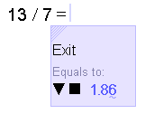

The Enter key places the result into the equation (it also gets automatically copied into the Auto-clipboard)

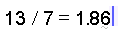

The Enter key is hit again to start the new line, and then the Ins key was hit to paste the 1.86 from the Auto-clipboard

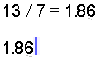

Calling the context menu with keyboard

As already mentioned, you can call the context menu by striking the Enter key once you selected a part of your expression. Then, from the context menu you can select (using keyboard arrow keys) your option and hit Enter key to execute it.

For example, you wrote the ‘a+b’ equation, and now you want to add a hat to the ‘b’ variable

- Press and hold the SHIFT and hit the left arrow key once to select the ‘b’

- Hit the enter key to open the context menu

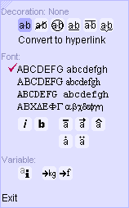

- Using keyboard arrow keys (or mouse) select the ‘a with hat’ option and hit the Enter key. The result is below:

Note: There are, in fact, more practical ways to add hats… after you typed a+b, just hit the ‘^’ key twice to add the hat over ‘b’.

Keyboard Implanting

This mysterious feature is a keyboard equivalent to mouse-made implanting. With implanting you can put objects ‘around’ already existing objects.

It is very straightforward to use keyboard implanting:
- using keyboard (SHIFT+left/right arrow key), select part of the expression
- hit any one of ‘implanting keys’

The recognized ‘implanting keys’ are:
- ‘(‘, ‘[‘ or ‘{‘ key – to put selected objects into parentheses
- ‘/’, ‘#’ or ‘`’ key – to put a fraction line below selected objects
- ‘0’…’9’ number keys – to put selected objects under exponent
- ‘\’ key – to put selected objects into a function (you will then need to type in the correct function name and then either hit the spacebar or the ‘(‘ key).
- ‘C’ key – puts the constraint (restriction) line after selected objects
- ‘R’ and ‘G’ keys – sets objects to red or green color
- ‘B’ and ‘I’ keys – sets object text to bold or italic style
- ‘U’, ‘O’, and ‘S’ keys – draws underline, overline or strikeout line

Note that the Ctrl+X, Ctrl+C, Del and Backspace will also work as expected with keyboard selections. The Enter key will call the context menu over selected objects as it is explained in previous chapter.

Example:
- let’s say that you already wrote the ‘2a+b’ expression, and then
realized that you had to put parentheses around ‘a+b’ part:

- to select the ‘a+b’ part, you will press and hold the SHIFT key and
hit the left arrow key three times (each hit to the left arrow will select one
additional element):

- now, as the wanted part is selected, you simply hit the ‘(‘ key. This
will put parentheses around objects that you selected.

What is the Enter key used for?

In Math-o-mir, the functionality of the Enter key depends on the context. Basically, the Enter key is used to move the blinking cursor to the next logical spot inside the equation. For example, you may be typing the numerator and then hit the enter key – the cursor is moved into the denominator.
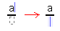
However, if the denominator was already defined, the cursor will be moved just after the fraction element:
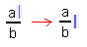

In many cases, if the element you are editing contains an empty box, the Enter key will jump into it. If there are no empty boxes, the Enter key will jump behind that element. This however is not a strict rule.

If the cursor is at the main equation line, the Enter key will jump out of the equation and will create the new equation box just below the one you were editing.

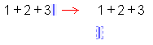

However, when mostly plain text is entered in a box, a small, pale sign may be displayed below the blinking cursor. This tells that the Enter key will not create the new box, but will instead only wrap the line (btw, you can force line wrapping any time by using ALT+Enter).

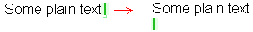

There are other functions of the Enter key as well. When you type in a command, you can execute it with the Enter key (or with the SpaceBar). When you select anything using the keyboard, you can hit the Enter key to open the context menu. Finally, using the Shift+Enter keystroke, you can add a new matrix/table row.

Instead of the Enter key, you can sometimes use the ++ (plus-plus) or the - - (minus-minus) or the = = (equal-equal) keystroke sequences. The plus-plus sequence is going to be translated as if you typed the Enter key, then the plus key. The minus-minus sequence is going to be translated as if you typed the Enter key, then the minus key. For example: a ^ 3 + + 1 will generate:

What is the Dot (period) key used for?

Depending on context, the dot (period) key may be used:

- as a decimal separator (decimal point) – when typed as a part of a number
- to convert a variable into a function – when typed immediately after a variable
- to start typing a measurement unit – when typed immediately before unit

The Autocomplete

As you type a math formula, the Math-o-mir constantly examines nearby equations and checks if there is any expression there that would ‘structurally match the position of your entry’. If such expression is found, it is marked with the yellow-orange color.

When such marking happens, you can use the comma key to execute the Autocomplete.

Example: Suppose you are writing the second equation, and as you moved your cursor into the fraction denominator, the Math-o-mir marked the denominator in the first equation.

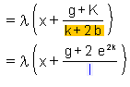

Now you can simply hit the comma key to execute the Autocomplete, and the marked expression will be copied to your cursor position.

In some cases, there will be more than one possible solution for the Autocomplete. The Math-o-mir will mark one of them, but will re-evaluate as you continue to type. Once the Math-o-mir marks the right expression, you can hit the comma key to execute the Autocomplete.

Unfortunately, the comma is also used as a list separator and therefore in order to execute the Autocomplete just after you typed a variable (or a number) you may need to hit the comma key twice. (The first comma is interpreted as the list separator, and only the second comma key hit will execute the Autocomplete.)

Example: As you were typing a formula, you entered the new fraction sign and the Math-o-mir childishly marked the numerator of the some existing fraction sign

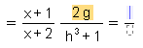

But we want the x+1 numerator from the very first fractions sign, therefore we type ‘x’:

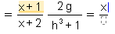

The Math-o-mir now marked the first numerator. But when we type the comma key, nothing much happens – the Autocomplete is not executed because the comma is interpreted as a list separator.

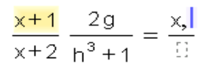

But if we hit the comma key once more, the Autocomplete will be executed.

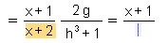

Advanced keyboard examples

Some more advanced examples of keyboard usage are presented here.

Example 1: limes
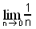
- Type lim and hit the dot key to convert what you typed into the limes. The cursor is automatically placed into the box below the limes. (An alternative way to enter a limes is to type the \lim command and use the underline ‘_’ key to create the limes. This way the cursor will be placed directly into the box below the limes. This would not be the case if we created the limes with the SpaceBar or the Enter key after the \lim.)
- Type n->0 (note that the ‘->’ sequence will be converted to the right arrow. Alternatively, you could use ALT+right_cursor_key to create the arrow. Or you could even use \to command to create it).
- Hit the Enter key (or the up_cursor_key) to move to the limes function argument box
- Type the slash key twice (‘//’) to create the fraction. (Alternatively, you can cast the \frac command).
- Type ‘1’ then hit the Enter (cursor is moved to the denominator). Type ‘n’ and hit the Enter key again (cursor is moved to the limes function argument baseline). Finally, if you want exit out of the limes, you could hit the Enter key again (or hit the right_cursor_key).

Note: It is possible to make steps 4 and 5 the following way: type 1, type #, type n, hit Enter, finally hit Enter again to exit the limes.

Note2: You can create index to any function if you hit the underline ‘_’ key when the cursor is at the very first position of the function argument. Even better, you can create index to a function by executing the function-creating-command with the underline key instead of SpaceBar or Enter key (example: \sin_1).

Example 2: powering a function (consider step 2)
- Type ‘s i n’ and then hit the dot key to create the sine function. (Alternatively, type the \sin command and hit the SpaceBar to create the sine function. Even better, instead of the SpaceBar use the ALT+2 keystroke directly - in this case skip the step 2)
- Hit the ALT+2 keystroke to square the function
- Type ‘x’.
- You can then hit the Enter key to exit the function argument.

Note: a function can be squared (or put to any exponent) from the function argument if the cursor is at the very first position of the argument. To make the exponent, you can use ALT+key combination, or the ‘^’ key. In fact, you can even execute a function-creating-command by the ALT+key or ‘^’ key.

Example 3: understanding the ‘d’ differential
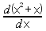
- Type the slash twice (‘//’) to create the fraction. The cursor is moved to the numerator
- Type d and then hit the dot key. This creates the differential without parentheses around its argument. (Alternatively, you could use the \d command to create the differential)
- Hit the ‘(‘ key to create parentheses and then type ‘x <ALT+2> + x’.
- Hit the Enter key to exit the argument of the ‘d’, and then hit the Enter key again to move the cursor into the denominator.
- Type the command \dx and hit the SpaceBar. There are several helping command (\dx, \dy, \dz, \dt) to quickly cast some more often used differentials. However we could also use the more general ‘d . x’ sequence.

Example 4: integrals
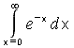
- Type the \int command and hit the space bar to create the integral. The cursor is moved inside its argument. Alternatively we could use ‘i n t .’ sequence to create the integral sign.
- Hit the underline key ‘_’ to move the cursor into lower integration limit box (Note: we could create the integral by typing \int and hitting the underline key instead of the space bar – this immediately places the cursor into the lower integration limit box.)
- Type ‘x=0’ and then hit the Enter key to move the cursor into the upper limit box
- Type the ‘@’ key. The ‘@’ key is always converted into the infinity sign
- Hit the Enter key again – this will move the cursor into the integral argument box.
- Type the ‘e’ and then hit the dot key the fancy-looking ‘e’ constant.
- Type ‘-x’ and hit the enter key. The cursor moves back to integral argument box.
- Now type the ‘d . x’ sequence (alternatively you can cast the \dx command). The dx factor is created, but the cursor is still inside integral argument box - you will need to hit the Enter if you want exit.

Example 5: creating a matrix (more…)
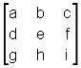

- Type the ‘[‘ key to create parentheses
- Type ‘a’ and then hit the SHIFT+TAB keystroke. The SHIFT+TAB keystroke creates new column (inserts the column separator)
- Type ‘b’ and hit the SHIFT+TAB keystroke again
- Type ‘c’ and hit the SHIFT+ENTER keystroke now. The SHIFT+ENTER keystroke creates new row (the new row is created and filled with empty boxes)
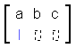
- Type the ‘d’ and then hit the right cursor key or the Enter key (you should not press the SHIFT+TAB now because this would insert new column).
- Type the ‘e’ and the right cursor key again.
- Type the ‘f’ and then the SHIFT+ENTER keystroke to create final row.
- Type ‘g’, right key, ‘h’ right key, ‘i‘. Finally you can hit Enter to exit the matrix.

Example 6: Typing a plain text (more…)
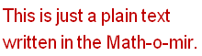

- Immediately as you started the new box, hit the space bar. This will convert equation box to text box. As a result, the blinking cursor will change its color from blue to green (you can hit the space bar again to toggle between equation/text box, but this only works while the box is still completely empty).
- Type ‘This is just a plain text’ and hit the Enter key to start new line.
- Type ‘written in the Math-o-mir.’
- Type the \big command (and press the space bar) to enlarge the font a bit
- Type the \red command (and press the space bar) to change the color.

Example 7: comparing variable modes (more…)

This table shows what keystrokes you can use to enter two different expressions for two different variable modes.
Expression example | Variable mode | Keystrokes
 | Single-letter* | a=x+y+ab
 | Multi-letter | a=x+y+a<SpaceBar>b
 | Single-letter | a=’one+’two+’three
 | Multi-letter* | a=one+two+three
*the more efficient variable mode to type this expression example

Example 8: editing an expression using keyboard (keyboard implanting)

We wrote the following expression
But we want to convert it to the following form
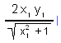
- Press and hold the SHIFT key, and then hit the left arrow key once. This will select the square root.
- Use CTRL+X to cut the square root (it is stored into internal memory – into the standard clipboard)
- Hit the backspace to delete the ‘/’ operator
- Press and hold the SHIFT key, and then hit the left arrow key three times. This will select the 2x₁y₁ expression.
- Hit the ‘/’ key. This will activate keyboard implanting function (a fraction line will be underlined under the selected expression). The cursor is moved into the denominator.
- Use CTRL+V to paste the square root sign, and then hit Enter key to move out of the denominator

Example 9: editing an expression using keyboard and mouse (more…)

We want to write the following expression
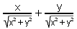

- Use double slash ‘//’ to insert the first fraction (alternatively, you can type ‘x’ and then hit the hash ‘#’ key – if you used this method, skip the next step.)
- Type ‘x’ in the numerator. Hit the Enter key to move the cursor to denominator.
- Cast the \sqrt command (or hit the CTRL+R) to insert root symbol.
- Use following keystrokes: x ALT+2 + y ALT+2. Then hit the enter key twice to exit back to the equation base line.
- Type ‘+’ and then use double slash ‘//’ again to insert second fraction (again, alternatively, you can type ‘y’ and then hit the hash ‘#’ key – if you used this method, skip the next step.)
- Type ‘y’ in the numerator. Hit the Enter key to move the cursor to denominator.
- Mouse click at the root sign of the first fraction. It will be copied to the denominator of the second fraction.

Note: Instead of the mouse click in the step 7, we could use the autocomplete feature (if we were lucky enough that Math-o-mir marked the first denominator). In this case we could just hit the dot key to copy the root sign.

Example 10: multiple cases
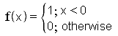
- Type ‘f’ and then hit the dot key to convert it to function (alternatively you could type \f command and then hit the ‘(‘ key or the Spacebar key or the Enter key)
- Type ‘x’ and hit Enter to exit the function argument
- Type ‘=’
- Type \{ (this inserts the single bracket)
- Type ‘1;x<0’ and then hit ALT+Enter to start new line
- Type 0;
- Hit ALT+Spacebar to change typing mode to plain text (the cursor changes to green color)
- Write ‘otherwise’ and hit Enter key to return to baseline

Example 11: multiple cases 2
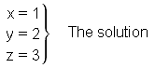
- Type ‘x=1’ and then hit Alt+Enter to start the new line
- Type ‘y=2’ and then hit Alt+Enter to start the new line
- Type ‘z=3’
- Type \} (this inserts the single bracket)
- Hit the TAB key to add some space (or you could just hit the spacebar two or three times)
- Hit the ALT+Spacebar to change the typing mode to plain text (the cursor goes green)
- Write “The solution”

Example 12: typing variables that are containing the underline or the period character

Because the underline key and the dot (period) key are used for special purposes, typing variables that contain these characters in their names is somewhat difficult.

Example 12a: A_1 Type: A [underline] [underline] 1
Example 12b: var_x_y Type: ‘ v a r [underline] [underline] x [underline] [underline] y
Example 12c: var_one Type: v a r [underline] [underline] o n e
(the example 12c only works if the software is configured to prefer multi-letter variables. If not, you can try to use the following trick: ‘ v a r [underline] [underline] o n e and then hit the Shift+backspace twice to join last two characters.)
Example 12d: var.one Type: [Alt+Spacebar] var.one [Alt+Spacebar]
(the period character can only be entered in the Text typing mode.)

Finely adjusting position of the equation you type

If you need to adjust the position of the equation that you are just typing, you can do it by using your keyboard. No need to grab the mouse and aim for the moving dot. Use the Spacebar+arrow combination (Spacebar+left/right/up/down). At each press, the equation will be moved for a few pixels.

Using the mouse while the Typing mode is active

While the Typing mode is active the mouse arrow has heart-like black shape . This way you know that behavior of your mouse will be different than usual.

You cannot carry objects…. You can touch an expression and you can pick it up, but you cannot carry it around. As soon as you pick it up, it will be transferred and placed down at the position of the keyboard cursor. This way you can click around your document at various expressions (or at toolbox items) and easily copy them into the equation you are currently editing.

In the advanced examples section, there is example 9 that is showing how to use mouse to grab existing expressions and insert them into the equation you are editing.

If you right click at empty document area, the Typing mode will finish and the mouse arrow will reshape to standard windows shape.

Using the quick-type feature

The quick-type feature enables entering text and math even without starting the Typing mode. This feature is aimed to be used in hand-drawing so that the user can type simple text/math without need to exit the hand-drawing mode.

The quick-type feature works straightforward: you just move the mouse pointer to any place where you want to enter text and then simply start typing (without any mouse-click that would start the Typing mode). This way you can edit existing equations/text or create new one.

The mouse pointer will automatically relocate as you type and you must be careful not to move the mouse. This is touchy, but can be useful to type few letters or words.

Example: We draw a line using line drawing tool:
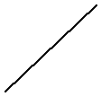

We want to keep the hand-drawing mode, but we also want to name the start and the ending point of the line. We do this by pointing our pen-shaped pointer at the line starting point and then stroking the ‘A’ key (SHIFT+A, actually, as we want capital letters):
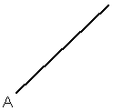

Then we move the mouse pointer to the other end, and hit the ‘B’ key:
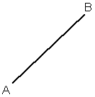

As you can see, we did not need to exit the hand-drawing mode to write those letters and therefore we can now continue drawing lines as the line drawing tool is still selected.

Tip: It is also possible to use the quick-type to create a plain text object. Just hit the space bar first (a green ‘T’ symbol will temporarily appear near the mouse pointer to indicate that the plain-text will be accepted) and then continue typing the text.

The Main Menu

The File menu
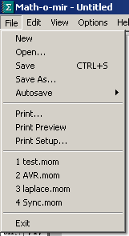

New – opens a blank document (you are asked to save your work before it is deleted)
Open – opens document
Save – saves document
Save As – saves document under new name
Autosave – you can choose from four options: Never, Low/Medium/High frequency. You can also load the autosaved document (the autosave function always saves into the ‘autosave.mom’ file).
Print – prints the document
Print Preview – enables previewing of the document prior printing
Print Setup... opens windows printer setup dialog box.
Recent documents (1..4) – opens recently used document
Exit – Exits the Math-o-mir

The Edit menu
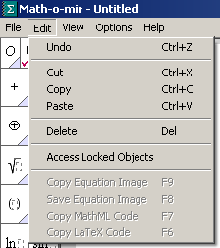

Undo – Undoes last action. There are 5 undo levels.
Cut - cuts the selection (copies data into windows clipboard)
Copy – copies the selection into windows clipboard
Paste – pastes from windows clipboard.
Delete – deletes the selection.
Find text – opens the find-text popup window
Access Locked Objects – Objects that are locked cannot be selected unless you check this option. Once you select them, you can unlock them for further manipulation.

Following options are only enabled when at least one object is selected.

Copy Equation Image – copies bitmap image of the selection into windows clipboard. The image is ready for pasting into other software.
Save Equation Image – saves bitmap image of the selection into a file. File-Save dialog will be opened and you will be able to define file name and file type. Allowed file types are PNG, JPEG, and BMP. Transparent PNG is supported.
Copy LaTeX Code – converts the selected expression/equation to LaTeX code. The LaTeX code is then copied into the windows clipboard (as a plain text) and you can paste it into any text editor.

The View menu

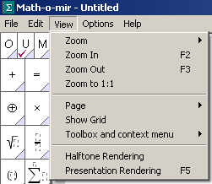

Zoom – you can choose various zoom levels for your document view (40...240%)
You can also choose whether the CTRL key must be used with mouse wheel for zoom action and whether mouse pointer position gets automatically adjusted when mouse wheel is used for zoom
Zoom In – zooms in one step
Zoom Out – zooms out one step
Zoom to 1:1 – zooms to 100%. (It is possible to use F1 shortcut only if you checked the following option: ” Options->Keyboard->F1 sets zoom level to 100%”. Otherwise the F1 shortcut will display the Handy Help guide)
Page – size and orientation of the displayed page (white region of the document view). Here you can also turn on the page numbering.
Show Grid – displays or hides the grid. Grid is displayed as raster of green dots.
Toolbox and context menu – you can choose the size of toolbox, toolbar and context menu. You can also show/hide the toolbar.
Halftone rendering – only meaningful when the presentation mode is active. Use to display graphics with halftone rendering (integrals, brackets...)
Presentation rendering – enables/disables the presentation mode. In presentation mode, equations look fancier, but are less editable. Display refreshing is slower, especially if the halftone rendering is enabled. (You can also use the F5 key to toggle the presentation mode.)

The Options menu
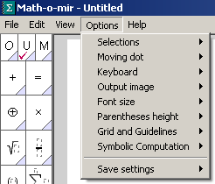

Selections – you can choose if and how Math-o-mir will enhance showing selections
- intelligent framing – drawing a dotted frame around expressions when it is not clear if the insertion point is inside or outside argument.
- bold selections – math-o-mir will bold touched/selected objects
Moving dot – defines the size of the Moving dot. Also, moving dots can be made permanently visible
Mouse – defines behavior of the mouse and the mouse wheel (scrolling speed, zoom/scroll, scrolling direction…)
Keyboard – defines handling of the keyboard
- Fix font for numbers – when numbers are written, always use first font.
- ALT for menu access – ALT+F, ALT+E, ALT+V activate main menu (otherwise, these keystrokes are used to enter Greek symbols).
- F1 to set zoom level to 100% - check to redefine the usage of the F1 key.
- Use CapsLock to toggle typing mode – to enable using the CapsLock to quickly toggle the math/text typing mode
- Allow comma as decimal separator – if in your country you use comma as a decimal separator in numbers, you might want to check this option
- Use complex indexes – allows placing math operators into indexes
- Prefer multi-letter variables – to make typing of multi-letter variables easier
- Prefer single-letter variables – to make typing of single-letter variables easier
Output Image – defines how output equation bitmap image is to be processed
- Size – defines the size of the image
- Presentation rendering – if the presentation mode is used when rendering
- Halftone rendering – if the halftoning is used when rendering
Font size – defines the size of font when new equation is started
Parenthese height – defines the default height of parentheses
- small – parentheses are of height of the font
- large – parentheses completely embrace its content
- medium – parentheses embrace its content to the point it is clear enough what their content is.
Grid and guidelines– defines the resolution of the grid and defines if objects are snapped to guidelines.
Symbolic computation – defines if the symbolic computation is used or not. And defines basic rules with symbolic computation.
Save settings – saves current Math-o-mir settings (the Options menu and toolbox settings)
- Save as default – these settings are automatically reloaded when Math-o-mir starts (settings are saved into the Mathomir.set file)
- Save as... – you can define your own file to save settings
- Load... – you can load settings from previously saved file

The Help menu

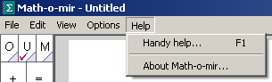

Handy help – displays Math-o-mir handy help.
About Math-o-mir – displays Math-o-mir about box.

Exporting equation images

You can export equation images (bitmaps) in following ways:
- copy them to windows clipboard
- save them to graphics file
- convert them to LaTeX

To copy equation image into windows clipboard, touch (with mouse) the expression you want to copy, and then press the F9 key. If you want to copy image of more than one expression, you have to select them (mouse click and-drag action to draw selection frame around them) and then press the F9 key (or choose the Edit->Copy Equation Image option).

The same procedure is used if you want to copy the image to file, only you then use the F8 key instead. When saving into the file you can choose following options:
- 32 bit PNG file (transparent)
- 24 bit PNG file
- 8 bit PNG file
- 1 bit PNG file
- JPEG file
- 24 bit BMP file
- 8 bit BMP file
To adjust the size and rendering quality of the resulting equation image, use the options in the Options->Output Image.

LaTeX export

You can also convert and export equations in LaTeX form. The procedure is identical – touch/select desired equation(s) and then press the F6 key. The LaTeX code will be generated and copied into the windows clipboard, as a plain text. You can then paste this code into any text application you want.

For example, the equation ‘a+b=c’ exported as LaTeX would look as below:

a +b =c

Note that the bare LaTeX code is generated – you will have to encapsulate it into appropriate tags depending on your needs.

Headlines, Labels and Hyperlinks

When you want to enter a headline into your document, you can use one of following three commands: \h1, \h2 or \h3. Any of these three commands will convert a normal box into a headline box. Any text contained in such headline box will be displayed in specific blue-green color for visual distinctiveness. Note that font size is automatically adjusted – largest in the \h1 case, smallest in the \h3 case:

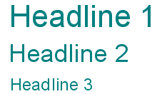

Note that you can either first type the headline text, and then cast the headline command (/h1, /h2 or /h3) or you can cast the headline command while the box is still empty. Note also that you can change the color of the headline text if you want.

Labels

You can create a label by casting the \label command, or by choosing the label element from the toolbox. The label element consists of a text box decorated with a small purple square. You should type the unique label-text inside this text box.

In the above example, a label element is added behind the “Here is the label:” text. The entered label-text is “my label” (the label-text is displayed in blue color). One example how labels could be used, is to label equations like in the following example:

Labels (and headlines) represent anchors where you can link your hyperlinks.

Hyperlinks

You can create a hyperlink by casting the \link command, or by choosing the hyperlink from the toolbox, or by converting math/text elements to hyperlinks. You can create internal hyperlinks (i.e., links that point to labels or headlines in the same document), or you can create external hyperlinks (i.e., hyperlinks that point to external files, programs or web pages).

A hyperlink element consists of a text box decorated with a small purple arrow. In this text box you should enter a descriptive hyperlink text. In addition, a hyperlink element also contains the hyperlink-command-text that is not visible.

When you mouse-click at a hyperlink, the hyperlink is executed.

To edit the hyperlink-command-text, you must right-click at the hyperlink element. The following menu will open:
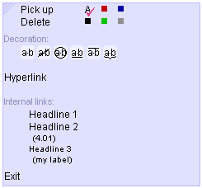

Here you can click at the “Hyperlink” option - an input box will be displayed where you can enter the hyperlink-command-text for the hyperlink element. In the following example a link to a web-page (http://mathomir.wordpress.com) is defined:

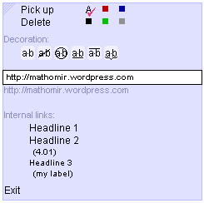

If you instead want to link to an internal label or headline, you can just click one from the list of internal links (note: labels are listed inside parentheses, while headlines are not).

More examples how to define external hyperlink-command-text is here:
- http://www.google.com – opens the google homepage
- g:\readme.txt – opens the ‘readme.txt’ file
- .\example.mom – opens the ‘example.mom’ file
- mailto://mathomir@gmail.com – opens a mail software
- c:\windows\notepad.exe – opens the windows notepad

Advanced: Any external hyperlink is executed by providing the hyperlink-command-text to the Windows ShellExecute command. It therefore depends on system configuration how external hyperlinks will behave on each system.

As you can see, the descriptive text written inside a hyperlink element text-box differs from the actual hyperlink-command-text. However, if the hyperlink-command-text is not defined, the Math-o-mir will try to execute the descriptive text directly.

Matrix (table) editing

In Math-o-mir you can work with matrices and tables. You can construct a matrix/table using keyboard. Alternatively you can start by choosing some predefined empty matrices from the toolbox.

In the toolbox, you can find several predefined matrices under the parentheses submenu. You will find matrices in form 1x2, 1x3, 2x1, 3x1, 2x2 and 3x3.

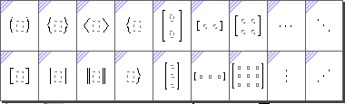

If you place for example a 3x3 empty matrix in the document, you will see the following:
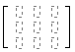
There are 9 empty boxes in 3x3 formation. As you already expect, you can mouse click at any empty box and write your expressions. You can also drop down anything at an empty box.

Matrices are edited as any other objects. For example, if you move your mouse over a matrix, some parts of the matrix will get touched (blue). You can also find many insertion points inside the matrix where you can insert more math.
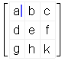
However, you can also touch column and row insertion lines. Column insertion lines can be found between columns while row insertion lines can be found between rows. There are also column and row insertion lines at matrix edges. Two examples below show a column insertion line (between columns 1 and 2) and row insertion line (between rows 1 and 2). When touched, the column and row insertion lines are displayed in blue color.
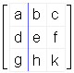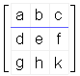

When you mouse click at a column insertion line, the new column is inserted. A click at a row insertion line will insert new row. In the example below the column insertion line is clicked. New empty column is inserted and Typing mode starts (blinking blue cursor appears) so that you can fill in the new column.
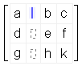
Therefore, by clicking at row/column insertion lines you can expand your matrix/table.

Matrices can be touched. You can touch the whole matrix including the parentheses (point at parentheses) or without parentheses (point at corners of parentheses content, just inside parentheses). The two examples show the difference – the left example includes parentheses, and the right one doesn’t.
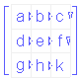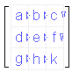
Column and row separators become visible (represented as small triangles) when the whole matrix content is touched.

You can touch a single cell of a matrix by pointing your mouse at lower or upper edge of the cell. You can also touch several cells by holding down the SHIFT key and dragging mouse arrow over cells that you want to touch. In the example below, the mouse was pointed at the ‘a’ cell, then the SHIFT key was held, and the mouse was moved to the ‘e’ cell.
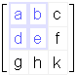
Once you have cell(s) selected, you can pick them up by mouse click (or CTRL+C) or delete them using the DEL key (or CTRL+X). Note that by selecting the entire row (or column) and by hitting the DEL key, you will wipe it out of the matrix. This way you can reduce the size of your matrix.

When you carry rows and columns with your mouse, you can insert them into any matrix by clicking at column or row insertion point. In the example below, the 2x2 ‘abde’ fragment was picked up and placed just below the ‘g’ cell (the row insertion line below the ‘g’ cell). As you can see new rows are created and filled with ‘abde’ values. Two empty cells are padded.
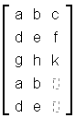
In the similar way you can place rows and columns that you are carrying over existing cells. Instead of placing at row/columns insertion point, just place them down at some particular cell (the whole cell must be touched, by pointing your mouse at upper/lower cell edge). In the example below, again the 2x2 ‘abde’ fragment was picked up and placed down at the ‘h’ cell. As result, the ‘h’ and ‘k’ cells are replaced with ‘a’ and ‘b’, but also a single new row is appended and filled with ‘d’ and ‘e’.
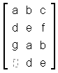
When you carry rows and columns and you click at a normal insertion point or at any element in the matrix, you will create matrix-in-matrix structure. In the example below, again the 2x2 ‘abde’ fragment is placed down at the ‘h’ element (clicked at the ‘h’ while the ‘abde’ was carried). The ‘h’ element is replaced by new matrix ‘abde’.
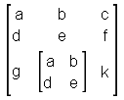

Matrix editing with keyboard

Matrices can also be constructed by keyboard. For example you can start by entering parentheses (the ‘[‘ was pressed to create parentheses).
Then you write data for the first cell. After you finish the first cell, you press the Shift+TAB keys to create new cell and so on. In the example below, three cells are created ‘a’, ‘b’ and ‘c’. (The following key sequence is used: a Shift+TAB b Shift+TAB c).
To start new matrix row, press the Shift+ENTER keystroke. The cursor will jump to new line. The new line will be padded with empty fields
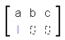
You fill the first cell, then press the Right Arrow Key (or Enter) and cursor will jump to the next field. Repeat this until you finish the whole row (you can then use Shift+ENTER to start another row, if you need).
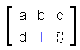
Note that when you are editing a not-first row, you don’t use the Shift+TAB keystroke to jump from cell to cell. Instead you use the Right Arrow keyboard key or the Enter key. This is because the Shift+TAB creates new columns. If you press the Shift+TAB instead the Right arrow, you will unwillingly create new column, and your matrix will look something like below.
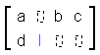

You can also select cells, rows and columns by holding the SHIFT key and using keyboard arrow keys. Once the selection is made you can delete it by using the DEL key (if whole rows or columns were selected then those rows/columns will be removed, but otherwise cells will be emptied) or cut/copy by using CTRL+X, CTRL+C keystrokes. Copied cells you can paste using the CTRL+V. (For more info about using keyboard to cut/copy/paste, see here…)

In the text control box, you will find two buttons that can be used to insert new rows and columns with mouse click.
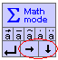

Adding borderlines to tables/matrices

You can decorate your tables/matrices by defining borderlines. You can right-mouse-click at a row or column insertion line to define the line – the following menu appears:
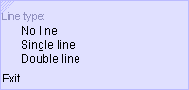

It is also possible to select one or more cells and right-mouse-click to open a menu with options to define table lines (internal lines and borders).
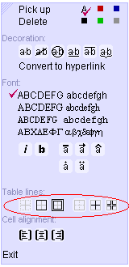

An example of a table with defined border lines (double), internal lines (single) and multiline text with various justifications is shown below:

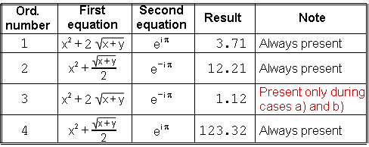

Hand drawing

Hand drawings can be created to illustrate your equations. To begin drawing, choose any hand drawing tool from the toolbox. Hand drawing tools can be found at toolbox bottom.

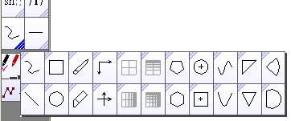

Following tools are available: freehand, line, rectangle/square, ellipse/circle, tiny eraser (pencil eraser), eraser, coordinate system, linear and logarithmic networks, 5-edge and 6-edge polygon, ellipse and rectangle drawn from center, sine function, parabolic function, triangle (right-angle and isosceles), sector and segment of circle.

When any hand-drawing tool is selected, the hand-drawing mode will start and the mouse arrow will change into a pen-like shape. You can select the desired line color and line thickness from the color-box. Then you start drawing by click-and-drag mouse (pen) over your document.

The color box is displayed below the toolbox.
Here you can choose line color and line thickness.

There are alternative and possibly quicker ways to select a hand-drawing tool. One possibility is by calling up the handy hand-drawing-popup toolbox where you can choose from 9 most often used drawing tools. There are two ways to display the hand-drawing-popup:

- hit the F4 key
- long right-mouse-click (right-click at document area and hold the button down for about 0.5 seconds; when a pale-blue box shows, release the right mouse button)

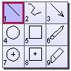

When the hand-drawing-popup opens, the tool that you last used will be automatically selected. If this is the tool that you want to use, just move your mouse pointer away and the popup will close by itself. If you want another tool, mouse-click on it or use 1-9 keys to select it. Using subsequent F4 key hits it is possible to cycle through 4 most basic tools (freehand, line, rectangle and ellipse)… If you just want to close the handy popup without selecting any tool, right-mouse-click on it or hit the Esc key.

In theory, an even quicker way to directly select among 9 most often used hand-drawing tools is by using Alt+1…Alt+9 keystrokes (this works if the Typing mode is not active and the mouse pointer not aiming at any math/text). Tools are numbered in the same order as in the hand-drawing-popup:

- Alt+1 – line drawing tool
- Alt+2 – freehand drawing tool
- Alt+3 – arrow drawing tool
- Alt+4 – ellipse drawing tool
- Alt+5 – rectangle drawing tool
- Alt+6 – pencil-eraser tool
- Alt+7 – centered ellipse drawing tool
- Alt+8 – centered rectangle drawing tool
- Alt+9 – eraser tool

You can also start the hand-drawing mode by clicking at either line color or line thickness from the color-box. This will select the last-used hand drawing tool… Last but not least, recall that you can define your own keyboard accelerator (Ctrl+some key) to any hand-drawing tool to quickly access it.

To exit the hand drawing mode, either right-mouse-click at document area, or press the ESC key. You can also temporarily ‘exit’ the hand drawing mode by holding down the CTRL key (this is handy when you need to, say, move an equation a bit or edit drawing nodes or do any other simple editing that cannot be done while a drawing tool is selected).

Touching and moving hand drawings
Similar to equations, all drawings can be touched (with the standard mouse arrow ), picked up, carried away and placed down. You can also touch more than one drawing by holding the SHIFT key while you touch them with the mouse pointer.

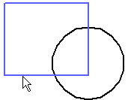
One hand-drawing shape is touched by the mouse arrow – becoming light-blue

Drawings don’t have moving dots. If you want to move a drawing around, simply click anywhere on it and then move it (the click-and-drag action). If you just mouse-click on a drawing (no click-and-drag) you will create a copy of it (pick-up) that you can carry and place-down whenever you want.

Right-mouse-click on a drawing will open the context menu. This way you can change line color, width and style; stretch, mirror and rotate; group, ungroup, combine and break-apart… Drawings can be grouped together with equations (but not combined).

The context menu will contain a somewhat different options, depending on the drawing you right-clicked. For example, open-path drawing will have option to close it, while closed-path drawing will have option to fill it with a solid color. Also, if you selected/touched more than one drawing you will be given options to group and/or combine them.

Tips:

- If you hold down the SHIFT key while drawing, depending on what drawing tool you use, you will: draw perfect horizontal/vertical/45_degree lines, perfect squares, perfect circles, equilateral triangles... The same effect can be achieved if you draw by holding both mouse buttons down (that is, holding down the right mouse button behaves as if you hold down the SHIFT key – useful when you are lazy to reach for the keyboard).

- Similarly, you can hold down the SHIFT key (or the right mouse button key) when using the free-hand drawing tool to draw straightened horizontal/vertical lines. It is quite difficult to draw straight lines with a mouse, so the Shift key is here to help you.

- When using rectangle or ellipse drawing tool, you can also draw horizontal and vertical lines by drawing really thin (few pixels only) rectangles/ellipses. A very thin rectangle/ellipse will be degraded to a line.

- To quickly draw a section line or a curly brace, you don’t need to choose any drawing tool at all. Read more about it in the Drawing lines and curly braces section.

- If you hold down the ALT key while you are drawing, you will temporarily toggle the snap-to-grid option.

- After you draw something, you can hit the Enter key to select the last drawn object. Once you have it selected you can modify its color and line thickness from the color box. An alternative way to select the last drawn object is by mouse clicking the ‘select last’ button in the color-box. (Note: you can click the ‘select last’ button several times or hit the Enter several times to select several last drawn objects)
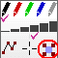

- In fact, it is not needed to select the last drawn object for simple operations as changing line thickness or line color. After you drawn something, you can just right-mouse-click at the desired color or line thickness from the color box to change the line properties of the last drawn object. This is effective if you forgot to change the line properties before drawing.

Adding line endings

You can add line endings to simple open-path curves (those that have no branches, no vertices and no loops). Just right-click at the curve and the menu will open where you can choose appropriate line ending.
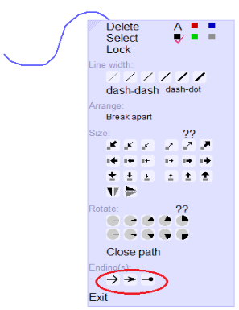
There are three possible line-endings: wide arrow, narrow arrow and a dot/box.

If you right-clicked at the open-path curve very near (within few pixels) from one of its ends, the line-ending will be only applied to that end. Otherwise, the line-ending will be applied to both ends

Editing nodes

Every drawing consists of nodes and line fragments. To edit nodes either:
- hold the CTRL key and touch the drawing with your mouse pointer (nodes will show up)
- in the color-box enable the ‘node edit’ option (nodes will show up on every drawing you touch with your mouse pointer)
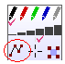

The following picture shows a freehand line with nodes visible and ready for node-editing.
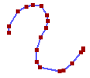
Nodes can be moved by mouse click-and-drag. If you move one node exactly to the neighbor node, then these two will be joined into single node (this way you can delete nodes). If you hold down the Shift key while you are moving nodes neighbor nodes will also move a little to make your editing smoother. (Note: instead of holding down the Shift key, you can hold down the right mouse button key – that is, drag the mouse with both keys pressed.)

To add a node, you can hit the SpaceBar key while nodes are visible and your mouse is pointing at the line. Alternatively, you can right-click at desired location choose the “Add node” option from the context menu.

Specific modifications of basic drawing shapes

Some basic drawing shapes can be modified by right-mouse-clicking on them and then choosing the specific option from the context menu:

- line – you can choose ‘Add arrows’ option to add arrows at both ends of the straight line. This can be useful when you draw dimension lines.
- ellipse/circle/hexagon – you can choose ‘Add center point’ to add center point to the ellipse, circle or hexagon
- coordinate system – you can choose ‘Add grid lines’ to add coordinate grid to coordinate system

Stretching and rotating

To stretch or rotate drawings freely, using your mouse, you must first select drawing(s) that you want stretch or rotate. By selecting them, four red squares (stretching handles) will be displayed at corners of the selection.

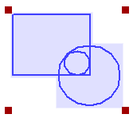

Left-mouse-click-and-drag on any of the stretching handles to stretch the selected drawing(s). (By holding down the Shift key you will keep the aspect ratio. Alternatively you can hold down the right mouse button to keep the aspect ratio – that is, stretch with both mouse buttons pressed.)

Right-mouse-click-and-drag on any of the stretching handle will rotate the selected drawing(s) around the selection central point.

A more controlled way to stretch and/or rotate is by right-mouse clicking at the selected objects and then choosing options from the context menu. There are several quickly-selectable stretching degrees (-50%, -15%, -5%, +5%, +15%, +50%) and several quickly-selectable rotating degrees
(5º, 15º, 45º, 60º, 90º). However, you can also stretch and rotate for some exact percentage or angle-degree: click at the ‘??’ options to type in the exact percentage or degree of arc. Note that you can type in the stretching percentage as, for example: +30 (meaning: increase 30%), -30 (meaning: decrease 30%) and 30 (meaning: set to 30% of the current size).

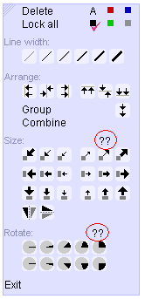

Grouping and combining

Drawings (and math expressions) can be grouped and then ungrouped at will. To group drawings and/or expressions, select them all, then right-click to the selection and choose ‘Group’ from the context menu.
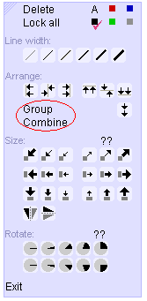

To ungroup, right-click to the group and choose ‘Ungroup’ from the context menu.

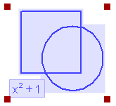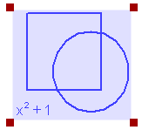
selection of three objects single group selected

Combining is only possible with drawings (it is not possible to combine drawings with equations). By combining, one single non-separable drawing will be created (it can, however, sometimes be broken apart). Combining sometimes has some advantages over grouping as it creates simpler and more easily editable objects.

Predefined drawings

Several predefined handy drawings can be selected from the toolbox under the ‘underline’ item.

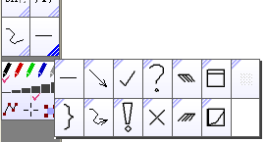

The underline – used to divide math sections in your document. You can place it to the document by click in which case it extends to the whole page width, or you can place it by click-and-drag action to control its length. The underline can draw horizontal, vertical and 45-degree lines. (Notice: when this tool is used inside the Drawing box, the line thickness is fixed to hair-thin. The same happens if you hold down the Shift key while you are drawing the underline.)
The ‘curly’ bracket – use click-and-drag action to place it into your document. It can be both, horizontal and vertical, depending on the way you drag your mouse.
The arrow, the freehand arrow – use click-and-drag action to place it into your document.
The checked sign, the exclamation sigh, the question-mark sign, the cross sign – use mouse click to place them down, or click-and-drag to control their size.
Diagonal line filling tools – these two tools can be used to fill shapes with left or right diagonal lines. Click-and-drag your mouse and diagonals will be painted without crossing lines of existing drawings.
The Drawing box – click-and-drag to place it into your document. More about drawing boxes in the next chapter.
The Function plotter – click-and-drag to place it into your document. More about the Function plotter you can find further in this manual.
The Bitmap box – click-and-drag to place it into your document. You can then load an image into the bitmap box. The bitmap box is also created when you paste a bitmap image into the document using Edit->Paste (or CTRL+V).

List of keyboard functions useful when drawing

SHIFT | Used to force kind of symmetry while some drawing tools are used. Force rectangle tool to draw perfect squares, or ellipse tool to draw perfect circles. It forces line tool to draw vertical, horizontal or 45-degree lines. It straightens the line drawn with the freehand drawing tool… The Shift key can also assist for smoother node editing.  Note that in many cases, instead of holding the Shift, you can hold down the right mouse button (that is, draw with both mouse buttons held down).
CTRL | Used for three purposes:  - to temporarily exit the drawing mode (white mouse pointer is shown as long as the CTRL is held) in order to arrange/move drawings or to invoke context menu without leaving the drawing mode  - to edit nodes of drawings without need to enable the ‘nodes edit’ option in the color-box  - to temporarily show the cross-hair cursor (to permanently show the corss-hair cursor, enable the ‘crosshair cursor’ option in the color-box).
ALT | Used to toggle snap-to-grid option.  (If used inside the Drawing box, it is used to toggle the snap-to-key-node option. Read about drawing boxes in the next chapter for details.)
ALT+1…ALT+9 | To quickly select a drawing tool (line, freehand, arrow, circle, rectangle, pencil-eraser, center-circle, center-rectangle, eraser)
ALT+R, ALT+G, ALT+B | To quickly select the line color (red, green, black).
ALT+T, ALT+M | To quickly select the line thickness (thin, medium). You can also use ALT+S for medium thickness.
Any letter or number key | Even while drawing mode is active, the quick-type feature is enabled and you can type simple expressions or numbers without need to exit the drawing mode.
F4 | If the drawing mode is not active, then F4 starts the drawing mode and selects the very last used drawing tool. If the drawing mode is already active, it cycles through four most important drawing tools (rectangle, line, ellipse, freehand)
F2/F3 | Can be used to zoom_in / zoom_out (However, the mouse wheel is more handy to do the same, if you have it. Note that, depending on how you configured Math-o-mir, you might need to hold down the Ctrl key to zoom with the mouse wheel.)
F1 | Used to set zoom level to 100% (1:1). This only works if you checked the ‘Options->Keyboard->F1 sets zoom to 100%’ option.
Enter | Selects the last-created object. (The last-created object can also be selected by clicking at the ‘select last’ option from the color-box.)

Drawing boxes (technical drawings)

A drawing box can be placed to your document. The drawing box is an active object inside which you can draw drawings of more technical nature. The Drawing box will show a simple drawing toolbox in its upper right corner and the coordinate grid whenever the mouse arrow is inside it. No Typing mode will start if you accidentally click at empty area inside the drawing box. Further, some figures (freehand, ellipse) are drawn with higher precision inside the drawing box… However the main advantage of the drawing box is the existence of the coordinate system and the existence of the command-line entry.

The drawing box can be found in the main toolbox, under the ‘underline’ item.

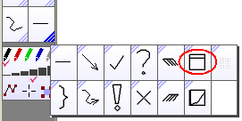

The example picture below shows a drawing box while a line is being drawn. The toolbox is in upper right corner (line tool, rectangle tool, ellipse tool, center-drawn ellipse tool, helping-lines tool, eraser, tiny eraser, diagonal line tools). At the upper left corner, coordinates of mouse pointer are displayed.

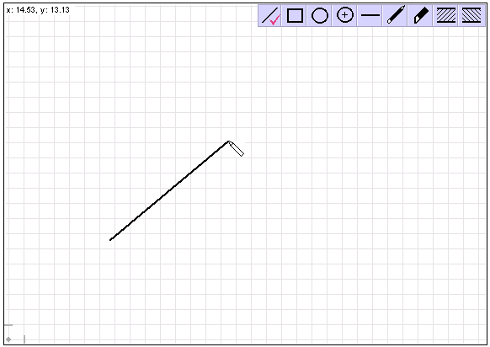

If more that one item is selected inside the drawing box, its toolbox changes to include options for gouping/ungrouping, aligning and mirroring.
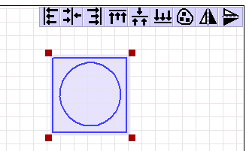

At the bottom left corner you can see Cartesian coordinate system origin point (small gray circle) and unit lengths (short gray lines). You can use your mouse (click-and-drag) to readjust them as you wish. Note that by moving x-axis unit length, you will adjust both, x and y, unit lengths, while y-axis unit length can be adjusted independently.

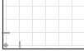

When no drawing tool is selected (that is, standard white mouse arrow is shown) then you will see ‘>’ sign at the upper left corner of the drawing box.

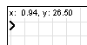

By clicking at it, you will activate the command line entry where you can type several commands:

- line length[,angle] – will draw a line of specified length and angle. Example: line 10, 45
- line x1,y1,x2,y1 – draws line from point x1,y1 to point x2,y2
- vline length– will draw a vertical line of specified length
- rect width[,height] – will draw a rectangle/square of specified width and height.
- rect x1,y1,x2,y2 – draws rectangle/square from point x1,y1 to point x2,y2
- ellipse width[,height] – will draw an ellipse of specified width and height
- ellipse x1,y1,x2,y2 – draws ellipse/circle specified with rectangle x1,y1 – x2,y2
- circle diameter – will draw a circle of specified diameter. Example: circle 10
- rotate angle – will rotate the last drawn object by specified angle
- move x[,y] – will move the last drawn object by specified x and y span.
- hair; thin; medium; thick – will change line thickness of the last drawn object
- black; gray; red; green; blue – will change line color of the last drawn object
- dashdash; dashdot – will change line type of the last drawn object

Note that commands are executed by the Enter key. You can type more than one command at once by separating them with the ‘;’ character (for example: line 5.3,45; thick).

Instead of typing x,y coordinate pairs manually, you can also mouse click anywhere inside drawing box and coordinates will be added to command line (if the command line is active).

The ALT key will act differently while you are drawing inside a drawing box (outside the drawing box it acts as ‘snap-to-grid’ toggle). Inside the drawing box, the ALT key will snap to key-nodes of existing drawings. The key-nodes include:

- starting and ending line points
- line intersection points
- sharp edge points

When you hold the ALT key (or when the ‘snap-to-grid’ option is selected from the menu), by moving your mouse pointer near any key-node inside drawing box, the key-node will be detected and pointed out by small green circle. Mouse actions will snap to key-nodes and this can be useful to make technical drawings. You can use the same trick when you move drawings with mouse to perfectly align a key-node to other key-node.

Symbolic computation

Important: If you don’t use the symbolic computation feature, you can disable it by unchecking: Options->Symbolic Computation->Enable. This way the Math-o-mir will become handier for pure equation editing.

The Math-o-mir includes symbolic calculator to assist you with math. The purpose of the symbolic calculator is not to provide solutions that are too difficult for you to solve yourself. Instead, it should be used to relieve you of the burden of boring steps.

The symbolic calculator is activated by touching some expression, and then right-clicking at it. The context menu is opened, and any found solution is added at the bottom of the context menu as soon as it gets calculated. At no moment Math-o-mir knows exactly what you want to do, but it can provide several calculated options for you to select.

Example... imagine you have the following two equations:

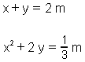

You can click at the ‘y’ in the first equation to extract it out. The following context menu appears:
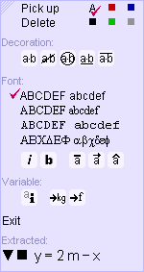

At the bottom of this context menu you have one ‘solution’ found: y=2m-x. We choose the black square left of the solution – this way we will ‘pick up’ the solution and it will become ‘attached to our mouse’. Then we will ‘place down’ the solution next to the first equation, so we will have:
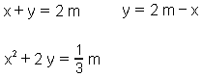

We can, for example, do the same with the second equation. The ‘y’ gets extracted.

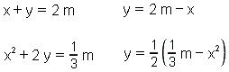

Now, the ‘2m-x’ can be selected and placed over ‘y’ so we will get:

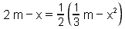

We can touch the right side of this equation (either, with the ‘=’ included or not) and then right click. Solutions will be provided:

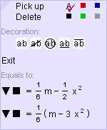

Suppose that we liked the first solution, so we click directly on it and the equation gets modified to:
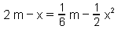

Options in the context menu

Several solutions can be provided in the context menu. Left of every provided solution there are two mini buttons – a small triangle and a small rectangle.

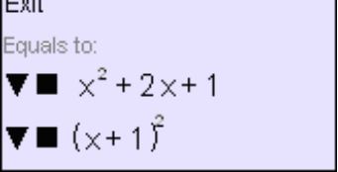

Clicking at the solution itself – the original equation/expression gets modified

Clicking at the triangle – the new equation/expression is created, just below the original one, with given modifications included.

Clicking at the rectangle – the solution is ‘picked up’. That is, it gets attached to mouse and you can latter place it down, anywhere you want (as with any item that you carry).

Using symbolic computation with keyboard

When you are typing an expression with your keyboard, you can enter the question mark ‘?’ twice to start the symbolic calculator. The expression left of the equal sign will be calculated, and solutions will be given in a popup menu. You can then choose the solution with keyboard arrows and the Enter key.

In the example below, a simple expression (215+231*21) was written, and then the ‘?’ was entered twice (‘??’). This popped up a menu with single solution ‘5066’

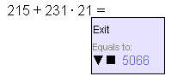
After pressing the ENTER key, the solution is inserted in the equation, and Typing mode is resumed:

What can Math-o-mir calculate?

- Simple calculations
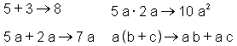
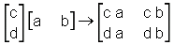
- Simple factorizations
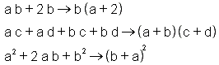
- Fraction reducing
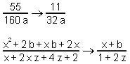
- Rationalize a denominator
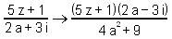
- Calculate determinant
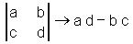

- Matrix inverse (small matrices only)
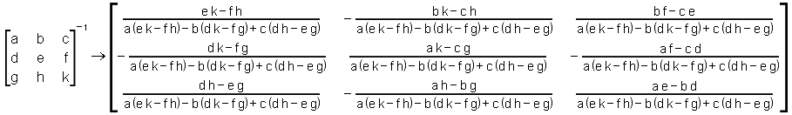

- Number rounding (and integer factorization)

- Variable extraction (within a well-formed equation, right click at the variable you want to extract)

- Casting to polynomial-like form (within a well-formed expression, right click at the variable you want to use)

10. Make simple derivations (you must put expression that you want to derive, into the d/d structure, and then right-click)
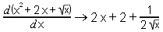

11. Substitute variables (you must pick up an equation from which you want to substitute a variable, and then, carrying this equation right-click at the wanted variable in an other expression. This way you gave following instruction to Math-o-mir: “extract the variable I clicked on from the equation I am carrying, and substitute it”.)
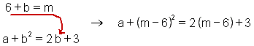

12. Solve simple (linear mostly) and complete systems of equations. The Math-o-mir will assume that all variables are unknowns. This is mostly used to insert values into general equations. (you must select all relevant equations – by dragging the selection frame around them – and then right click to the selection)
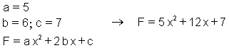

EXAMPLE: there is following equation, we want to cast numerator of the fraction into polynominal-like form:
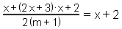

Right click at any ‘x’ in the numerator. The context menu appears, the last option is interesting to us.
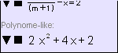

We press the triangle next to it and the result is new equation, just below the original one:
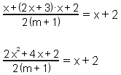

It takes practice to learn when and how the symbolic computation feature can help you.

Function Plotting

Simple functions can be plotted with Math-o-mir. You start by placing the function plotter into your document.... choose the function plotter from the toolbox, and place it (by click and drag action) anywhere into your document.

The function plotter can be found under the ‘underline’ subtoolbox:

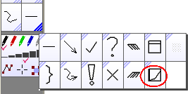

When placed on the document, the function plotter looks like this

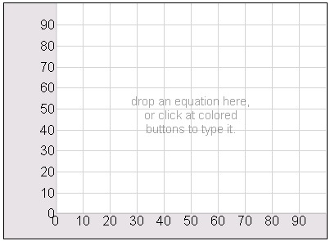

However, if you hover your mouse above it, additional controls become visible

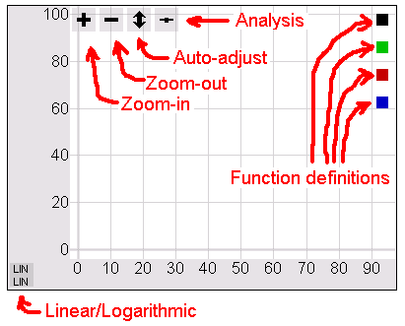

auto adjust button – redraws the function, and adjusts the ‘y’ range (the ‘x’ range remains unchanged)
zoom out button – broadens both, ‘x’ and ‘y’ range
zoom in button – lets you zoom any particular part of the function – by dragging a zoom-in frame with the mouse
linear/logarithmic button – toggles between linear/linear, linear/logarithmic, logarithmic/logarithmic and logarithmic/linear style
function definitions – Here you can type in functions that are to be plotted (or edit them). Up to three functions can be plotted.
analysis – click to toggle analysis/normal mode. In analysis mode the plotter shows function local minimums, maximums and intersection points (if two or more functions are plotted at the same time). For the ‘black’ function it also computes function integral for the displayed range.

In addition, there are also four range arrows, that are visible when mouse is hovering above them. By clicking on them, you can manually define x and y coordinate minimum and maximum.

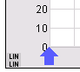

Another way to quickly re-define coordinate axis min and max is by click-and-drag action at the grayed portion of the plotter window.

How to plot a function?

- Write a function (equation) anywhere
- Place the function plotter nearby
- Pick up the function (with mouse) and drop it to the function plotter
- Function gets plotted.

EXAMPLE: A function was written: F=12 sin(m/10), then the function plotter is painted near it.

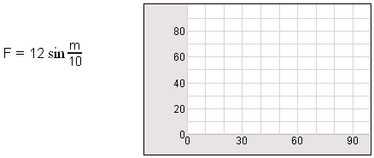

The function is ‘picked up’ by mouse, and dropped into the function plotter (to the white area). Function gets plotted immediately (note that ‘F’ and ‘m’ coordinates are named.)
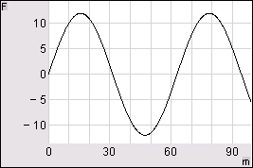

Tips:

- You can ‘move’ the plotted function by clicking at the white portion of the function plotter and dragging the mouse (click and drag).
- If you drop the function directly to any ‘function definition’ button, you will draw the function in that color
- by clicking at the ‘function definition’ button, you can edit the drawn function. You can also delete the function by keyboard (the DEL key) to remove it from the function plotter.

How to write a proper function

The Math-o-mir can plot functions of single variable. Functions of two variables are not plotted properly. The proper form is shown in examples below:

The expression is plotted. The horizontal coordinate is named ‘n’, while the vertical coordinate remains unnamed.
The expression is plotted. The horizontal coordinate is named ‘g’, while the vertical coordinate remains unnamed.
The equation is plotted. The horizontal coordinate is named ‘x’, while the vertical is named ‘y’.
The function is plotted. The horizontal coordinate is named ‘t’, while the vertical is named ‘f(t)’.
The ‘e^x’ is plotted. The horizontal coordinate is named ‘x’, while the vertical is named ‘ab+x’.

Following examples are invalid and cannot be properly plotted in Math-o-mir.

 | Cannot be plotted because contains two variables (on the ‘right’ side of equation)
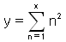 | Cannot be plotted because contains unsupported operator/function. Math-o-mir only supports limited range of operators and functions. Examples of unsupported operators/functions include: summation/product operator, integrals...

Managing documents

By default, Math-o-mir saves its files with .mom extension.

In the SaveAs dialog, using the ‘Save as type’ combo-box, you can choose to save your document in several different formats (all of them will have .mom extension):

MOM file (1.x) | This is legacy standard format – the XML textual file that can be edited in any plain-text editor when necessary. Specification of the format is out of scope of this manual.
MOM file (2.x) | This is optimized format (still XML) that generates smaller files
MOM encrypted file | This is both, compressed and encrypted – you will need to provide a password before the document is saved. Without the password, no one will be able to open the document. Note that the encryption is weak.
MOM exam file | This is used to store exam files that can be later open by students. This feature is added to support clasroom usage. More about it in the next chapter.
MOM view-only file | This format is used to store files that are protected from editing. When such file is loaded, the Toolbox will disappear leaving more space for the document.

Usage in math classroom – Math teachers read here!

Although not specifically designed to be used in the classroom, the Math-o-mir has few features that can make it practical for that purpose.

First of all, the Math-o-mir is small and low-resource software, therefore schools/students do not have to be equipped with up-to-date computers. A computer that barely runs Windows XP is enough. Second, the Math-o-mir itself is absolutely free software, being used inside the classroom or outside it.

The Math-o-mir is an electronic notepad, and students can write math in a similar way they do using pencil and sheet of paper. However, a period of training is necessary. Teachers have to decide about the minimum age of students that are able to accept the software.

Teachers are encouraged to send me their lists of suggestions and wishes in order to improve classroom usability of this software.

Making math exams with Math-o-mir

Teachers can create math exams using Math-o-mir. Exams are to be solved by students on their computers in electronic form. Math-o-mir uses public-key encryption scheme when dealing with exams to keep results produced by students secret.

Teacher will create file with exam questions as any other Math-o-mir document. He/she can store this file privately as a standard file, but should take care that it doesn’t become available to students.

Saving the exam file (teacher)

Only the exam file that is saved as “MOM exam file” should be made available to students. To save the file as “MOM exam file”, teacher must use File->SaveAs menu option, and then choose “MOM exam file” from the ‘Save as type’ combo box:

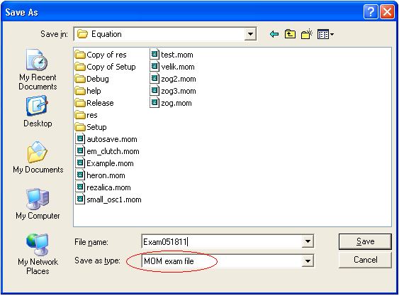

After clicking the ‘Save’ button, teacher will be prompted to provide some additional data. Notably, the password and time limit:

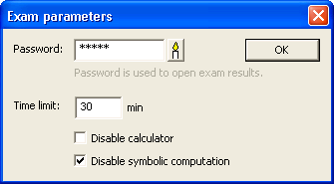

- password – here you must define the password. This password is not used to open the exam file (any student can open the exam file), but is used to open result files saved by students. Only teacher knowing the password can open result files.
- time limit – define the time limit for the exam. Typically, students will receive warning message several minutes before the time elapses. Set the time limit to zero for non-limited exams.
- disable calculator –completely disable all Math-o-mir computation ability. Students will not be able to use Math-o-mir to compute even most basic additions/substractions...
- disable symbolic computation – only disables symbolic computation abilities of Math-o-mir. Computations involving pure numbers only are still possible.

The exam file is to be saved at some place where all students can access it.

Opening and solving the exam file (student)

Being instructed to start the test, student will access and open the exam file. As soon as he/she opens it, the time will start running.

Depending on the overall time limit, the warning message will be displayed to student several minutes before the time elapses, see the following table:

Overal time limit | Warning message
>30 min | 10 min before the time elapses
11-30 min | 5 min before the time elapses
5-10 min | 2 min before the time elapses
1-4 min | no warning message

While he/she is doing the exam, the student will not be able copy/paste to/from other Math-o-mir instances.

After the time elapses, the student will be notified that he/she should save his/her work. No further editing will be allowed! Note that student can save his/her work many times during the exam course, and this is even recommended because it decreases possible loses if the software crashes. Students should name their files according to rules determined by teacher.

Software crash is a serious threat for students taking the exam. Teachers must prepare procedures for that case... If the software crashes, even if student saved his/her work just a moment ago he/she will not be able to re-open his/her work again (because of the password protection). Of course, student will be able to open the original exam file again and continue his/her work on further questions, taking care that his/her old file is not overwritten with the new one.

Reviewing results (teacher)

Teacher can open any result file saved by students by providing the correct password.

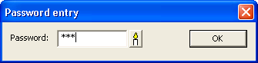

Each file with results is automatically subscribed with following data:
- date and time of its creation
- user name that was logged into computer and created this file
- name of the computer that was used

You will find this subscription data at the very end of the document. This data is provided in hope that it can help teachers if fraud is suspected.

Reviewed results files can be saved as any other Math-o-mir file, and will not be password protected (unless teacher intentionally saves them in encrypted format).

Where to search for additional help

If you need additional help, write to:

You can also send bug reports and suggestions to above mail address. You can watch the progress of Math-o-mir development (and comment on every step) by visiting Math-o-mir blog at the following web address: http://mathomir.wordpress.com

The Official Math-o-mir web site is at address: http://gorupec.awardspace.com/mathomir.html
There you will find the latest downloadable Math-o-mir version, and latest news.

You are free to distribute this document and use it in any way.

Good luck,
Danijel Gorupec
Zagreb, 2017.

