Spacecraft Structural Design and Launch Load Verification
  - Preliminary finite element assessment of axial combined lateral and linear buckling load cases

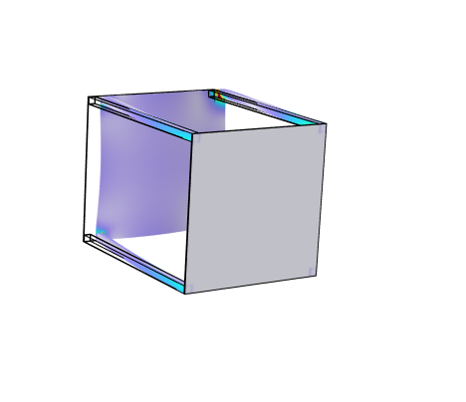
Combined axial and lateral load stress distribution capped at 150 MPa

Prepared by | Mathonwy Akiwumi Jones
Analysis software | COMSOL Multiphysics 6.3
Report date | 28 September 2026
Document status | Preliminary engineering study

Executive summary
The preliminary model indicates positive structural margins when stresses are assessed away from the idealised loaded boundary corner. Under the 6 g axial load case, the converged stress 10 mm inward from the corner is approximately 81.3 MPa, corresponding to a yield factor of safety of 6.18 against the assumed 503 MPa yield strength. Under the combined 6 g axial plus 2 g lateral case, the representative stress is 119.78 MPa and the corresponding factor of safety is 4.20.
The maximum finite element stress at the loaded corner rises from 426.45 MPa to 582.09 MPa as the axial mesh is refined and reaches 699.06 MPa in the combined-load study. This non-convergent local peak is treated as a boundary-condition singularity, not as a reliable material stress. The interpretation therefore uses the converged point value at a fixed physical distance from the corner and retains the peak plots as evidence of the modelling limitation.
The first ideal linear buckling load factor is 19.011. Applied proportionally to the 6 g reference load, this gives an idealised buckling threshold near 114 g. The result is useful for preliminary screening but does not include geometric imperfections, nonlinear material behaviour, joint flexibility or detailed launch-interface stiffness.
Overall conclusion:
The concept is acceptable for continued development at preliminary design level. Strength and ideal linear buckling margins are positive, while displacement acceptance and local joint stresses remain open until detailed interfaces, fasteners, imperfections and allowable limits are defined.

Scope and classification
This report records a concept-level finite element investigation of a simplified spacecraft primary structure. It supports design learning and portfolio evidence; it is not a formal structural qualification, certification or flight release. Loads, geometry, material data and boundary conditions are preliminary engineering assumptions.

Model definition

Geometry and material
The model represents a rectangular spacecraft bus approximately 0.7 m by 0.7 m by 0.912 m. The load-carrying concept consists of four hollow corner rails and two plates. Aluminium 7075-T6 is assigned throughout using the input properties below.
Property | Analysis input | Comment
Young modulus | 71.7 GPa | Linear elastic input
Poisson ratio | 0.33 | Isotropic assumption
Density | 2810 kg/m³ | Mass and inertial loading
Yield strength | 503 MPa | Assumed screening allowable

Mass and boundary conditions
The structural model mass is 19.193 kg. A distributed equipment load represents the remaining 40.807 kg needed to reach the 60 kg spacecraft design mass. The launch-interface face is fixed in all translational directions. This fully fixed interface is intentionally conservative for global restraint but creates an idealised stiffness discontinuity at its edges and corners.

Load cases
Case | Inertial acceleration | Equipment force | Purpose
Axial static | 6 g in negative y | 2401 N axial | Baseline launch compression
Combined static | 6 g axial plus 2 g in positive x | 2401 N axial plus 800.4 N lateral | Coupled launch loading
Linear buckling | Proportional reference loading | Same axial reference pattern | Ideal elastic stability screening

Finite element method
The static studies use linear elastic solid mechanics. Four physics-controlled tetrahedral meshes were solved for the axial study. The combined-load study uses the Fine mesh with 168,747 elements. Mesh refinement is judged using both maximum displacement and a stress sampled at the same physical location 10 mm inward from the singular corner.
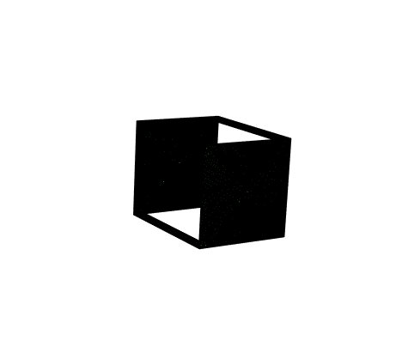
Figure 1 Fine mesh used for the combined-load solution with 168,747 elements

Axial load mesh convergence
Mesh | Elements | Peak von Mises stress MPa | Maximum displacement mm | Stress at 10 mm inward MPa
Coarse | 111,085 | 426.45 | 7.6233 | 76.392
Normal | 146,772 | 466.59 | 7.6385 | 80.832
Fine | 168,747 | 490.65 | 7.6549 | 79.276
Finer | 339,028 | 582.09 | 7.6705 | 81.337

The maximum displacement changes by only about 0.20% from Fine to Finer. The stress sampled 10 mm inward changes by approximately 2.5%, while the boundary-corner peak increases by 18.6%. The displacement and inward stress are therefore sufficiently stable for preliminary interpretation; the corner peak is not.
The stress sample is evaluated at x = 0.305 m, y = 0.906 m and z = -0.305 m. The maximum corner occurs near x = ±0.315 m, y = 0.906 m and z = ±0.315 m. Fixing the sampling point in physical space prevents the reported value from following the shrinking high-gradient region as the mesh changes.

Axial strength assessment
Metric | Value | Interpretation
Representative von Mises stress | 81.337 MPa | Finer-mesh point 10 mm inward
Maximum displacement | 7.6705 mm | Finer mesh
Yield factor of safety | 6.18 | 503 MPa divided by 81.337 MPa
Boundary-corner peak | 582.09 MPa | Mesh-sensitive singular value; not used for margin

The representative stress remains well below the assumed yield strength. The result does not independently verify bearing, fastener, contact or local crippling failure because these details are not represented in the simplified model.

Linear buckling assessment
Mode | Load factor
1 | 19.011
2 | 19.011
3 | 36.722
4 | 52.110
5 | 52.153
6 | 52.155

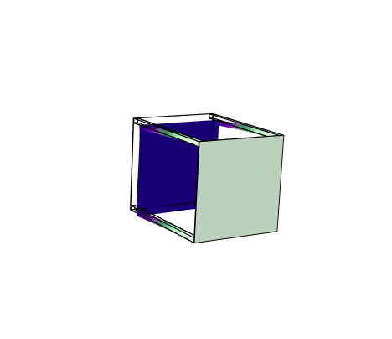
Figure 2 First ideal linear buckling mode with load factor 19.011
Modes 1 and 2 form a nearly repeated pair, consistent with similar stiffness about two lateral directions. Multiplying the reference 6 g loading by 19.011 gives an ideal proportional threshold of approximately 114 g. This should not be interpreted as a test-qualified capability: real imperfections, joints and nonlinear response normally reduce buckling resistance.

Combined axial and lateral assessment
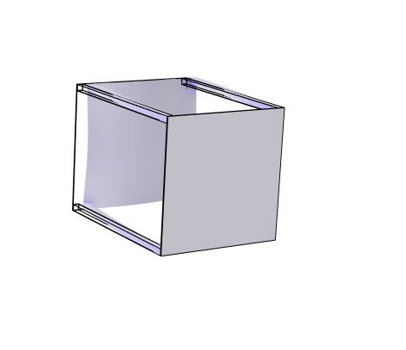
Figure 3 Combined-load von Mises stress shown over the full 699.06 MPa range
The full-range plot records the numerical maximum but visually compresses most of the structure into a narrow colour range because the corner peak dominates the scale.
Figure 4 Combined-load von Mises stress capped at 150 MPa to show the global distribution
Capping the plotted range does not change the solution. It makes the non-singular stress distribution visible while the uncapped plot preserves traceability to the reported numerical maximum.
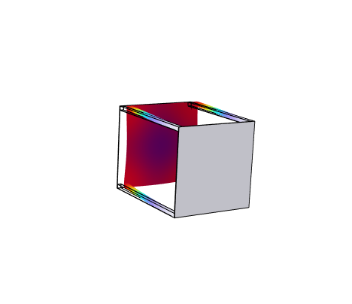
Figure 5 Combined-load displacement magnitude with a maximum of 15.401 mm
Metric | Value | Assessment
Representative von Mises stress | 119.78 MPa | Point 10 mm inward from loaded corner
Yield factor of safety | 4.20 | Positive preliminary strength margin
Maximum displacement | 15.401 mm | Acceptance criterion not yet specified
Boundary-corner peak | 699.06 MPa | Mesh-sensitive singular value; not used for margin

The lateral acceleration approximately doubles the maximum displacement relative to the axial-only case and raises the representative stress by about 47%. The strength margin remains positive at the selected evaluation point. However, the 15.401 mm displacement must be checked against payload alignment, clearances and interface requirements before displacement compliance can be claimed.

Safety margin summary
Check | Demand | Capacity or criterion | Margin status
Axial yield | 81.337 MPa | 503 MPa | FoS 6.18
Combined yield | 119.78 MPa | 503 MPa | FoS 4.20
Ideal elastic buckling | Reference factor 1.0 | Load factor 19.011 | Positive screening margin
Combined displacement | 15.401 mm | Not yet defined | Open

Factors of safety use a single assumed yield strength and do not include material knockdowns, manufacturing variability, fatigue, proof factors or programme-specific safety factors. They are screening values rather than certified margins of safety.

Limitations and required follow on work
- Replace the fully fixed interface and idealised edge loading with launcher-adapter stiffness, contact and realistic load introduction.
- Model joints, fasteners, rail-to-panel connections and local bearing regions so that local stresses can be assessed physically.
- Perform geometrically nonlinear buckling with measured or specified imperfections and verify sensitivity to joint stiffness.
- Define payload alignment and clearance limits, then compare them with the 15.401 mm combined-load displacement.
- Apply programme-specific yield, ultimate and buckling factors and approved material allowables.
- Evaluate modal frequencies and dynamic launch environments, including random vibration and shock, if required by the mission.

Conclusion
The simplified aluminium spacecraft structure shows stable global displacement and stable stress at a fixed point away from the idealised loaded corner. The axial and combined-load representative stresses provide preliminary yield factors of safety of 6.18 and 4.20 respectively. The ideal linear buckling factor is 19.011. These results support continued concept development, but they do not constitute structural qualification. The next meaningful improvement is detailed interface and joint modelling, followed by nonlinear buckling and requirement-based displacement verification.

