MThambeliyagodage_Data605_W13_Assign13

Matheesha Thambeliyagodage

May 4, 2018

Table of Contents

# Data 605 Assignment 13

### Problem 1

Use integration by substitution to solve the integral below.

$∫4e^{−7x}dx$

#### Solution 1

Let $u=−7x$, then $du=−7dx$.

$$\begin{matrix}∫4e^{−7x}dx & =∫\frac{−7×4}{−7}e^{−7x}dx \\ & =∫\frac{−4}{7}e^{u}du \\ & =\frac{−4}{7}e^{u}+constant \\ & =−\frac{4}{7}e^{−7x}+constant\end{matrix}$$

### Problem 2

Biologists are treating a pond contaminated with bacteria. The level of contamination is changing at a rate of $\frac{dN}{dt}=−\frac{3150}{t^{4}}−220$ bacteria per cubic centimeter per day, where $t$ is the number of days since treatment began. Find a function $N(t)$ to estimate the level of contamination if the level after $1$ day was $6530$ bacteria per cubic centimeter.

#### Solution 2

$$
\frac{dN}{dt} = N'(t) = \frac{-3150}{t^4}-220 \\
\int{(\frac{-3150}{t^4}-220) dt} = \frac{1050}{t^3}-220t+C = N(t)
$$

Since $N(1)=6530$, then

$$\begin{matrix}N(t) & =\frac{1050}{t^{3}}−220t+C \\ N(1) & =6530 \\ \frac{1050}{1^{3}}−220×1+C & =6530 \\ C & =6530−1050+220 \\ C & =5700\end{matrix}$$

The level of contamination can be estimated by the following function:

$N(t)=\frac{1050}{t^{3}}−220t+5700$

### Problem 3

Find the total area of the red rectangles in the figure below, where the equation of the line is $f(x)=2x−9$.

#### Solution 3

Each square in the graph has an area of $1$. Each rectangle has a width of $1$. Counting each rectangle left to right the areas are $Area=1+3+5+7=16$.

A more elegant and more universal solution can be produced using integral.

$Area=\int_{4.5}^{8.5}{(2x−9)dx}=16$

It is important to note that the line cuts off a quarter of a unit square from each rectangle. These little triangles above the line are the same as the missing triangles below the line, so the area of all rectangles is equal to the area under the line from $4.5$ (where the line intersects the $x$ axis) to $8.5$ (the right side of the last rectangle).

### Problem 4

Find the area of the region bounded by the graphs of the given equations.

$y_{1}=x_{1}^{2}−2x_{1}−2$ $y_{2}=x_{2}+2$

#### Solution 4

Let us plot two functions. $f_{1}(x)$ is in red and $f_{2}(x)$ is in green.

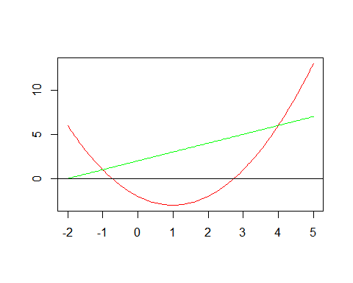

Because the quadratic function dips below the $x$ axis, we need 4 points to evaluate the integrals and find the area - intersections of two functions and roots of the quadratic function.

Let us find roots of the quadratic function $f_{1}(x)$.

Let us find the intersection of two functions. They intersect where $f_{1}(x)−f_{2}(x)=0$.

$(x^{2}−2x−2)−(x+2)=0$ $x^{2}−3x−4=0$

Find the roots.

Four points are as follows…

## [1] -1.0000000+0i -0.7320508+0i 2.7320508-0i 4.0000000-0i

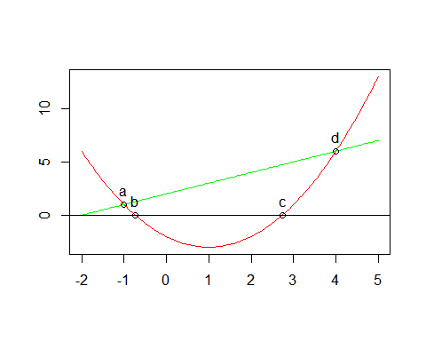

The area between two graphs is equal to the area under function 2 from $a$ to $d$ minus the area under function 1 from $a$ to $b$ and from $c$ to $d$ plus the area over function 1 from $b$ to $c$.

$Area=\int_{a}^{d}{f_{2}(x)dx}−\int_{a}^{b}{f_{1}(x)dx}−\int_{c}^{d}{f_{1}(x)dx}+\int_{b}^{c}{f_{1}(x)dx}$

## [1] 20.83333

$Area≈20.83$

### Problem 5

A beauty supply store expects to sell 110 flat irons during the next year. It costs $3.75 to store one flat iron for one year. There is a fixed cost of $8.25 for each order. Find the lot size and the number of orders per year that will minimize inventory costs.

#### Solution 5

Let $x$ be a number of flat irons to order.

$Yearly storage cost=Storage cost per iron×Average number of irons stored=3.75×x/2=1.875x$

$Yearly ordering cost=Cost of each order×Number of orders=8.25×110/x=907.5/x$

$Inventory cost=Yearly storage cost+Yearly ordering cost=1.875x+907.5/x=f(x)$

To find the minimized value, differentiate and solve at $0$:

$$\begin{matrix}f′(x) & =1.875−\frac{907.5}{x^{2}} \\ f′(x) & =0 \\ 1.875−\frac{907.5}{x^{2}} & =0 \\ 1.875 & =\frac{907.5}{x^{2}} \\ 1.875x^{2} & =907.5 \\ x^{2} & =\frac{907.5}{1.875} \\ x & =\sqrt{\frac{907.5}{1.875}} \\ x & =\sqrt{484} \\ x & =22\end{matrix}$$

Each order should contain $22$ flat irons, so there should be $110/22=5$ orders.

### Problem 6

Use integration by parts to solve the integral below.

$∫ln(9x)×x^{6}dx$

#### Solution 6

Let $u=ln(9x)$, then $\frac{du}{dx}=\frac{1}{x}$.

Let $\frac{dv}{dx}=x^{6}$, then $v=∫x^{6}dx=\frac{1}{7}x^{7}$.

Using the formula for integration by parts: $∫u\frac{dv}{dx}dx=uv−∫v\frac{du}{dx}dx$

$$\begin{matrix}∫ln(9x)×x^{6}dx & =\frac{1}{7}x^{7}×ln(9x)−∫\frac{1}{7}x^{7}×\frac{1}{x}dx \\ & =\frac{1}{7}x^{7}×ln(9x)−∫\frac{1}{7}x^{6}dx \\ & =\frac{7}{49}x^{7}×ln(9x)−\frac{1}{49}x^{7}+constant \\ & =\frac{1}{49}x^{7}(7ln(9x)−1)+constant\end{matrix}$$

### Problem 7

Determine whether $f(x)$ is a probability density function on the interval $[1,e^{6}]$. If not, determine the value of the definite integral.

$f(x)=\frac{1}{6x}$

#### Solution 7

$$\begin{matrix}\int_{1}^{e^{6}}{\frac{1}{6x}}dx & =\frac{1}{6}ln(x)|_{1}^{e^{6}} \\ & =\frac{1}{6}ln(e^{6})−\frac{1}{6}ln(1) \\ & =\frac{1}{6}×6−\frac{1}{6}×0 \\ & =1\end{matrix}$$

The definite integral of the function on interval $[1,e^{6}]$ is $1$. Additionally, if $x>0$, then $f(x)>0$, so for this interval $f(x)>0$. As long as $f(x)=0$ outside of the given interval, this satisfies PDF requirements and this function **is a probability density function**.