MThambeliyagodage_Data605_W7_Assign7

Matheesha Thambeliyagodage

March 28, 2018

Table of Contents

## Problem 1

Let $X_{1},X_{2},...,X_{n}$ be $n$ mutually independent random variables, each of which is uniformly distributed on the integers from $1$ to $k$. Let $Y$ denote the minimum of the $X_{i}$’s. Find the distribution of $Y$.

#### SOLUTION

Number of possible combinations of $X_{i}$’s is $k^{n}$ (choosing $n$ values out of $k$ options with replacement).

Consider number of combinations with at least one $1$. It is equal to all combinations ($k^{n}$) minus all combinations with values between $2$ and $k$ ($(k−1)^{n}$). So $P(Y=1)=\frac{k^{n}−(k−1)^{n}}{k^{n}}$.

Consider number of combinations with at least one $2$ and no $1$. It is euqal to all combinations ($k^{n}$) minus all combinations with at least one $1$ (see above: $k^{n}−(k−1)^{n}$) and minus all combinations with values between $3$ and $k$ ($(k−2)^{n}$). So $P(Y=2)=\frac{k^{n}−(k^{n}−(k−1)^{n})−(k−2)^{n}}{k^{n}}=\frac{k^{n}−k^{n}+(k−1)^{n}−(k−2)^{n}}{k^{n}}=\frac{(k−1)^{n}−(k−2)^{n}}{k^{n}}$.

Similarly considering combinations without $1$ or $2$ and with at least one $3$,

$$\begin{matrix}P(Y=3) & =\frac{k^{n}−(k^{n}−(k−1)^{n})−((k−1)^{n}−(k−2)^{n})−(k−3)^{n}}{k^{n}} \\ & =\frac{k^{n}−k^{n}+(k−1)^{n}−(k−1)^{n}+(k−2)^{n}−(k−3)^{n}}{k^{n}} \\ & =\frac{(k−2)^{n}−(k−3)^{n}}{k^{n}}\end{matrix}$$

.

More generally, we can see that $P(Y=a)=\frac{(k−a+1)^{n}−(k−a)^{n}}{k^{n}}$.

#### SIMULATION

Set up a function to run simulated trials.

problem1sim <- function(k,n,trials=100000) {  
 Y<-rep(0,trials)  
 for (i in 1:trials) {  
 x<-sample.int(k,size=n,replace=TRUE)  
 Y[i]<-min(x)  
 }  
 return(Y)  
}

Plot distribution of simulated trials and theoretical probability distribution for several values of $k$ and $n$.

# Run 1  
par(mfrow=c(1,2))  
k<-100  
n<-20  
hist(problem1sim(k,n),breaks=60,  
 main=paste("Simulation with k=",k," and n=",n,sep=""),  
 xlab="Y",xlim=c(1,k))  
pY<-((k-1:k+1)^n-(k-1:k)^n)/k^n  
barplot(pY,main=paste("Theoretical with k=",k," and n=",n,sep=""),  
 xlab="Y",xlim=c(1,k))

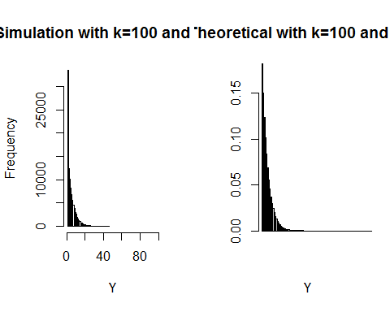

# Run 2  
par(mfrow=c(1,2))  
k<-100  
n<-5  
hist(problem1sim(k,n),breaks=60,  
 main=paste("Simulation with k=",k," and n=",n,sep=""),  
 xlab="Y",xlim=c(1,k))  
pY<-((k-1:k+1)^n-(k-1:k)^n)/k^n  
barplot(pY,main=paste("Theoretical with k=",k," and n=",n,sep=""),  
 xlab="Y",xlim=c(1,k))

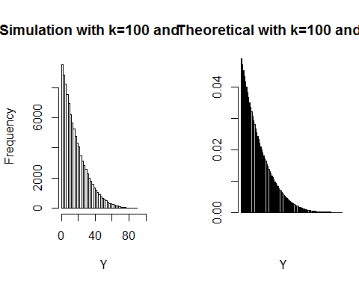

# Run 3  
par(mfrow=c(1,2))  
k<-20  
n<-5  
hist(problem1sim(k,n),breaks=60,  
 main=paste("Simulation with k=",k," and n=",n,sep=""),  
 xlab="Y",xlim=c(1,k))  
pY<-((k-1:k+1)^n-(k-1:k)^n)/k^n  
barplot(pY,main=paste("Theoretical with k=",k," and n=",n,sep=""),  
 xlab="Y",xlim=c(1,k))

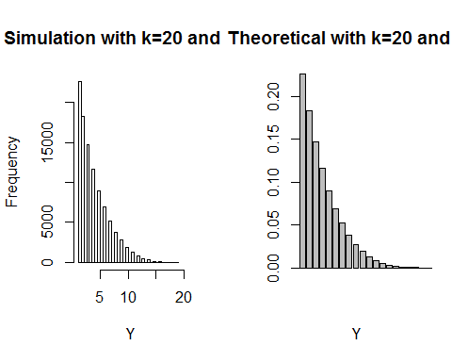

# Run 4  
par(mfrow=c(1,2))  
k<-20  
n<-100  
hist(problem1sim(k,n),breaks=60,  
 main=paste("Simulation with k=",k," and n=",n,sep=""),  
 xlab="Y",xlim=c(1,k))  
pY<-((k-1:k+1)^n-(k-1:k)^n)/k^n  
barplot(pY,main=paste("Theoretical with k=",k," and n=",n,sep=""),  
 xlab="Y",xlim=c(1,k))

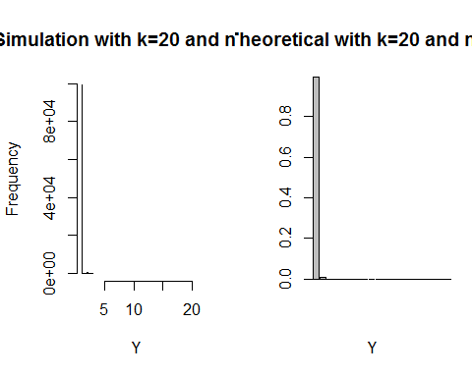

## Problem 2

Your organization owns a copier (future lawyers, etc.) or MRI (future doctors). This machine has a manufacturer’s expected lifetime of 10 years. This means that we expect one failure every ten years. (Include the probability statements and R Code for each part.).

With one failure every ten years $p=0.1$ and $q=1−p=0.9$. In this scenario, a failure of the machine is considered *success* in probability distributions.

### PART A

*What is the probability that the machine will fail after 8 years? Provide also the expected value and standard deviation. Model as a geometric. (Hint: the probability is equivalent to not failing during the first 8 years?)*

For geometric distribution, CDF $F_{X}(k)=P(X≤k)=1−q^{k+1}$, where $k$ is the number of failures before the first success (which is how R defines geometric distribution). Alternatively, $P(X>k)=1−P(X≤k)=1−(1−q^{k+1})=q^{k+1}$. So for $k=8$, $P(X>8)={0.9}^{9}≈0.3874$.

# Calculating P(X>8) using geometric distribution  
pgeom(8, 0.1, lower.tail=FALSE)

## [1] 0.3874205

Expected number of years before the first machine failure is $E(X)=q/p=0.9/0.1=9$.

Standard deviation $σ^{2}=\sqrt{q/p^{2}}=\sqrt{0.9/{0.1}^{2}}≈9.4868$.

### PART B

*What is the probability that the machine will fail after 8 years? Provide also the expected value and standard deviation. Model as an exponential.*

For exponential distribution, CDF $F_{X}(k)=P(X≤k)=1−e^{−λk}$, where $λ$ is the rate parameter. For this example, $λ=0.1$. $P(X>k)=1−P(X≤k)=1−(1−e^{−λk})=e^{−λk}$. So for $k=8$, $P(X>8)=e^{−0.8}≈0.4493$.

# Calculating P(X>8) using exponential distribution  
pexp(8, 0.1, lower.tail=FALSE)

## [1] 0.449329

Expected value is $E(X)=1/λ=1/0.1=10$.

Standard deviation $σ^{2}=\sqrt{1/λ^{2}}=1/λ=10$.

### PART C

*What is the probability that the machine will fail after 8 years? Provide also the expected value and standard deviation. Model as a binomial. (Hint: 0 success in 8 years)*

For binomial distribution, $P(X=k)=\left({n \atop k}\right)p^{k}q^{n−k}$. Probability of a machine failure after 8 years is the same as probability of 0 *successes* after 8 trials. So for $k=0$ and $n=8$, $P(X=0)=\left({8 \atop 0}\right){0.1}^{0}×{0.9}^{8−0}=1×1×{0.9}^{8}≈0.4305$.

# Calculating P(X=0) for n=8 using binomial distribution  
pbinom(0,8,0.1,lower.tail=TRUE)

## [1] 0.4304672

Expected value and standard deviation will depend on number of years/trials tracked. Consider first 8 years.

Expected value $E(X)=np=8×0.1=0.8$.

Standard deviation $σ^{2}=\sqrt{npq}=\sqrt{8×0.1×0.9}≈0.8485$.

### PART D

*What is the probability that the machine will fail after 8 years? Provide also the expected value and standard deviation. Model as a Poisson.*

On average we observe $λ=0.1$ machine failures per year. For Poisson distribution, $P(X=k)=\frac{e^{−λ}λ^{k}}{k!}$. Probabilty of a machine failure after 8 years is the same as probability of 0 *successess* after 8 intervals (similarly to the binomial distribution). $P(no failures in 8 years)=P(X=0)^{8}=(\frac{e^{−0.1}×{0.1}^{0}}{0!})^{8}=(e^{−0.1})^{8}≈0.4493$

# Calculating P(X=0) for 8 intervals using Poisson distribution  
ppois(0,0.1,lower.tail=TRUE)^8

## [1] 0.449329

For Poisson distribution, $E(X)=σ^{2}=λ=0.1$.