APPTRONIX QUIZ AUGUST 2026
EASY-1,2,3,6,7,9,12
MEDIUM-4,5,8,10,11,16
HARD-13,14,17,20

- What is the remainder when 2¹⁰⁰ is divided by 101
- 1
- 2
- 50
- 100
Answer: option A
Explanation:Fermat's Little Theorem, which states that if p is a prime number, then for any integer a, a^{p} ≡a (mod) p

2. For a set S with n elements, what is the number of subsets that have an even number of elements?
- 2^{n-1}
- 2^{n}
- 2^{n-1} - 1
- 2^{n-1} + 1
Answer: option A
Explanation: The number of subsets with an even number of elements is exactly equal to the number of subsets with an odd number of elements. Since the total number of subsets is 2^{n} both categories are exactly half of the total.

3. Evaluate the double Integral $\int{}\int_{R}{}xy dA, where R is the region bounded by x=0, y=x, and x=2.$
- 2
- 4
- 6
- 8
Answer: option A
Explanation: Integrating with respect to y from 0 to x, and then with respect to x from 0 to 2, gives a final result of 2.

4. A box contains 5 red, 4 blue, and 3 green balls.Three balls are drawn at random. What is the probability that the three balls are all of different colors?
- 3/11
- 2/11
- 3/22
- 5/11
Answer: option A


5. The base of a pyramid is a square with a side length of 10cm, and its height is 12cm. Find the total surface area of the pyramid?
- 260 sq. cm
- 360 sq. cm
- 460 sq. cm
- 400 sq. cm
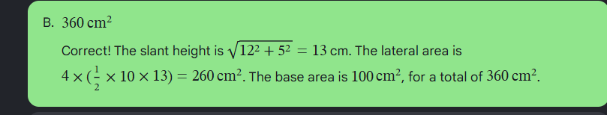

6. Find the value of cosh(i$π)$
- 1
- -1
- 0
- i
Answer: option B
Explanation: by using identity linking hyperbolic functions and trigonometric functions,
cosh(x)=cos(ix), we get cosh(i$π)$=cos($i^{2}π)= cos(-π)$ = -1



