Solving Simultaneous Equations

Task 1: Solve each simultaneous equation by scaling then adding.
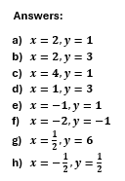
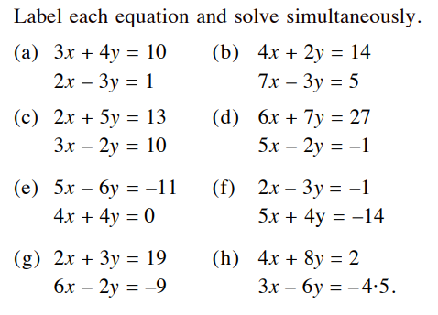

Task 2: Solve each by scaling then deciding whether to add or subtract.
