

PROJECT REPORT
COLLEGE CODE: 8227
COLLEGE NAME: Government College of Engineering, Thanjavur.
DEPARTMENT: Computer Science and Engineering
STUDENT NM-ID: 4f005c9b959405089fc422bdec15bc70
REG NO: 822723104021,822723104033,822723104042, 822723104501
DATE: 04-10-2025
TECHNOLOGY: Salesforce Developer
PROJECT NAME: WhatNext Vision Motors

SUBMITTED BY,
NAME: MATHUMATHI (Team Leader)
NAME: RAMA S
NAME: SANGEETHA M
NAME: NITHYA R

1. Project Overview
WhatNext Vision Motors is a Salesforce CRM project designed to manage vehicle-related business operations through a centralized Salesforce application. The project covers vehicle inventory, dealers, customers, vehicle orders, test drives and service requests. The system also uses Salesforce automation to reduce manual work and improve consistency in business processes.
The central purpose of the project is to convert a manual vehicle-management process into an organized CRM workflow. Customer and vehicle information can be maintained in Salesforce, orders can be processed using business rules, dealers can be associated with transactions, test-drive reminders can be automated, and management information can be presented through reports and dashboards.

1.1 Project Purpose
- Maintain vehicle and inventory information in one Salesforce system.
- Maintain dealer and customer information.
- Manage vehicle orders and their statuses.
- Manage customer test-drive bookings.
- Manage vehicle service requests.
- Automate dealer assignment and customer reminders.
- Validate vehicle stock before confirming an order.
- Provide reports and dashboards for business visibility.

1.2 Scope
Area | Scope
Vehicle Management | Vehicle model, stock quantity, price, dealer and status
Dealer Management | Dealer name, location, dealer code, phone and email
Customer Management | Customer name, email, phone, address and preferred vehicle type
Order Management | Customer, vehicle, dealer, order date and order status
Test Drive Management | Customer, vehicle, test-drive date and status
Service Management | Customer, vehicle, service date, issue description and status
Automation | Flows, stock validation, stock update, batch and scheduled processing
Analytics | Reports and dashboards

2. Objectives
- Create a centralized Salesforce CRM application for WhatNext Vision Motors.
- Design a connected data model for vehicles, dealers, customers, orders, test drives and service requests.
- Reduce manual processing by implementing Salesforce Flow automation.
- Prevent invalid vehicle orders when inventory is unavailable.
- Keep vehicle stock synchronized with confirmed orders.
- Provide automated test-drive reminders to customers.
- Process pending orders when stock becomes available.
- Provide reports and dashboards for operational visibility.
- Maintain professional documentation, screenshots and testing evidence for submission.

2.1 Business Value
- Centralized customer and vehicle information.
- Improved visibility of vehicle stock and order status.
- Reduced manual intervention in repetitive processes.
- More consistent order and inventory processing.
- Timely customer communication for test drives.
- Better management visibility through reports and dashboards.

3. System Architecture and Data Model
The application is organized around six main custom objects. Lookup relationships connect transactional records with the relevant customer, vehicle and dealer records
.
Object | Purpose | Important Fields
Vehicle | Stores vehicle and inventory information | Vehicle Name, Vehicle Model, Stock Quantity, Price, Dealer, Status
Vehicle Dealer | Stores dealer information | Dealer Name, Dealer Location, Dealer Code, Phone, Email
Vehicle Customer | Stores customer information | Customer Name, Email, Phone, Address, Preferred Vehicle Type
Vehicle Order | Stores vehicle purchase orders | Order Number, Customer, Vehicle, Dealer, Order Date, Status
Vehicle Test Drive | Tracks test-drive bookings | Test Drive Number, Customer, Vehicle, Test Drive Date, Status
Vehicle Service Request | Tracks vehicle service requests | Service Request Number, Customer, Vehicle, Service Date, Issue Description, Status

3.1 Relationship Model
- Vehicle has a lookup relationship to Vehicle Dealer.
- Vehicle Order has lookup relationships to Vehicle Customer and Vehicle.
- Vehicle Order also contains a Dealer lookup used for dealer assignment.
- Vehicle Test Drive has lookup relationships to Vehicle Customer and Vehicle.
- Vehicle Service Request has lookup relationships to Vehicle Customer and Vehicle.

4. Phase 1 – Requirement Analysis
Phase 1 establishes the business requirements and translates them into Salesforce objects, fields, relationships and automation requirements.

4.1 Functional Requirements
- Create and maintain vehicle records.
- Maintain dealer records and dealer locations.
- Maintain customer records and preferred vehicle types.
- Create and manage vehicle orders.
- Assign a dealer to a pending order based on customer information.
- Prevent orders when vehicle stock is unavailable.
- Update stock when an order is confirmed.
- Schedule and manage test drives.
- Send a reminder before a scheduled test drive.
- Create and manage vehicle service requests.
- Provide reports and dashboards.

4.2 Non-Functional Considerations
- Use Salesforce standard security and access controls.
- Maintain consistent field types and relationships.
- Use automation where it reduces repetitive manual work.
- Use professional documentation and testing evidence.
- Keep deployment and maintenance manageable through Salesforce metadata.

5. Phase 2 – Backend Development and Automation
Phase 2 focuses on Salesforce configuration, data model implementation and programmatic automation.

5.1 Salesforce Objects and Fields
Object | Key Configuration
Vehicle | Vehicle Name, Vehicle Model picklist, Stock Quantity number, Price currency, Status picklist, Dealer lookup
Vehicle Dealer | Dealer Name, Dealer Location, Dealer Code auto-number, Phone, Email
Vehicle Customer | Customer Name, Email, Phone, Address, Preferred Vehicle Type picklist
Vehicle Order | Order Number auto-number, Customer lookup, Vehicle lookup, Dealer lookup, Order Date, Status picklist
Vehicle Test Drive | Test Drive Number auto-number, Customer lookup, Vehicle lookup, Test Drive Date, Status picklist
Vehicle Service Request | Service Request Number auto-number, Customer lookup, Vehicle lookup, Service Date, Issue Description, Status picklist

5.2 Flow Automation – Dealer Assignment
A record-triggered Flow is used for pending vehicle orders. When a pending order is created, the Flow retrieves the related customer, finds the appropriate dealer using the available customer/dealer location information, and updates the order with the selected dealer.
- Vehicle Order is created with Status = Pending.
- Flow retrieves the related Vehicle Customer.
- Flow retrieves the matching Vehicle Dealer.
- Flow updates the Vehicle Order Dealer field.
- The order continues through the remaining order process.

5.3 Flow Automation – Test Drive Reminder
A record-triggered Flow with a scheduled path is used for scheduled test drives. The reminder path is configured relative to the Test Drive Date so that a customer can receive a reminder one day before the scheduled test drive.
- Test Drive record is created or updated with Status = Scheduled.
- Scheduled Path waits until one day before the Test Drive Date.
- Flow retrieves the related customer.
- Email reminder action sends the test-drive reminder to the customer.

5.4 Apex Automation
- The project also requires Apex-based automation for stock validation and inventory processing. The exact implementation should use the API names generated in the Salesforce org rather than relying on manually typed field names.
- Apex Trigger and Trigger Handler for vehicle-order stock validation.
- Reject an order when the selected vehicle has no available stock.
- Reduce vehicle stock when an order is confirmed.
- Batch Apex to process eligible pending orders when stock becomes available.
- Scheduled Apex to run the batch process automatically.

6. Phase 3 – UI Customization
The Salesforce Lightning application is organized as a dedicated WhatNext Vision Motors app so that users can access the main business objects from a single navigation bar.

6.1 Lightning App
Navigation Item | Purpose
Vehicle | Vehicle and stock management
Vehicle Dealer | Dealer management
Vehicle Customer | Customer management
Vehicle Order | Order management
Vehicle Test Drive | Test-drive management
Vehicle Service Request | Service management
Reports | Business reports
Dashboards | Management analytics

6.2 User Interface Considerations
- Use clear object labels and field labels.
- Keep related records accessible through lookup relationships.
- Use appropriate picklist values for controlled statuses.
- Provide useful list views for operational records.
- Use reports and dashboards for management-level visibility.

7. Phase 4 – Data Migration and Security
The submission guidelines require Phase 4 coverage of data migration and security. These activities should be documented based on the actual implementation performed in the Salesforce org.

7.1 Data Migration
- Prepare source data for vehicles, dealers and customers in a structured format.
- Validate required fields and lookup references before loading data.
- Load data using appropriate Salesforce import tools when required.
- Verify record counts, relationships and important values after migration.
- Record any data-cleaning or duplicate-handling steps used during the project.
- Implementation evidence to insert here: screenshots of imported records, import process and validation results.

7.2 Security
- Use Salesforce user access controls and profiles/permission sets as appropriate.
- Restrict access to sensitive records and fields according to project requirements.
- Use object permissions and field-level security where required.
- Review sharing/access settings before deployment.
- Do not include passwords, security tokens, access keys or other secrets in the documentation or GitHub repository.

8. Phase 5 – Deployment, Maintenance and Documentation

8.1 Deployment Strategy
- Maintain Salesforce metadata in a version-controlled project using Salesforce CLI and Git.
- Retrieve and organize custom objects, fields, flows, Apex classes and triggers as metadata.
- Commit changes to Git with meaningful messages.
- Validate metadata before deploying to the target Salesforce environment.
- Perform post-deployment functional testing.

8.2 Maintenance Approach
- Monitor Flow and Apex execution for failures.
- Review stock and order automation periodically.
- Update picklist values and business rules when requirements change.
- Review reports and dashboards as business needs evolve.
- Maintain version history through GitHub.
- Document future changes before implementing them in production.

8.3 Documentation Summary
The final submission should contain the implemented design, configuration, automation, testing evidence, screenshots and deployment/maintenance notes. Screenshots should be captured from the actual Salesforce org after each major feature has been completed.

9. Reports and Dashboards
The project requires reporting and dashboard capabilities for operational visibility. The following report areas are recommended based on the project requirements:
Report / Dashboard Component | Purpose
Order Status Report | View Pending, Confirmed, Delivered and Canceled orders
Vehicle Stock Report | Monitor available and out-of-stock vehicles
Dealer Performance Report | Analyze order/dealer activity
Sales Metrics | Summarize vehicle order activity
Management Dashboard | Present key order, stock and sales metrics in one view

Actual report names, filters, charts and screenshots should be updated after implementation.

10. Validation, Approval Processes and Business Rules
The submission guidelines require screenshots of validation rules and approval processes. The project requirements explicitly include stock validation and automated order processing. Any approval process that is implemented should be documented with its entry criteria, approver, actions and outcome.

10.1 Stock Validation
- Before an order is confirmed, the selected vehicle's stock should be checked.
- An out-of-stock vehicle should not be allowed to proceed as a confirmed order.
- The validation should produce a clear user-facing error or controlled automation outcome.

10.2 Approval Process Evidence
If an approval process is part of the final implementation, insert the approval configuration and test-result screenshots in this section. If no approval process is implemented, state that explicitly rather than claiming one.

11. Testing and Test Cases
Test Case | Input / Condition | Expected Result | Result
TC-01 | Create Vehicle with valid details | Vehicle record is created successfully | To be tested
TC-02 | Create Dealer with valid details | Dealer record is created successfully | To be tested
TC-03 | Create Customer with valid details | Customer record is created successfully | To be tested
TC-04 | Create Pending Order | Dealer assignment automation runs | To be tested
TC-05 | Create order for vehicle with zero stock | Order is rejected/blocked according to implemented rule | To be tested
TC-06 | Confirm an order with available stock | Vehicle stock decreases by one | To be tested
TC-07 | Schedule a Test Drive | Test-drive record is created | To be tested
TC-08 | Test Drive is scheduled for tomorrow | Reminder is sent one day before | To be tested
TC-09 | Pending order becomes eligible after stock arrives | Batch processing can confirm eligible order | To be tested
TC-10 | Open Reports/Dashboard | Required metrics are displayed | To be tested

12. Screenshot Evidence Checklist
The submission guidelines require screenshots of objects, flows, validation rules, approval processes and reports. Insert the actual Salesforce screenshots in the corresponding places before final submission.

12.1 Salesforce Setup / Object Manager
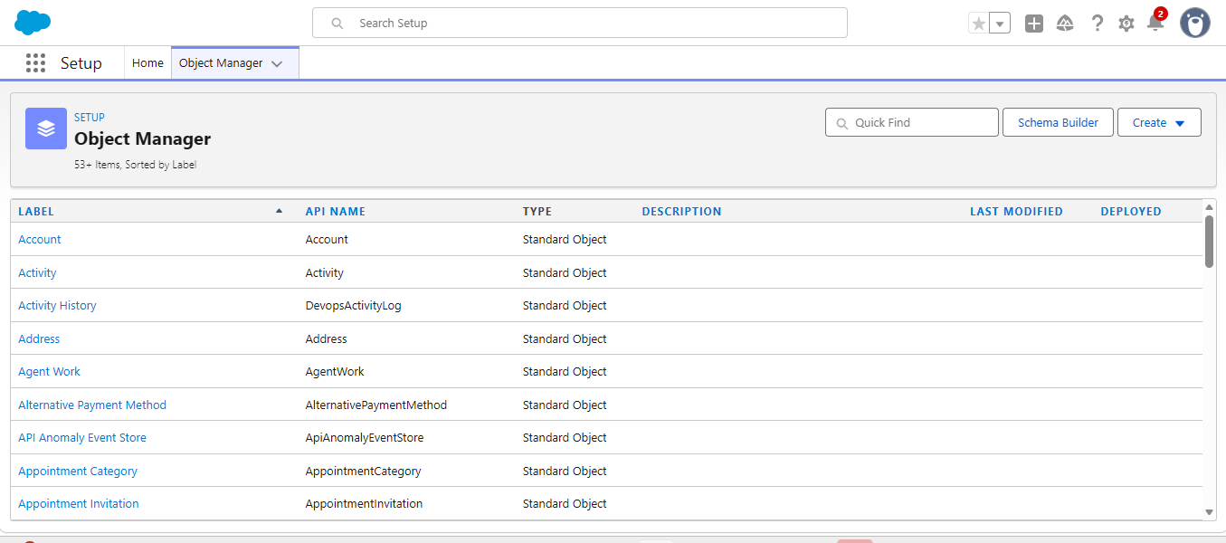
12.1 Salesforce Setup / Object Manager
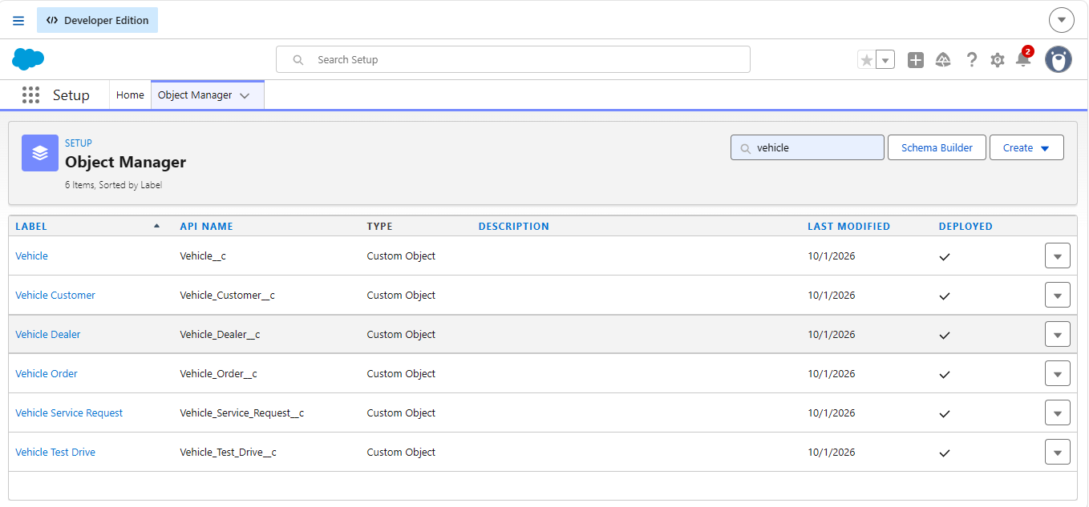

12.2 Vehicle Object
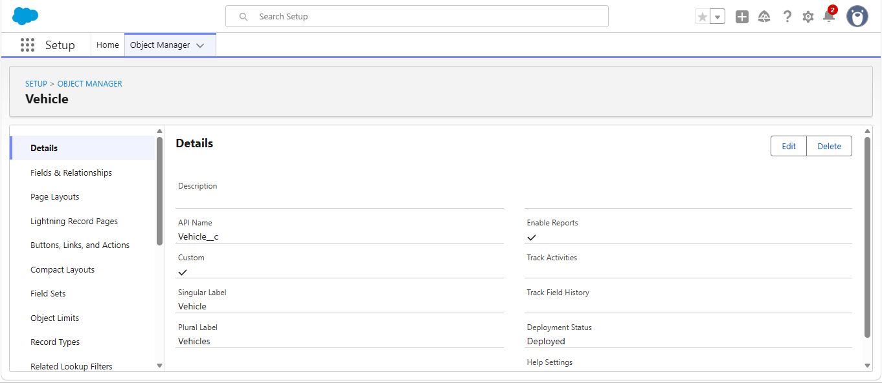

12.2 Vehicle Object
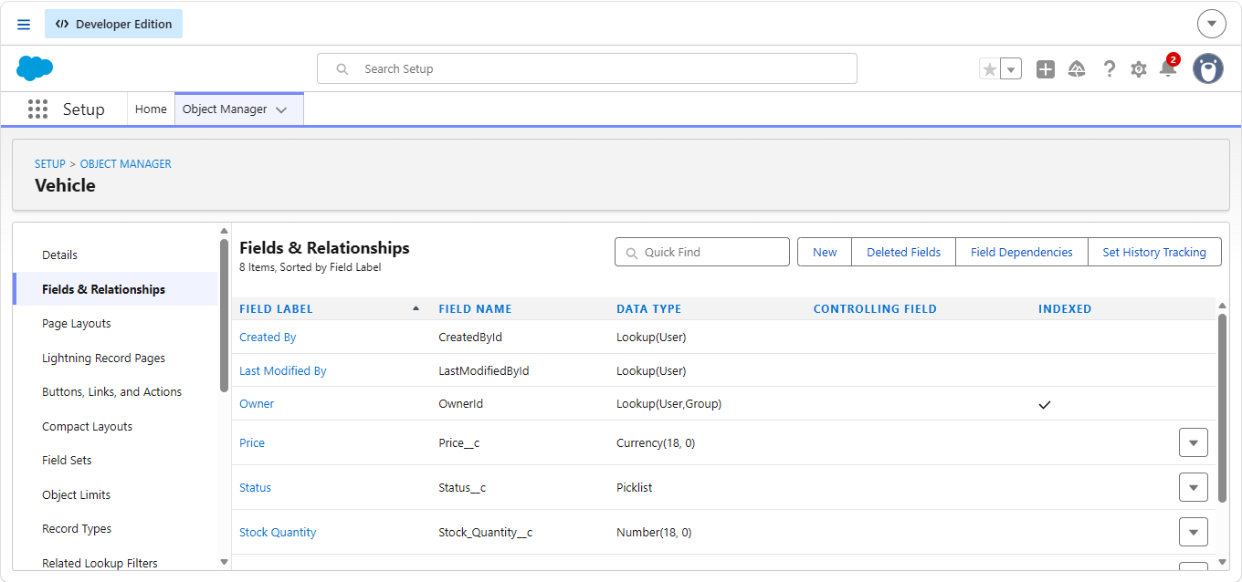

12.3 Vehicle Dealer Object
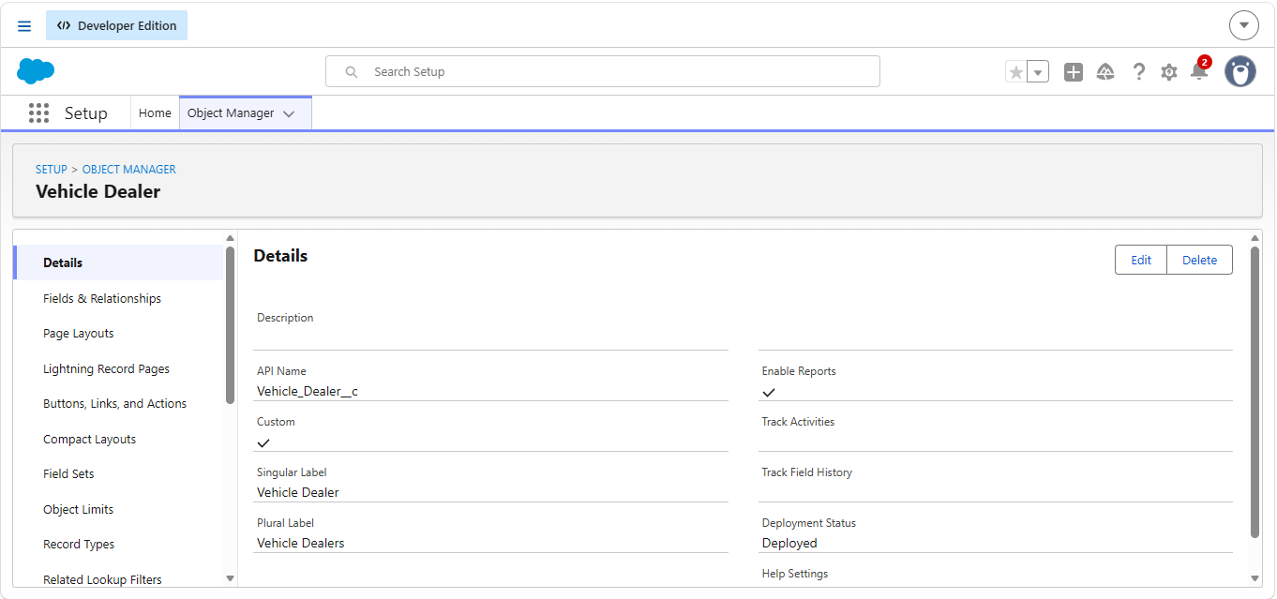
12.3 Vehicle Dealer Object
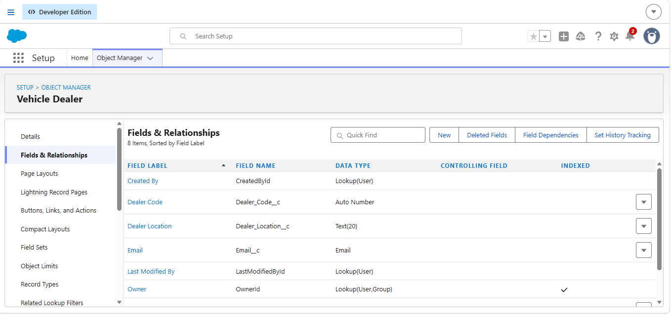

12.4 Vehicle Order Object
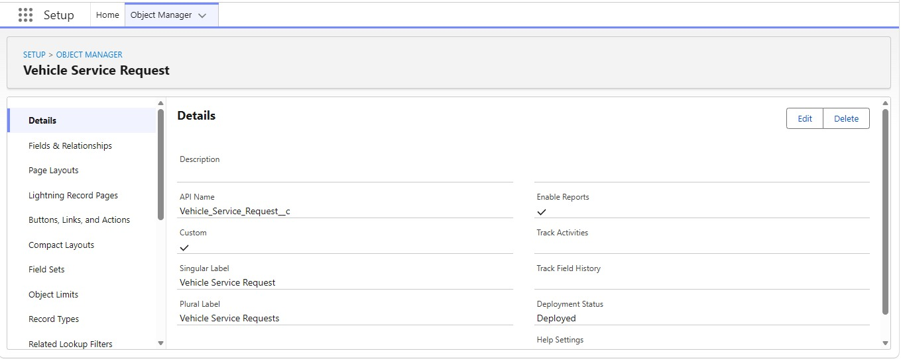

12.4 Vehicle Order Object
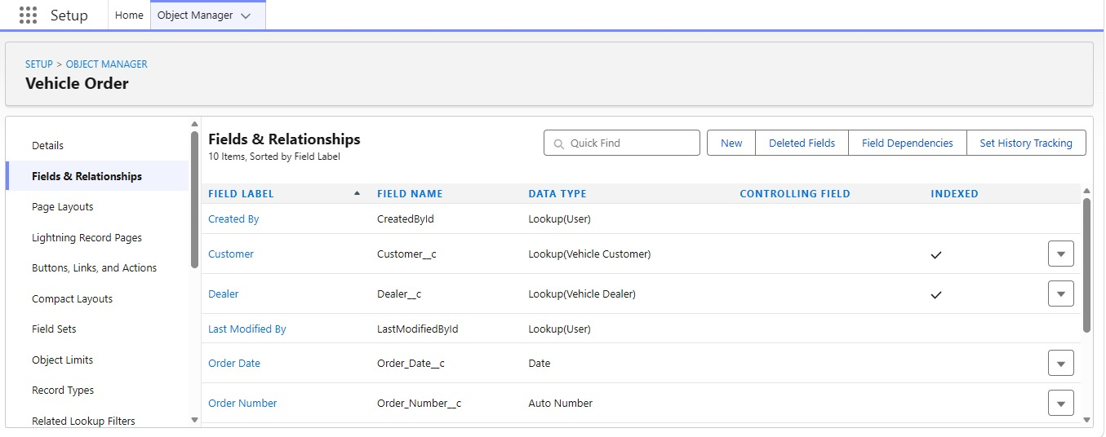

12.5 Vehicle Customer Object

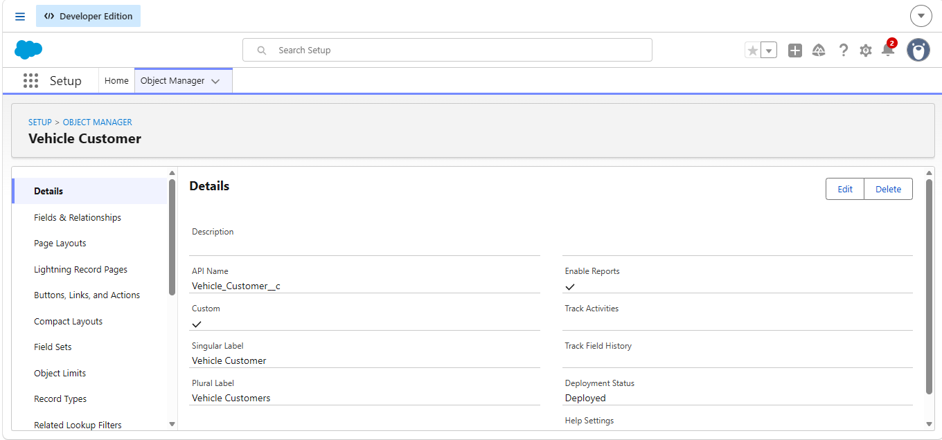

12.5 Vehicle Customer Object
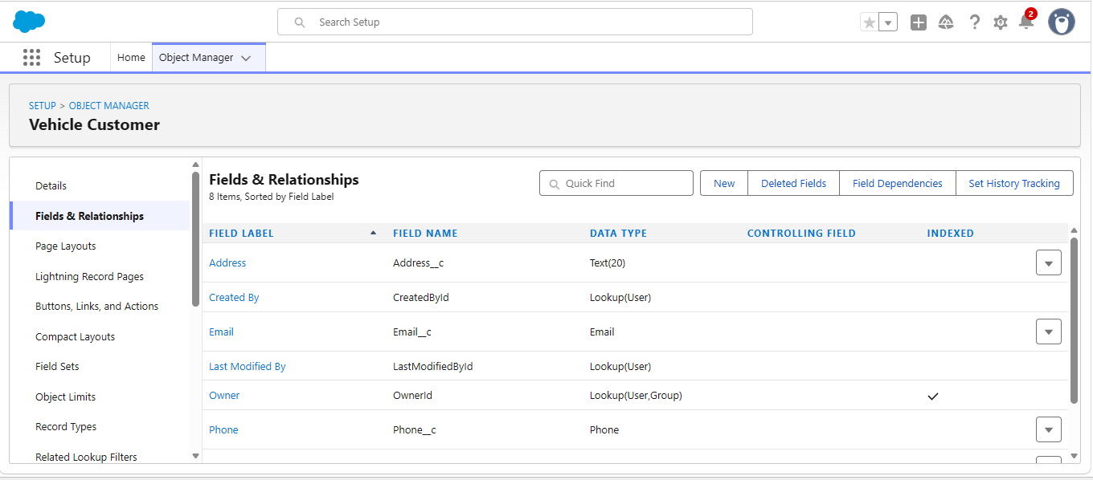

12.6 Vehicle Test Drive Object

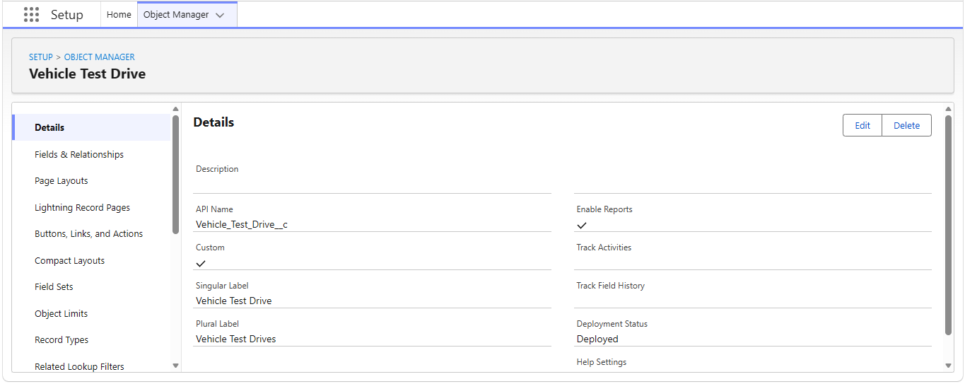

12.6 Vehicle Test Drive Object

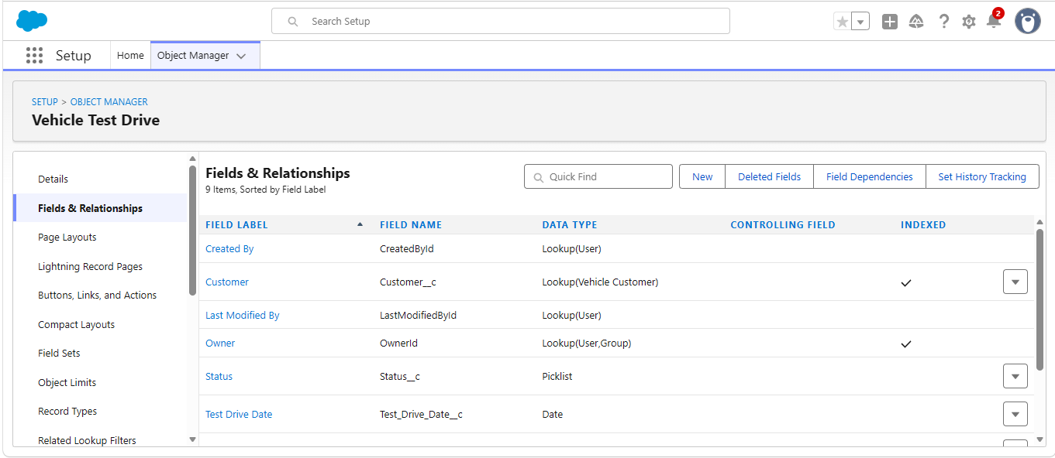

12.7 Vehicle Service Request Object

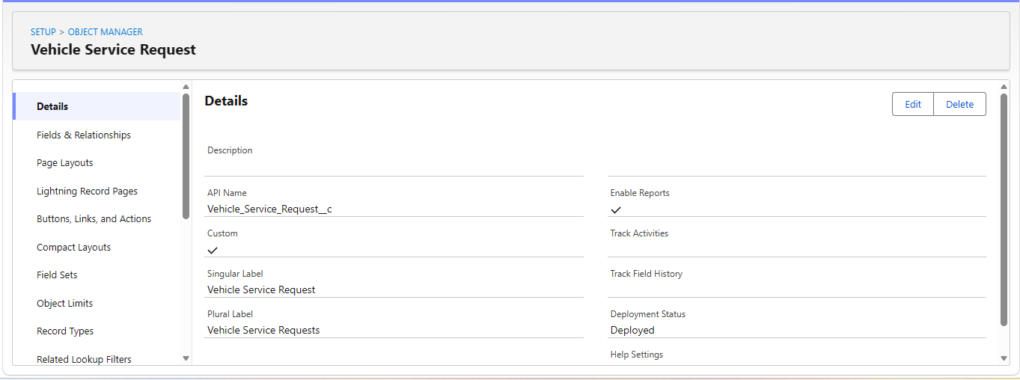

12.7 Vehicle Service Request Object

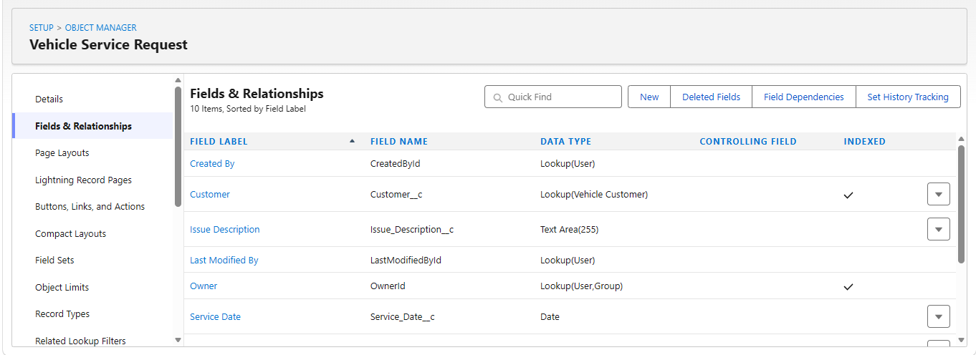

12.8 Dealer Assignment Flow

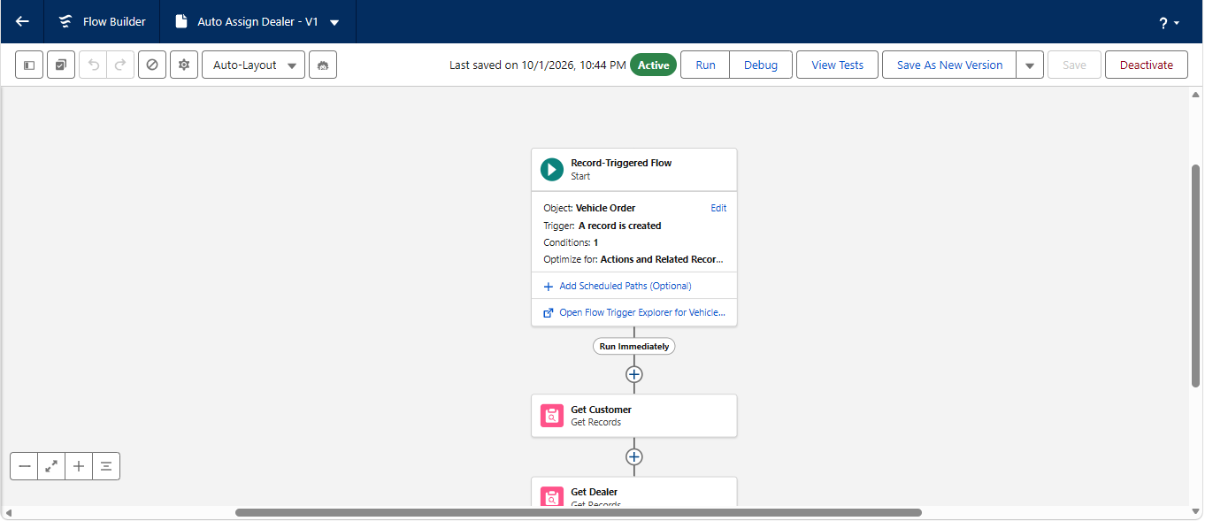

12.8 Dealer Assignment Flow
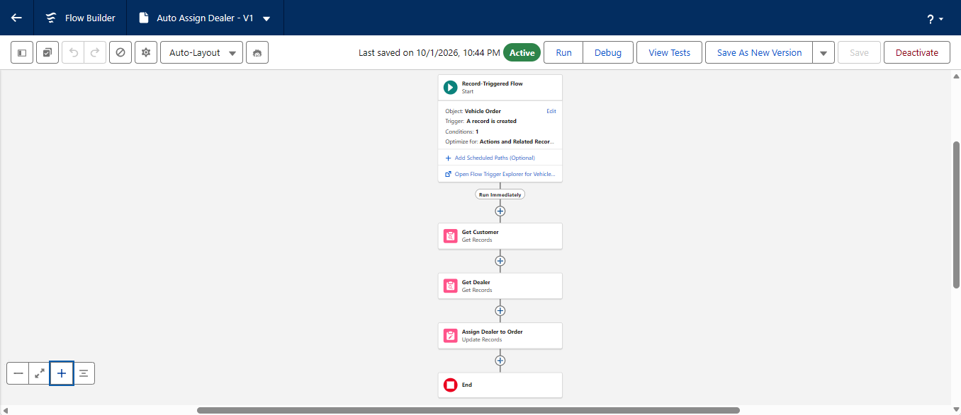

12.9 Test Drive Reminder Flow
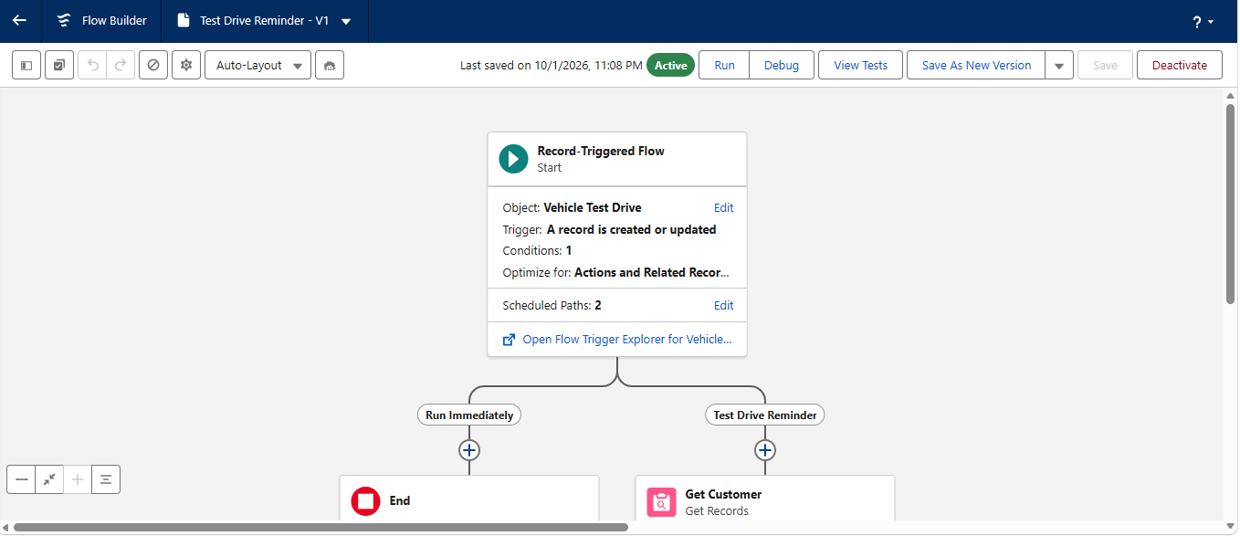

12.9 Test Drive Reminder Flow
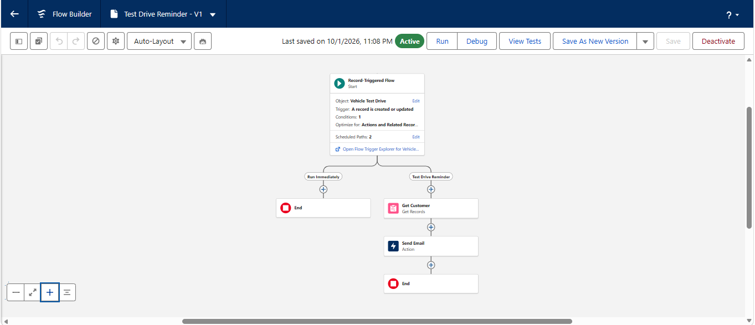

12.10 Validation Rules
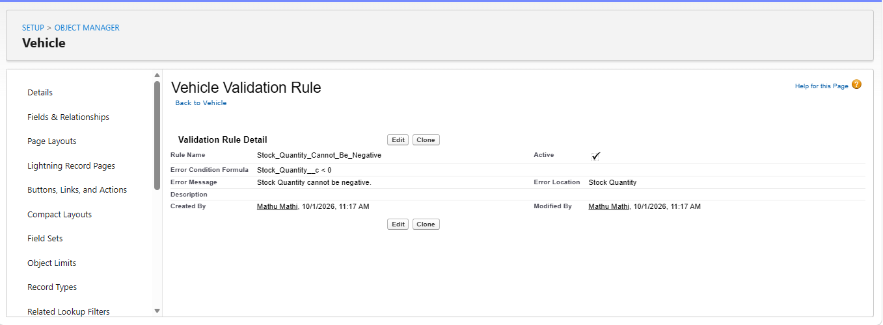
12.10 Validation Rules
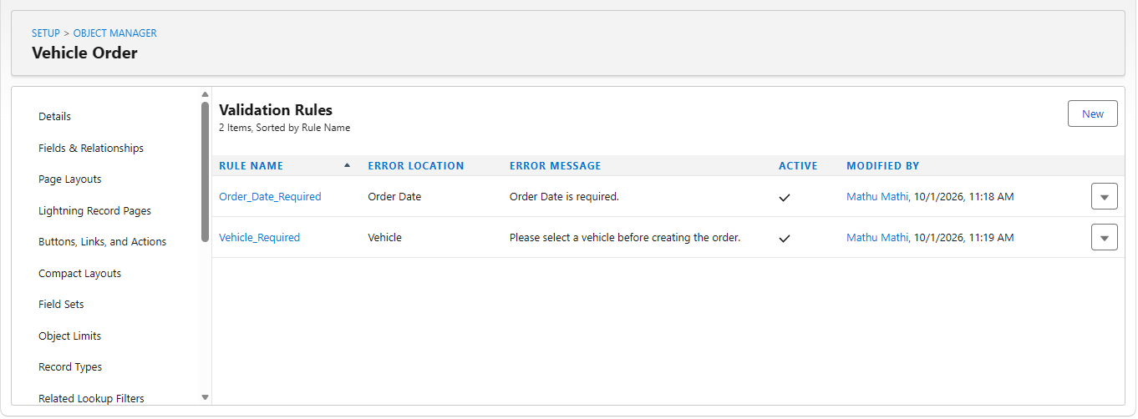

12.12 Reports
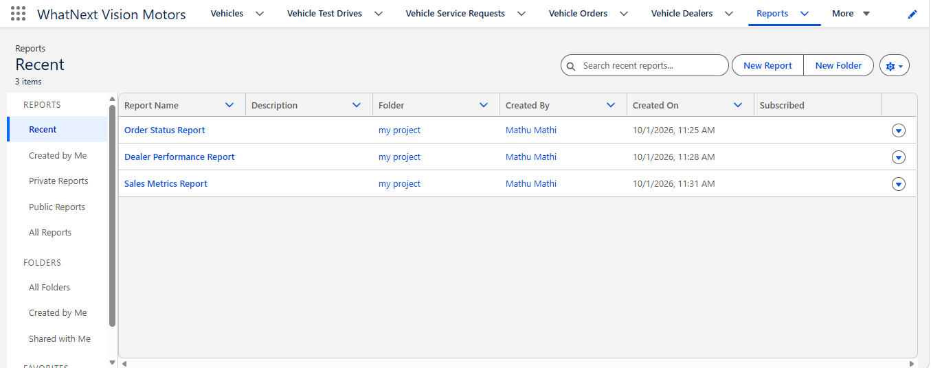
12.12 Reports
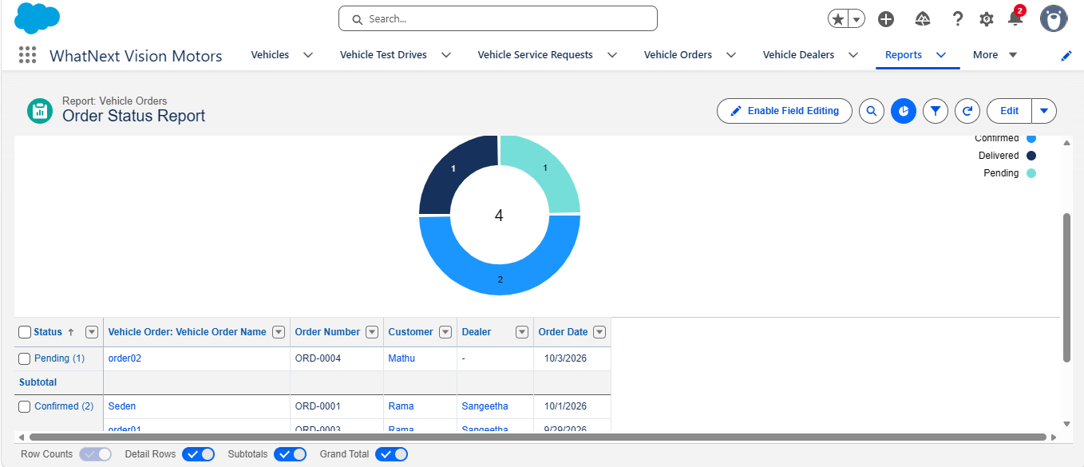

12.13 Dashboard
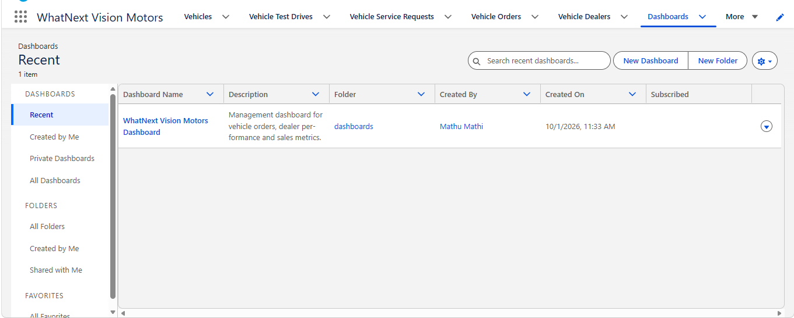
12.13 Dashboard
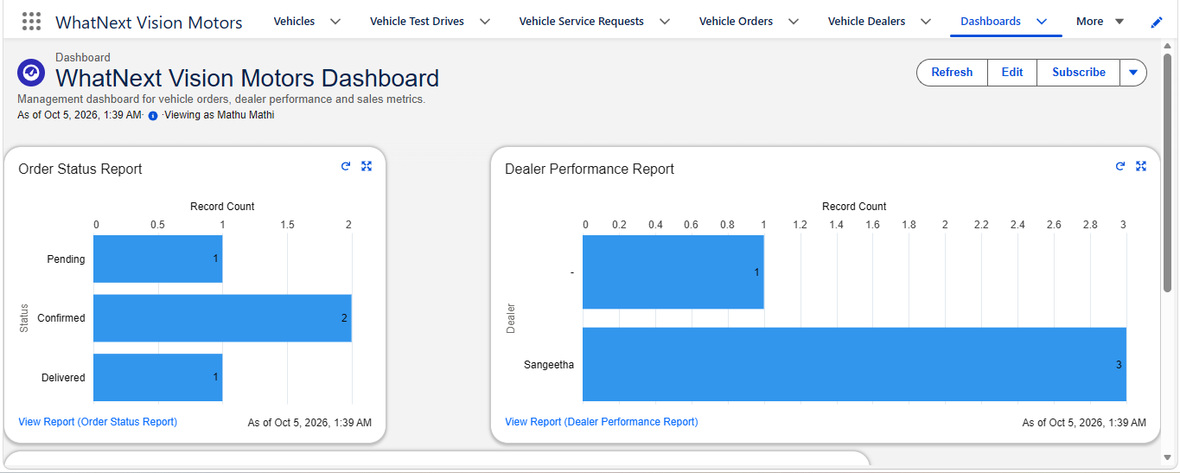

12.14 Approval Process

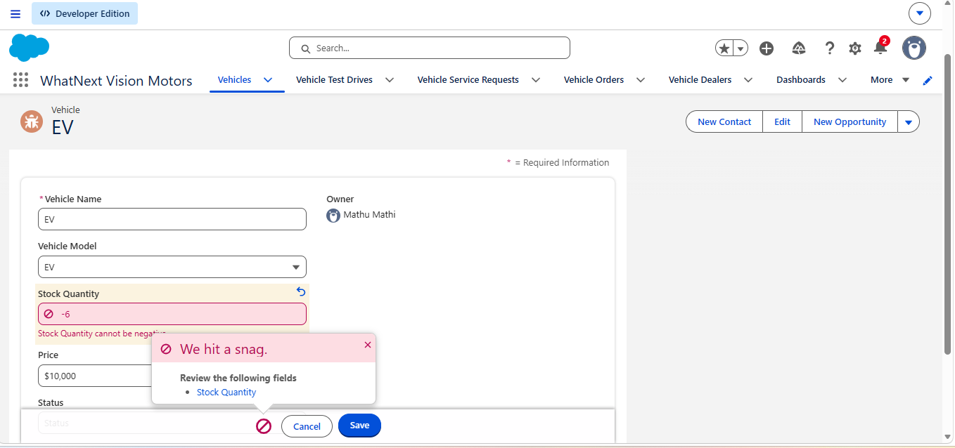

13. Version Control and GitHub
The project should be maintained using GitHub for version control. Salesforce metadata can be retrieved using Salesforce CLI into a local Salesforce DX project and committed to Git.
- Create a GitHub repository for the project.
- Create or open the Salesforce DX project in VS Code.
- Authenticate the Salesforce Developer Org using Salesforce CLI.
- Retrieve the implemented metadata from the org.
- Review objects, fields, flows, Apex classes and triggers in the local project.
- Commit the changes with meaningful commit messages.
- Push the repository to GitHub.
- Never commit passwords, access tokens, secret keys or other credentials.
Repository name: https://github.com/mathuammu6805-bot/WhatNextVisionMotors.git

14. Conclusion
The WhatNext Vision Motors Salesforce project provides a structured CRM approach for vehicle-related business operations. The solution brings vehicle, dealer and customer information together and connects these records to order, test-drive and service processes. Salesforce Flow and Apex automation are used to reduce repetitive manual work and enforce business rules, while reports and dashboards provide management visibility.
The project also provides practical experience in Salesforce object modeling, relationships, Flow automation, Apex development, data handling, security, testing, deployment and version control. The final documentation should be updated with actual implementation results and screenshots before submission.

15. Project Learning Outcomes
- Understanding Salesforce custom objects and fields.
- Understanding lookup relationships and CRM data modeling.
- Building Record-Triggered Flows and Scheduled Paths.
- Understanding Apex Trigger and Trigger Handler architecture.
- Understanding Batch Apex and Scheduled Apex.
- Creating Salesforce reports and dashboards.
- Applying testing and documentation practices.
- Using Salesforce CLI, VS Code and GitHub for version control.

Appendix A – Status of This Documentation Draft
This Word document is a professional documentation draft based on the project requirements and the submission guidelines provided. Sections marked “To be tested”, “To be inserted”, or similar must be replaced with evidence from the actual Salesforce implementation before final submission.

