# REACT APP CREATION

## Creating first react app Code:

**App.js**

import React from 'react';

import './App.css'; // make sure this is imported function App() {

return (

<div className="center">

<h1>Welcome to the first session of React</h1>

</div>

);

}

export default App;

## App.css

.center { display: flex;

justify-content: center; align-items: flex-start; margin-top: 50px; height: 100vh;

background-color: #f0f0f0;

}

# OUTPUT:

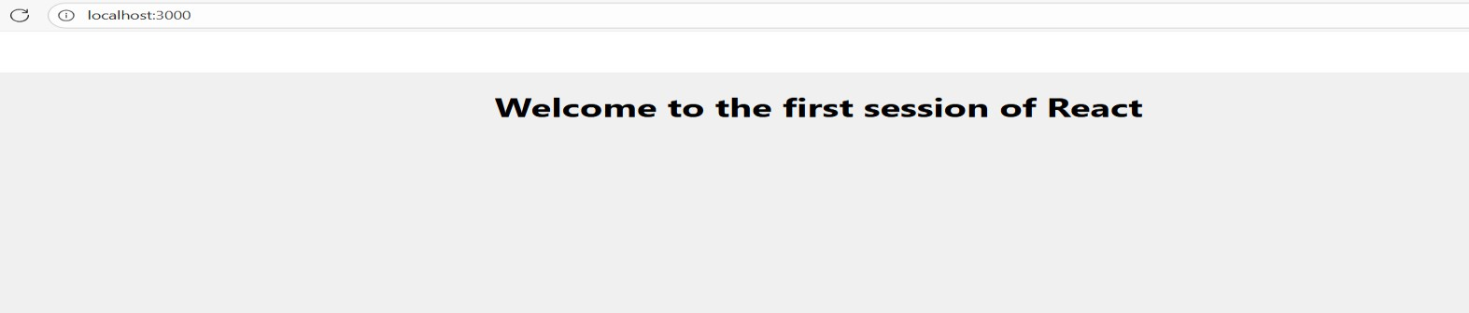

## Student Management Portal – React Application Code:

**Home.js**

import React from 'react'; function Home() {

return (

<div>

<h1>Welcome to the Home page of Student Management Portal</h1>

</div>

);

}

export default Home;

## About.js

import React from 'react'; function About() {

return (

<div>

<h1>Welcome to the About page of the Student Management Portal</h1>

</div>

);

}

export default About;

## Contact.js

import React from 'react'; function Contact() { return (

<div>

<h1>Welcome to the Contact page of the Student Management Portal</h1>

</div>

);

}

export default Contact;

## App.js

import React from 'react'; import Home from './Home'; import About from '. /About'; import Contact from './ Contact'; function App() {

return (

<div>

<Home />

<About />

<Contact />

</div>

);

}

export default App;

# OUTPUT:

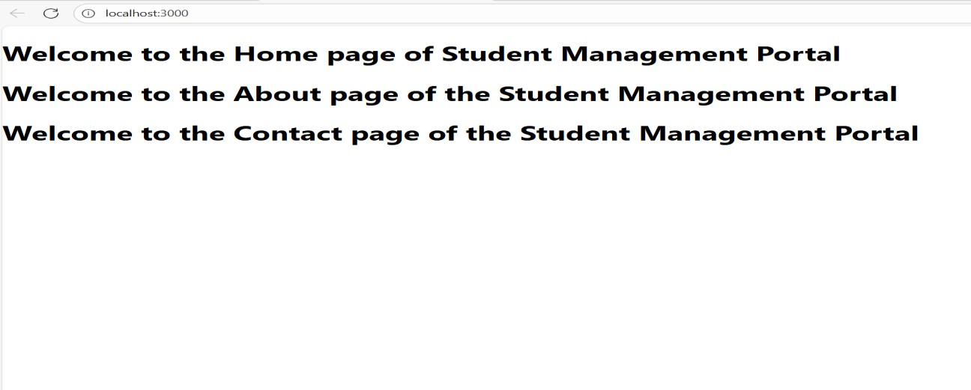

1. **Calculating Average Score-React Application**

**Code:**

**CalculateScore.js**

import React, { useState } from 'react'; import '../Stylesheets/mystyle.css';

function CalculateScore() {

const [name, setName] = useState(''); const [school, setSchool] = useState(''); const [total, setTotal] = useState(''); const [goal, setGoal] = useState('');

const [average, setAverage] = useState(null);

const handleCalculate = () => { const totalNum = parseFloat(total); const goalNum = parseFloat(goal);

if (!name || !school || isNaN(totalNum) || isNaN(goalNum) || totalNum <= 0) { alert('Please enter valid inputs');

return;

}

// average = (goal / total) * 100

const avgScore = (goalNum / totalNum) * 100; setAverage(avgScore.toFixed(2));

};

return (

<div className="container">

<h2>Student Score Calculator</h2>

<div className="form-group">

<label>Name:</label>

<input type="text" value={name}

onChange={(e) => setName(e.target.value)} placeholder="Enter student name"

/>

</div>

<div className="form-group">

<label>School:</label>

<input type="text" value={school}

onChange={(e) => setSchool(e.target.value)} placeholder="Enter school name"

/>

</div>

<div className="form-group">

<label>Total Marks:</label>

<input type="number" value={total}

onChange={(e) => setTotal(e.target.value)} placeholder="Enter total marks"

/>

</div>

<div className="form-group">

<label>Goal Marks:</label>

<input type="number" value={goal}

onChange={(e) => setGoal(e.target.value)} placeholder="Enter goal marks"

/>

</div>

<button onClick={handleCalculate}>Calculate Average Score</button>

{average !== null && (

<div className="result">

<h3>Result</h3>

<p>

Student <strong>{name}</strong> from <strong>{school}</strong> has an average score of <strong>{average}%</strong>.

</p>

</div>

)}

</div>

);

}

export default CalculateScore;

## mystyle.css

.container {

max-width: 400px; margin: 30px auto; padding: 20px;

border: 2px solid #4caf50; border-radius: 8px; background-color: #f9f9f9; font-family: Arial, sans-serif;

}

h2 {

text-align: center; color: #4caf50;

}

.form-group {

margin-bottom: 15px;

}

label {

display: block; margin-bottom: 6px; font-weight: bold;

}

input[type="text"], input[type="number"] { width: 100%;

padding: 8px;

box-sizing: border-box;

}

button {

background-color: #4caf50; color: white;

padding: 10px 15px; border: none;

border-radius: 4px; cursor: pointer; width: 100%;

font-size: 16px;

}

button:hover {

background-color: #45a049;

}

.result {

margin-top: 20px; padding: 15px;

background-color: #dff0d8; border: 1px solid #3c763d; border-radius: 5px;

color: #3c763d; font-weight: bold;

}

## App.js

import React from 'react';

import CalculateScore from './Components/CalculateScore';

function App() { return (

<div>

<CalculateScore />

</div>

);

}

export default App;

# OUTPUT:

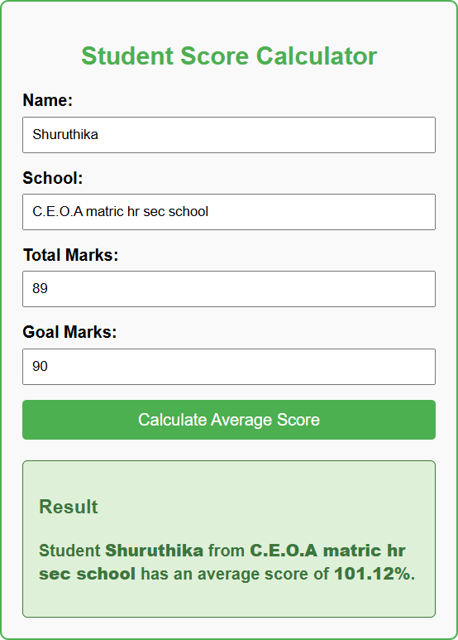

## BLOG APP- React Application Code:

**Post.js**

class Post {

constructor(id, title, body) { this.id = id;

this.title = title; this.body = body;

}

}

export default Post;

## Posts.js

import React, { Component } from 'react'; import Post from './Post';

class Posts extends Component { constructor(props) { super(props);

this.state = { posts: [], error: null

};

}

// Method to fetch posts using Fetch API loadPosts() { fetch('https://jsonplaceholder.typicode.com/posts')

.then(response => {

if (!response.ok) {

throw new Error('Network response was not OK');

}

return response.json();

})

.then(data => {

// Convert JSON data to array of Post instances

const posts = data.map(p => new Post(p.id, p.title, p.body)); this.setState({ posts });

})

.catch(error => { this.setState({ error });

});

}

// Called automatically after component is mounted componentDidMount() {

this.loadPosts();

}

// Catch any error in rendering componentDidCatch(error, info) {

alert('An error occurred: ' + error.message);

}

render() {

const { posts, error } = this.state;

if (error) {

return <h2>Error loading posts</h2>;

}

return (

<div>

<h1>Blog Posts</h1>

{posts.map(post => (

<div key={post.id} style={{ border: '1px solid #ccc', marginBottom: '10px', padding: '10px' }}>

<h2>{post.title}</h2>

<p>{post.body}</p>

</div>

))}

</div>

);

}

}

export default Posts;

## App.js

import React from 'react'; import Posts from './Posts'; function App() {

return (

<div className="App">

<Posts />

</div>

);

}

export default App;

# OUTPUT:

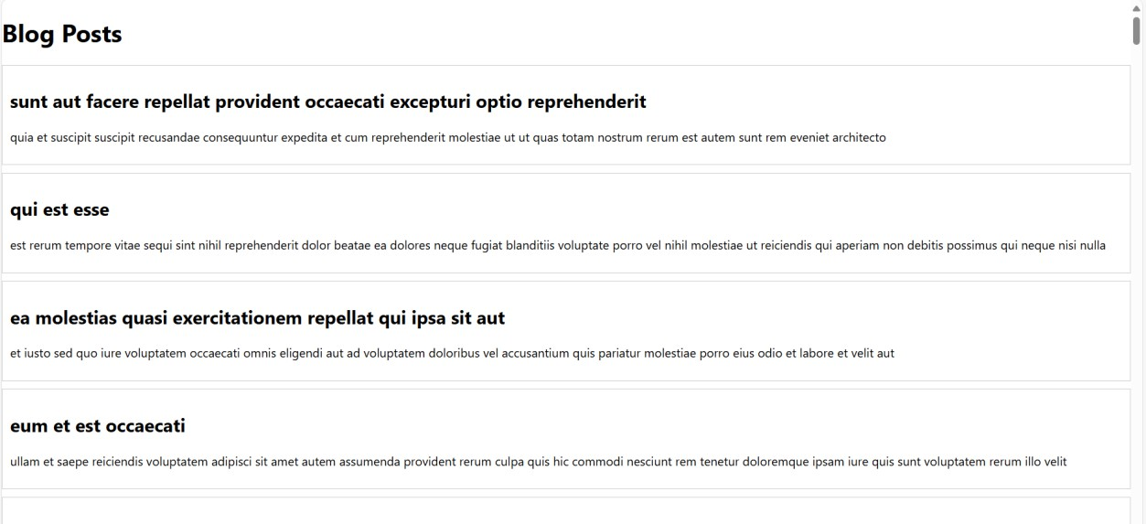

## Cohort Dashboard with Conditional Styling-React Application Code:

**CohortDetails.module.css**

.box {

width: 300px; display: inline-block; margin: 10px; padding: 10px 20px;

border: 1px solid black; border-radius: 10px;

}

dt {

font-weight: 500;

}

## CohortDetails.js

import React from 'react';

import styles from './CohortDetails.module.css'; // Import the CSS module

function CohortDetails({ cohort }) {

const { name, trainer, status, startDate, endDate } = cohort;

// Determine the color for the <h3> based on cohort status

const titleColor = status.toLowerCase() === 'ongoing' ? 'green' : 'blue';

return (

<div className={styles.box}>

<h3 style={{ color: titleColor }}>{name}</h3>

<dl>

<dt>Trainer:</dt>

<dd>{trainer}</dd>

<dt>Status:</dt>

<dd>{status}</dd>

<dt>Start Date:</dt>

<dd>{startDate}</dd>

<dt>End Date:</dt>

<dd>{endDate}</dd>

</dl>

</div>

);

}

export default CohortDetails;

## App.js

import React from 'react';

import CohortDetails from './components/CohortDetails'; function App() {

const cohorts = [

{

name: 'React Bootcamp', trainer: 'John Doe', status: 'ongoing', startDate: '2025-07-01',

endDate: '2025-08-01',

},

{

name: 'Node.js Mastery', trainer: 'Jane Smith', status: 'completed', startDate: '2025-05-15',

endDate: '2025-06-15',

},

];

return (

<div>

{cohorts.map((cohort, index) => (

<CohortDetails key={index} cohort={cohort} />

))}

</div>

);

}

export default App;

**OUTPUT:**

