
Sri Lanka Institute of Information Technology

IT2130 – Operating Systems and System Administration
Year 2, Semester 2- 2026

Practical Test Answer Submission

Student ID | IT24102099
Student Name | Mathuppriya Naguleswaran
Campus/ Center name | SLIIT – Northen UNI
Specialization | Software Engineering
Weekday/ Weekend | Weekday
Batch No | 1

Question 1
#include <stdio.h>
#include <unistd.h>
#include <sys/wait.h>
int main() {
int n;
printf("Enter an integer number : ");
scanf("%d",&n);

int pid = fork();
if (pid == 0) {
int a = 0;
int b= 1;
int next;

printf("Child Process\n");
printf("Process ID is (PID) :%d\n", getpid());
printf("Parent ID of the process is (PPID) : %d\n", getppid());

printf("Fibonacci Series: ");
for (int i= 0; i<n; i++) {
printf("%d ", a);
next = a + b;
a = b;
b = next;
} printf("\n");
} else {
wait(NULL);
printf("\nParent :Child process completed.\n");
}
return 0;
}
Here ,
- a = current number ,
- b = next number ,
- next = a + b

Explanation of the code : The parent process gets a positive integer from the user and creates a child process using fork(). The child process displays its PID and PPID, then generates and prints the Fibonacci series up to n terms. The parent process waits for the child process to complete using wait() and then prints a message indicating completion.

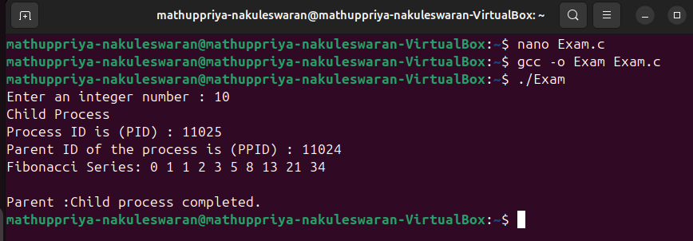 Figure 1 : Each process has a unique process ID.So we can identify each process unique and Different user input gave different output and Fibonacci series.
Question 2
#include <stdio.h>
#include <pthread.h>
#include <unistd.h>

void* work(void* arg) {
int n = *(int*)arg;

printf("Worker Thread ID: %lu\n", pthread_self());
printf("Process ID: %d\n", getpid());
printf("Prime numbers:\n");

for (int i = 2; i <= n; i++) {
int prime = 1;

for (int j = 2; j < i; j++) {
if (i % j == 0) {
prime = 0;
break;
}
}
if (prime) {
printf("%d ", i);
}
}
printf("\n");
return NULL;
}
int main() {
int n;
pthread_t t;

printf("Enter number: ");
scanf("%d", &n);

pthread_create(&t, NULL, work, &n);
pthread_join(t, NULL);
printf("Main thread: Worker thread finished.\n");
return 0;
}

Explanation of the code : The main thread takes a positive integer n from the user and creates a worker thread using pthread_create(). The worker thread generates and prints all prime numbers up to n, and displays its Thread ID using pthread_self() and Process ID using getpid(). The main thread waits for the worker thread to complete using pthread_join() and then prints a message indicating that the thread has finished execution.

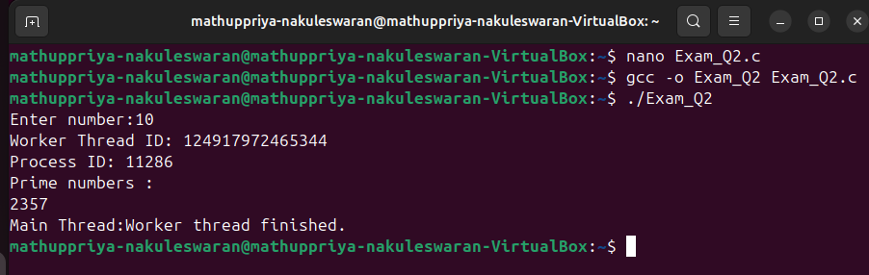Figure 2 : Get number from user , print the worker thread id & process id. And print all the prime numbers within the user input.
Question 3
#include <stdio.h>
#include <pthread.h>
#include <unistd.h>

int arr[100];
int partialSum[100];

typedef struct {
int start;
int end;
int index;
} Data;

void* work(void* arg) {
Data* d = (Data*)arg;
int sum = 0;
int count = 0;

for (int i = d->start; i <= d->end; i++) {
sum = sum + arr[i];
count++;
}
partialSum[d->index] = sum;
printf("\nThread ID: %lu\n", pthread_self());
printf("Process ID: %d\n", getpid());
printf("Range: %d to %d\n", d->start, d->end);
printf("Element Count: %d\n", count);
printf("Partial Sum: %d\n", sum);
return NULL;
}
int main() {
int n, t;

printf("Enter array size: ");
scanf("%d", &n);

printf("Enter %d elements:\n", n);
for (int i = 0; i < n; i++) {
scanf("%d", &arr[i]);
}
printf("Enter number of threads: ");
scanf("%d", &t);

if (t > n) {
printf("Number of threads must be less than or equal to array size.\n");
return 0;
}
pthread_t threads[t];
Data data[t];

int part = n / t;
int start = 0;

for (int i = 0; i < t; i++) {
data[i].start = start;

if (i == t - 1) {
data[i].end = n - 1;
} else {
data[i].end = start + part - 1;
}
data[i].index = i;
pthread_create(&threads[i], NULL, work, &data[i]);
start = data[i].end + 1;
}
for (int i = 0; i < t; i++) {
pthread_join(threads[i], NULL);
}
int total = 0;
for (int i = 0; i < t; i++) {
total = total + partialSum[i];
}
float average = (float)total / n;
printf("\nFinal Results\n");
printf("Total Sum: %d\n", total);
printf("Average: %.2f\n", average);
return 0;
}

Explanation of the code: The main thread takes input from the user to enter the size of an integer array “n”, the array elements, and the number of threads “t”. It then divides the array into t nearly equal parts and creates t worker threads using pthread_create().Each worker thread processes its assigned subarray. It computes the partial sum of its segment, counts the number of elements, and displays its Thread ID using pthread_self(), Process ID using getpid(), assigned range (start index to end index), and partial sum.The main thread waits for all worker threads to complete using pthread_join(). It then collects the partial sums using shared variables, calculates the total sum and average of all elements, and displays the final results.
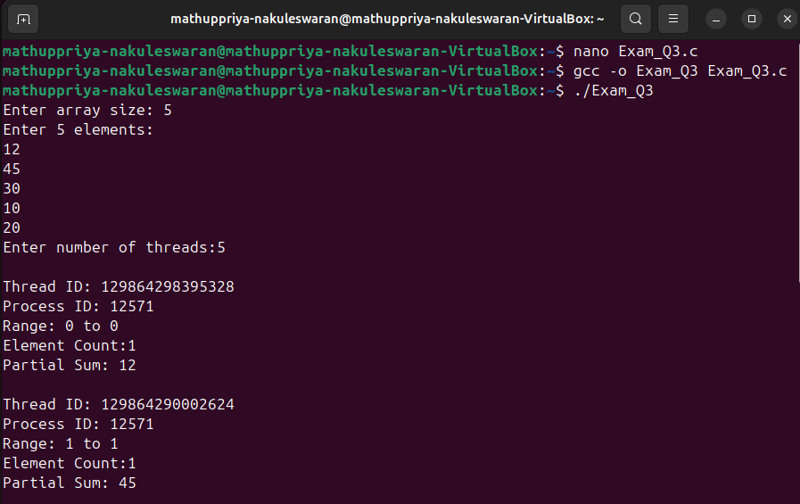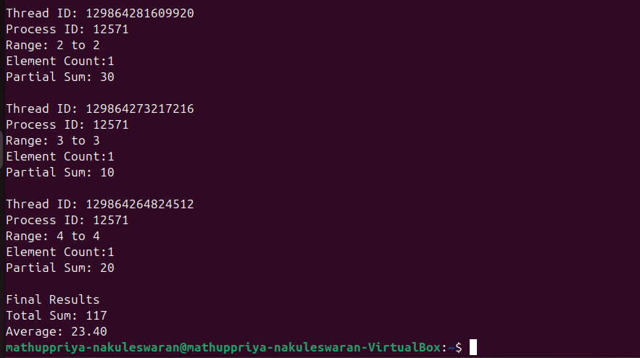Figure 3 : A main thread manages input and coordination, Multiple worker threads execute computations in parallel on different portions of the data. Results are combined to produce the final output.

