**Name: Som Mathur Group: Equitech email: som.mathur@mail.utoronto.ca**

1. **Provide a rationale behind your proposed solution, for your design concept and design choices discussed in 2­-3 paragraphs; its intended benefits when it is completed and its shortcomings, relating to takeaways that you developed in A3 and A4.**

The end goal of this prototype is to enable users to be able reach out to more volunteer opportunities thereby increasing public involvement in community issues. Designing a prototype application, which is the ideal platform for the modern society to get involved was the rationale behind my proposed solution. A major component of the platform was to search for opportunities which is something I was primarily focusing on.

The rationale behind the design concept was to design a prototype which is centered around the search feature of the platform. A search bar is available as soon as login is completed as a user to get the user started on their search to volunteer opportunities. Users are given flexibility in their search result as they can modify their search results based on the many filters provided on the “search results” page.

I decided to keep the design of the application as simple as possible with the intent of keeping the main search feature available on all pages of the prototype. The header and the footer had some additional features for the completeness of the application.

Relating to the takeaways, the prototype design managed to include all points mentioned in A3 and A4. To conclude, the intended benefit of this prototype is to increase awareness about social issues as a direct result of involving more members of the community in volunteering opportunities.

1. **Describe the aspects of the solution that your prototype is trying to address. Include details on the metaphor(s) you chose, the modalities and interactions you envision, and on any design decisions you have made.**

The main aspect that the prototype was intended to address was the search feature which enabled users to look up volunteer opportunities. Another feature within the search feature that was intended to be shown in the prototype was a button which would automatically show the user volunteer opportunities based on the information the user enter while making a profile for the application.

Related to the search feature, the prototype was looking to address the entire application process for opportunities to be included within the platform and also build a messaging platform as a means of communication between the user and the non profit organization, thereby making the user experience on the overall search and application process smoother and all included on one platform.

The main idea of the application is to involve the community more in social causes. In addition to the search feature, another feature which was intended to help the user improve/search for new kind of opportunities was a “news feed” feature which informed users of the current social issues and organizations would be able to post initiatives they were involved in. The goal of this feature was to raise awareness, thereby giving user more of an idea while using the search feature.

1. **What you learned in general from usability testing about your ideas, your design, and your prototype. These are the general results, not related to the two specific pages of your prototype that you will be discussing next.**

The key learnings from the usability testing were-

* Learn if participants are able to complete specified tasks successfully and
* Identify how long it takes to complete specified tasks
* Find out how satisfied participants are with your application
* Identify changes required to improve user performance and satisfaction
* Analyze the performance to see if it meets your usability objectives

4. **One important and complex page [Page A1 – BEFORE TESTING] from your prototype that you learned about the most from usability testing.**

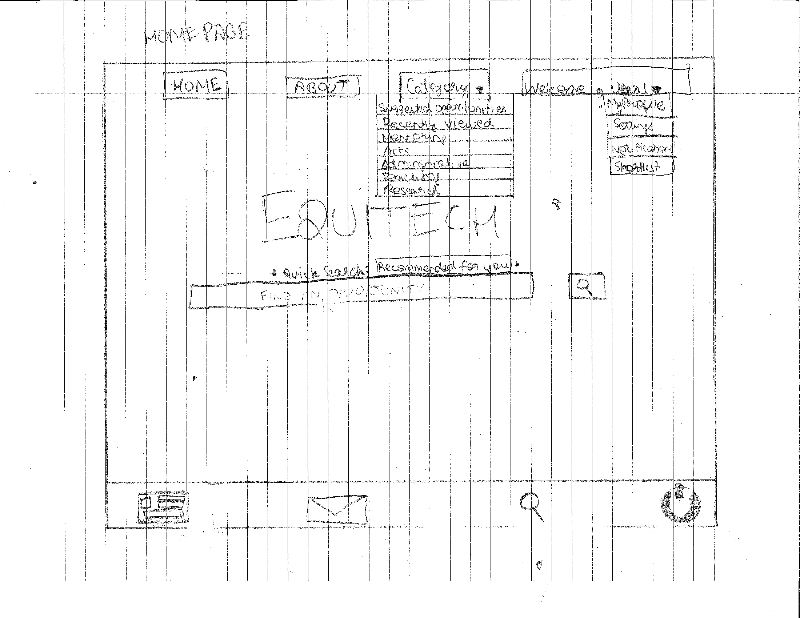

1. **2. 3.**

**4.**

**Many observations were made on the home page, an essential page to the entire prototype.**

In reference to the numbers above here are the observations-

1. The recommended search feature was not clear/visible to users.
2. The category list was not large enough and some categories sounded vague.
3. User could not identify this symbol as the logout button and did not expect it at the bottom of the screen.
4. Some users could not identify the news feed button at the bottom of the screen.

Another common observation made was that users were looking for the buttons of the essential features on the header instead of the bottom.

Note. Could not include the observations on the right side due to image sizing problems, instead the picture has been labelled and observations have been numbered according to the numbers used to label the picture.

5. **Updated design of important page [Page A2 ­ AFTER TESTING]**

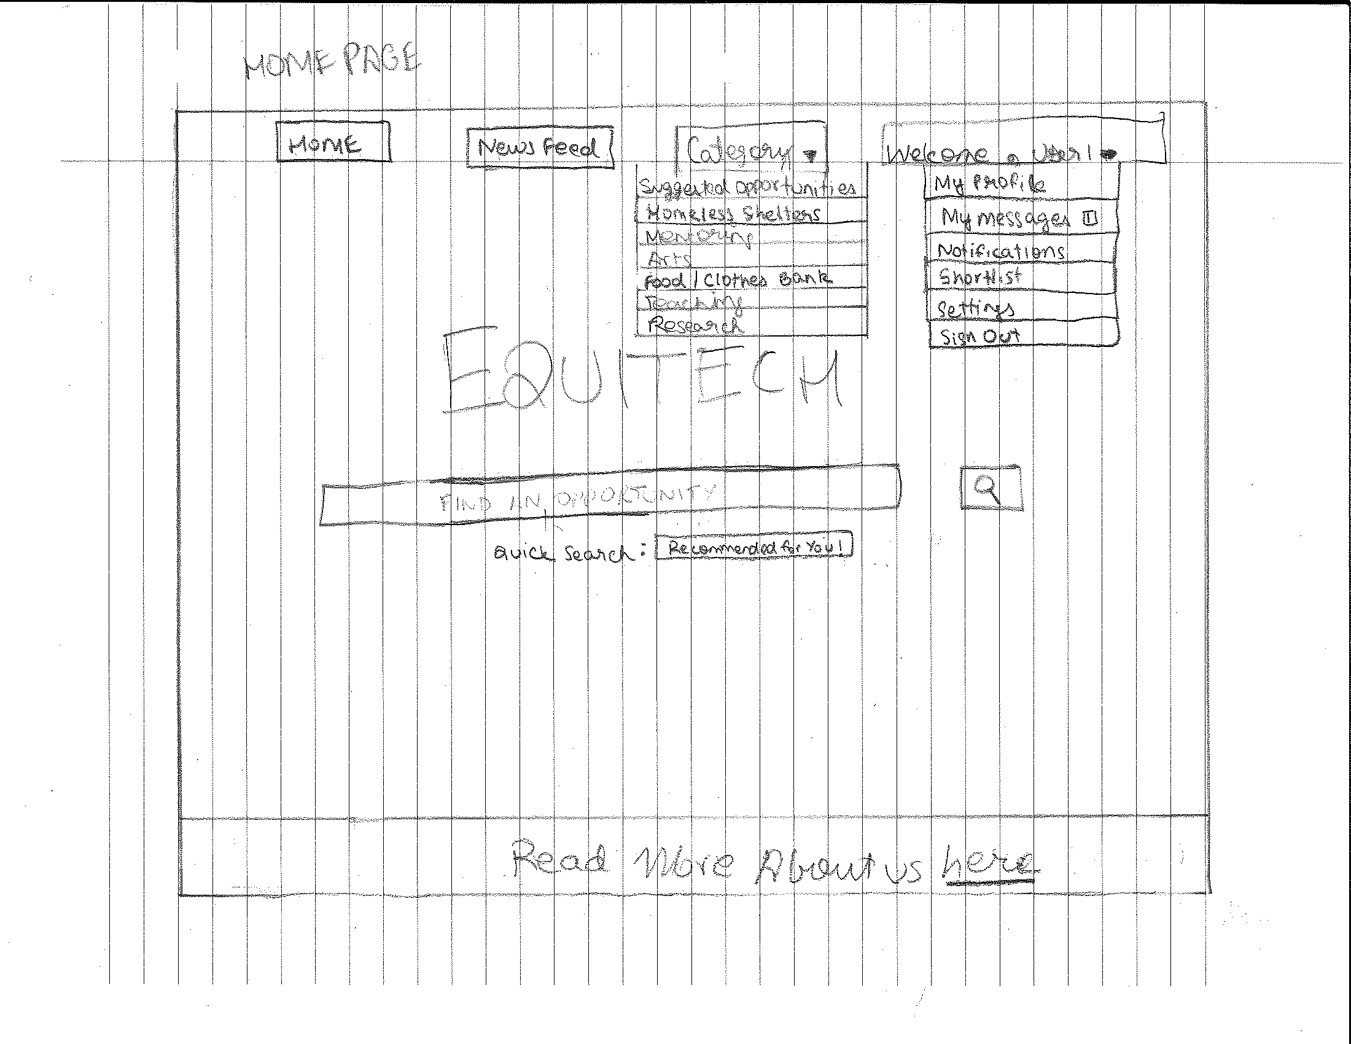

**3. 4.**

1. **5. 2.**

**The header and footer have been modified to include essential features at the header.**

**Design solutions (according to number) used to to label the picture-**

1. More relevant categories added.
2. Added the messages feature as part of the user options instead of having it at the footer.

Added the sign out option as part of the user options instead of having a symbol for it at the footer.

1. Added in a new feed option button at the top instead of at the footer for more visibility.
2. Shifted the recommended search button under the search bar instead of over it and made more visible by making the “Recommended for you” as a button
3. Moved the “About” button feature to the footer as it is a very secondary feature.

6. **Second important and complex page [Page B1 – BEFORE TESTING].**

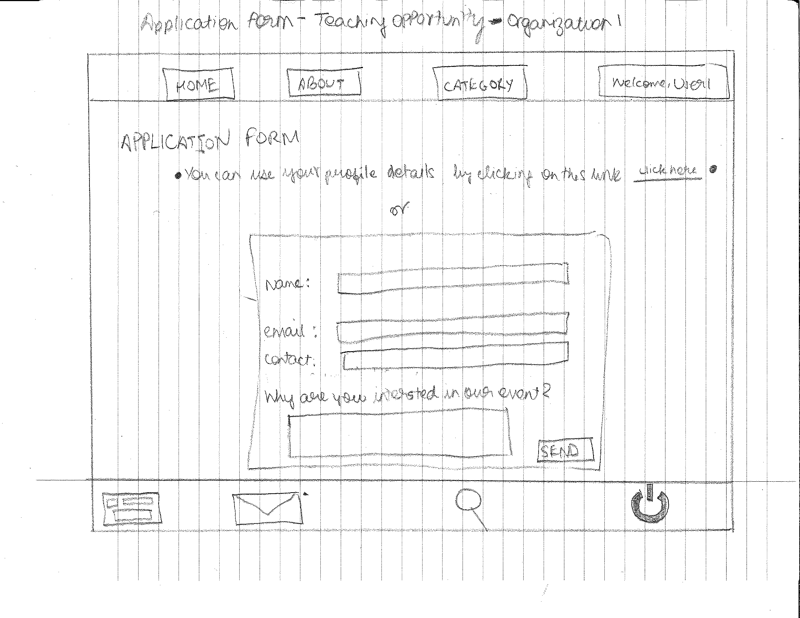

**1.**

**An important observation was made on the applications page. (Numbered according to the number labelled on the picture.)**

1. The goal was to make the application process easier and allowed users to apply by simply clicking on a button which would automatically apply for them using their profile details. Many users did not notice this and instead filled the entire form.

**7. Updated design of second important page [Page B2 ­ AFTER TESTING]**

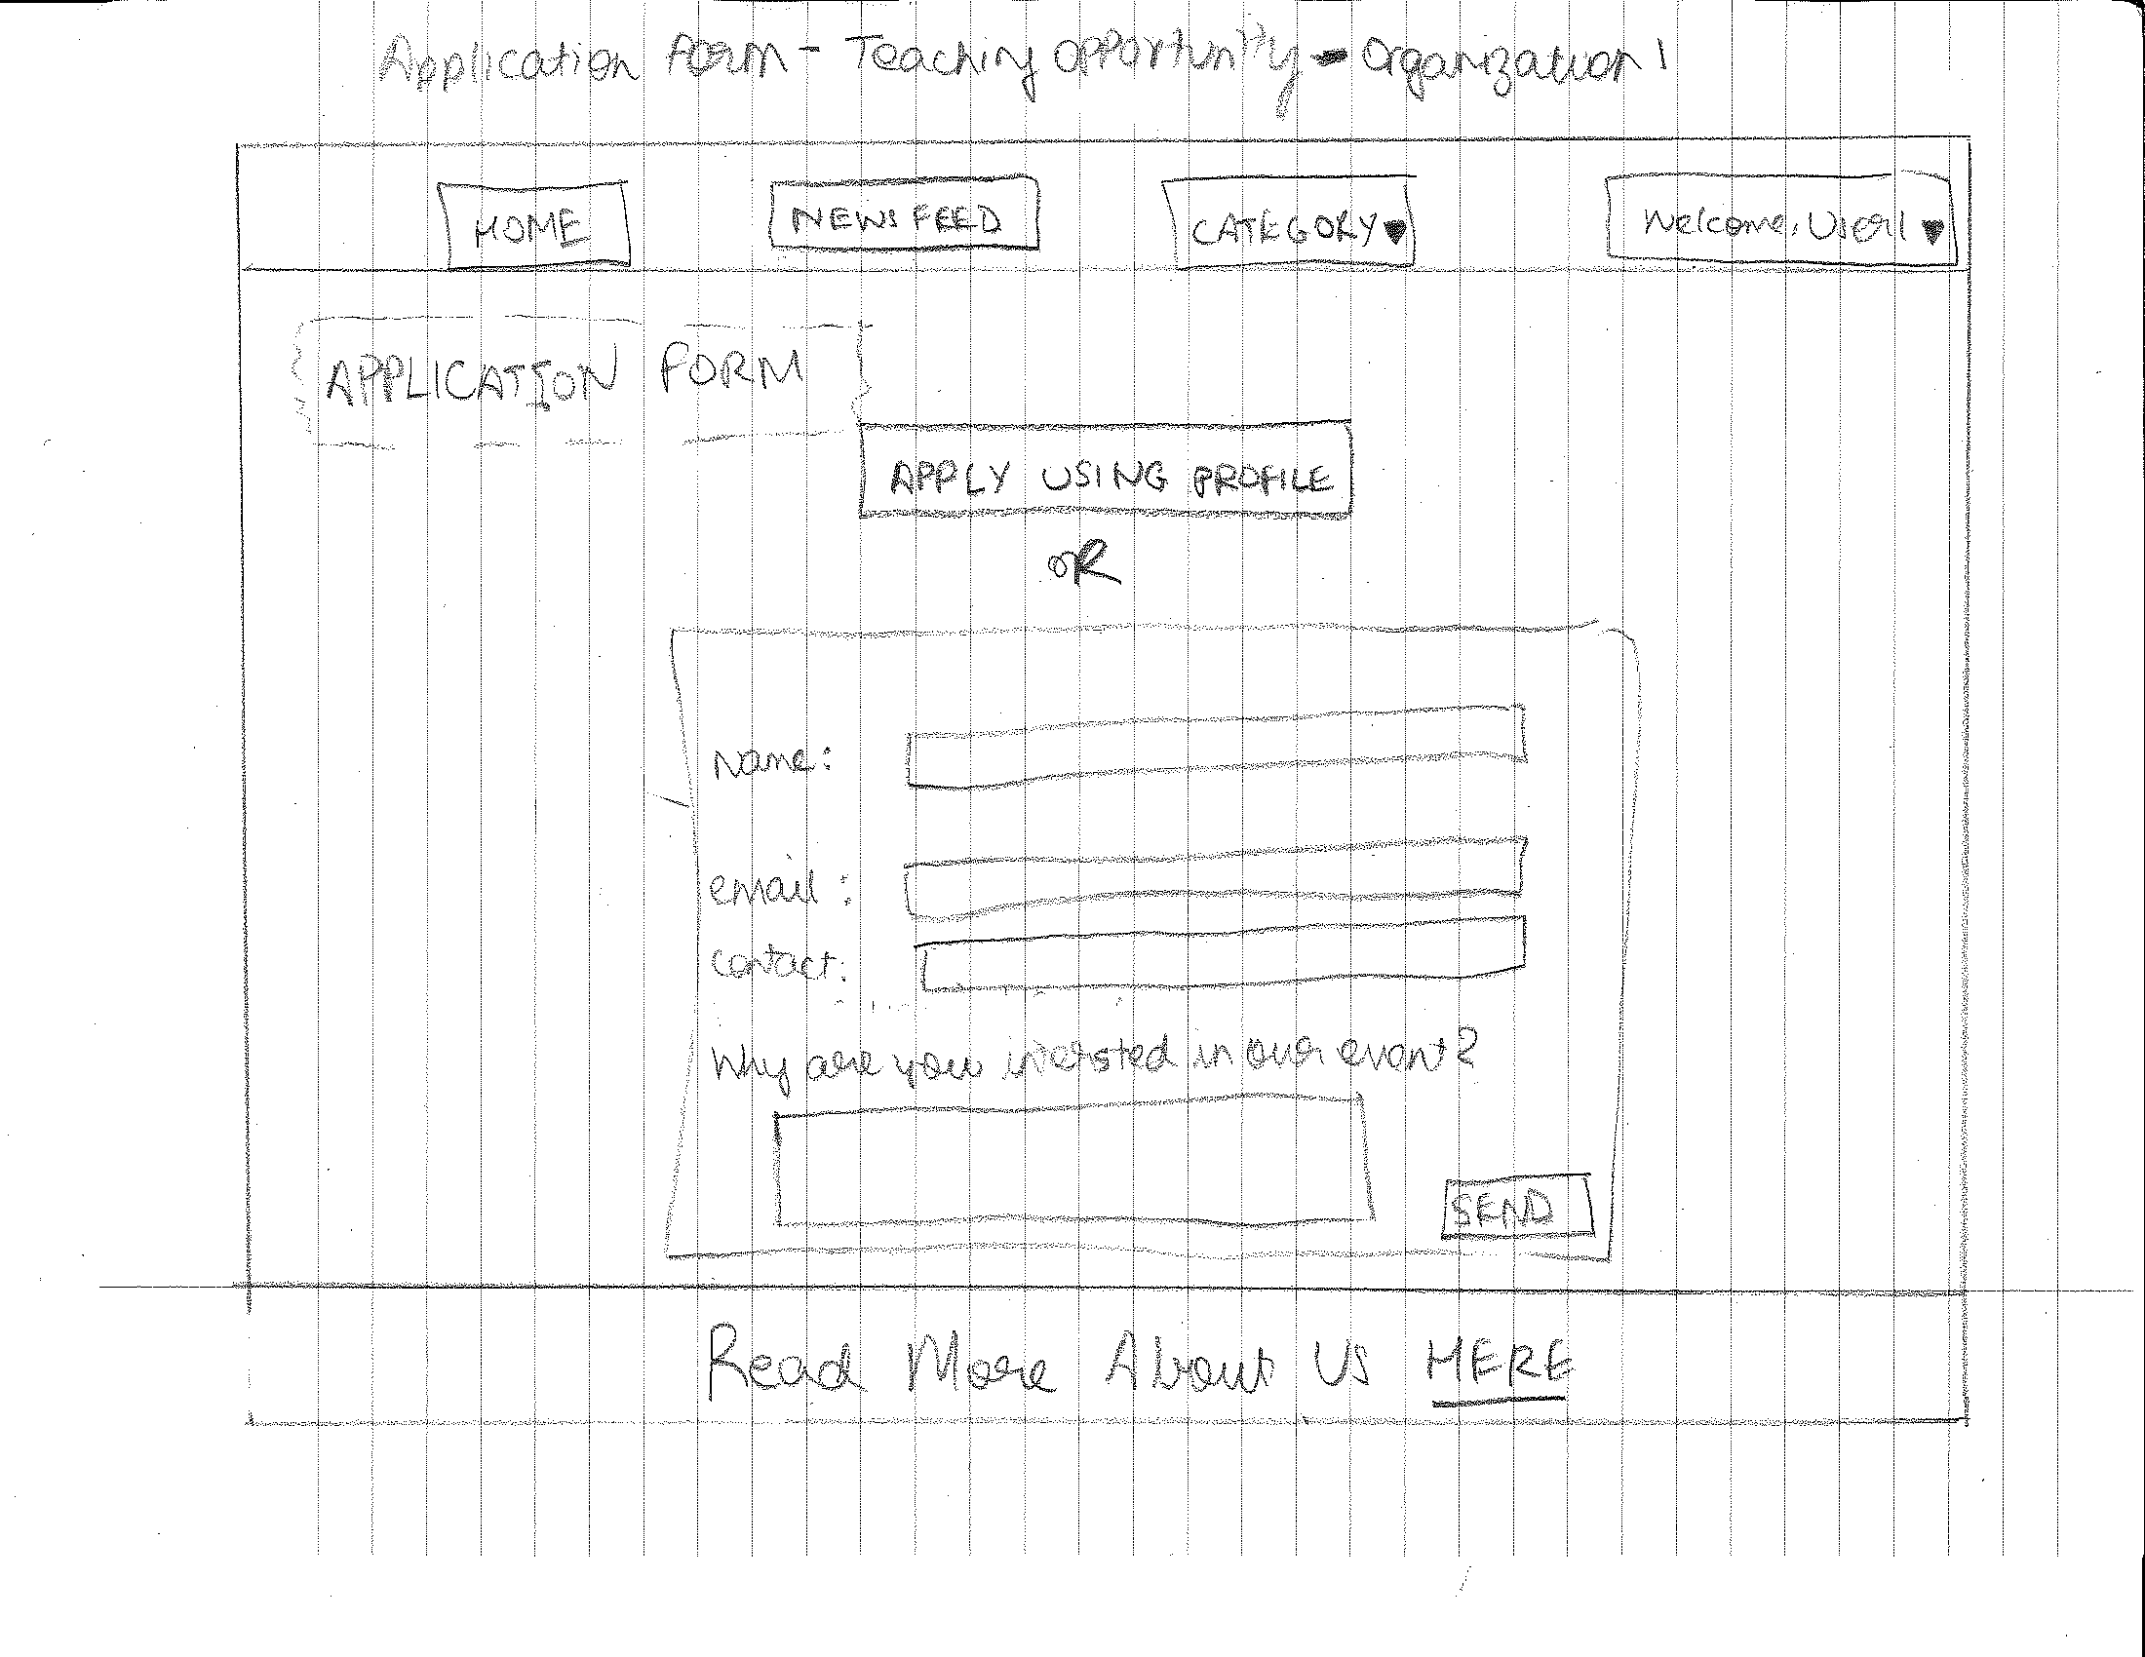

**1.**

**Note. Design changes made to the A2[After testing] sheet to header, footer and shifting of buttons, have also been included in this sheet as well, wherever appropriate.**

**Design Solutions (according to number on labelled on the picture)-**

1. Made the option of user using their profile to apply more visible(made into a button) and improve user experience by making the application process faster.