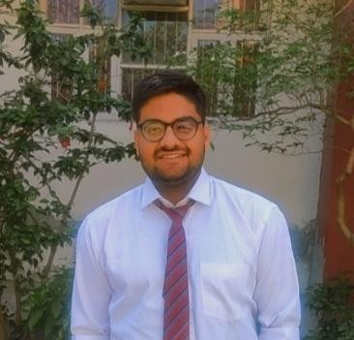Harsh Roop Rai

Address: Siwanchi gate, jodhpur, Rajasthan 140143 E-mail: [*mathurharsh773@gmail.com*](mailto:mathurharsh773@gmail.com)

Phone: +91 9928525911

[Linkedin Profile](https://www.linkedin.com/in/harsh-roop-rai)

# PROFESSIONAL SUMMARY

Hello. I am a self taught developer. I like to build backend for web apps.i work with technologies like Node JS,Express,MongoDB.I have build some projects too these projects helped me to get hands on experience with different technologies

**TECHNICAL COMPETENCIES**

C++ | JAVASCRIPT | NODE JS | MONGODB |SQL

**INTERPERSONAL SKILLS**

Team Leadership **|** Openness to Feedback**|** Decision Making **|** Active Listening **|**

**INTERESTS & HOBBIES**

Singing**|** Photography **|** Writing

**LANGUAGES KNOWN**

English **|** Hindi **|** Marwadi

**PERSONAL DETAILS**

Mother’s Name: Seema Mathur Father’ Name: Vinay Roop Rai D.O.B.: 18-08-2001

**EDUCATION**

Masters in Computing Application | Chandigarh University

Session:2022-2024(Pursuing)

Bachelors in Computer Application |LMC jodhpur

Session:2019-2022 | Percentage :82%

# PROJECTS

**Rent & Ride Web App**

It is a online platform where a user can rent there vehicle and anyone can book the vehicle for ride.this webapp includes admin dashboard,live order tracking. and authentication system

# E-commerce Bakery Web App

It is a e-commerce store for a bakery where anyone can order cakes online it includes order placing feature, live order tracking

# Tic Tac Toe Game

this game was developed using javascript,Bootstrap

# weather App

It includes third party API which is integrated to show weather of any city in the world

**CERTIFICATIONS & AWARDS**

Node JS Certified from infosys SpringBoard React Js Certified From infosys SpringBoard

**EXTRA CURRICULAR & CO-CURRICULAR ACHIEVEMENTS**

* 4 Start C++ Coder On Hackerrank
* 3 Star in Problem Solving On Hackerrank
* DSW Fest Photographer