Date: {{Date}}
To, The Owner(s) of Flat Number: {{Flat Number}}
Golfhomes & Kingswood Society
Subject: Confirmation for Official Allocation of Dedicated Parking Slot against your unit {{Flat Number}}
Dear Owner of {{Flat Number}},
We are pleased to inform you that your designated vehicle parking space has been officially allocated. Please find the details of your permanent parking slot below:
- Registered Apartment: {{Flat Number}}
- Allocated Parking Slot: {{Parking}}
Please contact our FMS Team members who will be happy to help you and identify the slot such that it can be used by you for future parking.
Please note that the society will allow only RFID registered vehicles within the society premises and request you to follow the norms.
We request you to please park your vehicle at your designated spot.
Warm regards,
The Management Committee
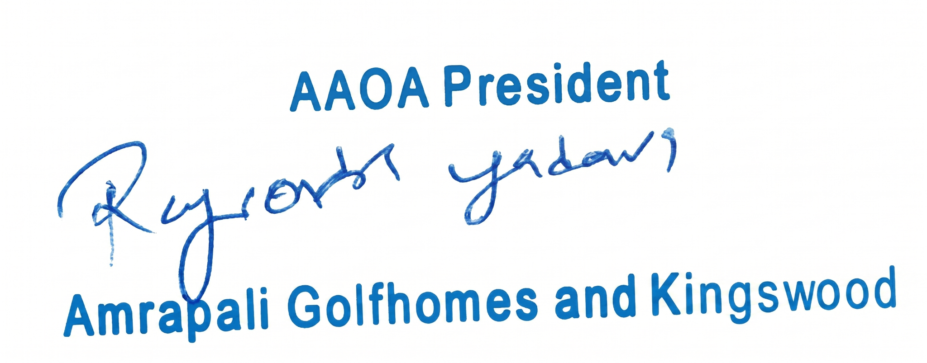
Adhoc Association of Apartment Owners (AAoA)
Golfhomes and Kingswood Society

A special thank you to all the volunteers who stepped in to ensure a successful and smooth parking allocation.
Your community-first spirit made a massive task look easy.

Original copy can be obtained via AAoA / Block Parking Committee Head / FMS

