PRISM - Sales Forecasting
Application Architecture, Flow, Assumptions, and Required Data
Prepared from the current repository implementation | May 2026

Purpose
This document explains the current PRISM application architecture and core flows for authentication, forecasting, administration, and analytics. It also captures assumptions and the data required to run the system reliably.

1. Executive Summary
PRISM is a role-based sales forecasting application with a React/Vite frontend, an Express API, PostgreSQL storage, and an asynchronous forecast worker. Users view forecasts, diagnostics, leaderboards, and forecast data based on their role and territorial access. Admin users manage regeneration, forecast events, and dashboard-card visibility.
- Frontend: React single-page app with hash-based navigation, role-aware side menu, dashboard card visibility, and management pages.
- Backend: Express API with JWT access tokens, HTTP-only refresh cookies, RBAC middleware, forecast query services, and OpenAPI documentation.
- Data: PostgreSQL schema for dealers, users, product hierarchy, monthly sales, forecasts, runs, event calendar, dashboard cards, bias corrections, and refresh tokens.
- Forecasting: dealer-level ARIMA/ETS candidate selection, sparse-dealer fallback, bias correction, event uplift, interval calibration, and rollup to state and zone levels.

2. Application Architecture
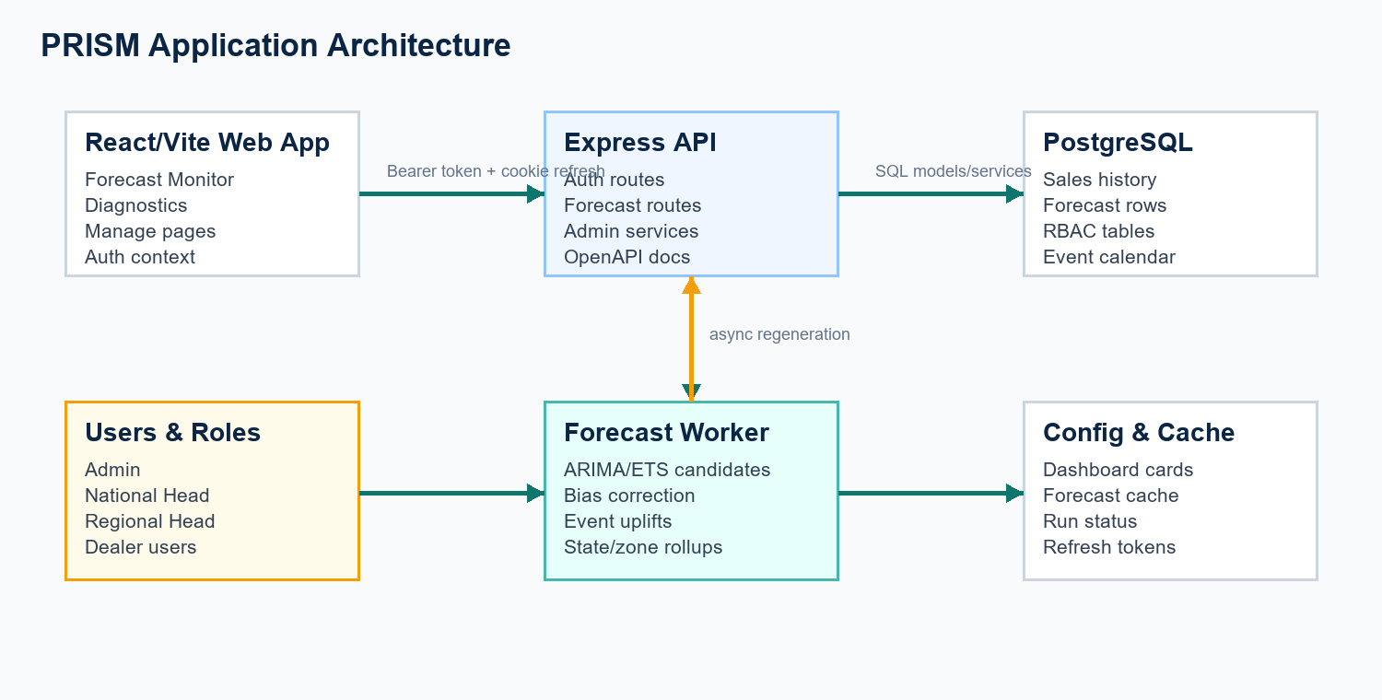
The frontend calls versioned forecast APIs through an authenticated fetch wrapper. The API delegates business behavior to services and models. Forecast regeneration is performed by a background worker that persists outputs to forecast_data and run metadata to forecast_runs.
Layer | Primary Components | Responsibilities
Frontend | App.jsx, Forecast.jsx, ManageForecast.jsx, ForecastEvents.jsx, DashboardCards.jsx, AuthContext.jsx | Role-aware navigation, forecast visualization, admin controls, session handling, and dashboard-card visibility.
API | server.js, authRoutes, referenceRoutes, forecastRoutes, forecastEventRoutes | HTTP routing, CORS, cookie parsing, authentication, permission checks, OpenAPI docs, and JSON responses.
Services | forecastQueryService, forecastAdminService, forecastAnalyticsService, forecastMetricsService, forecastDashboardCardService | RBAC-aware query shaping, regeneration status, analytics payloads, KPI calculations, and global card settings.
Forecast Engine | baselineForecast.js, forecastWorker.js, forecastBiasService.js | Forecast model selection, interval calibration, bias correction, event uplift, aggregation, and persisted forecast output.
Data | PostgreSQL migrations and data models | Operational records, sales history, product hierarchy, users/roles, forecast data, events, dashboard settings, and run audit history.

3. Runtime Flow
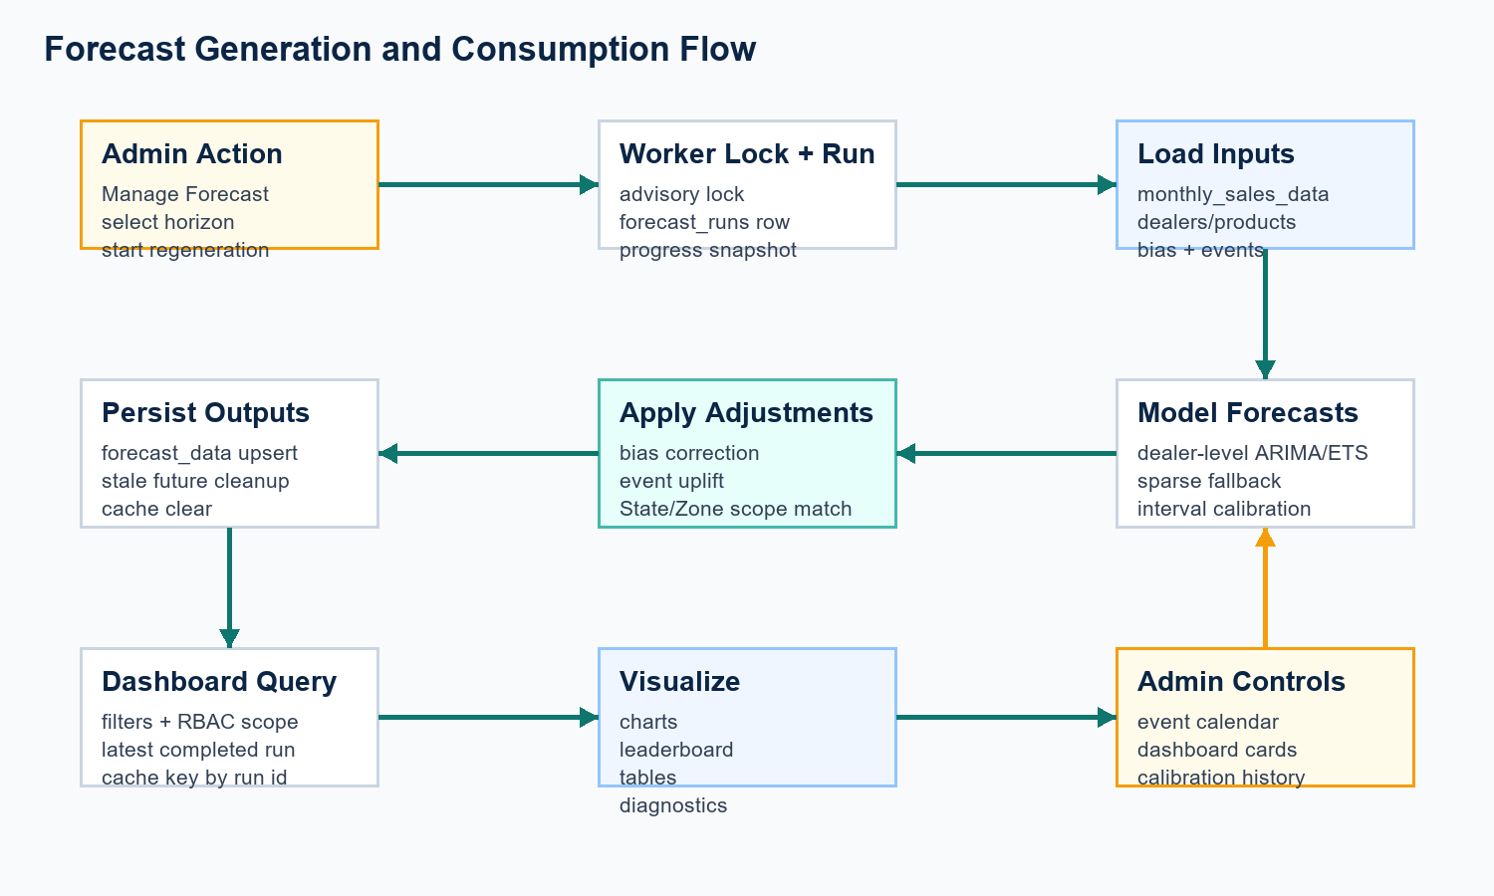

3.1 Authentication and Authorization
- Users sign in through /api/auth/login. The API returns a short-lived access token and sets a refresh token cookie.
- AuthContext attaches the Bearer token to API calls and retries once after a 401 by calling /api/auth/refresh.
- Routes use authenticate and requirePermission middleware. Forecast data is further scoped by role: Admin/National Head can see all, Regional Head is restricted to a region, and Dealer roles are restricted to their dealer.

3.2 Forecast Regeneration
- An admin starts regeneration from Manage Forecast. The API validates the horizon and starts runForecastWorker in the background.
- The worker obtains a PostgreSQL advisory lock, creates a forecast_runs record, computes bias corrections, loads forecast scopes, active events, and the latest actual month.
- Dealer-level forecasts are generated first. Sparse dealers can use zone-proportional fallback. Event uplifts are applied by matching National, Zone, or State scope against dealer metadata.
- Adjusted dealer forecasts are rolled up to state and zone levels, flattened, upserted into forecast_data, and stale future rows are removed.
- Forecast cache is cleared after regeneration so dashboard requests read the latest completed run.

3.3 Dashboard and Analytics Query Flow
- Forecast Monitor calls baseline or blended forecast endpoints plus actuals and segment breakdown APIs.
- Diagnostics calls metric trend, observations, histogram, and leaderboard endpoints.
- Forecast Data displays detailed forecast rows and segment breakdown tables.
- Dashboard Cards controls which graphs/tables are visible. The side menu hides Forecast Monitor, Diagnostics, Leaderboard, or Forecast Data when every card in that section is disabled.

4. Functional Areas
Area | Main Screen/API | Notes
Forecast Monitor | Forecast.jsx / /api/v1/forecasts/baseline, /actuals | Forecast trend, monthly forecast graph, regional segment split, model filters, horizon selection, interval display.
Diagnostics | Forecast.jsx / /metrics/trend, /metrics/observations, /metrics/histogram | Accuracy, bias, actual-vs-predicted, and error distribution views.
Leaderboard | Forecast.jsx / /metrics/leaderboard | Ranks forecast groups by MAPE and bias over matched forecast/actual observations.
Forecast Data | Forecast.jsx / versioned forecast endpoints | Forecast rows and segment breakdown tables.
Manage Forecast | ManageForecast.jsx / /admin/status, /admin/regenerate, /admin/clear | Run controls, status, calibration history, active forecast events, and latest generation output.
Forecast Events | ForecastEvents.jsx / /admin/events | Maintains dated event uplift rules with event type, National/Zone/State scope, scope value, date range, uplift percent, and active flag.
Dashboard Cards | DashboardCards.jsx / /dashboard-cards, /admin/dashboard-cards | Admin-only global visibility settings for forecast graphs and tables.

5. Required Data
Data Domain | Tables / Fields | Required For
Dealer hierarchy | dealers: dealer_id, dealer_name, region, city, state, dealer_type, sales_capacity_per_month | Role scoping, dealer forecasts, state/zone rollups, scope-value matching for forecast events.
Product hierarchy | vehicle_models, vehicle_variants: model, segment, variant, fuel_type, transmission, price | Segment/model/variant filters and product-level forecast scopes.
Sales history | monthly_sales_data: month, dealer_id, model_id, variant_id, units_sold, stock, enquiries, test drives, economic/competitor indices | Forecast model training, actuals, diagnostics, and calibration.
Stock/customer detail | stock_data, customer_sales_data | Supporting operational analysis and future feature expansion.
Users and RBAC | users, roles, permissions, role_permissions, user_refresh_tokens | Authentication, authorization, refresh-token sessions, and access scoping.
Forecast outputs | forecast_runs, forecast_data, forecast_bias | Audit history, latest forecast retrieval, intervals, validation metrics, bias correction, and cache invalidation.
Admin configuration | forecast_event_calendar, forecast_dashboard_cards | Event uplift behavior, side-menu/card visibility, and admin-controlled dashboard composition.

6. Assumptions
- Forecasting is currently centered on the baseline forecast type; blended forecasts are served from stored forecast data and dealer/zone weighting logic.
- Forecast horizons supported by the admin UI are 6, 12, and 24 months, while lower-level parsing allows bounded horizon values where applicable.
- Monthly sales history is complete enough for dealer-level modeling. Sparse dealers are expected and handled through proportional zone fallback.
- Dealer state and zone names in forecast_event_calendar scope_value should match dealer metadata. Runtime matching is trim and case-insensitive.
- Forecast event uplift is additive across overlapping events and is applied to dealer-level forecast points before state/zone aggregation.
- Dashboard card visibility is global, not per-user. Role permissions still control whether a user can access forecast or management pages.
- The application expects PostgreSQL and environment variables for database connection, JWT secrets, API port, and allowed client origin.

7. Operational Considerations
Concern | Current Handling | Recommendation
Concurrent regeneration | PostgreSQL advisory lock prevents parallel worker runs. | Keep lock id stable and expose run status to operators.
Cache freshness | Cache keys include latest completed run id; regeneration clears forecast cache. | Continue clearing cache after any data-changing admin operation that affects forecast output.
Security | Access token plus refresh cookie; RBAC checks at route and data-query level. | Rotate JWT secrets carefully and monitor refresh-token storage.
Data quality | Sparse dealer fallback and data-quality flags are persisted. | Track sparse/fallback counts as part of regular model quality review.
Calibration | Coverage and interval width are stored on forecast_runs. | Review calibration history after each major data load or modeling change.
Event configuration | Admin can define dated scoped uplift events. | Use controlled state/zone values in the UI if free-text scope values become error-prone.

8. Page and Permission Map
Role | Forecast Access | Management Access | Typical Landing
Admin | Zone, State, Dealer | Manage Forecast, Forecast Events, Dashboard Cards | Forecast dashboard
National Head | Zone, State, Dealer | No admin management by default | Forecast dashboard
Regional Head | Zone, State, Dealer within assigned region | No admin management by default | Forecast dashboard
Dealer Head / Dealer Manager | Dealer-level assigned dealer | No admin management by default | Forecast dashboard
Sales Executive / Team Lead | Restricted unless permission is granted | No admin management | Sales execution home

Document Boundary
This document reflects the current repository implementation and local migrations. External deployment topology, production infrastructure, CI/CD, monitoring, and data ingestion jobs are not defined in the current codebase and should be documented separately when finalized.

