VoC Frontend UI Style Guide
Reference direction based on the attached Executive Dashboard UI screenshot.

1. Visual Direction
The VoC frontend should follow an executive command-center style: dark navy header, light analytics canvas, compact KPI cards, large chart panels, and a persistent right-side insight and alert rail. The interface should feel polished, operational, and dashboard-first.
Reference Image
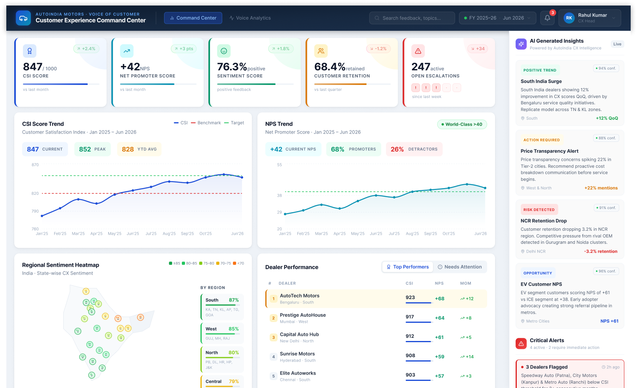

2. Layout Principles
- Use a dark navy command-center header with product identity, primary navigation, search, filters, notifications, and user profile controls.
- Use a light grey dashboard background with white cards, rounded corners, and soft shadows.
- Use a left-to-right executive scanning pattern: KPI cards first, trends and analytics next, insights and alerts in the right rail.
- Prefer compact spacing and dense operational views over marketing-style sections.
- Keep panels visually calm, with strong typography and clear metric hierarchy.

3. Component Direction
Component | Style Direction
Top Navigation | Dark navy bar, logo/product label, active nav pill, search, time filters, notification badge, user profile.
KPI Cards | White cards with colored left accents, icon badge, large metric, unit/label, trend pill, and progress indicator.
Chart Panels | Large white panels with title, subtitle, inline legend, summary chips, and clean line/bar/heatmap visuals.
Insight Cards | Right rail cards with category badge, confidence chip, short summary, region/source, and metric impact.
Critical Alerts | Red-accented compact cards with severity, affected dealers/customers, timestamp, and next action.
Tables | Compact ranking tables with highlighted first row, small rank badges, metric columns, and trend indicators.

4. Color and Status Usage
- Primary: deep navy header and blue action/data accents.
- Positive: teal/green for improvements, strong performance, and positive sentiment.
- Watch: amber/orange for attention-required signals and moderate risk.
- Critical: red for escalations, retention drops, and urgent action.
- Neutral: light grey backgrounds, muted secondary text, and subtle borders.

5. Implementation Notes
- Implement the dashboard as the first usable screen, not a marketing landing page.
- Use reusable card, metric, chart-panel, insight-card, alert-card, table, filter, and nav components.
- Preserve responsive behavior: on smaller screens the right insight rail can stack below main dashboard content.
- Use real charting components and realistic seeded data for stakeholder demos.
- Final design tokens should be captured during frontend implementation.

