VoC Module Technical Architecture Document
Voice of Customer Prototype Module

1. Purpose
This document defines the technical architecture for the Voice of Customer (VoC) prototype module. The prototype demonstrates how automobile aftersales feedback can be ingested, analyzed, scored, and converted into actionable insights for OEM and dealer stakeholders.
The prototype is not intended to be production ready. It will use seeded or uploaded data, mocked downstream integrations, and simplified operational controls while preserving a realistic application architecture that can be extended during productionization.

2. Architecture Goals
- Demonstrate end-to-end VoC workflows using realistic aftersales feedback data.
- Use the same technical stack pattern as Sales Forecasting Prism.
- Keep source code modular so prototype services can evolve into production services.
- Separate NLP/AI processing from business rules and dashboard APIs.
- Support role-based user journeys for OEM, dealer, admin, and review users.

3. Technical Stack
Layer | Technology
Frontend | React + TypeScript
Build Tool | Vite
Styling | Tailwind CSS
UI Components | shadcn/ui or equivalent reusable component library
Backend | Node.js + Express API service
Database | PostgreSQL
ORM / DB Access | Prisma
API Style | REST APIs
Authentication / Authorization | Role-based access control for prototype roles
AI / NLP | LLM/NLP service integration behind backend service boundaries
Data Upload | CSV/Excel upload for seeded prototype data
Configuration | Environment variables through .env files

4. High-Level Architecture
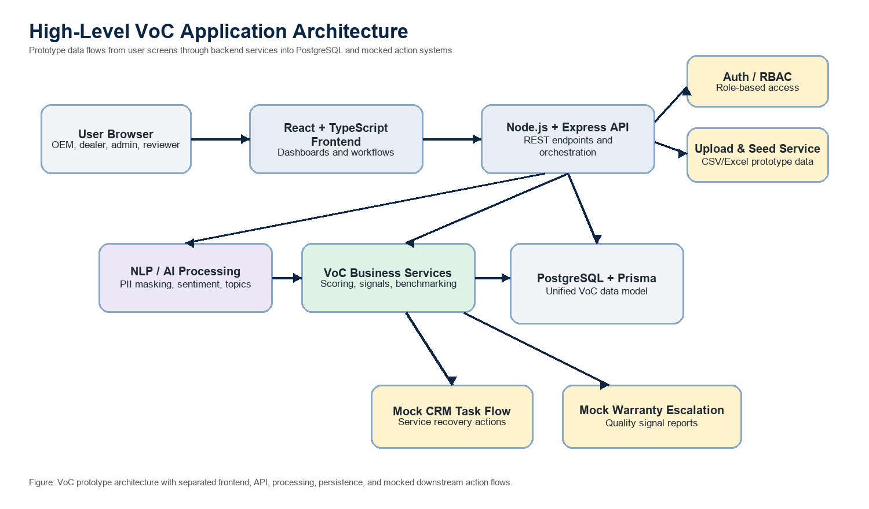

5. Application Structure
The repository should follow this top-level layout:
VoC/
doc/
technical-architecture.md
src/
frontend/
backend/
shared/
Recommended src organization:
Folder | Purpose
src/frontend | React application, routes, screens, components, hooks, and API clients
src/backend | Express server, REST APIs, services, and Prisma integration
src/shared | Shared TypeScript types, constants, taxonomies, and validation schemas

6. Core Prototype Modules

6.1 Data Ingestion
The prototype will ingest data through seeded datasets and file uploads rather than live integrations.
Initial sources:
- Post-service survey feedback
- Digital job-card technician notes
- Warranty claim descriptions
- Optional Google/dealer review sample data
The ingestion service will normalize source records into a common feedback model and store both the raw input and processed output.

6.2 NLP / AI Processing
The NLP pipeline should run as a backend service layer. It should be callable after upload, during seed execution, or through a manual reprocess action in the prototype UI.
Processing stages:
- PII masking
- Language detection
- Translation to English where required
- Sentiment classification
- Topic extraction
- Named entity extraction
- Automotive issue classification
- Urgency scoring
For the prototype, AI results may come from an LLM/NLP provider, deterministic rules, or a hybrid approach depending on data availability and demo reliability.

6.3 Automotive Intelligence
Business logic should be implemented separately from the NLP service. This layer converts processed feedback into automotive aftersales insights.
Key capabilities:
- Issue classification by automotive topic
- Repeat complaint detection within a configurable lookback window
- Churn risk scoring
- Warranty signal detection
- Dealer benchmarking
- Critical feedback identification

6.4 Action Layer
The action layer will be mocked for the prototype.
Supported flows:
- Create mock CRM recovery tasks for critical feedback.
- Generate LLM-assisted dealer response drafts.
- Create mock warranty escalation reports for quality/warranty signals.
- Track human review items for low-confidence classifications.
No live CRM, warranty, dealer portal, or notification integration is required for the prototype.

6.5 Dashboards and Screens
The frontend should support the planned stakeholder validation screens:
- OEM executive dashboard
- Dealer performance dashboard
- Feedback explorer
- Customer detail / complaint history
- Issue and sentiment analytics
- Warranty signal dashboard
- CRM recovery task view
- Human review queue
The first version may use seeded metrics and progressively connect screens to backend APIs as the data model stabilizes.

7. Database Architecture
PostgreSQL will be the system of record for prototype data. Prisma will manage schema definition and typed database access.
Core tables should include:
Table | Purpose
customers | Customer profile and masked identifiers
vehicles | Vehicle information linked to customers
dealers | Dealer master data
job_cards | Service visit and technician note data
warranty_claims | Warranty claim source records
feedback_records | Unified VoC feedback records from all sources
nlp_results | Language, translation, sentiment, topics, and entities
issue_classifications | Automotive issue categories and confidence
churn_scores | Customer churn risk scores and contributing factors
dealer_scores | Dealer-level performance metrics
warranty_signals | Potential quality/warranty escalation signals
crm_tasks | Mock service recovery tasks
human_review_queue | Items needing manual review or correction

8. API Architecture
The backend should expose REST APIs grouped by domain:
API Area | Example Routes
Health | GET /api/v1/health
Uploads | POST /api/v1/uploads/feedback
Feedback | GET /api/v1/feedback, GET /api/v1/feedback/:id
NLP Processing | POST /api/v1/feedback/:id/process, POST /api/v1/processing/run
Dashboards | GET /api/v1/dashboards/oem, GET /api/v1/dashboards/dealer/:dealerId
Dealers | GET /api/v1/dealers, GET /api/v1/dealers/:id/scorecard
Warranty Signals | GET /api/v1/warranty-signals, POST /api/v1/warranty-signals/:id/escalate
CRM Tasks | GET /api/v1/crm-tasks, POST /api/v1/crm-tasks/:id/close
Human Review | GET /api/v1/review-queue, POST /api/v1/review-queue/:id/resolve

9. Security and Access Control
Prototype security should be lightweight but explicit.
Roles:
- admin: Full prototype access
- oem_user: OEM dashboards, all dealers, warranty signals, analytics
- dealer_user: Assigned dealer dashboards, feedback, and CRM recovery tasks
- reviewer: Human review queue and correction workflows
Prototype authentication can use mocked users, seeded users, or a simple login mechanism. Production identity integration is out of scope for the prototype.

10. Non-Functional Considerations
For the prototype:
- Prioritize demo reliability and explainability.
- Use deterministic fallbacks where AI calls may be unavailable.
- Keep uploaded sample datasets small enough for local or lightweight hosted environments.
- Log processing decisions for traceability.
- Avoid storing unnecessary PII in processed fields.
- Keep threshold values configurable.
Productionization considerations:
- India hosting and data residency validation
- Full audit logging
- Production identity provider integration
- Data retention policy
- Observability and alerting
- Scalable async processing
- Model monitoring and human-in-loop retraining

11. Deployment View
Prototype deployment can run as:
- React frontend served by Vite during development.
- Express backend running as a Node.js process.
- PostgreSQL database running locally, in Docker, or in a hosted development database.
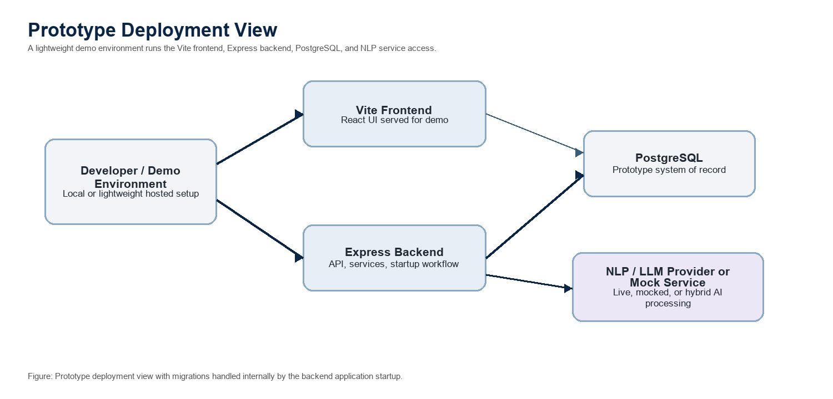

12. Prototype Scope Boundaries
In scope:
- Seeded/uploaded feedback data
- Prototype database schema
- VoC processing pipeline
- Dashboard APIs and UI screens
- Mock CRM and warranty flows
- Configurable scoring rules
Out of scope:
- Live CRM integration
- Live warranty system integration
- Live dealer portal integration
- Production SSO
- Production monitoring and alerting
- Model retraining pipeline
- Compliance certification

13. Open Technical Decisions
- Exact Sales Forecasting Prism repository conventions to mirror, if stricter than the stack listed here.
- Final automotive issue taxonomy.
- Warranty signal threshold values.
- Whether AI calls are live, mocked, or hybrid for demos.
- Seed dataset size and format.
- Whether local Docker Compose should be included in the prototype setup.

