LocalRCA: An Implementation of Privacy-Conscious Root-Cause Analysis for Windows Endpoints
Author names and affiliations to be added before submission
Abstract—LocalRCA is a Windows endpoint root-cause-analysis prototype that replaces synthetic demonstration data with consented, local telemetry. It stores system metrics, selected process snapshots, and allowlisted/redacted Event Log evidence in SQLite; constructs a clean, gap-aware baseline; detects anomalies with an LSTM autoencoder; and produces constrained causal rankings and process attribution. This implementation paper documents the architecture, data path, mathematical decision rules, and evaluation protocol. Quantitative runtime, CPU, memory, battery, detection, and RCA accuracy measurements are explicitly left pending a reproducible multi-device experiment.
Index Terms—endpoint observability, root-cause analysis, anomaly detection, telemetry, causal inference, Windows.

I. INTRODUCTION
Endpoint failures are often investigated after short-lived evidence has disappeared. General system telemetry, process behaviour, sleep gaps, and operating-system events must be reconciled without exporting sensitive local data. LocalRCA addresses this setting with a local-first collection and inference pipeline. Its contribution is an auditable implementation: no fabricated incident is used in the production path, model windows do not cross collection gaps, and the report exposes evidence rather than presenting correlation as certainty.

II. RELATED WORK AND POSITIONING
Reconstruction-based anomaly detection is a well-established approach for multivariate time series [1]. LocalRCA uses an LSTM autoencoder [5], following the reconstruction-error approach demonstrated for multi-sensor anomaly detection by Malhotra et al. [6]. Cloud RCA systems commonly combine performance signals with dependency graphs; MicroRCA is a representative example [7]. A recent broad evaluation of causal-RCA methods reports that no method is universally effective and that results on synthetic data may not transfer to real systems [8]. LocalRCA therefore treats Granger-derived links [2] as evidence-backed hypotheses, filtered by false-discovery control [3], an effect-size threshold, and a declared endpoint topology. Its local-only design, consent gate, data minimisation, and optional redaction are deliberate privacy-engineering decisions [9].

III. IMPLEMENTATION ARCHITECTURE
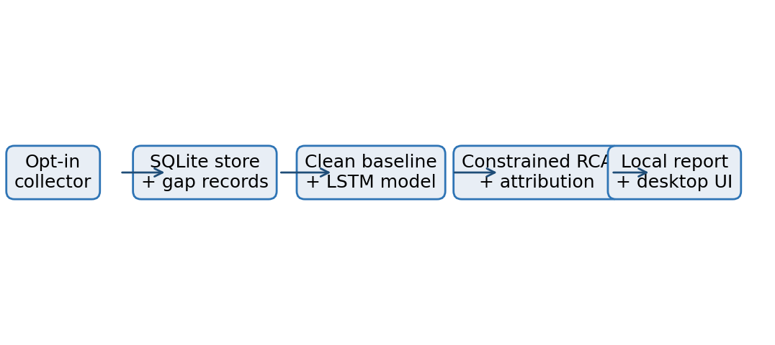
Fig. 1. Local-only evidence path from consented collection to RCA report.
The collector samples CPU, memory, swap, disk, network, power, context, and optional NVIDIA GPU channels. Process snapshots are retained for attribution rather than full command-line capture. Windows events are provider/Event-ID allowlisted and redacted. SQLite is configured for local persistence, and collection gaps are explicit records rather than values that are interpolated away.
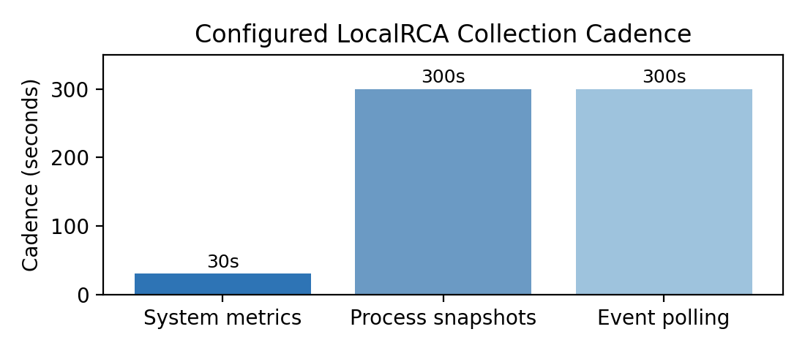
Fig. 2. Configured collection cadence; this is a design parameter, not a performance result.

IV. MODEL AND INFERENCE
Let x_t ∈ R^d be the d-dimensional normalised metric vector at time t. A window X_t = [x_(t-w+1), …, x_t] is passed to an LSTM autoencoder f_θ. The per-feature reconstruction error is:
e_j(X_t) = (1/w) Σ_(i=1)^w (x_(t-w+i,j) − f_θ(X_t)_(i,j))²
For a feature j, the stored threshold q_j is the calibration percentile from clean validation windows. The normalised score s_j(X_t) = e_j(X_t)/(q_j + ε) triggers an anomaly when e_j(X_t) > q_j. A detected incident is a run of at least k consecutive anomalous rows, or a window anchored by a retained fault event.
For candidate causal edges, the system tests ordered metric pairs after stationarity handling. The selected p-values are corrected with the Benjamini-Hochberg rule p_(i) ≤ (i/m)α, where m is the number of tested pairs and α is the false-discovery target. Edges must also meet a minimum effect proxy and must agree with the endpoint subsystem graph. This narrows the report to statistically and architecturally defensible hypotheses.

V. DATA AND PRIVACY MODEL
Evidence | Purpose | Protection
System metrics | Anomaly model and causal signals | Local SQLite; no network export
Process snapshots | CPU, RSS, and I/O attribution | Top-N/retention-limited; no command line
Event Log entries | Fault correlation and incident creation | Allowlist; optional redacted message capture
GPU metrics | Visibility in captured-data view | Optional NVIDIA NVML; not modelled until history exists
TABLE I. Evidence retained by the prototype.
Training data are filtered before use. Let G denote rows adjacent to a collector gap and E denote rows inside an event exclusion interval. The clean baseline B is B = {x_t : x_t ∉ G, x_t ∉ E, and required model features are non-null}. Training is permitted only when the longest uninterrupted portion of B spans at least three days. This avoids a misleading baseline created by joining samples across sleep or missed collection ticks.

VI. IMPLEMENTATION EFFICIENCY
The collector separates high-frequency system sampling from lower-frequency process sampling. Let C_s, C_p, and C_e denote configured system, process, and event cadences. The expected daily counts are N_s = 86400/C_s, N_p = 86400/C_p, and N_e = 86400/C_e. With C_s = 30 s and C_p = C_e = 300 s, the configuration produces 2,880 system ticks and 288 scheduled process/event opportunities per day before adaptive bursts.
Metric to report | Formula | Status in this draft
Inference latency | T_infer = t_report − t_request | Requires measurement
Collector CPU | mean CPU% over a fixed idle/workload interval | Requires measurement
Collector RAM | RSS collector process; report median and P95 | Requires measurement
Storage growth | Δbytes/day = (S_end − S_start)/days | Requires measurement
Energy impact | Δbattery%/hour vs. collector-off control | Requires measurement
TABLE II. Required empirical efficiency measures. No values are claimed before profiling.
Measure | Observed development profile | Interpretation
Collector CPU | 0.36% of one core | Single-device observation; not a benchmark
Collector RAM | 20-30 MB | Live collector-process observation
Model footprint | 129k parameters; 0.52 MB | Serialized LSTM model
Training | About 24 s for 1,716 windows x 25 features | Development-machine run; hardware-specific
Desktop RAM | About 455 MB | QtWebEngine dominates the packaged UI
TABLE III. Current development-machine observations. They are not cross-device performance claims.
A reproducible efficiency study should report inference latency T_infer = t_report - t_request, collector CPU over a fixed interval, RSS median/P95, daily storage growth, and battery delta against a collector-off control. The observations in Table III provide implementation context only; inference latency, energy impact, and storage growth remain pending measurements.

VII. REPRODUCIBILITY AND USER ONBOARDING
The reproducible first-use path is currently source based: clone the versioned repository, install the dependency manifest, and run the telemetry control commands from the source directory. The published Windows ZIP packages the desktop interface and must remain beside its _internal runtime directory, but it does not yet package a companion collector-control executable. Consequently, the ZIP alone is not yet a complete one-click onboarding artifact for a new user. A production-ready release should include an RCA-Collector executable or equivalent desktop onboarding controls for consent, install, status, uninstall, and delete-all-data.
The supported operational sequence is: (1) run python -m telemetry accept-consent and read the notice; (2) run python -m telemetry install to register collection at logon; (3) collect an uninterrupted healthy baseline for approximately 21 hours at the configured 30-s cadence; (4) launch the desktop app and train the Stage-1 model; (5) select a discovered incident or custom range in Stage 2; and (6) inspect the evidence-backed report, causal graph, timeline, and process attribution. Users may run python -m telemetry delete-all-data to remove the local database and stop collection. This makes the initial wait explicit rather than presenting a misleading immediate diagnosis.
For source-based replication, the repository provides the dependency manifest, collector command-line interface, tests, build script, screenshots, release instructions, and versioned code. This follows artifact-evaluation expectations that software be retrievable, functional, reusable, and accompanied by environment and reproduction instructions [10].

VIII. EVALUATION PLAN
The implementation should be evaluated on at least ten consented devices across seven or more days per device. Scenarios should include normal use, CPU saturation, memory pressure, disk pressure, network contention, sleep/resume, and retained Windows fault events. Report detection precision/recall/F1, alert delay, Top-1 and Top-3 RCA accuracy, process-attribution agreement, resource overhead, and storage growth. Compare against LSTM-only, rule-based, and unconstrained-causality ablations.
For each measured value y, report the device-level median, interquartile range, P95, and sample count n. For comparisons, use paired device-level analysis and report effect size and confidence intervals. Publish collection settings, model configuration, anonymised aggregate results, and reproducible scripts as an artifact.

IX. CURRENT VERIFICATION AND LIMITATIONS
The current codebase passes its automated test suite, including collector, persistence, incident, pipeline, and desktop smoke tests. This verifies implementation behaviour, not scientific effectiveness. The present draft does not assert that LocalRCA improves diagnosis accuracy, that Granger edges identify physical causation, or that collector overhead is acceptable. Those claims require the experiment in Section VI.
The implementation is Windows-focused. GPU collection currently targets optional NVIDIA NVML metrics and is collected-only rather than a model feature. A multi-GPU strategy, non-NVIDIA support, formal privacy study, and real-device performance benchmark remain future work.

X. CONCLUSION
LocalRCA provides an implementation foundation for local, privacy-conscious endpoint RCA. Its main design choices are consented real telemetry, explicit handling of missing coverage, persisted model context, statistically guarded causal ranking, and evidence-aware reporting. The next milestone is empirical validation, after which this implementation paper can be strengthened with measured overhead and diagnostic effectiveness results.

REFERENCES
[1] V. Chandola, A. Banerjee, and V. Kumar, “Anomaly Detection: A Survey,” ACM Comput. Surv., vol. 41, no. 3, 2009, doi: 10.1145/1541880.1541882.
[2] C. W. J. Granger, “Investigating Causal Relations by Econometric Models and Cross-spectral Methods,” Econometrica, vol. 37, no. 3, pp. 424–438, 1969, doi: 10.2307/1912791.
[3] Y. Benjamini and Y. Hochberg, “Controlling the False Discovery Rate,” J. R. Stat. Soc. Series B, vol. 57, no. 1, pp. 289–300, 1995, doi: 10.1111/j.2517-6161.1995.tb02031.x.
[4] IEEE Communications Society, “IEEE Transactions on Network and Service Management,” journal scope and author information, accessed Jul. 2026.
[5] S. Hochreiter and J. Schmidhuber, Long Short-Term Memory, Neural Comput., vol. 9, no. 8, pp. 1735-1780, 1997, doi: 10.1162/neco.1997.9.8.1735.
[6] P. Malhotra et al., LSTM-based Encoder-Decoder for Multi-sensor Anomaly Detection, arXiv:1607.00148, 2016.
[7] Y. Wang et al., MicroRCA: Root Cause Localization of Performance Issues in Microservices, in NOMS, 2020, doi: 10.1109/NOMS47738.2020.9110353.
[8] L. Pham, H. Ha, and H. Zhang, Root Cause Analysis for Microservice System based on Causal Inference: How Far Are We?, arXiv:2408.13729, 2024.
[9] NIST, An Introduction to Privacy Engineering and Risk Management in Federal Information Systems, NISTIR 8062, 2017, doi: 10.6028/NIST.IR.8062.
[10] ACM SIGSIM, Reproducibility and Artifact Evaluation, 2024. [Online]. Available: https://sigsim.acm.org/conf/pads/2024/blog/artifact-evaluation/.

