VISVESVARAYA TECHNOLOGICAL UNIVERSITY
“Jnana Sangama”, Belagavi, Karnataka


Automated Root Cause Analysis (RCA) System

PROJECT SYNOPSIS REPORT

Submitted by

Aditya Prakash 1RF23IS009
Shresth Modi 1RF23IS078
Utsav Upadhyay 1RF23IS090
Yashash Mathur 1RF23IS094

Under the Guidance of
Dr . Niharika P Kumar ,
Associate Professor ,
Department of Information Science Engineering,
RV Institute of Technology and Management®

in partial fulfillment for the award of degree of

Bachelor of Engineering

IN

Information Science & Engineering



RV INSTITUTE OF TECHNOLOGY AND MANAGEMENT®
(Affiliated to Visvesvaraya Technological University, Belagavi & Approved by AICTE, New Delhi)
Chaitanya Layout, JP Nagar 8th Phase, Kothanur, Bengaluru-560076

2025-26
PROJECT SYNOPSIS – Contents

- Title
- Introduction
- Literature Survey
- Problem Statement (Need and significance of the proposed project work)
- Objectives
- Design / Architecture (Explanation with Diagrammatic representation)
- Functional Requirements (Hardware / Software)
- Expected Outcome / Applications of the proposed work
- References

1. Title

Automated Root Cause Analysis (RCA) System

Project Type | Academic Project – Final Year B.E. (Information Science & Engineering)
Classification | Distinction-Level Build
Domain | AIOps | Log Analysis | Deep Learning | Causal AI | Intelligent Remediation
Team | Aditya Prakash | Shresth Modi | Utsav Upadhyay | Yashash Mathur
Guide | Dr. Niharika Prasanna Kumar, Dept. of ISE, RVITM
Year | 2025–26

2. Introduction

Modern distributed software systems – spanning microservices, containerised workloads, and multi-cloud infrastructure – generate enormous volumes of operational data during their execution. When production failures occur, site-reliability engineers (SREs) must examine gigabytes of logs, thousands of metric time-series, and complex service dependency graphs to identify the underlying root cause. The mean time to resolution (MTTR) of such incidents is frequently measured in hours, and each hour of downtime carries direct revenue impact and erosion of user trust.

Existing observability platforms such as Datadog, Prometheus with Alertmanager, PagerDuty, and AWS CloudWatch excel at detecting anomalies. However, they are fundamentally reactive and descriptive: they tell engineers that something is wrong, but cannot explain why it is wrong, which component initiated a cascading failure, or what upstream event triggered the current degradation.

The Automated Root Cause Analysis (RCA) System is a production-quality, AI-powered pipeline designed to automatically identify, rank, and narrate the root causes of production failures in distributed computing environments. It ingests multivariate time-series metrics, unstructured event logs, and system dependency graphs to perform comprehensive end-to-end incident analysis. By combining ensemble anomaly detection, causal inference algorithms, and natural language generation, the system closes the gap between anomaly detection and actionable diagnosis.

The system is structured as an eight-module pipeline deployed via Docker Compose, exposes a REST API with seventeen endpoints, and presents a six-tab React dashboard with D3.js visualisations. It achieves a Top-1 root cause accuracy exceeding 70% and Top-3 accuracy exceeding 88% across ten synthetic failure scenarios with ground-truth labels.

3. Literature Survey

Research in automated root cause analysis draws from three converging fields: anomaly detection in distributed systems, causal inference from observational data, and natural language generation for technical reporting.

3.1 Log-Based Anomaly Detection
He et al. [1] introduced Drain, an online log parsing algorithm that extracts structured templates from unstructured log streams in linear time using a fixed-depth parse tree, achieving over 98% grouping accuracy on production logs. The Drain3 Python library forms the preprocessing backbone of this system.

Zhang et al. [2] proposed LogBERT, applying a masked language model objective to log event sequences. By treating log keys as tokens, LogBERT captures semantic and sequential patterns, achieving superior precision-recall tradeoffs compared to LSTM-based approaches on HDFS and BGL datasets.

3.2 Metric Anomaly Detection
Hundman et al. [4] demonstrated that LSTM-based autoencoders are highly effective for anomaly detection in multivariate time-series telemetry. The architecture encodes metric windows into a lower-dimensional representation and flags windows whose reconstruction error exceeds a learned threshold. Vaswani et al. [5] introduced the Transformer with multi-head self-attention; subsequent variants [6] show that attention mechanisms can capture long-range dependencies in metric streams for forecast-deviation anomaly detection.

3.3 Causal Inference for Root Cause Analysis
Spirtes et al. [7] developed the PC algorithm, a constraint-based method for learning causal DAGs from observational data. Granger [8] introduced temporal causality testing to determine whether past values of one series improve prediction of another. Both are implemented in this system's causal inference module.

Wang et al. [9] proposed MicroRCA, constructing service dependency graphs and using personalised PageRank to identify root-cause services. The five-factor RCA scoring function in this system extends that work by incorporating temporal priority, anomaly score, rarity prior, and event bonus.

3.4 Knowledge-Augmented Bayesian Networks
Koller and Friedman [10] provide the theoretical foundation for Bayesian networks as probabilistic graphical models. The KHBN used in this system combines a structural prior from the service topology graph with data-driven parameter learning, enabling reasoning under partial observability.

3.5 AIOps and Integrated Pipelines
Lim et al. [11] surveyed AIOps platforms and identified the gap between anomaly detection and root cause explanation as the primary open challenge. Most production deployments remain at the level of alerting; causal reasoning and natural language reporting are noted as emerging research frontiers directly addressed by this project.

4. Problem Statement

4.1 Need and Significance
Production failures in distributed systems represent one of the highest-cost operational challenges in software engineering. Despite significant investment in observability tooling, the diagnostic gap – the difference between knowing a failure has occurred and understanding why – remains largely unaddressed by commercial solutions.

Questions Existing Tools Cannot Answer
Why did this failure occur?
Which component initiated the cascading failure?
What upstream event triggered the current degradation?
How did a configuration change 6 hours ago cause this incident?
Which specific log line is the root cause indicator?
What should be fixed first to restore service?

4.2 Technical Challenges
- Unstructured Log Text: The same error condition appears in dozens of phrasings across services and software versions.
- Cross-File Causality: Root cause may reside in db.log while symptoms appear in app.log, separated by service boundaries.
- Partial Observability: Not all causal factors are instrumented; some dependencies are implicit.
- High Dimensionality: During incidents, 50–100+ correlated metrics spike simultaneously, obscuring the originating cause.
- Temporal Delays: Root causes and downstream symptoms may be separated by minutes or hours.
- Noisy and Irregular Data: Production metrics contain missing values, irregular sampling, and spurious spikes.
- Cascading Effects: A single root cause propagates through multiple services, generating secondary alerts that obscure the original trigger.

5. Objectives

The primary objective is to design and implement a production-quality eight-module AI pipeline for automated root cause analysis in distributed systems. Specific objectives are:

- To implement a real-time log and metric ingestion pipeline using watchdog-based file monitoring and Prometheus-compatible metric collection.
- To develop a log preprocessing module using Drain3 for template extraction and event ID assignment.
- To build an ensemble anomaly detection engine combining TF-IDF, LogBERT, LSTM Autoencoder, and Temporal Transformer.
- To implement a causal inference module using Granger causality, the PC algorithm, and KHBN incorporating a service topology structural prior.
- To design a five-factor RCA scoring function integrating PageRank, temporal priority, anomaly score, rarity prior, and event bonus.
- To generate structured natural language incident reports using Jinja2 templating and spaCy NLP.
- To expose all outputs through a FastAPI REST backend (17 endpoints) and a six-tab React dashboard with D3.js causal graph rendering.
- To implement a three-tier remediation engine covering ten failure scenarios with safe auto-execution for reversible Tier 1 actions.
- To validate against 269 tests and achieve Top-1 accuracy > 70% and Top-3 accuracy > 88%.

6. Design and Architecture

6.1 High-Level System Architecture
The system is structured as a sequential eight-module AI pipeline with two parallel ingestion branches (logs and metrics) converging at the anomaly detection stage. Data flows from log files and Prometheus metrics through dedicated ingestion and preprocessing modules into the ensemble anomaly detector (M3), then into the causal inference engine (M4), whose ranked root cause output is consumed in parallel by M5 (NLG reports), M6 (API + dashboard), and M7 (remediation engine).

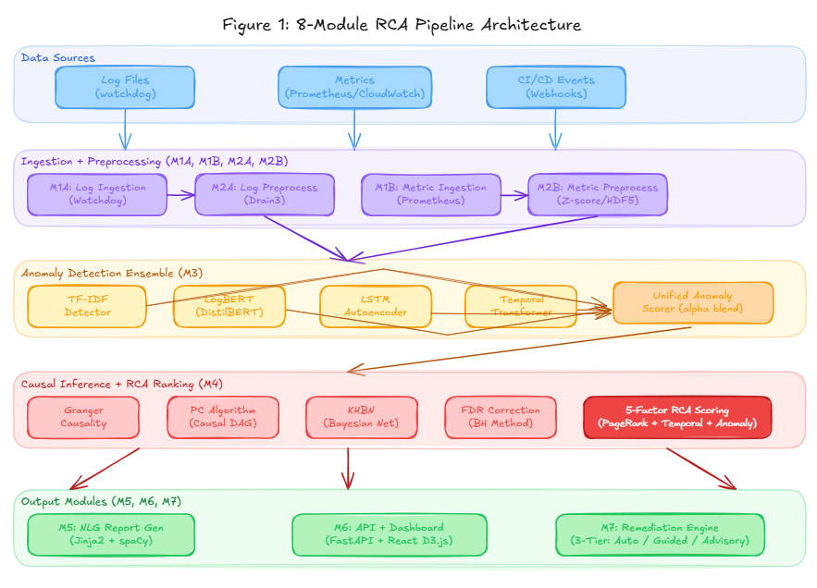 Figure 1: 8-Module RCA Pipeline Architecture

6.2 Module Breakdown
Module | Name | Owner | Description
M1A | Log Ingestion | Utsav | Tail log files via watchdog file-system monitoring
M1B | Metric Ingestion | Utsav | Pull metrics from Prometheus/CloudWatch; receive CI/CD webhooks
M2A | Log Preprocessing | Utsav | Drain3 template extraction and event ID assignment
M2B | Metric Preprocessing | Utsav | Gap filling, z-score normalisation, windowing to HDF5
M3 | Anomaly Detection | Aditya | Ensemble of four models with unified anomaly scoring
M4 | Causal Inference | Shresth | Granger, PC algorithm, KHBN, FDR correction, 5-factor RCA scoring
M5 | NLG Report Generator | Yashash | Jinja2 + spaCy narrative incident report generation
M6 | API and Dashboard | Yashash | FastAPI REST backend and React D3.js dashboard (17 endpoints)
M7 | Remediation Engine | Yashash | Three-tier safety classification with auto-execution for Tier 1

6.3 Anomaly Detection and Causal Inference Flow
The four ensemble models operate in parallel. Their scores are combined via: score = α × model_score + (1−α) × rarity_prior (α = 0.80). Flagged anomalies enter the causal inference engine where Granger causality, PC algorithm, and KHBN produce a causal DAG. The five-factor RCA scoring function computes: rca_score = 0.35 × pagerank + 0.25 × temporal_priority + 0.20 × anomaly_score + 0.10 × rarity_prior + 0.10 × event_bonus.

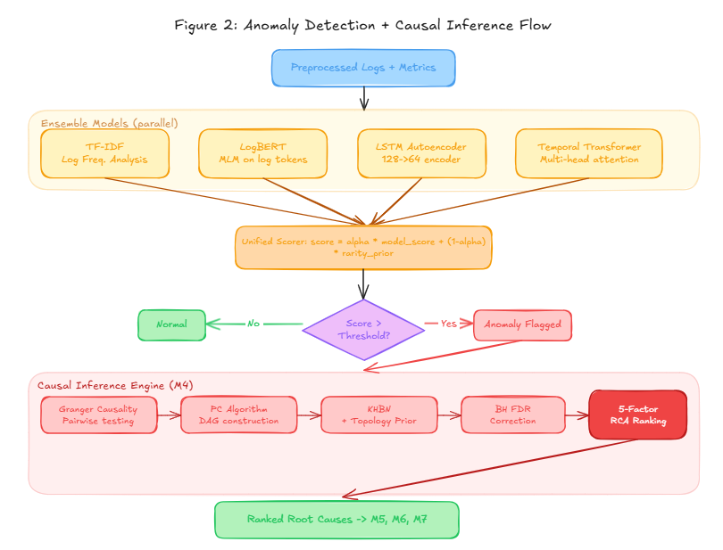 Figure 2: Anomaly Detection + Causal Inference Flow

6.4 Three-Tier Remediation Engine
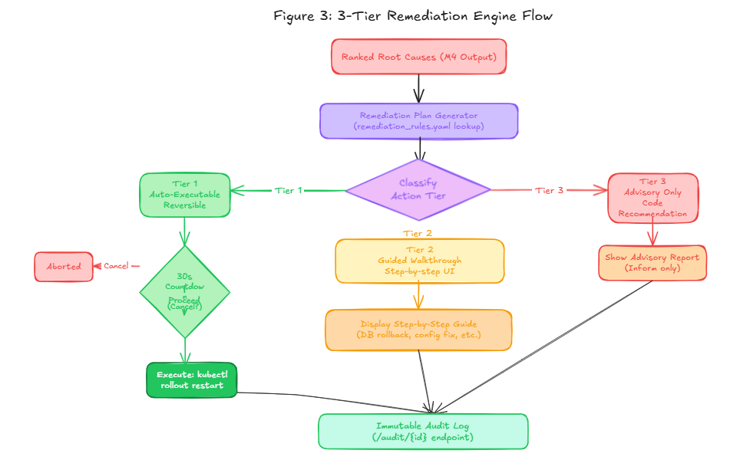 Figure 3: 3-Tier Remediation Engine Flow

Tier | Action Type | Example | Automation
Tier 1 | Auto-executable, reversible | kubectl rollout restart deployment | 30s countdown + cancel
Tier 2 | Guided walkthrough | Database migration rollback | Step-by-step UI
Tier 3 | Advisory, architectural | Code-level fix recommendation | Inform only

7. Functional Requirements

7.1 Software Requirements
Category | Technology / Version
Language | Python 3.11
Web Framework | FastAPI
ML / Deep Learning | PyTorch (CPU), Hugging Face Transformers (DistilBERT), scikit-learn
Causal Inference | causal-learn, pgmpy, NetworkX
Log Processing | Drain3
NLP / Reporting | spaCy, Jinja2
Frontend | React 18 + Vite, D3.js, Recharts, Nginx
Database | TimescaleDB (PostgreSQL 15 + Timescale extension)
Cache / Stream | Redis 7 (Streams)
Metrics Collection | Prometheus 2.51
Containerisation | Docker and Docker Compose (7 services)
Testing | pytest — 269 tests (199 unit, 27 integration, 43 system)

7.2 Hardware Requirements
Component | Minimum Specification
Processor | Quad-core CPU (Intel i5 / AMD Ryzen 5 or equivalent)
RAM | 16 GB (for running all 7 Docker services concurrently)
Storage | 20 GB free disk space (container images, log data, HDF5 files)
Operating System | Ubuntu 22.04 LTS / macOS 13+ / Windows 11 with WSL2
Network | Local network access (all services via Docker bridge network)

8. Expected Outcome and Applications

8.1 Expected Outcome
- A fully functional, containerised eight-module AI pipeline performing end-to-end automated root cause analysis of production failures.
- Top-1 root cause identification accuracy > 70% and Top-3 accuracy > 88% across ten ground-truth failure scenarios.
- 269 passing tests across unit, integration, and system/end-to-end categories.
- A six-tab React dashboard with D3.js causal graph visualisation, metric time-series views, annotated log rendering, and a remediation walkthrough interface.
- Structured natural language incident reports mapping technical causal graphs to human-readable diagnoses.
- A three-tier remediation engine covering ten failure scenarios with Tier 1 auto-execution and Tier 2 guided walkthroughs.
- A reusable KHBN architecture integrating structural priors from service topology graphs with data-driven causal learning.

8.2 Applications
- Site Reliability Engineering (SRE): Automated first-pass incident diagnosis to reduce MTTR.
- AIOps Platforms: Integration as a causal reasoning layer within Datadog, Grafana, or PagerDuty stacks.
- Cloud-Native Operations: Kubernetes-based microservice environments requiring cross-namespace causal tracing.
- DevOps CI/CD Pipelines: Automated detection of deployment-induced regressions.
- Cybersecurity Incident Response: Adaptation of the causal inference engine to trace attack paths through security logs.
- Research: Novel KHBN architecture and five-factor scoring function suitable for IEEE publication and benchmark participation.

9. References

[1] P. He, J. Zhu, Z. Zheng, and M. R. Lyu, "Drain: An Online Log Parsing Approach with Fixed Depth Tree," in Proc. IEEE ICWS, Honolulu, HI, USA, 2017, pp. 33–40.

[2] X. Zhang et al., "Robust Log-Based Anomaly Detection on Unstable Log Data," in Proc. ESEC/FSE, Tallinn, Estonia, 2019, pp. 807–817.

[3] J. Devlin, M.-W. Chang, K. Lee, and K. Toutanova, "BERT: Pre-training of Deep Bidirectional Transformers for Language Understanding," in Proc. NAACL-HLT, Minneapolis, MN, USA, 2019, pp. 4171–4186.

[4] K. Hundman, V. Constantinou, C. Laporte, I. Colwell, and T. Soderstrom, "Detecting Spacecraft Anomalies Using LSTMs and Nonparametric Dynamic Thresholding," in Proc. ACM SIGKDD, London, UK, 2018, pp. 387–395.

[5] A. Vaswani et al., "Attention is All You Need," in Advances in Neural Information Processing Systems (NeurIPS), vol. 30, Long Beach, CA, USA, 2017.

[6] B. N. Lim, S. O. Arik, N. Loeff, and T. Pfister, "Temporal Fusion Transformers for Interpretable Multi-horizon Time Series Forecasting," International Journal of Forecasting, vol. 37, no. 4, pp. 1748–1764, 2021.

[7] P. Spirtes, C. Glymour, and R. Scheines, Causation, Prediction, and Search, 2nd ed. Cambridge, MA: MIT Press, 2000.

[8] C. W. J. Granger, "Investigating Causal Relations by Econometric Models and Cross-spectral Methods," Econometrica, vol. 37, no. 3, pp. 424–438, 1969.

[9] P. Wang et al., "MicroRCA: Root Cause Localization of Performance Issues in Microservices," in Proc. IEEE/IFIP NOMS, Budapest, Hungary, 2020, pp. 1–9.

[10] D. Koller and N. Friedman, Probabilistic Graphical Models: Principles and Techniques. Cambridge, MA: MIT Press, 2009.

[11] M. Lim et al., "AIOps: Artificial Intelligence for IT Operations," arXiv preprint arXiv:2012.09552, 2020.

