Steven Wray

Physics 4620

10/11/12

**Simple Pendulum**

***Introduction***

This project uses a model explore the motion of a simple pendulum. The performance of several basic numerical methods for the solution of ODEs is evaluated in the context of an oscillating system.

***Activities***

2.15: Using the small angle approximation for a simple pendulum gives total energy:

$$E=\frac{1}{2}mL^{2}ω^{2}+\frac{1}{2}mgLθ^{2}-mgL$$

Show that $E$ monotonically increases with time when the Euler method is used to approximate the motion of the pendulum.

The basic equations arising from the Euler method are:

$$θ\left(t+τ\right)=θ\left(t\right)+τω\left(t\right)$$

$$ω\left(t+τ\right)=ω\left(t\right)+τα\left(t\right)$$

So

$$E\left(t+τ\right)=\frac{1}{2}mL^{2}{ω\left(t+τ\right)}^{2}+\frac{1}{2}mgL{θ\left(t+τ\right)}^{2}-mgL$$

$$=\frac{1}{2}mL^{2}{\left[ω\left(t\right)+τα\left(t\right)\right]}^{2}+\frac{1}{2}mgL{[θ\left(t\right)+τω\left(t\right)]}^{2}-mgL$$

$$=\frac{1}{2}mL^{2}\left[ω{\left(t\right)}^{2}+2τω\left(t\right)α\left(t\right)+τ^{2}α{\left(t\right)}^{2}\right]+\frac{1}{2}mgL\left[θ{\left(t\right)}^{2}+2τθ\left(t\right)ω\left(t\right)+τ^{2}ω{\left(t\right)}^{2}\right]-mgL$$

$$=\frac{1}{2}mL^{2}ω^{2}+mL^{2}τωα+\frac{1}{2}mL^{2}τ^{2}α^{2}+\frac{1}{2}mgLθ^{2}+mgLτθω+\frac{1}{2}mgLτ^{2}ω^{2}-mgL$$

$$=\frac{1}{2}mL^{2}ω^{2}+\frac{1}{2}mgLθ^{2}-mgL+mL^{2}τωα+\frac{1}{2}mL^{2}τ^{2}α^{2}+mgLτθω+\frac{1}{2}mgLτ^{2}ω^{2}$$

$$=E\left(t\right)+mL^{2}τωα+\frac{1}{2}mL^{2}τ^{2}α^{2}+mgLτθω+\frac{1}{2}mgLτ^{2}ω^{2}$$

$$=E\left(t\right)+mL^{2}τω(-\frac{g}{L}\sin{θ)}+\frac{1}{2}mL^{2}τ^{2}(\frac{g^{2}}{L^{2}}\sin^{2}{θ)}+mgLτθω+\frac{1}{2}mgLτ^{2}ω^{2}$$

Applying the small angle approximation gives:

$$=E\left(t\right)-mgLτθω+\frac{1}{2}mg^{2}τ^{2}θ^{2}+mgLτθω+\frac{1}{2}mgLτ^{2}ω^{2}$$

$$=E\left(t\right)+\frac{1}{2}mg^{2}τ^{2}θ^{2}+\frac{1}{2}mgLτ^{2}ω^{2}$$

$$>E(t)$$

The constants $m,g,$ and $L$ are all positive and $θ^{2}, τ^{2},$ and $ω^{2}$ are nonnegative by virtue of being squared. At least one of $θ$ and $ω$ must be nonzero at any point in time, and so the strict inequality is justified. So $E\left(t+τ\right)>E(t)$ and total energy is monotonically increasing at each time step under the Euler method.

2.16: Write a version of the pendulum program that implements the Euler-Cromer, leapfrog, and midpoint methods. Compare the results with the Euler and Verlet methods.

The results for the Euler-Cromer method are very similar to the results obtained with the Verlet method. Using an initial angle of 10° and timestep $τ=0.1$ seconds with 300 steps produces the result:

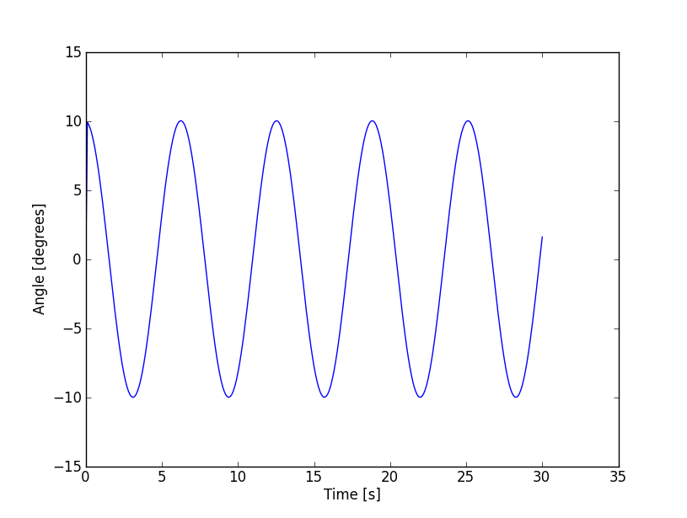

The amplitude is consistent across all the oscillations under the Euler-Cromer method. So the energy of the pendulum is numerically stable .

Using the same initial angle with a timestep of $τ=0.05$ seconds and 600 steps gives:

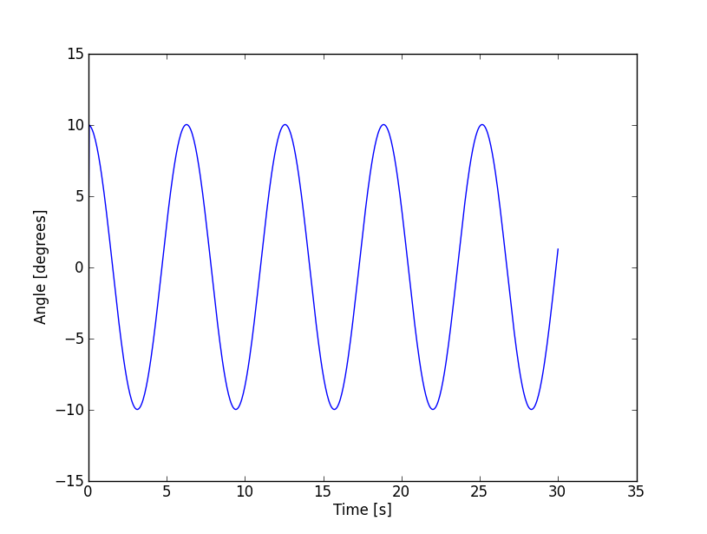

This plot shows the same pattern of stability in the amplitude of the pendulum. The curve is perhaps slightly smoother because of the additional data points.

Finally, setting the initial angle to 170° with $τ=0.1$ seconds and 300 timesteps yields:

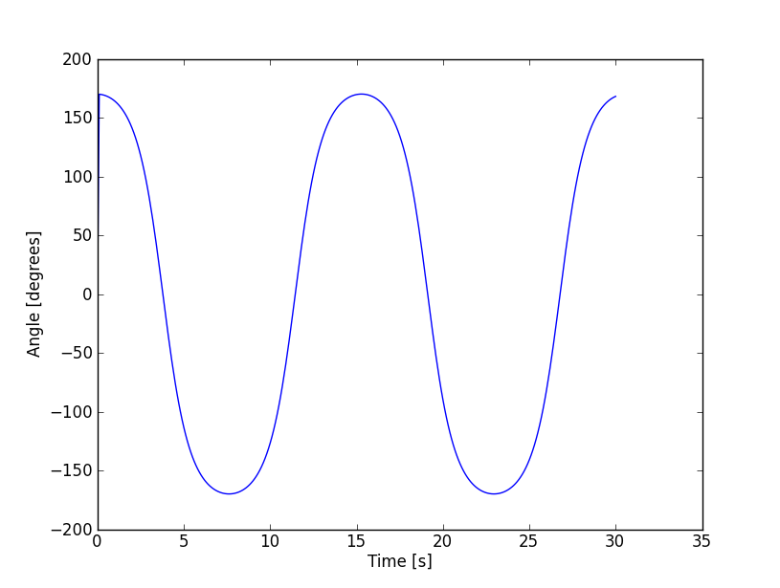

The amplitude is still stable between oscillations. The Euler-Cromer method shows the same flattening of the curve near the turning points that is seen under the Verlet method.

In contrast, the midpoint method fails to produce an accurate model of the pendulum’s motions. Starting with $θ_{0}=10°$ and $τ=0.1$ seconds with 300 steps results in the following plot:

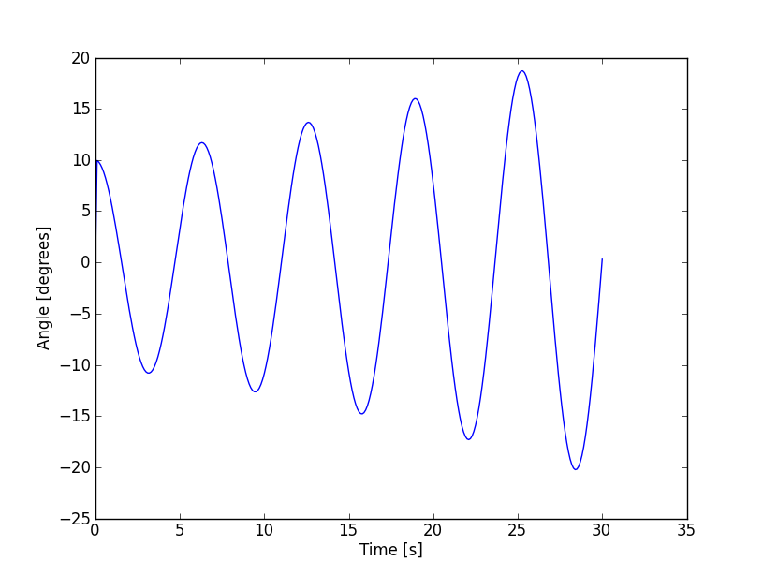

This graph shows evidence of the same problem that plagued the Euler method. Because the error at each step is accumulating, the amplitude of the oscillations increases over time. This implies that the total energy of the pendulum is also increasing. This result is physically unacceptable since it violates the law of conservation of energy.

Using the same initial angle with $τ=0.05$ and 600 timesteps produces:

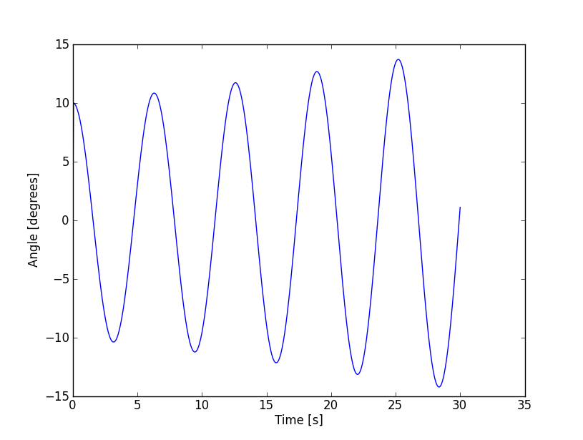

The increase in amplitude is not as dramatic in this second dataset. However, the same basic problem remains. The total energy of the pendulum is increasing between each oscillation due to accumulating error.

The problem becomes most drastic when beginning with a large initial angle. If the pendulum starts at $170°$ with $τ=0.1$ second and 300 timesteps, the midpoint method gives:

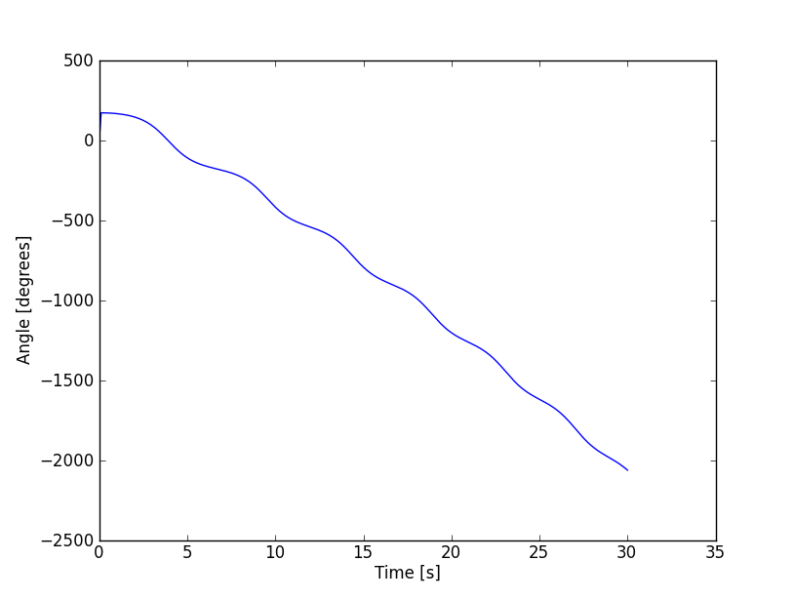

During its first oscillation, the pendulum accumulates so much energy that it swings through $180°$ and continues moving in an ever-faster circular orbit. This is clearly not the behavior that would be seen with a physical pendulum.

The leapfrog method does not have the same problem of accumulating error. Beginning with an initial angle of $10°$, $τ=0.1$ seconds and 300 timesteps yields:

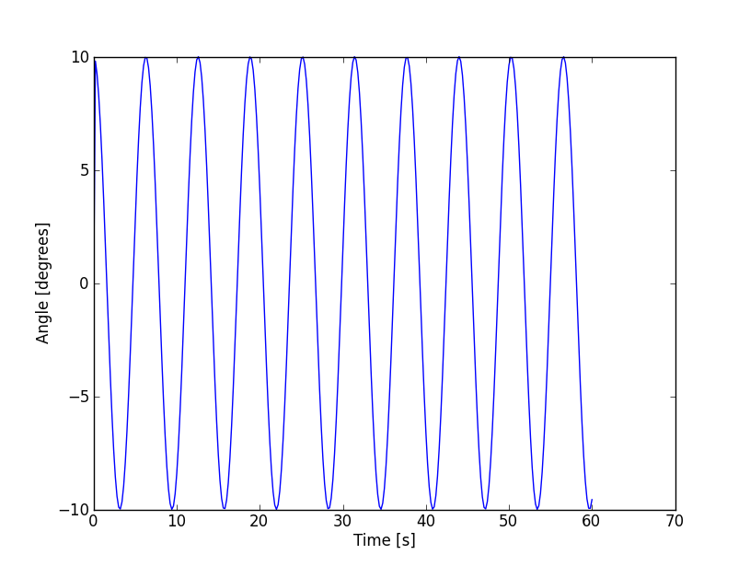

The amplitude of the pendulum remains the same between successive oscillations, and so the total energy of the pendulum is conserved. It is interesting to note that the leapfrog method uses 300 timesteps to produce 60 seconds of data. The Verlet and Euler-Cromer methods used the same number of steps but gave only 30 seconds of data. This suggests that the leapfrog method is a more efficient algorithm for this type of problem.

Starting at $10°$ with $τ=0.05$ seconds and 600 steps gives the result:

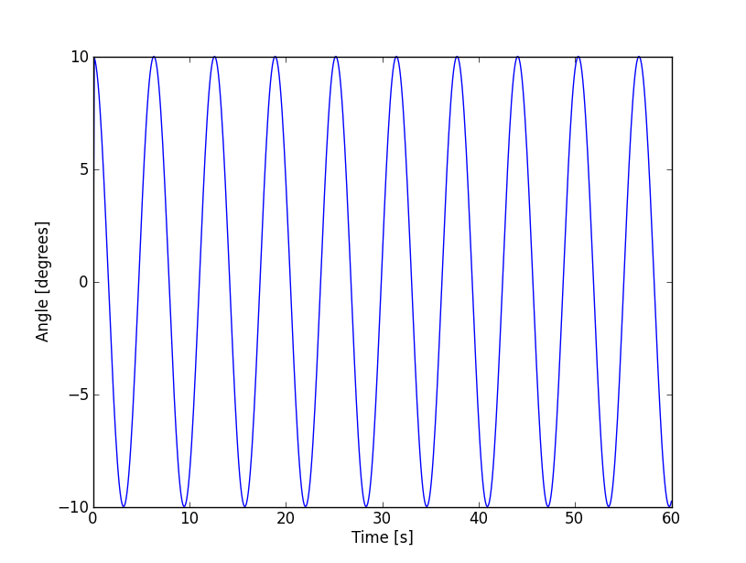

The energetics of the model are still stable. It is difficult to see how adding extra timesteps improved the performance of the leapfrog method in this example.

Finally, for a large initial angle $θ_{0}=170°$ with $τ=0.1$ seconds and 300 timesteps, the leapfrog method produces:

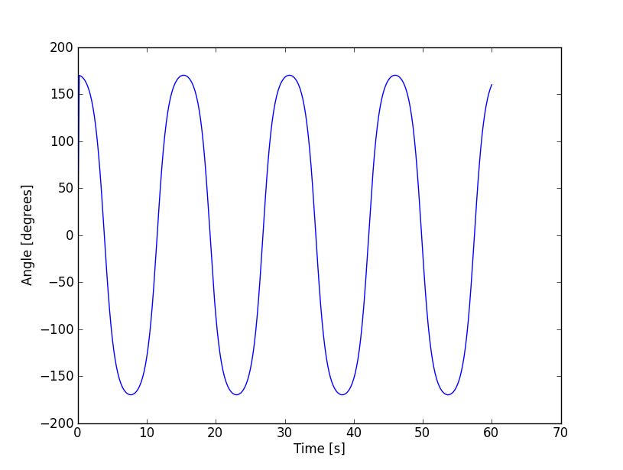

The total energy is still stable, and the curve shows the same flattening at the turning points that was visible with the Verlet method.

2.17: Plot the period $T$ as a function of the initial angle $θ_{m}$ using the Verlet method. Also include the estimates of the period given by the small angle (constant) and quadratic approximations. Find the value of $θ_{m}$ where each approximation exceeds an error of $10\%$.

The small angle approximation of the period is

$$T=2π\sqrt{\frac{L}{g}}$$

and the second degree approximation is

$$T=2π\sqrt{\frac{L}{g}}\left(1+\frac{1}{16}θ^{2}\right).$$

For initial angles ranging between $2°$ and $170°$, the approximations and the Verlet method give the following results:

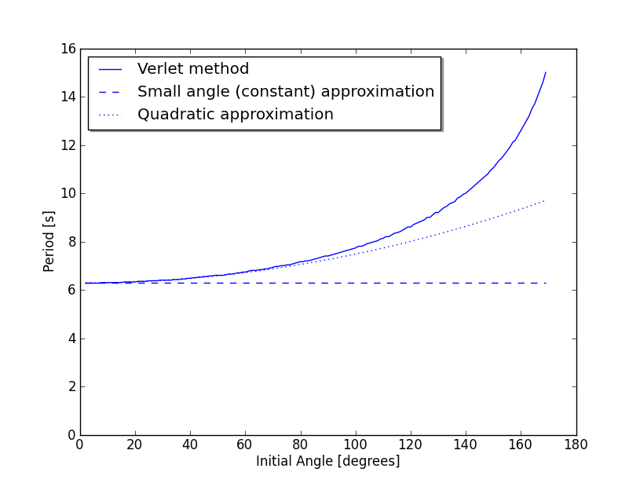

It is clear that the second degree Taylor expansion for the period is accurate over a much wider range of angles then the small angle approximation. The small angle approximation has a relative error of less than $10\%$ for $θ_{m}<73°$. The second order approximation has a relative error of less than $10\%$ for $θ_{m}<129°$. Obviously, an even better approximation could be obtained by including higher-order terms of the Taylor series.

8.7: Modify the pendulum program to create a phase space plot using the Verlet method. Halt the calculation when the pendulum has completed one period.

Using a consistent timestep of $τ=0.1$ second, a series of phase diagrams was plotted for several different initial angles. For $θ_{m}=10°$:

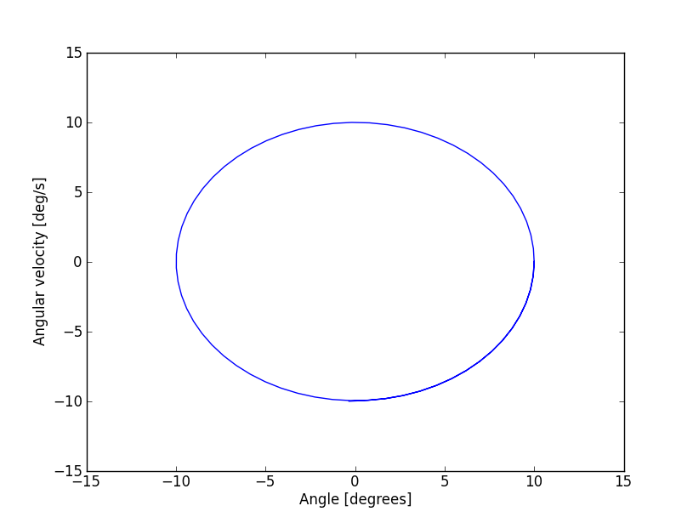

For $θ_{m}=45°$:

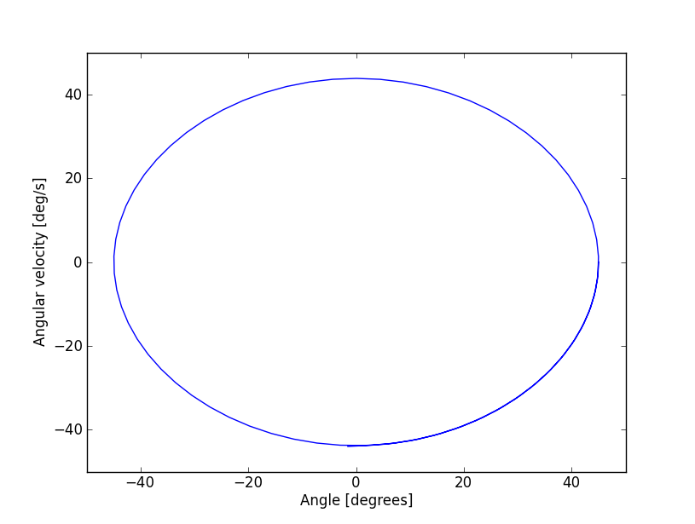

For $θ_{m}=90°$:

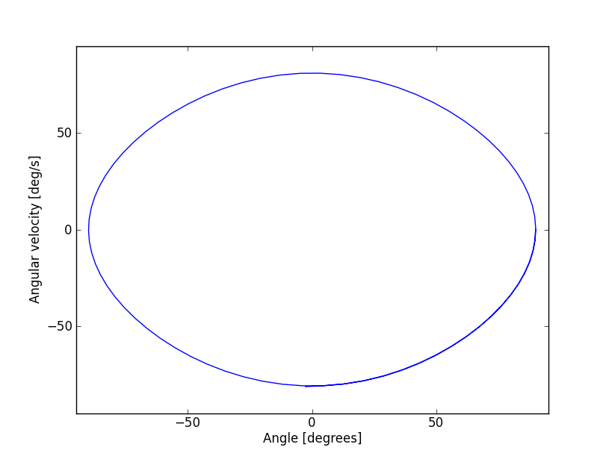

For $θ_{m}=120°$:

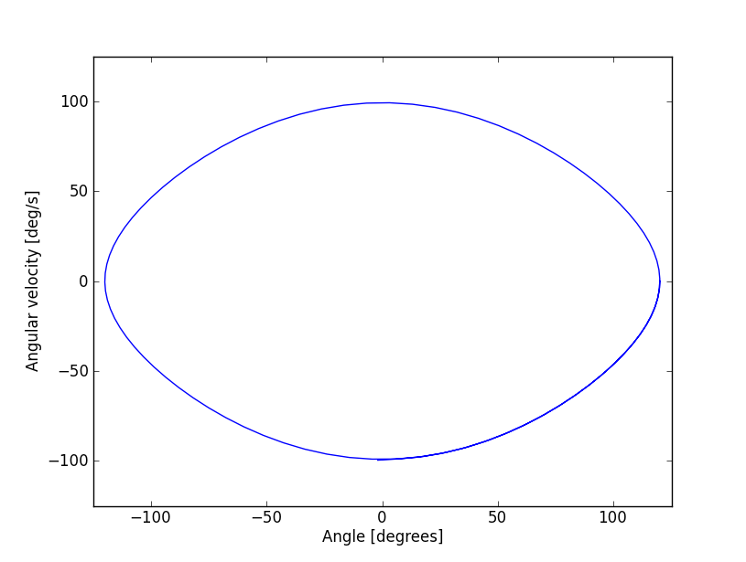

And finally for $θ_{m}=170°:$

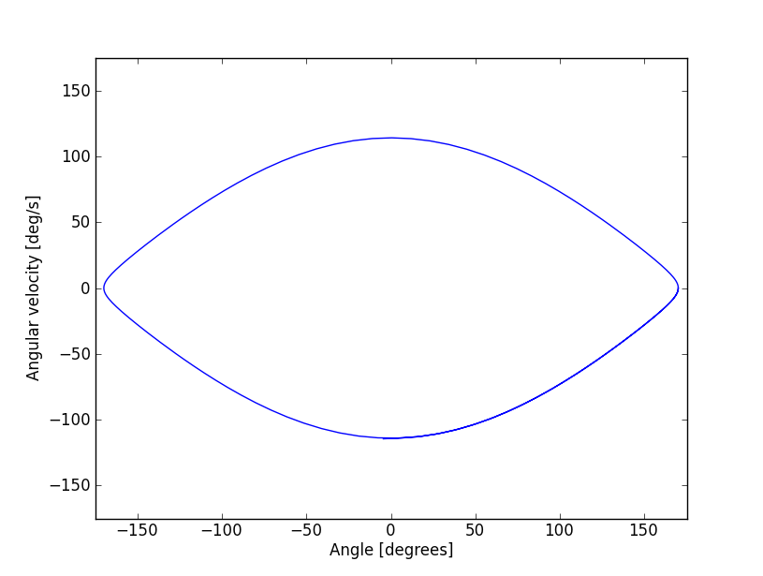

For small initial angles, the phase space diagram is almost perfectly elliptical. The curvature varies smoothly throughout the pendulum’s range. The maximum angular velocity has roughly the same numerical value as the maximum angle. As the initial angle increases, the phase plot flattens and becomes somewhat lemon-shaped. At the two points of maximum displacement, the curvature changes extremely quickly. The numerical value of maximum velocity on these graphs is much less than the value for maximum displacement.

2.20: Use interpolation to improve on the pendulum program. Comment on the relative improvement in the error for the estimation of the period.

The pendulum program estimates the period by recording estimates for the times when $θ=0$. At the point in the program when $θ$ changes from positive to negative, the time for $θ=0$ was interpolated using a quadratic Lagrange polynomial constructed with the three most recent data points.

For an initial angle of $10°$ and a timestep $τ=0.1$ seconds, the value of the period without interpolation over 300 iterations was $6.289±0.099$ seconds. When interpolation was added to the routine, the same initial conditions produced an estimate for the period of

$6.29255±0.0000896$ seconds. The range of error in the estimate was reduced by three orders of magnitude.

Using an initial angle of $45°$ with the same method and time values, the program without interpolation calculated the period as $6.525±0.097$ seconds. Adding interpolation gave a result of $6.53184±0.0000815$ seconds. Once again the error in the estimate was reduced by three orders of magnitude.

Finally, changing the initial angle to $170°$ gave a period of $15.333±0.094$ seconds without interpolation. Adding interpolation changed the estimate to $15.32833±0.0000791$ seconds.

The gain in accuracy from interpolation appears to be consistent for a wide range of initial angles. The error in the estimate of the period computed by the program is reduced by three orders of magnitude when interpolation is used to estimate the time when $θ=0$.

**Conclusion**

**APPENDIX:**

**Source Code**

# pendulum.py

# Python 2.7.2

# Steven Wray

# Physics 4620

# Project 1: Simple pendulum

# 2.16: Use Euler, Euler-Cromer, leap-frog, midpoint, and Verlet's methods

# to approximate the motion of a simple pendulum.

import math

import numpy as np

import matplotlib.pyplot as plt

EULER = 1

VERLET = 2

EULER_CROMER = 3

MIDPOINT = 4

LEAPFROG = 5

def main():

# Get parameters from user

print("Numerical methods")

print("\t1. Euler")

print("\t2. Verlet")

print("\t3. Euler-Cromer")

print("\t4. Midpoint")

print("\t5. Leapfrog")

s = input("Enter a numerical method: ")

numerical_method = int(s)

s = input("Initial angle [degrees]: ")

theta0 = float(s)

s = input("Enter time step [seconds]: ")

tau = float(s)

s = input("Enter number of time steps: ")

nstep = int(s)

# Set physical constants and variables

G_OVER_L = 1

time = 0 # Initial time

reversals = 0 # Count reversals of pendulum

# Set initial position of pendulum

theta = theta0 * math.pi / 180 # radians

omega = 0 # angular velocity

# Take a backward step to start Verlet

# and leapfrog methods

accel = - G_OVER_L * math.sin(theta)

if numerical_method == VERLET:

theta_old = theta - omega * tau + 0.5 * tau**2 * accel

if numerical_method == LEAPFROG:

omega = omega - tau * accel

# Lists to store data for plotting

theta_list = [theta]

time_list = [0]

time = time + tau

for i in range(nstep):

# Compute new position and velocity

accel = - G_OVER_L * math.sin(theta)

if numerical_method == EULER:

theta_old = theta

theta = theta + tau * omega

omega = omega + tau * accel

elif numerical_method == VERLET:

theta_new = 2 * theta - theta_old + tau**2 * accel

theta_old = theta

theta = theta_new

elif numerical_method == EULER_CROMER:

omega = omega + tau * accel

theta_old = theta

theta = theta + tau * omega

elif numerical_method == MIDPOINT:

omega_new = omega + tau *accel

theta_old = theta

theta = theta + tau * (omega_new + omega) / 2

omega = omega_new

else: # Leapfrog

omega = omega + 2 * tau * accel

time = time + tau

theta_old = theta

theta = theta + 2 * tau * omega

# Record angle and time for plotting

theta_list.append(theta * 180 / math.pi) # in degrees

time_list.append(time)

# See if the pendulum has passed through theta = 0

# and, if so, estimate period

if theta * theta_old < 0:

print "Turning point at time t = ", round(time, 4), " [s]."

if reversals == 0:

time_old = time

elif reversals == 1:

period_list = [2*(time - time_old)]

time_old = time

else:

period_list.append(2*(time - time_old))

time_old = time

reversals = reversals + 1

time = time + tau

# Estimate period of oscillation with error

if reversals > 1:

average_period = np.average(period_list)

error = np.std(period_list)

print "Average period ", round(average_period, 3), " +/- ", \

round(error, 3), " [s]"

# Plot the data

line1 = plt.plot(time_list, theta_list, 'b')

plt.ylabel('Angle [degrees]')

plt.xlabel('Time [s]')

plt.show()

main()

# pendulum.py

# Python 2.7.2

# Steven Wray

# Physics 4620

# Project 1: Simple pendulum

# 2.17: Use Verlet's method to find the period of a pendulum for a range

# of initial angles. Compare this to the period given by different

# approximations.

import math

import numpy as np

import matplotlib.pyplot as plt

def main():

# Set physical constants and parameters

G_OVER_L = 1

nstep = 300 # Number of timestep for Verlet method

tau = 0.05 # Timestep

# Lists to store data for plotting

theta_list = [0]

average_period_list = [0]

for theta0 in range(2, 170):

# Set initial conditions for pendulum

time = 0 # initial time

reversals = 0 # count number of reversals

theta = theta0 * math.pi / 180 # radians

omega = 0 # angular velocity

# Take a backward step to start Verlet method

accel = - G_OVER_L * math.sin(theta)

theta_old = theta - omega * tau + 0.5 * tau**2 * accel

for i in range(nstep):

# Update position with Verlet method

accel = - G_OVER_L * math.sin(theta)

theta_new = 2 * theta - theta_old + tau**2 * accel

theta_old = theta

theta = theta_new

# See if the pendulum has passed through theta = 0

# and estimate period

if theta * theta_old < 0:

if reversals == 0:

time_old = time

elif reversals == 1:

period_list = [2*(time - time_old)]

time_old = time

else:

period_list.append(2*(time - time_old))

time_old = time

reversals = reversals + 1

time = time + tau

# Estimate period of oscillation with error

if reversals > 1:

average_period = np.average(period_list)

error = np.std(period_list)

if error / average_period > 0.01:

print ("WARNING: Error in period is greater than 1%")

print ("\tfor initial angle", theta0)

# Record data for plotting

if theta_list[-1] == 0:

theta_list = [theta0]

average_period_list = [average_period]

else:

theta_list.append(theta0)

average_period_list.append(average_period)

# Record dataset for plotting small angle approximation of period

average_period = 2 * math.pi * math.sqrt(1/G_OVER_L)

small_angle_period = [average_period]

for theta0 in range(3, 170):

small_angle_period.append(average_period)

# Find theta where error in small angle approximation exceeds 10%

for i in range(len(theta_list)):

error = math.fabs(average_period_list[i] - small_angle_period[i]) \

/ average_period_list[i]

if error > 0.1:

theta = theta_list[i]

s = 'Error in small angle approximation exceeds 10% for theta = ' \

+ str(theta) + ' degrees.'

print(s)

break

# Record dataset for plotting quadratic approximation of period

elliptic_period_list = [0]

for theta0 in range (2,170):

theta = math.pi * theta0 / 180

period = 2 * math.pi * math.sqrt(1/G_OVER_L) * (1 + theta**2 / 16)

if elliptic_period_list[-1] == 0:

elliptic_period_list = [period]

else:

elliptic_period_list.append(period)

# Find theta where error in quadratic approximation exceeds 10%

for i in range(len(theta_list)):

error = math.fabs(average_period_list[i] - elliptic_period_list[i]) \

/ average_period_list[i]

if error > 0.1:

theta = theta_list[i]

s = 'Error in elliptic integral approximation exceeds 10% for theta = ' \

+ str(theta) + ' degrees.'

print(s)

break

# Plot the datasets

fig = plt.figure()

ax = fig.add_subplot(111)

ax.plot(theta_list, average_period_list, 'b', \

theta_list, small_angle_period, 'b--', \

theta_list, elliptic_period_list, 'b:')

leg = ax.legend(("Verlet method", "Small angle (constant) approximation", \

"Quadratic approximation"), 'upper left', shadow=True)

ax.set_ylim([0,16])

ax.grid(False)

ax.set_xlabel('Initial Angle [degrees]')

ax.set_ylabel('Period [s]')

plt.show()

main()

# pendulum.py

# Python 2.7.2

# Steven Wray

# Physics 4620

# Project 1: Simple pendulum

# 2.18: Use a numerical method to create a phase space plot

# of the pendulum's motion.

import math

import numpy as np

import matplotlib.pyplot as plt

EULER = 1

VERLET = 2

EULER_CROMER = 3

MIDPOINT = 4

LEAPFROG = 5

def main():

# Get parameters from user

print("Numerical methods")

print("\t1. Euler")

print("\t2. Verlet")

print("\t3. Euler-Cromer")

print("\t4. Midpoint")

print("\t5. Leapfrog")

s = input("Enter a numerical method: ")

numerical_method = int(s)

s = input("Initial angle [degrees]: ")

theta0 = float(s)

s = input("Enter time step [seconds]: ")

tau = float(s)

# Set physical constants and variables

G_OVER_L = 1

time = 0 # Initial time

reversals = 0 # Count reversals of pendulum

max_steps = 10000 # Maximum timesteps

# Set initial position of pendulum

theta = theta0 * math.pi / 180 # radians

omega = 0 # angular velocity

# Take a backward step to start Verlet

# and leapfrog methods

accel = - G_OVER_L * math.sin(theta)

if numerical_method == VERLET:

theta_old = theta - omega * tau + 0.5 * tau**2 * accel

if numerical_method == LEAPFROG:

omega = omega - tau * accel

# Lists to store data for plotting

theta_list = [theta0]

omega_list = [omega]

time = time + tau

i = 0

while i < max_steps:

# Compute new position and velocity

accel = - G_OVER_L * math.sin(theta)

if numerical_method == EULER:

theta_old = theta

theta = theta + tau * omega

omega = omega + tau * accel

elif numerical_method == VERLET:

theta_new = 2 * theta - theta_old + tau**2 * accel

omega = (theta_new - theta_old) / (2 * tau)

theta_old = theta

theta = theta_new

elif numerical_method == EULER_CROMER:

omega = omega + tau * accel

theta_old = theta

theta = theta + tau * omega

elif numerical_method == MIDPOINT:

omega_new = omega + tau *accel

theta_old = theta

theta = theta + tau * (omega_new + omega) / 2

omega = omega_new

else: # Leapfrog

omega = omega + 2 * tau * accel

time = time + tau

theta_old = theta

theta = theta + 2 * tau * omega

# Record angle and time for plotting

theta_list.append(theta * 180 / math.pi) # in degrees

omega_list.append(omega * 180 / math.pi)

# See if the pendulum has passed through theta = 0

# and estimate period. Exit the loop if the pendulum

# has finished one complete period.

if theta * theta_old < 0:

print "Turning point at time t =", round(time, 4), " [s]."

if reversals == 0:

time_old = time

elif reversals == 1:

period_list = [2*(time - time_old)]

time_old = time

else:

period_list.append(2*(time - time_old))

time_old = time

break

reversals = reversals + 1

time = time + tau

i = i + 1

# If we are using the Verlet method we need one additional value

# of omega to make our lists match up.

if numerical_method == VERLET:

theta_new = 2 * theta - theta_old + tau**2 * accel

omega = (theta_new - theta_old) / (2 * tau)

omega_list.pop(0)

omega_list.append(omega * 180 / math.pi)

# Estimate period of oscillation with error

if reversals > 1: # Make sure there is at least one data point

period_sum = 0

average_period = np.average(period_list)

error = np.std(period_list)

print "Average period ", round(average_period, 5), " +/- ", \

round(error, 5), " [s]"

# Plot the data

# Plot the datasets

fig = plt.figure()

ax = fig.add_subplot(111)

ax.plot(theta_list, omega_list, 'b')

ax.set_ylim([-theta0 - 5, theta0 + 5])

ax.set_xlim([-theta0 - 5, theta0 + 5])

ax.grid(False)

ax.set_xlabel('Angle [degrees]')

ax.set_ylabel('Angular velocity [deg/s]')

plt.show()

main()

# pendulum.py

# Python 2.7.2

# Steven Wray

# Physics 4620

# Project 1: Simple pendulum

# 2.20: Improve the estimate of the pendulum's period by using

# interpolation.

import math

import numpy as np

import matplotlib.pyplot as plt

# Function to interpolate between three data points

# using a quadratic Lagrange polynomial.

def interp(xi, x, y):

# x and y are arrays that contain the coordinates for the three

# data points

# xi: interpolate the function at this value

yi = (xi-x[1]) * (xi-x[2]) / ((x[0]-x[1]) * (x[0]-x[2])) * y[0] \

+ (xi-x[0]) * (xi-x[2]) / ((x[1]-x[0]) * (x[1]-x[2])) * y[1] \

+ (xi-x[0]) * (xi-x[1]) / ((x[2]-x[0]) * (x[2]-x[1])) * y[2]

return yi

EULER = 1

VERLET = 2

EULER_CROMER = 3

MIDPOINT = 4

LEAPFROG = 5

def main():

print("Numerical methods")

print("\t1. Euler")

print("\t2. Verlet")

print("\t3. Euler-Cromer")

print("\t4. Midpoint")

print("\t5. Leapfrog")

s = input("Enter a numerical method: ")

numerical_method = int(s)

s = input("Initial angle [degrees]: ")

theta0 = float(s)

s = input("Enter time step [seconds]: ")

tau = float(s)

s = input("Enter number of time steps: ")

nstep = int(s)

# Set physical constants and variables

G_OVER_L = 1

time = 0 # Initial time

reversals = 0 # Count reversals of pendulum

# Set initial position of pendulum

theta = theta0 * math.pi / 180 # radians

omega = 0 # angular velocity

# Take a backward step to start Verlet method

accel = - G_OVER_L * math.sin(theta)

theta_old = theta - omega * tau + 0.5 * tau**2 * accel

# Lists to store data for plotting

theta_list = [theta]

time_list = [0]

time = time + tau

for i in range(nstep):

# Record angle and time for plotting

# Compute new position

accel = - G_OVER_L * math.sin(theta)

if numerical_method == EULER:

theta_old = theta

theta = theta + tau * omega

omega = omega + tau * accel

elif numerical_method == VERLET:

theta_new = 2 * theta - theta_old + tau**2 * accel

theta_old = theta

theta = theta_new

elif numerical_method == EULER_CROMER:

omega = omega + tau * accel

theta_old = theta

theta = theta + tau * omega

elif numerical_method == MIDPOINT:

omega_new = omega + tau *accel

theta_old = theta

theta = theta + tau * (omega_new + omega) / 2

omega = omega_new

else: # Leapfrog

omega = omega + 2 * tau * accel

time = time + tau

theta_old = theta

theta = theta + 2 * tau * omega

# Record angle and time for plotting

theta_list.append(theta * 180 / math.pi) # in degrees

time_list.append(time)

# See if the pendulum has passed through theta = 0

# and estimate period

if theta * theta_old < 0:

# Make sure we have at least three data points for interpolation

# Otherwise just use the current time as turning point

if (len(theta_list) >= 3):

# Estimate turning point using interpolation

turning_point = interp(0.0, \

[theta_list[-3], theta_list[-2], theta_list[-1]],

[time_list[-3], time_list[-2], time_list[-1]])

else:

turning_point = time

print "Turning point at time t =", round(turning_point, 4), " [s]."

if reversals == 0:

turning_point_old = turning_point

elif reversals == 1:

period_list = [2*(turning_point - turning_point_old)]

turning_point_old = turning_point

else:

period_list.append(2*(turning_point - turning_point_old))

turning_point_old = turning_point

reversals = reversals + 1

time = time + tau

# Estimate period of oscillation with error

if reversals > 1:

period_sum = 0

average_period = np.average(period_list)

error = np.std(period_list)

print "Average period ", round(average_period, 5), " +/- ", \

round(error, 7), " [s]"

# Plot the data

line1 = plt.plot(time_list, theta_list, 'b')

plt.ylabel('Angle [degrees]')

plt.xlabel('Time [s]')

plt.show()

main()