Conditional Probability Worksheet

1. Andrea is a very good student. The probability that she studies and
passes her mathematics test is 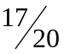. If the probability that Andrea
studies is 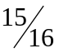, find the probability that Andrea passes her
mathematics test, given that she has studied.

2. The probability that Janice smokes is 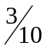. The probability that she
Smokes and develops lung cancer is 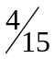. Find the probability that
Janice develops lung cancer, given that she smokes.

3. The probability that Sue will go to Mexico in the winter and to France
in the summer is 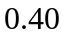. The probability that she will go to Mexico in
the winter is 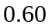. Find the probability that she will go to France this
summer, given that she just returned from her winter vacation in
Mexico.

4. A penny and a nickel are tossed. Find the probability that the penny
Shows heads, given that the nickel shows heads.

5. A penny is tossed. Find the probability that it shows heads. Compare
this answer to your answer to #4 and explain the results.

6. A spinner with dial marked as shown is spun once. Find the probability
that it points to an even number given that it points to a shaded
region:
- directly
- using conditional probability formula

7. A family that is known to have two children is selected at random
from amongst all families with two children. Find the probability that
both children are boys, given that there is a boy in this family.

8. A die is tossed. Find 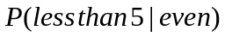.

9. A number is selected, at random, from the set 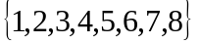. Find:
a) 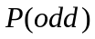
b) 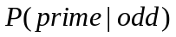

10. A box contains three blue marbles, five red marbles, and four white
marbles. If one marble is drawn at random, find:
a) 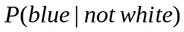
b) 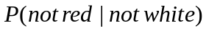

11. A number is selected randomly from a container containing all the
integers from  to 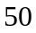. Find:
a) 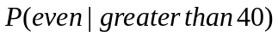
b) 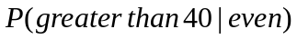
c) 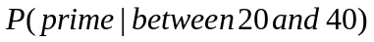

12. A coin is tossed. If it shows heads, a marble is drawn from Box 1,
which contains one white and one black marble. If it lands tails, a
marble is drawn from Box 2, which contains two white and one black
marble. Find:
a) 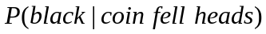
b) 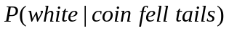

Answers:
1. 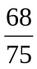 2.
3.  4. 
5. , heads appearing is independent
6. a) b) 7.
8. 9. a) b) 
10. a) b) 11. a) b) 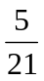 c) 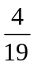
12. a) b)

