DO-178C Project

User Guide



Table of Contents
Introduction 3
Product Description 3
System Requirements 3
Getting Started 4
Creating a New DO-178C Project 4
Navigating the DO-178C Project 5
Reconfiguring the Standard Model Configurations 6
Adding a New Model 7
Case Study 10
Opening the DO-178C Case Study Project 10
Navigating the DO-178C Case Study Project (Before Exercising Workflow Demonstration) 10
Exercising the Workflow Demonstration of the DO-178C Case Study Project 12
Navigating the DO-178C Case Study Project (After Exercising Workflow Demonstration) 12
Utility Functions 15

Introduction

Product Description
The DO-178C Project is a template for use to streamline the adoption of Model-Based Design for high-integrity airborne software development. This template is designed to create a new project that stores all documents, requirements, designs, code, tests, results, and tools that are relevant for DO-178C applications. This project is prepopulated with:
- Planning document templates
- Recommended modeling and coding standards
- Design constraints in the forms of libraries, model templates, model configurations, and checks
- Tooling for automation of vital development and verification tasks
Upon creating a new project using this template, add your software requirements, design models, and requirement-based tests, with the proper traceability. Then use the tools and utilities provided in the project to exercise the necessary development and verification tasks to meet the applicable DO objectives. For an illustration of how to apply the DO-178C Project to the Model-Based Design workflow for DO-178C, see the example “DO-178C Case Study”.

System Requirements
- Supported platforms:
- Windows
- Linux
- Minimum MATLAB software requirements:
  - MATLAB®
  - Simulink®
  - MATLAB Report Generator™
  - Simulink Report Generator™
  - MATLAB Coder™
  - Simulink Coder™
  - Embedded Coder®
  - Simulink Requirements™
  - Simulink Check™
  - Simulink Coverage™
  - Simulink Test™
  - Simulink Design Verifier™
  - Simulink Code Inspector™
  - Polyspace Bug Finder™
  - Polyspace Code Prover™
- External software requirements:
  - Supported C/C++ compiler per https://www.mathworks.com/support/compilers.html.

Getting Started

Creating a New DO-178C Project
The DO-178C Project is a template for managing/conducting software development process for DO-178C/DO-331 using MathWorks tools. To take advantage of the outline of this project when starting a new program, you can create a new project based on this template. To do this,
- On the MATLAB Home tab, click Simulink to open the Simulink Start Page.
- In the Simulink Start Page, hover over DO-178C Project under the DO Qualification Kit panel, and then click Create Project. This opens the Create Project dialog.
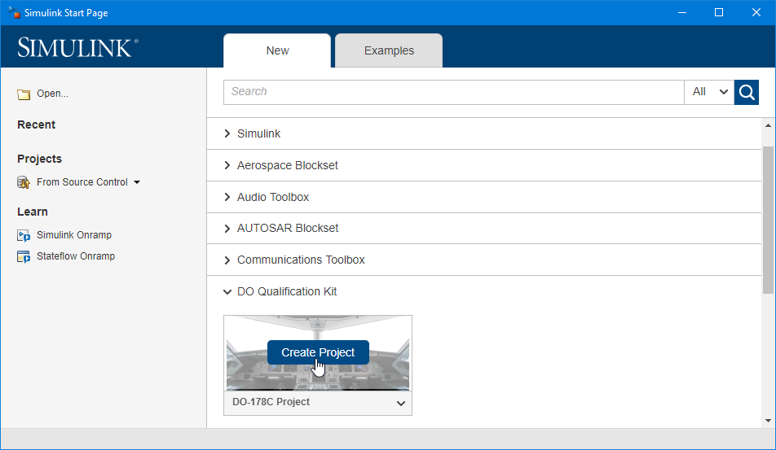
- In the Create Project dialog, enter the Name and Folder, and then click OK. This creates a new project based on the DO-178C Project template.
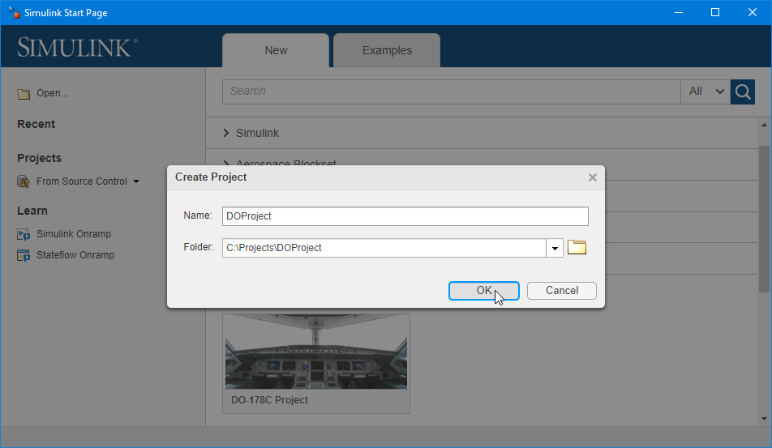

Navigating the DO-178C Project
After the project is created, Simulink automatically launches the new project. In this new project, you will find the following folders:
- DO_01_Planning
- In the checklists subfolder, you will find checklists that are useful for reviewing requirements, models, code, test cases, test results, and trace data.
- In the plans subfolder, you will find templates for Plan for Software Aspects of Certification (PSAC), Software Development Plan (SDP), Software Verification Plan (SVP), Software Configuration Management Plan (SCMP), and Software Quality Assurance Plan (SQAP)
- In the standards subfolder, you will find templates for Software Requirements Standards (SRS), Software Design Standards (SDS), Software Code Standards (SCS), and Software Model Standards (SMS).
- DO_02_Requirements
- In the specification subfolder, you will store all documents that capture your high-level software requirements and derived requirements.
- In the verification subfolder, you will store checklists related to all review activities of the high-level software requirements and derived requirements.
- DO_03_Design
- In the common subfolder, you will create block libraries and data that are shared across multiple models in the project.
- The sample_model subfolder is a folder template for use to create actual model folders based on model names. Once a model folder is created, you will create the model and its data in the specification subfolder, develop test cases used for verifying the model against software requirements in the test_cases subfolder, and store all verification results for the model in the verification_results subfolder.
- DO_04_Code
- In the specification subfolder, you will store all source code and executable object code generated from the models in the project.
- In the verification_results subfolder, you will store all verification results for the source code and executable object code.
- DO_05_Artifacts
You will find placeholders for life cycle data that is not produced with MathWorks tools.
- DO_06_ToolQualification
You will find placeholders for tool qualification life cycle data.
- help
You will find a user guide and a description of the contents of each folder in the project.
- tools
- In the checks subfolder, you will find the configuration files for Model Advisor checks and Polyspace Coding Standard checks designed to complement the Software Model Standards (SMS) and Software Code Standards (SCS) provided in the project, respectively.
- In the compatible_blocks subfolder, you will a block library that holds all primitive blocks that are compatible with Simulink Code Inspector, which serves as the software design constraints.
- In the templates subfolder, you will find model configurations that are compatible with the software design constraints and the Software Model Standards.
- In the utilities subfolder, you will find utilities for project management, model query, report generation, code generation, and model/code verification.
- work
The default working folder. This folder also contains the cache folder in which model build artifacts used for simulation are stored.

Reconfiguring the Standard Model Configurations
Every new project created from the template is equipped a csMultiInstance.sldd and a csSingleInstance.sldd in DO_03_Design\common\specification\data. These standard data dictionaries each holds a model configuration meant to be used by all models you plan to develop in the project. For reusable (multi-instantiable) models, use the configuration in csMultiInstance.sldd. Otherwise, use the configuration in csSingleInstance.sldd. Except for the ModelReferenceNumInstancesAllowed property, the configurations in both csMultiInstance.sldd and csSingleInstance.sldd have the same settings. Created using reusableModelConfig.m and nonreusableModelConfig.m, these configurations derive their standardized settings from do178Config.m. The standardized settings, in turn, are exported from the model baseModelConfiguration.slx.
The model configurations must be reconfigured to account for the correct Hardware Implementation settings for your application. To do this,
- Enter baseModelConfiguration to open the model.
- Select MODELING > SETUP > Model Settings to open the Configuration Parameters dialog.
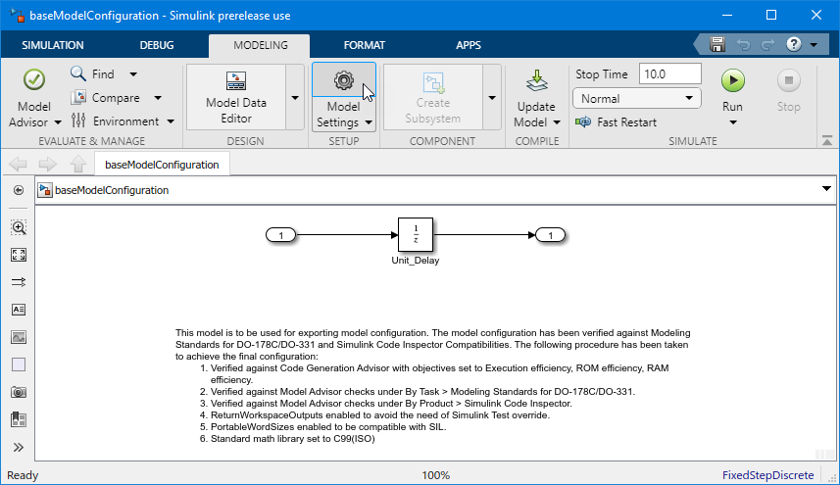
- In the Configuration Parameters dialog, click the Hardware Implementation item to open the Hardware Implementation pane.
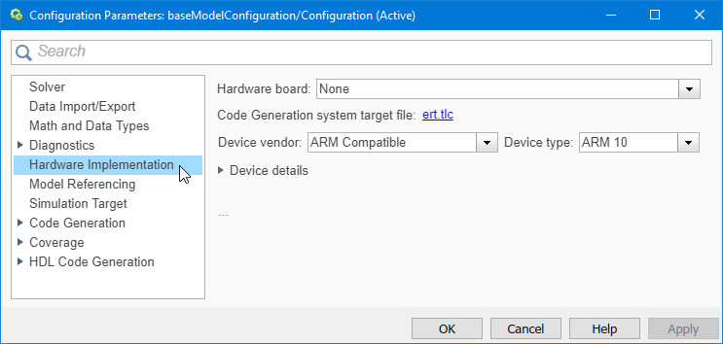
- Set the Device vendor and Device type options per your hardware specifications, and then click OK.
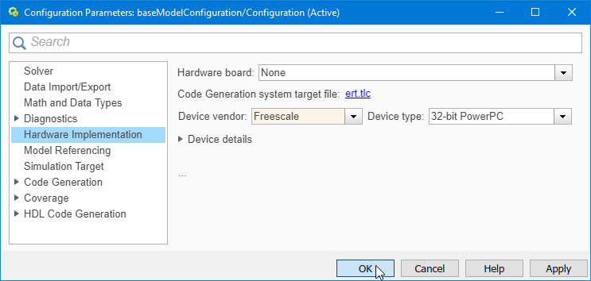
- Save the model.
- Use the following command to get the new Simulink.ConfigSet object from the model:
>> configSet = getConfigSet('baseModelConfiguration', 'Configuration');
- Then use the following command to export the new Simulink.ConfigSet object to do178Config.m, overwriting the existing settings in the file:
>> configSet.saveAs('..\tools\templates\model_configurations\do178Config');
- Use the following commands to update the data dictionary that holds the model configuration for reusable (multi-instantiable) models:
>> dd = Simulink.data.dictionary.open('csMultiInstance.sldd');
>> cfg = dd.getSection('Configurations');
>> cfg.importFromFile('reusableModelConfig.m', 'existingVarsAction', 'overwrite');
>> dd.saveChanges();
- Use the following commands to update the data dictionary that holds the model configuration for nonreusable (not multi-instantiable) models:
>> dd = Simulink.data.dictionary.open('csSingleInstance.sldd');
>> cfg = dd.getSection('Configurations');
>> cfg.importFromFile('nonreusableModelConfig.m', 'existingVarsAction', 'overwrite');
>> dd.saveChanges();

Adding a New Model
Based on the high-level software requirements, you create models that serve as the low-level software requirements. This kit expects that each model has its own model folder under the DO_03_Design folder based on the folder structure of sample_model.
Before you create a new model, use the addModelFolder utility to create a new model folder based on the model name. For example, to create a new model folder for a new model named controller, use the following command:
>> addModelFolder('controller')
or
>> addModelFolder('controller', 'Nonreusable')
This command creates a new controller folder under DO_03_Design. Like sample_model, this new folder contains a specification, a test_cases, and a verification_results subfolder. In the specification subfolder, you will find an empty model controller.slx. In addition, you will find a complementary data dictionary DD_controller.sldd in the specification\data subfolder. Note that this data dictionary is automatically attached to the model and it includes either csMultiInstance.sldd or csSingleInstance.sldd as a referenced dictionary. If the command is called without a second argument, you will also find a localDD_controller.m in the specification\data subfolder. You are now ready to build the model using permissible blocks from the library do178Lib. All blocks from do178Lib are accessible from the Simulink Library Browser under DO-178C/DO-331 Primitive Library.
When developing a model, you often define data to help characterize its behavior. Keep in mind that the required data may be specific to the model or shared across multiple models. The collection of data that is consumed only by the model is referred to as its model specific data dictionary, whereas data that is shared forms a common data dictionary.
Every model you develop in the project is associated with a complementary Simulink data dictionary that is named after the model with a prefix of DD_ in the specification\data subfolder of the model folder. For a nonreusable model:
- The complementary data dictionary must include csSingleInstance.sldd, which holds the model configuration derived from nonreusableModelConfig.m.
- Use the complementary data dictionary to hold model specific data.
For a reusable model:
- The complementary data dictionary must include csMultiInstance.sldd, which holds the model configuration derived from reusableModelConfig.m.
- Use the complementary data dictionary to hold model specific data that is not instance specific.
- You may additionally need to create instance specific data, including model arguments, in the model workspace.
- Use a MATLAB script that is named after the model with a prefix of localDD_ in the specification\data subfolder of the model folder to hold instance specific data.
- Set up the model to automatically load instance specific data into its model workspace by running this script.
Using the example above, you would create a DD_controller.sldd and a localDD_controller.m (if reusable) in DO_03_Design\controller\specification\data.
For shared data, you create Simulink data dictionaries in DO_03_Design\common\specification\data. These data dictionaries must be referenced by the complementary data dictionary of every model that consumes the data. Note that both csMultiInstance.sldd and csSingleInstance.sldd are also found in DO_03_Design\common\specification\data.
You may need to create user-defined data types like aliases, buses, and enumerations to work with the model. For Simulink.AliasType and Simulink.Bus objects, create Simulink data dictionaries in DO_03_Design\common\specification\data_types, and then reference these data dictionaries as necessary. For enumeration classes, simply create the appropriate class definition files in DO_03_Design\common\specification\data_types.
Upon developing the model and its data dictionaries, you should create a MATLAB script for use to open the model. This script is required if you intend to leverage utilities in the DO-178C Project to perform downstream tasks. The script must be named after the model with a prefix of open_. Using the example above, you would create an open_controller.m to achieve this goal.

Case Study

Opening the DO-178C Case Study Project
For an illustration of how to apply the DO-178C Project, enter do178CaseStudyStart to launch the DO-178C Case Study example. This opens an example project that is developed based on the DO-178C Project.

Navigating the DO-178C Case Study Project (Before Exercising Workflow Demonstration)
This example project has the following additional contents used to explain the workflow and the available utilities:
- Under DO_02_Requirements
- In the specification subfolder, you will find documents and trace data for system requirements and high-level software requirements. Authored using the Requirement Editor, both system requirements and high-level software requirements are captured in requirement sets SR.slreqx and HLR.slreqx, respectively. Along with HLR.slreqx, you will also find an HLR.slmx that stores the trace data between the high-level software requirements and the associated system requirements.
- Under DO_03_Design
- In the common\specification\block_libraries subfolder, you will find two user libraries ControlLib.slx and FilterLib.slx. As part of the convention when using the DO-178C Project, notice that each library has a complementary MATLAB script for use to open the library.
- In the common\specification\data_types subfolder, you will find a data dictionary bus_types.sldd. This data dictionary holds the definition of a Simulink.Bus object that is vital to several models in the project.
- There are 5 model folders, all derived from the sample_model folder template. These folders contain the low-level software requirements, in the form of Simulink models, that trace to the high-level software requirements captured in DO_02_Requirements\specification\HLR.slreqx.
- Software architecture is typically derived from how the design is organized. With Model-Based Design, software architecture is inherently established by the model hierarchy of the design, based on natural grouping of the high-level software requirements. In this case study, the design is subdivided into several models to satisfy the various requirements in HLR.slreqx. Within the model hierarchy of the design, Flight_Control is the top-level model that implements the overall control strategy, while the rest are lower-level models that characterize various parts of the design. Note that Actuator_Control is created as a reusable model while the others are all nonreusable.
- In the specification subfolder of each model folder, you will find the model file itself. Along with the .slx file, you will also find a .slmx file that stores the trace data between the model and the associated high-level software requirements. As part of the convention when using the DO-178C Project, notice that every model has a complementary MATLAB script for use to open the model.
- In the specification\data subfolder of each model folder, you will find a complementary Simulink data dictionary that is named after the model with a prefix of DD_ for holding its model specific data. Because Actuator_Control is reusable, there is an additional MATLAB script that is named after the model with a prefix of localDD_ in the folder for holding its instance specific data.
- The specification\documents subfolder of each model folder is used for holding a design description of the model. This folder is empty initially.
- In the test_cases subfolder of each model folder, you will find an HLR and an LLR folder that are used for holding test cases of the model.
- The HLR folder is used for keeping test cases developed to verify the model against the high-level requirements it implements. In this folder, you create a Simulink Test file to manage all high-level test cases. This test file must be named after the model with a postfix of _REQ_Based_Test. In this case study, we have developed three high-level test cases for AHRS_Voter. You will find them in AHRS_Voter_REQ_Based_Test.mldatx under AHRS_Voter\test_cases\HLR. These test cases make use of externally stored test harnesses AHRS_Voter_Harness_HLR_11.slx, AHRS_Voter_Harness_HLR_12.slx, and AHRS_Voter_Harness_HLR_13.slx to verify AHRS_Voter against requirements HLR_11, HLR_12, and HLR_13, respectively. Along with AHRS_Voter_REQ_Based_Test.mldatx, you will also find an AHRS_Voter_REQ_Based_Test.slmx that stores the trace data between the test cases and the high-level software requirements they are developed to verify.
- The LLR folder is used for keeping test cases derived from the model. These low-level tests are often needed to supplement the high-level tests to achieve the necessary test coverage. This folder is empty initially.
- In the verification_results subfolder of each model folder, you will find folders for the various model verification tasks. These tasks include design review of the model, verification of the model against requirements, coverage analysis of the model, examination of the model against design errors using static analysis, inspection of the model against design standards, and measurement of model metrics.
- The verification_results\model_reviews subfolder of each model folder is used for holding the design review checklist of the model. This folder is empty initially.
- The verification_results\simulation_results subfolder of each model folder contains an HLR and an LLR folder that are used for holding simulation results of the model. These folders are empty initially.
- The verification_results\model_coverages subfolder of each model folder contains an HLR and an LLR folder that are used for holding coverage results of the model. These folders are empty initially.
- The verification_results\design_error_detections subfolder of each model folder is used for holding Simulink Design Verifier analysis results of the model. This folder is empty initially.
- The verification_results\design_standard_checks subfolder of each model folder is used for holding Model Advisor check results of the model. This folder is empty initially.
- The verification_results\model_metrics subfolder of each model folder is used for holding design metrics of the model. This folder is empty initially.
- Under DO_04_Code
- In the verification_results subfolder, you will find folders for the various code verification tasks. These tasks include code review, verification of code against requirements, code coverage analysis, finding of defects in code using static analysis, inspection of code against coding standards, and measurement of code metrics.
- The verification_results\code_reviews subfolder contains a folder for each model that is used for holding Simulink Code Inspector verification results of the generated code. The folder created for each model is empty initially.
- The verification_results\eoc_test_results subfolder contains a folder for each model that is used for holding software-in-the-loop and hardware-in-the-loop test results of the generated code. The folder created for each model is empty initially.
- The verification_results\code_coverages subfolder contains a folder for each model that is used for holding coverage results of the generated code. The folder created for each model is empty initially.
- The verification_results\coding_error_detections subfolder contains a folder for each model that is used for holding Bug Finder analysis results of the generated code. The folder created for each model is empty initially.
- The verification_results\code_proving subfolder contains a folder for each model that is used for holding Code Prover verification results of the generated code. The folder created for each model is empty initially.
- The verification_results\code_standard_checks subfolder contains a folder for each model that is used for holding Bug Finder coding rule checker results of the generated code. The folder created for each model is empty initially.
- The verification_results\code_metrics subfolder contains a folder for each model that is used for holding code metrics of the generated code. The folder created for each model is empty initially.
- Under work
- The demo subfolder contains a MATLAB live script runDemo.mlx created for use in this case study to illustrate the Model-Based Design workflow for DO-178C. This live script contains instructions to the entire workflow demonstration.

Exercising the Workflow Demonstration of the DO-178C Case Study Project
After launching the case study project, you can simply follow the instructions given in work\demo\runDemo.mlx to run the workflow demonstration. Use the following command to open the live script if necessary:
>> open('runDemo.mlx')
Following the explanations given in the live script, use the hyperlinks to carry out the tasks called out in the workflow demonstration. You can hover over a hyperlink to view the MATLAB command it executes.

Navigating the DO-178C Case Study Project (After Exercising Workflow Demonstration)
Upon the completion of the workflow demonstration, you should find the following generated artifacts in the example project:
- Under DO_02_Requirements
- In the specification\documents subfolder, you will find the reports of system requirements and high-level software requirements. These reports are generated from SR.slreqx and HLR.slreqx using genReqReport (tools\utilities\report_generation\genReqReport.m).
- Under DO_03_Design
- In the specification\documents subfolder of each model folder, you will find the design description of the model. This report is generated from the model using genSDD (tools\utilities\report_generation\genSDD.m).
- In the test_cases\LLR subfolder of AHRS_Voter, you will find the low-level test generation results and report of AHRS_Voter, including a test file and a test harness. You will find the generated low-level test cases in AHRS_Voter_SLDV_Based_Test.mldatx. These test cases make use of an externally stored test harness AHRS_Voter_Harness_SLDV.slx. They are generated from AHRS_Voter to satisfy objectives that are not achieved in its high-level test coverage using genLowLevelTests (tools\utilities\verification\dynamic_testing\genLowLevelTests.m).
- In the verification_results\simulation_results\HLR subfolder of AHRS_Voter (test cases for the other models are not available), you will find the high-level simulation results and report of AHRS_Voter. These simulation results are generated from running the test cases that verify AHRS_Voter against the high-level requirements it implements using verifyModel2Reqs (tools\utilities\verification\dynamic_testing\verifyModel2Reqs.m).
- In the verification_results\model_coverages\HLR subfolder of AHRS_Voter, you will find the high-level model coverage results and report of AHRS_Voter. These coverage results are collected from running the test cases that verify AHRS_Voter against the high-level requirements it implements using verifyModel2Reqs (tools\utilities\verification
\dynamic_testing\verifyModel2Reqs.m).
- In the verification_results\design_error_detections subfolder of each model folder, you will find the design error detection report of the model. This report is generated from examining the model against potential run-time errors and dead logic with Simulink Design Verifier using detectDesignErrs (tools\utilities\verification\static_analysis\detectDesignErrs.m).
- In the verification_results\design_standard_checks subfolder of each model folder, you will find the modeling standard conformance report of the model. This report is generated from examining the model against Model Advisor checks enabled by tools\checks\do178Checks.json using checkModelStds (tools\utilities\verification\static_analysis\checkModelStds.m).
- Under DO_04_Code
- In the specification subfolder, you will find the generated code of all five models developed for use in this cases study. This source code is generated from the models using genSrcCode (tools\utilities\code_generation\genSrcCode.m). Note that the code for the top-level model is placed under Flight_Control_ert_rtw while the code for each of the lower-level models is placed under slprj\ert along with the shared code.
- In the verification_results\code_reviews subfolder, you will find the code inspection report of the generated code for each model. This report is generated from inspecting the source code of each model with Simulink Code Inspector using verifySrcCode2Model (tools\utilities\verification
\static_analysis\verifySrcCode2Model.m).
- In the verification_results\eoc_test_results\AHRS_Voter\host\HLR\instrumented, you will find the high-level software-in-the-loop test results and report of the generated code for AHRS_Voter. These test results are generated from running the test cases that verify AHRS_Voter against the high-level requirements it implements in software-in-the-loop mode using verifyObjCode2Reqs (tools\utilities\verification\dynamic_testing\verifyObjCode2Reqs.m).
- In the verification_results\eoc_test_results\AHRS_Voter\host\LLR\instrumented, you will find the low-level software-in-the-loop test results and report of the generated code for AHRS_Voter. These test results are generated from running the test cases derived from AHRS_Voter to complement its high-level test coverage in software-in-the-loop mode using verifyObjCode2LowLevelTests (tools\utilities\verification\dynamic_testing
\verifyObjCode2LowLevelTests.m).
- In the verification_results\code_coverages\AHRS_Voter\host\HLR subfolder, you will find the high-level code coverage results and report of the generated code for AHRS_Voter. These coverage results are collected from running the test cases that verify AHRS_Voter against the high-level requirements it implements in software-in-the-loop mode using verifyObjCode2Reqs (tools\utilities\verification\dynamic_testing\verifyObjCode2Reqs.m).
- In the verification_results\code_coverages\ AHRS_Voter\host\LLR subfolder, you will find the low-level code coverage results and report of the generated code for AHRS_Voter. These coverage results are collected from running the test cases derived from AHRS_Voter to complement its high-level test coverage in software-in-the-loop mode using verifyObjCode2LowLevelTests (tools\utilities\verification\dynamic_testing
\verifyObjCode2LowLevelTests.m).
- In the verification_results\code_coverages\AHRS_Voter subfolder, you will find the cumulative code coverage report of the generated code for AHRS_Voter. These coverage results are assembled from merging both the high-level and low-level code coverage results using mergeCodeCoverage (tools\utilities\verification\dynamic_testing\mergeCodeCoverage.m).
- In the verification_results\code_proving\Flight_Control subfolder, you will find the Code Prover verification report of the generated code for Flight_Control and its lower-level models. This report is generated from checking the source code of Flight_Control and its lower-level models against potential software defects with Polyspace Code Prover using proveCodeQuality (tools\utilities\verification\static_analysis\proveCodeQuality.m).
- In the verification_results\code_standard_checks subfolder, you will find the coding standard conformance report of the generated code for each model. This report is generated from checking the source code of each model against Bug Finder coding rules enabled by tools\checks\MISRA_C_2012_ACG using checkCodeStds (tools\utilities\verification
\static_analysis\checkCodeStds.m).

Utility Functions
The following table summarizes the utilities available in the DO-178C Project:
Utility Name | Description
addModelFolder | Create a new model folder based on the folder template DO_03_Design\sample_model. This also creates model specific folders under the subfolders in DO_04_Code\verification_results.  Syntax:  - addModelFolder('MODEL')  - addModelFolder('MODEL', 'Nonreusable')  Use the Nonreusable option if you want the new model to be nonreusable, otherwise it is reusable.
clearTestManager | Clear all test files and result sets loaded in the Test Manager.  Syntax:  clearTestManager()
deleteModelFolder | Delete the model folder. Use this to erase the model folder from the file system after removing it from the project.  Syntax:  deleteModelFolder('MODEL')
removeModelFolder | Remove the model folder from the current project. This only excludes the model folder from the project. It does not erase the model folder from the file system.  Syntax:  removeModelFolder('MODEL')
resetDefaultMdlAdvCfg | Reset the default Model Advisor configuration to use the factory default.  Syntax:  resetDefaultMdlAdvCfg()
resetWorkspace | Clear all variables in the workspace except the default model configurations. Use this in lieu of clear.  Syntax:  resetWorkspace()
setDefaultMdlAdvCfg | Set the default Model Advisor configuration to use the groups of checks based on tools\checks\do178Checks.json.  Syntax:  setDefaultMdlAdvCfg()
viewFileDependency | Launch the Model Dependency Viewer to display model and library file dependency.  Syntax:  viewFileDependency('MODEL')
viewModelDependency | Launch the Model Dependency Viewer to display model hierarchy.  Syntax:  viewModelDependency('MODEL')
genReqReport | Generate a requirement report from the requirement set.  Syntax:  - genReqReport('REQSET')  - genReqReport('REQSET', 'AUTHOR')  - genReqReport('REQSET', [], 'CI')  Use the second argument to optionally specify an author’s name. Use the CI option to operate within the context of continuous integration. This option suppresses launching of all reports upon completion.  This utility creates the following:  A document named after the requirement set with a postfix of _ReqReport under DO_02_Requirements\specification  \documents
genSDD | Generate a System Design Description (SDD) report from the model.  Syntax:  - genSDD('MODEL')  - genSDD('MODEL', 'AUTHOR')  - genSDD('MODEL', [], 'CI')  Use the second argument to optionally specify an author’s name. Use the CI option to operate within the context of continuous integration. This option suppresses launching of all reports upon completion.  This utility creates the following:  A document named after the model with a postfix of _SDD under DO_03_Design\MODEL\specification\documents  This utility depends on the following:  open_MODEL
genSrcCode | Generate source code from the model using Embedded Coder.  Syntax:  - genSrcCode('MODEL')  - genSrcCode('MODEL', 'TreatAsTopMdl')  Use the TreatAsTopMdl option to handle the model as a top-level model, otherwise it is regarded as a referenced model.  This utility creates the following:  Code under MODEL_ert_rtw or slprj\ert\MODEL in DO_04_Code\specification  This utility depends on the following:  open_MODEL
genLowLevelTests | Generate low-level tests for the model based on existing coverage data using Simulink Design Verifier.  Syntax:  - genLowLevelTests('MODEL')  - genLowLevelTests('MODEL', 'ModelCoverageObjectives', 'MCDC', 'TestSuiteOptimization', 'IndividualObjectives' 'MaxProcessTime', 300, 'AbsTol', 1e-6, 'RelTol', 1e-3, 'CI', true)  Use the ModelCoverageObjectives setting to decide which type of coverage analysis to perform, i.e., Decision, ConditionDecision, or MCDC. Use the TestSuiteOptimization setting to decide which test generation strategy to use, i.e., Auto, IndividualObjectives, LongTestCases, or LargeModel (Nonlinear Extended). Use the MaxProcessTime setting to control the time limit of the analysis. Use the AbsTol and RelTol settings to control the baseline criteria tolerances of the generated test cases. Use the CI setting to control if the operation is within the context of continuous integration. Setting this option to true suppresses launching of all reports upon completion. If not specified, the default values of ModelCoverageObjectives, TestSuiteOptimization, MaxProcessTime, AbsTol, RelTol, and CI are MCDC, IndividualObjectives, 300, 1e-6, 1e-3, and false, respectively.  This utility creates the following:  - A test generation report named after the model with a postfix of _Test_Generation_Report under DO_03_Design\MODEL  \test_cases\LLR  - A test file named after the model with a postfix of _SLDV_Based_Test under DO_03_Design\MODEL\test_cases  \LLR.  This utility depends on the following:  - open_MODEL  - DO_03_Design\MODEL\verification_results\model_coverages  \HLR\MODEL_REQ_Based_Model_Coverage.cvt
mergeCodeCoverage | Merge coverage results from verifying the generated code of the model against the high-level software requirements and low-level tests generated by Simulink Design Verifier.  Syntax:  - mergeCodeCoverage('MODEL', 'SIL')  - mergeCodeCoverage('MODEL', 'PIL')  - mergeCodeCoverage('MODEL', 'SIL', 'CI')  Use the second argument to control if the coverage results are collected from exercising the compiled code on the host computer via SIL simulations or the target computer via PIL simulations. Use the CI option to operate within the context of continuous integration. This option suppresses launching of all reports upon completion. It also returns a result object that captures the operational outcome.  This utility creates the following (SIL):  A cumulative coverage report named after the model with a postfix of _Merged_Code_Coverage_Report under DO_04_Code\verification_results\code_coverages\MODEL  \host.  This utility depends on the following (SIL):  - DO_04_Code\verification_results\eoc_test_results\MODEL  \host\HLR\instrumented  \MODEL_SIL_REQ_Based_Test_Results.mldatx  - DO_04_Code\verification_results\eoc_test_results\MODEL  \host\LLR\instrumented  \MODEL_SIL_SLDV_Based_Test_Results.mldatx
mergeModelCoverage | Merge coverage results from verifying the model against the high-level software requirements and low-level tests generated by Simulink Design Verifier.  Syntax:  - mergeModelCoverage('MODEL')  - mergeModelCoverage('MODEL', 'CI')  Use the CI option to operate within the context of continuous integration. This option suppresses launching of all reports upon completion. It also returns a result object that captures the operational outcome.  This utility creates the following:  A cumulative coverage report named after the model with a postfix of _Merged_Model_Coverage_Report under DO_03_Design\MODEL\verification_results\model_coverages.  This utility depends on the following:  - DO_03_Design\MODEL\verification_results\simulation_results  \HLR\MODEL_REQ_Based_Test_Results.mldatx  - DO_03_Design\MODEL\verification_results\simulation_results  \LLR\MODEL_SLDV_Based_Test_Results.mldatx
verifyModel2LowLevelTests | Verify the model against low-level tests generated by Simulink Design Verifier, and then perform model coverage analysis. All tests exercise the compiled model on the host computer via normal simulations.  Syntax:  - verifyModel2LowLevelTests('MODEL')  - verifyModel2LowLevelTests('MODEL', 'TreatAsTopMdl')  - verifyModel2LowLevelTests('MODEL', [], 'AUTHOR')  - verifyModel2LowLevelTests('MODEL', [], [], 'CI')  Use the TreatAsTopMdl option to handle the model as a top-level model, otherwise it is regarded as a referenced model. Use the third argument to optionally specify an author’s name. Use the CI option to operate within the context of continuous integration. This option suppresses launching of all reports upon completion. It also returns a result object that captures the operational outcome.  This utility creates the following:  - A test report named after the model with a postfix of _SLDV_Based_Test_Report under DO_03_Design\MODEL  \verification_results\simulation_results\LLR  - A coverage report named after the model with a postfix of _SLDV_Based_Model_Coverage_Report under DO_03_Design  \MODEL\verification_results\model_coverages\LLR  This utility depends on the following:  DO_03_Design\MODEL\test_cases\LLR  \MODEL_SLDV_Based_Test.mldatx
verifyModel2Reqs | Verify if the model complies with the high-level software requirements, and then perform model coverage analysis. All tests exercise the compiled model on the host computer via standard simulations.  Syntax:  - verifyModel2Reqs('MODEL')  - verifyModel2Reqs('MODEL', 'TreatAsTopMdl')  - verifyModel2Reqs('MODEL', [], 'AUTHOR')  - verifyModel2Reqs('MODEL', [], [], 'CI')  Use the TreatAsTopMdl option to handle the model as a top-level model, otherwise it is regarded as a referenced model. Use the third argument to optionally specify an author’s name. Use the CI option to operate within the context of continuous integration. This option suppresses launching of all reports upon completion. It also returns a result object that captures the operational outcome.  This utility creates the following:  - A test report named after the model with a postfix of _REQ_Based_Test_Report under DO_03_Design\MODEL  \verification_results\simulation_results\HLR  - A coverage report named after the model with a postfix of _REQ_Based_Model_Coverage_Report under DO_03_Design  \MODEL\verification_results\model_coverages\HLR  This utility depends on the following:  DO_03_Design\MODEL\test_cases\HLR  \MODEL_REQ_Based_Test.mldatx
verifyObjCode2LowLevelTests | Verify the executable object code of the model against low-level tests generated by Simulink Design Verifier. All tests exercise the compiled code on the target computer via PIL simulations.  Syntax:  - verifyObjCode2LowLevelTests('MODEL', 'SIL')  - verifyObjCode2LowLevelTests('MODEL', 'PIL')  - verifyObjCode2LowLevelTests('MODEL', 'SIL', 'DisableCoverage')  - verifyObjCode2LowLevelTests('MODEL', 'SIL', [], 'TreatAsTopMdl')  - verifyObjCode2LowLevelTests('MODEL', 'SIL', [], [], 'AUTHOR')  - verifyObjCode2LowLevelTests('MODEL', 'SIL', [], [], [], 'CI')  Use the second argument to control if the tests exercise the compiled code on the host computer via SIL simulations or the target computer via PIL simulations. Use the DisableCoverage option to suppress coverage analysis, otherwise the code is instrumented for coverage analysis. Use the TreatAsTopMdl option to handle the model as a top-level model, otherwise it is regarded as a referenced model. Use the fifth argument to optionally specify an author’s name. Use the CI option to operate within the context of continuous integration. This option suppresses launching of all reports upon completion. It also returns a result object that captures the operational outcome.  This utility creates the following (SIL):  - A test report named after the model with a postfix of _SIL_SLDV_Based_Test_Report under DO_04_Code  \verification_results\eoc_test_results\MODEL\host\LLR\instrumented  - A coverage report named after the model with a postfix of _SLDV_Based_Code_Coverage_Report under DO_04_Code  \verification_results\code_coverages\MODEL\host\LLR  This utility depends on the following:  DO_03_Design\MODEL\test_cases\LLR  \MODEL_SLDV_Based_Test.mldatx
verifyObjCode2Reqs | Verify if the executable object code of the model complies with the high-level software requirements. All tests exercise the compiled code on the target computer via PIL simulations.  Syntax:  - verifyObjCode2Reqs('MODEL', 'SIL')  - verifyObjCode2Reqs('MODEL', 'PIL')  - verifyObjCode2Reqs('MODEL', 'SIL', 'DisableCoverage')  - verifyObjCode2Reqs('MODEL', 'SIL', [], 'TreatAsTopMdl')  - verifyObjCode2Reqs('MODEL', 'SIL', [], [], 'AUTHOR')  - verifyObjCode2Reqs('MODEL', 'SIL', [], [], [], 'CI')  Use the second argument to control if the tests exercise the compiled code on the host computer via SIL simulations or the target computer via PIL simulations. Use the DisableCoverage option to suppress coverage analysis, otherwise the code is instrumented for coverage analysis. Use the TreatAsTopMdl option to handle the model as a top-level model, otherwise it is regarded as a referenced model. Use the fifth argument to optionally specify an author’s name. Use the CI option to operate within the context of continuous integration. This option suppresses launching of all reports upon completion. It also returns a result object that captures the operational outcome.  This utility creates the following (SIL):  - A test report named after the model with a postfix of _SIL_REQ_Based_Test_Report under DO_04_Code  \verification_results\eoc_test_results\MODEL\host\HLR\instrumented  - A coverage report named after the model with a postfix of _REQ_Based_Code_Coverage_Report under DO_04_Code  \verification_results\code_coverages\MODEL\host\HLR  This utility depends on the following:  DO_03_Design\MODEL\test_cases\HLR  \MODEL_REQ_Based_Test.mldatx
checkCodeStds | Check the generated code of the model against software code standards, and then generate the Bug Finder report.  Syntax:  - checkCodeStds('MODEL')  - checkCodeStds('MODEL', 'TreatAsTopMdl')  - checkCodeStds('MODEL', [], 'CI')  Use the TreatAsTopMdl option to handle the model as a top-level model, otherwise it is regarded as a referenced model. Use the CI option to operate within the context of continuous integration. This option suppresses launching of all reports upon completion. It also returns a result object that captures the operational outcome.  This utility creates the following:  A report named after the model with a postfix of _SCS_Conformance_Report under DO_04_Code  \verification_results\code_standard_checks\MODEL  This utility depends on the following:  - open_MODEL  - Code under MODEL_ert_rtw or slprj\ert\MODEL in DO_04_Code\specification
checkModelStds | Check the model against software model standards, and then generate the Model Advisor report.  Syntax:  - checkModelStds('MODEL')  - checkModelStds('MODEL', 'TreatAsTopMdl')  - checkModelStds('MODEL', [], 'CI')  Use the TreatAsTopMdl option to handle the model as a top-level model, otherwise it is regarded as a referenced model. Use the CI option to operate within the context of continuous integration. This option suppresses launching of all reports upon completion. It also returns a result object that captures the operational outcome.  This utility creates the following:  A report named after the model with a postfix of _SMS_Conformance_Report under DO_03_Design\MODEL  \verification_results\design_standard_checks  This utility depends on the following:  open_MODEL
computeCodeMetrics | Compute metrics for the generated code of the model, and then generate the Bug Finder report.  Syntax:  - computeCodeMetrics('MODEL')  - computeCodeMetrics('MODEL', 'TreatAsTopMdl')  Use the TreatAsTopMdl option to handle the model as a top-level model, otherwise it is regarded as a referenced model.  This utility creates the following:  A report named after the model with a postfix of _Code_Metrics_Report under DO_04_Code\verification_results  \code_metrics\MODEL  This utility depends on the following:  - open_MODEL  - Code under MODEL_ert_rtw or slprj\ert\MODEL in DO_04_Code\specification
computeModelMetrics | Compute metrics for the model, and then generate the Model Advisor report.  Syntax:  - computeModelMetrics('MODEL')  - computeModelMetrics('MODEL', 'TreatAsTopMdl')  Use the TreatAsTopMdl option to handle the model as a top-level model, otherwise it is regarded as a referenced model.  This utility creates the following:  A report named after the model with a postfix of _Model_Metrics_Report under DO_03_Design\MODEL  \verification_results\model_metrics  This utility depends on the following:  open_MODEL
detectCodingErrs | Detect coding errors in the generated code of the model, and then generate the Bug Finder report.  Syntax:  - detectCodingErrs('MODEL')  - detectCodingErrs('MODEL', 'TreatAsTopMdl')  - detectCodingErrs('MODEL', [], 'CI')  Use the TreatAsTopMdl option to handle the model as a top-level model, otherwise it is regarded as a referenced model. Use the CI option to operate within the context of continuous integration. This option suppresses launching of all reports upon completion. It also returns a result object that captures the operational outcome.  This utility creates the following:  A report named after the model with a postfix of _Bug_Finder_Report under DO_04_Code\verification_results  \coding_error_detections\MODEL  This utility depends on the following:  - open_MODEL  - Code under MODEL_ert_rtw or slprj\ert\MODEL in DO_04_Code\specification
detectDesignErrs | Detect design errors or dead logic in the model, and then generate the Design Verifier report.  Syntax:  - detectDesignErrs('MODEL')  - detectDesignErrs('MODEL', 'DetectActiveLogic')  - detectDesignErrs('MODEL', [], 300)  - detectDesignErrs('MODEL', [], [], 'CI')  Use the DetectActiveLogic option to enable active logic analysis, otherwise the model is not analyzed for active logic. Use the third argument to control the time limit of the analysis. Use the CI option to operate within the context of continuous integration. This option suppresses launching of all reports upon completion. It also returns a result object that captures the operational outcome.  This utility creates one of the following:  A report named after the model with a postfix of _Design_Error_Detection_Report under DO_03_Design\MODEL  \verification_results\design_error_detections  This utility depends on the following:  open_MODEL
proveCodeQuality | Prove the absence of defects in the generated code of the model, and then generate the Code Prover report.  Syntax:  - proveCodeQuality('MODEL')  - proveCodeQuality('MODEL', 'TreatAsTopMdl')  - proveCodeQuality('MODEL', 'IncludeAllChildMdls')  - proveCodeQuality('MODEL', 'CI')  - proveCodeQuality('MODEL', 'TreatAsTopMdl', 'IncludeAllChildMdls', 'CI')  Use the TreatAsTopMdl option to handle the model as a top-level model, otherwise it is regarded as a referenced model. Use the IncludeAllChildMdls option to include the generated code of all referenced models for analysis. Use the CI option to operate within the context of continuous integration. This option suppresses launching of all reports upon completion. It also returns a result object that captures the operational outcome.  This utility creates the following:  A report named after the model with a postfix of _Code_Prover_Report under DO_04_Code\verification_results  \code_proving\MODEL  This utility depends on the following:  - open_MODEL  - Code under MODEL_ert_rtw or slprj\ert\MODEL in DO_04_Code\specification
verifySrcCode2Model | Verify if the generated code complies with and is traceable to the model, and then generate the Simulink Code Inspector report.  Syntax:  - verifySrcCode2Model('MODEL')  - verifySrcCode2Model('MODEL', 'TreatAsTopMdl')  - verifySrcCode2Model('MODEL', 'IncludeAllChildMdls')  - verifySrcCode2Model('MODEL', 'CI')  - verifySrcCode2Model('MODEL', 'TreatAsTopMdl', 'IncludeAllChildMdls', 'CI')  Use the TreatAsTopMdl option to handle the model as a top-level model, otherwise it is regarded as a referenced model. Use the IncludeAllChildMdls option to include the generated code of all referenced models for inspection. Use the CI option to operate within the context of continuous integration. This option suppresses launching of all reports upon completion. It also returns a result object that captures the operational outcome.  This utility creates the following:  A report named after the model with a postfix of _summaryReport under DO_04_Code\verification_results  \code_reviews\MODEL  This utility depends on the following:  - open_MODEL  - Code under MODEL_ert_rtw or slprj\ert\MODEL in DO_04_Code\specification

