**Aileron System Requirements**

Revision 2.0

1. **Overall System Requirements**The following requirements apply to the aileron actuator system
   1. Range of travel: Aileron must move through a range of travel from -60 degrees to +75 degrees
   2. Aerodynamic load: Aileron must withstand wind speeds of 1000 km/h at full extension with less than 1mm deflection.
   3. Speed requirement: Aileron must track a 2 Hz signal within 0.5 degrees deflection
2. **Mechanical System Requirements**The following requirements apply to the functionality of this module
   1. The mechanical system is as shown below in Figure 1:

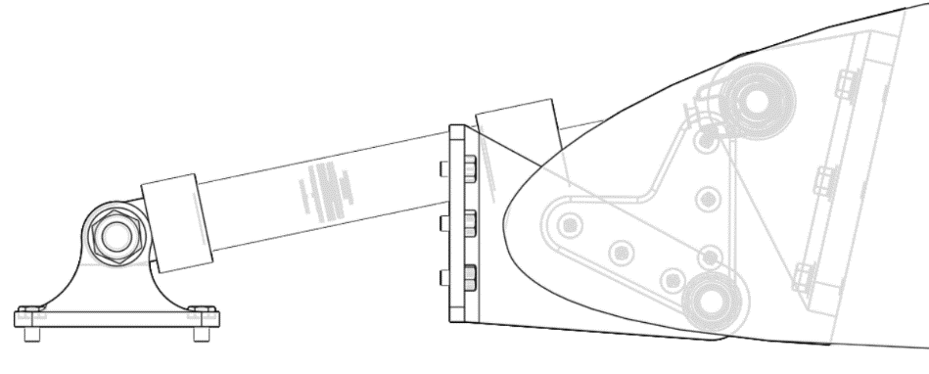

1. **Actuator System Requirements**The following requirements apply to the Aileron System:
   1. Force characteristics: The system must not require more than XXX N force to track any text signal.
   2. Tracking requirement: The actuator must track the required angle within 0.1 degree at all times
2. **Speed Controller Module Requirements**The following requirements apply to the Speed Controller module.
   1. Upon a change of angle, the system must be within 5% of the final value within 0.1 seconds (Settling Time).
   2. Upon a change of 10% of angle the system must achieve 10% of the final value within 0.7 seconds
3. **Current Controller Module Requirements**The following requirements apply to the Current Controller module of the aileron.
   1. The current must remain within 1% of the command value during flight.
   2. The current may not exceed XXX amperes.
4. **Aero Load Requirements**The system must provide adequate performance on the following flight cycles
   1. Constant speed at varying altitude and varying angle of attack
   2. Varying speed at constant altitude and varying angle of attack