**APN Test Report**

**Chapter 1. Overall Network**

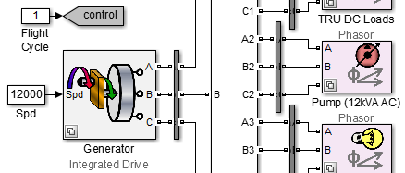

**1. Flight Cycle 1**

**Figure 1.1. Generator Power**

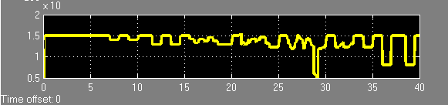

**Figure 1.2. Engine RPM**

