# Lung Physical Models

## Disclaimer

**This example may not represent an implementable design, and no validation has been done. This purpose of the example is to provide a starting point for designers working ventilators showing how interfacing between the real-time controller and the system model can be done, how a real-time controller can be defined in Simulink® and Stateflow™ and how a full system model can be used to support the design process.**

## Mechanical Modelling of Lungs

The system of lungs and trachea, in terms of the purpose of mechanical ventilation, can be approximated by a one-dimensional variable-volume chamber with a pipe.

* Moist air can flow (in and out), changing the pressure and volume of the chamber.
* This chamber has stiffness and certain friction (damping).
* Heat exchange towards the moist air, as well as addition of moisture, can be considered in the modelling too.
* Depending on requirements of fidelity of this approximation, we can consider the stiffness to be constant (linear lung) or to change depending on the volume (nonlinear lung)
* For even higher fidelity, 2D or 3D models would need to be implemented in Finite Element Methods and Computational Fluid Dynamics, which is outside the scope of Simscape™ tools. However, in practice this level of detail is not usually required.

## Simscape™ Implementation

Components:

* Translational Mechanical Converter (MA[1]) for the variable-volume chamber
* Translational spring for lung stiffness (either linear spring or modified nonlinear spring)
* Translational damper for damping
* Pipe (MA) for trachea

Most parameters for lungs are in terms of pressure-volume, but these components are in terms of force-position. Hence, the interface cross-section of the Translational Mechanical Converter is used as a dummy parameter (changing its value does not change results) defaulted to 0.1 m2 to serve as a transition from pressure-volume to force-position, internally in the lung models.

## Lung parameters

* Final Respiratory Capacity (FRC) [liters]: is the remaining volume after exhalation. It is used as the reference volume for the spring not to produce any elastic force.
* Elastance at equilibrium volume [cmH2O/liter]: is the elastic pressure increase (in cmH2O) per liter of volume incremented.
* Respiratory resistance [cmH2O/lpm]: damping coefficient
* Initial lung volume [liters]
* Initial moist air temperature inside lungs [degrees Celsius]

**Note that these parameters vary amongst people and their health condition**

## Linear Lung

The spring stiffness (or elastance) is constant, independently of the volume.

## Nonlinear Lung

The stiffness (or elastance) depends on the volume. An additional parameter is required: Maximum Lung Volume [liters] which is the volume at which elastic pressure tends to infinity, making it impossible to overpass that volume. It depends on the size of the thorax of the patient.

To model this behaviour, the elastic pressure has the shape of a tangent, following the formula:

$$p_{elastic}\left(V\right)=K_{1}\tan\left(K_{2}\left(V-FRC\right)\right)$$

With K1 and K2 chosen to meet the elasticity and maximum volume targets.

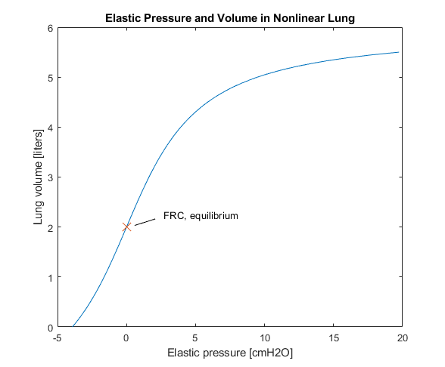

**Please remember this is intended as an example for people to build on if they are working on ventilator projects and is not a working design in itself.**

1. Moist Air domain