Option-Implied Probability Distributions for Asset Pricing
By Ken Deeley, MathWorks
Individual or collective beliefs about future financial performance often play an influencing role in the current market. For example, in a period of deflation, consumers may hold off purchases of high-value goods in the belief that the price will drop further. This could lead to a supply surplus and subsequent price deflation, strengthening the consumers’ belief and causing a deflationary spiral.
Within a market, beliefs concerning the future performance of an asset are often manifested in the observed prices of call and put options on the asset. (Call and put options are contracts to buy or sell a fixed quantity of the asset at a certain price at a predefined future date.)
Financial professionals such as analysts and economists may face challenges when tasked with forecasting the future performance of an asset and quantifying the uncertainty associated with such a forecast. For example, there may be a shortage of observed data for a given asset, or implementation of advanced mathematical techniques using traditional spreadsheets solutions may pose a challenge.
Recently, there has been interest from central banks in using observed option price data for creating forecasts, particularly during periods of financial uncertainty (for example, see [1] and [2]). This article shows how MATLAB® can be used to create a forecast for the future performance of an asset, starting with relatively scarce observed option price data. Topics include deriving probability distributions of the future asset price at different expiry times, using SABR and other interpolation methods to increase the number of available data points, and presenting the forecast uncertainty in a readily-understood graphical format (for example, a fan chart as shown in Figure 1).
The MATLAB code used in this article is available for download.
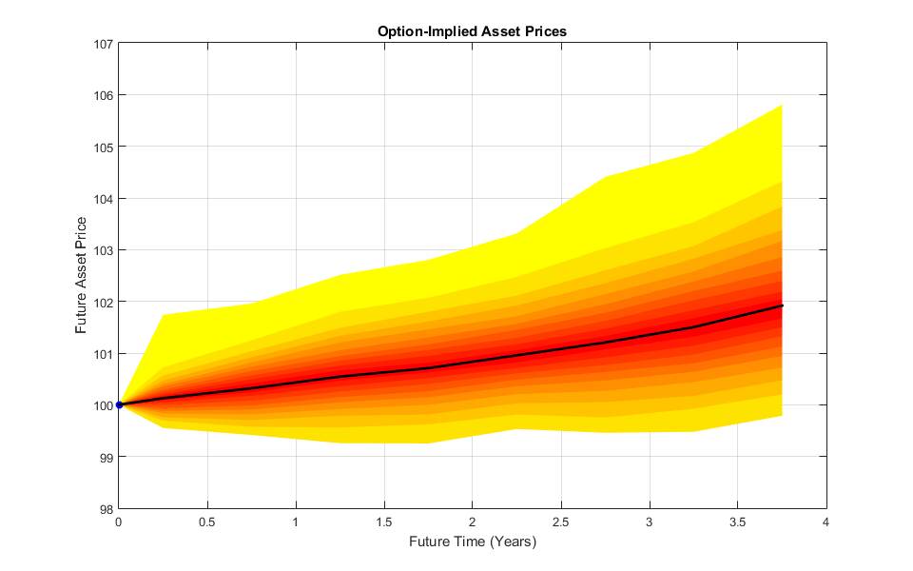
Figure 1: Asset price forecast and associated uncertainty

Computing Implied Volatility from Market Data
One of the key challenges facing analysts is gaining insight from a potentially small amount of available market data. We assume, at a minimum, that we can observe strike-call price pairs (or strike-put price pairs) for a given asset, and that we also know the underlying asset price, risk-free rate and expiry time for the option. We store this data in a MATLAB table using the following notation.
- K – strike price ($)
- C – call price ($)
- P – put price ($)
- T – expiry time of the option (years)
- rf – risk-free rate (decimal number in the range [0, 1])
- S – underlying asset price ($)
Figure 2 shows a snapshot of the first few rows of the table.
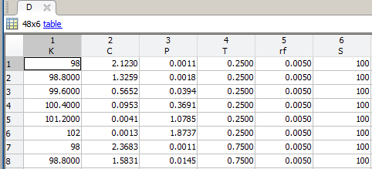
Figure 2: Observed market data may be scarce. In this hypothetical data set we have six observations relating to options with a given expiry time. There are eight distinct expiry times, giving 48 observations in total.
One technique for creating additional data points is interpolation in (K, σ)-space, where σ is the asset volatility, measured as a decimal number in the range [0, 1]. We compute the implied volatilities using the Financial ToolboxTM function blsimpv:
D.sigmaCall = blsimpv(D.S, D.K, D.rf, D.T, D.C, [], [], [], {'call'});
D.sigmaPut = blsimpv(D.S, D.K, D.rf, D.T, D.P, [], [], [], {'put'});
Figure 3 shows the observed market data in (K, σ)-space, stratified by the option expiry time.
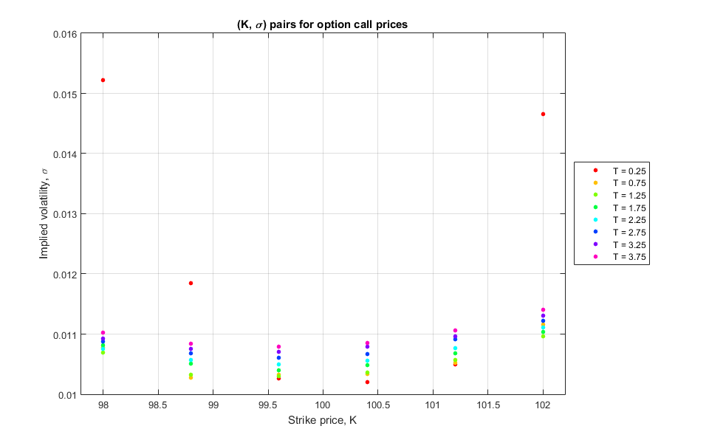
Figure 3: Observed market data in strike-volatility space, stratified by the option expiry time. Note the larger values at the endpoints for expiry time T = 0.25.

Creating Additional Data Points
There are different approaches we could use when generating additional points in (K, σ)-space. Simpler methods include fitting quadratic functions to the data for each expiry time, or using the interp1 function to construct cubic spline interpolants. Instead, we choose to use SABR interpolation to create additional data points, since this technique can often give more satisfactory results at the endpoints of the data set.
The SABR model is a four-parameter stochastic volatility model used by financial professionals to fit volatility smiles, so named after the shape of the resulting curves. Fitting the volatility smile is a two-step process in MATLAB: first, we calibrate the SABR model using the lsqnonlin solver from Optimization ToolboxTM. This minimizes the norm of the difference between the observed data and the candidate SABR smile, resulting in a vector of optimal parameters for the SABR model. Next, we use these optimal parameters together with the Financial Instruments ToolboxTM function blackvolbysabr to interpolate across the required range of strike prices.
Applying this technique to the data for each expiry time results in the curves shown in Figure 4. We note the good performance of the SABR technique when fitting the awkward data corresponding to the expiry time T = 0.25.
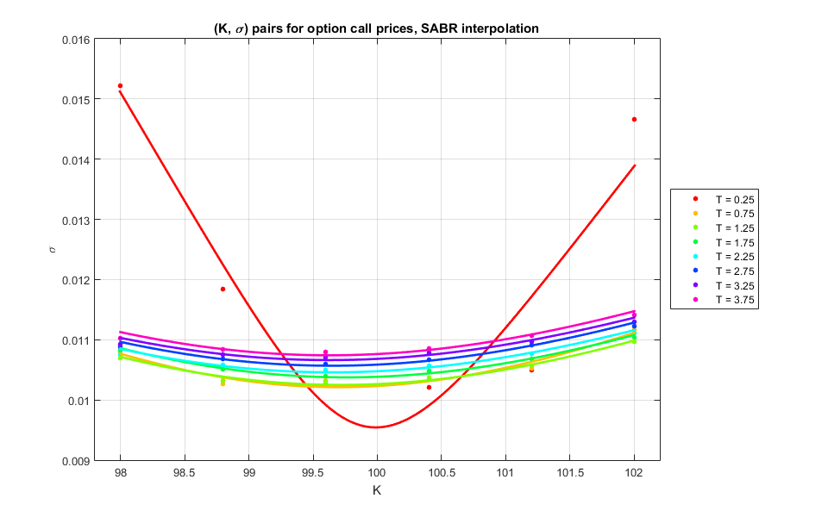
Figure 4: Volatility smiles for each expiry time obtained using SABR interpolation

Estimating Implied Probability Densities
After interpolation in (K, σ)-space, we obtain enough data points to estimate the implied strike price density functions at each expiry time. To do this we use a well-known result in computational finance due to Breeden and Litzenberger [3], which states that the probability density function f(K) of the value of an asset at time T is proportional to the second partial derivative of the asset call price C = C(K). We first transform the data to the original domain ((K, C)-space) for each expiry time using the blsprice function:
T0 = unique(D.T);
S = D.S(1);
rf = D.rf(1);
for k = 1:numel(T0)
newC(:, k) = blsprice(S, fineK, rf, T0(k), sigmaCallSABR(:, k));
end
Here, fineK is a vector defining the range of strike prices used for the interpolation, and sigmaCallSABR is the matrix created using SABR interpolation in which the columns contain the interpolated volatility smiles for each expiry time.
We then compute the numerical partial derivatives with respect to the strike price. This can be done efficiently in MATLAB using the in-built vectorization of the diff function.
dK = diff(sampleK);
Cdash = bsxfun(@rdivide, diff(newC), dK);
Cddash = bsxfun(@rdivide, diff(Cdash), dK(2:end));
We also use logical indexing to remove spurious negative values which appear as unwanted artifacts of this process. Figure 5 shows the resulting functions for each expiry time. We note that as the expiry time increases, the functions become less complete.
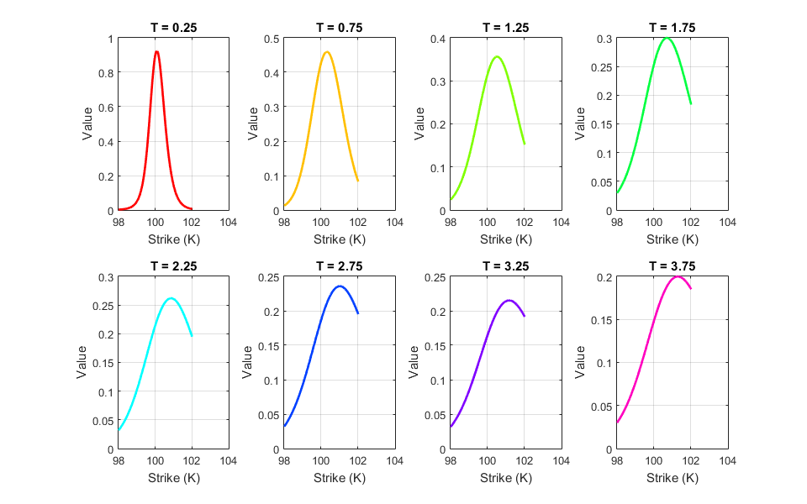
Figure 5: Option-implied functions approximated from the interpolated market data
To extend the definitions of these functions over the complete strike price domain, we use the fit function from Curve-Fitting ToolboxTM to create a linear interpolant. It is then easy to extrapolate from this interpolant to cover the range of interest.
for k = 1:numel(T0)
pdfFitsCall{k} = fit(pdfK, approxCallPDFs(:, k), 'linear');
end
Here, pdfK is a vector defining the required range of strike prices, and approxCallPDFs is a matrix storing the approximations to the implied densities for each expiry time in its columns. After extrapolating and normalizing the area under each function to ensure that we have valid probability density functions, we obtain the implied densities shown in Figure 6. We observe that the distribution modes gradually move upwards as the time to expiry increases, and there appears to be a general trend towards increasing volatility over time.

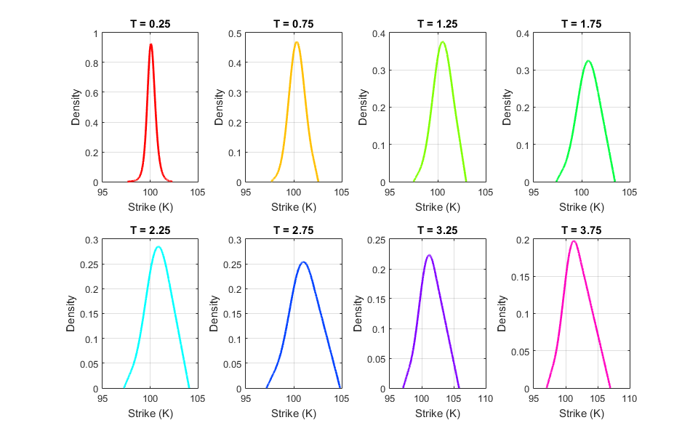
Figure 6: Final approximations to the implied density functions, after linear extrapolation and normalization

Simulating Future Asset Prices
Now that we have complete probability distributions for the asset prices at all future times, we can randomly sample from each distribution to create a forecast matrix. We need to randomly sample (with replacement) from a given range of asset prices according to the probability distributions defined in the previous step. This is straightforward to implement using the randsample function from Statistics and Machine Learning ToolboxTM.
nSamples = 1e3;
priceSimCall = NaN(numel(T0), nSamples);
for k = 1:numel(T0)
priceSimCall(k, :) = randsample(fitKCall{k}, nSamples, true, fitValsCall{k});
end
This code preallocates a matrix priceSimCall in which each row represents a future time and each column represents a random asset price drawn from the corresponding probability distribution. The loop iterates over each future time, and each iteration creates a row of priceSimCall by randomly sampling from the appropriate distribution. The first input fitKCall{k} to randsample contains the asset prices from which to draw the random samples. The second input nSamples is the number of samples required and the third input (true) specifies that we want to sample with replacement. The fourth input fitValsCall{k} is the probability distribution used by the randsample function when drawing the random samples.

Creating a Fan Chart
A fan chart is a type of graph commonly used for plotting the projected future evolution of a time series, together with the uncertainties associated with the forecasted values. Since release R2014b, Financial ToolboxTM has provided users with the fanplot function for creating fan charts. This function requires two inputs, namely the historical and forecast data. We define the historical data to be simply a point comprising time T = 0 with corresponding asset price S = 100, although if we had historical data for the asset prices then we could incorporate them here.
historical = [0, S];
The forecast data comprises the expiry times together with the results from the simulation performed in the previous step.
forecastCall = [T0, priceSimCall];
We then create the fan chart with a call to the fanplot function.
fanplot(historical, forecastCall)
The resulting graph is shown in Figure 7. The central line represents the median trajectory, and the edges of each band represent different quantiles of the forecast simulation matrix. Bands close to the central line indicate more likely outcomes, whereas bands further away from the center show more unlikely scenarios. We observe that there is an increasing trend in the projected asset price, and as we might expect, the forecast uncertainty increases with time.
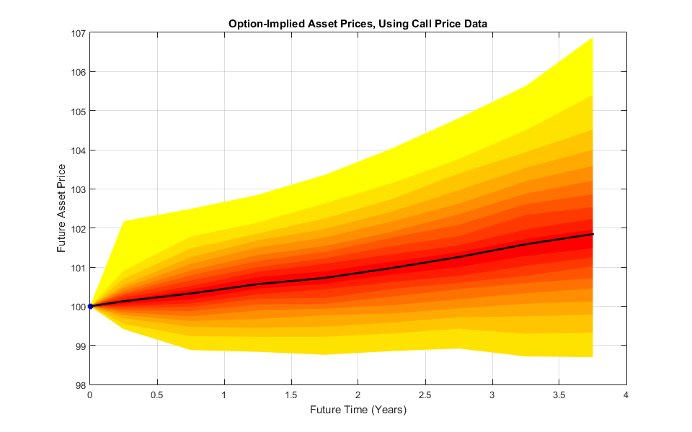
Figure 7: Fan chart showing the results of the simulation.

Assumptions and Further Improvements
We would expect the final forecast accuracy to be improved if we had more data points available. We could also try to fit probability distributions rather than using extrapolation to complete the definition of the implied density functions, although this may introduce unwanted distributional assumptions. We can repeat the process using the put price data. Averaging the forecasts created from the call and put price data results in the fan chart shown in Figure 1. Such averaging tends to smooth out small fluctuations, and counter bias caused by working with only one type of price data.
Forecasting Clarity
The purpose of creating a fan chart was to derive information content from a relatively small starting set of data. Presenting the results in this accessible graphical form enables financial professionals to communicate their forecasted projection and uncertainties to a non-specialist audience.

Products Used
MATLAB
Financial Toolbox
Statistics and Machine Learning Toolbox
Optimization Toolbox
Financial Instruments Toolbox
Learn More
Calibrate the SABR Model
Price a Swaption Using the SABR Model
References
[1] Option-implied probability distributions for future inflation, Tom Smith, Quarterly Bulletin of the Bank of England, 2012 Q3
[2] The Information Content of Option Prices During the Financial Crisis, ECB Monthly Bulletin, February 2011
[3] Prices of state-contingent claims implicit in options prices, Breeden, D. T. and Litzenberger, R. H. (1978), Journal of Business, Vol. 51, pages 621–51.

