Overall thoughts:
First, I think this is great. It’s easy to follow and understand. Overall, the organization makes sense and flows well.

I think it might be helpful to break the scripts into smaller sections than they currently are. For me, it would be helpful to read a little, do a thing (open a model, run a model, execute a function, etc.), read a bit more, and do the next thing, read a bit more, etc., rather than have everything happen at once with text interspersed.

I have broken the feedback up by script, each script getting a section to itself. Let me know if you have questions or don’t understand what I’m trying to say. I also get pretty nitpicky, so feel free to ignore anything that seems irrelevant.

I put grammar and wording changes directly into the scripts. You may want to do a diff on this branch to see what I’ve changed and to make sure I didn’t change the meaning of anything.

DesignCoolingSystem.m
The strange white rectangle shows up for dark mode, but not for light mode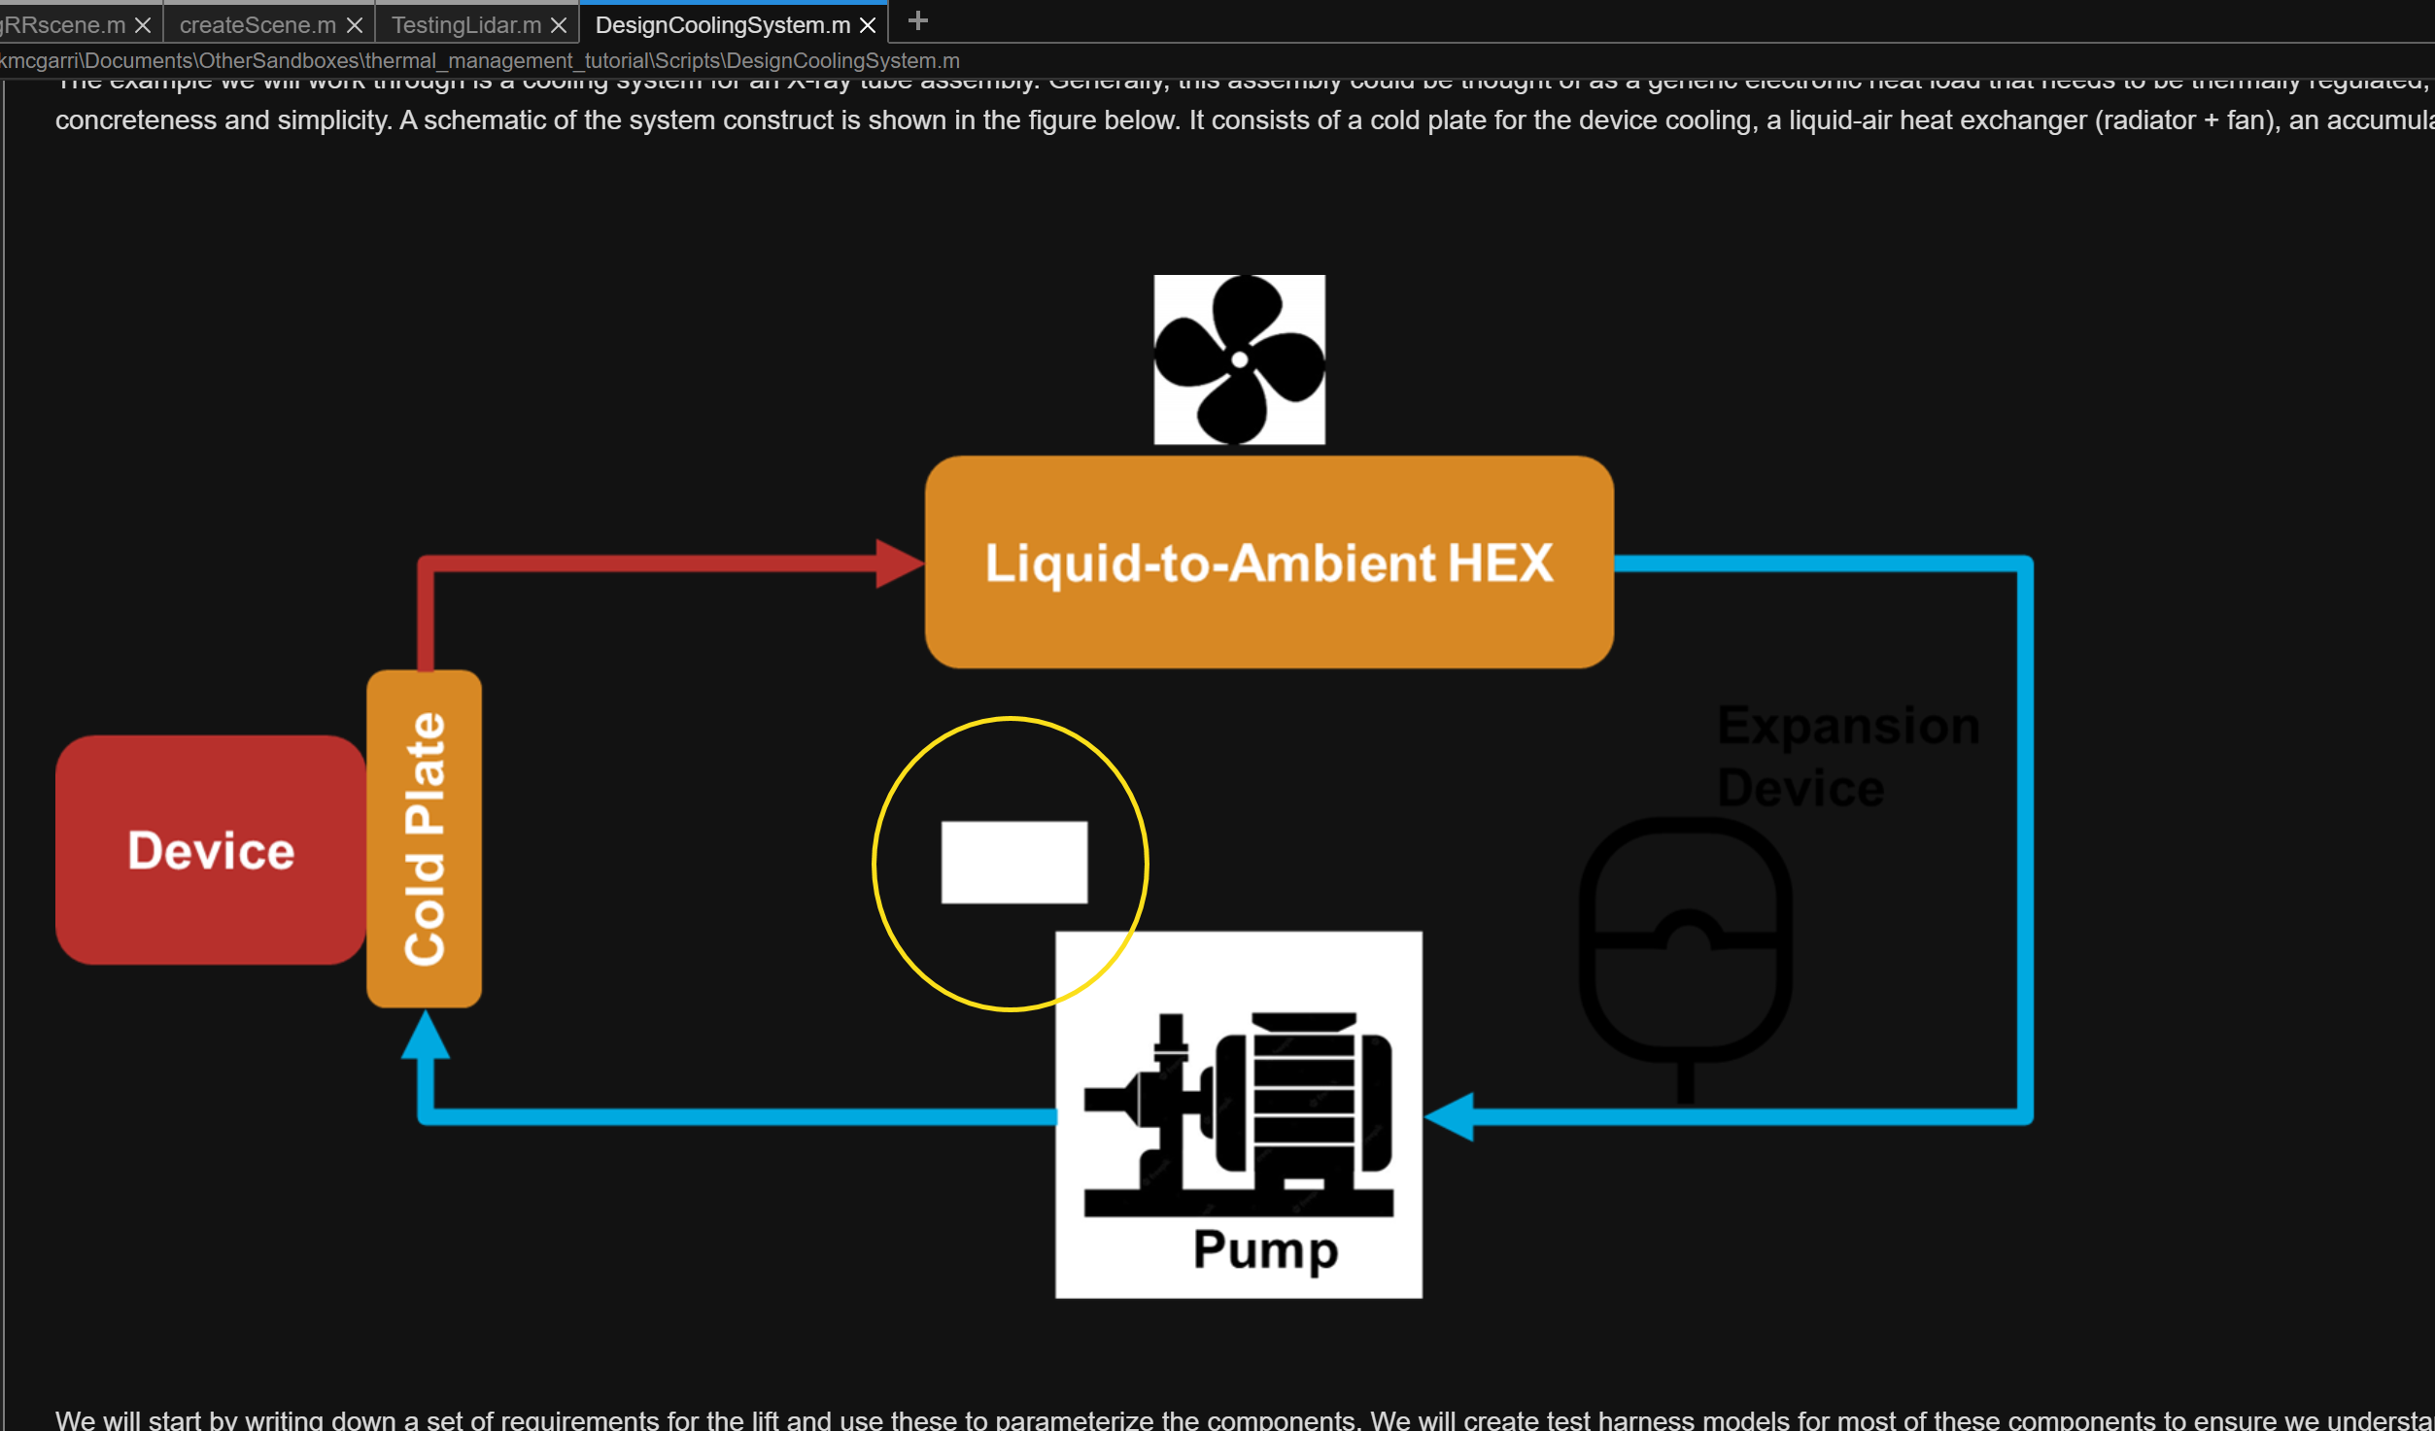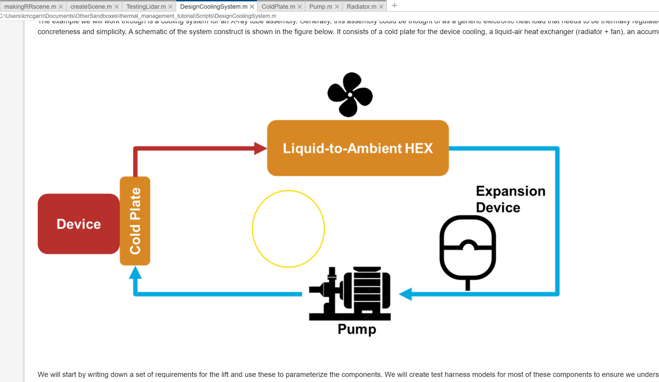

I think you should explicitly tell the user to work through these three scripts before moving on to the next step. It feels more like a suggestion rather than a must, especially because the main script continues after this.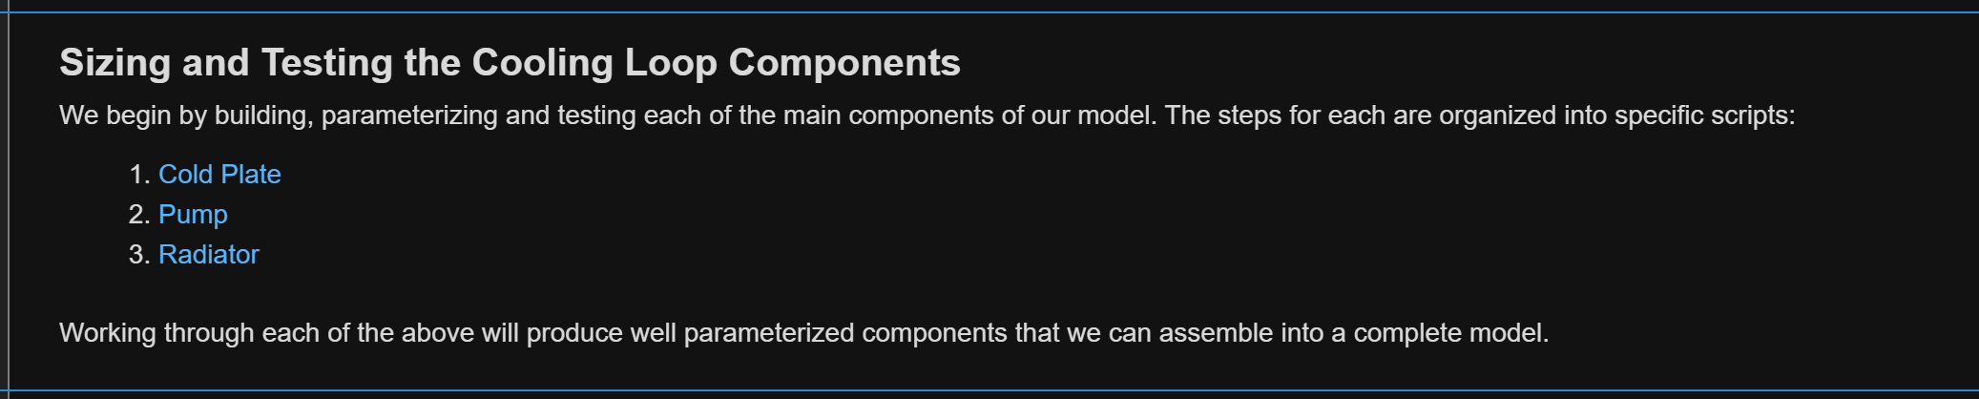

You refer to connecting the subsystem references twice. It sounds like you have two separate models, but I don’t think you do. It’s a bit confusing because I think the paragraphs say more or less the same thing.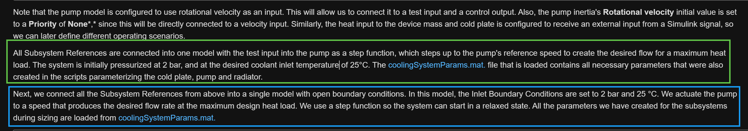

Actually, it’s difficult to see. I added an axis expansion so that the purple like becomes more obvious (not shown in the image but it will change next time the script is run).
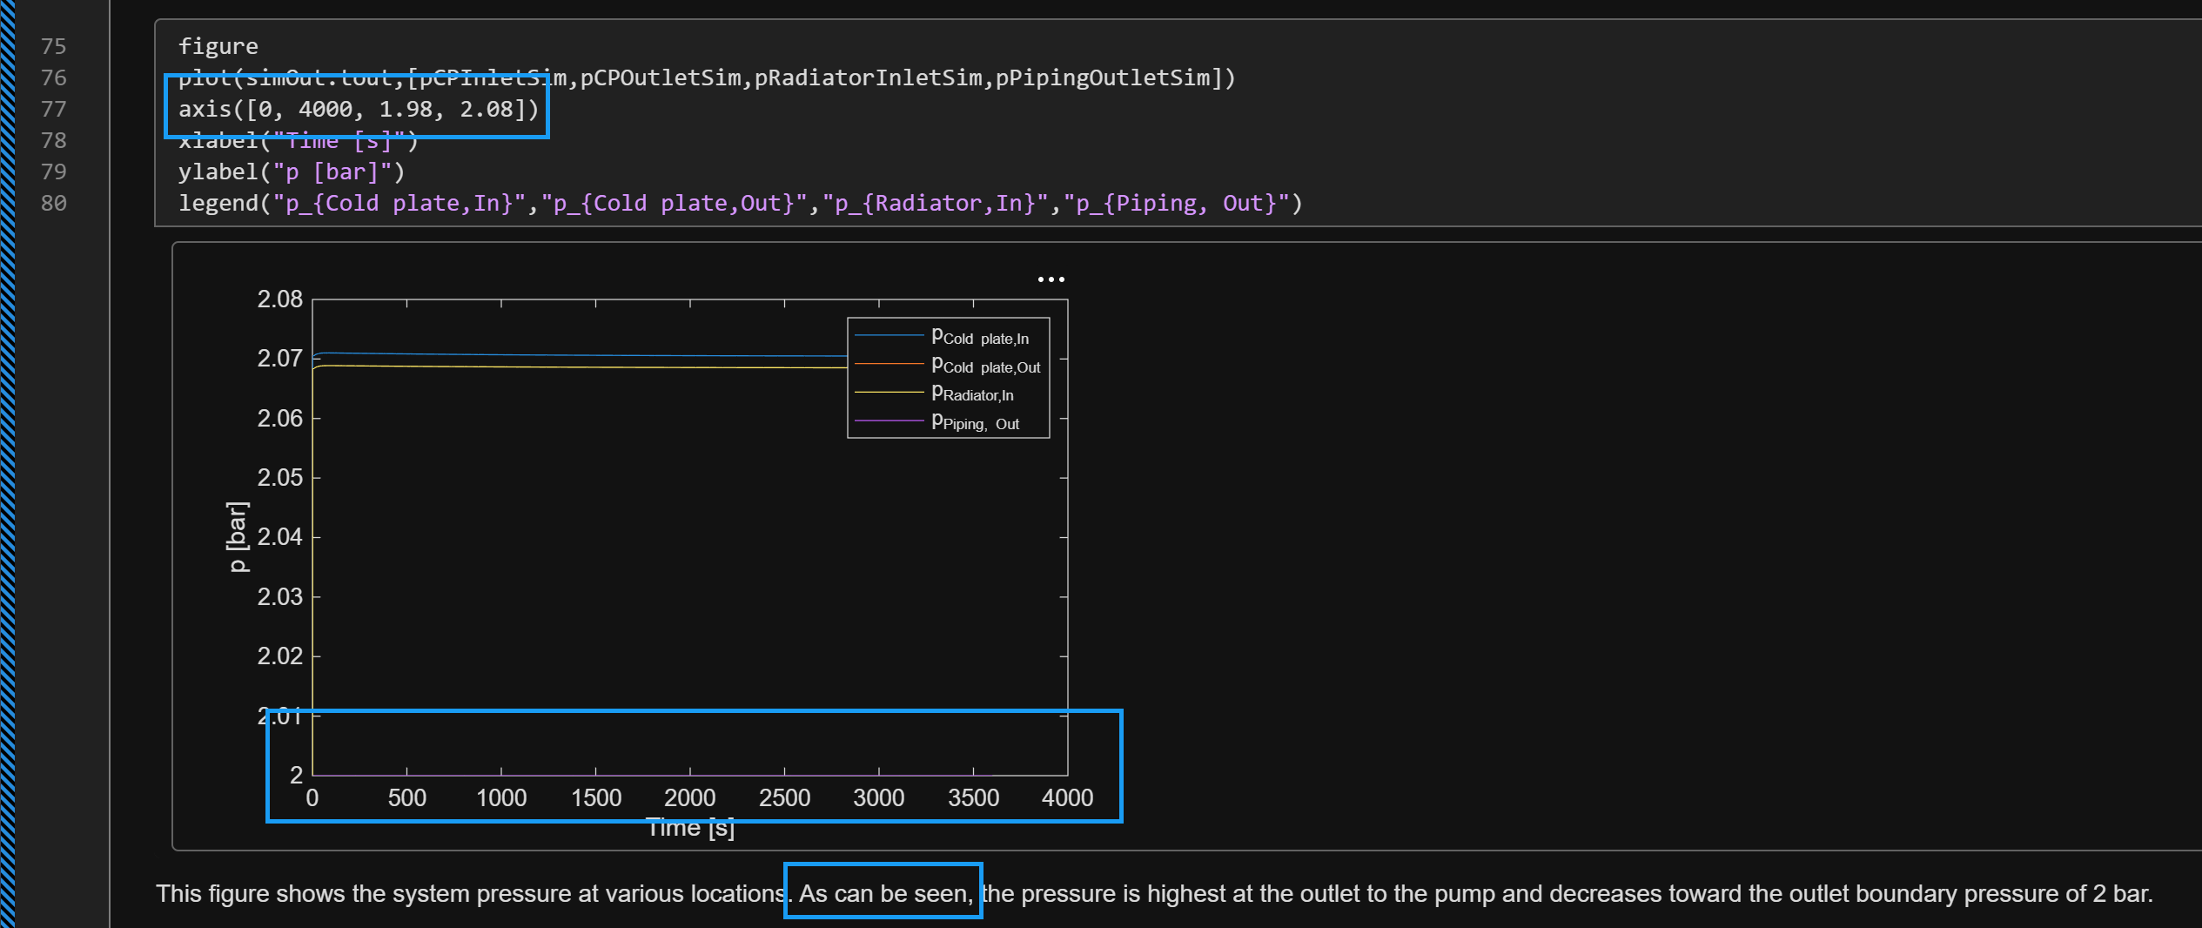

Is it possible for the link to open to the final section of the Pump.m script? 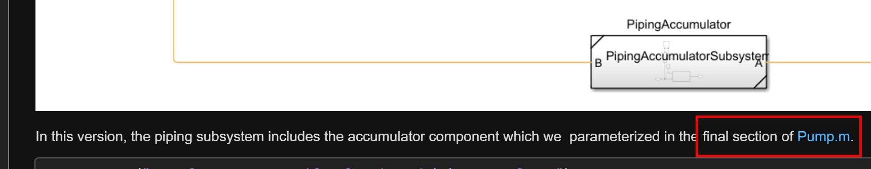

ColdPlate.m
The formatting of “Power added parameter” looks odd to me, and I stumbled while I read it. (I really like the explanation of why we set it to none! That’s helpful.)
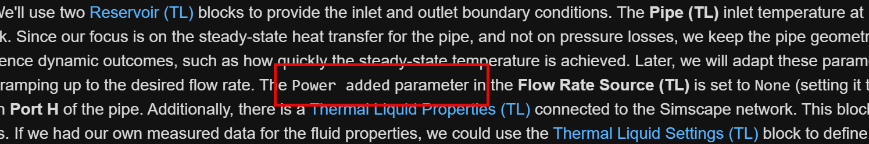

The link for Thermal Liquid Properties (TL) went to Thermal Liquid Settings (TL). I updated it in the script. (Make sure I did that right.)
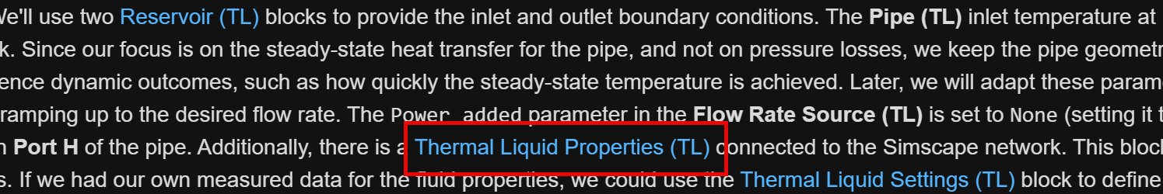

What is this button for?
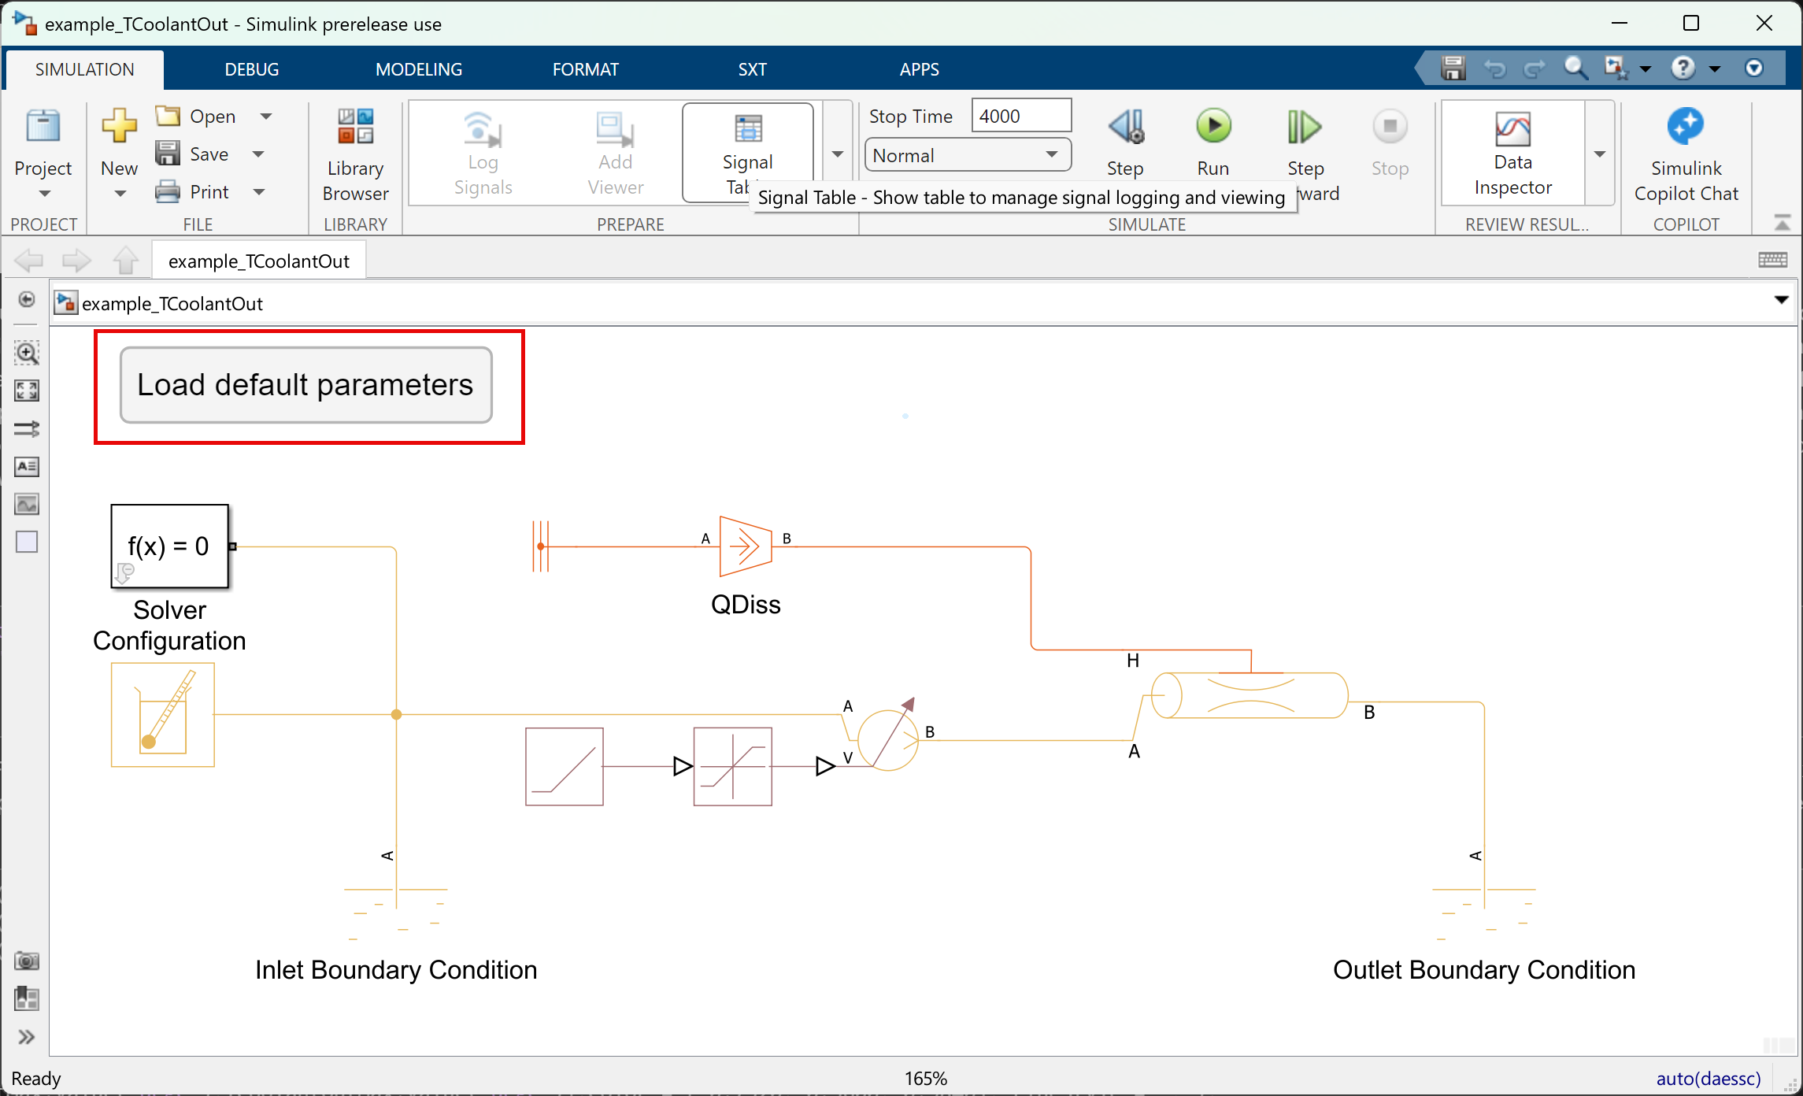

I was a bit confused by this. It seemed to come out of nowhere. 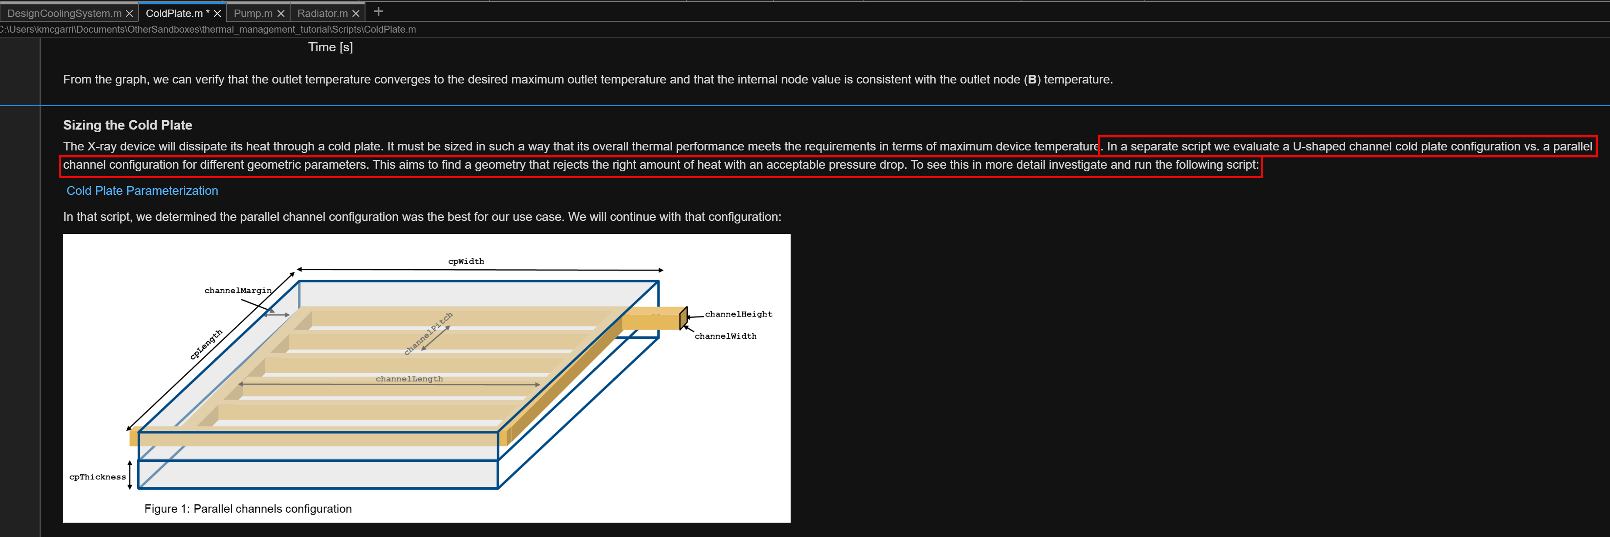Perhaps if you flipped the sentences and said something like:
“It must be sized in such a way that its overall thermal performance meets the requirements in terms of maximum device temperature. The geometry of the cold plate is important to select properly. Therefore, we will investigate a U-shaped channel cold plate configuration and a parallel channel configuration using various geometric parameters. Before continuing here, run the following script:”

Is it possible to link this directly to the final parameter table in the script?
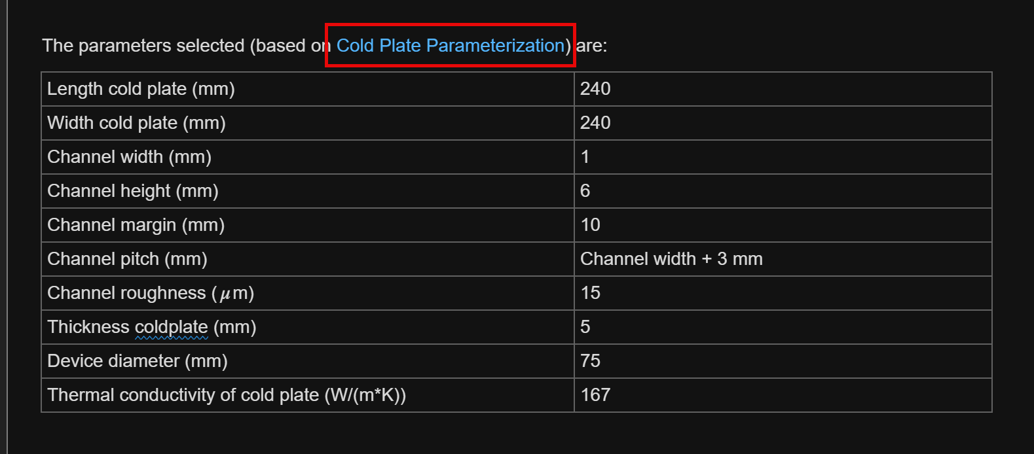

Previously used pipe block in which model? I’ve just opened three of them. Why not have this discussion in the ColdPlateParameterization.m script? Or why not use this in the first model, example_TCoolantOut.slx? Also, in the script, it is not obvious that Pipe (TL) is different from Pipe (TL) unless the user clicks on the links. It would be helpful if you were more explicit in pointing out the differences in the text.

What if you have the conversation about the splitters here, rather than in ColdPlateParameterization.m and then just jump into the parameterization in that script? Why have it in two places?
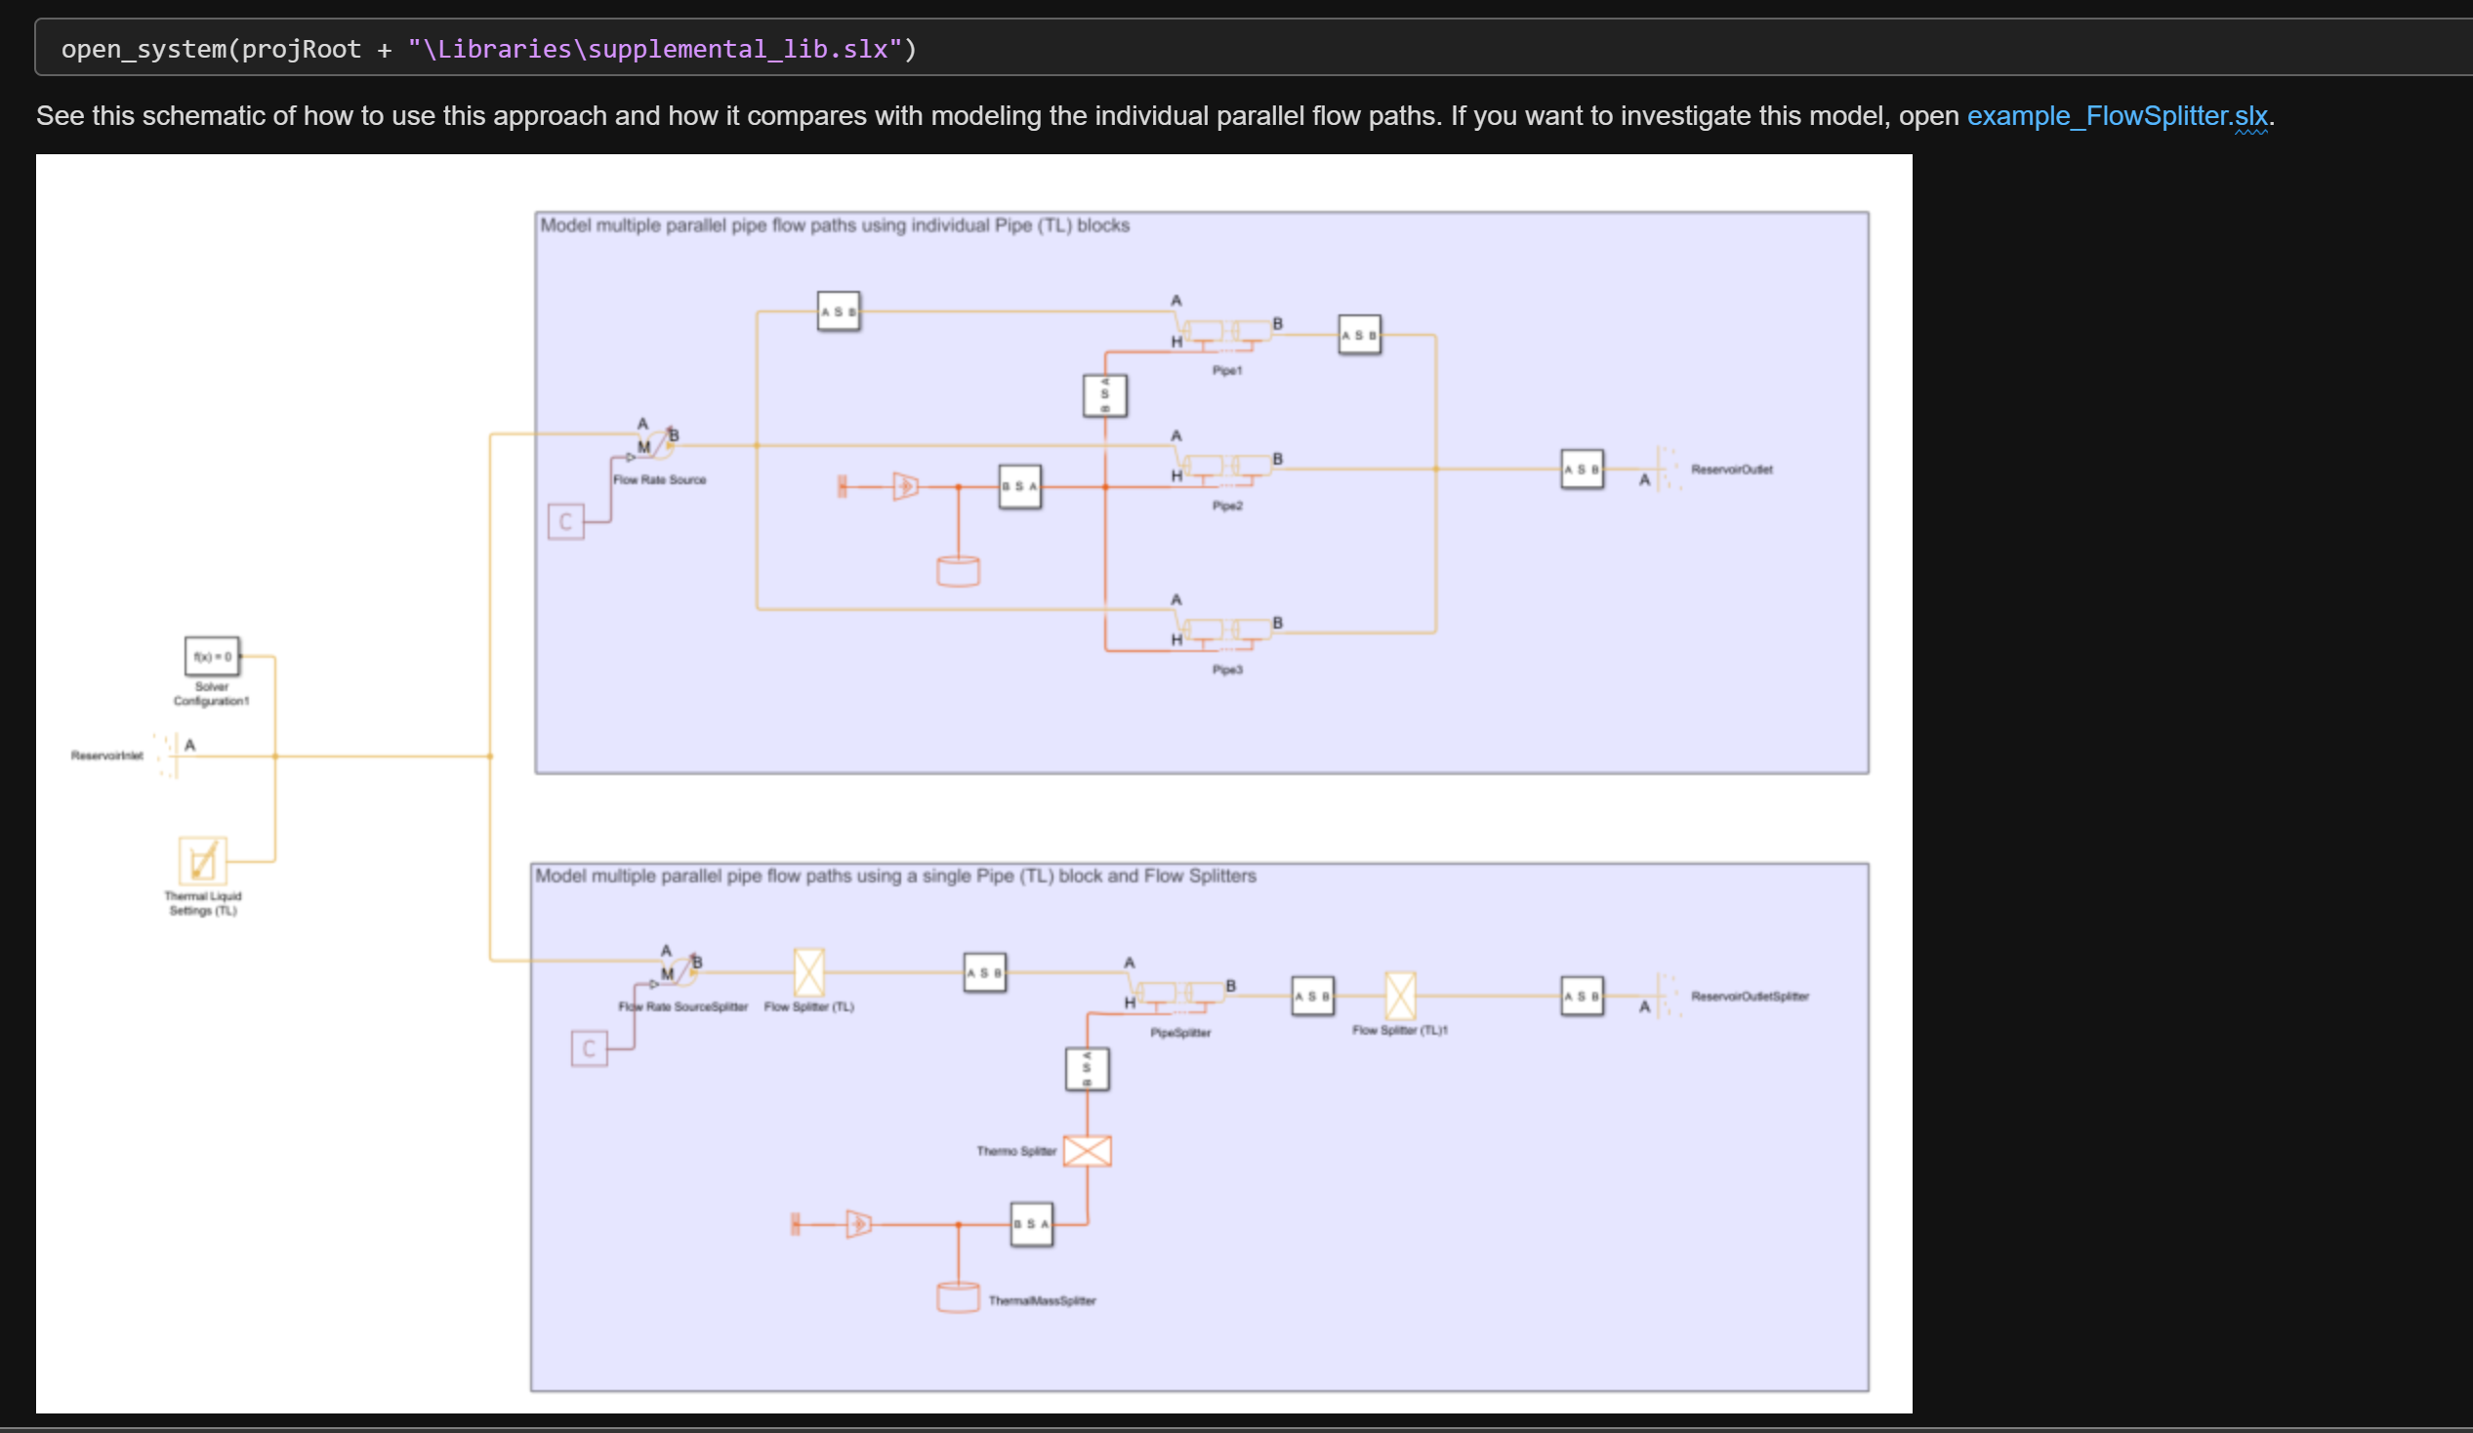

Isn’t it too late for this? We should have done this earlier in the script:
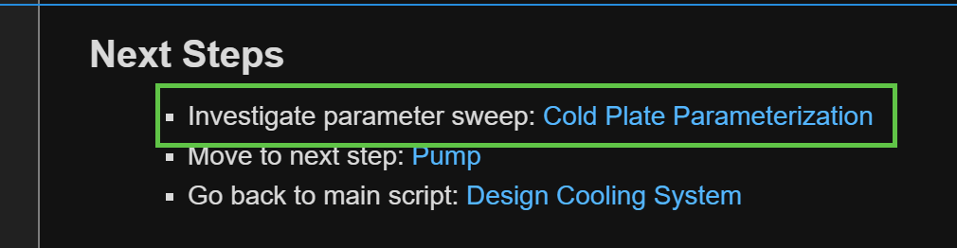

ColdPlateParameterization.m
I’m not entirely clear on what your point is here. I think it might be backwards.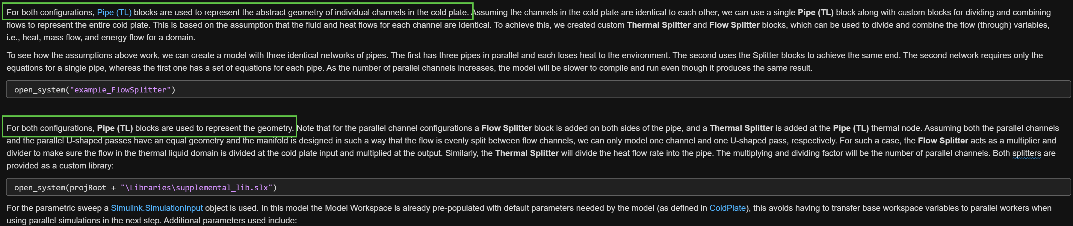Perhaps you should flip the script and show the flow splitter first to justify why you make the spitter blocks. Then you can say, because we may need more than three pipes to model our system, we will go with the splitter to explore the U and parallel configurations. This would make a nice section break. The first section discusses splitters and I can run example_FlowSplitter.slx to see that with and without the splitter it gives the same results. I don’t know if there’s a way to show the speed difference for running the model without providing a stupid number of pipes, but that could also bring home the point. Then, the next section opens example_compareColdPlate.slx (should compare be capitalized here? Or should Flow be lower case in the other model name?) and you can discuss the two configurations before running the parametric sweep.

Why do you use two different outlet reservoirs when you had an entire discussion on using the same reservoirs for inlet and outlet and use the same reservoir in the other models?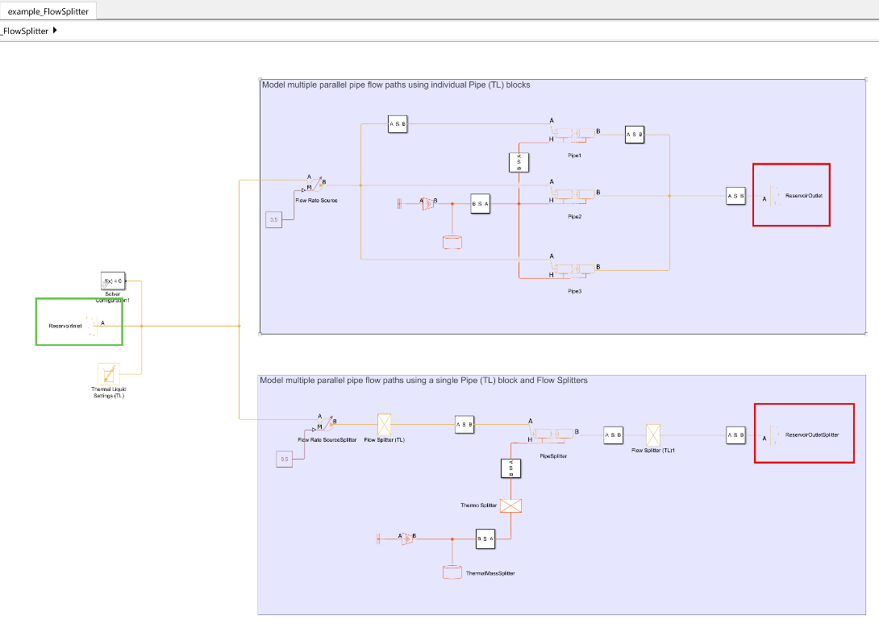

I don’t have the same number of simulations (144) as you show in the script (256). Also, only one figure pops up for me.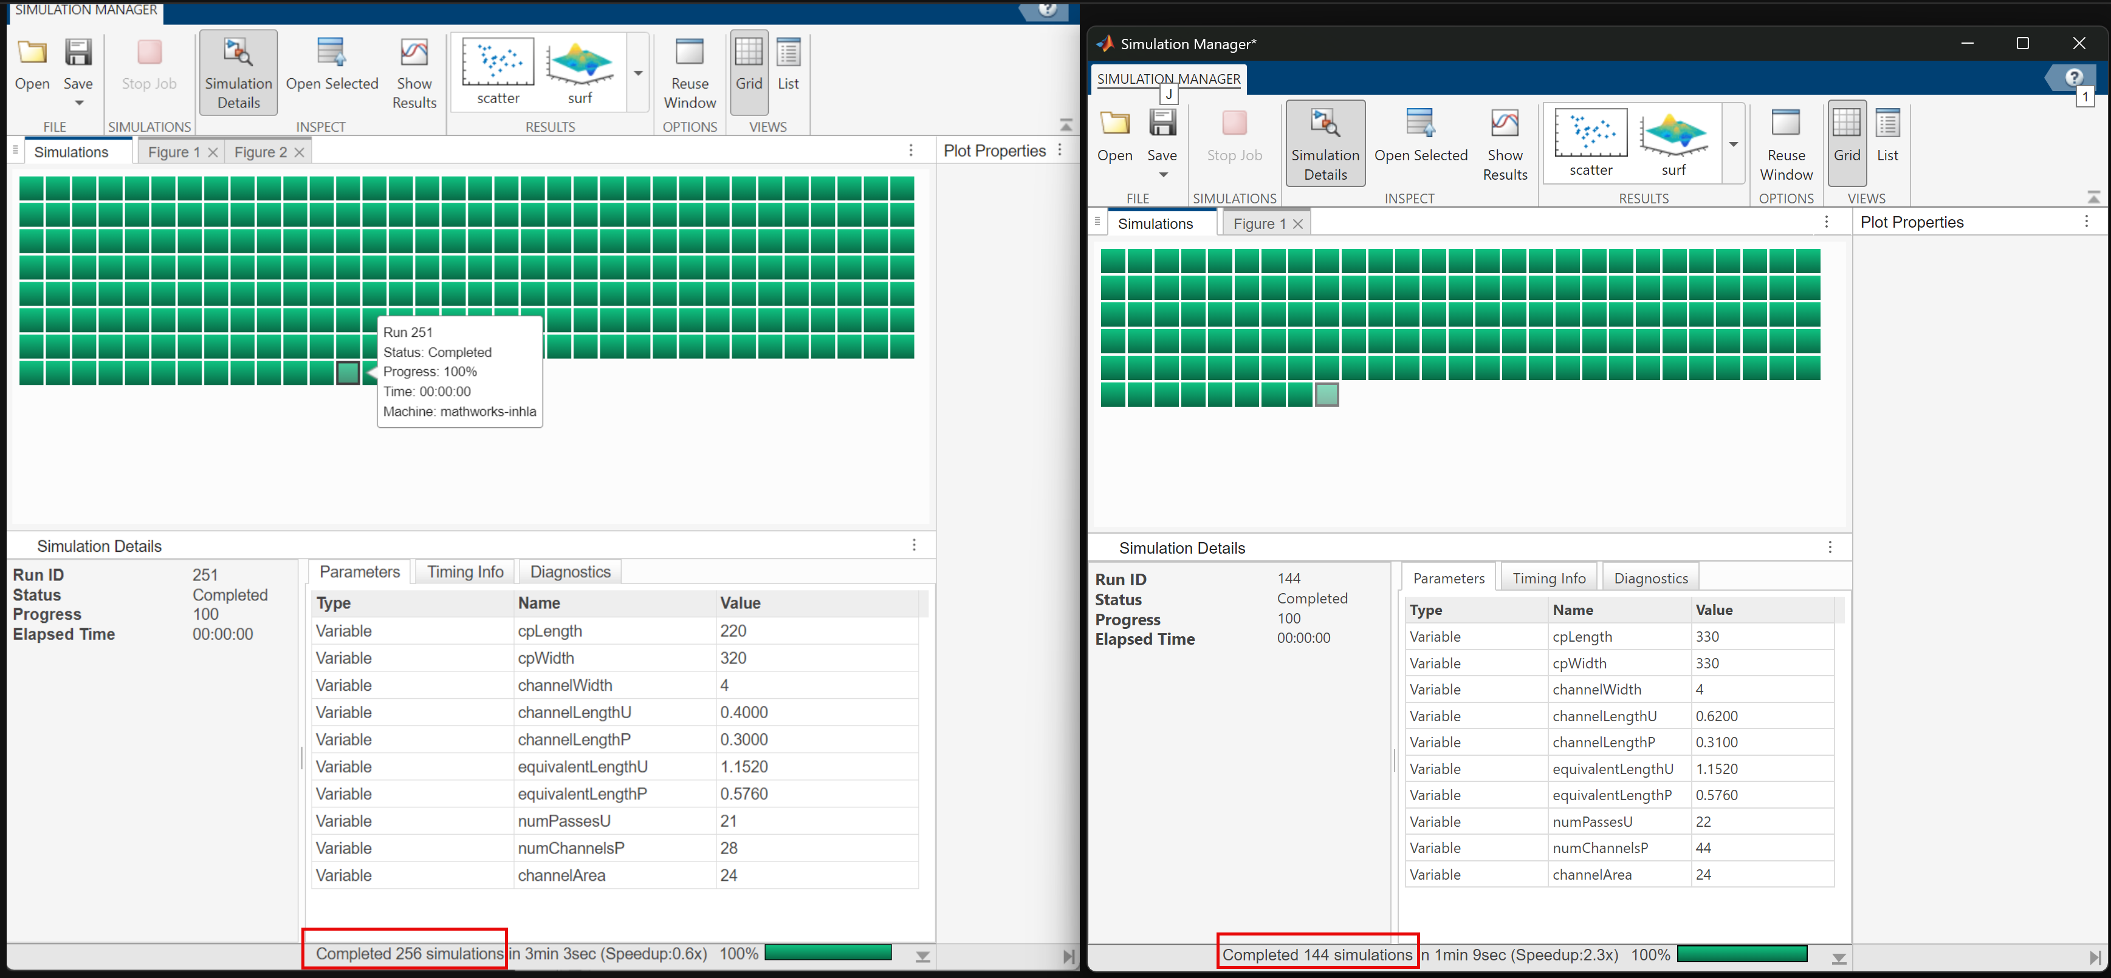

Pump.m
What is this button for?
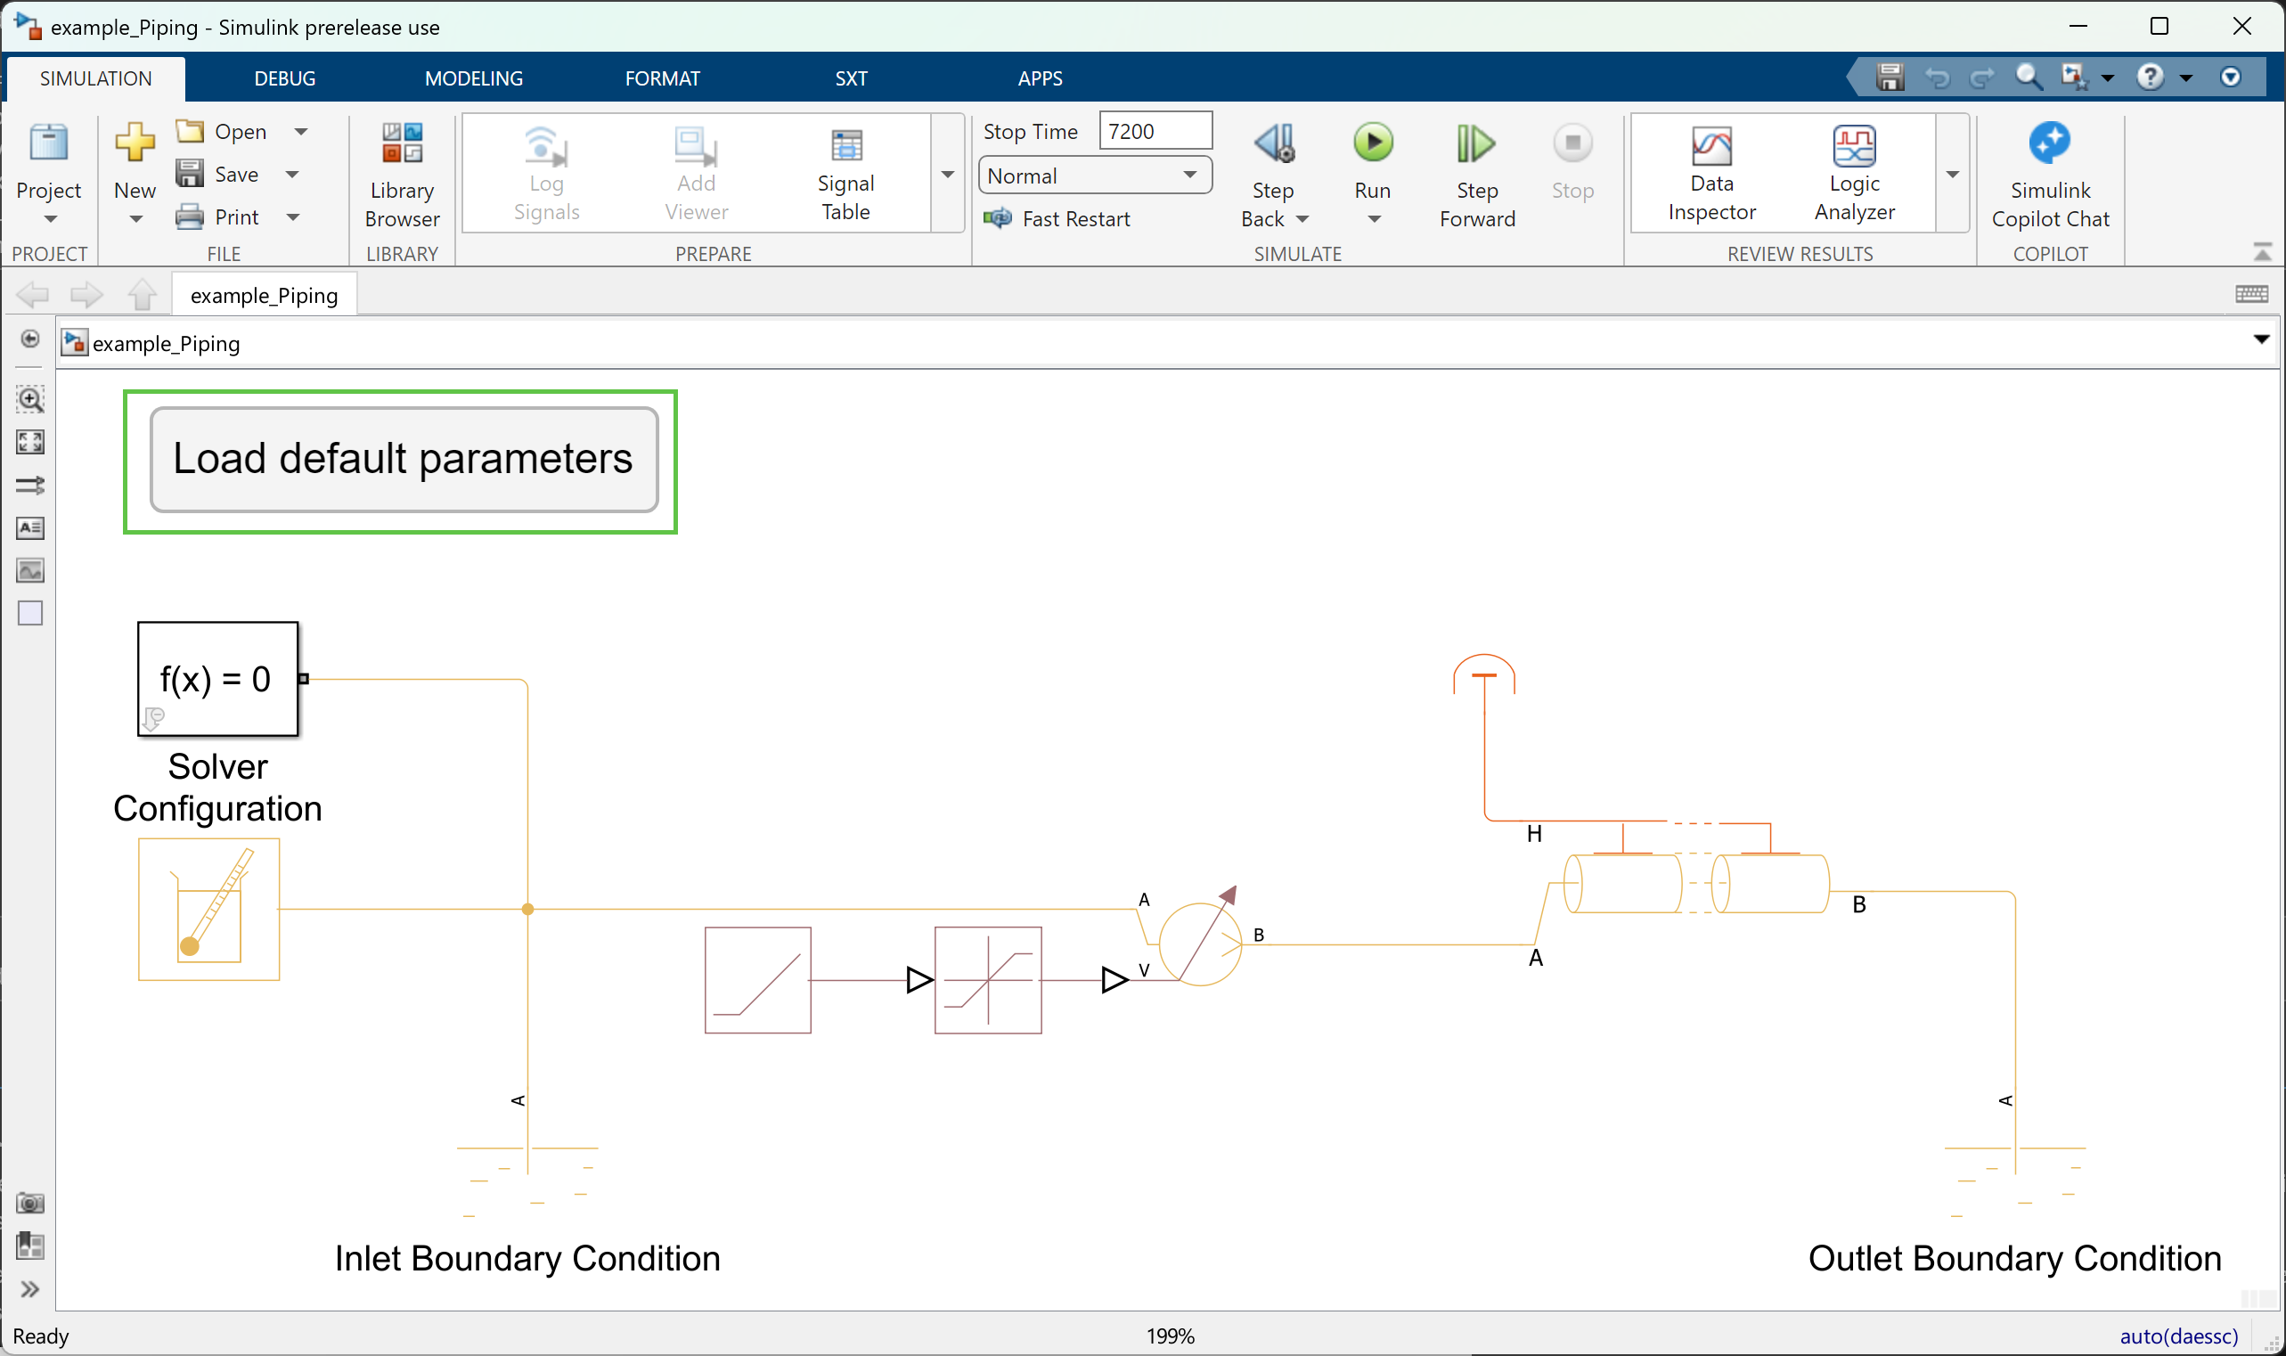

Can you put this paragraph directly under the picture of the model? Then, maybe also have a picture of the mask. You have a lot of references to parameters in the mask, and it would be helpful to see them as you refer to them.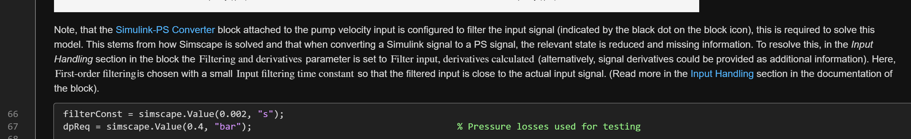

The discussion about the operating point belongs with the figure above the pump efficiency figure. You should also discuss the efficiency curve, otherwise, why are you plotting it? And, where did we determine the operating point of 5.75 lpm? A reference would be helpful here.
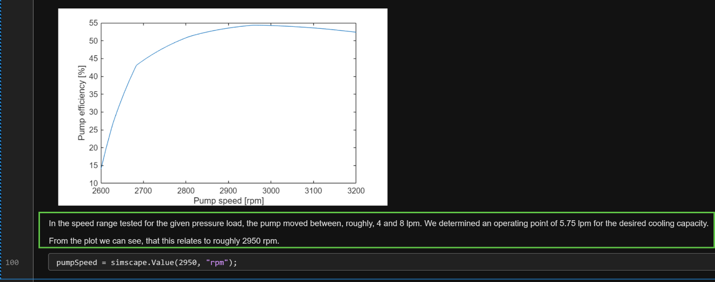

It might be nice to have a link back to the previous step: Cold Plate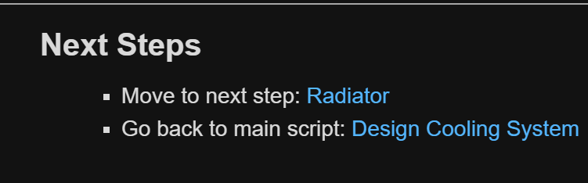

Radiator.m
Maybe a picture of the mask would be helpful here. The parameter is “Flow Geometry”, the parameter value is “Flow inside one or more tubes”. Should the formatting be different to reflect that? Or, should the parameter name be called out explicitly?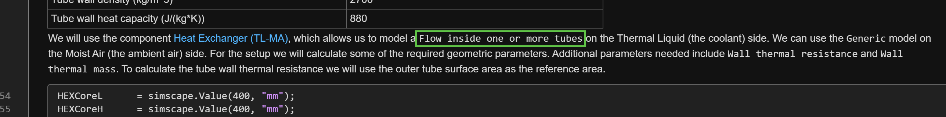

Reading further, I think it’s doubly important to show the mask and the parameters you care about because now it’s getting confusing just looking at words. Maybe put both of these paragraphs together and show the mask image between them rather than the code.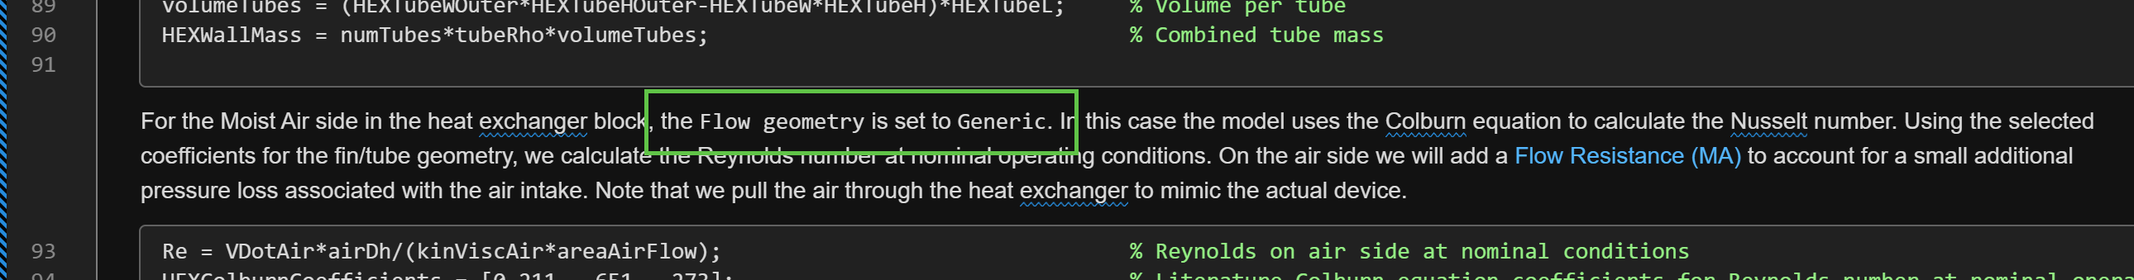

You suddenly switched units from bar to Pa. I recommend remaining consistent with your units. As a reader, it’s jarring and a bit confusing to have them change in the middle of the discussion.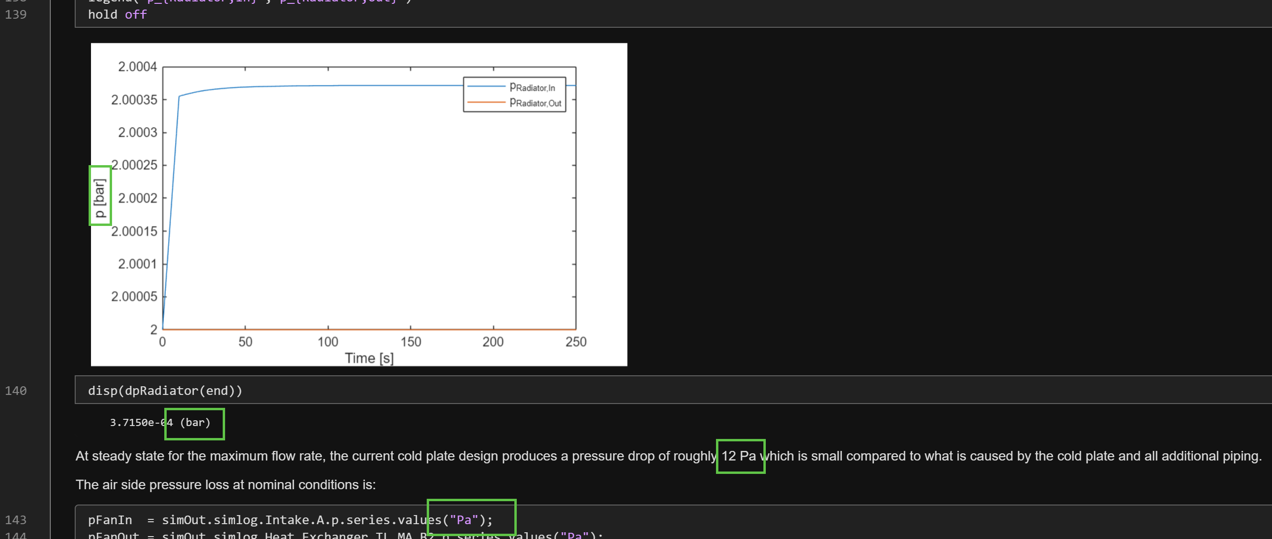

It could be nice to have a link back to the previous step: Pump

