**HELLO MUSIC!!**

**ABSTRACT:**

This can be one of the best application for music lovers. This app will initially look as a normal mp3 player but it will be much more than just that. It will let the others in the user’s contact just that. It will let the others in the user’s contact list alone to know what the person is listening and if they like that song, they will be able to share that song in real time. Suppose when listening to a particular song and do not want to share it, this app has the features to mute or hide that song. If anybody want to verify with a song before listening to it,it is also possible to view that songs current rating, comments, etc via this app.There is one option that says "Make video online". Just pressing that for every song,it willdownload that songs video, and so we can watch it via data or wirelconnection. It reduces the searching time in Google, to hear and watch that song. It also has the great advantage that this app is not language restricted.

**PROBLEM STATEMENT:**

In order to make easy sharing to music listeners to their friends, without

access to the internet everytime, instead of searching everywhere to hear and view their favourite

songs etc,all these purposes are available in a single application –“HELLO MUSIC”and which is user friendly.

**HARDWARE & SOFTWARE REQUIREMENTS:**

HARDWARE : Processor: P IV or higher

RAM 512 Mb free space

SOFTWARE : Eclipse

Google play service API

**JAVA CODE:**

MUSIC PLAYER:

**package** musicmain;

**import** java.awt.GridLayout;

**import** java.awt.event.ActionEvent;

**import** java.awt.event.ActionListener;

**import** java.io.IOException;

**import** javax.swing.JButton;

**import** javax.swing.JFrame;

**import** sun.audio.AudioPlayer;

**import** sun.audio.AudioStream;

**publicclass** MusicPlayer **implements** ActionListener{

AudioStream as;

JButton play=**new** JButton("play");

JButton stop=**new** JButton("stop");

JButton pause=**new** JButton("pause");

**publicstaticvoid** main(String[] args) {

**new** MusicPlayer().CreateGui();

}

**publicvoid** CreateGui()

{

JFrame frame=**new** JFrame("HELLO MUSIC");

frame.setDefaultCloseOperation(JFrame.*EXIT_ON_CLOSE*);

frame.setLayout(**new** GridLayout(1,3,5,5));

frame.add(play);

frame.add(stop);

frame.add(pause);

frame.pack();

frame.setVisible(**true**);

play.addActionListener(**this**);

stop.addActionListener(**this**);

pause.addActionListener(**this**);

**try**{

as=**new** AudioStream(**this**.getClass().getResourceAsStream("/guitarup_full.wav"));

}

**catch**(IOException e){}

}

**publicvoid** actionPerformed(ActionEvent arg0) {

**if**(arg0.getSource()==play)

{

AudioPlayer.*player*.start(as);

}

**elseif**(arg0.getSource()==stop){

AudioPlayer.*player*.stop(as);

**try**{

as=**new** AudioStream(**this**.getClass().getResourceAsStream("/guitarup_full.wav"));

}**catch**(IOException e){}

}

**else**

{

AudioPlayer.*player*.stop(as);

}

}

}

SHARE CONTACTS:

package com.example.contacts;

import android.app.Activity;

import android.content.Intent;

import android.database.Cursor;

import android.net.Uri;

import android.os.Bundle;

import android.provider.ContactsContract;

import android.view.Menu;

import android.view.View;

import android.widget.Toast;

public class MainActivity extends Activity {

private final static int PICK_CONTACT= 1;

@Override

protected void onCreate(Bundle savedInstanceState) {

super.onCreate(savedInstanceState);

setContentView(R.layout.activity_main);

}

public void ShareContacts(View v)

{

Intent i=new Intent(Intent.ACTION_PICK,ContactsContract.Contacts.CONTENT_URI);

startActivityForResult(i, PICK_CONTACT);

}

@Override

protected void onActivityResult(int reqCode, int resultCode, Intent data) {

super.onActivityResult(reqCode, resultCode, data);

if(reqCode==PICK_CONTACT)

{

if(resultCode==ActionBarActivity.RESULT_OK)

{

Uri contactData=data.getData();

Cursor c=getContentResolver().query(contactData,null,null,null,null);

if(c.moveToFirst()){

String name=c.getString(c.getColumnIndexOrThrow(ContactsContract.Contacts.DISPLAY_NAME));

Toast.makeText(this,"Successfully shared: "+name,Toast.LENGTH_LONG).show();

}

}

}

};

public boolean onCreateOptionsMenu(Menu menu) {

// Inflate the menu; this adds items to the action bar if it is present.

getMenuInflater().inflate(R.menu.main, menu);

return true;

}

}

ActionBarActivity.java

**package** com.example.contacts;

**public class** ActionBarActivity {

**public static final int** *RESULT_OK* = 0;

}

**XML CODE:**

<?xmlversion=*"1.0"*encoding=*"utf-8"*?>

<manifestxmlns:android=*"http://schemas.android.com/apk/res/android"*

package=*"com.example.contacts"*

android:versionCode=*"1"*

android:versionName=*"1.0"*>

<uses-sdk

android:minSdkVersion=*"8"*

android:targetSdkVersion=*"17"*/>

<uses-permissionandroid:name=*"android.permission.READ_CONTACTS"*/>

<application

android:allowBackup=*"true"*

android:icon=*"@drawable/ic_launcher"*

android:label=*"@string/app_name"*

android:theme=*"@style/AppTheme"*>

<activity

android:name=*"com.example.contacts.MainActivity"*

android:label=*"@string/app_name"*>

<intent-filter>

<actionandroid:name=*"android.intent.action.MAIN"*/>

<categoryandroid:name=*"android.intent.category.LAUNCHER"*/>

</intent-filter>

</activity>

</application>

</manifest>

<RelativeLayout xmlns:android="http://schemas.android.com/apk/res/android"

xmlns:tools="http://schemas.android.com/tools"

android:layout_width="match_parent"

android:layout_height="match_parent"

android:paddingBottom="@dimen/activity_vertical_margin"

android:paddingLeft="@dimen/activity_horizontal_margin"

android:paddingRight="@dimen/activity_horizontal_margin"

android:paddingTop="@dimen/activity_vertical_margin"

tools:context=".VideoplayerActivity" >

<Button

android:id="@+id/button1"

android:layout_width="wrap_content"

android:layout_height="wrap_content"

android:layout_centerHorizontal="true"

android:layout_centerVertical="true"

android:text="Button" />

</RelativeLayout>

**SCREENSHOTS:**

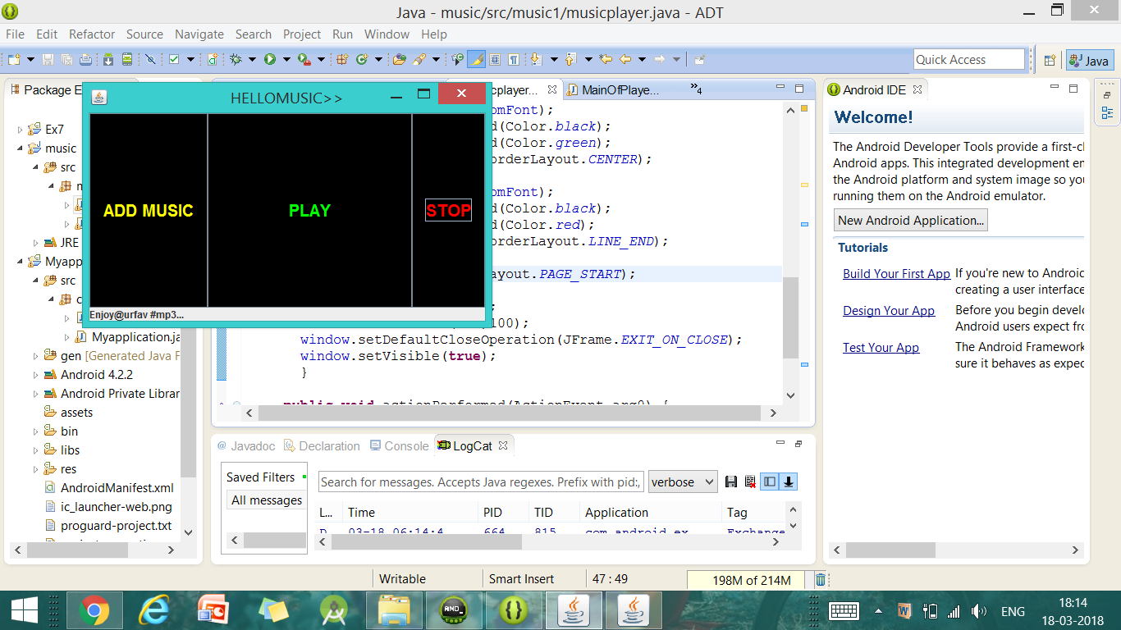

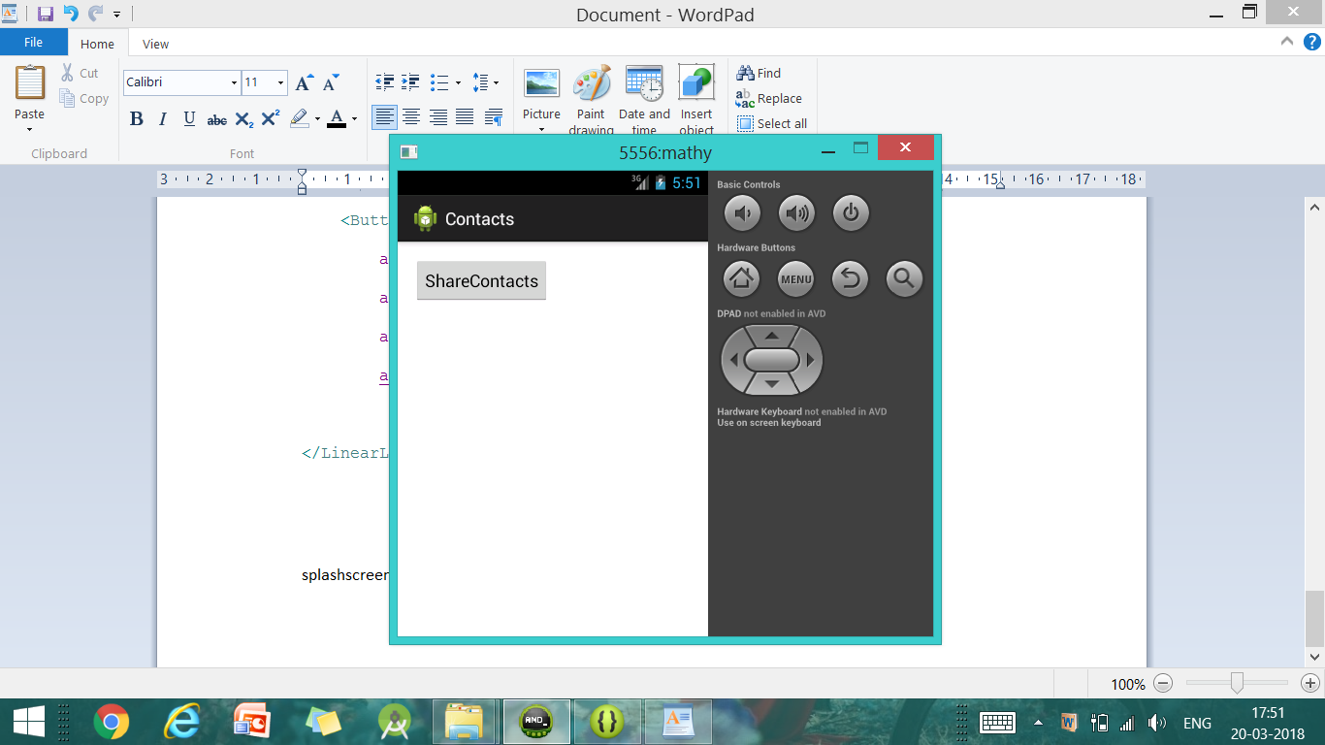

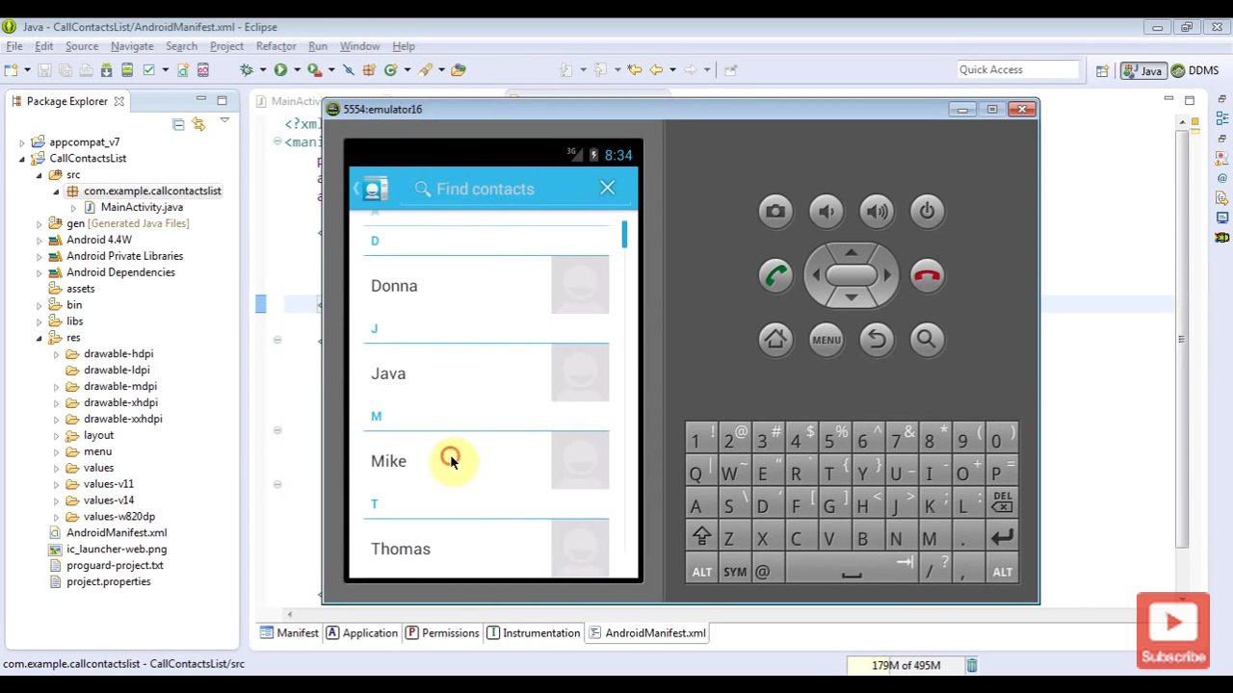

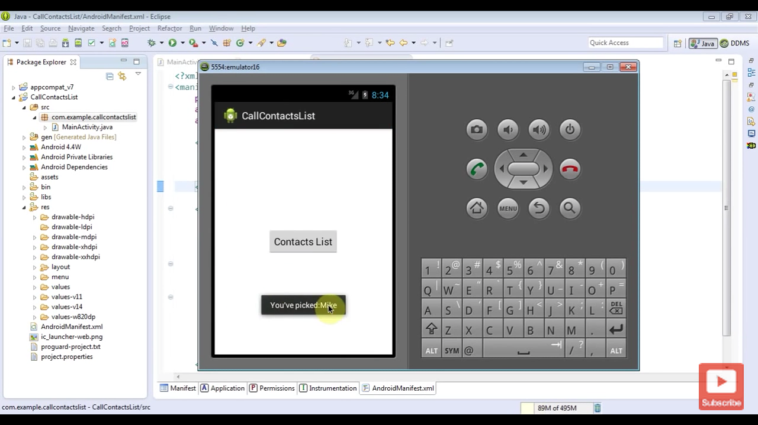

**CONCLUSION:**

This application is useful for all the music lovers to hear ,view and share the favourite songs with their beloved ones.