ECEN 4/5632 Theory and Applications of Digital Filters Fall 2026
9-24-26 P. Mathys
Name:

Midterm 1

“On my honor, as a University of Colorado at Boulder student, I have neither given nor received unauthorized assistance on this work” (see full Honor Code at http://www.colorado.edu/academics/honorcode)
- Closed book, notes, electronics basic scientific calculator ok.
- Covers Lectures 1 to 8 and Problem Sets 1 to 4.
Instructions. Show enough work to support every numerical answer. State ROCs explicitly. Label units and discrete-time frequencies. Unsupported answers may receive little credit.
Problem | 1 | 2 | 3 | 4 | 5
Points | /20 | /18 | /24 | /20 | /18
Total: /100

Convolution and Transforms | $y\left[n\right]=\sum_{k}{x\left[k\right]h[n-k]}$ $X\left(z\right)=\sum_{n}{x\left[n\right]z^{-n}}$  $X\left(e^{jω}\right)=\sum_{n}{x\left[n\right]e^{-jωn}}$
Frequency Mapping
Quantization
Filter Design

Left blank
Problem 1 Convolution and LTI Frequency Response, 20 points, approx. 14 minutes
Let $x\left[n\right]=δ\left[n\right]+2δ\left[n-1\right]-δ[n-2]$ and $h\left[n\right]=δ\left[n\right]-δ[n-1]$.
(a) [2 points] Predict the index range on which $y\left[n\right]=x[n]*h[n]$ can be non-zero.

(b) [4 points] Compute every non-zero sample of $y[n]$.

(c) [10 points] Find $H\left(e^{jω}\right)$. For the input signal voltage $v\left[n\right]=3cos⁡({πn}/{2+π/6)}$, find the steady-state output in cosine form.

(d) [4 points] PyTorch conv1d computes cross-correlation. For an input window ordered $[x\left[n-1\right],x\left[n\right]]$, give the two fixed kernel weights that produce $y\left[n\right]=x\left[n\right]-x[n-1]$. Explain the reversal.

Left blank

Problem 2 Sampling Aliasing and Quantization, 18 points, approx. 12 minutes
A signal $x_{a}\left(t\right)=2\cos\left(2π∙1500t\right)+cos⁡(2π∙6500t)$ is sampled at $f_{s}=8000$ Hz.
(a) [6 points] Write $x[n]$ using discrete-time angular frequencies reduced to the interval $\left[-π,π\right].$

(b) [5 points] Show that the two analog components produce the same discrete-time cosine. Simplify $x[n]$. What information has been lost?

(c) [3 points] If the 1500 Hz component is desired and the 6500 Hz component is unwanted, state a defensible anti-alias filter requirement needed before sampling.

(d) [4 points] A 10-bit uniform quantizer spans -1 V to +1 V. Find $∆$ and estimate the full-scale sine SQNR in dB.

Left blank

Problem 3 Inverse z-Transform and ROC, 24 points, approx. 18 minutes

Problem 4 Difference Equation Poles Zeros and Stability, 20 points, approx. 14 minutes

Problem 5 FIR Window Design and conv1d, 18 points, approx. 12 minutes

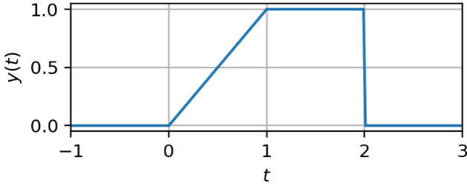
Problem 1. Consider the signal
$$y\left(t\right)=\frac{1}{5}x(-2t-3)$$
shown in the figure on the right.

(a) Does $y(t)$ have an odd portion, $y_{o}(t)$? If so, determine and carefully sketch and label $y_{o}(t)$. Otherwise, explain why no odd portion exists.

(b) Determine and carefully sketch and label the original signal $x(t)$.

Left blank

Problem 2. A discrete time system is described by
$$y\left[n\right]=\frac{1}{2}\sum_{k=-∞}^{∞}{x\left[k\right]\left(δ\left[n-k\right]+δ\left[n+k\right]\right)}$$
(a) Explain what this system does.

(b) Is this system BIBO stable? Justify your answer.

(c) Is the system linear? Justify your answer.

(d) Is the system memoryless? Justify your answer.

(e) Is the system causal? Justify your answer.

(f) Is the system time-invariant? Justify your answer.

Left blank

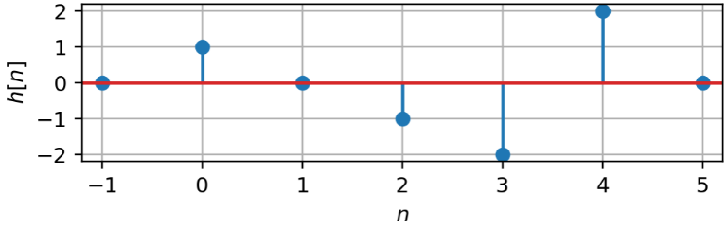
Problem 3. The figure on the right shows a cascade of three causal LTI systems. The impulse response $h_{1}\left[n\right]$ is
$h_{1}\left[n\right]=u\left[n\right]-2u\left[n-1\right]+u[n-2]$
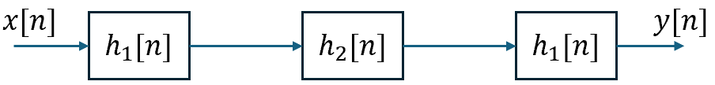
and the overall impulse response $h[n]$ is shown in the stem plot on the right.

(a) Find the impulse response $h_{2}[n]$.

$h_{2}[n]$=

(b) Find, sketch and label the response of the overall system to the input
$$x\left[n\right]=δ\left[n\right]+δ[n-1]$$

Left blank

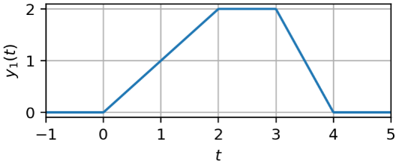
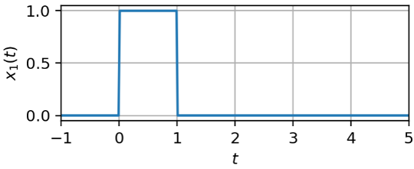
Problem 4. The input $x_{1}(t)$ and corresponding output $y_{1}(t)$ of a causal CT LTI system are shown below.

(a) Determine the unit step response $s(t)$ and the unit impulse response $h(t)$ of the CT LTI system. Show all your computations and/or reasonings.

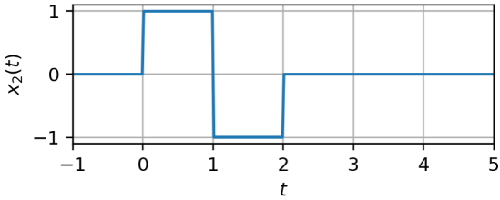
(b) If an input $x_{2}(t)$, as shown on the right, is applied to the above CT LTI system, what is the corresponding output $y_{2}(t)$? Carefully plot and label $y_{2}(t)$.

Left blank

