$$x\left(t\right) ⇔ X\left(s\right)=\int_{-∞}^{∞}{x\left(t\right)e^{-st}dt}$$

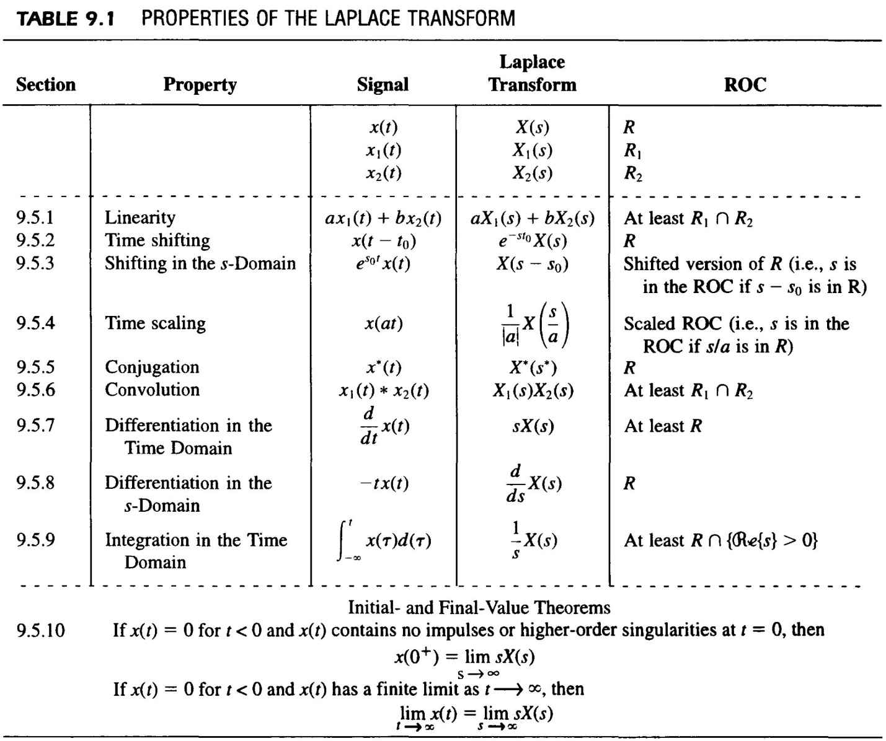

Convolution:
$$x_{1}\left(t\right)*x_{2}\left(t\right)=\int_{-∞}^{∞}{x_{1}\left(τ\right)x_{2}\left(t-τ\right)dτ} ⇔ X_{1}\left(s\right)X_{2}(s)$$

