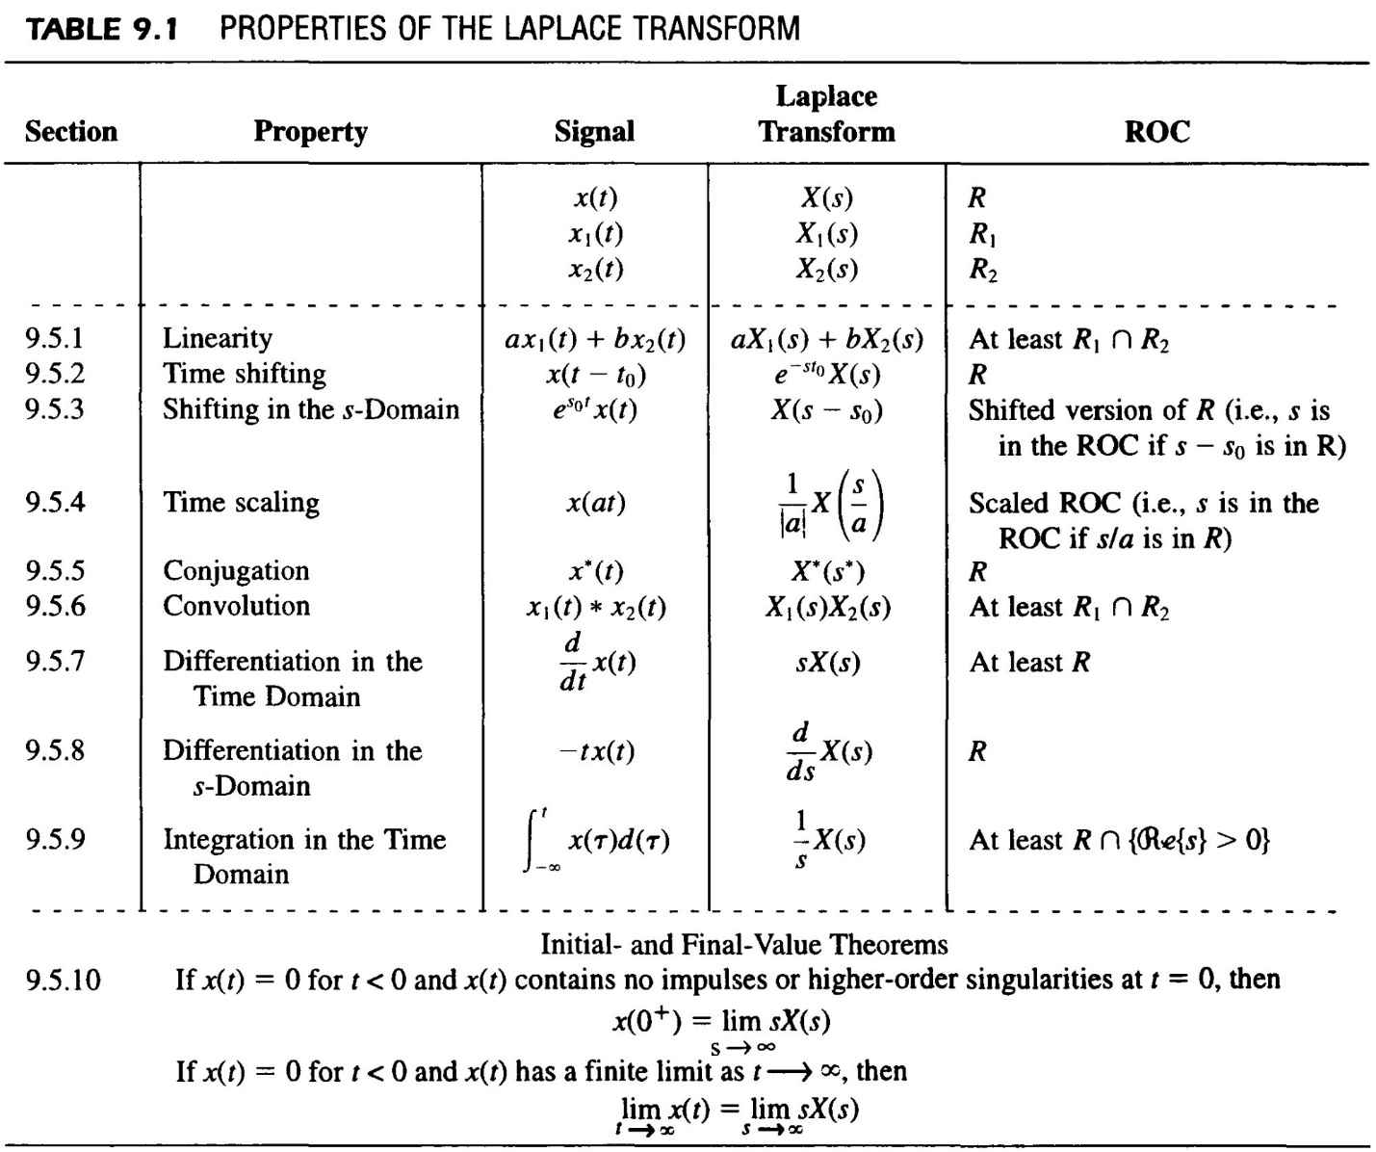

Convolution:
$$x_{1}\left(t\right)*x_{2}\left(t\right)=\int_{-∞}^{∞}{x_{1}\left(τ\right)x_{2}\left(t-τ\right)dτ} ⇔ X_{1}\left(s\right)X_{2}(s)$$

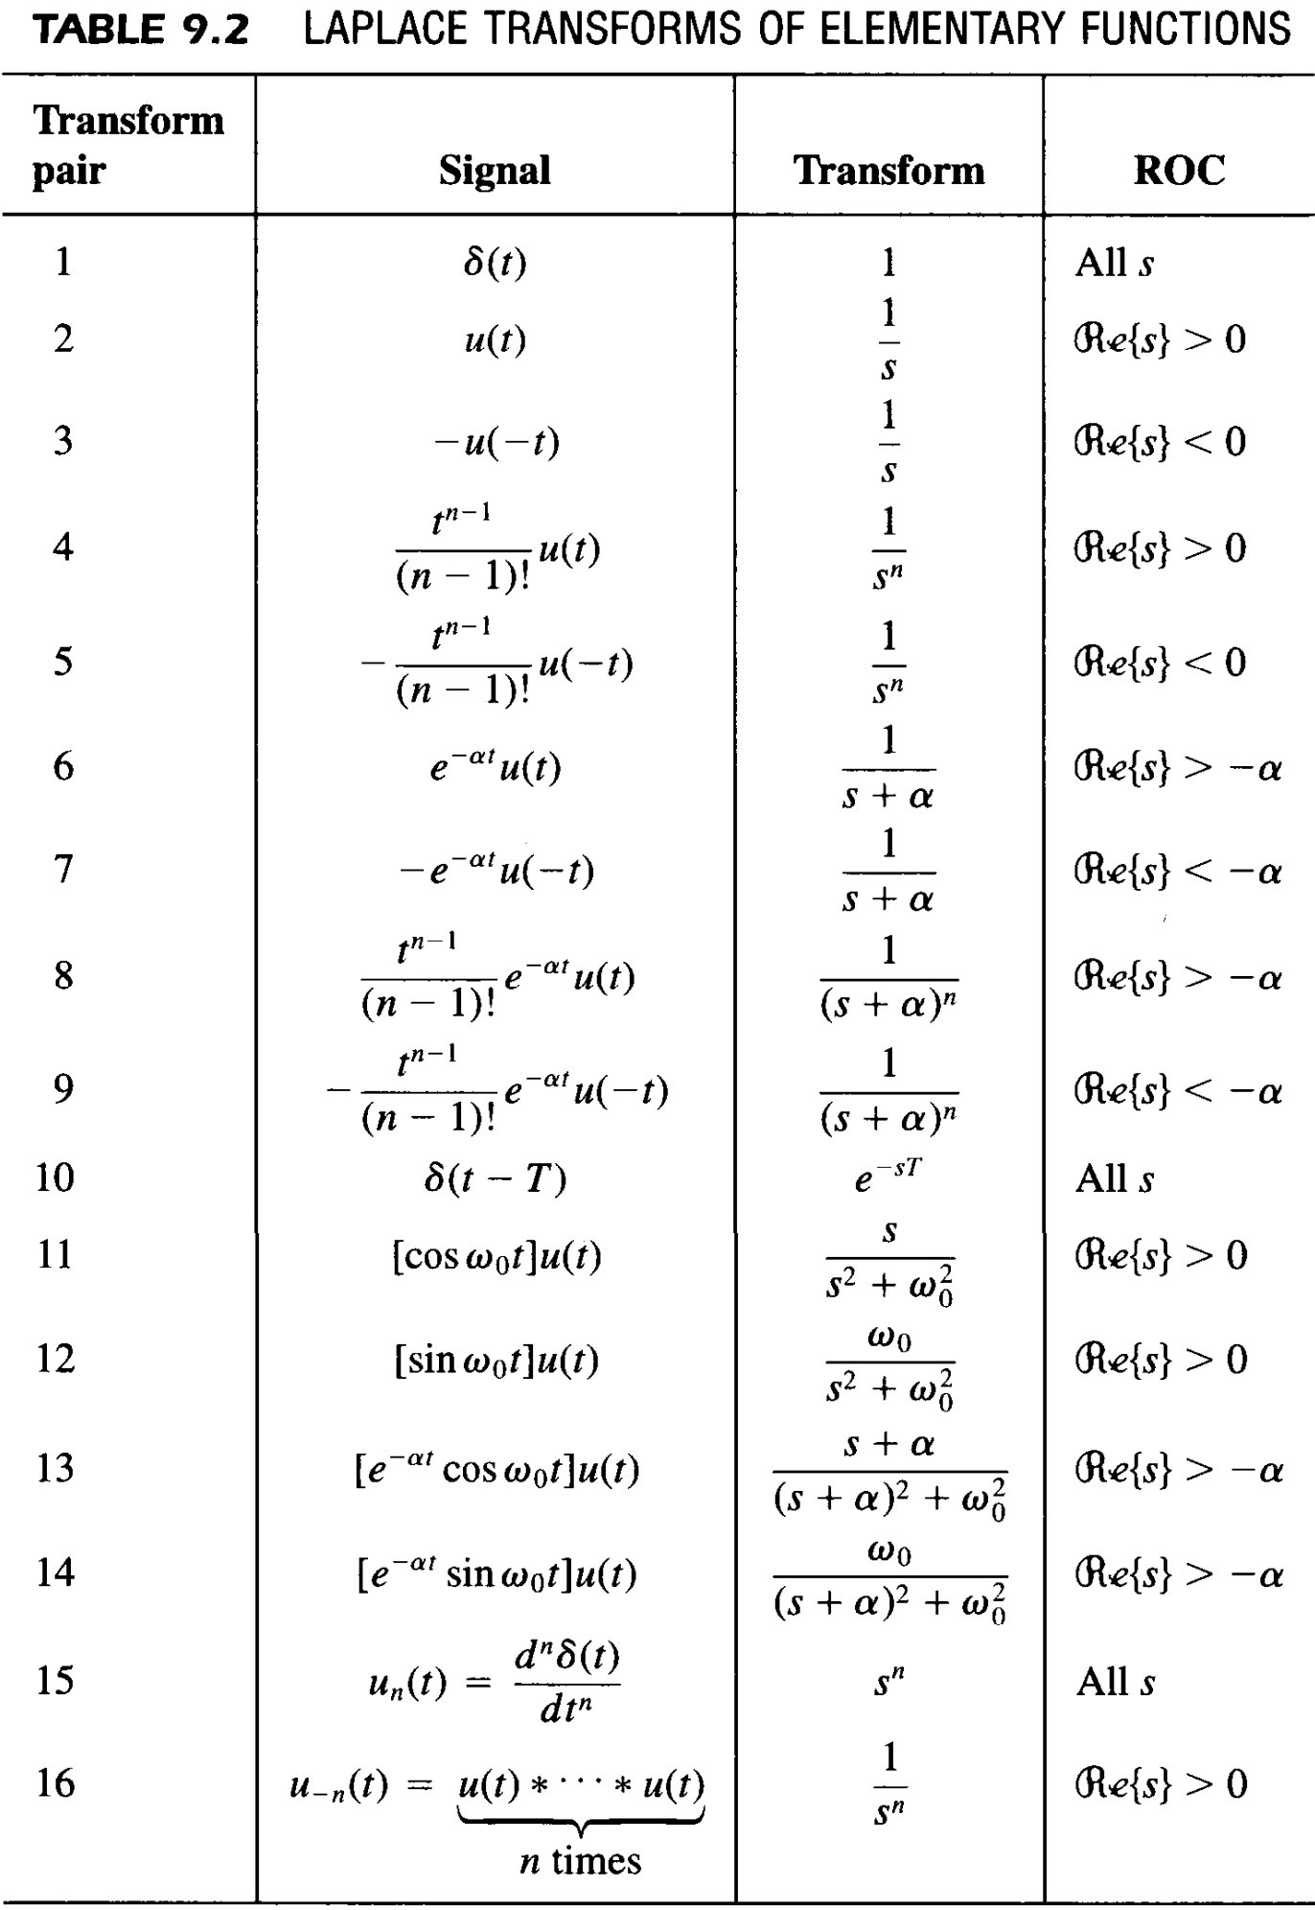
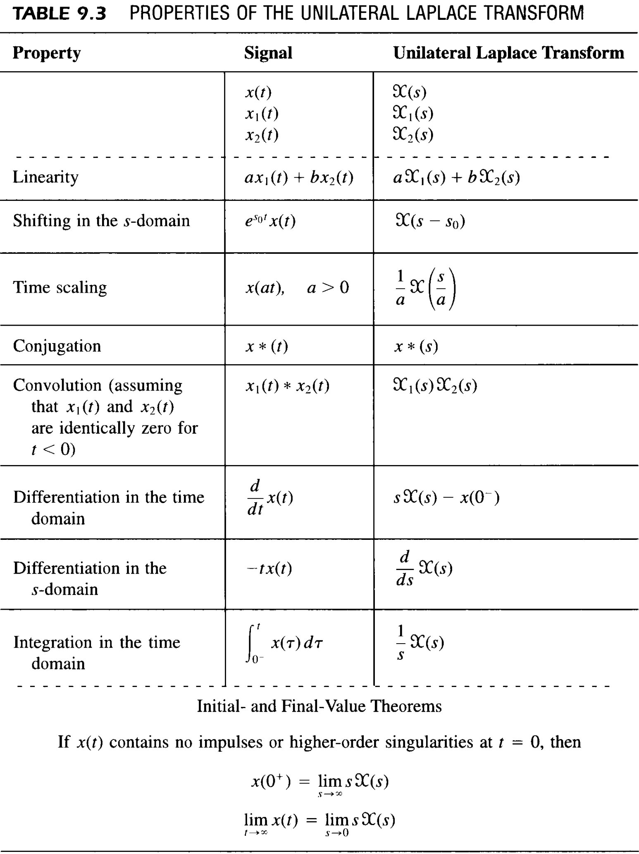
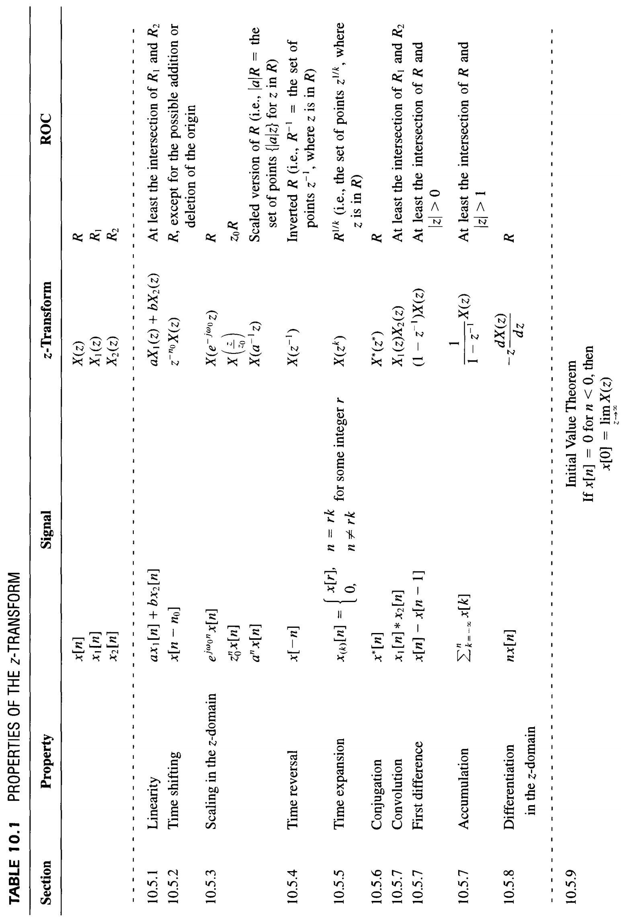
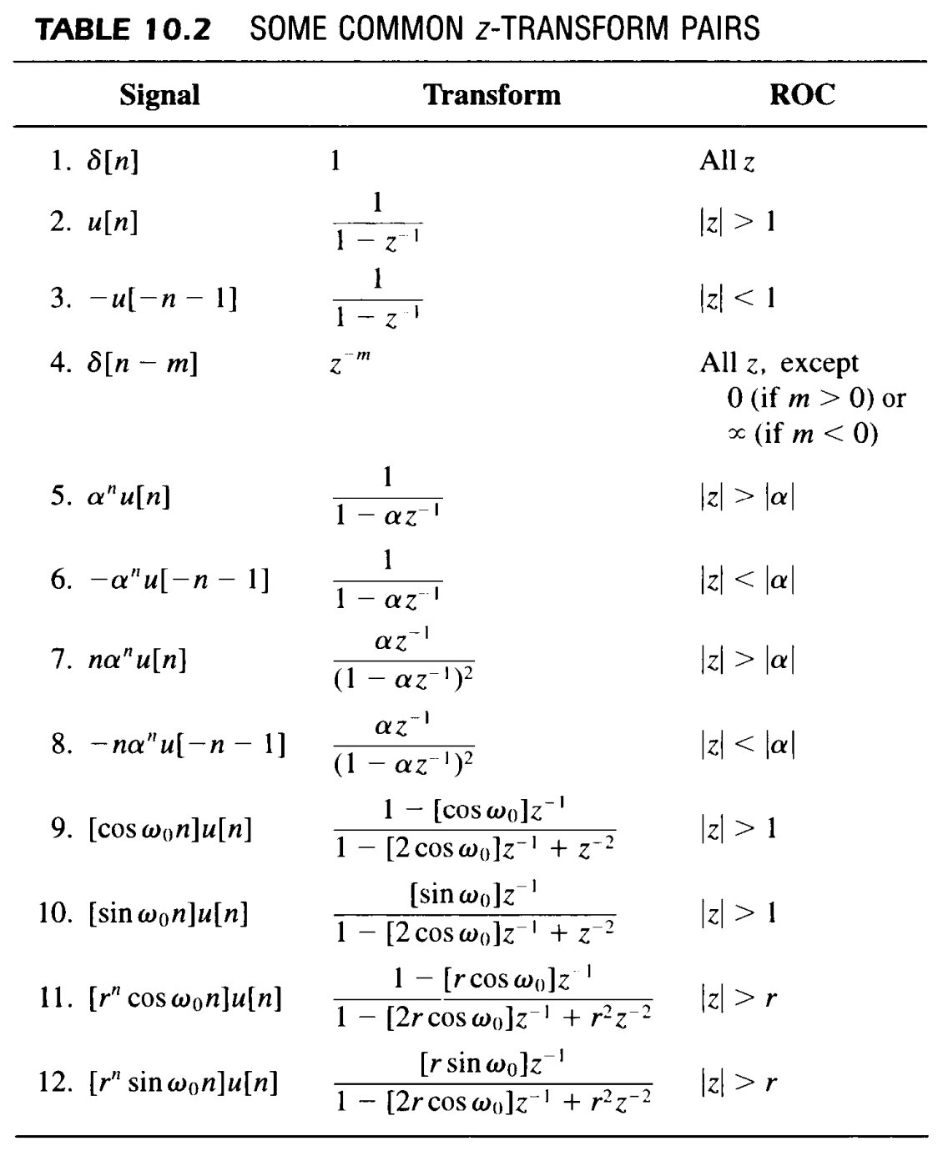

Convolution:
$$x_{1}\left[n\right]*x_{2}\left[n\right]=\sum_{k=-∞}^{∞}{x_{1}\left[k\right]x_{2}\left[n-k\right] ⇔ X_{1}\left(z\right)X_{2}(z)}$$
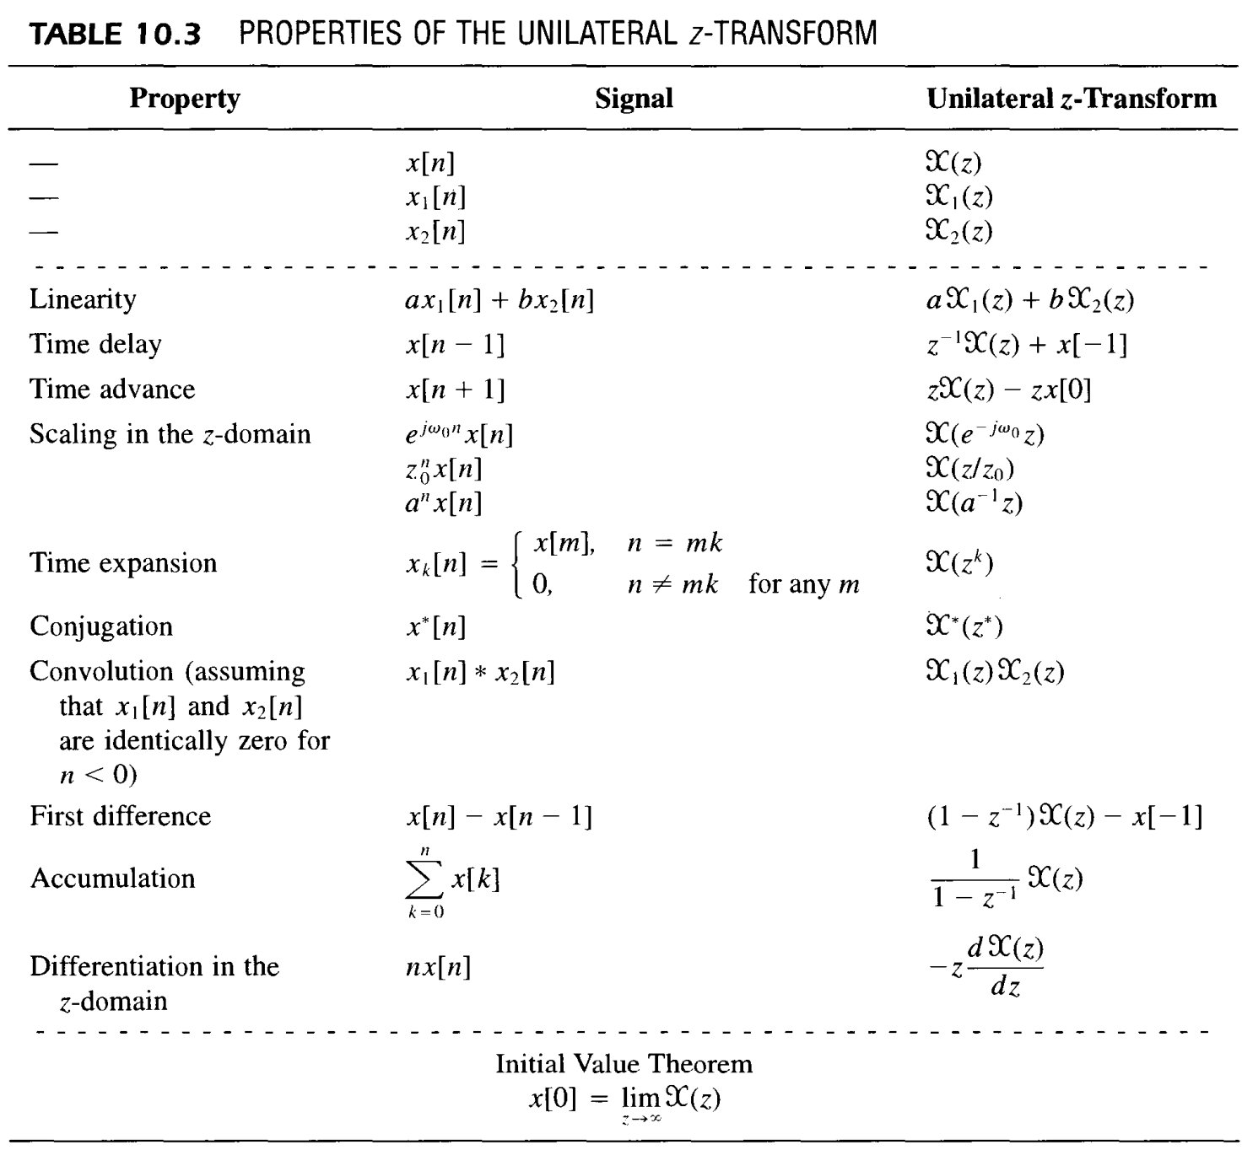

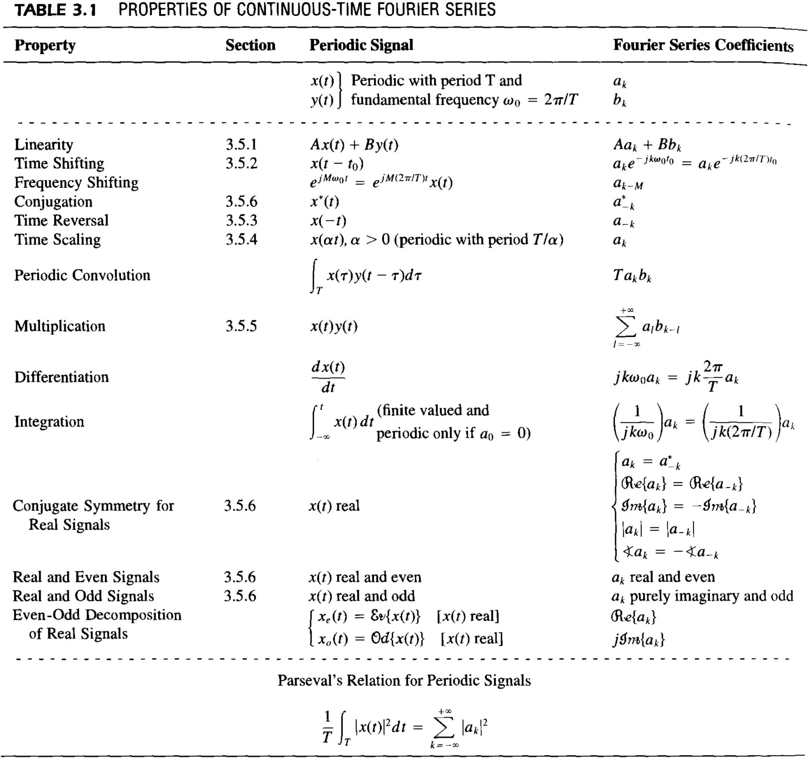

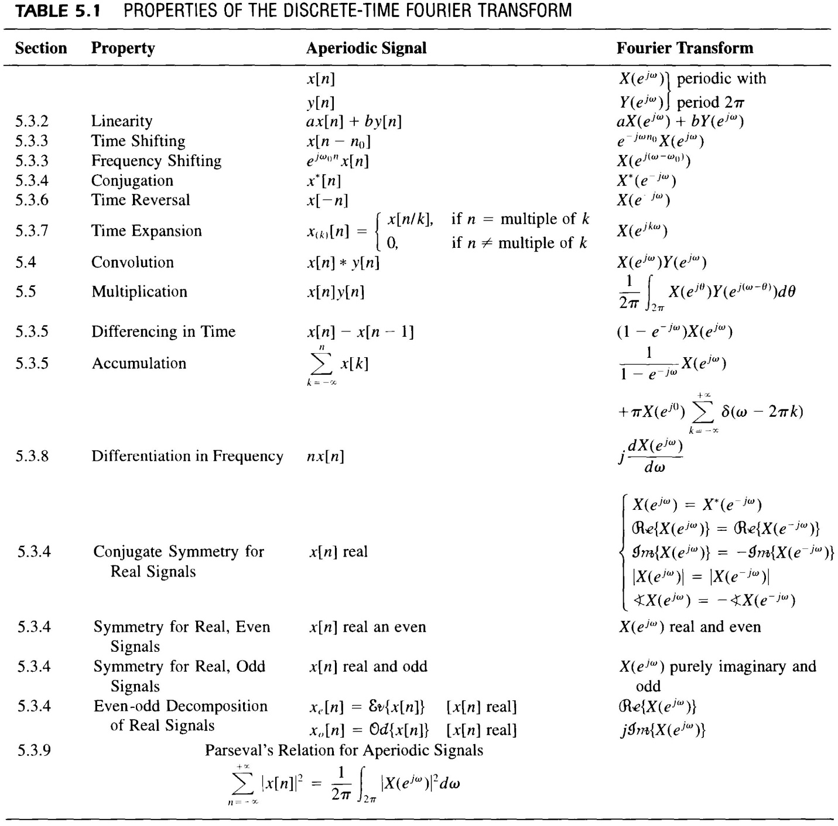

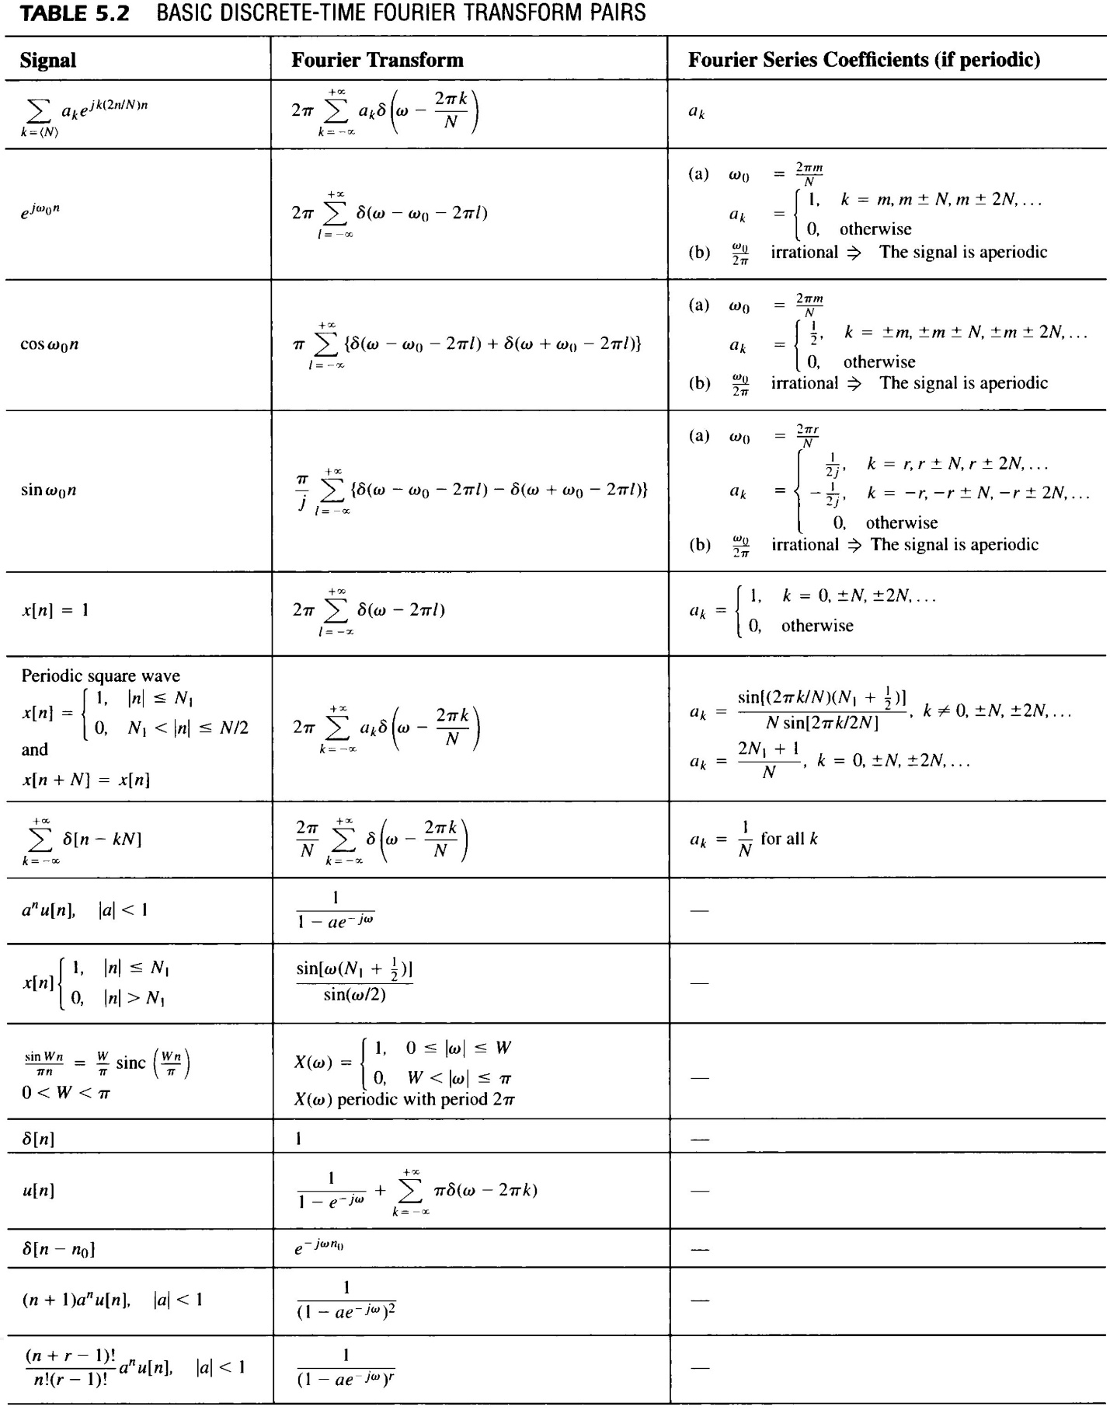

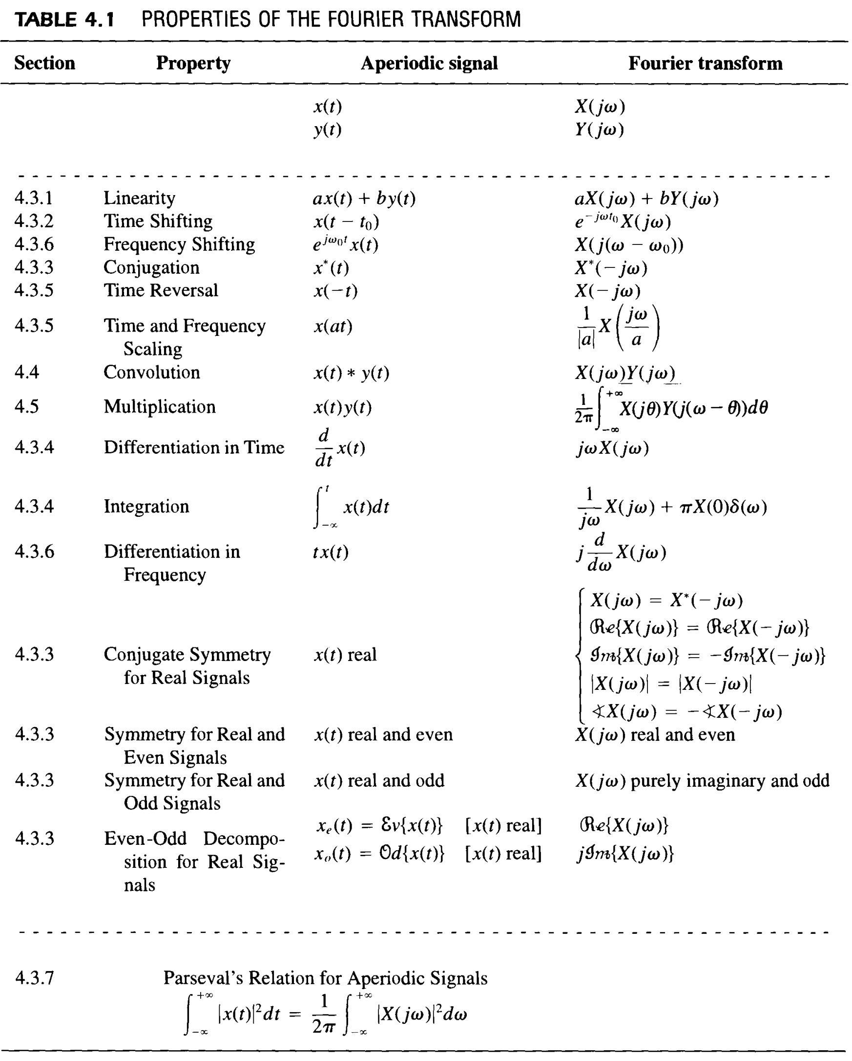

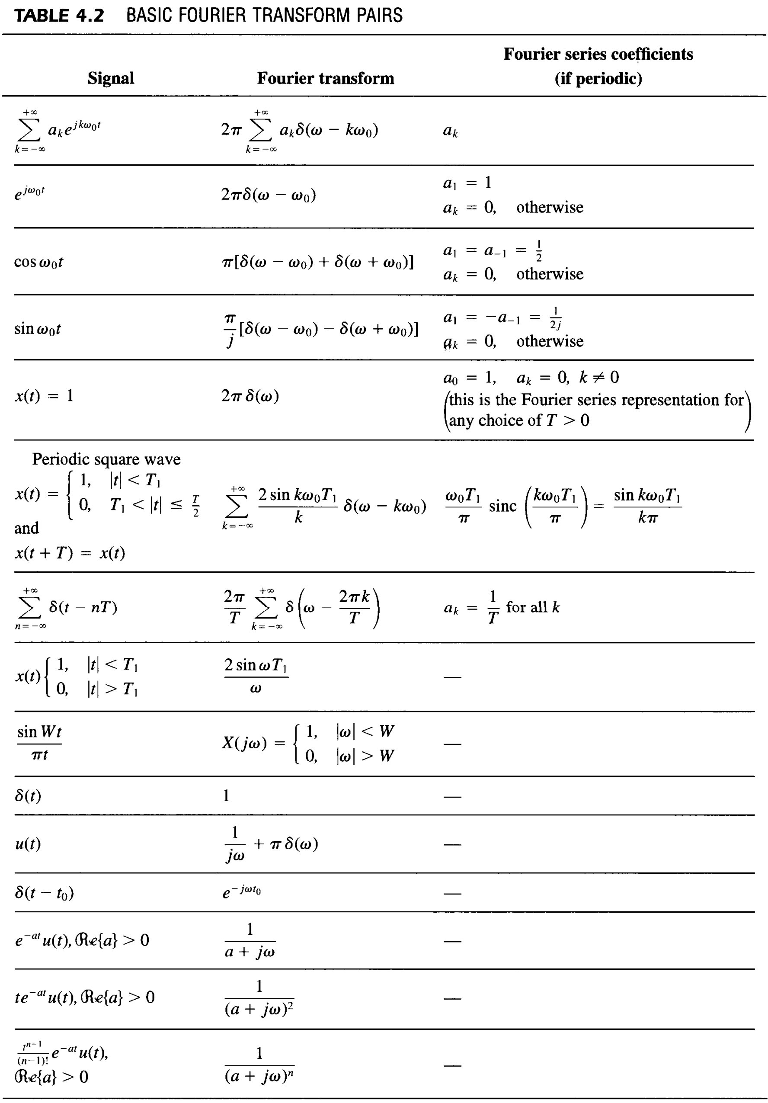
Discrete Fourier Transform (DFT)
