Fourier Series (FS)

$$x\left(t\right)=\sum_{k=-∞}^{∞}{a_{k}e^{j2πkt/T} ⇔ a_{k}=\frac{1}{T}\int_{0}^{T}{x\left(t\right)e^{-j2πkt/T}dt,} ω_{0}=\frac{2π}{T}}$$

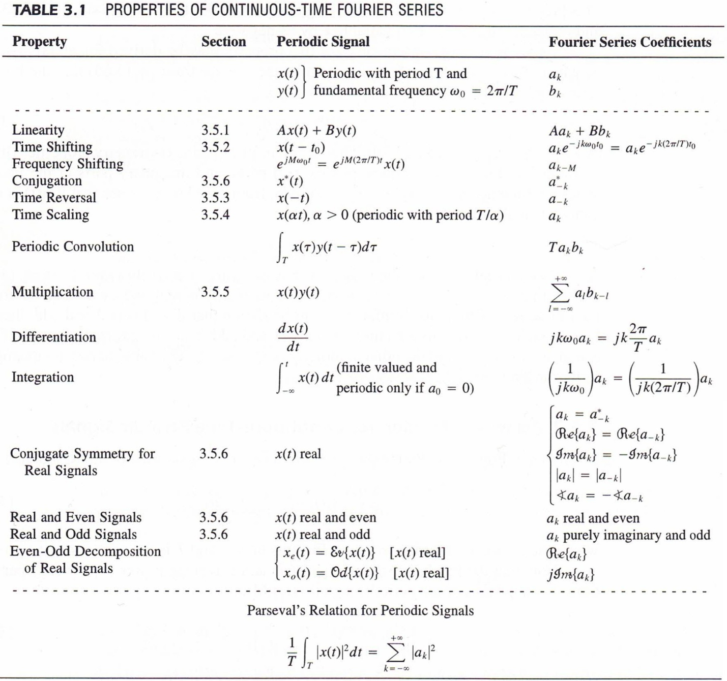

Fourier Transform (FT)
$$x\left(t\right)=\frac{1}{2π}\int_{-∞}^{∞}{X\left(jω\right)e^{jωt}dω ⇔ X\left(jω\right)=\int_{-∞}^{∞}{x\left(t\right)e^{-jωt}dt}}$$
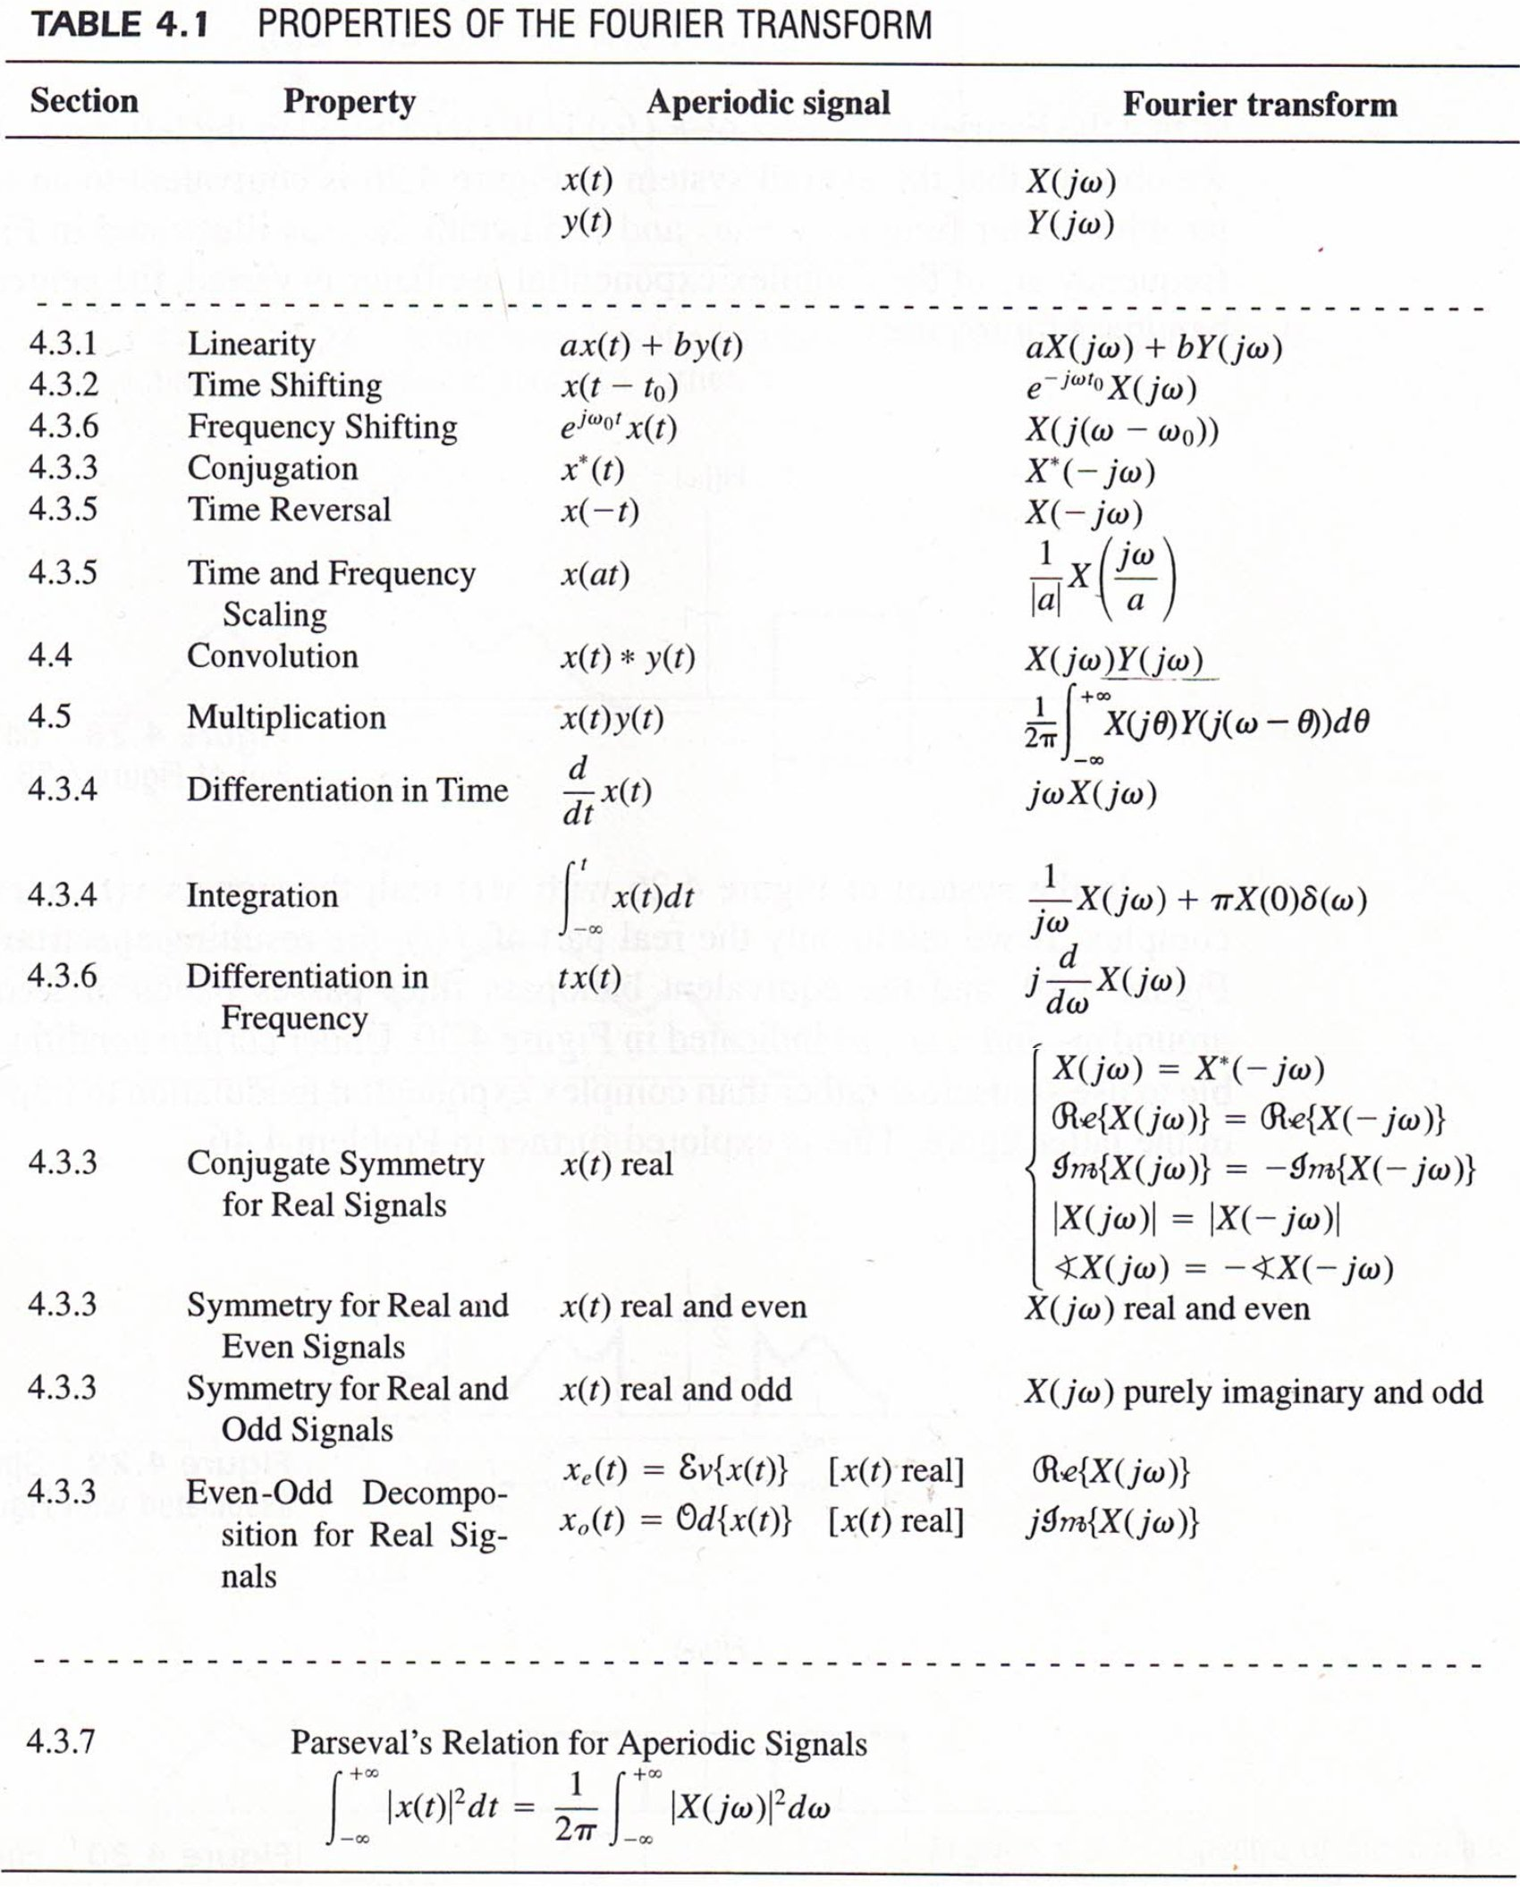
Convolution:
$$x_{1}\left(t\right)*x_{2}\left(t\right)=\int_{-∞}^{∞}{x_{1}\left(τ\right)x_{2}\left(t-τ\right)dτ} ⇔ X_{1}\left(jω\right)X_{2}(jω)$$
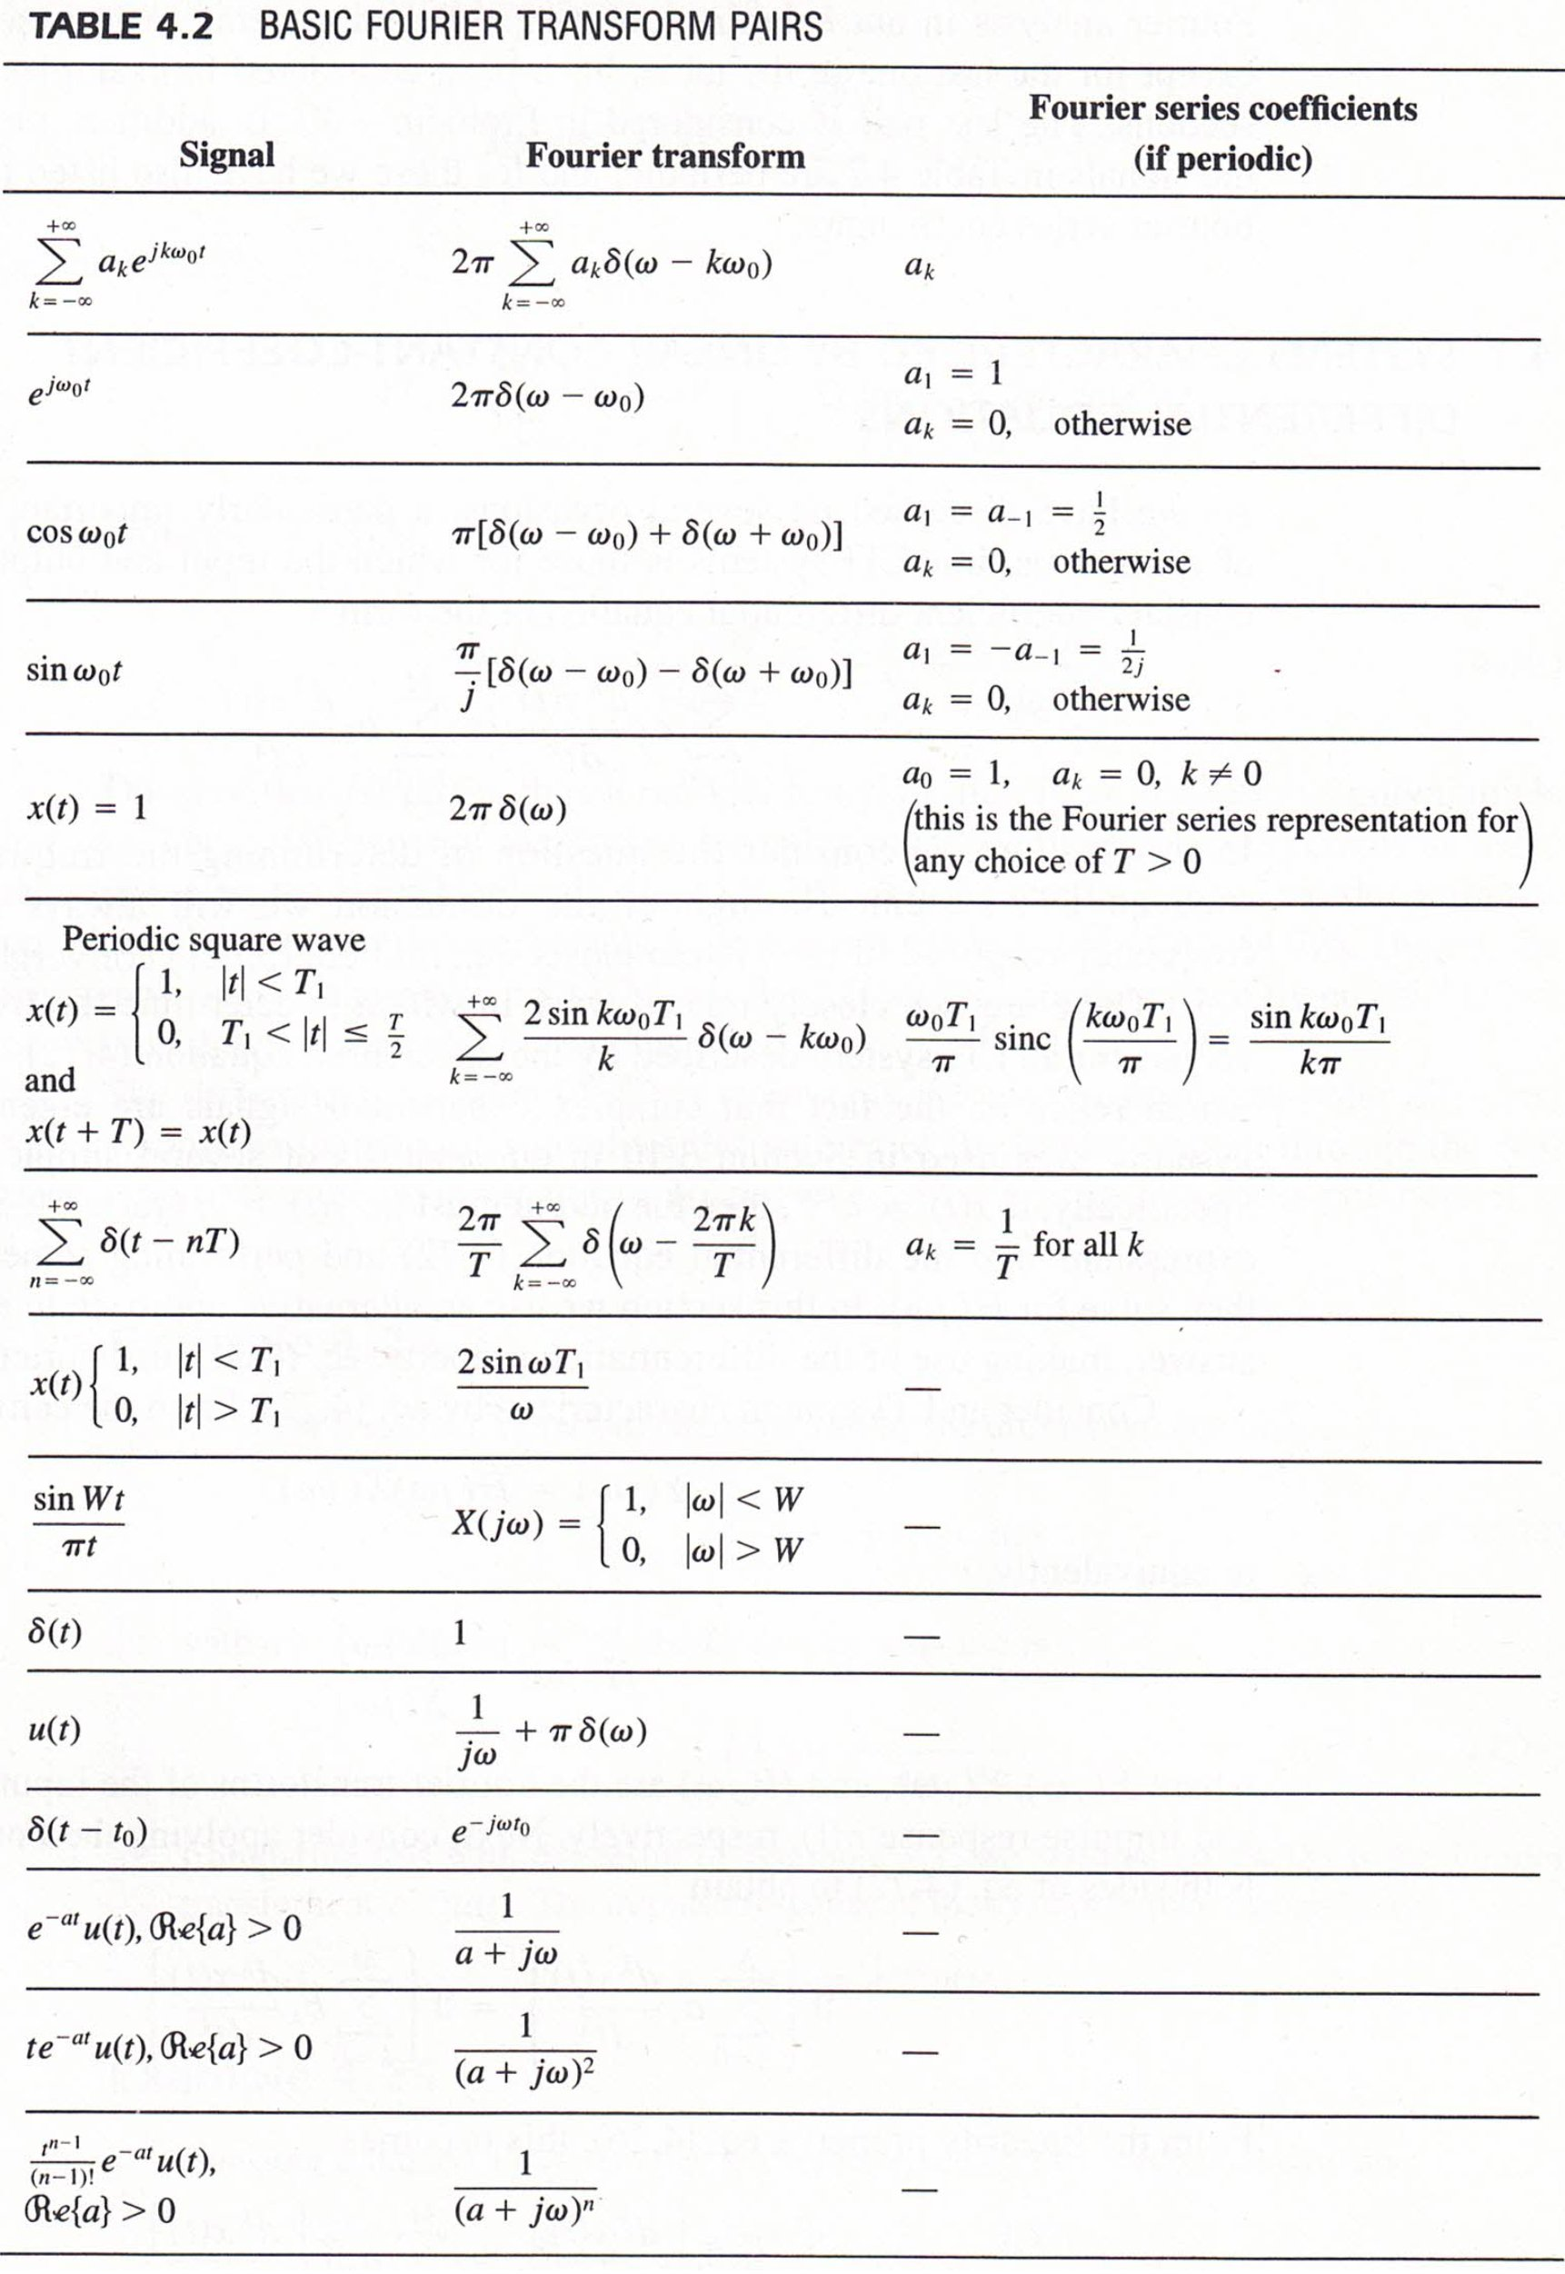
Discrete-Time Fourier Transform (DTFT)
$$x\left[n\right]=\frac{1}{2π}\int_{-π}^{π}{X\left(e^{jω}\right)e^{jωn}dω ⇔ X\left(e^{jω}\right)=\sum_{n=-∞}^{∞}{x\left[n\right]e^{-jωn}}}$$

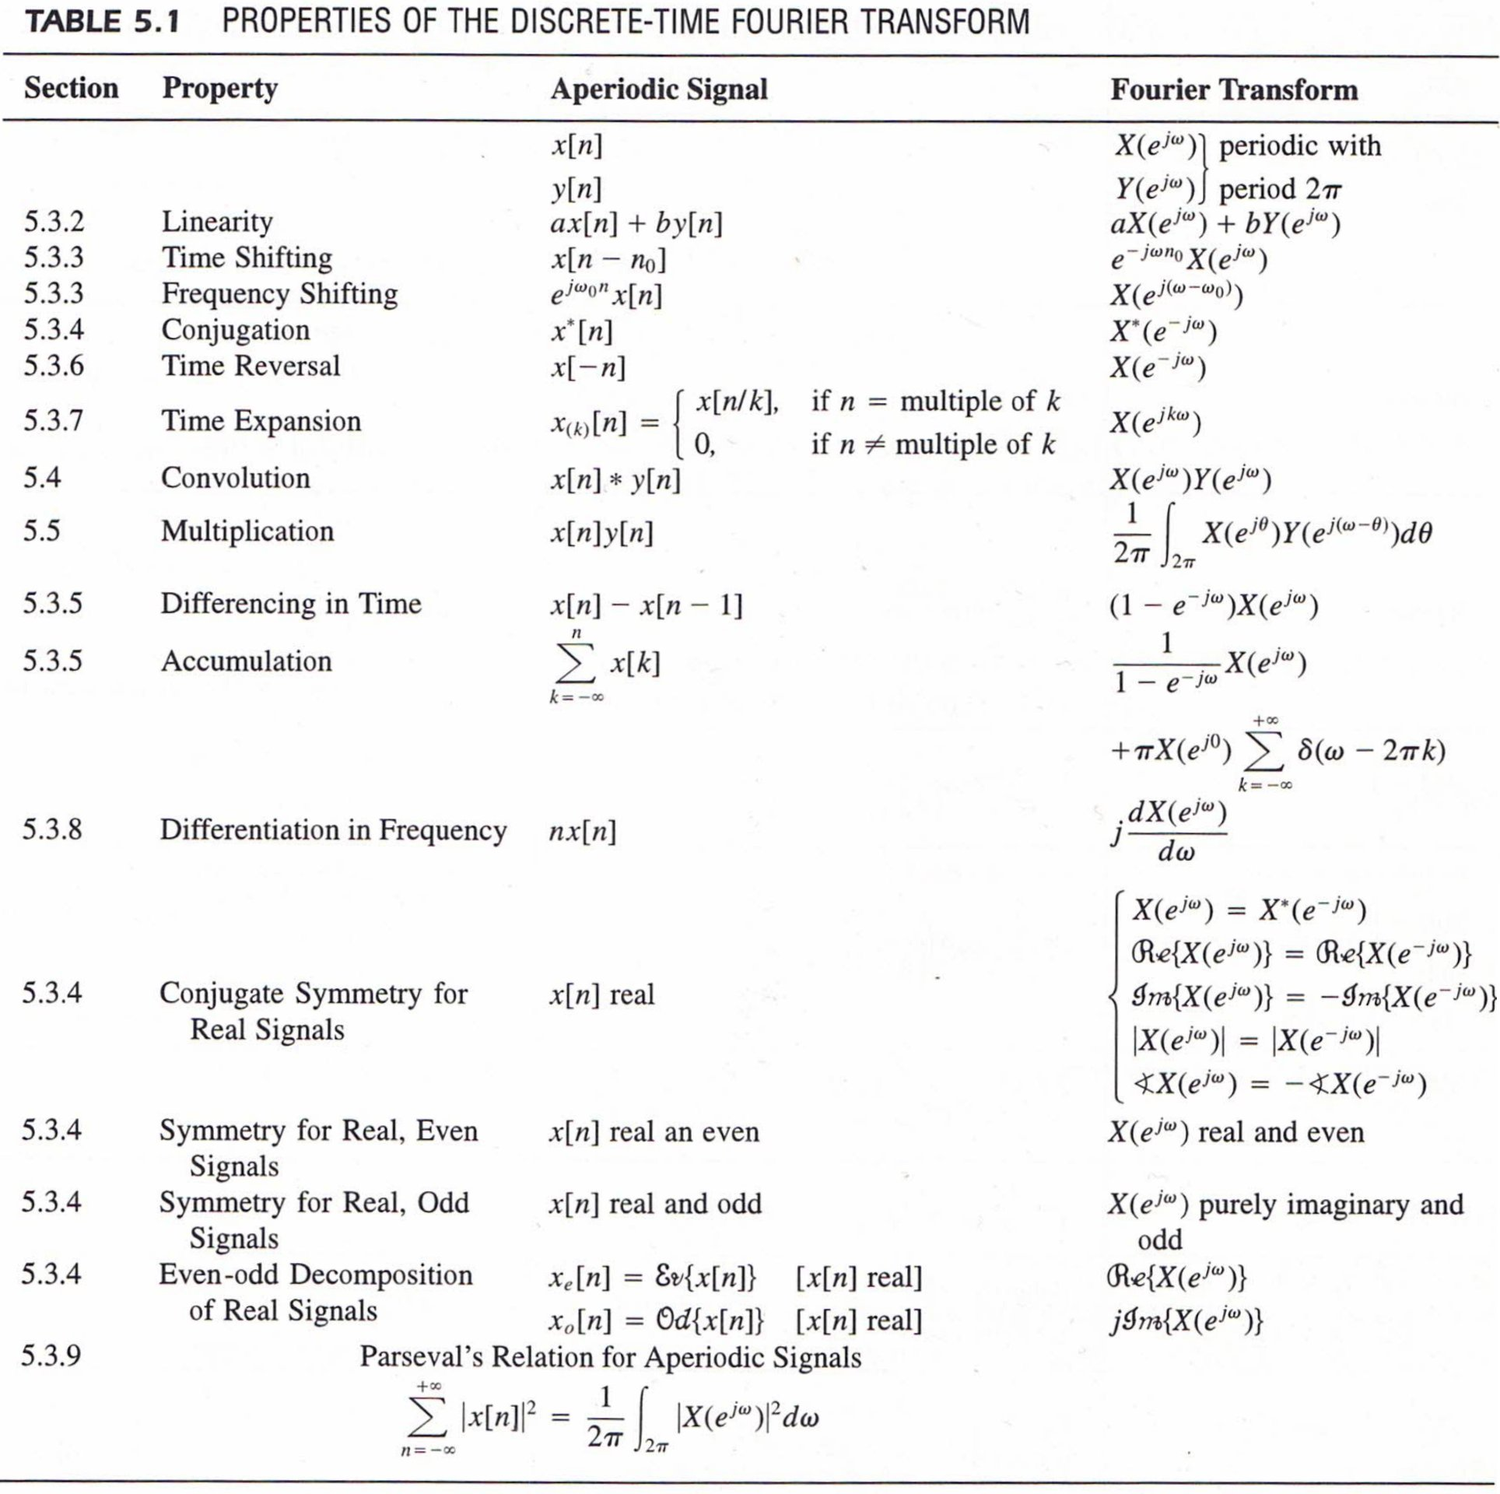
Convolution:
$$x_{1}\left[n\right]*x_{2}\left[n\right]=\sum_{k=-∞}^{∞}{x_{1}\left[k\right]x_{2}\left[n-k\right] ⇔ X_{1}\left(e^{jω}\right)X_{2}(e^{jω})}$$
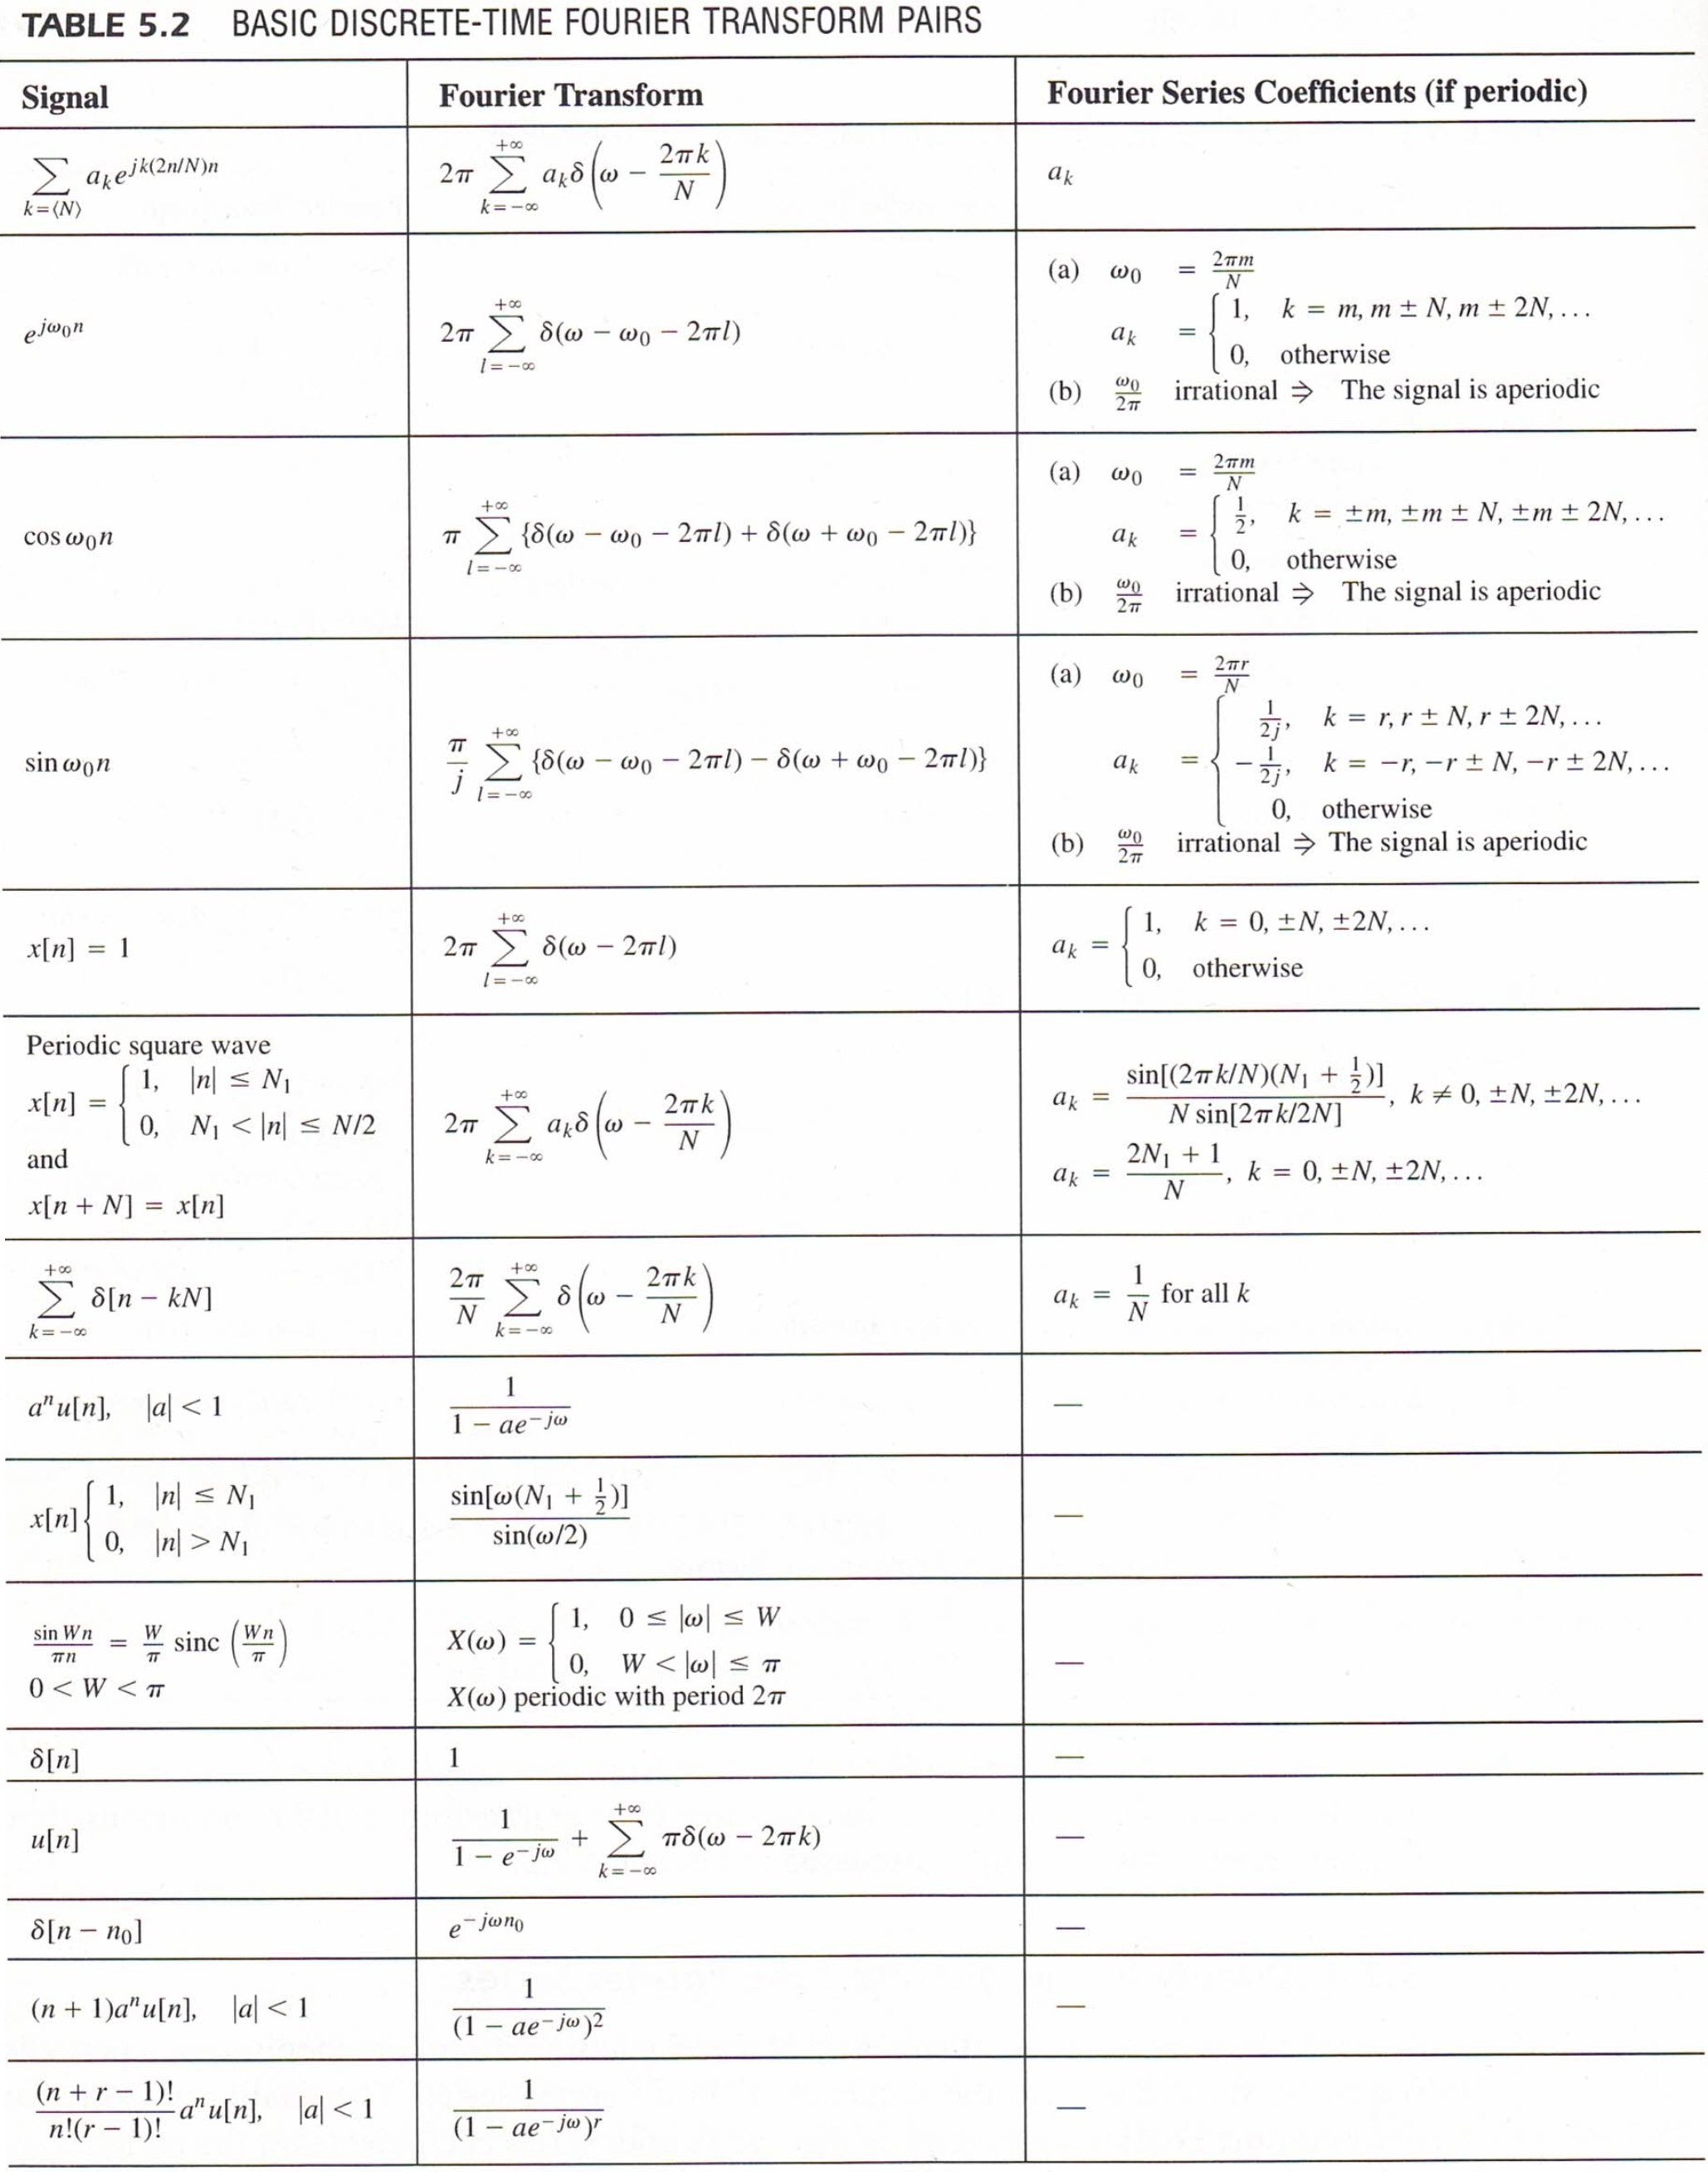

Discrete Fourier Transform (DFT)

$$x\left[n\right]=\frac{1}{N}\sum_{k=0}^{N-1}{X\left[k\right]e^{j2πkn/N} ⇔ X\left[k\right]=\sum_{n=0}^{N-1}{x\left[n\right]e^{-j2πkn/N}}}$$

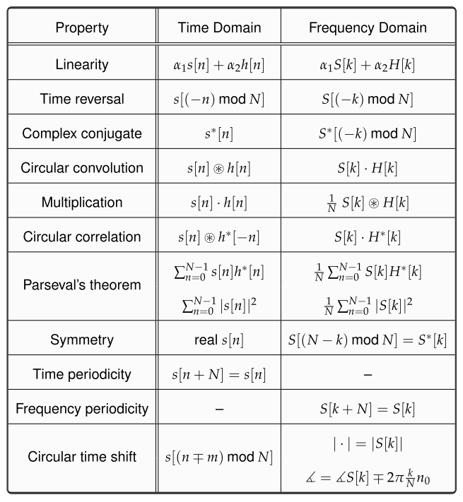

Laplace Transform

$$X\left(s\right)=\int_{-∞}^{∞}{x\left(t\right)e^{-st}dt}$$

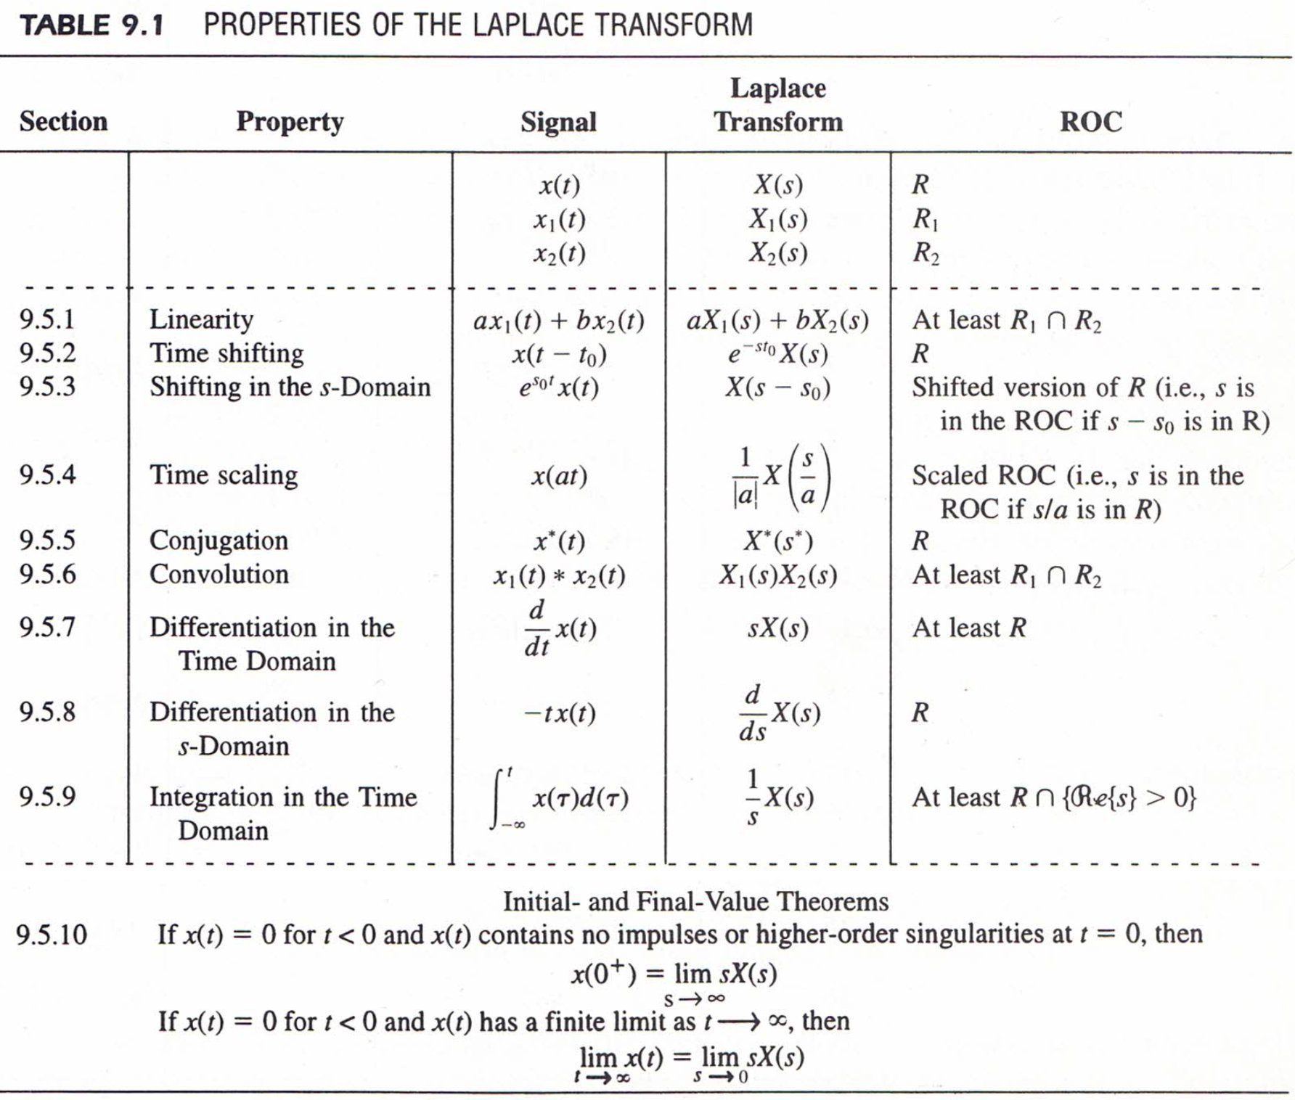

Convolution:
$$x_{1}\left(t\right)*x_{2}\left(t\right)=\int_{-∞}^{∞}{x_{1}\left(τ\right)x_{2}\left(t-τ\right)dτ} ⇔ X_{1}\left(s\right)X_{2}(s)$$

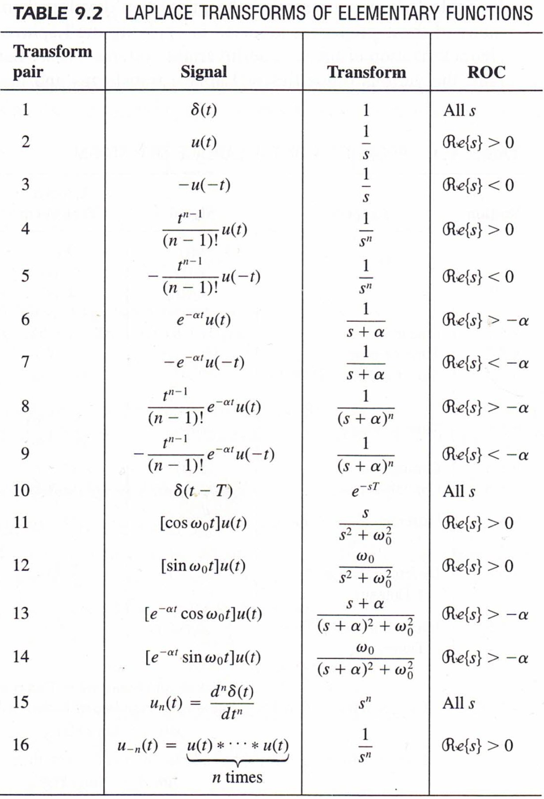

$$X\left(s\right)=\int_{0}^{∞}{x\left(t\right)e^{-st}dt}$$

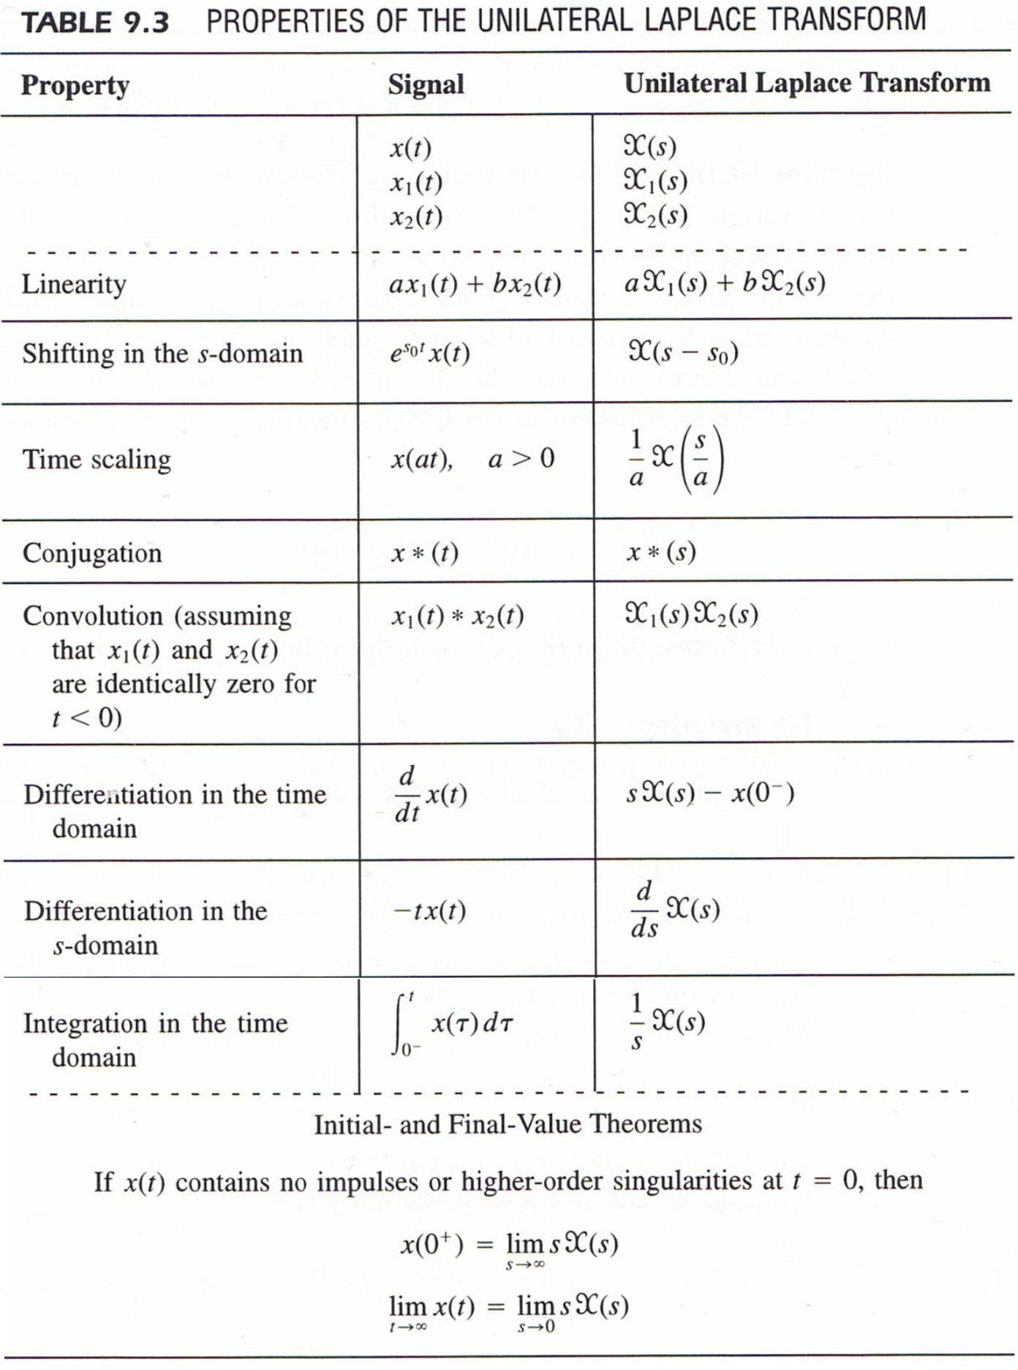

z-Transform
$$X\left(z\right)=\sum_{n=-∞}^{∞}{x\left[n\right]z^{-n}}$$
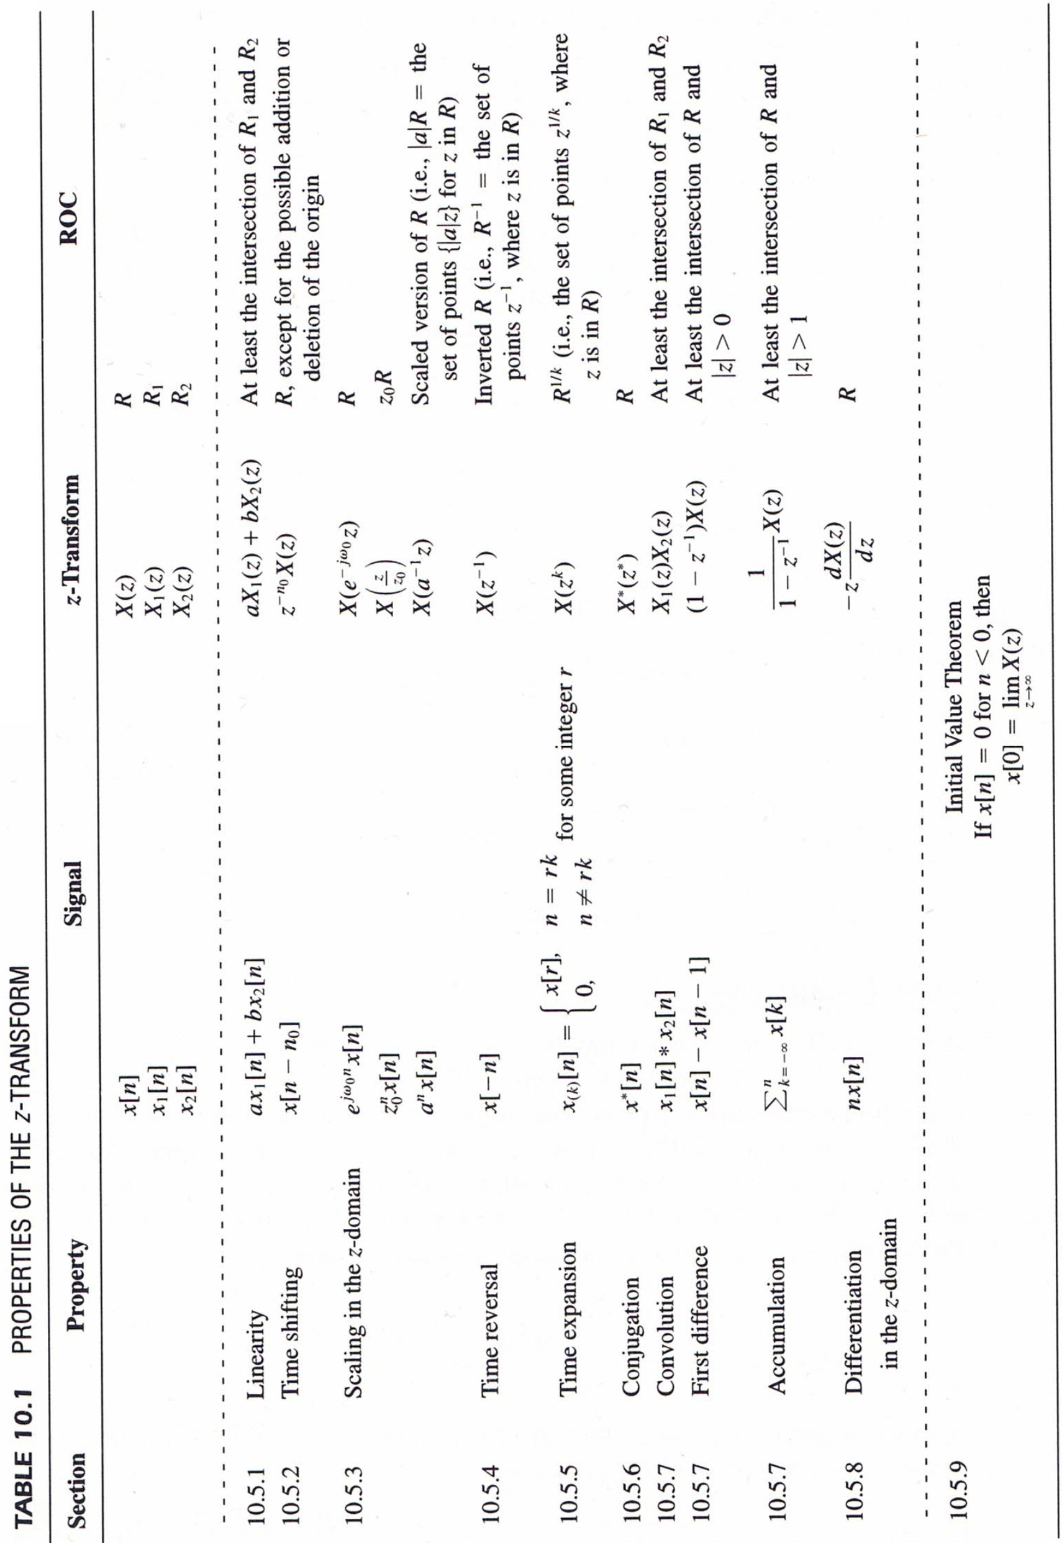
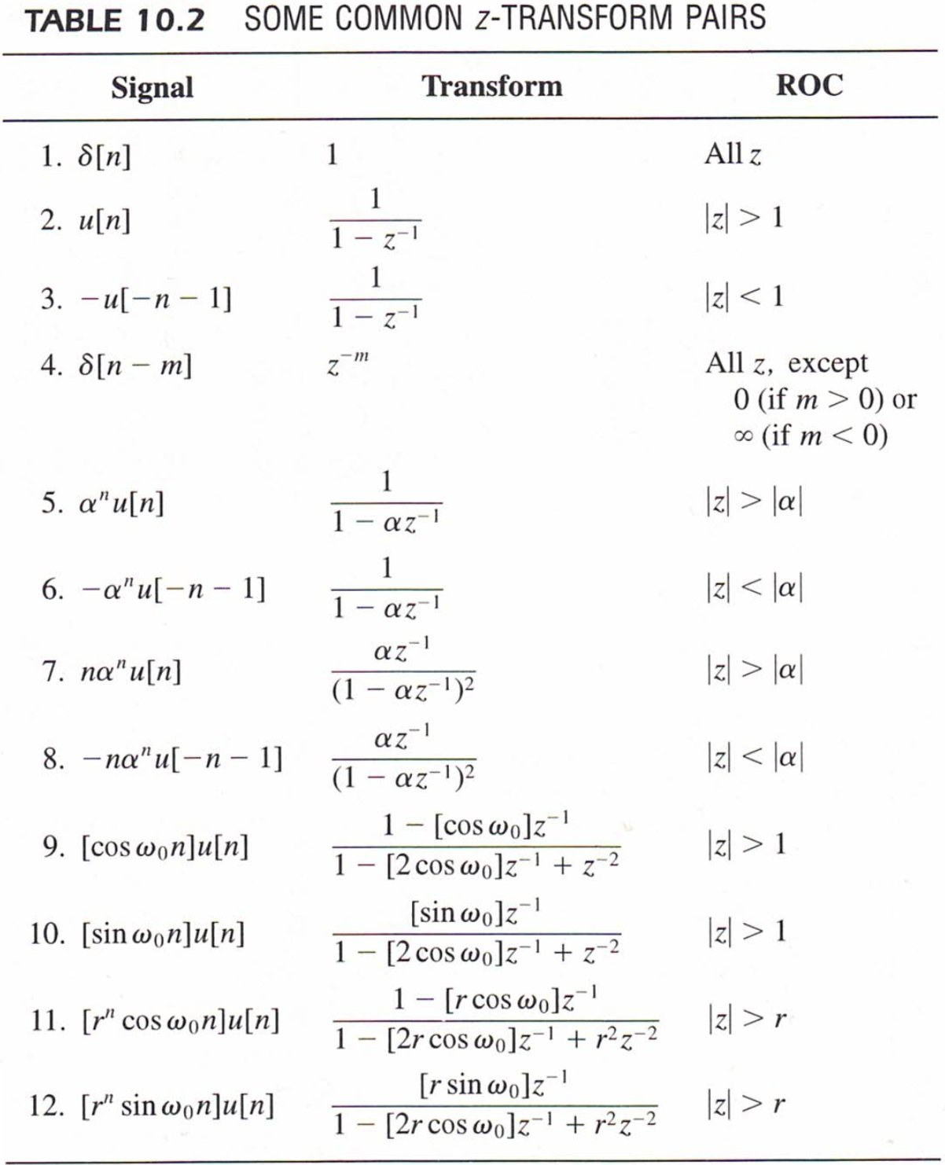

Convolution:
$$x_{1}\left[n\right]*x_{2}\left[n\right]=\sum_{k=-∞}^{∞}{x_{1}\left[k\right]x_{2}\left[n-k\right] ⇔ X_{1}\left(z\right)X_{2}(z)}$$

$$X\left(z\right)=\sum_{n=0}^{∞}{x\left[n\right]z^{-n}}$$

