ECEN 4/5632 Thy/Appl of Digital Filtering, Fall 2026
Digital Signal Processing (DSP) has its theoretical origins back in the late 1960s. With the advent of fast digital hardware and programming tools like Python and Matlab, DSP has become a cornerstone of modern engineering and technology. More recently, the synergy between Machine Learning (ML) and DSP has led to new possibilities ranging from speech and image processing to healthcare diagnostics and autonomous vehicles.
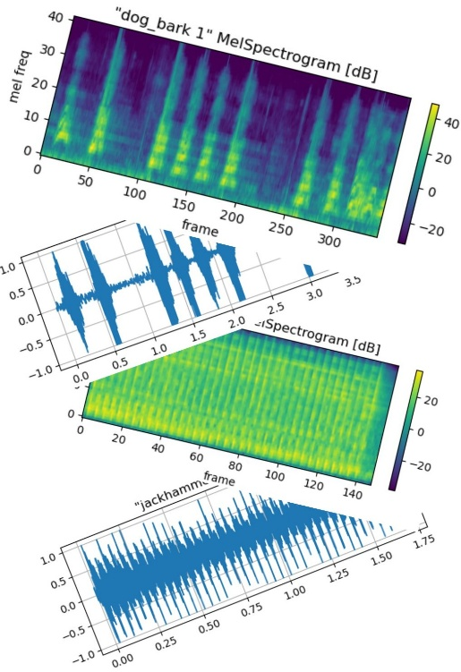
In ECEN 4/5632 we will explore the theory and applications of discrete-time (DT) signal processing in the context of audio signals with a view towards applications in ML. The main learning outcomes are:
- Learn how to model DT signals in the time, frequency, and z-domains.
- Learn the properties, structures and design of filters including multi-rate filter banks.
- Learn how to represent and analyze DT random signals (e.g., speech).
Topics covered:
- DT Signals and Systems, DTFT, z-Transform (review)
- Random Signals, Correlation Functions, and Power Spectra
- Transform Analysis of Linear Time Invariant (LTI) Systems
- Sampling of Continuous Time Signals, Multi-rate Filter Banks
- Representation of Audio Signals in PyTorch for Machine Learning
- DT System Structures and Filter Design Techniques
- The Discrete Fourier Transform (DFT) and Fourier Analysis of Signals
Textbook: Oppenheim and Schafer, Discrete-Time Signal Processing
Prerequisite: ECEN 3300 Linear Systems, Instructor: Prof. Peter Mathys

