My_student_dsp_001_NB
My student_dsp.py notebook, first experimental version.
"""Fill the three required algorithms. common.py supplies fixtures and the receiver."""
import numpy as np
import matplotlib.pyplot as plt
from scipy import signal
from common import FS, read_wav, relerr
import IPython.display as ipd
rng = np.random.default_rng()
%matplotlib widget
fsz = (7,4)
fsz2 = (fsz[0], 1.5*fsz[1]/2)
Let Lx be length of x, L length of blocks (frames), H hop size, Lp length of padding Lx Lp x |---------------------|---|
L # of blocks: NB = 1 + ceil((Lx - L)/H)
blocks |-------| padding of x: Lp = (NB - 1)*H + L - Lx H |-------| H |-------| H |-------|
def analysis(x, L=1024, hop=None, window='hann', nfft=None):
# TODO: periodic window, padded frames, local-index two-sided FFT, metadata.
"""
Break up x into M frames of length L using hop size `hop`
(padding with zeros as necessary)
Multiply each x frame by window w of length L
Then take FFT of length nfft (default nfft=L) of windowed frames
Return (M x L) array of STFTs and meta data: L, hop, nfft, window, w, Lx, pad_front,
pad_back, M, complex, fs
"""
x = np.asarray(x) # make sure x is an array
cplx = np.iscomplexobj(x) # check if x is complex-valued
L = x.size if L>x.size else int(L)
hop = L//4 if hop is None else int(hop) # hop length
nfft = L if nfft is None or nfft<L else int(nfft) # FFT blocksize nfft
#pad_f = L # front padding
pad_f = 16 # front padding # no front padding looks better in spectrograms
# but some padding is needed for NOLA
xp = np.hstack((np.zeros(pad_f, x.dtype), x))
#xp = np.hstack((np.zeros(pad_f, x.dtype), x, np.zeros(pad_f, x.dtype)))
M = int(1 + np.ceil((xp.size-L)/hop)) # number of frames
pad_b = int((M-1)*hop + L - xp.size) # length of back padding
xp = np.hstack((xp, np.zeros(pad_b, x.dtype)))
w = signal.get_window(window, L, fftbins=True) # periodic (vs symmetric) window for DFT/FFT
xA = np.zeros((M, L), x.dtype)
for i in range(M):
xA[i] = w*xp[i*hop: i*hop+L]
if cplx:
X = np.fft.fft(xA, n=nfft, axis=1)
else:
X = np.fft.rfft(xA, n=nfft, axis=1)
meta = dict(L=L, hop=hop, N=nfft, window=window, w=w, Lx=x.size, pad_front=pad_f,
pad_back=pad_b, M=M, complex=cplx, fs=FS)
return X, meta
x = np.arange(10)
X, meta = analysis(x, L=4, hop=2)
print(X)
print(meta)
[[ 0.+0.j 0.+0.j 0.+0.j]
[ 0.+0.j 0.+0.j 0.+0.j]
[ 0.+0.j 0.+0.j 0.+0.j]
[ 0.+0.j 0.+0.j 0.+0.j]
[ 0.+0.j 0.+0.j 0.+0.j]
[ 0.+0.j 0.+0.j 0.+0.j]
[ 0.+0.j 0.+0.j 0.+0.j]
[ 0.+0.j 0.+0.j 0.+0.j]
[ 3.+0.j -2.+1.j 1.+0.j]
[ 7.+0.j -4.+1.j 1.+0.j]
[11.+0.j -6.+1.j 1.+0.j]
[15.+0.j -8.+1.j 1.+0.j]]
{'L': 4, 'hop': 2, 'N': 4, 'window': 'hann', 'w': array([0. , 0.5, 1. , 0.5]), 'Lx': 10, 'pad_front': 16, 'pad_back': 0, 'M': 12, 'complex': False, 'fs': 16000}
def frame_times(meta):
"""
Frame center times in seconds, with the leading padding offset removed.
"""
return (meta["hop"]*np.arange(meta["M"]) + meta["L"]/2 - meta["pad_front"])/meta["fs"]
def frame_freqs(meta):
"""
FFT bin frequencies in Hz: One-sided for real x, two-sided for complex x.
"""
T = 1/meta["fs"] # sampling time interval
if meta["complex"]:
ff = np.fft.fftfreq(meta["N"], T)
else:
ff = np.fft.rfftfreq(meta["N"], T)
#ff = np.fft.fftfreq(meta["N"], T)
return ff
frame_freqs(meta)
array([ 0., 4000., 8000.])
# Convert STFTs to dB
def spec_db(X, floor=-80):
m = np.abs(X); m = m / m.max()
return np.maximum(20 * np.log10(m + 1e-12), floor)
# Read test signal
f_name = 'signals/tf_probe.wav'
_, x = read_wav(f_name)
ipd.Audio(x, rate=FS)
<IPython.lib.display.Audio object>
def show(ax, X, meta, title, fmax=4000):
f = frame_freqs(meta); t = frame_times(meta)
im = ax.pcolormesh(t, f, spec_db(X).T, vmin=-80, vmax=0, shading="auto")
#im = ax.pcolormesh(t, f, spec_db(X).T, cmap='inferno', vmin=-80, vmax=0, shading="auto")
ax.set_ylim(0, fmax); ax.set_xlabel("Time (s)"); ax.set_ylabel("Frequency (Hz)")
ax.set_title(f"{title}\n fs={meta['fs']} Hz, {meta['window']}, L={meta['L']}, H={meta['hop']}, N={meta['N']}", fontsize=8)
return im
def analysis_AI(x, L=1024, hop=256, window='hann', nfft=None):
nfft = L if nfft is None else nfft
if not (0 < hop <= L <= nfft):
raise ValueError('Require 0 < hop <= L <= nfft')
w = signal.get_window(window, L, fftbins=True)
# Padding before sample zero covers window endpoints; crop precisely at synthesis.
left = L
xp = np.pad(x, (left, L))
count = 1 + int(np.ceil((len(xp)-L)/hop))
needed = (count-1)*hop + L
pad_b = needed-len(xp)
xp = np.pad(xp, (0, needed-len(xp)))
frames = np.array([xp[m*hop:m*hop+L]*w for m in range(count)])
X = np.fft.fft(frames, n=nfft, axis=1)
#meta = dict(w=w, L=L, hop=hop, nfft=nfft, left=left, length=len(x),
# real_input=not np.iscomplexobj(x))
meta = dict(L=L, hop=hop, N=nfft, window=window, w=w, Lx=x.size, pad_front=L,
pad_back=pad_b, M=count, complex=np.iscomplexobj(x), fs=FS)
return X, meta
x_test = np.arange(10)
L_test = 4
left = L_test
xp_test = np.pad(x_test, (left, L_test))
print(xp_test)
[0 0 0 0 0 1 2 3 4 5 6 7 8 9 0 0 0 0]
# ------------ Part A1 -----------------------------------------------------------------------
# Spectrograms for part A1
L1, L2, L3, L4 = 256, 1024, 4096, 1024
N1, N2, N3, N4 = L1, L2, L3, 4096
fig, axs = plt.subplots(2, 2, figsize=(9, 6), sharey=True, sharex=True)
fig.canvas.toolbar_position = 'top'
X, meta = analysis(x, L=L1, hop=L1//4, nfft=N1)
print(X.shape)
im = show(axs[0,0], X, meta, f"Relative dB, frame_time={1e3*L1/meta["fs"]} ms")
X, meta = analysis(x, L=L2, hop=L2//4, nfft=N2)
im = show(axs[0,1], X, meta, f"Relative dB, frame_time={1e3*L2/meta["fs"]} ms")
#X, meta = analysis_AI(x, L=L1, hop=L1//4, nfft=N1)
#im = show(axs[0,1], X[:,:L1//2+1], meta, "Relative dB")
X, meta = analysis(x, L=L3, hop=L3//4, nfft=N3)
im = show(axs[1,0], X, meta, f"Relative dB, frame_time={1e3*L3/meta["fs"]} ms")
X, meta = analysis(x, L=L4, hop=L4//4, nfft=N4)
im = show(axs[1,1], X, meta, f"Relative dB, frame_time={1e3*L4/meta["fs"]} ms")
#X, meta = analysis_AI(x, L=L3, hop=L3//4, nfft=N3)
#im = show(axs[1,1], X[:,:L3//2+1], meta, "Relative dB")
plt.tight_layout()
(998, 129)
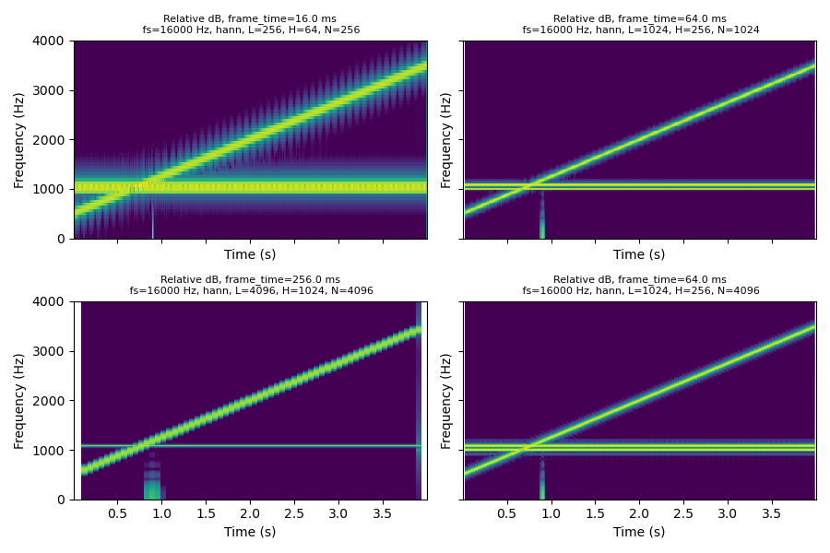
# Plot frequency resolution
L1, L2, L3, L4 = 256, 1024, 4096, 1024
N1, N2, N3, N4 = L1, L2, L3, 4096
fig, axs = plt.subplots(2, 2, figsize=(9, 6), sharey=True, sharex=True)
fig.canvas.toolbar_position = 'top'
X, meta = analysis(x, L=L1, hop=L1//4, nfft=N1)
f = frame_freqs(meta); t = frame_times(meta)
ixt = np.where(t<=3.5)[0]; ix = ixt[-1]
#print(t[ix]) # measurement time used
axs[0,0].plot(f, 20*np.log10(np.abs(X[ix])))
axs[0,0].set_title(f'L={L1}, nfft={N1}, tmeas={t[ix]:.1f} sec')
axs[0,0].set_ylabel('|X(f)| (dB)')
axs[0,0].grid(alpha=0.5)
axs[0,0].set_ylim([-80, 60])
axs[0,0].set_xlim([600, 1400])
X, meta = analysis(x, L=L2, hop=L2//4, nfft=N2)
f = frame_freqs(meta); t = frame_times(meta)
ixt = np.where(t<=3.5)[0]; ix = ixt[-1]
#print(t[ix]) # measurement time used
axs[0,1].plot(f, 20*np.log10(np.abs(X[ix])))
axs[0,1].set_title(f'L={L2}, nfft={N2}, tmeas={t[ix]:.1f} sec')
axs[0,1].grid(alpha=0.5)
X, meta = analysis(x, L=L3, hop=L3//4, nfft=N3)
f = frame_freqs(meta); t = frame_times(meta)
ixt = np.where(t<=3.5)[0]; ix = ixt[-1]
#print(t[ix]) # measurement time used
axs[1,0].plot(f, 20*np.log10(np.abs(X[ix])))
axs[1,0].set_title(f'L={L3}, nfft={N3}, tmeas={t[ix]:.1f} sec')
axs[1,0].set_ylabel('|X(f)| (dB)')
axs[1,0].set_xlabel('Frequency (Hz)')
axs[1,0].grid(alpha=0.5)
X, meta = analysis(x, L=L4, hop=L4//4, nfft=N4)
f = frame_freqs(meta); t = frame_times(meta)
ixt = np.where(t<=3.5)[0]; ix = ixt[-1]
#print(t[ix]) # measurement time used
axs[1,1].plot(f, 20*np.log10(np.abs(X[ix])))
axs[1,1].set_title(f'L={L4}, nfft={N4}, tmeas={t[ix]:.1f} sec')
axs[1,1].set_xlabel('Frequency (Hz)')
axs[1,1].grid(alpha=0.5)
plt.show()
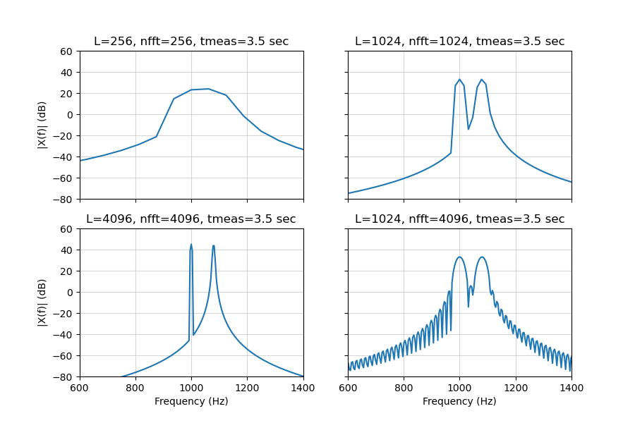
# Plot transient width
L1, L2, L3, L4 = 256, 1024, 4096, 1024
N1, N2, N3, N4 = L1, L2, L3, 4096
fig, axs = plt.subplots(2, 2, figsize=(9, 6), sharey=True, sharex=True)
fig.canvas.toolbar_position = 'top'
X, meta = analysis(x, L=L1, hop=L1//4, nfft=N1)
f = frame_freqs(meta); t = frame_times(meta)
ixf = np.where(f<500)[0]; ix = ixf[-5]
#print(f[ix]) # measurement frequency used
axs[0,0].plot(t, 20*np.log10(np.abs(X[:,ix])))
axs[0,0].set_title(f'L={L1}, nfft={N1}, fmeas={f[ix]} Hz')
axs[0,0].set_ylabel('Pulse Energy (dB)')
axs[0,0].grid(alpha=0.5)
axs[0,0].set_xlim([0.7, 1.2])
X, meta = analysis(x, L=L2, hop=L2//4, nfft=N2)
f = frame_freqs(meta); t = frame_times(meta)
ixf = np.where(f<500)[0]; ix = ixf[-20]
#print(f[ix]) # measurement frequency used
axs[0,1].plot(t, 20*np.log10(np.abs(X[:,ix])))
axs[0,1].set_title(f'L={L2}, nfft={N2}, fmeas={f[ix]} Hz')
axs[0,1].grid(alpha=0.5)
X, meta = analysis(x, L=L3, hop=L3//4, nfft=N3)
f = frame_freqs(meta); t = frame_times(meta)
ixf = np.where(f<500)[0]; ix = ixf[-80]
#print(f[ix]) # measurement frequency used
axs[1,0].plot(t, 20*np.log10(np.abs(X[:,ix])))
axs[1,0].set_title(f'L={L3}, nfft={N3}, fmeas={f[ix]} Hz')
axs[1,0].set_ylabel('Pulse Energy (dB)')
axs[1,0].set_xlabel('Time (s)')
axs[1,0].grid(alpha=0.5)
X, meta = analysis(x, L=L4, hop=L4//4, nfft=N4)
f = frame_freqs(meta); t = frame_times(meta)
ixf = np.where(f<500)[0]; ix = ixf[-80]
#print(f[ix]) # measurement frequency used
axs[1,1].plot(t, 20*np.log10(np.abs(X[:,ix])))
axs[1,1].set_title(f'L={L4}, nfft={N4}, fmeas={f[ix]} Hz')
axs[1,1].set_xlabel('Time (s)')
axs[1,1].grid(alpha=0.5)
plt.show()
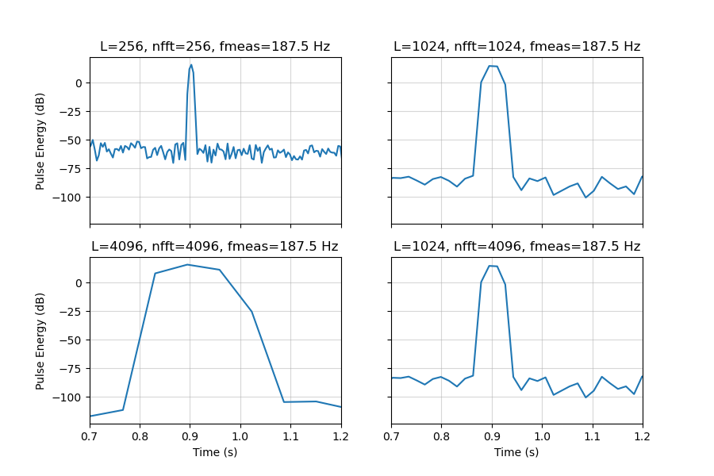
With L=256 the frequency difference of 80 Hz cannot be resolved. Transient pulsewidth defined as -10 dB points from maximum pulse energy.
L | Nfft | Window ms | Bin Hz | Main lobe Hann Hz | Hop ms | Pwidth ms
256 | 256 | 16.0 | 62.5 | 250.0 | 4.0 | 9
1024 | 1024 | 64.0 | 15.63 | 62.5 | 16.0 | 37
4096 | 4096 | 256.0 | 3.906 | 15.625 | 64.0 | 139
1024 | 4096 | 256.0 | 3.906 | 62.5 | 16.0 | 37
# ------------ Part A2 --------------------------------------------------------------------------
# Read test signal
f_name2 = 'signals/leakage.wav' # 1024 samples with strong 1003 Hz and weak 1140 Hz tones
_, x_leak = read_wav(f_name2)
ipd.Audio(x_leak, rate=FS)
<IPython.lib.display.Audio object>
# A2 Spectral leakage
L2, N2 = 1024, 65536
nn2 = np.arange(L2)
win_names = ['boxcar', 'hann', 'hamming', 'blackman']
w2 = np.zeros((len(win_names), L2)) # window, time domain
ENBW = np.zeros(len(win_names))
W2 = np.zeros((len(win_names), N2)) # window, frequency domain
X_leak = np.zeros((len(win_names), N2//2+1)) # 'leakage' signal, frequency domian
for i in range(len(win_names)):
w2[i] = signal.get_window(win_names[i], L2, fftbins=True) # time domain window
ENBW[i] = FS*np.sum(w2[i]**2)/np.sum(w2[i])**2
W2[i] = np.abs(np.fft.fft(w2[i], N2)) # FFT of window
W2[i] = W2[i]/W2[i,0] # Window FFT normalized by dc amplitude
X_leak[i] = np.abs(np.fft.rfft(x_leak*w2[i], N2))/w2[i].sum() # signal in freq domain, normalized by window sum
# Results from spectral leakage
ff2 = np.fft.rfftfreq(N2, 1/FS)
A20, A21 = -80, 5 # amplitude limits in dB
f20, f21 = 800, 1400 # frequency limits in Hz
fig, axs = plt.subplots(2, 2, figsize=(9, 5))
fig.canvas.toolbar_position = 'top'
fig.suptitle(f'Spectral Leakage for Different Windows, f0=1003 Hz, f1=1140 Hz Tones')
#axs[0,0].plot(ff2, X_leak[0], label=win_names[0])
axs[0,0].plot(ff2, 20*np.log10(2/.65*X_leak[0]), label=win_names[0])
axs[0,0].set_ylabel('Amplitude [dB]')
axs[0,0].grid(alpha=0.5)
axs[0,0].set_ylim([A20, A21])
axs[0,0].set_xlim([f20, f21])
axs[0,0].legend()
#axs[0,1].plot(ff2, X_leak[1], label=win_names[1])
axs[0,1].plot(ff2, 20*np.log10(2/.65*X_leak[1]), label=win_names[1])
axs[0,1].grid(alpha=0.5)
axs[0,1].set_ylim([A20, A21])
axs[0,1].set_xlim([f20, f21])
axs[0,1].legend()
#axs[1,0].plot(ff2, X_leak[2], label=win_names[2])
axs[1,0].plot(ff2, 20*np.log10(2/.65*X_leak[2]), label=win_names[2])
axs[1,0].set_ylabel('Amplitude [dB]')
axs[1,0].set_xlabel('Frequency [Hz]')
axs[1,0].grid(alpha=0.5)
axs[1,0].set_ylim([A20, A21])
axs[1,0].set_xlim([f20, f21])
axs[1,0].legend()
#axs[1,0].plot(ff2, X_leak[3], label=win_names[3])
axs[1,1].plot(ff2, 20*np.log10(2/.65*X_leak[3]), label=win_names[3])
axs[1,1].set_xlabel('Frequency [Hz]')
axs[1,1].grid(alpha=0.5)
axs[1,1].set_ylim([A20, A21])
axs[1,1].set_xlim([f20, f21])
axs[1,1].legend()
plt.show()
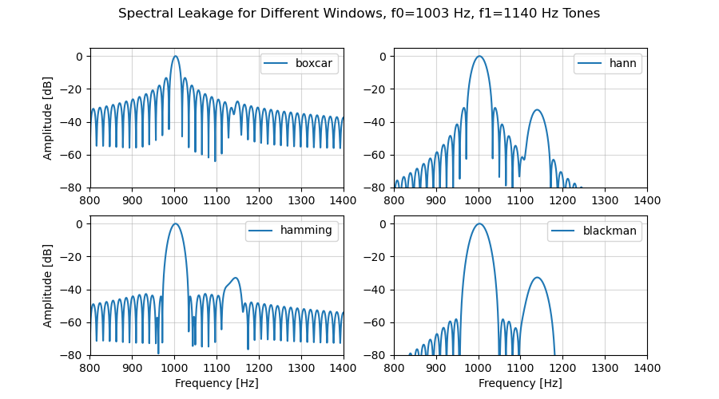
# Plot of window FFTs
ff2w = np.fft.fftfreq(N2, 1/FS)
#ff2w = np.fft.fftshift(np.fft.fftfreq(N2, 1/FS))
A20w, A21w = -80, 5 # amplitude limits in dB
f20w, f21w = -100, 100 # frequency limits in Hz
fig, axs = plt.subplots(1, 1, figsize=(9, 5))
fig.canvas.toolbar_position = 'top'
for i in range(len(win_names)):
axs.plot(ff2w, 20*np.log10(np.maximum(W2[i],1e-6)), label=f'ENBW={ENBW[i]:2.2f} Hz, {win_names[i]}')
axs.set_title('DFT/FFTs of Window Functions')
axs.set_ylabel('Amplitude [dB]')
axs.set_xlabel('Frequency [Hz]')
plt.grid(alpha=0.5)
axs.set_ylim([A20w, A21w])
axs.set_xlim([f20w, f21w])
axs.legend()
plt.show()
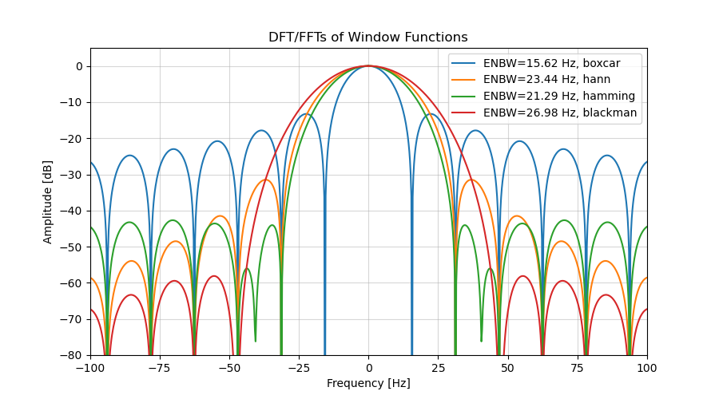
Here we use L=1024, Nfft=65,536, FS=16,000 Hz
Main lobe width for Boxcar is 2xFS/L, for Hann and Hamming it is 4xFS/L, for Blackman it is 6xFS/L
Parameter | Boxcar | Hann | Hamming | Blackman
null2null | 31.25 Hz | 62.5 Hz | 62.5 Hz | 93.75 Hz
pksidelobe | -13.26 dB | -31.47 dB | -42.67 dB | -58.11 dB
ENBW | 15.625 Hz | 23.438 Hz | 21.294 Hz | 26.981 Hz
# ----------- Part B1 ------------------------------------------------------------------------------
def synthesis(X, meta):
"""
X is (M x L) array of STFTs and meta is the accompanying dictionary of meta data.
`synthesis` takes inverse DFT/FFT to obtain time domain frames, then windows each
time domain frame using meta["w"] window (this is beneficial if X has been modified
between `analysis` and `synthesis`). Samplewise normalization to undo the scaling
introduced by the `analysis` and `synthesis` windows needs to be applied in the
denominator d while reconstructing the output signal y from the frames. A nonzero
denominator for every retained sample is necessary for this to work correctly (NOLA:
nonzero overlap add requirement).
Returns y, d (output y, denominator d, cropped to length of original signal).
"""
L = meta['L'] # frame length
hop = meta['hop'] # hop length in samples
w = meta['w'] # window samples (length L)
nfft = meta['N'] # DFT/FFT block size
if meta['complex']:
frames = np.fft.ifft(X, n=nfft, axis=1)[:, :L] # recovered frames (complex-valued)
else:
frames = np.fft.irfft(X, n=nfft, axis=1)[:, :L] # recovered frames (real-valued)
M = frames.shape[0] # number of frames
Lyp = (M - 1)*hop + L # length of padded output y
yp = np.zeros(Lyp, frames.dtype) # allocate array for yp
dp = np.zeros(Lyp) # allocate array for dp (padded denominator)
for i in range(M):
idx = slice(i*hop, i*hop+L) # current range of indexes
yp[idx] += frames[i]*w # windowed frame
dp[idx] += w*w # samplewise denominator for normalization
crop = slice(meta['pad_front'], meta['pad_front']+meta['Lx'])
d = dp[crop] # denominator for original data length
if np.any(np.abs(d) < 1e-12):
raise ValueError('NOLA violated in retained samples')
y = yp[crop]/d # samplewise normalized output with original data length
if not meta['complex']:
y = y.real
return y, d # output and denominator
# Read jammed test signal
f_name3 = 'signals/jammed.wav'
_, x_jam = read_wav(f_name3)
ipd.Audio(x_jam, rate=FS)
<IPython.lib.display.Audio object>
# Small example for testing
X, meta = analysis(x, L=L1, hop=L1//4, nfft=N1)
x_hat, d = synthesis(X, meta)
x_err = x - x_hat
print(np.min(np.abs(d)))
print(np.max(np.abs(x_err)))
0.0014485813926750633
8.326672684688674e-16
fig, axs = plt.subplots(1, 1, figsize=(7,3))
fig.canvas.toolbar_position = 'top'
axs.plot(x[:100])
axs.plot(x_hat[:100], linestyle='--')
axs.set_title(f'Small Example for Testing, L={L1}, hop={L1//4}, nfft={N1}')
axs.grid(alpha=0.5)
plt.show()
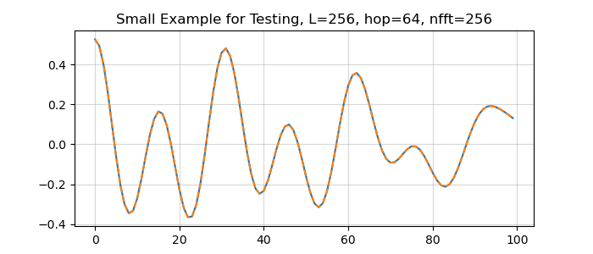
# Reconstruction using normalized synthesis
L = 1024
h1, h2, h3, h4, h5 = L, 3*L/4, L/2, L/4, L/8
w1, w2 = 'boxcar', 'hann'
X, meta = analysis(x, L=L, hop=h1, window=w1, nfft=L)
x_hat, d = synthesis(X, meta)
x_err = x - x_hat
print(f'hop={h1}, frames={X.shape[0]}, window={w1}, Drange={np.min(d)} to {np.max(d)}, error={np.max(np.abs(x_err)):.1e}')
try:
X, meta = analysis(x, L=L, hop=h1, window=w2, nfft=L)
x_hat, d = synthesis(X, meta)
x_err = x - x_hat
print(f'hop={h1}, frames={X.shape[0]}, window={w2}, Drange={np.min(d)} to {np.max(d)}, error={np.max(np.abs(x_err)):.1e}')
except:
print(f'hop={h1}, window={w2}, NOLA violated')
X, meta = analysis(x, L=L, hop=h2, window=w2, nfft=L)
x_hat, d = synthesis(X, meta)
x_err = x - x_hat
print(f'hop={h2}, frames={X.shape[0]}, window={w2}, Drange={np.min(d):.2e} to {np.max(d)}, error={np.max(np.abs(x_err)):.1e}')
X, meta = analysis(x, L=L, hop=h3, window=w2, nfft=L)
x_hat, d = synthesis(X, meta)
x_err = x - x_hat
print(f'hop={h3}, frames={X.shape[0]}, window={w2}, Drange={np.min(d):.2e} to {np.max(d)}, error={np.max(np.abs(x_err)):.1e}')
X, meta = analysis(x, L=L, hop=h4, window=w2, nfft=L)
x_hat, d = synthesis(X, meta)
x_err = x - x_hat
print(f'hop={h4}, frames={X.shape[0]}, window={w2}, Drange={np.min(d):.2e} to {np.max(d):.1f}, error={np.max(np.abs(x_err)):.1e}')
X, meta = analysis(x, L=L, hop=h5, window=w2, nfft=L)
x_hat, d = synthesis(X, meta)
x_err = x - x_hat
print(f'hop={h5}, frames={X.shape[0]}, window={w2}, Drange={np.min(d):.2e} to {np.max(d):.1f}, error={np.max(np.abs(x_err)):.1e}')
hop=1024, frames=63, window=boxcar, Drange=1.0 to 1.0, error=2.9e-16
hop=1024, window=hann, NOLA violated
hop=768.0, frames=84, window=hann, Drange=5.80e-06 to 1.0, error=3.0e-14
hop=512.0, frames=125, window=hann, Drange=5.80e-06 to 1.0, error=3.0e-14
hop=256.0, frames=248, window=hann, Drange=5.80e-06 to 1.5, error=3.0e-14
hop=128.0, frames=494, window=hann, Drange=5.80e-06 to 3.0, error=3.0e-14
Ovlp % | Hop | Frames | Window | Denominator range | Error
0 | 1024 | 63 | boxcar | 1.0 to 1.0 | 2.9e-14
0 | 1024 | 63 | hann | failure | NOLA
25 | 768 | 84 | hann | 5.8e-06 to 1.0 | 3.0e-14
50 | 512 | 125 | hann | 5.8e-06 to 1.0 | 3.0e-14
75 | 256 | 248 | hann | 5.8e-06 to 1.5 | 3.0e-14
87.5 | 128 | 494 | hann | 5.8e-06 to 3.0 | 3.0e-14
# --------- Part B2 --------------------------------------------------------------------------------
def ola_filter(x, h, B=512, nfft=None):
"""
Exact linear convolution using overlap-add method and FFT multiplication.
Output length len(x)+len(h)-1 (full convolution).
x is broken up into blocks of size B
"""
x = np.asarray(x) # data sequence
h = np.asarray(h) # filter impulse response
Lx, Lh = x.size, h.size
if nfft is None:
nfft = 1 << (B+Lh-1).bit_length()
if nfft < B+Lh-1:
nfft = B+Lh-1
cplx = np.iscomplexobj(x) or np.iscomplexobj(h)
H = np.fft.fft(h, nfft) # FFT of filter response h
y = np.zeros(Lx+Lh-1, complex) # output array
i = 0
for n in range(0, Lx, B):
blk = x[n:n+B] # block of length B
#blk_conv = np.fft.ifft(np.fft.fft(blk, nfft) * H, nfft)[:B+Lh-1] # block convolution
blk_conv = np.fft.ifft(np.fft.fft(blk, nfft) * H, nfft) # block convolution
Lconv = len(blk)+Lh-1
y[n:n+Lconv] += blk_conv[:Lconv] # overlap-add
i += 1
print(i) # number of frames
if not cplx:
y = y.real
return y
# Testing with small B
B_test = 4
x_test = np.arange(10)
for nn in range(0, len(x_test), B_test):
print(x_test[nn:nn+B_test])
[0 1 2 3]
[4 5 6 7]
[8 9]
# Read jammed test signal
f_name3 = 'signals/jammed.wav'
_, x_jam = read_wav(f_name3)
ipd.Audio(x_jam, rate=FS)
<IPython.lib.display.Audio object>
# B2. Frequency domain FIR filtering
B_jam = [512, 128, 2048]
nfft_jam = [1024, 256, 4096]
h = signal.firwin(129, 1200, fs=FS, window="hamming")
y_jam = ola_filter(x_jam, h, B=B_jam[2])
reference = np.convolve(x_jam, h)
assert len(y_jam) == len(reference)
assert relerr(reference, y_jam) < 1e-10
# TODO: repeat for B=128 and 2048.
32
# Test audio result
ipd.Audio(y_jam, rate=FS)
<IPython.lib.display.Audio object>
# Filter with different B and report errors
y_jam = ola_filter(x_jam, h, B=B_jam[1], nfft=nfft_jam[1])
print(f'\nB={B_jam[1]}, nfft={nfft_jam[1]}')
print(f'L(x_jam)={len(x_jam)}, L(y_jam)={len(y_jam)}, L(ref)={len(reference)}')
print(f'Error: {np.max(np.abs(y_jam-reference))}')
print(f'relerr: {relerr(reference, y_jam)}')
y_jam = ola_filter(x_jam, h, B=B_jam[0], nfft=nfft_jam[0])
print(f'\nB={B_jam[0]}, nfft={nfft_jam[0]}')
print(f'L(x_jam)={len(x_jam)}, L(y_jam)={len(y_jam)}, L(ref)={len(reference)}')
print(f'Error: {np.max(np.abs(y_jam-reference))}')
print(f'relerr: {relerr(reference, y_jam)}')
y_jam = ola_filter(x_jam, h, B=B_jam[2], nfft=nfft_jam[2])
print(f'\nB={B_jam[2]}, nfft={nfft_jam[2]}')
print(f'L(x_jam)={len(x_jam)}, L(y_jam)={len(y_jam)}, L(ref)={len(reference)}')
print(f'Error: {np.max(np.abs(y_jam-reference))}')
print(f'relerr: {relerr(reference, y_jam)}')
500
B=128, nfft=256
L(x_jam)=64000, L(y_jam)=64128, L(ref)=64128
Error: 2.7755575615628914e-16
relerr: 3.4301494526076115e-16
125
B=512, nfft=1024
L(x_jam)=64000, L(y_jam)=64128, L(ref)=64128
Error: 2.220446049250313e-16
relerr: 3.2815413012810876e-16
32
B=2048, nfft=4096
L(x_jam)=64000, L(y_jam)=64128, L(ref)=64128
Error: 2.220446049250313e-16
relerr: 3.4199731608199134e-16
Block size B | FFT size | # Blocks | Relative Error
128 | 256 | 500 | 3.43e-16
512 | 1024 | 125 | 3.28e-16
2048 | 4096 | 32 | 3.42e-16
# ----------- Part C2 ---------------------------------------------------------------------------------
from pathlib import Path
from common import fixtures
a = fixtures(Path("signals"))
# QPSK receiver (from common.py)
def receive(x, symbols, bits, pulse):
"""Known timing, no carrier recovery or per-symbol correction. Transients excluded."""
mf = np.convolve(x, pulse.conj()[::-1])
z = mf[(len(pulse)-1)+16*np.arange(len(symbols))]
keep = slice(10, -10); z = z[keep]; ref = symbols[keep]; b = bits[keep]
evm = 100*np.linalg.norm(z-ref)/np.linalg.norm(ref)
decisions = np.column_stack((z.real < 0, z.imag < 0))
ber = np.mean(decisions != b)
return dict(evm_percent=float(evm), ber=float(ber)), z
# Read QPSK signal
x_qpsk = a["tx"]
ipd.Audio([x_qpsk.real, x_qpsk.imag], rate=FS)
<IPython.lib.display.Audio object>
# Generate spectrogram
X, meta = analysis(x_qpsk)
# Generate different signal variants
y_rec, d_rec = synthesis(X, meta)
y_mag, d_mag = synthesis(np.abs(X).astype(complex), meta)
y_randth, d_randth = synthesis(X*np.exp(2j*np.pi*rng.random((X.shape[0], 1))), meta)
# Receive different QPSK signals
a = fixtures(Path("signals"))
met_orig, z_orig = receive(x_qpsk, a["symbols"], a["bits"], a["pulse"])
met_rec, z_rec = receive(y_rec, a["symbols"], a["bits"], a["pulse"])
met_mag, z_mag = receive(y_mag, a["symbols"], a["bits"], a["pulse"])
met_randth, z_randth = receive(y_randth, a["symbols"], a["bits"], a["pulse"])
# Plot signal constellations
fig, axs = plt.subplots(2, 2, figsize=(8, 6), sharey=True, sharex=True)
fig.canvas.toolbar_position = 'top'
fig.suptitle(f'QPSK Phase Coherent Communication')
axs[0,0].plot(z_orig.real, z_orig.imag, '.', label=f'EVM={met_orig['evm_percent']:.1f}%')
axs[0,0].set_title(f'Original, BER={met_orig['ber']}')
axs[0,0].set_ylabel('Q')
#axs[0,0].set_xlabel('I')
axs[0,0].grid(alpha=0.5)
axs[0,0].legend()
axs[0,0].set_aspect('equal')
axs[0,1].plot(z_rec.real, z_rec.imag, '.', label=f'EVM={met_rec['evm_percent']:.1f}%')
axs[0,1].set_title(f'Reconstructed, BER={met_rec['ber']}')
#axs[0,1].set_ylabel('Q')
#axs[0,1].set_xlabel('I')
axs[0,1].grid(alpha=0.5)
axs[0,1].legend()
axs[0,1].set_aspect('equal')
axs[1,0].plot(z_mag.real, z_mag.imag, '.', label=f'EVM={met_mag['evm_percent']:.1f}%')
axs[1,0].set_title(f'Magnitude Only, BER={met_mag['ber']:.2f}')
axs[1,0].set_ylabel('Q')
axs[1,0].set_xlabel('I')
axs[1,0].grid(alpha=0.5)
axs[1,0].legend()
axs[1,0].set_aspect('equal')
axs[1,1].plot(z_randth.real, z_randth.imag, '.', label=f'EVM={met_randth['evm_percent']:.1f}%')
axs[1,1].set_title(f'Random Frame Phase, BER={met_randth['ber']:.2f}')
#axs[1,1].set_ylabel('Q')
axs[1,1].set_xlabel('I')
axs[1,1].grid(alpha=0.5)
axs[1,1].legend()
axs[1,1].set_aspect('equal')
plt.tight_layout()
plt.show()


