ECEN 4/5632 — Theory and Application of Digital Filters
Problem Set 6 — Solutions
Fall 2026
1. Conv1d and the sliding dot product
(a) Relating the DSP convolution to PyTorch cross-correlation
DSP convolution (FIR filter with M+1 taps, h[0],…,h[M]):
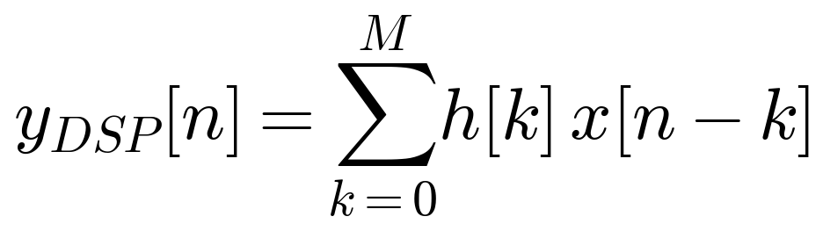
PyTorch cross-correlation:
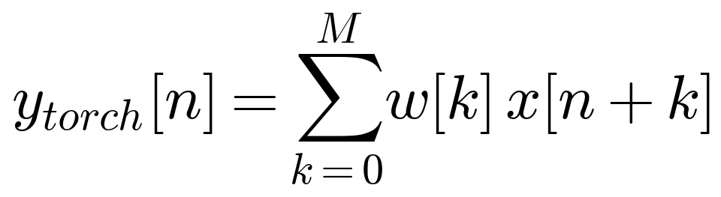
Substitute j = M − k (so k = M − j) in the DSP sum:
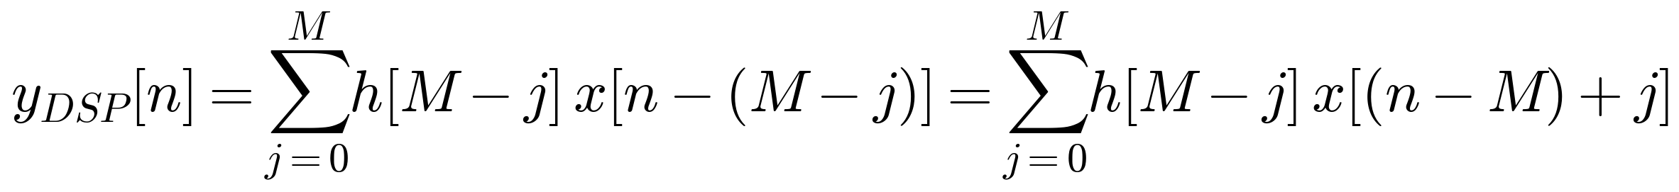
Compare this to ytorch[m] = Σⱼ w[j] x[m+j] evaluated at m = n − M. The two expressions match term-by-term if
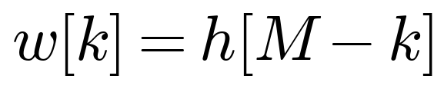
i.e. the PyTorch kernel is the time-reversed DSP impulse response.
With this substitution,
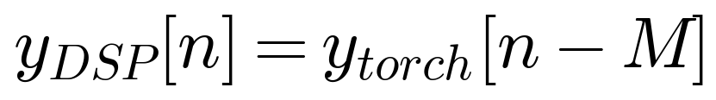
PyTorch's un-padded (“valid”) output is shifted left by M samples relative to the causal DSP output. To make the torch output start at index 0 and align exactly with yDSP[n] for n = 0,…,N−1, you must left-pad x with M zeros (and add no right padding). This supplies the “missing” samples x[−M],…,x[−1] = 0 that the causal filter implicitly assumes, and produces an output of the same length N as the input, in valid (“no-padding”) mode:
(b) Implementation and comparison
import numpy as np
import torch
import torch.nn.functional as F
import soundfile as sf

# ---------- 1. Design a Hamming-windowed lowpass FIR ----------
N = 51 # number of taps
M = N - 1 # 50 -> highest tap index
wc = np.pi / 3 # cutoff frequency (rad/sample)

n = np.arange(N)
m = n - M / 2.0 # centered index for linear phase
h_ideal = np.where(m == 0, wc / np.pi, np.sin(wc * m) / (np.pi * m))
w_hamming = 0.54 - 0.46 * np.cos(2 * np.pi * n / M)
h = (h_ideal * w_hamming).astype(np.float32)

# ---------- 2. Load the chirp ----------
x, fs = sf.read('chirp_001.wav')
x = x.astype(np.float32)
if x.ndim > 1:
x = x[:, 0] # force mono

# ---------- 3. NumPy reference: causal DSP convolution ----------
y_np_full = np.convolve(x, h, mode='full')
y_np = y_np_full[:len(x)] # causal output, same length as x

# ---------- 4. Equivalent F.conv1d computation ----------
w = h[::-1].copy() # w[k] = h[M-k]
w_t = torch.from_numpy(w).view(1, 1, -1) # (out_ch=1, in_ch=1, K)
x_t = torch.from_numpy(x).view(1, 1, -1) # (batch=1, in_ch=1, L)
x_pad = F.pad(x_t, (M, 0)) # left-pad by M zeros only

y_torch = F.conv1d(x_pad, w_t).view(-1).numpy()

# ---------- 5. Compare ----------
diff = np.max(np.abs(y_np - y_torch))
print(f"max abs difference: {diff:.3e}")

# ---------- 6. Save filtered audio for a spectrogram check ----------
sf.write('chirp_filtered.wav', y_torch, fs)

Expected result: the reported max abs difference should be on the order of 10⁻⁶ to 10⁻⁷, limited only by float32 rounding, since the two computations are mathematically identical.
Evidence the filter works: load chirp_filtered.wav in Audacity and generate a spectrogram (Analyze → Plot Spectrum, or the spectrogram track view). The chirp's energy should be clearly visible up to the cutoff frequency fc = ωc/(2π)·fs = fs/6, and sharply attenuated above that — the sweep should visibly disappear once it crosses the cutoff line in the spectrogram, unlike the unfiltered chirp, which sweeps the full band.
(c) Rebuttal to “PyTorch's conv1d does convolution backwards, so it's a bug”
It's not a bug, just a different (and for machine learning purposes, more natural) convention. Mathematically, convolution and cross-correlation differ only by flipping the kernel, w[k] = h[M−k], exactly as derived in part (a), so no information or capability is lost, and the two are trivially interconvertible. In classical DSP the kernel h[k] is a fixed, physically meaningful impulse response, derived from a difference equation or an analog prototype, so the flip in the definition matters and must be tracked carefully. In deep learning, however, the kernel w[k] is a set of learned parameters with no prior physical meaning: gradient descent will happily learn whichever set of numbers minimizes the loss, whether the operation is called “convolution” or “correlation.” Since training and inference both consistently use the same cross-correlation definition, and autograd computes the correct corresponding gradients automatically, there is no mismatch anywhere in the pipeline. The “backwards” framing only becomes an issue when reusing a fixed, externally designed filter, like the FIR filter in part (b), inside a conv1d call, and even then, as shown above, it is a one-line fix: flip the kernel and left-pad by M, not a bug.

2. Pole-zero geometry
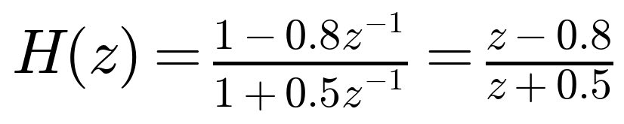
(a) Zero and pole
Zero:
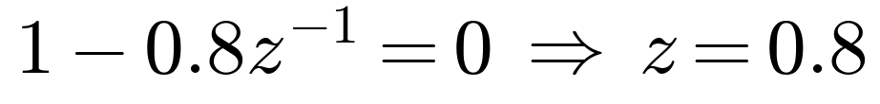
Pole:
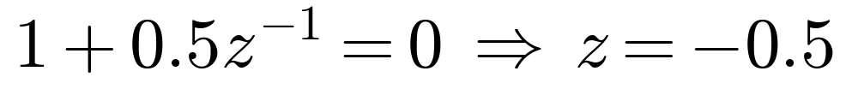
(b) Geometric interpretation
Writing
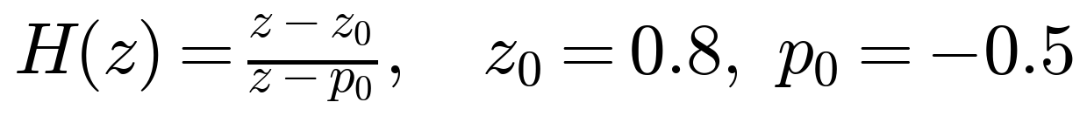
and evaluating on the unit circle z = ejω:
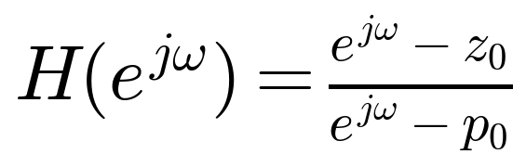
Each factor ejω − z0 (or ejω − p0) is literally the vector in the complex plane pointing from the zero (or pole) location to the point ejω on the unit circle. The magnitude of a complex ratio equals the ratio of magnitudes, so
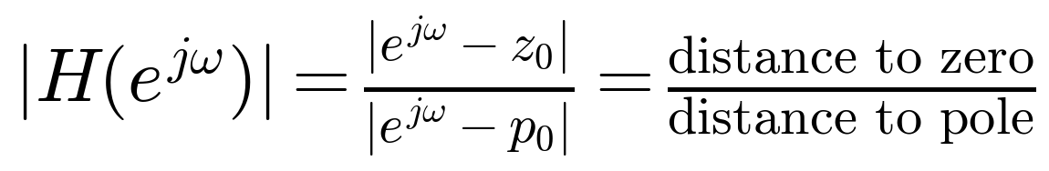
For a general
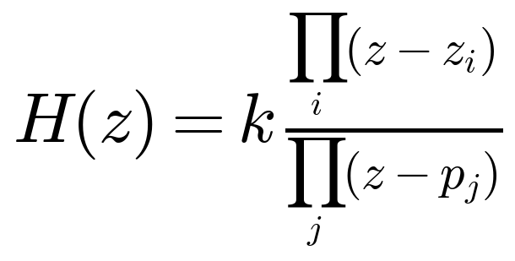
this generalizes directly: the magnitude response at each frequency is |k| times the product of all zero-vector lengths divided by the product of all pole-vector lengths, each measured from the corresponding pole or zero to the point ejω on the unit circle.
(c) Larger near ω = 0 or ω = π?
At ω = 0 (z = 1):
At ω = π (z = −1):
So |H(ejω)| is much larger near ω = π than near ω = 0, a highpass-leaning response: the zero sits close to ω = 0 on the unit circle (suppressing low frequencies) while the pole sits close to ω = π (boosting high frequencies).

3. Phase delay and group delay
Let
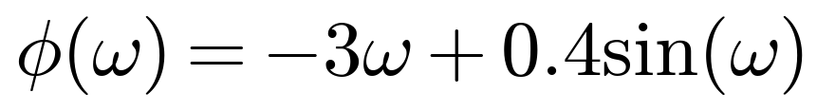
(a) Phase delay
(b) Group delay
(c) Why the system is not linear phase
A linear-phase system requires
This is a straight line through the origin with slope −α, which gives a constant group delay for all ω. Here φ(ω) has the extra nonlinear term 0.4 sin(ω), so τg(ω) = 3 − 0.4 cos(ω) varies with ω (ranging from 2.6 at ω = 0 to 3.4 at ω = π) instead of staying constant. Since different frequency components experience different delays, a signal passed through this system will suffer phase distortion, with its frequency components smeared in time relative to one another, which is the defining symptom of a non-linear-phase system.

4. First-order allpass
For real |a| < 1,
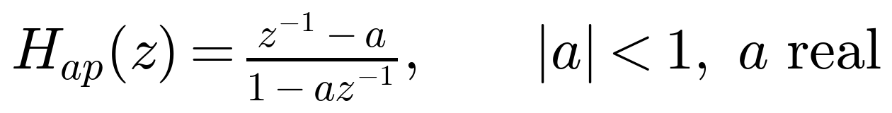
Magnitude on the unit circle
Evaluate at z = ejω:
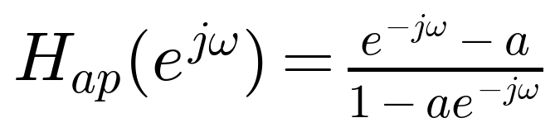
Compute |Hap|2 = Hap· Hap*:
Numerator magnitude squared:
Denominator magnitude squared:
The two are identical, so
Pole/zero locations and reciprocal relationship
Pole:
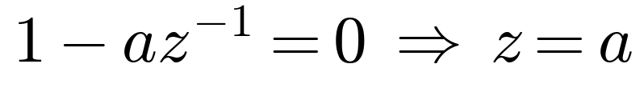
Zero:
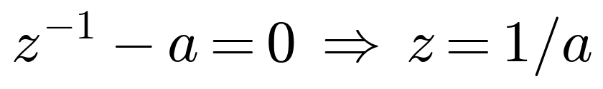
Since |a| < 1, the pole z = a lies inside the unit circle, and the zero z = 1/a lies at its reciprocal position, outside the unit circle, on the same ray from the origin. This zero-is-reciprocal-of-pole geometry is exactly what makes |Hap(ejω)| constant: reflecting a pole through the unit circle to its reciprocal location (here 1/a, since a is real) is precisely the transformation that preserves the ratio of distances to every point on the unit circle, so the numerator and denominator vector lengths from part 2(b) stay in a fixed ratio of 1 at every frequency. This is the defining pole/zero pattern of a first-order allpass filter.

5. Inverse system properties (ECEN 5632 Problem)
From the pole-zero plot: H(z) is causal, with a complex-conjugate pole pair at approximately 0.3 ± j0.65 (magnitude
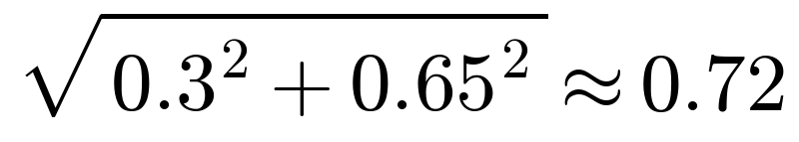
), a third pole near z ≈ −0.75 on the real axis, and a complex-conjugate zero pair at approximately −0.4 ± j0.4 (magnitude
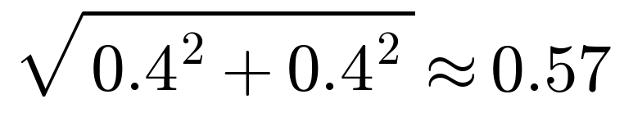
).
Is H(z) itself stable? All three poles lie inside the unit circle (0.72 < 1 and 0.75 < 1), so the causal system H(z) is BIBO stable, consistent with it being given as a causal system.
What about the inverse, Hi(z) = 1/H(z)? The poles of Hi(z) are the zeros of H(z). Since H(z)'s zeros are at magnitude ≈ 0.57 < 1, i.e. inside the unit circle, the poles of Hi(z) are also inside the unit circle.
For Hi(z) to be causal, its ROC must be the exterior of its outermost pole (|z| > 0.57). Because that outermost pole is inside the unit circle, this causal ROC includes the unit circle, so Hi(z) is simultaneously causal and stable.
Conclusion: Yes, the inverse system can be both causal and stable in this case, because H(z) is minimum phase: all of its zeros, not just its poles, lie inside the unit circle. In general, a causal, stable H(z) has a causal, stable inverse if and only if it is minimum phase; if any zero of H(z) were outside the unit circle, the causal inverse would necessarily be unstable, and a stable but noncausal inverse would be required instead.

