DFT and FFT Problem Set
DSP Theory and Applications | Senior and first year graduate electrical and computer engineering students. Six original problems, 100 points. Suggested effort: 6 to 8 hours. Submit derivations and an executable Python script or notebook with labeled plots. Use complex128 calculations and state both the acquired record length and the FFT length.
Reading: Oppenheim and Schafer, Discrete Time Signal Processing, sections on DFT representations and properties, circular convolution, FFT computation, and Fourier analysis of finite records. In the third edition these topics are in Chapters 8, 9 and 10; use the corresponding sections in your edition. These are original exercises aligned with those topics.

Conventions
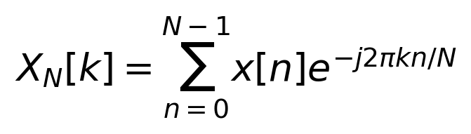
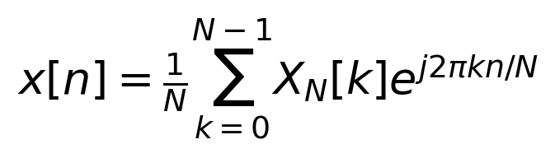
Use L for the number of acquired samples and N for FFT length. If N exceeds L, append zeros after the L samples. An FFT is an algorithm for computing a DFT. All spectral experiments use complex sinusoids to isolate positive frequency components: normalize their magnitudes by L, not N, and do not double them as for a one sided real cosine amplitude plot.

Problem 1 Periodic representations 10 points
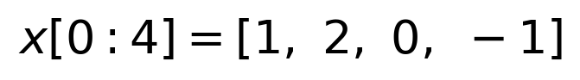
(a) Compute the four point DFT by hand or by a direct DFT matrix. Show the arithmetic or intermediate terms. Use an FFT only to verify your result. [4 points]
(b) Extend the DFT formula to any integer k. Prove that X[k+4] equals X[k]. What frequencies do bins k=3 and k=-1 represent relative to the sampling frequency? [2 points]
(c) Evaluate the inverse DFT expression at n=-1, 4, 5 and 6. Prove that this expression repeats every four samples. Distinguish this periodic representation from the finite sequence taken to be zero outside samples 0 through 3. [3 points]
(d) Does an FFT change either of these periodicity properties? Explain. [1 point]

Problem 2 A Delay That Wraps Around
15 points. Let the eight sample record be the sequence below and define its eight point DFT to be X8.
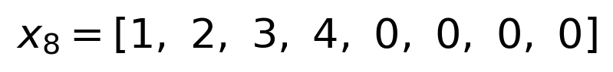
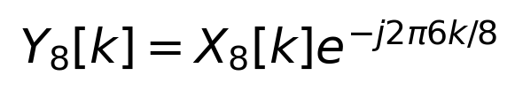
(a) Find the eight sample inverse DFT of Y8. Derive the circular shift relation and identify exactly which samples wrap around. Verify with np.roll and FFT multiplication. [5 points]
(b) Instead interpret the original signal as zero outside its nonzero support, samples 0 through 3. Delay it by six samples on the infinite time axis. List its first eight samples. Explain why this differs from part (a), although both calculations are often called a delay. [4 points]
(c) Append zeros to create a 16 sample record, compute the 16 point DFT, and apply the phase ramp with denominator 16. List the complete output. What is the smallest transform length that avoids wrapping any nonzero delayed sample for this signal? Explain using its support. [4 points]
(d) Does padding eliminate DFT periodicity, or does it change the period and provide space before nonzero samples would wrap? Explain. [2 points]

Problem 3 Circular and Linear Convolution 20 points
(a) Compute the full linear convolution by hand. [4 points]
(b) Compute IFFT(FFT(x,N) times FFT(h,N)) for N=4 and N=5. Predict both results by folding the full linear convolution before running Python. Show the folding arithmetic. [6 points]
(c) Find the minimum N that permits the FFT product to recover the full linear convolution without time aliasing. Verify at that length and at N=8, including any trailing zeros. [4 points]
(d) Let c denote the finite linear convolution extended by zero outside its support. Derive the folding relationship between c and the N point circular convolution, using inverse DFT orthogonality. [4 points]
(e) Explain why using a longer FFT can fix circular convolution aliasing, even though a longer FFT does not necessarily separate two close tones. Identify what the padding accomplishes in each setting. [2 points]

Problem 4 Boundaries and Spectral Leakage
15 points. Use fs=1024 samples per second and acquire L=64 complex samples. Consider two signals, each separately:
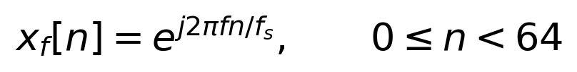
Use f=128 Hz for the first signal and f=136 Hz for the second. Use a rectangular observation window unless part (d) specifies otherwise.
(a) Derive the finite record DTFT as a geometric sum. Express its magnitude as a ratio of sine functions, including the limiting value at the tone frequency. State where the 64 point DFT samples this DTFT. [5 points]
(b) Compute the number of cycles in each 64 sample observation interval. Evaluate the underlying sinusoid at n=64 and compare with x[0]. Which sinusoid matches the continuation implied by repeating the record? The matching condition is x[64]=x[0] for the underlying tone, not equality of the last stored sample x[63] and x[0]. Explain why. [4 points]
(c) Plot DFT magnitudes for N=64 and N=1024 on the same frequency axes for each tone. Use magnitude in dB relative to 1, normalized by L, and a display floor of -60 dB. Explain why the unpadded 128 Hz case has only one nonzero DFT bin, yet its zero padded plot reveals sidelobes between the original DFT sample frequencies. Did padding create these lobes? [4 points]
(d) For the 136 Hz tone compare rectangular and periodic Hann windows on a dense grid. Normalize by each window sum. Explain the changes in sidelobes and main lobe width. Can tapering generally remove all leakage while retaining a rectangular window’s resolving power? [2 points]

Problem 5 Zero Padding and Frequency Plot Detail
20 points. Acquire a single complex sinusoid with amplitude 1, fs=2048 samples per second, f0=403.3 Hz and L=128 samples. Keep these 128 measured samples fixed throughout the problem.
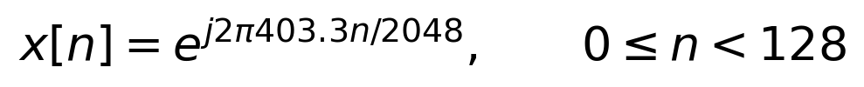
(a) Compute spectra for N=128, 512 and 4096. Overlay or compare plots over 350 to 450 Hz using magnitude divided by 128. Make a table of N, frequency grid spacing, largest bin frequency in this interval, and its amplitude. Explain the improvement in locating the sampled peak. [4 points]
(b) Write the M point DFT of the zero padded record. Prove that it samples the same finite record DTFT at a denser set of frequencies. If M=qL for integer q, identify exactly which padded DFT bins equal the original L point DFT bins. Verify the result for q=4. [4 points]
(c) Find the first spectral zeros on either side of f0 and the null to null main lobe width. Do these frequencies change as N increases? Explain the distinction between plot grid spacing and main lobe width. [3 points]
(d) Use the L point inverse DFT to show that every M point zero padded DFT value can be calculated from the original L DFT values. Give an explicit interpolation sum. Explain why this establishes that padding supplies no additional measured information. [5 points]
(e) Explain why normalization by N would falsely suggest that the signal amplitude decreases with padding. What changes if the FFT library uses a normalized forward transform? Explain why improved single tone peak localization does not establish improved two tone separation. [4 points]
Use N=128, 512 and 4096 only as computational and display choices; do not acquire additional samples in this problem.

Problem 6 Two Close Tones and Observation Duration
20 points. Observe the same two equal amplitude complex tones at fs=2048 samples per second on centered time intervals. The centered phase convention controls interference between their finite record spectra.
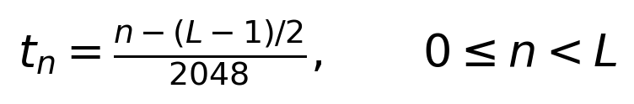
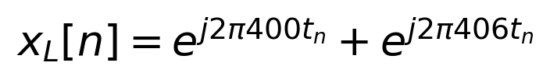
(a) Make three amplitude plots with identical axes: L=128 and N=128; L=128 and N=4096; L=1024 and N=4096. Normalize by L in each case and use the frequency interval 380 to 426 Hz. Do not simply pad the short record to create the third case; evaluate the signal at all 1024 sample times. [6 points]
(b) For this experiment, call the tones spectrally separated if the dense finite record magnitude has two dominant local maxima with a local minimum between them. Inspect the interval 397 to 409 Hz, ignoring maxima below 60 percent of the largest peak. Report peak locations and whether each record meets the criterion. A very dense direct DTFT evaluation can check the shape between FFT bins. Explain why a finer plot of one broad peak is still one broad peak. [6 points]
(c) Make a table of acquired sample count, observation interval length L/fs, FFT length, plot grid spacing fs/N, and rectangular window null to null width 2fs/L. Which change narrows the individual tone lobes? Why is comparing the two N=4096 plots especially persuasive? [4 points]
(d) Critique the statement: “An FFT with a 0.5 Hz bin spacing can always distinguish sinusoids 6 Hz apart.” Also explain why these experiments do not prohibit a model based estimator from estimating close frequencies under stronger assumptions. [4 points]

Graduate discussion extension
In addition to the common questions, repeat the dense two tone plots after changing the relative phase of the second tone. Explain why visible peak separation depends on phase, amplitude, window and noise as well as duration. Keep the conclusion precise: zero padding does not change the spectral shape of a fixed record. This extension may be assessed within the explanation points rather than changing the 100 point total.

Submission standard
Label fs, L, N, normalization and units on all plots. Keep FFT coefficients complex; discard only numerical imaginary residuals when a theoretical output is real. The distinction among acquired duration, frequency grid spacing and spectral separation is central to grading.

