DFT and FFT Problem Set Solutions
Instructor key for six original exercises aligned with the DFT and finite record Fourier analysis topics in Oppenheim and Schafer. Numerical results were verified with the accompanying solution.py. An FFT computes the DFT and preserves all its mathematical properties.

Problem 1 Periodic representations
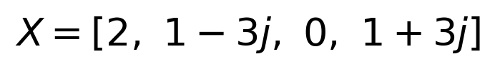
For bin 1 the factors are 1, -j, -1 and j, giving 1-2j-j=1-3j. Bin 2 gives 1-2+0+1=0. Bin 3 is the conjugate of bin 1 because the input is real. Replacing k by k+4 in each DFT exponential multiplies it by exp(-j2 pi n)=1.
Bins 3 and -1 are equivalent; in the centered frequency convention both represent -fs/4. In the uncentered convention bin 3 is 3fs/4. The inverse sum yields x[-1]=-1, x[4]=1, x[5]=2 and x[6]=0. The finite zero extended record instead is zero outside n=0 through 3. Using the inverse sum for arbitrary n gives a periodic extension, not the zero extended record.

Problem 2 Circular delay
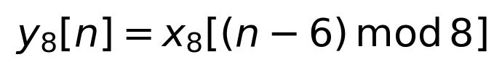
Multiplication by the phase ramp shifts the inverse DFT argument to n-6. Taking indices modulo 8 gives [3,4,0,0,0,0,1,2]. Values 3 and 4 wrap to output indices 0 and 1. The first eight samples of the linear delay are [0,0,0,0,0,0,1,2], with 3 and 4 at indices 8 and 9.
The 16 point result is [0,0,0,0,0,0,1,2,3,4,0,0,0,0,0,0]. The minimum transform length for this support is 10 because the latest nonzero delayed sample is at n=9. Trailing zeros in the original eight sample array do not change that minimum. Padding creates a longer periodic representation with enough room for the delayed support; it does not remove periodicity.

Suggested grading
Problem 1: arithmetic 4, frequency periodicity 2, inverse extension 3, FFT interpretation 1. Problem 2: correct circular shift and derivation 5, linear comparison 4, support and padded calculation 4, interpretation 2.

Solution 3 Circular Convolution and Time Aliasing
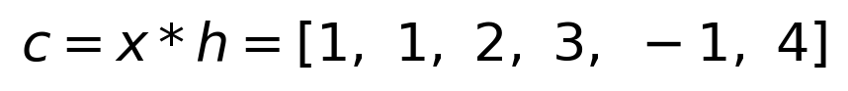
N | FFT product inverse | Folding explanation
4 | [0, 5, 2, 3] | c[0]+c[4]=0; c[1]+c[5]=5
5 | [5, 1, 2, 3, -1] | c[0]+c[5]=5
6 | [1, 1, 2, 3, -1, 4] | Complete linear output
8 | [1, 1, 2, 3, -1, 4, 0, 0] | Complete output and two zeros

The required length is at least 4+3-1=6. A four point circular convolution folds the two late samples into the beginning; a five point convolution folds one. Both are correct circular results, rather than failed FFT computations.
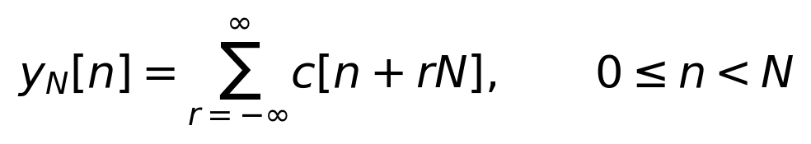
Expand the product of the two DFTs inside the inverse transform. The inverse sum of exp(j2 pi k(n-a-b)/N) is 1 when a+b equals n modulo N and 0 otherwise. Thus all linear convolution terms whose indices differ by integer multiples of N add at one circular output sample.
Padding prevents nonzero output support from overlapping its periodic copies. In a spectral display, padding samples an unchanged DTFT more finely; that is a different role. These two statements about zero padding are consistent.
Grading: linear convolution 4; folded N=4 and N=5 values 6; minimum length and verification 4; orthogonality derivation 4; explanation 2. The code also verifies the folded results independently, before comparing the FFT outputs.

Solution 4 Leakage and Periodic Boundaries
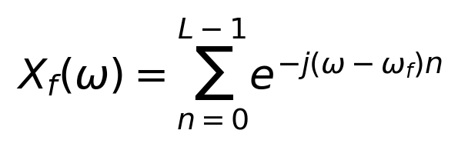
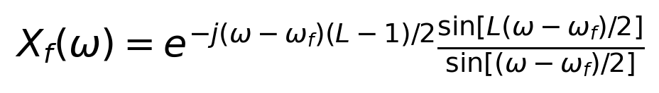
The limiting magnitude at the tone frequency is L. The DFT evaluates this finite record DTFT at omega=2 pi k/N. With L=N=64, 128 Hz corresponds to 8 cycles and bin 8; all other DFT samples land on zeros of the rectangular window transform. The 136 Hz tone completes 8.5 cycles and lies halfway between bins 8 and 9.
At n=64 the underlying 128 Hz tone equals 1, agreeing with x[0]; the 136 Hz tone equals -1, disagreeing with x[0]. A periodic continuation of the second record therefore does not continue that sinusoid smoothly. Adjacent samples of a sinusoid ordinarily differ, so requiring the last stored sample to equal the first would be the wrong condition.
The finite record DTFT already has sidelobes for both tones. For the bin centered tone, the original DFT grid samples their zeros; padding makes the existing response visible between those sample frequencies. Padding did not introduce sidelobes. It repeats a longer block that contains the short tone record followed by zeros.
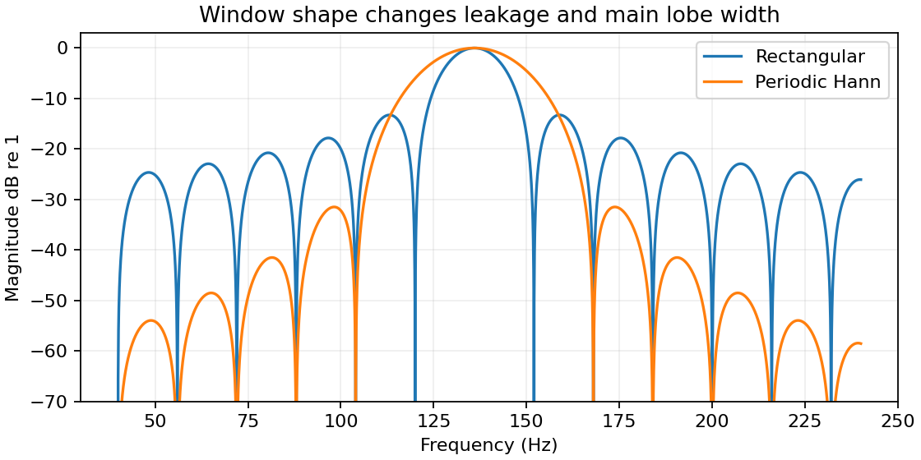
The periodic Hann window has coherent gain 0.5; dividing by its sum corrects amplitude scaling. Compared with the rectangular window it lowers sidelobes and doubles the approximate null to null main lobe width here, from 32 to 64 Hz. Leakage suppression and tone separation therefore compete. Grading: geometric sum 5; cycle and seam reasoning 4; plots and sampling explanation 4; window tradeoff 2.

Solution 5 Zero Padding Is Spectral Interpolation
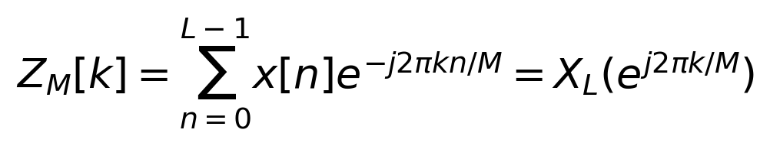
Appending zeros leaves the finite sequence DTFT unchanged. When M=qL, ZM[qr]=XL[r] for every original bin r. For M=512 and L=128, every fourth padded bin equals an original bin. The original DFT already determines every acquired sample through its inverse.
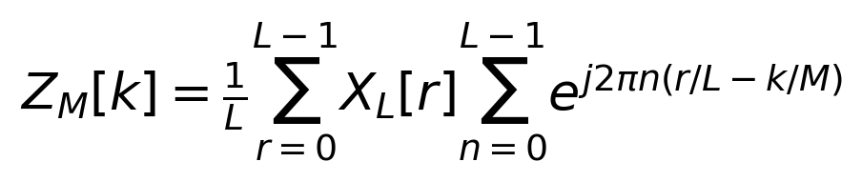
Substitute the L point inverse DFT into the zero padded transform and interchange the sums to obtain this interpolation identity. The inner sum is a complex Dirichlet kernel; it is not generally straight line interpolation of magnitudes. Every padded coefficient is a linear combination of the original coefficients.
N | Grid Hz | Largest bin Hz | Peak amplitude
128 | 16.0 | 400.0 | 0.931484
512 | 4.0 | 404.0 | 0.996855
4096 | 0.5 | 403.5 | 0.999743

The grid approaches the actual 403.3 Hz peak and reduces scalloping in the displayed sample maximum. The first zeros are f0 minus and plus fs/L: 387.3 and 419.3 Hz. The full main lobe width remains 32 Hz at every padding length. The displayed amplitude tends to 1 because normalization uses the acquired length 128.
Dividing the ordinary FFT by N introduces a false L/N amplitude reduction. If a library divides the forward transform by N, undo that convention or multiply the normalized result by N/L. For a general window use the window sum in place of L. FFT normalization conventions must be stated explicitly.
Better single tone peak localization is a denser numerical evaluation of existing information. It is not the addition of measured observations and does not narrow the spectral lobes of two tones. At high SNR a frequency estimate can be more precise than a bin spacing; bin spacing is not a universal estimation error bound.
Grading: measured table and plots 4; unchanged DTFT and preserved bins 4; zeros and width 3; interpolation derivation 5; normalization and interpretation 4.

Solution 6 Separating Two Close Sinusoids
L | N | Duration ms | Grid Hz | Lobe width Hz
128 | 128 | 62.5 | 16.0 | 32.0
128 | 4096 | 62.5 | 0.5 | 32.0
1024 | 4096 | 500.0 | 0.5 | 4.0

Both short record spectra have one dominant maximum at 403 Hz on a common dense DTFT grid. Padding from N=128 to N=4096 describes this same broad shape more finely. It does not produce two peaks. The longer record produces dominant maxima near 400.21 and 405.79 Hz and a minimum between them. These locations are shifted slightly from the true tones by interference between their finite record responses.
The acquired interval increases from 62.5 to 500 ms. Each tone’s rectangular window response narrows from 32 to 4 Hz between first zeros. Both padded plots have the same 0.5 Hz grid, so the separation is attributable to more measured data and narrower lobes, not to grid spacing.
A 0.5 Hz grid alone does not guarantee resolution of 6 Hz spaced tones. Conventional spectral separation depends on observation duration, window, relative phase, amplitude and noise. This experiment makes that dependence concrete; it does not define a universal minimum separation for every estimator.
A parametric estimator can exploit an assumed sinusoidal model to infer frequencies closer than the width of a plotted spectral lobe, subject to identifiability and noise sensitivity. Padding does not add information for that estimator either, although it may help evaluate an objective or interpolate a peak numerically.
For the graduate extension, changing relative phase changes how the complex finite record spectra add, so peak counts may change even when frequencies and record duration do not. Avoid using a peak count as a universal law of resolution. Grading: controlled plots 6; criterion and peak interpretation 6; duration and width comparison 4; estimator qualifications 4.

Running the reference experiments
Install requirements.txt and run python solution.py from the extracted package. results contains plots and metrics.json. starter.py supplies FFT amplitude normalization and the centered two tone generator. The solution script verifies DFT arithmetic, inverse periodicity, circular shifting, convolution folding, preserved original bins and the spectral peak comparison.

