Worked DSP project solution
The implementation is in dsp_solution.py. This notebook runs all experiments and displays measured evidence. Parameters and theoretical interpretation are in the accompanying solution document. The saved outputs below are from a completed run.
from run_solution import main
metrics = main()
{
"time_frequency": [
{
"L": 256,
"window_ms": 16.0,
"bin_hz": 62.5,
"hop_ms": 4.0,
"transient_10percent_energy_width_ms": 8.0
},
{
"L": 1024,
"window_ms": 64.0,
"bin_hz": 15.625,
"hop_ms": 16.0,
"transient_10percent_energy_width_ms": 32.0
},
{
"L": 4096,
"window_ms": 256.0,
"bin_hz": 3.90625,
"hop_ms": 64.0,
"transient_10percent_energy_width_ms": 192.0
}
],
"windows": [
{
"window": "boxcar",
"null_to_null_hz": 31.25,
"peak_sidelobe_db": -13.263647577714902,
"enbw_hz": 15.625
},
{
"window": "hann",
"null_to_null_hz": 62.5,
"peak_sidelobe_db": -31.467626478524792,
"enbw_hz": 23.4375
},
{
"window": "hamming",
"null_to_null_hz": 62.5,
"peak_sidelobe_db": -42.6743663692628,
"enbw_hz": 21.294152949245543
},
{
"window": "blackman",
"null_to_null_hz": 93.75,
"peak_sidelobe_db": -58.10884368817948,
"enbw_hz": 26.98058390022675
}
],
"overlap": [
{
"overlap_percent": 0,
"hop": 1024,
"window": "boxcar",
"frames": 65,
"relative_error": 2.6735228456948584e-16,
"min_denominator": 1.0,
"max_denominator": 1.0,
"elapsed_seconds": 0.04068229999393225
},
{
"overlap_percent": 0,
"hop": 1024,
"window": "hann",
"frames": 65,
"expected_failure": "NOLA failure in retained samples",
"elapsed_seconds": 0.0032158999238163233
},
{
"overlap_percent": 25.0,
"hop": 768,
"window": "hann",
"frames": 86,
"relative_error": 3.7200893184236793e-16,
"min_denominator": 0.0428932188134525,
"max_denominator": 1.0,
"elapsed_seconds": 0.004012899938970804
},
{
"overlap_percent": 50.0,
"hop": 512,
"window": "hann",
"frames": 128,
"relative_error": 2.444013099020329e-16,
"min_denominator": 0.5,
"max_denominator": 1.0,
"elapsed_seconds": 0.005510699935257435
},
{
"overlap_percent": 75.0,
"hop": 256,
"window": "hann",
"frames": 255,
"relative_error": 2.0087174059560197e-16,
"min_denominator": 1.4999999999999993,
"max_denominator": 1.5000000000000007,
"elapsed_seconds": 0.010108600021339953
},
{
"overlap_percent": 87.5,
"hop": 128,
"window": "hann",
"frames": 509,
"relative_error": 1.9368621161930796e-16,
"min_denominator": 2.999999999999999,
"max_denominator": 3.0000000000000013,
"elapsed_seconds": 0.020057399990037084
}
],
"ola": {
"relative_error": 3.267306983317611e-16,
"output_samples": 64128,
"fft_length": 1024,
"group_delay_samples": 64
},
"ola_block_sweep": [
{
"B": 128,
"nfft": 256,
"blocks": 500,
"relative_error": 3.486251505589894e-16
},
{
"B": 512,
"nfft": 1024,
"blocks": 125,
"relative_error": 3.267306983317611e-16
},
{
"B": 2048,
"nfft": 4096,
"blocks": 32,
"relative_error": 3.4427220579912124e-16
}
],
"jammer": {
"input_snr_db": -9.241890416521894,
"output_snr_db": 17.349087100818082,
"stationary_notch_snr_db": -8.481089473614823
},
"jammer_sweep": [
{
"L": 256,
"width_hz": 30,
"output_snr_db": -0.8024310924202096,
"jammer_attenuation_db": 8.439462222975777,
"clean_relative_error": 0.00024308965005550364
},
{
"L": 256,
"width_hz": 60,
"output_snr_db": 4.843103849910849,
"jammer_attenuation_db": 14.08499339328788,
"clean_relative_error": 0.00037779775091329127
},
{
"L": 256,
"width_hz": 120,
"output_snr_db": 12.481593042684294,
"jammer_attenuation_db": 21.72345862836615,
"clean_relative_error": 0.0005655553072143046
},
{
"L": 1024,
"width_hz": 30,
"output_snr_db": 11.76507671056524,
"jammer_attenuation_db": 21.007007364925418,
"clean_relative_error": 0.0002810228251903903
},
{
"L": 1024,
"width_hz": 60,
"output_snr_db": 17.349087100818082,
"jammer_attenuation_db": 26.590936278608414,
"clean_relative_error": 0.000404427480612134
},
{
"L": 1024,
"width_hz": 120,
"output_snr_db": 19.878447725307534,
"jammer_attenuation_db": 29.120208120571572,
"clean_relative_error": 0.0005753947233051704
},
{
"L": 4096,
"width_hz": 30,
"output_snr_db": 11.350648144222896,
"jammer_attenuation_db": 20.59250594230059,
"clean_relative_error": 0.00027841472515402395
},
{
"L": 4096,
"width_hz": 60,
"output_snr_db": 17.0753710187401,
"jammer_attenuation_db": 26.317142591547835,
"clean_relative_error": 0.0004034867182518259
},
{
"L": 4096,
"width_hz": 120,
"output_snr_db": 19.76949495780763,
"jammer_attenuation_db": 29.01121795144676,
"clean_relative_error": 0.0005751797356772257
}
],
"iq_wav_roundtrip_error": 2.3820580951013048e-08,
"communications": {
"original": {
"evm_percent": 0.947661602826916,
"ber": 0.0,
"waveform_relative_error": 0.0
},
"coherent": {
"evm_percent": 0.9476616028269153,
"ber": 0.0,
"waveform_relative_error": 2.3268009963511954e-16
},
"magnitude_only": {
"evm_percent": 101.02894144350883,
"ber": 0.4990138067061144,
"waveform_relative_error": 1.0103187240492075
},
"frame_phase_reset": {
"evm_percent": 127.67102277627777,
"ber": 0.5226824457593688,
"waveform_relative_error": 1.2816860544023
}
},
"checks": "PASS: identity, expected NOLA failure, real and complex full OLA, QPSK BER"
}

Time frequency tradeoff
print(metrics['time_frequency'])
[{'L': 256, 'window_ms': 16.0, 'bin_hz': 62.5, 'hop_ms': 4.0, 'transient_10percent_energy_width_ms': 8.0}, {'L': 1024, 'window_ms': 64.0, 'bin_hz': 15.625, 'hop_ms': 16.0, 'transient_10percent_energy_width_ms': 32.0}, {'L': 4096, 'window_ms': 256.0, 'bin_hz': 3.90625, 'hop_ms': 64.0, 'transient_10percent_energy_width_ms': 192.0}]
from IPython.display import display, Image
display(Image(filename="results/uncertainty.png"))
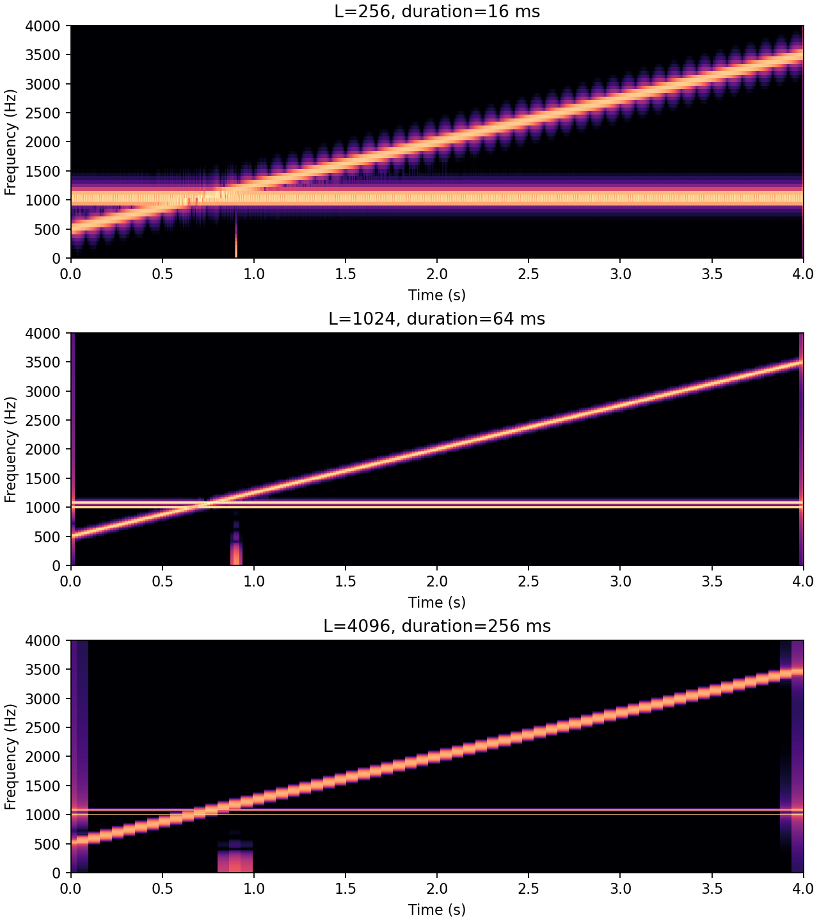

Zero padding
print(metrics['time_frequency'])
[{'L': 256, 'window_ms': 16.0, 'bin_hz': 62.5, 'hop_ms': 4.0, 'transient_10percent_energy_width_ms': 8.0}, {'L': 1024, 'window_ms': 64.0, 'bin_hz': 15.625, 'hop_ms': 16.0, 'transient_10percent_energy_width_ms': 32.0}, {'L': 4096, 'window_ms': 256.0, 'bin_hz': 3.90625, 'hop_ms': 64.0, 'transient_10percent_energy_width_ms': 192.0}]
from IPython.display import display, Image
display(Image(filename="results/zero_padding.png"))
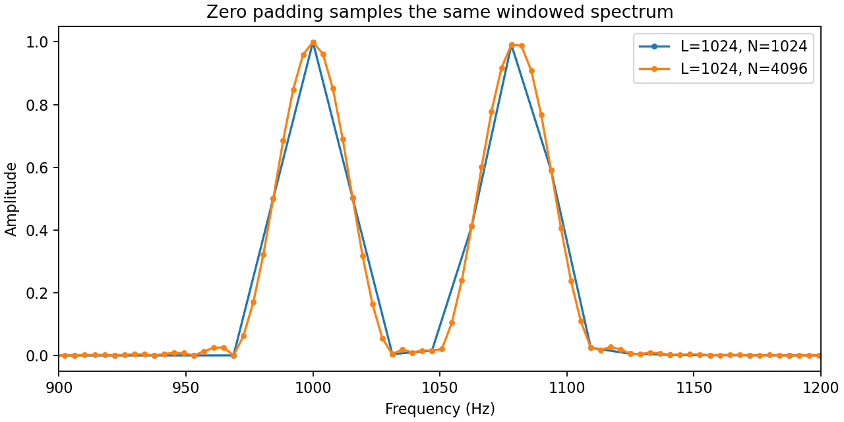

Windows and leakage
print(metrics['windows'])
[{'window': 'boxcar', 'null_to_null_hz': 31.25, 'peak_sidelobe_db': -13.263647577714902, 'enbw_hz': 15.625}, {'window': 'hann', 'null_to_null_hz': 62.5, 'peak_sidelobe_db': -31.467626478524792, 'enbw_hz': 23.4375}, {'window': 'hamming', 'null_to_null_hz': 62.5, 'peak_sidelobe_db': -42.6743663692628, 'enbw_hz': 21.294152949245543}, {'window': 'blackman', 'null_to_null_hz': 93.75, 'peak_sidelobe_db': -58.10884368817948, 'enbw_hz': 26.98058390022675}]
from IPython.display import display, Image
display(Image(filename="results/windows.png"))
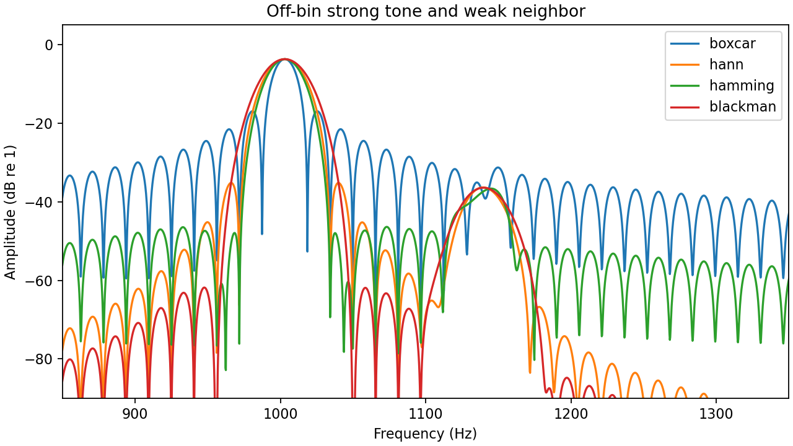

Overlap and exact FFT convolution
print(metrics['overlap'])
[{'overlap_percent': 0, 'hop': 1024, 'window': 'boxcar', 'frames': 65, 'relative_error': 2.6735228456948584e-16, 'min_denominator': 1.0, 'max_denominator': 1.0, 'elapsed_seconds': 0.04068229999393225}, {'overlap_percent': 0, 'hop': 1024, 'window': 'hann', 'frames': 65, 'expected_failure': 'NOLA failure in retained samples', 'elapsed_seconds': 0.0032158999238163233}, {'overlap_percent': 25.0, 'hop': 768, 'window': 'hann', 'frames': 86, 'relative_error': 3.7200893184236793e-16, 'min_denominator': 0.0428932188134525, 'max_denominator': 1.0, 'elapsed_seconds': 0.004012899938970804}, {'overlap_percent': 50.0, 'hop': 512, 'window': 'hann', 'frames': 128, 'relative_error': 2.444013099020329e-16, 'min_denominator': 0.5, 'max_denominator': 1.0, 'elapsed_seconds': 0.005510699935257435}, {'overlap_percent': 75.0, 'hop': 256, 'window': 'hann', 'frames': 255, 'relative_error': 2.0087174059560197e-16, 'min_denominator': 1.4999999999999993, 'max_denominator': 1.5000000000000007, 'elapsed_seconds': 0.010108600021339953}, {'overlap_percent': 87.5, 'hop': 128, 'window': 'hann', 'frames': 509, 'relative_error': 1.9368621161930796e-16, 'min_denominator': 2.999999999999999, 'max_denominator': 3.0000000000000013, 'elapsed_seconds': 0.020057399990037084}]

Moving jammer
print(metrics['jammer_sweep'])
[{'L': 256, 'width_hz': 30, 'output_snr_db': -0.8024310924202096, 'jammer_attenuation_db': 8.439462222975777, 'clean_relative_error': 0.00024308965005550364}, {'L': 256, 'width_hz': 60, 'output_snr_db': 4.843103849910849, 'jammer_attenuation_db': 14.08499339328788, 'clean_relative_error': 0.00037779775091329127}, {'L': 256, 'width_hz': 120, 'output_snr_db': 12.481593042684294, 'jammer_attenuation_db': 21.72345862836615, 'clean_relative_error': 0.0005655553072143046}, {'L': 1024, 'width_hz': 30, 'output_snr_db': 11.76507671056524, 'jammer_attenuation_db': 21.007007364925418, 'clean_relative_error': 0.0002810228251903903}, {'L': 1024, 'width_hz': 60, 'output_snr_db': 17.349087100818082, 'jammer_attenuation_db': 26.590936278608414, 'clean_relative_error': 0.000404427480612134}, {'L': 1024, 'width_hz': 120, 'output_snr_db': 19.878447725307534, 'jammer_attenuation_db': 29.120208120571572, 'clean_relative_error': 0.0005753947233051704}, {'L': 4096, 'width_hz': 30, 'output_snr_db': 11.350648144222896, 'jammer_attenuation_db': 20.59250594230059, 'clean_relative_error': 0.00027841472515402395}, {'L': 4096, 'width_hz': 60, 'output_snr_db': 17.0753710187401, 'jammer_attenuation_db': 26.317142591547835, 'clean_relative_error': 0.0004034867182518259}, {'L': 4096, 'width_hz': 120, 'output_snr_db': 19.76949495780763, 'jammer_attenuation_db': 29.01121795144676, 'clean_relative_error': 0.0005751797356772257}]
from IPython.display import display, Image
display(Image(filename="results/jammer.png"))
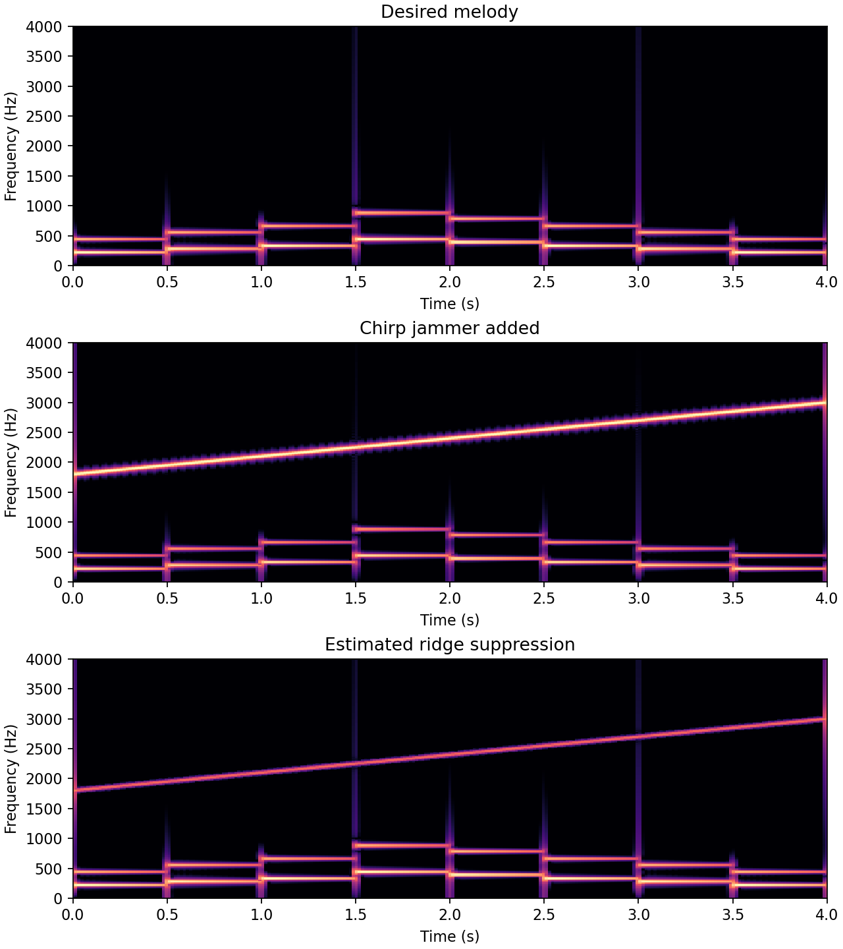

Phase coherent QPSK
print(metrics['communications'])
{'original': {'evm_percent': 0.947661602826916, 'ber': 0.0, 'waveform_relative_error': 0.0}, 'coherent': {'evm_percent': 0.9476616028269153, 'ber': 0.0, 'waveform_relative_error': 2.3268009963511954e-16}, 'magnitude_only': {'evm_percent': 101.02894144350883, 'ber': 0.4990138067061144, 'waveform_relative_error': 1.0103187240492075}, 'frame_phase_reset': {'evm_percent': 127.67102277627777, 'ber': 0.5226824457593688, 'waveform_relative_error': 1.2816860544023}}
from IPython.display import display, Image
display(Image(filename="results/constellations.png"))
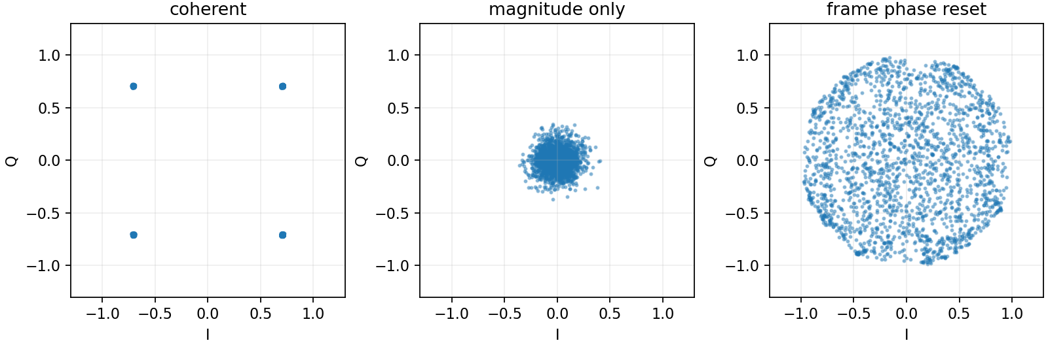

Acceptance checks
main() checks identity reconstruction, expected Hann NOLA failure, real and complex full FFT convolution, and zero BER after coherent QPSK reassembly. EVM includes finite RRC pulse truncation. WAV round-trip error is separate from float64 identity error. Runtime values vary across machines. See the solution document for the derivations and grading notes.

