**Wallapop Frontend Test**

**What is this about**

The purpose of this test is to know your ability to create a modern and functional single page

application.

**What we’ll evaluate**

* You can use any JavaScript libraries and/or frameworks you want. However, an MVC/MVVM style framework is encouraged.
* The use of CSS processors (SASS, LESS...) is allowed and encouraged.
* The use of Typescript is allowed and encouraged.
* Test everything! We really like unit testing and we consider essential to have a good coverage.
* You can develop the application taking into consideration IE11+ browsers only (with ES5 support). IE8​ support is NOT needed.
* The use of ES6 features is allowed and encouraged. If you use them, remember you’ll need a transpiler to produce valid Javascript.
* The following are bonus points that we will be happy to see:
  + Responsive design
  + Application structure (tidiness, patterns, ...)
  + Friendly and easy to use UX/UI
  + Optimization (load times, rendering performance, ...)

**What we want you to do**

As stated, you’ll develop a single page application that provides the functionality defined by the needs of the following user:

As a user I want to have access to an Item Manager where I can search items given the

following criteria:

* Title
* Description
* Price
* Email

Each item will have these fields and a picture.

When I perform a search that has results, I’d like to view a list of the items showing all the information. The app must provide me the ability to sort the listed items by title, description, price or email.

Also, I want to be able to have a favourite items list, so I must be able to select the items from the list and save them on my favourite list. The list should be displayed on a modal containing all those items showing only the picture and the title. The modal should be opened by clicking on a button displayed in some place on the page where it’s easily accessible.

In the favourite modal, I want to be able to search by title and the possibility to remove the items from the favourite list without having to close the modal. I don’t want the favorite items to be preserved when I refresh the page.

The data that holds the items contains 20 items. The 20 items should NOT be displayed all at once. I’d like to see 5 items each time (with an initial load of 5 when the page is loaded), so some pagination method should be implemented to view the remaining items (clicking a button, with endless scroll...it’s up to you).

**Data source**

You will find the JSON that has all the items available in this URL:

<https://webpublic.s3-eu-west-1.amazonaws.com/tech-test/items.json>

Here is a sample of the content of the JSON:

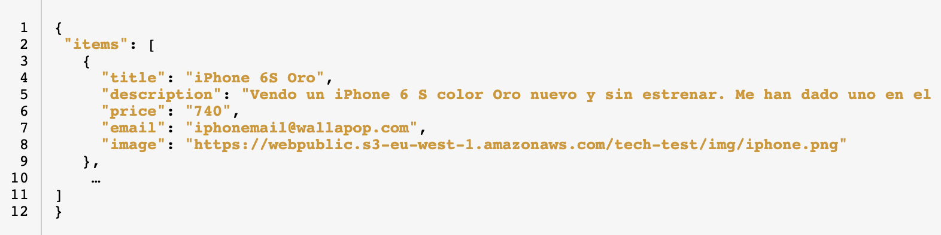

**How to deliver**

Important! In order to ensure the test will be easily corrected,​ you must send your solution with all the files needed via a repository such as Github or Bitbucket, adding a ​ README.md ​ with compilation and run instructions. We recommend testing the compilation before sending it.

Good luck and have fun :)